**Design Doc: Escape the Matrix Web App**

# **Background**

[In just a few sentences, summarize the project. This is a brief summary of your 1 Pager/PRD]

Escape the Matric Web App, is a horizontal, side scrolling, and endless runner web app. Player have to avoid all sort of hurdles/stones while achieving all the coins at the same time to achieve the points in game. While playing game, users can navigate through different lanes to collect treasures, level up, and avoid mystery obstacles coming towards them. This App used web languages like JavaScript, HTML, and CSS to create and design key stylistic features of the game. Some basic level graphic design was involved to draw characters or basic mock-ups for how the game worked.

**Overview**

[Provide a high-level overview of the design. Details go in the next section(s) and background in the previous section. This should be understandable to someone not familiar with the project.]  
This section includes some basic functions the Escape the Matrix web app, the user is majorly collecting the point through achieving the coins and making new coins and achieving the level from basic to pro level. The hurdles are also presented to the user and he can avoid such hurdles by skipping to different levels. For each encounter between user and hurdle the life system of the user life on the game will decrease and eventually with specific hits with hurdle will lose his life.

**Collection and Score**

The player will vertically navigate through five horizontal lanes in order to collect various coins or other items in order to fill a score bar that will be implemented using a counter to iterate the score and keep track of how many items are collected. Differently colored coins and treasures will be worth different amounts of money and increase the score bar with various values.

**Avoidance Element**

The player will traverse each run while avoiding objects that are moving towards the player at random speeds within a predetermined range. The difficulty of the game shall increase as the game progresses by leveling up the speed and/or acceleration of the objects as well as increasing the number of objects moving towards the player until they are defeated.

**Life System**

The player will be allowed three hits before they are killed and their current run is over. The player loses a hit point by either failing to avoid an oncoming object or by colliding with the side of a hazard before it is fully off-screen.

# **Detailed design**

[In this section, dive into the details of how the system will work. You will likely want to use multiple subsections, or even have multiple top-level headers if that makes more sense for a particular project.] (Examples Database Design, Object Model and System APIs)

This section will cover the major functional requirements for the Escape for the Matrix web app along with the object model and System APIs storyboarding. This is a web app which is suppose to work perfect on web browsers like Chrome, Firefox and Edge web browsers using both Mac and Windows. All the libraries were configured so that app can run successful on the web. The major modules of the system and their details are:

1. MVP: Login Page, Vertical Control of player, Items to Collect, Hazards to Avoid
2. Score Keeping Leaderboards
3. Player Customization
4. One Hit Mode

##### User scenario

### P1 Requirements

1. User login/landing page
   1. Users can enter/change the name of whoever is playing.
   2. Users can change their character’s color
   3. Users can decide if they want background music on or off.

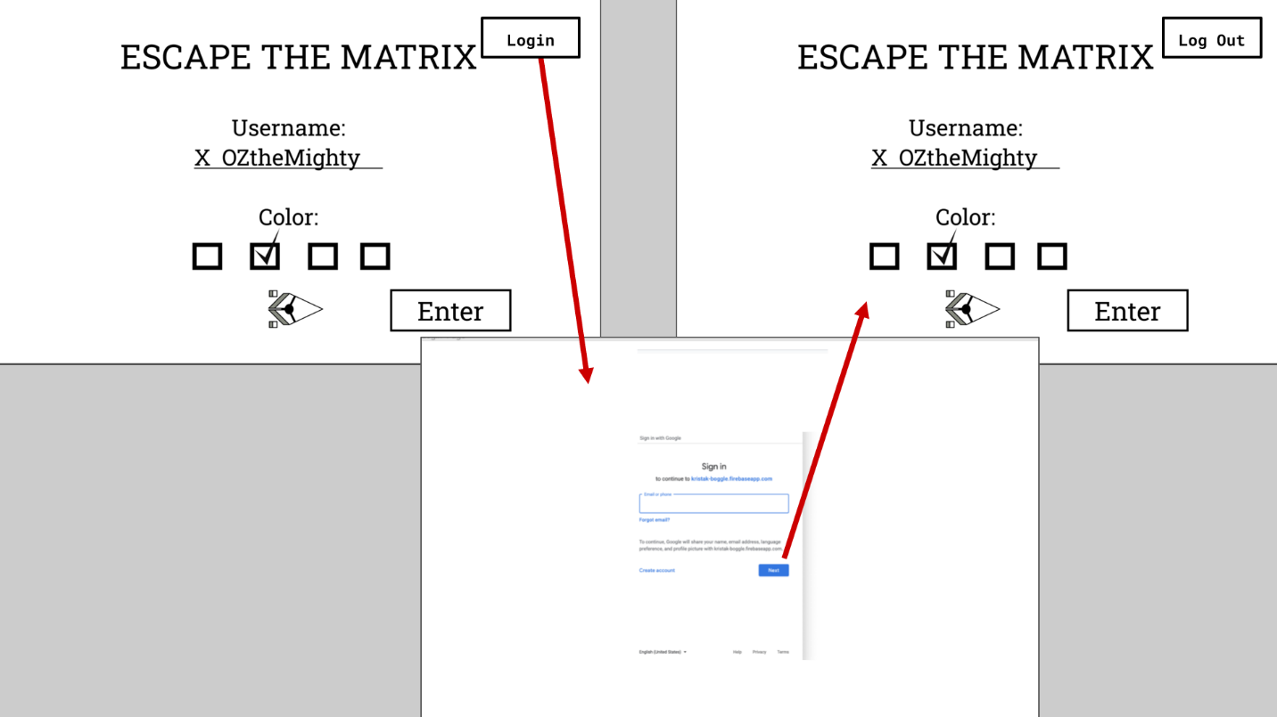

1. Players start their run of the game
   1. Decides which mode of the game they wish to play (Classic or One-hit mode).
   2. Decide the initial difficulty level of that run.
   3. Press the start button

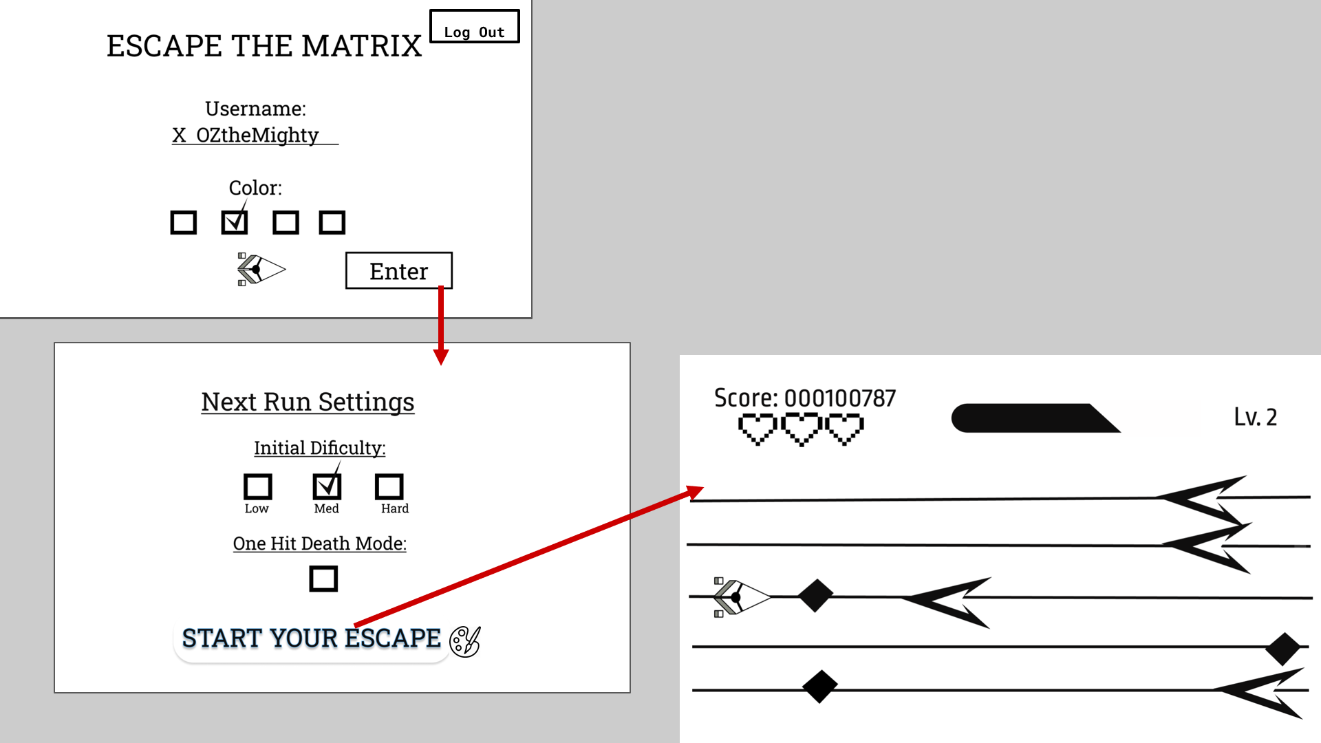

1. Player collects items
   1. The various items move towards the player for them to collect
   2. Upon collection, the item disappears from the play area.
   3. The counter keeps track of how many items and points collected with the level bar will increase the more objects the player collects.
   4. Upon reaching certain thresholds, the players’ level will upgrade with an exponentially increasing number of required objects to be collected between each upgrade.

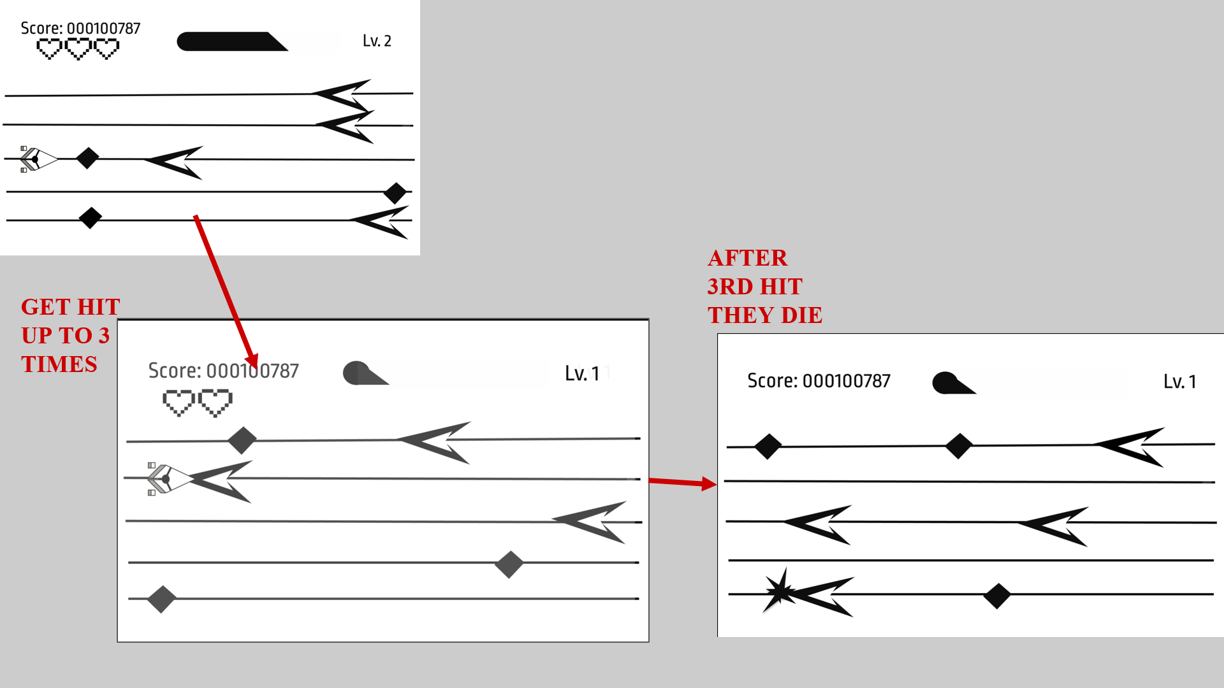

1. Hazards to Avoid
   1. If the player is hit by a hazard then the screen fades red for an instant indicating damage was taken.
   2. STRETCH: Players must avoid objects that will break their ship/degrade their score and power levels.

#### P2 Requirements

1. Score/Leaderboards screen
   1. The current leader board is displayed with the user’s login name and previous run scores are displayed in comparison with the rest of the high scores.
   2. STRETCH: If the player’s last run did not make it into the top scores, the player is shown a number indicating where they would rank.
   3. Users can share a link or game code to play with friends.

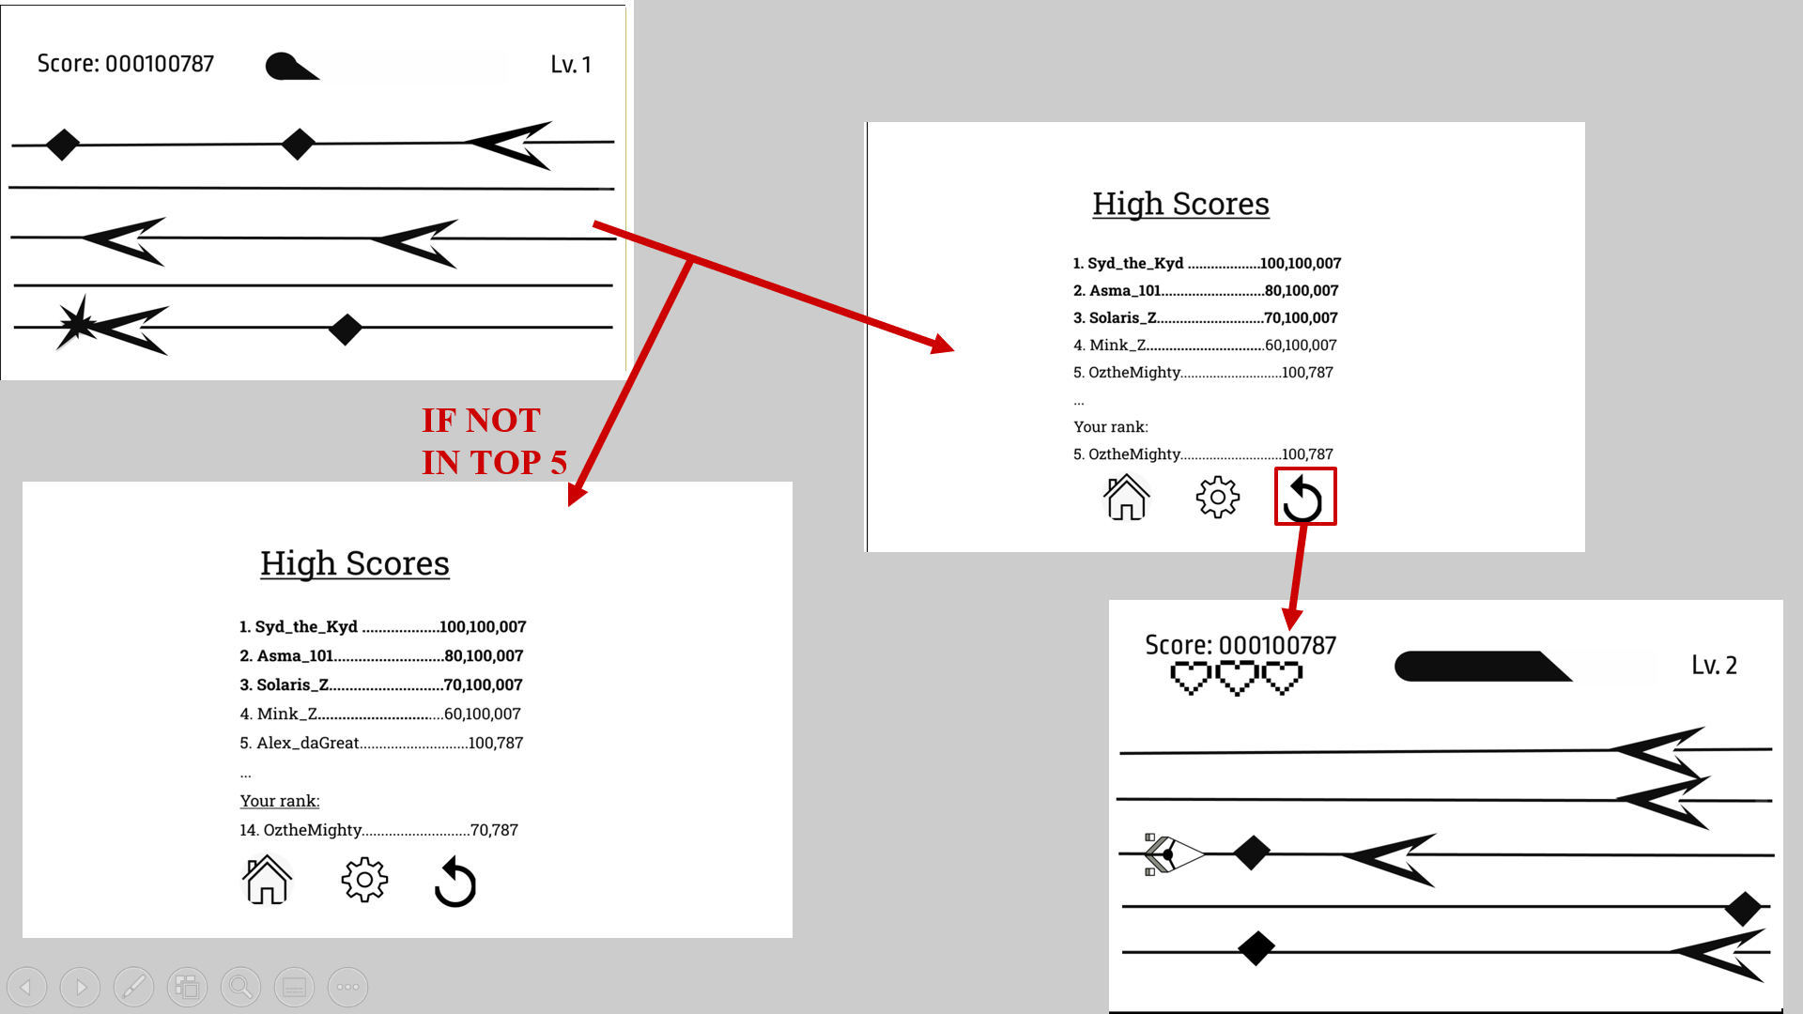

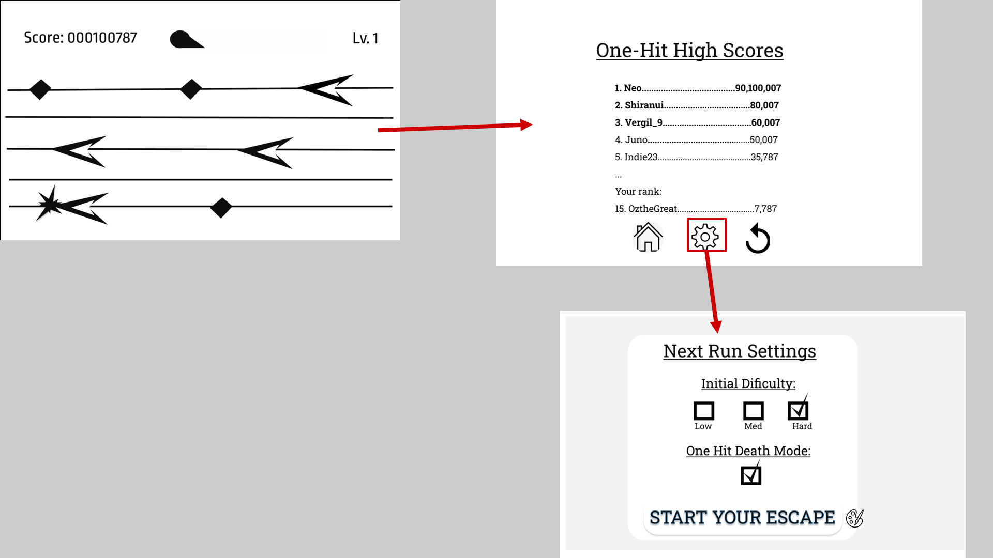

#### P3 Requirements

1. Character Customizer
   1. The player can go back to pick a different color for their ship
   2. The player can pick different simple shapes for their ships’ designs from a series of predetermined shapes.
   3. STRETCH: Include other small accessories into the model.

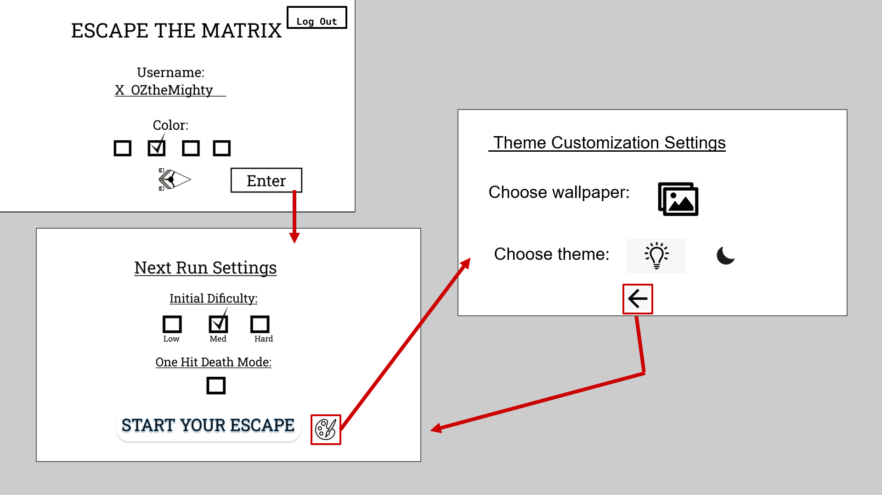

#### P4 Requirements - Optional, stretch goals

1. A one-hit Death mode of the game
   1. The player goes through a regular run of the game but with only one hit of health before losing
   2. The player’s score is compared to a separate leaderboard for just one-hit run scores
2. A multi-language version of the game
   1. Extra-stretch: Making a Spanish language version of the game
3. Extra UI Features
   1. Able to customize the theme of that specific user’s background
   2. Create a damage model of the player’s ship where pieces of users ship break away as when they take damage.



##### Non-functional

## Localization

We will currently support an American English language version of Explore the Matrix. Future versions of the game will add support for other languages.

### Privacy

Users should only be able to see each other's scores on a leaderboard view. They should not be able to see user login credentials like their email, username, and password. The user’s current score (not compounded) should only be visible to the user at that time.

###### Detailed Design Evaluations

In this section the heuristic evaluations of all three storyboards that are shown in the mockups along with the detailed discussion of results.

To evaluate each storyboard, we considered 10 heuristics:

1. Visibility of system status
2. Match between system and the real world
3. User control and Freedom
4. Consistency and Standards
5. Error prevention
6. Recognition rather than recall
7. Flexibility and Efficiency of use
8. Aesthetic and Minimalist design
9. Help users recognize, diagnose, and recover from errors
10. Help and Documentation

**Heuristic Evaluation (Questions)**

1. Visibility of system status
   1. When you played/created/deleted the challenge were you able to see what was going on during the process?
2. Match between system and the real world
   1. Is our game UI intuitive?
   2. Do you know what to do without direction from me?
3. User control and freedom
   1. Did you find it easy to navigate the application?
   2. How easy was it to rectify mistakes, go back or cancel changes you decided you no longer wanted?
4. Consistency and standards
   1. Do you think the design is consistent?
5. Error prevention
   1. Did you come across any bugs or errors?
6. Recognition rather than recall
   1. Will you be able to do the task that you have already done solely based on the instructions and designs in the application?
7. Flexibility and efficiency of use
   1. How easy or difficult is it to do what you want with this app?
   2. Are the steps/clicks that you make the shortest way to do your task?
8. Aesthetic and minimalist design
   1. Is the design pleasing to your eyes?
   2. Do you think it is cluttered or has too much space?
9. Help users recognize, diagnose, and recover from errors
   1. Were you able to do all the tasks that you wanted in the application?
   2. If not, did you get an error?
   3. Was the error descriptive about the problem and comprehensive about how to resolve it?
10. Help and documentation
    1. Are you comfortable navigating the application?
    2. Did the words and instructions in the application help you make choices during this process?

**Storyboard 1 Evaluation**

Storyboard 1 illustrates the user journey of playing through the regular course of the game. Based on this we concluded the resulting evaluation:

Screen 1:No heuristics were violated.

* Users are presented with the title page.
* The title page displays the game title/logo.
* The title page follows real-world conventions by showing a login button.
* The login button prompts users to sign in with a Google account.
* No room for errors when the user visits the title page.
* Users are able to change their character colors on this page.
* ‘Enter’ button is present so that users know they are entering the menu and not the game.

Screen 2: No heuristics were violated.

* The title/login page leads to the menu page.
* The setting page displays customizable game settings.
* Users can choose their difficulty for the game or choose which mode they want to play.
* There is no room for error here as there are labels for each both underneath.
* There is a ‘Start Your Escape’ button so that users can start game without the use of fancy commands
* The user can begin playing the game once the button is pressed.

Screen 3:No heuristics were violated.

* The user begins playing the regular mode (three-hit mode) of the game.
* There are no onscreen controls for the computer version of the game.
* The user is aware of their game status with on-screen symbols.
* The amount of user lives represented by the number of hearts.
* The level status bar represents progress towards the next level so the user is aware of their achievements.
* The user's score is represented by an integer at the top left corner of the screen.
* Real life conventions are used as the design layout of the game resembles those of a classic arcade game.

Screen 4: No heuristics were violated.

* The game clearly shows that the user is playing as the icons are moving horizontally from right to left of the screen.
* Users are alerted if they are hit by an opposing object/enemy with an impact crash graphic.
* The screen also flashes warning colors of yellow (if the user has been hit once) and red (if they have been hit twice or for the third final time.)
* Icons and colors follow real-world conventions.
* Error prevention is unnecessary because the screen will keep moving (infinitely) until the player is hit three times.
* If the player is hit 3 times, they are automatically taken to a high score screen so no need to exit the game themselves.
* If the player is in the top three rank positions of the leaderboards, their username and score number is clearly displayed in bold font.
* If the user is not in the top three positions then they have the option to go back to the main menu, settings, or replay the game to improve their score.
* The three options for the user are clearly displayed by icons/symbols at the bottom of the leaderboard so there is no confusion.
* The game remains in classic three hit mode until the box is unchecked.
* The replay button automatically resets a new game screen so no commands are needed.
* The user can clearly see that they are playing a new game because their lives, score, and level bar progress are all reset.
* The design is a classic arcade theme.

In conclusion, our evaluation of the first storyboard is that no heuristics were violated.

**Storyboard 2 Evaluation**

Storyboard 2 illustrates the user going through the one-hit version of the game. The player can only be struck by an opposing object once before they are defeated in this version of the game. Based on this, we concluded the following evaluation:

Screen 1: No heuristics were violated.

* Users are presented with the title page.
* The title page displays the game title/logo.
* The title page follows real-world conventions by showing a login button.
* The login button prompts users to sign in with a Google account.
* No room for errors when the user visits the title page.
* Users are able to change their character colors on this page.
* ‘Enter’ button is present so that users know they are entering the menu and not the game.

Screen 2: No heuristics were violated.

* The title/login page leads to the menu page.
* The setting page displays customizable game settings.
* Users can choose their difficulty for the game or choose which mode they want to play.
* The user must click the checkbox under the one hit mode description
* There is no room for error here as there are labels for each both underneath.
* There is a ‘Start Your Escape’ button so that users can start the game without the use of fancy commands
* The user can begin playing the game once the button is pressed.
* There are no onscreen controls for the computer version of the game.
* The user is aware of their game status with on-screen symbols.
* The amount of user lives represented by the number of hearts (only one heart for this version).
* The level status bar represents progress towards the next level so the user is aware of their achievements.
* The user's score is represented by an integer at the top left corner of the screen.
* Real-life conventions are used as the design layout of the game resembles those of a classic arcade game.

Screen 3:No heuristics were violated.

* The game clearly shows that the user is playing as the icons are moving horizontally from right to left of the screen.
* Users are alerted if they are hit by an opposing object/enemy with an impact crash graphic.
* The screen only turns red one the player is hit since this version of the game only allows for one hit occurrence.
* Icons and colors follow real-world conventions.
* Error prevention is unnecessary because the screen will keep moving (infinitely) until the player is hit once.
* If the player is hit one time (in this mode), they are automatically taken to a high score screen so no need to exit the game themselves.
* If the player is in the top three rank positions of the leaderboards, their username and score number is clearly displayed in bold font.
* If the user is not in the top three positions then they have the option to go back to the main menu, settings, or replay the game to improve their score.
* The three options for the user are clearly displayed by icons/symbols at the bottom of the leaderboard so there is no confusion.
* The game remains in one hit mode until the box is unchecked.
* The replay button automatically resets a new game screen so no commands are needed.
* The user can clearly see that they are playing a new game because their lives, score, and level bar progress are all reset.
* The design is a classic arcade theme.

In conclusion, our evaluation of the third storyboard is that no heuristics were violated.

**Storyboard 3 Evaluation**

Storyboard 3 illustrates the user going through the regular 3-hit version of the game but with customizations. In this version of the game, users can choose the specific game theme they would like to play in. Based on this, we concluded the following evaluation:

Screen 1:No heuristics were violated.

* Users are presented with the title page.
* The title page displays the game title/logo.
* The title page follows real-world conventions by showing a login button.
* The login button prompts users to sign in with a Google account.
* No room for errors when the user visits the title page.
* Users are able to change their character colors on this page.
* ‘Enter’ button is present so that users know they are entering the menu and not the game.

Screen 2: No heuristics were violated.

* The title/login page leads to the menu page.
* The setting page displays customizable game settings.
* Users can choose their difficulty for the game or choose which mode they want to play.
* There is no room for error here as there are labels for each both underneath.
* There is a paint palette icon to indicate customization for the actual gameplay.
* Users click on the customization button to change the UI features of their game.
* This page tells the user that they are at the game settings and can customize two UI options
* Players can choose a background wallpaper for their game.
* Players can choose either a light or dark theme for the game.
* The icons are represented by real-life conventions so users are easily able to pick the desired theme.
* There is a ‘Start Your Escape’ button so that users can start the game without the use of fancy commands
* The user can begin playing the game once the button is pressed.

Screen 3: No heuristics were violated.

* The user begins playing the regular mode (three-hit mode) of the game.
* There are no onscreen controls for the computer version of the game.
* The user is aware of their game status with on-screen symbols.
* The amount of user lives represented by the number of hearts.
* The level status bar represents progress towards the next level so the user is aware of their achievements.
* The user's score is represented by an integer at the top left corner of the screen.
* Real-life conventions are used as the design layout of the game resembles those of a classic arcade game.

Screen 4: No heuristics were violated.

* The game clearly shows that the user is playing as the icons are moving horizontally from right to left of the screen.
* Users are alerted if they are hit by an opposing object/enemy with an impact crash graphic.
* The screen also flashes warning colors of yellow (if the user has been hit once) and red (if they have been hit twice or for the third final time.)
* Icons and colors follow real-world conventions.
* Error prevention is unnecessary because the screen will keep moving (infinitely) until the player is hit three times.
* If the player is hit 3 times, they are automatically taken to a high score screen so no need to exit the game themselves.
* The top three rank positions of the leaderboards display the username and score number in bold font.
* If the user is not in the top three positions then their ranking is displayed below the top five with their rank number, their username, and their score.
* The user has the option to go back to the main menu, settings, or replay the game to improve their score.
* The three options for the user are clearly displayed by icons/symbols at the bottom of the leaderboard so there is no confusion.
* The game remains in classic three-hit mode until the box is unchecked.
* The main menu button automatically takes the player back to the menu page.
* The user can change their color, difficulty, game mode, and theme customization for their next game in the main meny.
* The user can clearly see that they are playing a new game because their lives, score, and level bar progress are all reset.
* The design is a classic arcade theme.

Screen 5: No heuristics were violated.

* The user has left the leaderboard screen and decided to go back to the home screen.
* The home screen is the same as the one that users see after using their Google account to log in.
* The last selected settings that the user chose are pre-selected.
* The user has the option to change these selections if desired or continue the game with their previous selections.
* The user has the option to begin the game again or log out of their account.

In conclusion, our evaluation of the third storyboard is that no heuristics were violated.

**Result of Heuristic Evaluation**

All three storyboards did not violate any heuristics. The goal was to design a simplistic arcade game which could be easily navigated by users of all ages. We used universal and conventional symbols in order to match games already created in real life. The user has freedom to control and customize their game play by choosing customization options and difficulty levels.

The screens are consistent with each other as they all display the same menus and only change if the user clicks a certain button. The design keeps error prevention in mind as we create straightforward buttons with labels to point out which action the user can take. The user can use recognition rather than recall to identify where game menus are (the player does not have to memorize a game layout.) The game design is fun, easy to use, and has a nostalgic feel with the classic arcade theme.

[Highlight limitations in the design, and areas for future improvement.]

The major limitation in design

* Musical elements, either simple background music or a rhythm aspect
* Optional one-hit sudden death mode
* High score feature to keep track of top users/players for each mode
* Customization of the character (can choose a color to play as at beginning of the game)
  + Having a player’s custom avatar be able to be uploaded into the game
* Power-ups:
  + Special effects like a project to shoot objects for a short amount of time

# **Security and Privacy**

[Absolutely mandatory in real life. Optional for this class, although still a good idea to think about.]

The security and privacy is very important for our system because the user details at advance level can breacher personal information of members of the system. The two factor authorization will be a mandatory option if this game go to professional level and ask user to buy their points/coins through some payment methods to play for longer time per visit. The two factor authorization will help to secure the user information as well as new fraudulent users can be avoided.

# **Accessibility**

[Absolutely mandatory in real life. Optional for this class, although still a good idea to think about.]

The web app is accessible on browsers like Chrome, Firefox or Microsoft Edge which are very easy accessible through browser but through login details. The future extension includes to add this app to the Apple store as well as android store to make it available to all mobile users too.

# **Future Goals**

The future of this web app includes to make it available to the Apple and Android mobile users. The future goals also include to introduce the characters more dynamically.