# Abstract

Online journal management system are helpful for the research oriented institutions to bring positive competition among students for not only research but also bring novelty in their research work too. Many universities and institutions are providing online journal management systems to the students, and editors who can collaboratively work on scholarly work before publication. The major benefit of such collaboration online saves time of both ends as well as keep record of the work progress. Such system is also needed to be installed in Glyndwr University due for its research oriented students. The aim of this project is to provide a single platform to all the stakeholders of the journal publication group. Each stakeholder have certain limits and rights to do their work online. This will allow students or authors to work remotely without having any hassle to meet with the supervisor or reviewer in order to have complete publishing process. Moreover they don’t have to go for the publishing department for publishing papers. This report is based on the research conducted before the actual implementation of Online Journal Management System for Glyndwr University. This report also presents the literature survey we have conducted as well as the implementation details. Outcomes of the report showed that successful implementation of Online journal management system can help all the stakeholders of the journal publication authorities.

Chapter 1: Aims and Objectives

# Journal Management system

Today we are in world of digital information which has effected in many positive ways in past few years in our lives. For example, it cut down the cost of extra resources we pay for the hard copies, similarly access at 24*7. Information access is very important for both students and facility members, we see many implementations of online education such as Blackboard. Similarly, there are many institutes which has their own journal management system so that authors, reviewers, editors and all other stakeholders have equal access to the scholarly information as well as it remain there as a matter or record. Such systems are not only facilitating the current research students and facilities but also give guidelines or directions for future research. This overall improves the quality of the research, if such journals are open source as they can help other researcher to evaluate and see the recent research an institution has made.

Based upon the general introduction about journal management system and its importance in research field I am motivated to develop an open journal system for Glyndwr University, however before proposing my own system I evaluates some other open sources journals and guess how they are helping research community as a whole and its benefits. The major things I have concluded after reviewing such system are:

1. They facilitate online submission and online review of the scholarly work or research work
2. Helping through different stages of the publication from initial submission to review and from changes based upon review to final publication.
3. Some open source journal management systems like author2reader by VISTA internationals[1] are also providing facilities like information analysis, editorial, and production management with physical and digital fulfilment of publications
4. These online journal management system helping the author through peer reviews.
5. Keep the track record of the whole publication and changes in it

## What Lacks in Glyndwr University

Based upon review of different journal management systems implemented for different research and development communities, I have observed that in Glyndwr University there is a lack of journal management system for students and facility members. They are recently dependent on meetings and manual system to get feedback from reviewers. This method has some drawbacks including:

1. Reviewer and author have to fix meeting and have proper time dedication for review purpose
2. They may skip some points during their review discussion as reviewer may be confused or forget to mention during the review process
3. Take more resources including time, meeting and hard copies or some other word processing software to save comments
4. Take extra effort to stay connected and updated with the editor of the publication
5. Need to be in-touch with professor about the research advancement about the publication

Based upon these lacks I have observed that communication among the stakeholders is the major problem. So in order to provide a platform where each stakeholder can communicate with each other easily and effectively there is a need to have such system which can help them to communicate and give feedback effectively. The solution can be journal management system where reviewer can give his feedback to author and professor can also evaluate it and editor can have timely updates for the publication.

# Solution

In the problem scenario there must be a journal management system for our university which can help all stakeholders to communicate, review and publish in more organized and professional way. This system can be permanent asset to the Glyndwr University as it will be eventually a catalogue with a lot of research articles and work published in the campus. This will help future students to select their research dimension.

The major facilitations this journal management system would provide be following:

1. Help writer to connect with reviewer, supervisor and editor to get their feedback and improve it.
2. Help reviewers to evaluate and suggest the corrections in the journal without hassle to fix a meeting.
3. Help chief editor to get latest updates right on his table without worrying to receive from reviewer and final version.
4. Provide all stakeholders of the system to access online and search their catalogue easily.

## Aims of Journal Management system for Glyndwr University

1. Review of implemented journal management systems and their target audiences and how they are helpful to students, reviewer and editors
2. Facilitate all users with friendly user interface
3. Stakeholders can use it like a social media site for example, make groups, share thoughts on research article and comment with each other
4. Provide a profile for stakeholders like professors, students, reviewer and editors
5. Facilitate users to check the current status of the publications
6. Facilitate reviewers to add comments on any line or paragraph of the article
7. Develop a strong database to store all information about the publications
8. Facilitate editors to make decision about the journals publication while on basis of feedback from reviewers.

## Objectives

The objective of this project is to have deep analysis of existing systems including;

1. Make a strong analysis of existing journal management systems, evaluate their recent information management system their working, and develop information system diagrams for each of them.
2. Based upon the information system diagrams develop a proposed information system and compare it with existing systems.
3. Make a strong analysis by proposing complete software development life cycle.
4. Requirement elicitation and gathering to be perform after detailed discussion with stakeholders
5. Development of all software engineering modules and their respective diagrams.
6. Implement the proposed system by using proper techniques and development approaches.
7. Development of strong user interface which would be providing an interaction with the user.

# Conclusion

This chapter discussed the basic of journal management system along with some prior systems implemented. It proceeds to benefits of using such system and lack of this feature implementation at Glyndwr University campus. Chapter also discuss how it would be beneficial if this system is implementation and how it would be considered as a catalogue for future students to set their research dimension. The chapter also discuss the major aims and objectives of this research project.

# Background

Most of the journal management systems needed in academic context are based collecting world class research papers or at least get integrated with libraries which are providing research work to the scholar community. These systems are important as they are providing services and helping students to either propose a novel approach to research or enhance some research aspects. Electronic journals are also encouraged in academics due to cost effective, available round the clock and helpful to students to get involved into community of their own interest. There are a lot of journal management systems in different academics which are developed or taken services from third party to help students and research community. This chapter will discuss some of journal management systems working in market and their positive and negative aspects from different point of views.

# How Online Journal Management System works?

Online journal management system only relies on the online communication between its stakeholders once author submits his/her paper to the forum, the paper is received to the editor who assign it to the creditable reviewer, reviewer reviews the work and based upon the work he gives the feedback. This scenario is only based on online information and what is given by reviewer, author or editor. The communication cycle is supported by the online journal management system. Figure 1 shows the scenario and situation how the online journal management works in general settings.

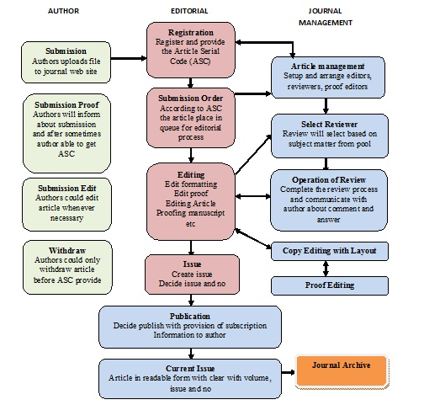

Figure 1: The editorial and publishing process workflow is automated by a journal management system. Retrieved from[2]

# Examples of Online journal management system

# confSys2

This is an online journal management which serve both conference as well as journal submission and publication system. This journal management system has some advance features like general chair, program chair and program committee. These features are level higher than the other journal management systems. This system can effectively handle all sort of academic conferences, along with the all the services related to a conference like editing, proof reading and reviews from peer are handled. This is majorly an improved version of confSys which was developed to only provide the journal submission and publication purpose only. This system has been developed with the better user interface experience as well as better functionalities then its previous one. This journal management system has a novelty in it that the scholar who submits the paper to the journal can manually or automatically select a reviewer for his paper (Huang et al, 2009). They can debate on a paper as well as rate that paper easily. This journal was a successful installation due to number of reasons including its improvement session for the conference/ journal series management, user group function management.

This journal management system has a important feature which is known as data sharing which all the stakeholders including author, reviewer and editor can do. They can share information and data across the board or just only to the selected people (Huang et al, 2009). This helps them to reduce the extra effort to duplicate the work and make it possible for peers to contribute in effective way.

## Pros

This journal has some positive points in its implementation, including usability and interaction. The system is highly based on user interaction and is a improvement of previous system. This proves the success factor of this journal because on general account the improvement to a software is only made once its concept is novel or worth for community to get benefit from it. This system is helpful for the authors, and reviewers that they can easily communicate with each other without getting involved the editor directly. Similarly, author can deliberately choose a single multiple reviewers of his own choice.

## Cons

I have observed some drawback in this model of journal management system. The openness is good but the group discussions and forum discussions may lead the research to get into a other dimension. It may help the researcher and reviewer to improve their work but it is equally possible that the research and its essence would be lost if the research original goal is distracted.

# CINDI academic journal

This is another scholarly work for a journal management system. Basically this journal management system serve as a subpart or subsystem of CINDI digital library. CINDI is a online journal which help the authors to guide in each and every step of the journal publishing, it range from roles to operations and operations to collaboration among the peers (Zhao et al, 2011). The major functions introduced in the journal management system were, uploading a paper, allocating the paper by editor to a qualified reviewer, evaluation of paper using the online mechanism as well as blind debate, the clarification between original writing and reviews are made between authors and reviewers. This system has a uniqueness of having a collaboration function which blindly helping authors to get interact with reviewers without having any trouble. This system also have subsystem in it, which is fee submission for the journal publication, this is a totally online feature (Zhao et al, 2011).

The major distinction of CINDI from other online journal management systems is it features like collaboration among the relevant stakeholders as well as integration of CINDI with all its subsystems like online fee submission, peer reviews and editors (Zhao et al, 2011). It has two most significant sub systems like conference management as well as search function along the website. The searching function is applied through the Meta data search, which require to index the information Meta data, stored and then retrieved upon search function. This feature extremely helping the community to get addressed with their issues through search function too (Zhao et al, 2011).

## Pros

The major benefit of this journal management system is its organization and integration of different systems altogether, these systems are helpful to understand and get the help from submitting the research work to payment and guidance and reviews from reviewer on single platform. So the biggest benefit is single platform integration.

## Cons

The major drawback of this system is its application time constraint, because there are a lot of subsystems including credit card information and other things are attached to the application, so it is difficult for an application to manage its resources in effective way, so this application is costly off course.

# Digital Publishing System (DPubS)

It is basically an open source software system which has major responsibilities to organize, present, and deliver scholarly journals, monographs, conference proceedings and other academic facilitations. It was basically conceived by the Cornell University in order to guide colleges and universities in scholarly writing and publishing.

It has a modular architecture providing flexibility, provide presentation templates which can be tailored according to the need of each and every scholarly work. This forum also provide the creative branding opportunities. Meta data can be received in any format as well as it is configured to deliver the full work at once.

## Pros

The benefits includes the characteristics it offer including publication enabling, resources delivery, journal delivery, and literature sharing. It is well organized journal which is scaled to support a great number of publications submissions, it is flexible due to its modular architecture. It is also supporting the open access as well as business support models in its architecture.

## Cons

They claim that “DPubS is an excellent tool with which to engage the community in a dialogue on the challenges to scholarly publishing. The adoption of open-source publishing systems like DPubS can correct the imbalance in the scholarly communication environment by providing a venue for nontraditional publishing initiatives” (DPubS). However I have observed that need to be established like the ACM or Springer libraries in order to get proper rank in the scholarly or journal submission works.

# Conclusion

There are many online journal management systems, some of which I have discussed in this chapter, each journal management system has its own pros and cons which can be handled by the teams accordingly. However this chapter also discusses a model or overall picture how a online management system works as a flow diagram. Every communication regarding a online journal management system is discussed on the particular forum only and among the relevant stakeholders only but certain platforms also provides some functionalities like collaboration and forum discussions.

# References

Huang, M., Feng, Y., & Desai, B. C. (2009, May). ConfSys2: an improved web-based multi-conference management system. In *Proceedings of the 2nd Canadian Conference on Computer Science and Software Engineering* (pp. 155-159). ACM.

Zhao, K., Desai, B. C., Chen, R., Huang, M., & Lu, M. (2011, May). An online academic journal system for CINDI. In *Proceedings of The Fourth International C* Conference on Computer Science and Software Engineering* (pp. 145-150). ACM.

Cornell University, Digital Publishing System, available at: <http://dpubs.org/>

# Literature Review

Online journal management systems are good sources to not only improve the quality of communication among the stakeholders of publishing but also a library builder for online users. It also shows that information can be accessed all around the world insuring novelty in research and increased research space for everyone working in the research streamline. However the services online journal management system provides in based on some software development. This can be developed on certain platform, framework like .Net, Net beans and certain others, besides this certain development approaches are used. They are cost effective due to reasonable development and maintenance cost. In this chapter I will be focusing on different online journal management system applied in United Kingdom Universities across the country. Their use of technology is then evaluated with respect to tools and technologies they are adopted, this will also depict the recent trends of development in online journal management systems. I will also elaborate the database technologies these online journal management systems are adopting, and compare these technology adoptions with the technology we are adopting in this journal management system development.

# Online Journal Management Technology Profiles

## Openconf

Openconf is an international peer-review, abstract and conference management system available online. They upgrade the professional edition which is having features like multiple files, reviews form for the reviewers, copyright content for the publications and many other features which are showing the novelty of their system. However for permanent membership there is a license purchasing for the license.

The technology portfolio they have is based on webserver, SSL certificate and hosting providing hosting providing of the Future Quest, this shows that they are providing high level security to their users (Vavilapalli et al, 2013). Apache server is used as a web server, there is a significant number of web services over 1 million people using Apache technology server. However overall top 10,000 sites are using this server.

They are using SSL certificate based on Geo Trust SSL and RapidSSL, the secure socket layer (SSL) encryption. There are certain multi-format SSL network environment due to upgrading and conversion of SSL certificate (Böhme et al, 2012). SSL encryption library is a proprietary SSL certificate, client can upgrade the certificate based on the server upgrading as not doing so may cause loss of client and server communication. The compromised standards are the installation, communication among server and client side. Ecommerce transaction security was integral issue back in decade which was resolved by the Secure Socket Layer (SSL) protocol. SSL protocol encrypt the customer’s personal data and information. The safe transaction was ensured by the authentication and integration in the ecommerce website. SSL protocol ensures that third party only infer in the end point connections, can know the amount of data sent but he doesn’t have access to change the information given by the customer. SSL was renamed by the IETF and was given the name of Transport Layer Security (TLS).

The hosting provider for the Hosting providers, which is Future Quest, which shows that they are based on web hosting, PHP and business hosting services. The most verified locations of Future Quest are USA, UK, Canada, France, Germany, Italy, and Australia showing the top tier countries are relying heavily on future quest for the technological needs (Builtwith). Such kind of services are used in highly demanding domains like news, social media services, and technology and entertainment industries. This shows that future quest is providing high level services with reliable relationship with their clients. Due to these reasons they have some world best databases dictionaries, and quality of the work too (Barsky).

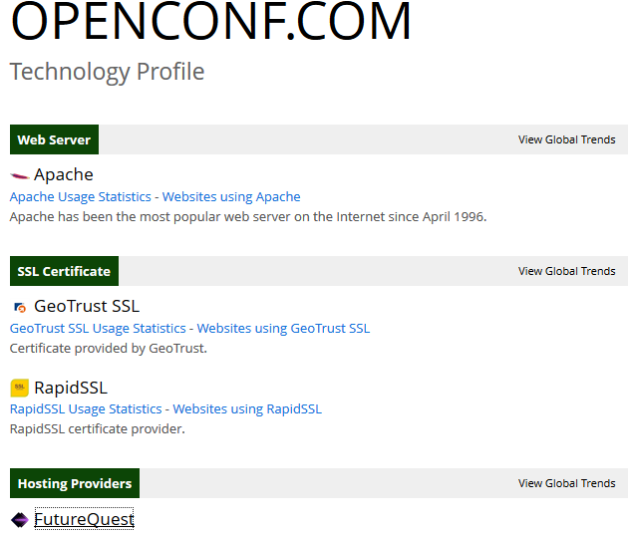

Figure 2: technology profile for Openconf. Retrieved from[3]

## MSOR Connections

This is a MSOR connection journal which is based on Greenwich University for online journals and working papers. It is basically a peer-reviewed journal, and entertains papers, case studies, and opinion pieces for mathematics, statistics and operational research.

The technological profile of this journal presents the Apache as their web server provider with PHP framework of development. The major reason of selecting Apache web server is the security providing through open source HTTP server. The global trend of using Apache server shows that overall 31% of the web servers are using this technology. Next one is IIS with 17%, and nginx with 25% web servers. This shows the popularity of Apache web servers and usage in overall working (Builtwith). The framework they used in PHP, which is a server-side scripting language it is used for the web development as well as general purpose language. The java script libraries they have used is Google JS API, jQuery, jQuery Cookie, and jQuery validate for the outlook and formatting of the web application. Their journal management system is very interactive in nature and is greatly taking part in outlook of the management system.

They are also using aggregation functionality which is an atom for the XML language showing semantics adoption for their online journal management system. The other features includes RSS feed is another option they are providing due to interactive interface they are trying to communicate. RSS feed is also important to deliver the latest updates to the members of the journal too.

The encoding mode they are adopting is known as UTF-8 which is a 8-bit Unicode transformation format. It has variable length for character encoding for the Unicode. Besides this it is the preferred method for encoding in the web pages. The other semantic web schema they are adopting is known is RDF which is best of its kind due to the nature of semantic properties which means that they are up to date to the latest standards of the data-modelling vocabulary for the RDF data. This feature in the online journal management system also ensures that they are properly addressing each and every component of the system including meta-data and meta-keywords description.

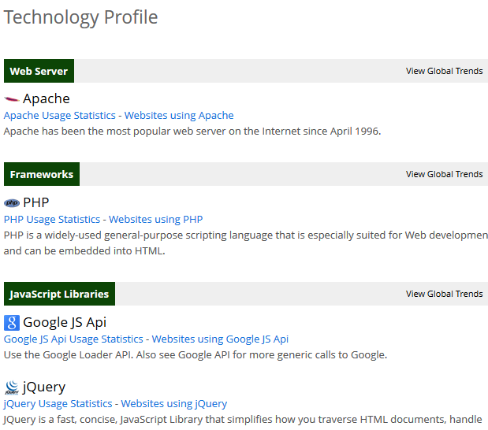

Figure 3: Technology Information for MSOR Connections Retrieved from[4]

## The Journal of Educational Innovation, Partnership and Change

This is also an online journal management system from Greenwich University which is basically entertaining the innovations in education, partnership and change management. This is basically a peer-reviewed cross disciplinary research journal. The important difference of this journal from other online management system for journals are contribution of staff and students as change agents.

The technological profile of this paper presents the Apache server as your provider with PHP framework development. The main reason choosing the Apache web server is a good security by the open-source HTTP server. The global trend towards the use of Apache Server total shows that 31% of the Web servers are using this technology. Next is IIS with 17% and 25% with Nginx web server. This shows the popularity of the Apache Web Server in use and total work (BuiltWith). They took advantage of the framework in PHP is qui a server side scripting language, it is used for web development and general purpose language. The Javascript libraries it is used is Google JS API, jQuery, jQuery Cookie, and jQuery validation and prospects for the formatting of the web application. Your log management system is highly interactive in nature and is strongly share the view of the management system.

This online journal management system is also working with aggregation functions on qui an atom for the XML language semantics for the adoption of its online system management protocol. Reviews The other functions include RSS feed is another option reviews on providing good they are, they are to try interactive interface, try communication. RSS feeds also value to provide the latest updates for members of the newspaper.

The encoding you are fashion is the assumption known as UTF-8 qui is 8-bit Unicode Transformation. It has variable-length character encoding for Unicode for. In addition, it is the preferred method of encoding the web pages. The other Semantic Web regime is you are adopting known RDF is the best kind of ICT is due to the nature of the semantic properties qui means clustering that they. Up to date with the latest standards of data modeling vocabulary for RDF data this feature in the online newspaper management system also guarantees that you. Properly addressing each component of the system, including Meta data Meta keywords and description

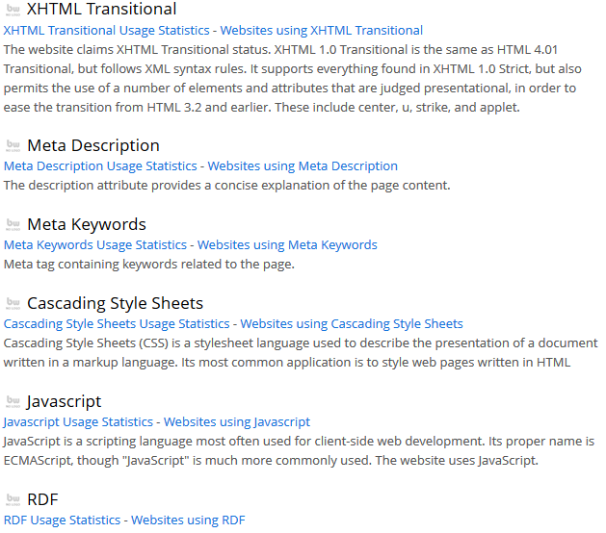

Figure 4: Technology information for The Journal of Educational Innovation, Partnership and Change. Retrieved from[5]

## International Journal of Health Policy and Management

It is a online peer review journal, however not academic level but international medical and health related issues oriented. It is also open access however, so needing more secure level for its users. It is multi-disciplinary journal with health and management related issues to be discussed.

They are using the Apache web server for their online space occupation. However they are using the email services in their journal to keep updated their members of the journal. For this purpose they are using SPF services for the statistics, and blue host mail services. The name server provider is BlueHost DNS. The framework it is working on is PHP which means that they are integrate for the basic level of development. They are also using RSS services.

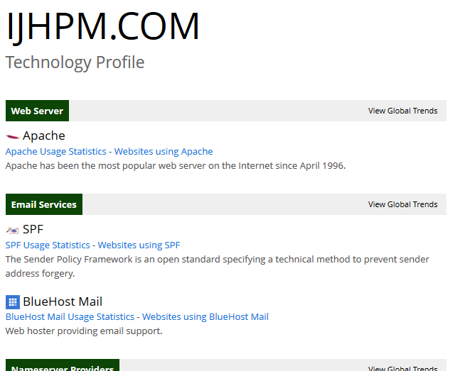

Figure 5: Technology information for IJHPM, retrieved from[6]

# Summary and Drawback of Existing Online Journal Management systems

The overall summary of the online journal management systems I have studied is given below:

|  |  |  |  |  |  |  |
| --- | --- | --- | --- | --- | --- | --- |
|  | Web server | Hosting provider | Framework | Miscellaneous features | Database | Security |
| Openconf | Apache | Future Quest | PHP | Geo trust, Rapid SSL | MySQL | SSL level only |
| MSOR connection | Apache | Not mentioned | PHP | RSS feed, XHTML, UTF-8 encoding,  RDF | Ontology schema | Not mentioned |
| The Journal of Educational Innovation, Partnership and Change | Apache | Not mentioned | PHP | RSS feed, XHTML, UTF-8 encoding,  RDF | Ontology schema | Not mentioned |
| International Journal of Health Policy and Management | Apache | BlueHost DNS | PHP | BlueHost mail, Mootool, RSS, Webgozar | MySQL | Not mentioned |

Table 1: Summary of technologies used in online journal management systems

From this table we can easily summarize that there is almost same trend of using web servers and framework in online journal management system in academia. It is Apache and PHP, the major influence to use such technology is being open source which has it own benefits and drawbacks too. However when each system is also providing some technological innovations too including SSL, semantic technologies like RDF, XHTML, and ontology. Beside this different facilities like RSS and email services are also provided to the members of journal. These facilities are good for the members of the system however, they also need security parameters too. Here we see that every system except the openconf is not concentrated for the security level. Openconf is providing SSL level security to its users, however no other journal management system have no level of TCP level security in them, ignoring the security parameter. This is a serious landmark for the journal webhosts, because most of the time we are concerned about security and hope not to be violated by any third party for security breach (Kaufman et al, 2002).

## Working of Security level services

The working of TLS protocol majorly relies on authentic communication with TLS basic hand shake which includes negotiation, change cipher Spec which includes all the authentic information from that point. After that client send the finish message with authentic and encrypted information. Same change cipher spec would be sent by server telling the client that his authenticate information is sent and perform the finish. After that the handshake is complete and application layer protocol is enables with 23 content type. Similarly, for resumed TLS hand shake the session ID are used by server hello and client hello messages (Rescorla et al, 2001). This would ensure that newly generated keys would be different from the previous session’s ones. The negotiation phase includes client hello and server hello. After that servers sends the change cipher spec to ensure the authenticate information is encrypted now. Similarly client also send the change cipher sec shake. Session tickets are also used to resume the communication between client and the TLS communication. Session tickets resume TLS session without requiring that session-specific state is stored at TLS server. The session tickets stores the session specific state in session ticket. This session ticket is sent to the client to store for next time use. Client can resume the TLS session by sending the session ticket to the server. Which is resumed by the server according to the session state, which is encrypted and authenticated by the server only (Rescorla et al, 2001).

## Solution

These problems are addressed in our proposed system and I am motivated to provide a online journal management system for Glyndwr University which is error prone and completely secure. It should be working on security protocol strictly. To implement the proposed solution there would be five most generic steps involved in it. Which involve the development of security strategy, management of organizational and business process changes, organization of IT services delivery, and manage and monitoring of online system with data. Each phase I have described need to have are further some milestones to be achieved in each phase. In development if security strategy involves high level business case, implementation phase, workloads, system architecture, employee’s suggestions to improvements, figure 5 presents the diagrammatic illustration of proposed solution of the online journal management system security.

The organizational and business process management includes the IT specific process to develop plan for the each project, engage business users to define and documents new and existing business process. Similarly, the proposal must cater how to determine how teams work together. In order to get expertize on the unskilled knowledge about online system security there must be session held to get skills on management by the organizational and business management of the organization.

# Conclusion

Apache and PHP, the major impact of the use of such technology is open source, it has its own advantages and disadvantages as well. But when each system also provides a number of technological innovations to include SSL, semantic technologies such as RDF, XHTML and ontology. Besides these various facilities such as RSS and email services are also provided to the members of the review. These facilities are good for the members of the system, however, they also need the security settings as well. Here we see that all systems except OpenConf does not focus on the level of security. OpenConf is providing SSL security for its users, but no other store management system will have a level of security in TCP, ignoring the security setting. This is a serious step for magazines hosts because most of the time we are concerned about the security and hope not to be violated by third parties for security breach

Work cited

Barsky, Aaron. "FutureQuest. A Sustainability Database Explorer."

Böhme, Rainer, and Stefanie Pötzsch. "Collective exposure: Peer effects in voluntary disclosure of personal data." *Financial Cryptography and Data Security*. Springer Berlin Heidelberg, 2012. 1-15.

Builtwith, Future Quest Usage Statistics, available at <http://trends.builtwith.com/hosting/FutureQuest>, last retrieved November 23, 2015

Builtwith, web server usage statistics, available at <http://trends.builtwith.com/web-server/> last retrieved November 23, 2015

Vavilapalli, Vinod Kumar, et al. "Apache hadoop yarn: Yet another resource negotiator." *Proceedings of the 4th annual Symposium on Cloud Computing*. ACM, 2013.

Rescorla, Eric. *SSL and TLS: designing and building secure systems*. Vol. 1. Reading: Addison-Wesley, 2001.

Kaufman, Charlie, Radia Perlman, and Mike Speciner. *Network security: private communication in a public world*. Prentice Hall Press, 2002.

# Methodology

Software development methodology or development approach basically defines the framework or standard used to structure, plan, and control and maintain the process of development of any information system. There are different software methodologies being adopted for different nature of project and software depending upon their needs. There is no best or no worst software methodology but only the requirements of the system set their best software methodology process to be adopted. So software analyst try their level best to adjust such requirements at first phase. For our proposed system which is online journal management system, we have proposed Rational Unified Process (RUP) model as our standard methodology to be adopted. The reasons to select this approach involves its modern ways to handle the changes in requirements at any phase of the development, as at each phase requirements are analyzed and checked again and again, plus the facilities of integration with different technologies is a big plus in this methodology. In this chapter we will be discussion the process methodology being adopted as well as the phases in it and how the following methodology will help us to follow the standard software engineering rules. We will discuss different phases of RUP methodology as well as different software engineering practices in those phases. One other major reason to use RUP is the integration facility and risk identification at this phase.

# Rational Unified Process

Rational Unified Process (RUP), demonstrates the different prospective including dynamic prospective, static prospective, and practice prospective. It has four major phases including inception, elaboration, construction, and transition. Inception phase elaborates all the entities of the system and its stakeholders including people and system (Bahsoon et al, 2013). The next phase elaboration which is more focused towards the requirement engineering and its phases including architectural framework of system, project plan, key risks management, UML use-cases, and developmental plans. It includes all the UML modeling too. The construction phase includes the system designing, programming and testing of the system. And the last phase is the transition phase which requires the deployment from development community to real users. Figure 4.1 represents the RUP phases and iterations in general

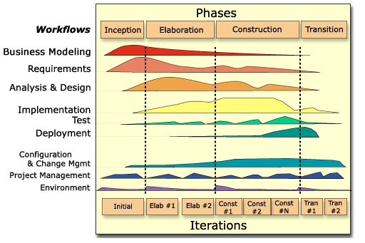

Figure 6:RUP Phases and work flow retrieved from[7]

There are two sorts of iterations in RUP, each phase has enacted in a iterative way, in order to enacted incrementally. The iteration facility makes it happened, it is easier to identify common parts as they are partially designed or implemented than to recognize them during planning. It has robust architecture when in several iterations of the error detection are performed. I choose this model due to its robustness and quick detection of errors for the future iterations and proper identification of stakeholders and their contribution in the system development. In the next sections of this chapter I will discuss in detail the phases of RUP methodology with respect to the Online Journal Management system for Glyndwr University and the relevant UML modelling for each phase of the system life cycle.

# Inception Phase

The first and most crucial phase of the software development in RUP is inception phase, it determines the feasibility of the system questioned to be develop. At this phase different analysis of cost and effectiveness of the system are done. When I consider my system of Online Journal Management system, I understood the complete domain and its examples adopted by different institution of the UK and around the world. This helped me to understand my domain as well as define and identify their lacks which I can cover in my online Journal Management System.

At the next step I collected the information according to the initial business case model needs. The basic questions which I entertained at this step are:

1. **Cost of the product**. I believe that cost of the system would be least to the system resources like hardware and software needs are meeting already, I have done a literature survey already which is helpful to define the existing system requirements and Glyndwr University needs in specific.
2. **Delivery time of the system**. The second important question to address is the delivery time of the system after complete development, I have done the initial phase of the prototyping and I am strongly sure to deliver it before the final deadline of my thesis submission as I am motivated to deliver a Online Journal Management system for Glyndwr University.
3. **Risks involved**. The major risks involved are adoption of system in the Glyndwr University and participation of stakeholders to promote the system.
4. **Documentation**. I am motivated to document each and every phase of the system, including the requirement elicitation which is one of the major phase of the inception, I will be documenting initial requirements artifacts including functional and non-functional requirements, use cases diagrams, ERD, Class Diagram, System Sequence Diagram, and Deployment Diagram.

## Requirements elicitation in Inception Phase

There are different requirement types which can be elaborated in inception phase. Requirements defines the scope of the stakeholders and their expected system needs. For example, in Journal management system I will be focusing on functional and non-functional requirements of the system.

### Functional requirements

The functional requirements of Online Journal Management system are:

* The system will store all the information of the authors, reviewers and chief editors.
* The system will generate a unique key for each journal uploaded which will help to discern journal from other journals.
* Author will be able to do quick update of his/her journal with the help of unique key.
* The system will store all the information of the journals.
* The system will provide the facility for author and reviewer to register them.
* The system will store the history of the author and reviewers who has uploaded the journals on GJMS.
* The system will allow searching of journals with title, author name and keywords.
* Chief Editor will have the ability whether to accept the journal and publish it or not.
* Chief Editor will be able to see all details about the journals and users.
* The email notification will be sent to author’s email after any update occurs to their journal(s).
* The author will have their account to check the current status of the journal.
* The author will be able to check the accepted or rejected status in their accounts.

### Non-Functional Requirements

This system has following non-functional requirements:

#### Performance

The system performance will be efficient. System will take very less time to respond against any action. System will be running smoothly.

#### Design

The look and feel of the system will be decent. All the buttons and links will be easily noticeable to the user. The order of the all button, links and menus will be well organized.

#### Quality

This system will include the qualities like usability, scalability, security, user friendly, cost, development time. System will provide help and prompt to reduce the mistakes.

#### Reliability

The system will be reliable in a way that it can be access from anywhere anytime. It will be online 365days in a year. Accurate information will be provided in the system.

# Elaboration Phase

Inception and elaboration phase are overlapped in requirement elicitation type, because most of the analysis workflow is done in this phase this also clears the requirements and indicate any future changes if needed. Moreover in this phase the whole domain model is formulated, as well as business model for the Online Journal Management system. It also entertain the complete requirements elicitation artifacts including use cases, use case diagrams. It also elaborates the complete analysis artifacts including ERD, database classes, class diagrams, sequence diagrams and deployment diagrams too. All these artifacts are always helpful for the system developers to understand the requirements of the system. At this phase I will elaborate all these artifacts in this section of the chapter.

## Use Cases Descriptions

In this section I will explain some major use case scenarios for the Online Journal management system. The major steps of the use case description are given in the table 1.

### Store information

|  |  |
| --- | --- |
| STORE INFORMATION |  |
| Name | STORE IFNORMATION |
| Actor | User/ system |
| Description | Describe the process of storing all the information about authors, reviewers, and chief editors. |
| Successful completion | 1. User Successfully LOGIN to the system 2. He click to UPDATE or ADD his information 3. UPDATE or ADD PERSONAL INFORMATION 4. He can add his personal address, marital status and other information to be updated 5. User can browse to other classes too. |
| Alternative | 1. User LOGIN to system 2. User found information correct 3. He log off the system |
| Precondition | User is registered on the Online Journal Management System |
| Post condition | User is being registered and also updated his information successfully |
| Assumptions | 1. User is already registered. 2. He is well aware to use a system 3. He can manage the system to completely his own level. |

Table 2:Use Case 1: Store all information

### Store Journal records

|  |  |
| --- | --- |
| STORE JOURNAL RECORD |  |
| Name | STORE JOURNAL RECORD |
| Actor | User/ system |
| Description | Describe the process of storing all the information about journal and work done by the authors, editor reviews and reviewer reviews. |
| Successful completion | 1. User Successfully LOGIN to the system 2. He click to UPDATE or ADD his work according to the reviews 3. UPDATE or ADD JOURNAL RECORDS 4. He can add CHANGES and Save them for future reference 5. User can browse to other comments, previous records and increments to see the progress. |
| Alternative | 1. User LOGIN to system 2. User found information correct 3. He log off the system |
| Precondition | User is registered on the Online Journal Management System |
| Post condition | User is being registered and also updated his information successfully |
| Assumptions | 1. User is already registered. 2. He is well aware to use a system 3. He can manage the system to completely his own level. |

Table 3: Use Case 2: Store Journal Record

### View History

|  |  |
| --- | --- |
| AUTHOR HISTORY |  |
| Name | AUTHOR HISTORY |
| Actor | User/ system |
| Description | Describe the process of storing all the information about authors and their work history |
| Successful completion | 1. User Successfully LOGIN to the system 2. He click to UPDATE or ADD his information 3. UPDATE or ADD PERSONAL INFORMATION and VIEW HISTORY 4. He can add his work updates, view history and previous records. 5. User can browse to other authors records too. |
| Alternative | 1. User LOGIN to system 2. User found information correct 3. He log off the system |
| Precondition | User is registered on the Online Journal Management System |
| Post condition | User is being registered and also updated his information successfully |
| Assumptions | 1. User is already registered. 2. He is well aware to use a system 3. He can manage the system to completely his own level. |

Table 4: Use case 3: View Author History

### Search Journal

|  |  |
| --- | --- |
| SEARCH JOURNAL |  |
| Name | SEARCH JOURNAL |
| Actor | User/ system |
| Description | Describe the process of SEARCHING all the information about authors, research titles, and keyword search . |
| Successful completion | 1. User Successfully LOGIN to the system 2. He click to SEARCH 3. UPDATE or ADD PERSONAL INFORMATION 4. May use the KEYWORD SEARCH 5. May use the AUTHOR NAME 6. May use the JOURNAL TITLE TERMS 7. User can browse to other KEYWORD TERMS TOO. |
| Alternative | 1. User LOGIN to system 2. User found information correct 3. He log off the system |
| Precondition | User is registered on the Online Journal Management System |
| Post condition | User is being registered and also updated his information successfully |
| Assumptions | 1. User is already registered. 2. He is well aware to use a system 3. He can manage the system to completely his own level. |

Table 5: USE CASE 4: Search Journal

### Email notification

|  |  |
| --- | --- |
| EMAIL NOTIFICATION |  |
| Name | EMAIL NOTIFICATIONS |
| Actor | User/ system |
| Description | Describe the process of storing all the information about authors, UPDATE them with EMAIL NOTIFICATIONS |
| Successful completion | 1. Admin Successfully LOGIN to the system 2. He sets the settings for all the users of a journals 3. He add them to email list of notification 4. UPDATE or ADD INFORMATION about journals 5. Save changes 6. Automated EMAIL NOTIFICATION is sent to all users of system 7. User can browse to other classes too. |
| Alternative | 1. User LOGIN to system 2. User found information correct 3. He log off the system |
| Precondition | User is registered on the Online Journal Management System |
| Post condition | User is being registered and also updated his information successfully |
| Assumptions | 1. User is already registered. 2. He is well aware to use a system 3. He can manage the system to completely his own level. |

Table 6: use case 5: Email notification

## Use case Diagram

The diagrammatic illustration of use cases for the online journal management system for Glyndwr University is given in figure below.

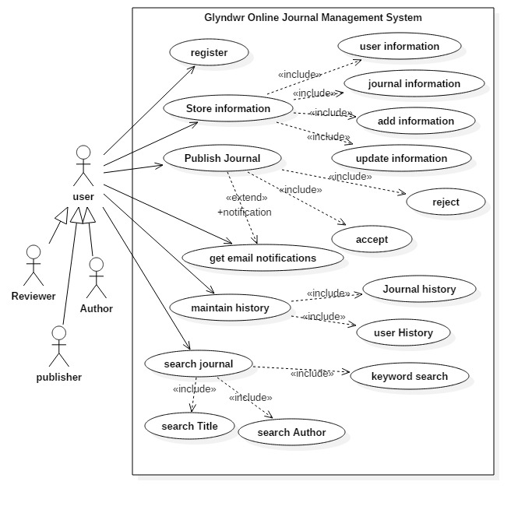

Figure 7: Use Case: Glyndwr Online Journal Management System

## Entity Relationship Diagram (ERD)

In entity relationship diagram the major entities involved are:

1. Users: the major stakeholders are editors, authors and reviewers and these classes will be entertained accordingly.
2. Registrations: the registration process will be followed by the conventional method of registration.
3. Information store: the information about user and journal are stored as two sub-class entities. It will also maintain add and update information concerns.
4. Journal publication: the journal publication will be done by the editor consent and an automated email will be generated after the accepting or rejecting the scholarly work.
   1. Accept
   2. Reject
5. Email notifications: there are different situations for which email notifications are handled including email notification for updates, changes or accept or reject of the publication of journal.
6. Maintain history: the history is maintained for the database for present and future references of the journals.
7. Search journals
   1. Keyword search
   2. Author search
   3. Title search

Figure in the below shows the overall entity relationship diagram for the Glyndwr Online Journal Management System

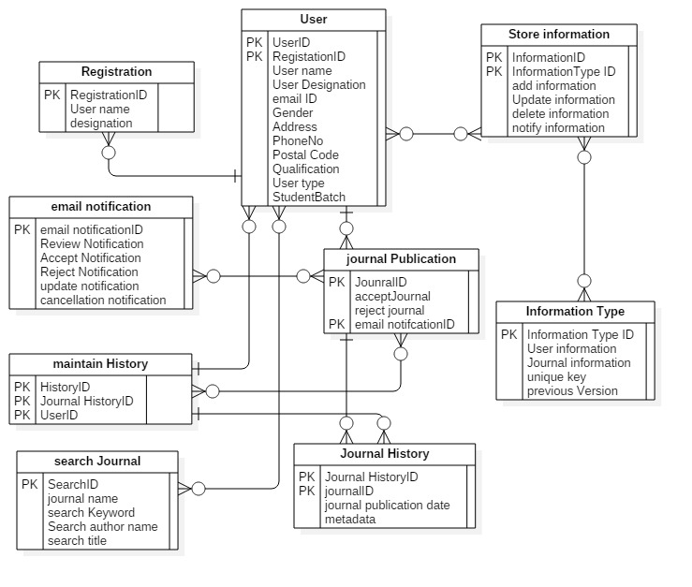

Figure 8: ERD for GOMS

## Class diagram

The class diagram for the system includes the same classes as we identified in the entity relationship diagram. The figure shows the class diagrams and their attributes and major operations for the system.

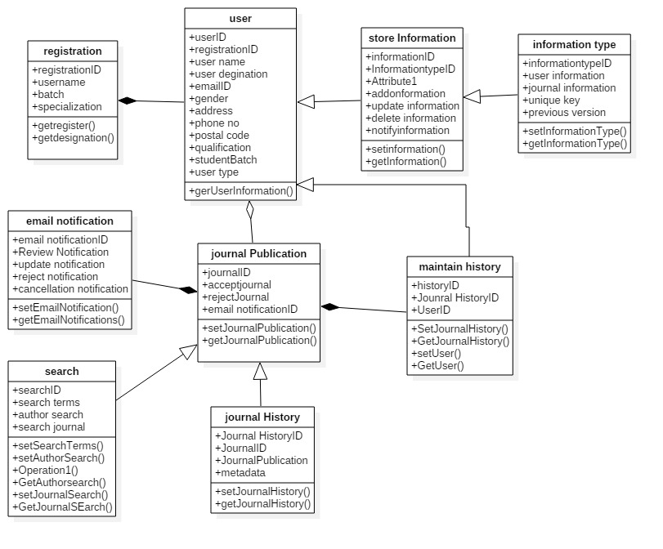

Figure 9: Class diagram for GOMS

## Sequence Diagram

### Store information sequence diagram

For the store information we have illustrated the user information to store, however the journal, and other necessary information’s are also stored in the store information class. The sequence for the user information store includes:

* User Successfully LOGIN to the system
* He click to UPDATE or ADD his information
* UPDATE or ADD PERSONAL INFORMATION
* He can add his personal address, marital status and other information to be updated

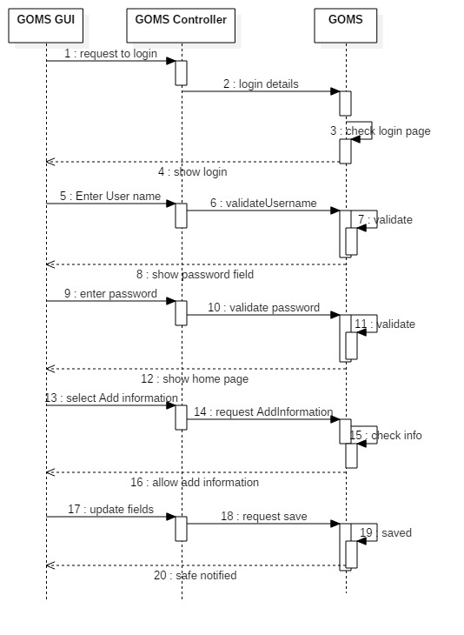

Figure 10: system sequence diagrams

### Store journal records

* User Successfully LOGIN to the system
* He click to UPDATE or ADD his work according to the reviews
* UPDATE or ADD JOURNAL RECORDS
* He can add CHANGES and Save them for future reference
* User can browse to other comments, previous records and increments to see the progress.

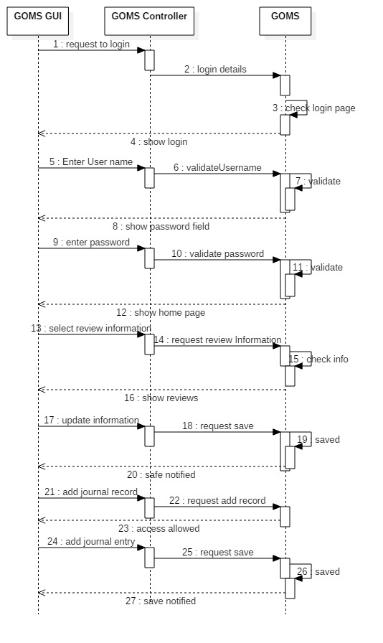

Figure 11:sequence diagram

# Construction phase

The construction phase is a important phase in development point of view as most of the development occurs in this phase. So at the start of the I will make up a Gantt chart for the implementation details as well as the basic code examples for the Glyndwr Online Journal management system.

To set up a RUP-based project schedule (Gantt chart) on Microsoft Project using work components, perform the following steps:

* Create a coarse-grained project schedule.
* Insert and customize work components for the current iteration.
* Insert and customize work components for the next iteration

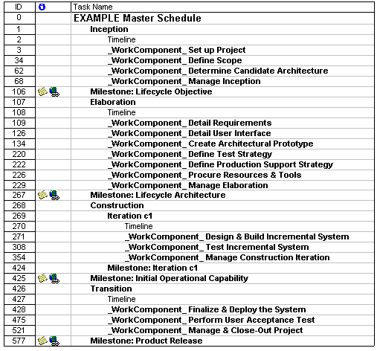

Figure 12: work map for the Gantt chart

## Implementation details

After design phase of the system is completed, implementation phase starts. Here it is insured that implementation of the system would be done correctly, efficiently, and quickly on a particular environment with a computer or a range of computers, using particular tools and programming languages. The objective of development phase is to transfer design in to executable system. The end deliverable of this phase is the product itself. The tool, platform and programming languages are selected according to the nature and requirement of the project.

### Web Application Implementation

The implementation of web application part of project includes choice of development tool and environment, tool and programming language. Here is a brief description of it.

#### Selection of Programming Language

When we start implementation of our system, the selection of language is important. The choice of language is done by considering which language would suite our system and we also have to keep this thing in mind that we can easily develop our system using that language. When I started working development of web based application, it required me to choose a programming language in order to build my application. There were different languages available while making choice for this project. As embedded VC, Vb.net, C#.net compact edition any could be used but I chose C # for development of web application part of my project.

#### Reason for the selection of C#

The main reason of selecting C# as development tool was that it supports Java style code documentation where definitions of properties and methods are commented in such a way as to make the component interfaces self-documenting. It also provides full COM/Platform support for existing code integration as well as support extensible metadata concepts. Apart from this, C # also provides security through garbage collection and type safety.

#### Advantages of C#

##### Easy to learn and understand

Decision about the language is made while considering the face that the language which is selected for development should be such that it is easy to learn and understand. This in turn helps with enforcement of correct code.

##### Portability

The chosen language should also support portability and be fit for the purpose, C# was found best for development of web Application part of the project.

### Support for software engineering principle

The implementation language should provide support for software engineering principle such as strong type checking, array bounds checking, detection of attempts to use uninitialized variables and automatic garbage collection. Software robustness, durability, and programmer productivity are important. Its strong typing helps to prevent many programming errors that are common in weakly typed languages. C# was found to be the best choice keeping these things in mind.

### Overview of ASP.NET

ASP.NET is a unified Web development model that comprises the services necessary to construct enterprise-class Web applications with a minimum of coding. ASP.NET is part of the .NET Framework, and one has the access to classes in the .NET Framework while coding ASP.NET applications. One is able to code applications in any language compatible with the common language runtime (CLR), which includes Microsoft Visual Basic and C#. These languages facilitate the development of ASP.NET applications that benefit from the common language runtime, type safety, and inheritance and so on.

ASP.NET supports separation of code from the HTML, maintaining the code in separate files.ASP.NET introduces the concept of web services, which make it easier to incorporate dynamic web pages and customization.

### Web Services

In order to communicate two electronic devices on web, a method is used which is referred as web services.

**Web services** are client and server applications that communicate over the World Wide Web’s (WWW) Hypertext Transfer Protocol (HTTP). As described by the World Wide Web Consortium (W3C), web services provide a standard means of interoperating between software applications running on a variety of platforms and frameworks. Web services are characterized by their great interoperability and extensibility, as well as their machine-processable descriptions, thanks to the use of XML. Web services can be combined in a loosely coupled way to achieve complex operations. Programs providing simple services can interact with each other to deliver sophisticated added-value services.

Unlike traditional [client/server](http://www.webopedia.com/TERM/C/client_server_architecture.html) models, such as a Web [server](http://www.webopedia.com/TERM/S/server.html)/Web page system, here the user is not provided with a [GUI](http://www.webopedia.com/TERM/G/GUI.html). As a substitute, web services share business logic, data and processes through a programmatic interface across a network. The applications interface, not the users. Developers add the Web service to a GUI (such as a Web page or an executable program) in order to present specific functionality to users.

#### Types of Web Services

The W3C categorizes two major classes of Web services, [REST](http://en.wikipedia.org/wiki/Representational_state_transfer)-compliant Web services, where the major purpose is to manipulate XML representations of Web resources using a uniform set of "[stateless](http://en.wikipedia.org/wiki/Stateless_protocol)" operations. And other category includes arbitrary Web services, in which the service may expose an arbitrary set of operations. Here is a brief description of currently available web services and situations where they are best suited:

* **WCF**

It appears appropriate in the situation where the service can be viewed as the business layer of the application and when the service has "intelligent" operations like "CalculateDiscountForClient".

* **ADO.NET Data Services**

It seems suitable where the application is basically data-centric and the service is simply a front-end for the database. That is, all the service methods are of type GetCustomers, CreateInvoice, etc.

* **RIA services**

**It** is one of the latest technologies which seem to be valuable to develop applications in which the Silverlight part and the service are very tightly coupled: service classes and methods are defined in the service project, and they are automatically replicated to the Silverlight project in design time.

* **POX**

**It is useful when** there is a chance that you change the client part from Silverlight to any other technology (for example HTML+AJAX) in the future as it is considered the most interoperable option.

* **WPF**

It is for building Windows client applications with visually stunning user experiences. It facilitates creation of wide range of both standalone and browser-hosted applications.

### Web API

[Web API](http://en.wikipedia.org/wiki/Web_API) is a development in Web services (in a movement called [Web 2.0](http://en.wikipedia.org/wiki/Web_2.0)) which emphasizes to move away from [SOAP](http://en.wikipedia.org/wiki/SOAP) based services towards [representational state transfer](http://en.wikipedia.org/wiki/Representational_state_transfer) (REST) based communications. XML, SOAP, or [WSDL](http://en.wikipedia.org/wiki/Web_Services_Description_Language) service-API definitions are not required in REST. A combination of multiple Web services into new applications is allowed by Web API and it is known as [mashups](http://en.wikipedia.org/wiki/Mashup_(web_application_hybrid)).

### Restful services

**REST** attempts to describe architectures that use HTTP or similar protocols by constraining the interface to a set of well-known, standard operations (like GET, POST, PUT, DELETE for HTTP). Here, the focus is on interacting with [stateless](http://en.wikipedia.org/wiki/State_(computer_science)) resources, rather than messages or operations. [Clean URL](http://en.wikipedia.org/wiki/Clean_URL)s are tightly associated with the REST concept.

An architecture based on REST can use WSDL to describe SOAP messaging over HTTP, can be implemented as an abstraction purely on top of SOAP (e.g., WS-Transfer), or can be created without using SOAP at all.

[WSDL version 2.0](http://en.wikipedia.org/wiki/Web_Services_Description_Language) offers support for binding to all the [HTTP request methods](http://en.wikipedia.org/wiki/Request_method) (not only GET and POST as in version 1.1) so it enables a better implementation of RESTful web services. However, support for this specification is still poor in [software development kits](http://en.wikipedia.org/wiki/Software_development_kit), which often offer tools only for WSDL 1.1.

# Transition phase

Transition phase includes deployment and testing of the system. The systematic test is an inevitable part of the verification and validation process for software. Testing is aimed at finding errors in the test object and giving confidence in its correct behaviour by executing the test object with selected input values. Software testing is a process that continues throughout the development process. **Test cases are based on use cases**. Testing is a V&V (verification and validation) practice. We verify system functionality according to our requirements and check feasibility of the system.

As far as the overall description of a testing plan is concern it is done by considering different factors including

* Nature of product
* Tool used for development
* Platform of the product deployment
* Development and design constraints
* User consideration
* Architecture of software
* Resources constraints

Three basic **goals** of software testing would be:

* Error detection. Is output of test matches to the expected result?
* Verification. Are we developing the software/product right?
* Validation. Are we developing the right software/product?

## Testing Techniques

There are many testing strategies that are being used currently. A system can be tested either manually or automatically. Two testing techniques are been used for testing of this application.

* White Box Testing.
* Black Box Testing.

### Black-box Testing

Black-box-testing is a testing method in which test data is derived from functional requirements. Internal structure is invisible and tester is unaware of internal working or data flow within different components of the system. He concerns only to input, output and functionality provided because system is like a black box. It is also known as data-driven, input/output driven or requirement based testing.

### White-box-testing

Contrary to black-box testing, here software is viewed as a white-box, or glass-box in white-box testing, as the structure and flow of the software under test are visible to the tester. Testing plans are made according to the details of the software implementation, such as programming language, logic, and styles. Test cases are derived from the program structure.

### Test Cases

A set of test inputs, execution conditions, and expected results developed for a particular objective, such as to exercise a particular program path or to verify compliance with a specific requirement (IEEE Standard 610 (1990). So, a test case is a document that describes the procedure to test the system.

## Classification of Testing:

There is a plethora of testing methods and testing techniques, serving multiple purposes in different life cycle phases.

* **Classified by purpose**, software testing can be divided into:
* Correctness testing, performance testing, reliability testing and security testing.
* **Classified by life-cycle phase**, software testing can be classified into the following categories:
* Requirements phase testing, design phase testing, program phase testing, evaluating test results, installation phase testing, acceptance testing and maintenance testing.
* **Classified By scope**, software testing can be categorized as follows:
* Unit testing, component testing, integration testing, and system testing.

## Testing Strategies:

First, requirements document would be tested to customer requirements. Second, design document was tested to requirements document. Errors that were found would be corrected in the future documents versions.

### Unit Testing

This kind of testing is conducted to ensure that program logic is complete and correct. Unit testing is kind of white-box testing. The unit test medium is shown in figure below



Figure: Unit testing

Driver is a special program that uses test cases for checking module and prints the result. Stubs are used for replacing complicated modules. The smallest testable unit is the encapsulated class. Class testing is driven by the operations encapsulated by the class and the state behavior of the class.

### Integration Testing

This kind of testing is conducted to ensure that combined units perform major system functions. Thread-based approach for integration testing was chosen. According to it classes required to respond to one input or event for the system is integrated and tested individually.

### Validation Testing

Validation testing is kind of black-box testing which is basically to make sure that program satisfies the customer requirements. These requirements are defined in the Requirements Document.

### Security Testing:

It is done to ensure that designed system is protected from improper penetration. During this testing tester try to acquire passwords from external clerical means, attack the system with custom software designed to break down any defenses, cause system errors.

### Recovery Testing

This testing is used to check software tolerance to failure. During this testing tester fails software in different ways and sees if program automatic recovered or not.

### Performance Testing

Performance testing is designed to test run-time performance of the software within the context of an integrated system.

### Regression Testing

If some changes with software will be made regression testing is needed. It serves to ensure that changes do not carry in any errors into the system.

### Acceptance Testing

Acceptance tests are conducted to enable the customer to validate all requirements. Two types of tests can be applied:

* alpha test
* beta test

The alpha test will conducted at the developer’s site by a customer. The beta test will conducted at one or more customer sites by the end user of the software.

# References

Bahsoon, Rami, et al. "The future of software engineering IN and FOR the cloud." *Journal of Systems and Software* 86.9 (2013): 2221-2224.

Kruchten, Philippe. *The rational unified process: an introduction*. Addison-Wesley Professional, 2004.

Kroll, Per, and Philippe Kruchten. The rational unified process made easy: a practitioner's guide to the RUP. Addison-Wesley Professional, 2003.

Myers, Glenford J., Corey Sandler, and Tom Badgett. *The art of software testing*. John Wiley & Sons, 2011.

Haller, Michel Yves, et al. "Dynamic whole system testing of combined renewable heating systems–The current state of the art." *Energy and Buildings* 66 (2013): 667-677.

# Requirement Analysis

Requirement elicitation is a complicated phase of any project due to its nature of problem identification. It is a crucial phase of the whole project development, due to identification of major stakeholders, system needs, scope of the project and many other important milestones to be achieve. Different approaches like meeting with the end users, surveys, and card board approaches are used to identify the needs of the system. In our case, we have done an extensive research on online journal systems in educational endures and also make sure to evaluate their success factors. Study have shown that educational institutes are having online journal management systems installed in their universities or colleges to help students for their publications. Moreover there is a strong need to have a Glyndwr University its own journal management system to achieve several purposes which is making it important for the university management to implement. For example, this journal will help students to enhance their research capabilities, and make them able to ideally research and see it purposes. Moreover it will help students to evaluate their research dimension as well as making record of their research on single platform and saved for ever use for future students too. This chapter will address the major requirement analysis phase of the project, along with functional and non-functional requirements analysis and use case scenario depictions.

## Requirements

Requirements are the needs of the stakeholders of the system who would be using it in future. They are the most important source of requirement elicitation for the problem at hand, but however certain methods like interviews, surveys and many other approaches like card board, observation and many other approaches are used to elicit requirements. The requirements has two major components to discuss always including functional and non-functional requirements.

The functional requirements are one which are required to be fulfilled for the system to work on, and non-functional requirements are those which are used to identify the system resources and other non-functional compatibilities required. The major functional requirements are derived from the stakeholders and their needs which are necessary to be fulfilled to run the system. The non-functional requirements are those which are required to be fulfilled but they are not directly related to the system development or hindrance in its development.

### Identification of stakeholders

The major stakeholders of the system includes admin, author, reviewers and editor. These stakeholders are those which will be using the system primarily. The major functions performed by the stakeholders includes paper submissions, edit submissions, view submissions, status check, update files, withdrawal of the paper or submission and many others. The major details of the stakeholders and their respective functions are includes as:

1. Author

The author functions includes:

* Submit papers (word or pdf format)
* Edit submission (update or modify paper submission)
* View paper (shows in pdf)
* Check status/track paper status
* Update paper
* Withdraw submission (request to editor and admin)
* View reviewer comments (on submitted paper)

1. Reviewer

The major functions performed by the reviewer stakeholder includes:

* View submission (automatically shown on home page)
* Discussion (comments of different reviewers based upon different papers)
* Marking (paper marking through pre-defined rubics)

1. Editor

The major functions performed by the editor includes

* Accept/ Reject (Take decisions based upon reviewers marks)
* Assign submission to reviewers (based upon the expertise of reviewers)

1. Admin

The major functions performed by admin are

* Generate unique key for the journals
* Reviewers (delete/enable/disable)
* Editor (delete/enable/disable)
* Make editor/ remove editor
* Add/delete/update technical areas for author/reviewers
* Delete/withdraw and list submissions

### Functional requirements

Based upon the stakeholders’ identification as well as their functions I have acquired some of the functional requirements of the system. These requirements will be further elaborated as use case scenarios and use case diagrams. The functional requirements of Online Journal Management system are:

* The system will store all the information of the authors, reviewers and chief editors.
* The system will generate a unique key for each journal uploaded which will help to discern journal from other journals.
* Author will be able to do quick update of his/her journal with the help of unique key.
* The system will store all the information of the journals.
* The system will provide the facility for author and reviewer to register them.
* The system will store the history of the author and reviewers who has uploaded the journals on GJMS.
* The system will allow searching of journals with title, author name and keywords.
* Chief Editor will have the ability whether to accept the journal and publish it or not.
* Chief Editor will be able to see all details about the journals and users.
* The email notification will be sent to author’s email after any update occurs to their journal(s).
* The author will have their account to check the current status of the journal.
* The author will be able to check the accepted or rejected status in their accounts.

## Use Cases

Use cases are the descriptive or analysis work of the stakeholders and their major functions. Figure 1 shows the overall use case analysis of the system as a whole. It shows its major stakeholders along with their functions with in the scope of the system.

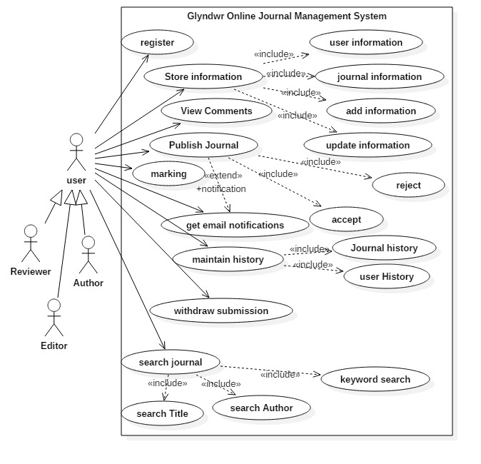

Figure 13: Use case diagram

## Use Cases Descriptions

In this section I will explain some major use case scenarios for the Online Journal management system. The major steps of the use case description are given in the table 1.

### Store information

|  |  |
| --- | --- |
| STORE INFORMATION |  |
| Name | STORE IFNORMATION |
| Actor | User/ system |
| Description | Describe the process of storing all the information about authors, reviewers, and chief editors. |
| Successful completion | 1. User Successfully LOGIN to the system 2. He click to UPDATE or ADD his information 3. UPDATE or ADD PERSONAL INFORMATION 4. He can add his personal address, marital status and other information to be updated 5. User can browse to other classes too. |
| Alternative | 1. User LOGIN to system 2. User found information correct 3. He log off the system |
| Precondition | User is registered on the Online Journal Management System |
| Post condition | User is being registered and also updated his information successfully |
| Assumptions | 1. User is already registered. 2. He is well aware to use a system 3. He can manage the system to completely his own level. |

Table 7:Use Case 1: Store all information

### Store Journal records

|  |  |
| --- | --- |
| STORE JOURNAL RECORD |  |
| Name | STORE JOURNAL RECORD |
| Actor | User/ system |
| Description | Describe the process of storing all the information about journal and work done by the authors, editor reviews and reviewer reviews. |
| Successful completion | 1. User Successfully LOGIN to the system 2. He click to UPDATE or ADD his work according to the reviews 3. UPDATE or ADD JOURNAL RECORDS 4. He can add CHANGES and Save them for future reference 5. User can browse to other comments, previous records and increments to see the progress. |
| Alternative | 1. User LOGIN to system 2. User found information correct 3. He log off the system |
| Precondition | User is registered on the Online Journal Management System |
| Post condition | User is being registered and also updated his information successfully |
| Assumptions | 1. User is already registered. 2. He is well aware to use a system 3. He can manage the system to completely his own level. |

Table 8: Use Case 2: Store Journal Record

### View History

|  |  |
| --- | --- |
| AUTHOR HISTORY |  |
| Name | AUTHOR HISTORY |
| Actor | User/ system |
| Description | Describe the process of storing all the information about authors and their work history |
| Successful completion | 1. User Successfully LOGIN to the system 2. He click to UPDATE or ADD his information 3. UPDATE or ADD PERSONAL INFORMATION and VIEW HISTORY 4. He can add his work updates, view history and previous records. 5. User can browse to other authors records too. |
| Alternative | 1. User LOGIN to system 2. User found information correct 3. He log off the system |
| Precondition | User is registered on the Online Journal Management System |
| Post condition | User is being registered and also updated his information successfully |
| Assumptions | 1. User is already registered. 2. He is well aware to use a system 3. He can manage the system to completely his own level. |

Table 9: Use case 3: View Author History

### Search Journal

|  |  |
| --- | --- |
| SEARCH JOURNAL |  |
| Name | SEARCH JOURNAL |
| Actor | User/ system |
| Description | Describe the process of SEARCHING all the information about authors, research titles, and keyword search . |
| Successful completion | 1. User Successfully LOGIN to the system 2. He click to SEARCH 3. UPDATE or ADD PERSONAL INFORMATION 4. May use the KEYWORD SEARCH 5. May use the AUTHOR NAME 6. May use the JOURNAL TITLE TERMS 7. User can browse to other KEYWORD TERMS TOO. |
| Alternative | 1. User LOGIN to system 2. User found information correct 3. He log off the system |
| Precondition | User is registered on the Online Journal Management System |
| Post condition | User is being registered and also updated his information successfully |
| Assumptions | 1. User is already registered. 2. He is well aware to use a system 3. He can manage the system to completely his own level. |

Table 10: USE CASE 4: Search Journal

### Email notification

|  |  |
| --- | --- |
| EMAIL NOTIFICATION |  |
| Name | EMAIL NOTIFICATIONS |
| Actor | User/ system |
| Description | Describe the process of storing all the information about authors, UPDATE them with EMAIL NOTIFICATIONS |
| Successful completion | 1. Admin Successfully LOGIN to the system 2. He sets the settings for all the users of a journals 3. He add them to email list of notification 4. UPDATE or ADD INFORMATION about journals 5. Save changes 6. Automated EMAIL NOTIFICATION is sent to all users of system 7. User can browse to other classes too. |
| Alternative | 1. User LOGIN to system 2. User found information correct 3. He log off the system |
| Precondition | User is registered on the Online Journal Management System |
| Post condition | User is being registered and also updated his information successfully |
| Assumptions | 1. User is already registered. 2. He is well aware to use a system 3. He can manage the system to completely his own level. |

Table 11: use case 5: Email notification

## Non-Functional Requirements

As for as non-functional requirements are concerned it is also mandatory part of any software system. We cannot ignore the non-functional requirements. Non-functional requirements are given below:

### **Usability**

Usability is the ease of use and learning of a human-made object. The object of use can be a software application, website etc.

### Security

To confirm the identity of the person the system authenticates a user. Secure coding practices are applied to development of software. The software can authenticate users who can access the system. Security is the degree of protection against danger, damage, loss, and crime.

### Speed

The speed of the system is its processing speed. It can be measured by the throughput of the system.

### Efficiency

The user data shall be stored that is still accessible even after the time period is complete or expired. The system should be much more efficient for checking the information about user and items. System should be efficient and self-explanatory. It means easy to understand and easy to use.

### Reliability

System must be stable and reliable. If there is any exception or error, system must handle this problem by exception handling or show proper message and close the application.

### Availability

Availability is defined as the probability that the system is operating properly when it is requested for use. System should be available to all users at all time. Availability should be a key consideration for the client/server environment.

## External Requirements

### User Interfaces

A user interface is the system by which people interact with a machine. The home page (first page) is the simple and fully designed page, which is easily accessible by all the users. All contents of the system are included in the tabs and tree view in which all contents of the website’s are accessible.

### Hardware Requirements

The system, on which this application will be developed should have at least

* Core 2 Duo 2.0 GHz processor
* 2 GB Ram
* 60 GB Hard Disk

### Software Development Requirements

* Visual studio 2012 or above will be used as development tool.
* C# is used as developing language.
* SQL server.
* Object oriented approach will be followed in the application development.

# Design Analysis

Design is an important milestone of elaboration phase which take the requirements, stakeholders and their need identified to more deep level. It evaluates the user requirements in more detail by identifying the clear scenarios for the main requirements. The design analysis revolves around the entity relationships, databases, tables and entities identifications, as well as design management for use case scenario, system sequence diagrams, activity diagrams which will elaborate the major functioning of the system as a whole. The data flow diagrams are also important part of the design analysis as they are helpful in system development at more integrated level. This chapter will include the maximum level of system analysis along with their respective diagrams. So this chapter will majorly serve the elaboration phase of the development.

## Entity Relationship Diagram (ERD)

In entity relationship diagram the major entities involved are:

1. Users: the major stakeholders are editors, authors and reviewers and these classes will be entertained accordingly.
2. Each user will perform his functions accordingly.
3. Registrations: the registration process will be followed by the conventional method of registration.
4. Information store: the information about user and journal are stored as two sub-class entities. It will also maintain add and update information concerns.
5. Journal publication: the journal publication will be done by the editor consent and an automated email will be generated after the accepting or rejecting the scholarly work.
   1. Accept
   2. Reject
6. Email notifications: there are different situations for which email notifications are handled including email notification for updates, changes or accept or reject of the publication of journal.
7. Maintain history: the history is maintained for the database for present and future references of the journals.
8. Search journals
   1. Keyword search
   2. Author search
   3. Title search

Figure in the below shows the overall entity relationship diagram for the Glyndwr Online Journal Management System

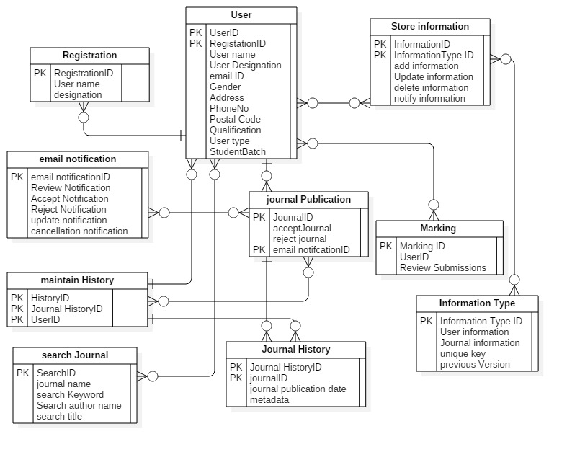

Figure 14ERD diagram for Online Journal management system

## Class diagram

The class diagram for the system includes the same classes as we identified in the entity relationship diagram. The entities includes all the relevant stakeholders and their functions. Class diagram is an important diagram foe both databases point of view as well as development of entities and classes point of view in the development phase. The major classes of the class diagram includes:

1. Users: the major stakeholders are editors, authors and reviewers and these classes will be entertained accordingly. The user have their own unique values with ID, name, complete details along with their role to be played in the system.
2. Registrations: the registration process will be followed by the conventional method of registration. The registration will also be helpful to generate an automatic code for each user and their roles according to their selection.
3. Information store: the information about user and journal are stored as two sub-class classes. It will also maintain add and update information concerns. The major attributes includes information ID, information type, addition, deletion, updating and other function with respect to nature of the information available.
4. Marking: based upon the performance the reviewer will mark the publication, which has different attributes but have operations like set marking and it will be get the admin and editor, as well as set decision will help editor to accept or reject the publication based upon marking.
5. Journal publication: the journal publication will be done by the editor consent and an automated email will be generated after the accepting or rejecting the scholarly work.
   1. Accept
   2. Reject

The accept and reject attributes will be awarded based upon the marking criteria done by the reviewer in the system.

1. Email notifications: there are different situations for which email notifications are handled including email notification for updates, changes or accept or reject of the publication of journal. The attributes includes all the types of event happening for the journal publication to all relevant stakeholder. The operations includes set and get of the email notifications.
2. Maintain history: the history is maintained for the database for present and future references of the journals. The operations will be get and set to completely get the information history on the journal.
3. Search journals
   1. Keyword search (operations can be settled on search terms, author name, and title of the operation too)
   2. Author search (operations can be settled on search terms, author name, and title of the operation too)
   3. Title search (operations can be settled on search terms, author name, and title of the operation too)

The figure shows the class diagrams and their attributes and major operations for the system.

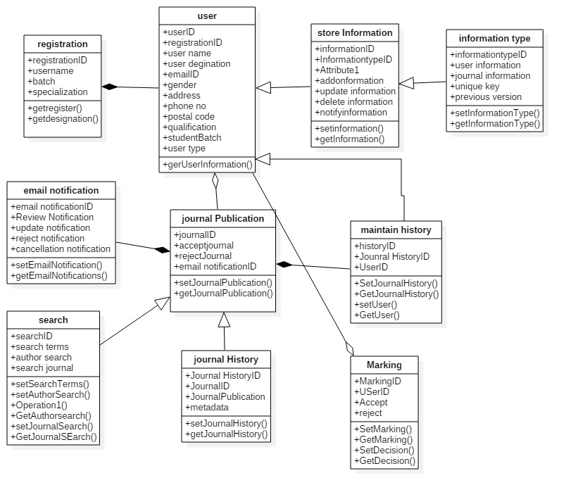

Figure 15: Class diagram for Online Journal Management system

## Sequence Diagram

Sequence diagrams elaborate the sequence of events occurred to secure the operation in any scope of system development. A sequence diagram depicts a dynamic collaboration between a numbers of objects. It shows how different objects collaborate with each other. The important aspect of this diagram is that it shows a sequence of messages sent between the objects. It also shows an interaction between objects, something that happens at one specific point in the execution of the system. The diagram consists of a number of objects shown with vertical lifelines. Time passes downward in the diagram, and the diagram shows the exchange of messages between the objects as time passes.

### Admin operations

Admin can add delete or generate any sort of information with online journal management system. This system will be flexible enough to facilitate all sort of admin operations. Figure shows the sequence diagram for the admin operations as follows:

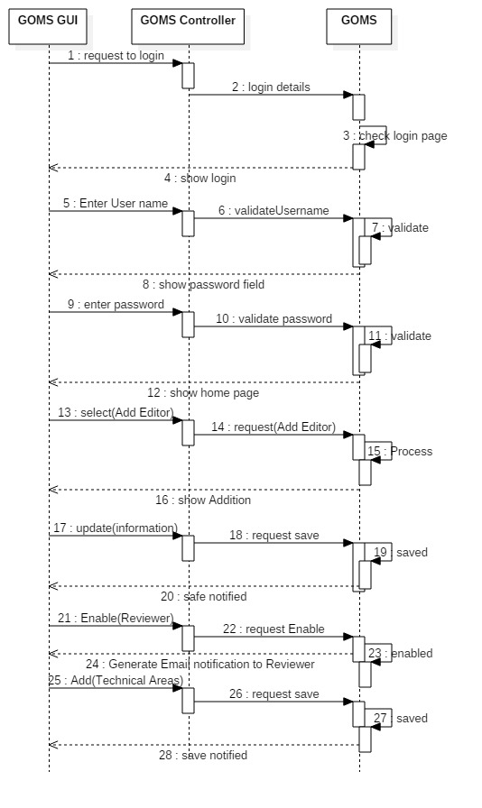

### Reviewer Sequence diagram

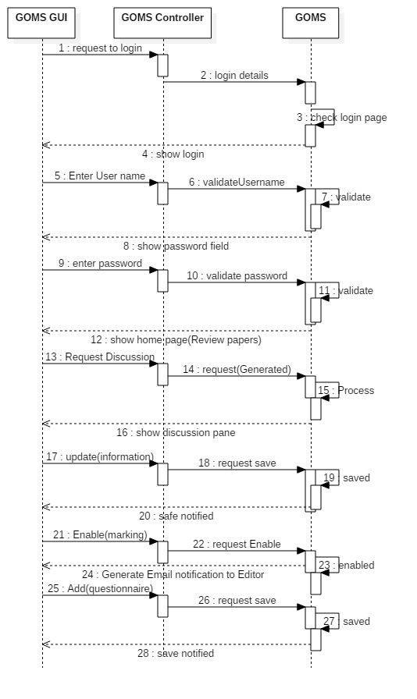

### Store information sequence diagram

For the store information we have illustrated the user information to store, however the journal, and other necessary information’s are also stored in the store information class. The sequence for the user information store includes:

* User Successfully LOGIN to the system
* He click to UPDATE or ADD his information
* UPDATE or ADD PERSONAL INFORMATION
* He can add his personal address, marital status and other information to be updated



Figure 16: system sequence diagrams

### Store journal records

* User Successfully LOGIN to the system
* He click to UPDATE or ADD his work according to the reviews
* UPDATE or ADD JOURNAL RECORDS
* He can add CHANGES and Save them for future reference
* User can browse to other comments, previous records and increments to see the progress.



Figure 17: sequence diagram

# Implementation

## Language Selection

### C#

Selection of language is very important for implementation of the system. There are different languages as VC, Vb.net, C#, that are available to develop web based systems. I have chosen C# for implementing this web application. There are some reasons for selecting C# as It is an object-oriented programming language and it enables the developers to build a variety of secure and fast applications that runs on the .NET Framework. C# is used to develop windows client applications, client-server applications, database application and much more. It also provides full COM/Platform support for existing code integration as well as support extensible metadata concepts. By using C#, Web programs and Web services can be developed more easily than other Microsoft tools such as Visual C++ and Visual Basic.

### HTML

HTML is Hyper Text Markup Language. Html is not a programming language but it is used in this project for the user interface. It is used to represent the look and feel of the application with the help of CSS (cascading style sheets). I have used Html with CSS (cascading style sheets) to make the user interface attractive and more user friendly. We can change the style of whole website using cascading style sheets.

### JavaScript

JavaScript is a scripting language used to create interactive Html pages. It is a lightweight programming language and directly embedded to the Html pages. Although it copies many names and naming conventions from java, it has different semantics from java.

### ASP.NET

ASP.NET is a web application framework and a server side scripting technology that enables scripts (embedded in web pages) to be executed by an Internet server. It is an object oriented programming language and contains systematic classes and objects. Microsoft developed the Asp.Net and first released in January 2002 with version 1.0 of .NET Framework that allows to build dynamic websites, web services. Asp.Net runs on the internet service provider called Internet information Server (IIS) that is Microsoft’s internet server.

# Codes

# Testing

In development of online journal management system for Glyndwr University, we have used Rational Unified Process methodology. At the transition phase of this methodology there is testing and deployment of the system is performed. So in this chapter we will cover the last phase of the proposed methodology as well as testing methods adopted for the system. However the practical approach for testing was followed throughout the development of the system which is “test early and test often” approach. Because being developer of the system it was important to understand not only each and every phase but also it was important to keep the development within the scope defined at earlier stage. The testing approach was functional testing and non-functional testing majorly which is described in this chapter with detail.

## Functional testing

Functional testing means that we should test and evaluate all the functional requirements are full filled or not. In this phase of the testing the essential and basic of the system should be working, for example in this type of testing the major categories includes:

1. Alpha and beta testing before the final deployment
2. White box testing to ensure that every module is working correct with inputs and outputs with going into details of the coding
3. Black box testing to ensure that every module is working correct with inputs and outputs without going into details of the coding
4. Unit testing for each module of the system
5. Integration testing
6. System testing as a whole

## Non-functional testing

Non-functional testing is majorly to test the non-functional requirements fulfilment. For example, reliability, speed, performance and other non-functional requirements.

In this category we usually test based on following features:

1. Usability testing
2. Performance testing

There are three main aspects over which testing are performed 1. Efficiency, 2. Effectiveness and 3. Usability. Efficiency and effectiveness deals with the systems aspects like accuracy, completeness. While usability deals with the user aspects of interaction. Usability testing methods covers a wide range of evaluation methods for interactive information systems. These methods could be ethnographic style of evaluations, large scale log analysis, and User interactions evaluation model. [Wichansky et al. 2000] presented all possible usability evaluation methods that are being practiced in the field of evaluative research. They distributed their research work into four working groups (WGs); WG1 identified all available UEMs, categorize and classified them. WG2 Evaluate and compare Usability Evaluation methods, WG3 contributed to the research work by considering valuable attribute during evaluations, WG4 presented their research contribution by focusing on automatic Usability Evaluation Methods.

## Black box Testing

With black box testing, the software tester does not (or should not) have access to the source code itself. The code is considered to be a “big black box” to the tester who can’t see inside the box. The tester knows only that information can be input into to the black box, and the black box will send something back out.

## Test cases

Test cases are the testing performed in order to test the effectiveness and working of the system. Following are the testing cases for the Online University management system.

### Test case for author to submit a paper

|  |  |  |  |  |  |  |  |
| --- | --- | --- | --- | --- | --- | --- | --- |
| Online University management system | | | | | | | |
| Test case: submit a paper | | | | | | | |
| Test case ID: TC_UI_1 | | | | Test designed by: Basir | | | |
| Test Case Priority: (Medium/low/high): high | | | | Test designed date: December 28, 2015 | | | |
| Module name: Author Paper Submission | | | | Test executed by: Basir | | | |
| Test Title: Author Submits paper | | | | Test execution date: December 28, 2015 | | | |
|  | | | |  | | | |
| Pre-condition: author must be member of the system and should be login. | | | | | | | |
| Dependencies: depends upon administrator to have rights to submit the paper | | | | | | | |
|  | | | | | | | |
| **Steps** | **Test step** | **Test data** | **Expected result** | | **Actual result** | **Status (pass/fail)** | **Notes** |
| 01 | Navigate to submit paper | Paper (pdf/word format) | Paper submission form | | Paper submission form appears | Pass |  |
| 02 | Fill information | Information is valid | Information is correct | | Doesn’t accept any numbers on name, course name field. | Pass |  |
| 03 | Browse to paper location | Paper formats acceptance | System should only accept word or pdf format | | System accepted pdf and word format only | Pass |  |
| 04 | Submit | Submit button | Submit button should work | | Submit button accepted the paper | pass |  |
| Post condition: paper is submitted properly and shown a congratulation message after successful completion of submission | | | | | | | |

### Test case for author to withdraw a paper submission

|  |  |  |  |  |  |  |  |
| --- | --- | --- | --- | --- | --- | --- | --- |
| Online University management system | | | | | | | |
| Test case: Withdraw paper submission | | | | | | | |
| Test case ID:TC_UI_2 | | | | Test designed by: Basir | | | |
| Test Case Priority: (Medium/low/high):medium | | | | Test designed date: December 28, 2015 | | | |
| Module name: author | | | | Test executed by: Basir | | | |
| Test Title:: author wants to withdraw paper submission | | | | Test execution date: December 28, 2015 | | | |
|  | | | |  | | | |
| Pre-condition:   * author should be member of the system * he should have submitted paper * paper is reviewed and ready to be published * author is notified by email for submission on journal | | | | | | | |
| Dependencies: author is dependent on administrator to take decision for withdraw | | | | | | | |
|  | | | | | | | |
| **Steps** | **Test step** | **Test data** | **Expected result** | | **Actual result** | **Status (pass/fail)** | **Notes** |
| 01 | Navigate to withdraw submission | User information | Corrected user information | | Accept user information for valid submission | Pass |  |
| 02 | Fill the form | User name, student ID, submission title, Reviews made, reason to withdraw submission | User based information | | Accepts user based information entered | Pass |  |
| 03 | Mention reason to withdraw | Should have minimum of 500 words reason to withdraw submission | Accepts the standard language only | | Accepts user based information entered | pass |  |
| 04 | Submit | Request is submitted | Request sent to admin | | Request send to admin | pass |  |
| Post condition: a paper withdraw application is submitted to admin, and he notifies the author to take time on his request reviewed. | | | | | | | |
|  | | | | | | | |

### Reviewer comments on submitted papers

|  |  |  |  |  |  |  |  |
| --- | --- | --- | --- | --- | --- | --- | --- |
| Online University management system | | | | | | | |
| Test case: Reviewer comments on submitted papers | | | | | | | |
| Test case ID: TC_UI_3 | | | | Test designed by: Basir | | | |
| Test Case Priority: (Medium/low/high): high | | | | Test designed date: December 28, 2015 | | | |
| Module name: Reviewer | | | | Test executed by: Basir | | | |
| Test Title: Reviewer comments on submitted paper | | | | Test execution date: December 28, 2015 | | | |
|  | | | |  | | | |
| Pre-condition: reviewer is member of system,  He is logged in and have rights to discuss with author and review rights too | | | | | | | |
| Dependencies: none | | | | | | | |
|  | | | | | | | |
| **Steps** | **Test step** | **Test data** | **Expected result** | | **Actual result** | **Status (pass/fail)** | **Notes** |
| 01 | Navigate to latest submissions to review | Display of new submission | New submissions are shown at the top | | New submissions are shown at the top | pass |  |
| 02 | Open a submission to review | Opens in a pdf viewer | Proper formation is displayed at pdf viewer | | File is open in pdf file viewer | Pass |  |
| 03 | Add comments | Comments are added | Comments are added by reviewer | | Comments are added for discussion with author | Pass |  |
| 04 | Submit to view for author | Submit | Successful submission | | Submission succeed | pass |  |
| Post condition: reviewer has submitted the reviewed file for author | | | | | | | |
|  | | | | | | | |

### Paper marking by reviewer

|  |  |  |  |  |  |  |  |
| --- | --- | --- | --- | --- | --- | --- | --- |
| Online University management system | | | | | | | |
| Test case: marking | | | | | | | |
| Test case ID: TC_UI_4 | | | | Test designed by: Basir | | | |
| Test Case Priority: (Medium/low/high):medium | | | | Test designed date: December 28, 2015 | | | |
| Module name: reviewer | | | | Test executed by: Basir | | | |
| Test Title: reviewer can mart author paper based upon his feedback and work effort | | | | Test execution date: December 28, 2015 | | | |
|  | | | |  | | | |
| Pre-condition: reviewer is member of system,  He is logged in and have rights to discuss with author and review rights along with marking rights | | | | | | | |
| Dependencies | | | | | | | |
|  | | | | | | | |
| **Steps** | **Test step** | **Test data** | **Expected result** | | **Actual result** | **Status (pass/fail)** | **Notes** |
| 01 | Navigate to marking screen | Marking criteria | Check rubrics to mark | | Checked rubrics to mark | pass |  |
| 02 | Select marking range | Marking criteria | Select a range | | Range is selected | Pass |  |
| 03 | Give a grade | Grade | Select a grade | | Grade selected | Pass |  |
| Post condition : reviewer has graded author effort for the paper | | | | | | | |
|  | | | | | | | |

### Make decision

|  |  |  |  |  |  |  |  |
| --- | --- | --- | --- | --- | --- | --- | --- |
| Online University management system | | | | | | | |
| Test case: make decision | | | | | | | |
| Test case ID: TC_UI_5 | | | | Test designed by: Basir | | | |
| Test Case Priority: (Medium/low/high): high | | | | Test designed date: December 28, 2015 | | | |
| Module name: editor | | | | Test executed by: Basir | | | |
| Test Title: editor accepts or rejects the submission | | | | Test execution date: December 28, 2015 | | | |
|  | | | |  | | | |
| Pre-condition: editor is login to the system | | | | | | | |
| Dependencies | | | | | | | |
|  | | | | | | | |
| **Steps** | **Test step** | **Test data** | **Expected result** | | **Actual result** | **Status (pass/fail)** | **Notes** |
| 01 | Navigate to paper submission decision screen | Accept/reject | Submission with reviews and original submission | | Review the work and see actual submissions | Pass |  |
| 02 | Take decision | Accept/ reject | Based upon review take decision | | Decision taken on submission | Pass |  |
| Post condition : decision is made based on information and review of the work | | | | | | | |
|  | | | | | | | |

### Make or remove editor

|  |  |  |  |  |  |  |  |
| --- | --- | --- | --- | --- | --- | --- | --- |
| Online University management system | | | | | | | |
| Test case: make or remove editor | | | | | | | |
| Test case ID: TC_UI_5 | | | | Test designed by: Basir | | | |
| Test Case Priority: (Medium/low/high): high | | | | Test designed date: December 28, 2015 | | | |
| Module name: admin | | | | Test executed by: Basir | | | |
| Test Title: editor accepts or rejects the submission | | | | Test execution date: December 28, 2015 | | | |
|  | | | |  | | | |
| Pre-condition: admin is login to the system | | | | | | | |
| Dependencies | | | | | | | |
|  | | | | | | | |
| **Steps** | **Test step** | **Test data** | **Expected result** | | **Actual result** | **Status (pass/fail)** | **Notes** |
| 01 | Navigate to editor selection decision screen | Make/remove | Submission with reviews and original submission | | Review the work and see actual submissions | Pass |  |
| 02 | Take decision | Make/ remove | Based upon review take decision | | Decision taken on submission | Pass |  |
| Post condition : decision is made based on information and review of the work | | | | | | | |
|  | | | | | | | |

# References

Wichansky, Anna M. "Usability testing in 2000 and beyond." *Ergonomics* 43.7 (2000): 998-1006.

# 

# Critical Evaluation

This project development was a challenging task as it involved the research aspects to be handled as its first and foremost requirement. In general online journal management system is helpful to not only the recent students in their research activities but also guide future students for their research work. Glyndwr University always needed a journal management system which can facilitate students, editors and reviewers. This system was lacking in the university, the recent systems on different forums are quite helpful for authors, the same facility is developed for Glyndwr University and this can facilitate the future students too for their problem formulation and research topic extraction, as well as university scholarly material writing policies.

## Challenges

The major challenges involves during the development of online journal management system included:

1. **Scope definition challenge**

The definition of scope for any project is very difficult task to do, so it was the first challenge to accomplish. It keep the scope limited to the authors, editors and reviewer of the system. This helped me to understand the basics of the system as well as a systematic approach to improve it in future.

1. **System analysis challenges**

The system analysis phase was challenging one because the scope was elaborated in this stage. The requirements elicitation in detail was challenging task to do which I accomplished by using a UML drawing tool (STAR UML). I preferred to use noun and other relevant words for the use cases and UML diagrams. The system analysis was a challenging task as I have to keep a symmetry between different diagrams and their relevance within the scope of the project. The methodology adopted to develop this system is object-oriented, it developed a complete use cases, and software development life cycle phases and their respective diagrams. It elaborated each phase and components in it. I also adopted Rational Unified Process model methodology for this journal management system.

## Future Enhancements

In future the scope of this application can be increased to various other features including:

1. SMS notifications

The email notifications module to the stakeholders of the system can be extended to the SMS notifications so they can check their status about the journal paper right in their message box. This feature will be especially helpful to users who are not using internet on 24X7 basis or are located in some remote location due to certain reason.

1. Mobile App

This system can be increased to a mobile app which can be beneficial to the users who are travelling or not at their working terminal, so they can check the status of their work at any place.

1. Department wise distribution

When this application is used in university with different departments, and a lot of papers with different domains and topics are published and saved in repository, then this application can be distributed internally on department wise.

## Conclusion

Glyndwr University needed a journal management system which can facilitate students, editors and reviewers. This system was lacking in the university, the recent systems on different forums are quite helpful for authors, the same facility is developed for Glyndwr University and this can facilitate the future students too for their problem formulation and research topic extraction, as well as university scholarly material writing policies.

1. <http://www.publishingtechnology.com/vista/>
2. <http://journal.nepha.org.np/journal-management-editorial-process>
3. <http://builtwith.com/openconf.com>
4. <http://builtwith.com/?https%3a%2f%2fjournals.gre.ac.uk%2findex.php%2fmsor>
5. <http://builtwith.com/?https%3a%2f%2fjournals.gre.ac.uk%2findex.php%2fstudentchangeagents%2findex>
6. <http://builtwith.com/ijhpm.com>
7. <https://era.nih.gov/docs/rup_fundamentals.htm>