+<Type Course name>

<Type Your name>

<Date>

**Google apps Vs Office 365**

Google claim to replace the Microsoft office and compete it back few years was considered as quite challenging one. Google after some time launched their Google apps store and get market attention for some time. But office 365 release revive back its reputation in market. But in order to make the comparison we have to see some major aspects of both cloud based applications upon basis of some parameters like usability, user managements, malware attack protection, mail server, document management, chatting and communication, online apps, offline working, supports provided. Upon basis of these parameters we would decide which cloud based application would be best for our organization. The next phase of the report will cover these parameter comparison and our selection of the tool.

Usability is a parameter upon which tells how any tool is effective in use from end user point of view. Both google apps and office 365 are managed online so the usability factors are provided by both companies accordingly. But office 365 is more user friendly due to the interface provided and it is easy to use and end user can easily learn it upon glance of the application. Beside it has the role of user defined up to five levels from top level management to the normal end data entry or user with lowest level of access to the office 365. Whereas google apps have two level of management. So in this parameter office 365 has edge on google apps. The user management in office 365 is better than the google apps, due to supply of role and policies, and clear dash board representing the clear objectives. So office 365 have better user management than google apps. The malware protection in both tools is provided at best level so there is a tie between them. The document management in office 365 is better than the google apps but some people may prefer the simplicity provided in the google apps. The communication features provided in the office 365 are better than the google apps, due to the availability of the Microsoft Lync, which is more powerful than the google talks. The online apps of both office 365 and google apps are better, and google docs are better in sharing and collaboration. The offline support of the office 365 is better due to the SharePoint and subscription access to access the office suite. But google apps need to improve a lot in this parameter. At last is the support provided by both applications, we come to know from the web search and other analysis made by different bloggers that office 365 has better availability of the technical and other support?

From the analysis results we have collected from different web resources lead us to select a cloud based application for our organization. Based upon this analysis I have decide to choose office 365 as our choice, the reason to select this tool is the availability of different useful features which would help us to perform different organizational tasks. Beside we can easily distribute the level of access and administrative priorities.

In this section of the report we would present the application approach we would use as project description,

Project Charter

The project charter is one of the most important milestone in the startup of the project. It explains the plan and responsibilities of the team and it also discuss the overall expenses of the system to be developed. It describes the project title along with the estimated date to be start and project completion date and also tells the estimated budget information and objective of the system to be developed. It also discuss the major success criteria or milestone of the main project. It also explain roles and responsibilities of the team who are going to be part of the project development.

This file would be helpful to inform the higher management to highlight the concerning authorities related to the project this would help for higher management to directly concern the specific person about the issues or milestone reporting.

**Project Title**: cloud based application office 365 implementation.

**Project Start Date:** February 8th 2014 **Projected Finish Date:** March 3 2014

**Budget Information: __$**

**Project Manager:** Ali Sultan,

**Project Objectives:** conversion from traditional client server to Office 365.

**Main Project Success Criteria:** successfully converted the organization mode of working from traditional client server application to office 365.

**Approach:** Cloud software as a service (SaaS) is used as an approach upon conversion.

**Roles and Responsibilities**

|  |  |  |  |
| --- | --- | --- | --- |
| **Role** | **Name** | **Organization/**  **Position** | **Contact Information** |
| Manage activates | Ali | Project manager | **-------------** |
| Coordination between activities | Abc | Application Team lead | **--------------** |
| Coordinate for resources | Xyz | Technical Team leader | **--------------** |
| Ensures the defect less transfer | Jhjd | QA team Leader | **------------** |
| Document the changes and new system | Fkkk | Technical Writer | --------------- |

**Weighted Score for project selection**

The weighted score for the project selection for the project help the team to highlight the importance of the different criteria like usability, user management, male ware attack prevention, mail server check, document management, communication, offline working and online applications. For both application i.e. google apps and office 365 the overall need of having the decision matrix is 43.85 and 70.6 respectively.

The advantage of having such decision matrix let the team to choose the best solution to shift from one of the possible solutions these decisions are made on the basis of literature team had made so far and they rated office 365 as their desired tool for shifting the from traditional documentation to the office 365.

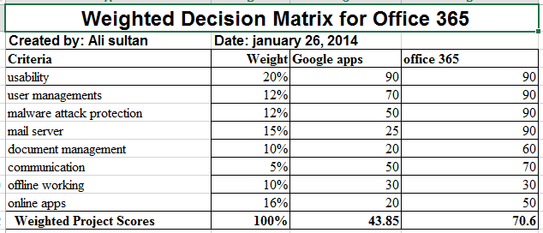

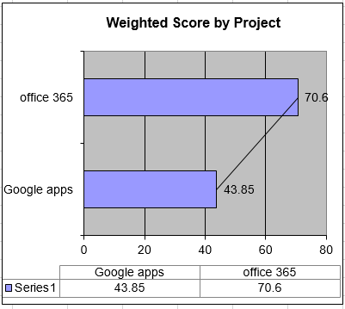

**Preliminary Scope Statement**

The scope of the project defines the project title and its justification about it why they are developing this software or decision. It also include the characteristics of the project scope as well as the requirements of the new product to be developed. It also highlights the deliverables of the project which are needed to be done. This would be helpful to the whole team to focus and put their efforts in a reasonable way in order to develop the product. It also include the deliverables related to the product which are the reports and documents related to the product development phases.

At the end of the milestone it is necessary to have an success criteria which would be the guaranteed successful conversion of traditional client server management documentations to MS world 365.

|  |
| --- |
| **Project Title:** cloud based application office 365 implementation  **Date: 8 February 2014** **Prepared by:** Ali sultan |
| **Project Justification:**  This project focus on conversion of organization activities from traditional client server application to the cloud based application i.e. office 365.. |
| **Product Characteristics and Requirements:**   1. The requirements of the product are the operating system, distributed networking, sharing and communication. 2. The characteristics of the product are to provide access to all user according to their access level, synchronized work, and team management. |
| **Summary of Project Deliverables**  **Project management-related deliverables:** project charter, scope statement, Work Breakdown Schedule, Gant chart with a response histogram, quality check list, quality assurance plan, team contract, and progress report.  **Product-related deliverables:** research reports, design documents, software code, hardware, etc. |
| **Project Success Criteria:**  The success criteria for our project would be the successful conversion of our organizational activities from traditional client server to the office 365. |

Work Breakdown Structure for office 365

The work breakdown structure of the conversation from traditional system to the office 365. It shows the logical breakdown and milestones to be achieved step by step so that the task can be completed. The rest description is provided in the template itself.

**Prepared by:** Ali sultan **Date: February 26, 2014**

1. **Activate the User licenses**

User license is issued or obtained after the registration on official forum of office 365.

1. **Issue notification to the Employees**

**2.1 Send Manager Email**

Send email to all mangers about the time and schedule of migration of the system to office 365.

* 1. **Send General email**

Send general email to all staff about the alert date when the system would be updated or shifted form one medium to another.

1. **Mailbox to office 365**
   1. **Staged migration**

Make a plan to in order to set variables and milestones to convert from one system to the other one.

* 1. **Cutover Migration**

Make initial migration of the information.

1. **Migrate collaborating documents**
   1. **Analyze existing share point**

Analyze information and prioritize it which information must be converted first.

* 1. **Content migration**

Migrate the information or content according to the prioritized one.

1. **Change DNS record**

Change domain name record to the office 365.

1. **Configure devices for office 365**
   1. **Setup mobile devices for Lync online**

Setup all necessary device like mobile phones, smart phones, and tabs to configure for the Lync online.

1. **Post-migration testing**

Test properly that everything is migrated properly and need no further configuration or any change.

Gantt chart with a Resource Histogram

Gantt chart resources histogram is one which shows the progress made by the team lead of different departments who are strongly involved in shifting of information from traditional system to the office 365.

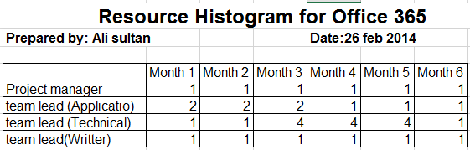

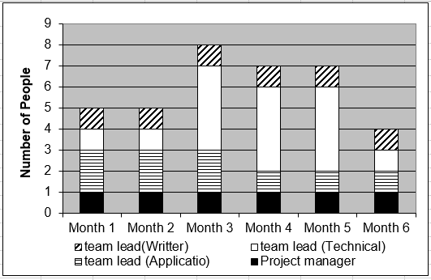

Risk Matrix

Risk matrix describe the potential risks involved in the migration from traditional system to the office 365. This would help the team lead and the management to highlight and aware of potential risks that may hinder the process of the migration.

|  |  |
| --- | --- |
| **Ranking** | **Potential Risk** |
| 1 | User activation failure |
| 2 | Notification issue failure |
| 3 | Migration to office 365 mailbox failure |
| 4 | Migration of documents failure |
| 5 | Changes on DNS record failure |
| 6 | Configuration failure |

**Quality Matrix**

Quality matrix shows the milestone testing after the successful migration of system from traditional system to the office 365. This would help and ensure the higher management that all the information and data is shifted properly and now they can enjoy and get facilitied from the benefits of the online office system.

|  |  |  |  |  |
| --- | --- | --- | --- | --- |
| **Milestone** | **Date** | **Status** | **Responsible** | **Issues/Comments** |
| User license | 26 feb | Successful | Ali | Successful activation of user account |
| Notification to others | 26 feb | Successful | Ali | Successful notification to other team members |
| Mailbox migration | 26 feb | Successful | Ali | Successful migration from normal mailbox to office 365 mailbox |
| Document migration | 26 feb | Team lead | Jjdf | Successful migration of documents. |
| DNS record changed | 26 feb | Team lead | Jhjfg | Successful migration of DNS records. |
| Configuration of devices | 26 feb | Team lead | Sdjf | Successful |

Issue log

Issue log describes the issue or hindrance that occurred during the migration from one system to the other one. It also describes the priority level of the issues. This file would be helpful to determine the issues and resolve them immediately, this would also be helpful in future in order to have a strong informational background of the previous issues.

|  |  |  |  |  |  |  |  |  |  |
| --- | --- | --- | --- | --- | --- | --- | --- | --- | --- |
| Issue # | Issue Description | Impact on Project | Date Reported | Reported By | Assigned To | Priority  (M/H/L) | Due Date | Status | Comments |
| 1 | Authentication | Unable to progress | 22 feb | Ali | Xyz | H | 26 feb | Unsuccessful | Need to address immediately |
| 2 | DNS migration | Technical issues | 21 feb | Xys | www | M | 26 feb | Unsuccessful | Need to be address. |
| 3 | Documentation migration | Application issue | 21 feb | Ali | www | H | 26 feb | Unsuccessful | Need to address immediately |

Team contract

The team contract and code of conduct would bound team to fulfil their responsibilities and follow them accordingly so that no one can get confuse about his responsibilities.

|  |  |
| --- | --- |
| **Name** | **Sign-off on Team Contract** |
| Ali sultan | Project manager |
| John | Team lead (Application) |
| Michael | Team Lead (Technical) |
| Sara | Team lead(Writing) |

**Code of Conduct:** As a project team, we will:

* Available for maximum time of 8 hours at the work place
* Will take part in issues as a team
* Will ensure the best possible results

**Participation:** We will:

* Participate in each and every step of the project equally.
* Make sure that every team member has same pace of work.
* Cooperate with other members in their ups and downs.

**Communication:** We will:

* Communicate in team to solve all possible issues.

**Problem Solving:** We will:

* Try our best to solve the problems.
* Will communicate with team lead first and project manager afterwords.
* Will collaborate with each other.

**Meeting Guidelines:** We will:

* Follow the meeting guide lines
* Will fulfil our daily tasks as soon as possible.

Progress report

The progress report would be helpful to see the progress made by the team, the achievements they had made and the rest of the tasks which are still under observation and task which are complete and which need to be completed. This would be helpful to see the progress of the team and their involvement in the project. If the progress reports are bi-weekly then it would be better and shows a strong bond of team during the task development.

|  |
| --- |
| **Project Name**: Conversion to Office 365  **Team Member Name:** ali, john, Sara, Michael.  **Date: 26 feb**  **Reporting Period: 1 day** |
| **Work completed this reporting period:**  70% of the work has been completed. |
| **Work to complete next reporting period:**  100% of the work would be completed. |
| **What’s going well and why:**  We are converting the documents contents from local to office 365, and assigning the role for the employees and their access levels. |
| **What’s not going well and why:**  Its going good |
| **Suggestions/Issues:**  Nil |
| Project changes  Nil |

Bibliography

Mary BranscoMBe “Office 365 vs Google Apps”