

knowledge management systems

Your name



[Date]

institute name

[Company address]

Contents

Introduction 2

Automotive Company case study 7

Requirements 7

Knowledge Model 8

System Framework 10

Interaction overview Flow 12

User interfaces 14

Interface 1: 14

Interface 2 15

Interface 3 16

Interface 4 17

Conclusion 17

References 19

The Knowledge Management System for Automotive Company

# Introduction

With the advent of worldwide Web (WWW), there was a trend to produce information and make it available online. The access of production of information caused a mesh information on the internet. Research community felt the gap that there must be organization in the information and they proposed the solution in the form of some way to manage the knowledge. So “Knowledge age” is the term mostly used in this recent era which was started almost 2 decades ago. Knowledge management have become very important due to access and overwhelming data. It helped the researcher community to avail the opportunity to propose the models and graphs and process to manage the knowledge or information. These models are proposed to practically implement the system according to the design it requires. The management of information and knowledge is applied to many field like medical, nuclear, physics and many other fields of research and development, these examples of knowledge management are designed in such a way that they manage the knowledge by proper integration with the databases and other business process layers rather than just pages of data and information which are just utilizing the resources. One other kind if example of knowledge management is Automotive industry which also get benefit of this technology, due to less in cost, greater value to customers and competitive advantages (Nor 2013). “Knowledge management is basically a process which identifies, develop and apply existing organizational knowledge to achieve organization goals, and showing flexibility to create further knowledge” (Sunassee 2003). Knowledge management systems are usually developed by large organization to them the knowledge or information has vital importance and it need to be maintained all the time. Because the organizations usually majorly rely on information and its safety so usually organization also adopt some mechanism to make back up of that information or knowledge in case of some emergency case like fire, flood or earth quakes. Usually this information is saved on a very reliable and save place where it can not be damaged that much or very less loss of information is ensured in case of big damage. According to Yip, “knowledge management is defined as a process of managing the tacit and explicit knowledge in the organization in order to increase the competitive advantages” (Yip 2010). The knowledge and its importance for a particular organization is different for example for a software house the knowledge management need to define the clients details, software’s which are being developing, software which are developed, services which are provided to the clients and the offer company made to the clients as well as the bio data and other information of the employees. Another example of knowledge management from tacit and explicit context is the petro-chemical company where there is a strong need to manage information and a very strong backup model is followed in case of any emergency situation. In such large organization the knowledge is managed in different context for example it can be managed for refinery, for the products, for the major clients, major needs, crude income, yearly reports, progress reports, outgoing products, revenues, taxes, employee management. For such large number of knowledge management systems under one organization there is a need to have a separate department in the organization who manage and create new relevant knowledge in an efficient way. According to Alavi, knowledge management systems are the information systems developed to “support and enhance the organizational knowledge processes of knowledge creation, storage, retrieval, transfer and application” (Alavi et al., 2001). Knowledge management systems may have some types known as expert systems, groupware, documents management system, decision support system, database management system, and simulation systems. Each knowledge management system is used according to its problem domain for example expert systems are used by the domain experts who use it during their critical analysis durations, similarly groupware facilitates the collaboration between workers, document management is used to keep the versioning, store and share the document, decision support systems are used to present information to user in such a way that he can make decision very easily.

There are some goals of a knowledge management systems which includes to capture knowledge, improve knowledge access, enhance knowledge environment, and manage knowledge as an asset[1]. With these goals the management of knowledge can be easily organized and can have best results according to the organization needs. These goals led the knowledge management team to uniquely identify the needs of the organization and make the process model so that one can contribute his best to achieve the goals of that organization. There are also some functions involved in knowledge management development, like finding information, mapping it, gathering and filtering information. When new knowledge is developed the function used are identification of relation between new entities and information. When it comes to sharing of information the major function used are conversion of personal resources to shared knowledge, understand it and learn it. The sharing of data in knowledge management needs authentication, in knowledge management techniques certain authentications are allocated so that user can have an access to information accordingly. For example for the certain information which is concerning to the CEO of the organization must be updated, viewed or managed by him only and must not be showed to any employee at all. Similarly, in this way the authentications are performed. One other factor is the verification of the information which is very important for the knowledge management team to verify and they usually do it by questioning or informing the concerning authorities. All these functions combinable form some other functions like intermediation, externalization, internalization, cognition and measurement. Intermediate function insures that transfer of knowledge is performed in an efficient way. This can be achieved by matching information seeker requirements to the optimal source matched in the knowledge base. Externalization is used to express the knowledge from mind of people to the knowledge base repository in an efficient way. Externalization may include searching, viewing information, requesting for downloading the information. Internalization refers to extraction of knowledge from external repository[2] , the presented knowledge must be presented to him in most suitable person. Measurement to all activities that measures, map and quantify corporate knowledge[3]. Beside the functions of the KM there are some technical requirements needed to be fulfilled when designing the knowledge management system these are scalability, extensibility, secure, relevant, collaborations, fast, easy and reliable, flexible, and heuristic. The technical requirements can be fulfilled by proper identification of your system boundary, its scope, its purpose, target audience, their knowledge level, and their importance to use the system. Next level of technical requirements need to provide an secure information and knowledge access which should not be attack or hack by any external source, so security is the major technical requirement for managing the information.

The most important applications of the knowledge management in information system field is the search engines like Google[4], Yahoo[5], and Msn[6]. These are the web based information system, which are one of the largest and most used information management system. Some other applications of the knowledge management system are oracle knowledge management which ensures the searching made by user over wide variety of sources[7]. Some other knowledge base applications are data ware technologies[8], introspect software Inc.[9], knowledge Inc.[10], Inference crop, fulcrum technologies. Other applications of knowledge management system are web based, standalone applications, E-commerce, E-learning, E-social-networking, e-entertainment, petroleum industry, human resource management, knowledge engineering, quality management and project management. Key technologies followed in the knowledge management system are the collaborations and communications for web based internet and intranet usage. For mobile technologies the knowledge management such as PDA’s, PC’s, video conferencing. Recent trends in which most companies are interested in are: (Contreras 2011), ability to create value and differentiate from competitors, improve business process, speed up time to market. Organizing memory, design engineering, information sharing, e-learning are the applications developed using these technologies.

# Automotive Company case study

With all the discussion on functions, technology, applications, technologies, with their implications and benefits we would describe in rest of our report a knowledge management system for a very important field, i.e., automotive company. Automotive industry is basically involved in manufacturing, design, development, marketing and selling of the automobiles. The importance of knowledge base management system is more revealed here by applying it in this domain. The reason for this is that automotive is one of the most revenue industry of the world. Our automotive company case study has two main actors of the system user to project manager, and design engineers. They usually performed store, design and capture the design knowledge. System requires to have basic operations like addition, deletion, updating and viewing the knowledge base.

## Requirements

The basic requirements of the system are according to the responsibility of the project manager and design engineers. Project manager is responsible to manage all the automotive activities, like accessing project requirements, negotiating on project budget, development and implementation of the test procedures, supervise the team of design, production and manufacturing engineers, interpreting the results data via spreadsheets. Similarly the design engineer responsibilities are to develop CAD models for automobiles, prepare design reports, diagrams.

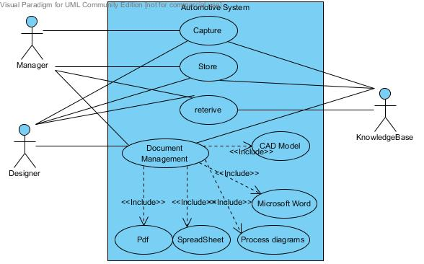

Figure 1: Requirement use case diagram

## Knowledge Model

The knowledge model represents how the information or knowledge is represented. There are several ways to represent knowledge of the domain. The possible ways of representing knowledge could be hierarchal, process model description, activity description of the knowledge flow. In our case study we used hierarchical model to represent our knowledge the reason to select this approach is that we want to know the responsibilities of both manager and designer so that we can easily differentiate between them as our system major relies on management of documents so there was need to understand how and what documents are responsibilities of both are required. The hierarchical knowledge model of the automotive company case study is as follows:

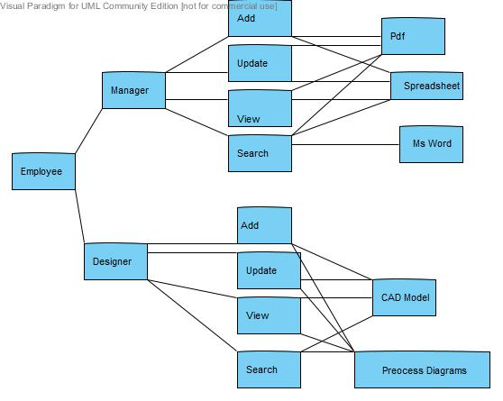

Figure 2: knowledge model for automotive company

## System Framework

The framework consist of three major entities i.e., user interface, business process model, and database or knowledge base layer. The user interface layer is to manage and design all the interfaces of the application and make them flexible enough that they communicate with the business process layer in a very efficient and professional way. The next layer of a system framework is business process layer which differentiate between different entities of the knowledge base system in our system the business process entities are data operations, user management, and document management. The last layer of knowledge base is the storage layer or the knowledge base layer.

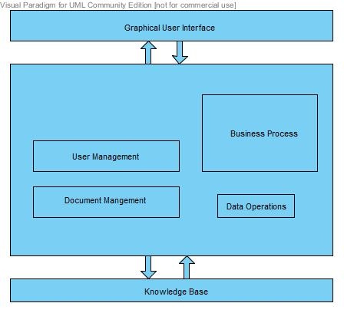

Figure 3: system framework for automotive company

## Interaction overview Flow

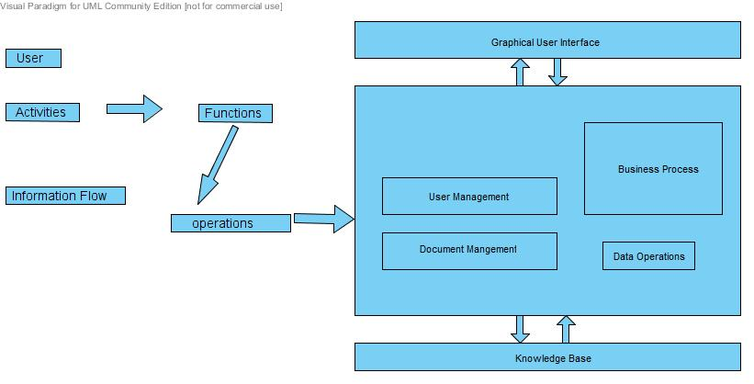

Figure 4: interaction flow diagram for automotive company

D:\LivePerson\task32\Interaction Overview Diagram1.jpgD:\LivePerson\task32\Interaction Overview Diagram1.jpgThe interaction flow consist of activates of user, functions and the operation they perform to complete the knowledgebase requirements. The user interaction model represent the flow of these entities within the system boundary but we also have to explicitly describe it in our problem domain. The main users of our system are manager and designer, and the activities they perform are management of CAD models, component process pictures, sketches, testing reports, brief design reports, paper work administrative purpose, illustration of process, description of work components, and calculations. The major functions of this domain model are updating, viewing, searching, and adding. The major operations they perform are updating the documents, view all the knowledge information, add/edit/delete the document, search a specific document, and view a specific information.

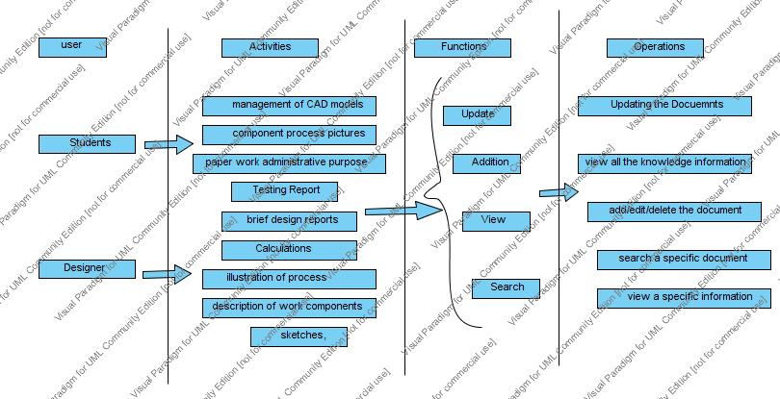

Figure 5: interaction diagram for automotive systems

## User interfaces

## Interface 1:

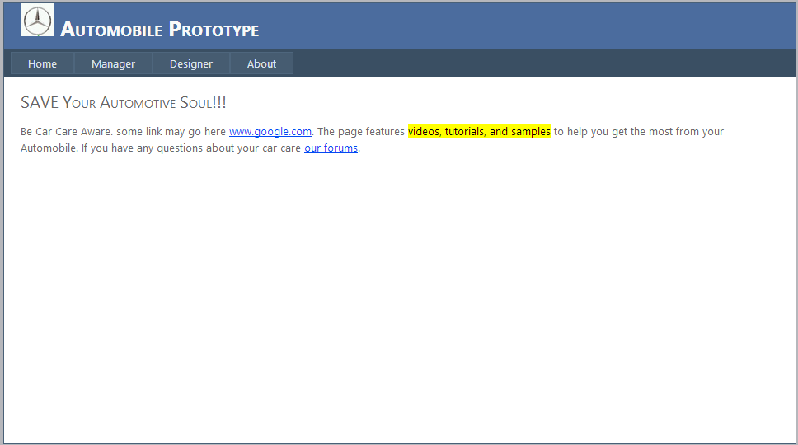

Figure 6: interface 1 of the prototype

## Interface 2

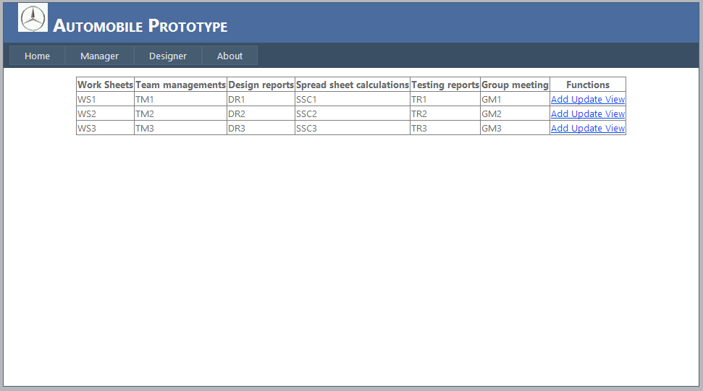

Figure 7: interface 2 of the prototype

## Interface 3

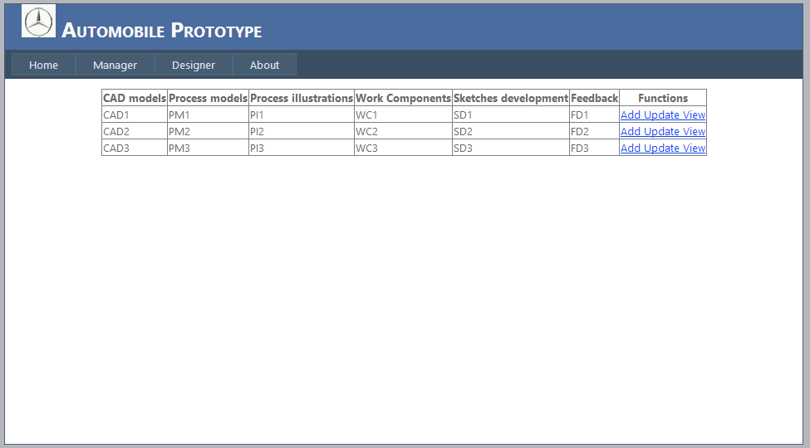

Figure 8: interface 3 for the prototype

## Interface 4

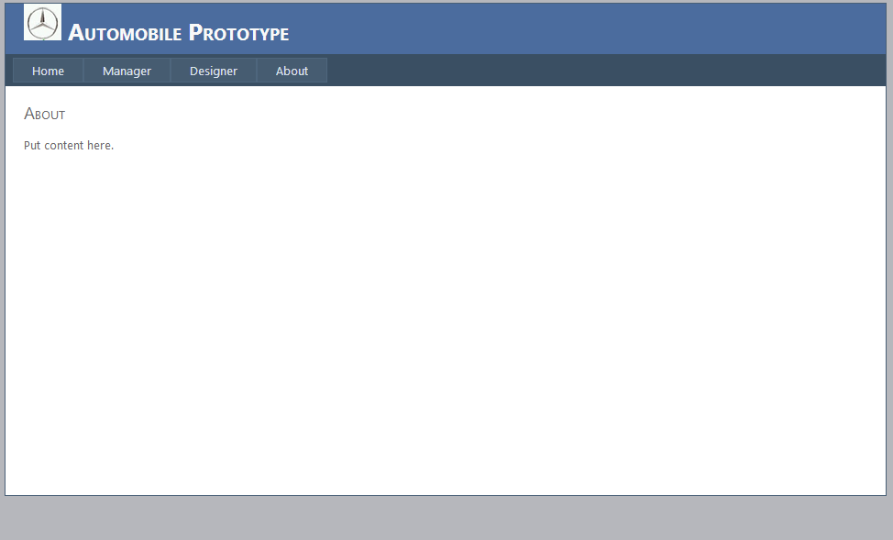

Figure 9: interface 4 for automotive company

# Conclusion

In this report we made our background information about knowledge management and application of these theories into practical examples since 1990’s. Knowledge management systems are best serving for their quality of generating, sharing, disseminating information and increasing knowledge of the team members or others. Knowledge management systems also provide information and organize it for the organizational purpose. We also look at the examples or the practical implementation of the knowledge management systems now a days. After that we have described a case study of automotive industry for engineers and the manager who are continuously using different kind of information all the time by having different documents like CAD model, testing reports, financial reports and many others. For that purpose we proposed a document based knowledge management system and get its requirements and their knowledge management requirements. In order to get better understanding we also developed an HTML based prototype for the automotive knowledge based upon the document management system.

# References

Alavi, M., Leidner, D. E. (2001). Review: knowledge management and knowledge management systems: conceptual foundations and research issues. MIS Quarterly. 25(1).

Contreras, J. (2011). Some Market Trends for Knowledge Management Solutions. In Context and Semantics for Knowledge Management (pp. 215-227). Springer Berlin Heidelberg.

Nor Fadzil, Azmi Jaafar, Rusli Abdullah, Masrah Azrifah Azmi Murad, 2013, ‘Preliminary Study of Knowledge Management Implementation Strategy for the Automotive Industry in Malaysia’, Vol III, WCE 2013,

**No index entries found.**Sunassee, N. N. and Sewry, D.A., (2003), “An investigation of knowledge management implementation strategies”, Proceedings of the South African Institute of Computer Scientists and Information Technologists 2003, pp. 24-36.

Yip, M. W., Lau, H. C., and Songip, A. R., (2010), “Influence of soft elements on knowledge management implementation in Malaysia Higher Learning Institutions”, Journal of Knowledge Management Practice, 11(3).

1. <http://web.mit.edu/ecom/www/Project98/G4/Sections/section1b.html>
2. <http://web.mit.edu/ecom/www/Project98/G4/Sections/section1c.html>
3. <http://web.mit.edu/ecom/www/Project98/G4/Sections/section1c.html>
4. [www.google.com](http://www.google.com)
5. [www.yahoo.com](http://www.yahoo.com)
6. [www.msn.com](http://www.msn.com)
7. <http://www.oracle.com/us/products/applications/knowledge-management/index.html>
8. [www.datatware.com](http://www.datatware.com/)
9. www.intraspect.com
10. www.knowledgex.com