Paint Robot In Automobile Industry

Your name

Instructor name

Section/class

Date

Institute name

# Abstract

Since 1970 industrialization have taken new dimension of automation which has improved the quality and quantity production of the goods. Automotive industry is not different, as introduction of robots have fastened the speed of production and quality of products. The automatic paints robots bring a revolution of fine and high quality finishing looking for vehicles which was a tedious, time consuming and very lengthy work as manual part of job in industry. However the improvements in paint robots in automobile industry also bring a lot of new technological aspects to consider. This paper will explore the automotive industry for paint robots and how over the decades the paints robots improved. The paper will discuss the technical details of paint robots and how they work.

Contents

Abstract 2

Introduction 5

1. Purpose 6

2. Scope 7

Literature Survey 7

Architecture Analysis of Paint Robot 9

3. Functions of Paint Robots 11

4. Paint Robot Production System 13

5. Control configuration for the Paint Robot functions 14

Technical/Component level Analysis of Paint Robots 15

6. Manipulator 15

7. End Effector/Spray Gun 15

8. Actuator 15

9. Sensor, Controller, Processor, and software and painting and object 16

Discussion 17

10. Advantages and Challenges 18

11. Virtual Simulation and Paint Robot 18

Conclusion and Recommendations 19

Bibliography 20

List of Figure

Figure 1: Flow chart for automatic Coating process 6

Figure 2: world colours popularity for vehicles 2015 analysis data 8

Figure 3:Structure of Paint Shop for the Paint Robots 9

Figure 4:Front view of Paint Robot Architectural Settings 10

Figure 5: Top view of Paint Robots 11

Figure 6:Different Functions performed by Paint Robots 1: Main Computer, 2: Position Control Loop, 3: Manipulator, RC for Robot Controller, and A for Axes 12

Figure 7: Paint Robot Production Unit 13

Figure 8: configuration Functions 14

Figure 9: Programming flow chart for the paint robot 17

# Introduction

The industrialization and globalization concepts have made consumer quality as well as cost conscious with acute factorization to be considered in manufacturing process. The manufacturing process is completely focusing to deliver the quality products with competitive price range due to increase in competitors in the industry. To produce flawless, accurate, efficient, and effective automobiles the industries are using robots at large scales. These robots perform all sort of jobs including the paint job for the vehicles (Melendez, 2020). The paints we get in today’s vehicles are almost flawless and very professionally done due to cutting-edge precision and accurate technology improvement in paint robots.

Paint robots in automotive industry perform the job by providing a smooth layer, and through coating of different sort of paint in layers, which are sent to the assembly station after being carefully handled by paint robots. The automatic process consist of phases like welding with raw material, after that the coating is performed, and paint job is done, and objects are sorted in next stage, and sent for the final assembly of the product. These tasks are performed using the robot manipulators due to their compact size, fast, efficient workload, and accuracy in working model (Melendez, 2020). Human hand can do a lot of good and neat work but deep inside and cutting-edge technology and welding or paint jobs at the complex corners are not done that effectively which are done and managed by the paint robots. The paint job can be very challenging because some corners and nooks if left unseen or unattended can lead to some serious damage to the vehicle. The paint robot does their job with the complex degree of freedom and paint the vehicle parts with perfection and efficiency. The electroplating process is used to protect the layers of the surface so that different parts can be protected from corrosion and erosion process (Kiran et al., 2020). The robot manipulators are helpful to achieve this job with different configurations such as Sacra configuration robot, cylindrical configuration robot, Stanford arm robot, articulated configuration robot, and spherical configuration robots. Figure 1 shows the general hierarchy to develop a vehicle.

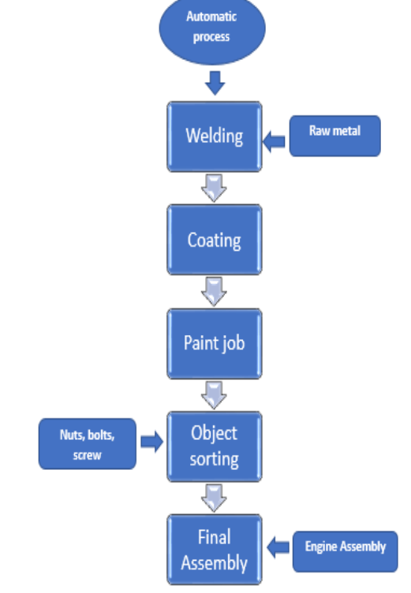

Figure 1: Flow chart for automatic Coating process (Kiran et al., 2020)

The general flow of how different jobs in vehicle development are carried out are very complex and tedious tasks in themselves (Kiran et al., 2020). In this paper we will talk about the paint job robots and their working for the automotive industry.

## Purpose

The purpose of this report is to discuss the architectural analysis of Paint robots, along with functions performed by the paint robots, production system, and control configuration for the paint robot functions. The purpose of the report also includes the technical/component level analysis of the paint robot through its components like manipulator, end effectors, actuator, and sensors. This will give the reader a good understanding of the processes and methods for paint robots currently being used and educate readers who are interested in working in the automobile industry.

## Scope

This report provides the reader with in-depth explanation of paint robot technology in automation, control systems, power supply, and mechanical parts used in paint robots. Including several ways to increase production rates and improve product quality of paint robots used in the automation industry.

# Literature Survey

In 1914, a moving line assembly was introduced by Henry Ford in his factory to make vehicle more efficient and professionally finished. This addition to the factory made a car to leave the factory every three minutes which was a huge success in automobile industry. His factory gives the customers a variety to choose from designs, models, bodywork and many more options. However, the limitation faced by the factory was variety of vehicles in which the different colours can be made available to the customers (Bysko et al., 2020). In 1909, Ford’s management team proposed a idea that “any customer can have a car in colour he wants so long as it is black”, however the idea was limited due to many factors like technology, the resources required to paint the different ideal colours and many other things like how to manage the garages for different colours (Kiran et al., 2020). However, his proposal was implemented after many decades as industry was able to work with the paint robots and different colours options was available to work on.

Paint of a vehicle is so important that analysist say that 60% of the consumers make their decision by seeing at the colour of the vehicle. Figure 2 shows the 2015 global colour popularity colour where nearly 75% of the vehicles are painted in conservative colours like white, black, grey, and silver (Bysko et al., 2020).

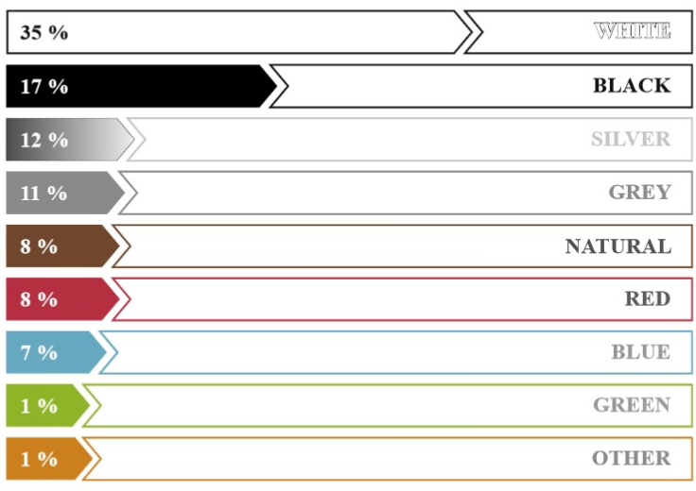

Figure 2: world colours popularity for vehicles 2015 analysis data

Today sellers are more open to different colours as compared to last century and all this is possible to cutting-edge technology of paint robots, these colours shows that consumers today have more options as compared to previous century. The paint operation performed by the paint robots is very energy consuming, multistage, and complex process. To protect the vehicle from corrosion the paint job is done in six layers completed separated but act together to prevent and give a professional finish looks. The paint robots also consider a lot of factors like temperature, humidity level, air pressure, substrate composition, colour match and many other beyond control modern facilities are carefully triggered by these paint robots (Bysko et al., 2020). We will discuss the detail of paint robot in literature review phase, at this stage we will demonstrate the room structure of the paint where the paint robots perform their jobs.

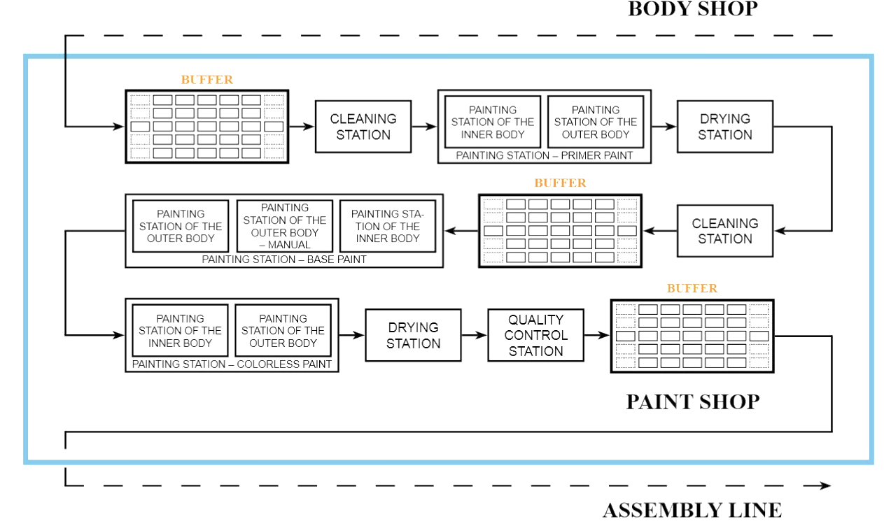

Figure 3:Structure of Paint Shop for the Paint Robots

# Architecture Analysis of Paint Robot

The first paint robot was used in 1980 in Germany for Mercedes-Benz and BMW followed by Opel, Volkswagen, Peugeot and Fiat to upgrade their facilities for the automatic paint robots. At that time it was a really expensive installation due to complex task performance and taking a lot of energy consumption for the task performance. However new innovations over the years bring new technological improvements in paint robots. The paint robots are electronically driven which can work for more time and consume less energy and maintenance cost is also less. The paint robots as compare to their ancestor technologies have more speed of painting and in some cases they are faster up to 50%, as well as the accuracy, path tracking, and absolute accuracy also improved in latest versions. The following figures show the front and top view of the architectural plan for paint robots (Grohmann, 1996).

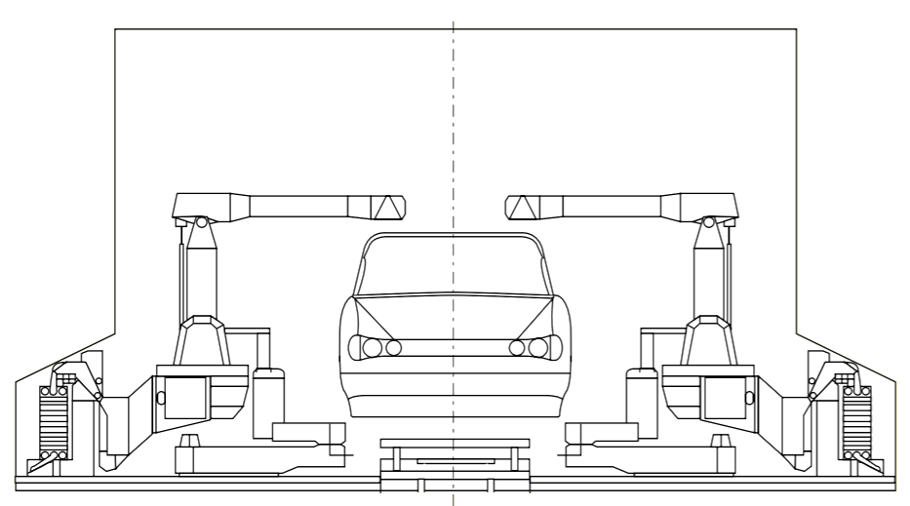

Figure 4:Front view of Paint Robot Architectural Settings

Inside a painting booth, the customarily interior coating is performed to control different factors such as humidity level, temperature, air pressure, and environmental factors. On an average, almost ten paint robots work on a single car to paint its different parts. There are two manipulators which work on the engine hood, the trunk lid, four on door opener, and four paint robots (Grohmann, 1996). The paint robots work on the mechanism of air spray and improved displacement axis, the power supply equipment, and outside located equipment’s.

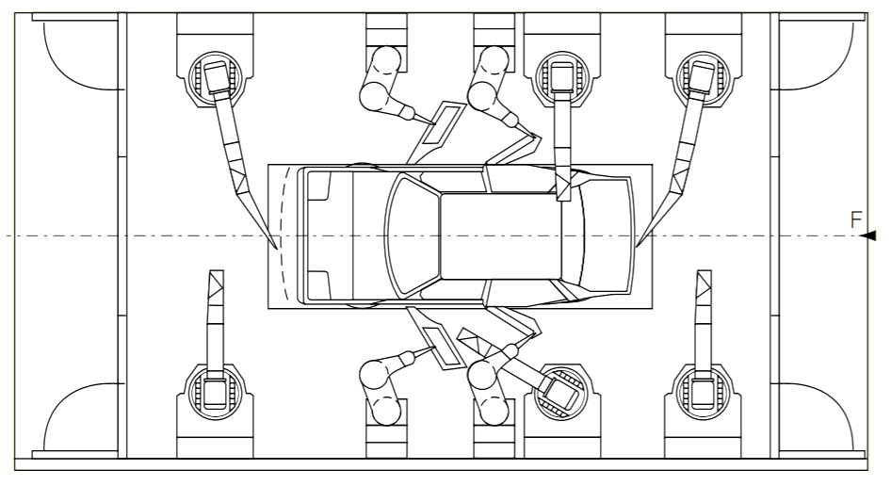

Figure 5: Top view of Paint Robots

The modern state of the art robot controllers include multi motion controls, process multitasking, and system visualization processes. With the increase in overall power of robot processing it is possible for them to control different manipulators as well as control the monitors simultaneously (Grohmann, 1996). The biggest advantage of this architectural structure approach is use of less space and use of less resources. This approach has a drawback at the same time by having availability of controls. The performance of paint robots is connected with the process multitasking, by making the parallel processing of and functions related to the robots and the process.

## Functions of Paint Robots

The major functions performed by the paint robots includes

Motion control: controlling the motion of robot along the programmed path

Communication: communicating the peripheral devices, exchange of data with other and overriding controls via digital I/O and serial data exchange

Paint quantity and air-pressure: Application engineering for monitoring and controlling for “paint quantity” and “air-pressure” controls, processing their component materials by monitoring and mixing the ratio, for multicolour operations.

Process visualization and online editing: the process parameters for graphical representation, and shown to the operator in the real time. This makes the continuous monitoring and allows the fast troubleshooting at the time of disturbance.

The following figures shows the different functions of paint robot by illustrating them in the diagram (Grohmann, 1996).

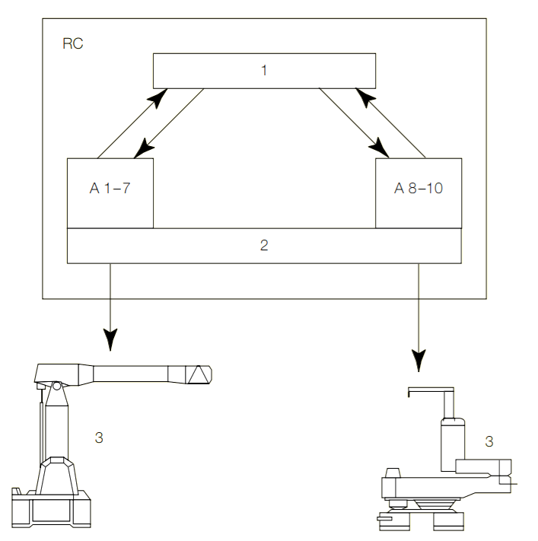

Figure 6:Different Functions performed by Paint Robots 1: Main Computer, 2: Position Control Loop, 3: Manipulator, RC for Robot Controller, and A for Axes

## Paint Robot Production System

The major job done by paint robot are to continue the coating process, and real time coating is a trending research domain for the paint robots. The real time coating means that on real time the robot is able to analyse its object and paint it. This can be done by adjusting the spray-jet geometry with the path and the point accuracy as a function for the actual robot motion. This also involves the automatic compensation for the response and control delay whenever the individual robot parameters are changed. This problem can be addressed by software and hardware integration through switching of atomizer along with the point and position accuracy to result the reduction of paint consumptions (Grohmann, 1996).

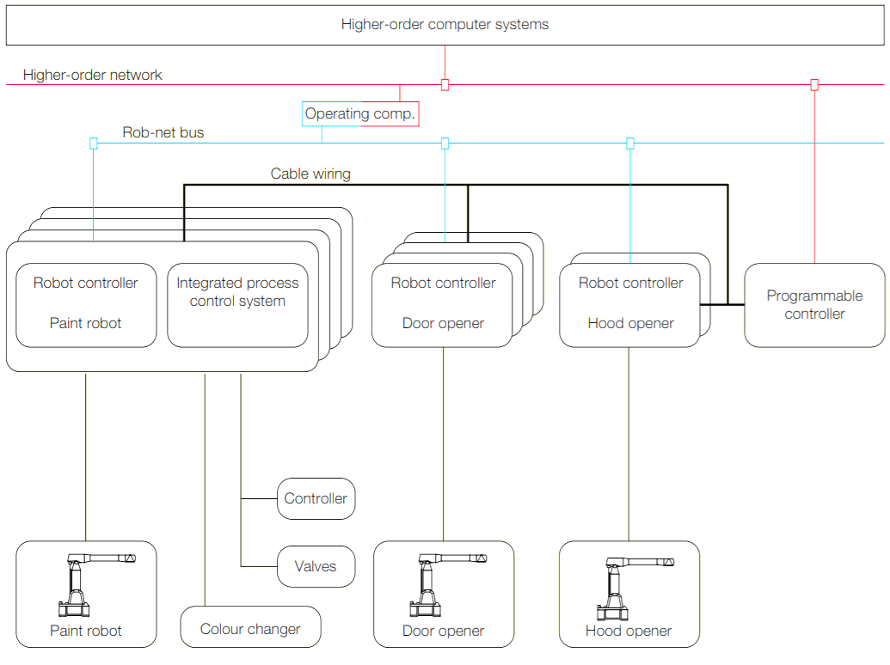

Figure 7: Paint Robot Production Unit

The production system of paint robot demonstrate how the robot controllers help the paint robot to integrate difference processes of colour change and control their values. The robot controller also help the robot to open its doors for the spray and hood opener manipulator through programmable controller.

## Control configuration for the Paint Robot functions

The control configuration for the functions of paint robot consist of main computer, basic I/O unit of computer, manipulator I/O, IPS /O computer and/or amplifier board. The function performed its task through 4ms to 12ms cycles to process its parameters. The displacement speed of the paint robot is highly dependent upon the response of the application system. The diagram shows the control configuration for the paint robot along with its functions (Heldt et al, 2016).

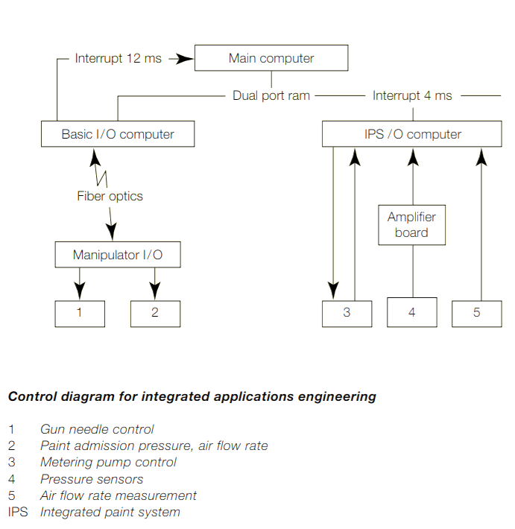

Figure 8: configuration Functions

# Technical/Component level Analysis of Paint Robots

The paint robots used for the automobile or industrial level paint purposes have 6-axis, providing a flexible robot based automation. It can be easily used and configure for the internal and external systems. Examples of such robot include IRB1410 robots which are famous for painting, welding, cutting, pick and place, assembling and inspection purposes. The overall components of this robot includes the Manipulator, End Effector or Spray gun, Actuator, sensor, controller, processor and software controller. We will discuss the technical components in detail in this section (Muzan et al, 2012).

## Manipulator

The manipulator consist of links, joints, and structural elements of the paint robot. It can weigh roughly 225kg with operating system of BaseWare OS to control every aspect of the robot including motion control, development and execution of the paint robot, its working envelop or reach is up to 1.44m (Muzan et al, 2012).

## End Effector/Spray Gun

It is a device which is placed at the end of the manipulator, which can interact with the environment. The spray gun for the end effector works on a programmable way is stored in the system to perform the required task. The spray gun is suction feed with standard nozzle of Φ1.5mm, with operating pressure range from 3-4bars, air consumption of 3.5-6 cfm, paint capacity of 750cc, fluid flow 120-160 ml/min and a spout distance of 200mm. the acute of spray gun is 2HP, 1.5KW air compressor with a rated pressure of 8bar, along with the output volume of 188L/Min, 38L tank, and a cylinder of 47mm (Muzan et al, 2012).

## Actuator

The muscle of the manipulator are known as actuator which are controlled by the robot controller. They are able to convert the stored energy into movement. In operational mode the robot controller actuator uses the air compressor along with a directional valve with a fast response time of 12ms or less at a pressure of 0.5MPa without light/surge voltage suppressor and 15ms or less pressure of 0.5 MPa with light/surge voltage suppressor. The weight of the valve is 80g and the operating voltage is 24VDC (Muzan et al, 2012).

## Sensor, Controller, Processor, and software and painting and object

Sensor in the paint robot act as information collector, about the internal state of the robot, and/or communicate inside and outside the manipulator. Sensor have 12 signals on the upper arm along with the integrated supply of maximum 8bars on the upper arm and 24 VDC Omron relays were used in the sensor, to send the signals to directional control valve indicating when to activate the air pressure (Muzan et al, 2012).

The controller in the robot control the motion of the paint robot, it receive information from computer, sends the signals to the actuator to control its motion, and sensory feedback information coordination.

The processor is the central piece where all the information is processed and decisions are made, calculation of robot motion joints, determination of length and width of the motion control controller. The software used by the processor is BaseWare OS for the paint robots with 1RB1410 ABB robot. It controls the motion, development and execution of the application program and the communication. The following figure shows the programming flowchart of how the processor of paint robot works (Muzan et al, 2012).

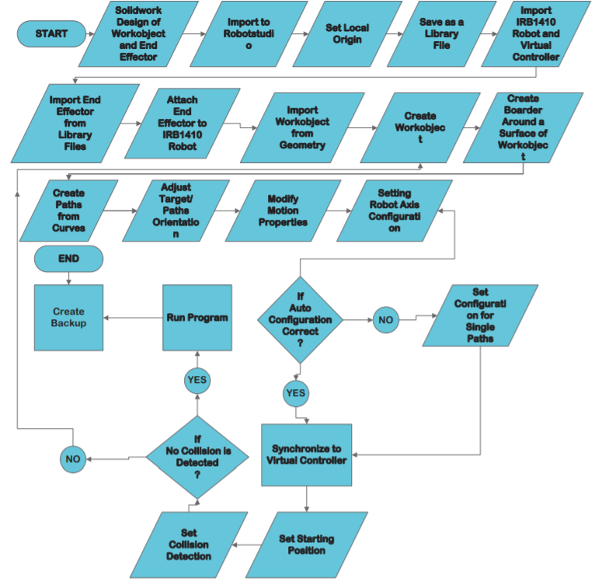

Figure 9: Programming flow chart for the paint robot

The diagram shows the programmable level of paint robot and its architectural details at software level. The details flow chart shows that paint robots are complex and technically challenging to handle due to their complex system integration.

# Discussion

Paint robots have a tremendous role in automobile industry because they give the final look of the vehicle which makes the customer likely to buy the products. However, the paint robots are expensive yet very reliable sources to produce quality vehicle. The automation process have bring a lot of new quality metrics in vehicle development, however factors like output coating and quality are both very critical to analyse and discuss in research forums. The paint robot also predict the thickness variation based on the computer program or controller processor coding through simulation. The future improvements may include to introduce the artificial intelligence algorithms like fuzzy logic, neural networks and robot studio automation. These automations can bring more power to the paint robots and they can verily develop the sense of more sophisticated paint jobs. There is also need to train the paint robot on the knowledge base of neural networks which can be achieved through simulation process. The simulation process is carried out to some extend in recent developments but I believe that more enhancement can be achieved through new technologies like semantic web integration which can add meaningful learning process to the paint robots models to have sophisticated results.

## Advantages and Challenges

There are several advantages to apply the paint robot technology into automotive industry including, increase in the production ratio, high accuracy and precision of the working models, and reduction in labour and cost as well as high return on investment based on accurate result achievement. However, this domain has several challenges too including high initial cost which can take a lot of investment ratio at the start of installation. for small and medium business, the cost to install such expensive facility is very difficult however automotive industry is already and billion dollar industry so the funds may not be the problem for them. The second challenge is social one which can cause unemployment because paint robots may bite a lot of labour cost, and work alone instead of whole team required to perform the paint jobs.

## Virtual Simulation and Paint Robot

The paint robots are expensive installation to the facility so therefore it is highly needed that virtual simulations can be performed before the final installation or demonstration of the paint robot. The end mistake or testing can cost a lot more to optimize the paint robot performance. The virtual tools are really helpful to achieve such results where the engineers can easily integrate and test all the possible test cases and check how the paint robot response for each scenario, the changes at that point are nearly very easy and they are easy to integrate into the blue print as compare to identifying the problem at implementation phase. Due to this feature it is highly recommended to use the simulation or virtual reality feature to consider the installation and working mode of the paint robots.

# Conclusion and Recommendations

The study demonstrates the paint robots in automobile industry and how they work to provide a better and effective paint coating using the robot optimal functions. The paint robot in automobile industry have been optimized to a perfection level but still there is room to grow in a lot of domains like the cost of implementation of paint robot is still very high and paint robots have difficulty in moving its different manipulator functions. There is also need to integrated strong neural network based training which can train the paint robots for different scenarios. The programming implementation of paint robots also needs to be optimized for more dimensional movements of paint robots which are moved to 6-directions at the time being. Paint robots are beneficial because they are providing the services by paint coating on vehicle to such crucial parts where human hands or eyes cannot work well and prevent the vehicles from corrosion.

It is recommended that paint robots must be integrated and tested with new technologies such as augmented reality, semantic web and neural networks as well as artificial intelligence based learning models which can help paint robot to learn more about its environment and control factors.

# Bibliography

Melendez, O., Thamma, R., & Kirby, E. D. AUTOMATION IN THE AUTOMOTIVE INDUSTRY.

Kiran, J. S., & Prabhu, S. (2020, August). Robot Nano Spray Painting-A Review. In *IOP Conference Series: Materials Science and Engineering* (Vol. 912, No. 3, p. 032044). IOP Publishing.

Bysko, S., Krystek, J., & Bysko, S. (2020). Automotive paint shop 4.0. *Computers & Industrial Engineering*, *139*, 105546.

Grohmann, U. (1996). Paint robots in the automotive industry-process and cost optimization. *Industrial robot*, *23*(5), 11-16.

Muzan, I. W., Faisal, T., Al-Assadi, H. M. A. A., & Iwan, M. (2012). Implementation of industrial robot for painting applications. *Procedia Engineering*, *41*, 1329-1335.

Heldt, R., Grigoleit, J., Sougioltzis, V., & Bucknell, T. A. (2016). *U.S. Patent No. 9,375,746*. Washington, DC: U.S. Patent and Trademark Office.