**SOFTWARE REQUIREMENTS DOCUMENT**

**COMP 3300**

**SOFTWARE ENGINEERING**

**Library Management System**

*by*

student 1

student 2

students 3

# ACKNOWLEDGEMENTS

In this report we have proposed a library management system for Tennessee University. We as a team hereby declare that all the work done in this document is solely by us and we don’t copy anything from internet or any other online sources

Thank you.

Contents

1. INTRODUCTION 6

1.2 NEED ANALYSIS 7

1.3 RELATED WORK 7

1. USER REQUIREMENTS DEFINITION 7

I. Functional Requirements 8

II. Non-Functional Requirements 8

II. system model 11

III. Architectural Design 12

III. Context diagram 12

IV. System architecture 13

V. search a book state chart 14

IV. Design and implementation 15

VI. Functional requirements implementation 15

a. Functional Requirements 15

b. Non-Functional Requirements 17

V. Testing 19

VII. Login Screen 19

VIII. Return book shows all books issued to user and user can select book that he wishes to return 22

IX. Add category 22

X. Add Books or remove books 23

XI. Register a new user 24

XII. Change user password 24

Table of figures

Figure 1: context diagram 11

Figure 2: system architecture 12

Figure 3: search a book 13

**PREFACE**

This project is designed for the software engineering course requirements. The major stakeholders of this system are students, librarian and library management. Included in this document are the Software Requirements Specifications (SRS) which provides all the necessary requirements and specifications of everyone previously mentioned as well as the developers and testers of the system.

This Software Requirements Specifications (SRS) document provides software requirement definitions and specifications and intended to be used by the product clients, management team, software developers, and software test engineers. The SRS is developed by following the IEEE recommended format for software requirements specifications.

The requirements were gathered using the following instruments:

1. Identification of common features of similar products.
2. Review of relevant literature.
3. Communication with the Client.
   1. Conducting questionnaires.
   2. Semi-structured interviews.

This SRS mainly includes user requirements definitions and software specifications. User requirements are expressed in such way that a non-technical person can understand each stated requirement. They are mainly targeted for the end users and clients. System requirements are described in more detail and may include a more technical language. They are mainly targeted for software developers and test engineers. Both user and system requirements are further categorized as functional and non-functional requirements. Functional requirements describe the services that will be provided by the systems. Non-functional requirements set the constraints and limitations (both for the system and development process). The SRS also provides a software architecture that shows the main sub-systems and their interfaces. Additionally, a number of models are included using the Unified Modeling Language (UML) notation.

# INTRODUCTION

Library management system will help us to rent books from our library. This system will help its users to get book for reading either online or offline world through convenience. Library cards can be issued by student registration over the system, librarian can rent the books to the students, teachers, instructor and other stakeholders of the university, school or college. This library management system will also help the private community to get books on loan and they can be member of library through a membership plan which can not only help the library to maintain its expenses but also the library to raise it quality of content.

Today students have diverse needs all associated with somehow computers and information search systems. Students in computer science and Information technologies related courses need to learn a lot of information about the programming languages. They are almost in need to have different books as a help to link different books to their course and complete their course work and labs successfully. This project is being processed to make students and readers able to get enough information about any book they want to read. For example:

- Title of the book.

- Author’s name.

- Edition of a book.

- Year of publishing.

- Publisher.

- Availability of a book.

- Rate of a book.

Library Management System is an desktop application which refers to library systems which are generally small or medium in size. It is used by librarian or students to manage the books information about the digital library using a computerized system where he/she can record various transactions like name off books, issues of book, author and publisher and price information.

The library management system will have modules like issue a book, register, login, book history, book loan track and others. The major modules for the teachers and instructors include register, login, book on loan, books issued to them, fines on books, and due date to return the book. Similarly librarian can login the system based upon the admin user name and password, can issue a book, and see the books on loan, books returned, books not returned, and books on fine, and people who didn’t returned books on time.

Library management system will help its users to not only use the books with effeteness but also use to track books and handle them with proper management.

## NEED ANALYSIS

The need of library management system is crucial for Tennessee University because the book management and demand of books online and offline had exceeded the library limits over the past two sessions. For this purpose the library management system will help to resolve this issue.

## RELATED WORK

It has been said and we hear it everywhere: Information is power. The importance of information to individuals and organizations, and therefore the need to manage it well, is growing rapidly. Now more than ever, we need to understand the critical role information plays in so many aspects of our life. Especially in the field of education information is always precious and always helpful.

A repository of information is also necessary that should contain and manage such information. Manual library systems are used for this purpose but they are not good enough and user face many difficulties while using them ,so there is a need to build a digital library as any kind of information that is precious to us. Digital libraries are important for this purpose and play a very important role in every aspect of life. A digital library is a library in which collections are stored in digital formats (as opposite to print, microform, or other media) and accessible by computers. The content of a digital library may be stored locally, or it can be accessed remotely.

The first published use of the term may have been in a 1988 report to the Corporation for National Research Initiatives. The term was first popularized by the NSF /DARPA /NASA Digital Libraries Initiative in 1994, created a vision based on experience (“Digital library.”)[1].

# USER REQUIREMENTS DEFINITION

This section lists functional and non-functional user requirements definitions. They are expressed in a non-technical format.

## Functional Requirements

A functional requirement defines a function of a system or its component. A function is described as a set of inputs, the behavior, and outputs.

*Requirement-1:* The system shall enable a user to create a user account.

*Requirement-2:* The system shall enable a user to create books records.

*Requirement-3:* The system shall enable a user to create racks having books.

*Requirement-4:* The system shall enable a user to search a specific book

*Requirement-5:* The system shall enable a user to issue a book to specific student

*Requirement-6:* The system shall enable a user to manage the student record

*Requirement-7:* The system shall enable a user to authenticate yourself to use the system.

*Requirement-8:* The system shall enable a user to calculate the fine if the book will be late

*Requirement-9:* The system shall enable a user to add the category of the books.

*Requirement-10:* The system shall have report generation utility. The report will include, total numbers of book available in the library, issue books, issue to which student, late books detail, student detail, which student contain which books etc.

## Non-Functional Requirements

A non-functional requirement is a requirement that specifies criteria that can be used to judge the operation of a system, rather than specific behaviors. They are contrasted with functional requirements that define specific behavior or functions.

*Requirement-1:* The system shall be a web-based application that will enable users to access the system using latest versions of Internet Explorer, Safari, or Firefox browsers.

*Requirement-2:* The system shall support at least 10,000 simultaneous connections/users.

*Requirement-3:* The system shall be running on a Windows Operating System based server.

*Requirement-4:* The system shall be developed using .NET technology and use ASP.NET framework.

*Requirement-5:* The system shall be available for 99.9% of time.

*Requirement-6:* The system shall be secure so that the user profiles will be encrypted.

*Requirement-7:* The system shall be robust and in case of the system failure the user data will not be lost. Due to database backup

*Requirement-8:* The system should accurately provide real time information taking into consideration various concurrency issues.

# system model

The major business requirements for the digital library management system includes the user or the student as a major stakeholder of the system. It includes the valid login along with the facility to search by the book, author, or book ISBN number, he can have details of the book, the topics in it and the rate of the book. All the topics will continue to the content of the book. The overall business requirements of the system are shown in figure 1 of the context diagram of the library management system.

Manage

Student

Librarian/user

Manage

View

Issued to

Manage

Loan request

Contain

Manage

Books

Library

Staff

# Architectural Design

## Context diagram

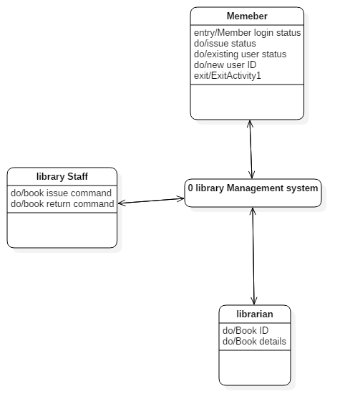

Figure : context diagram

The context diagram shows that member of the system can make his account and library staff can view, issue, and maintain record of the students.

## System architecture

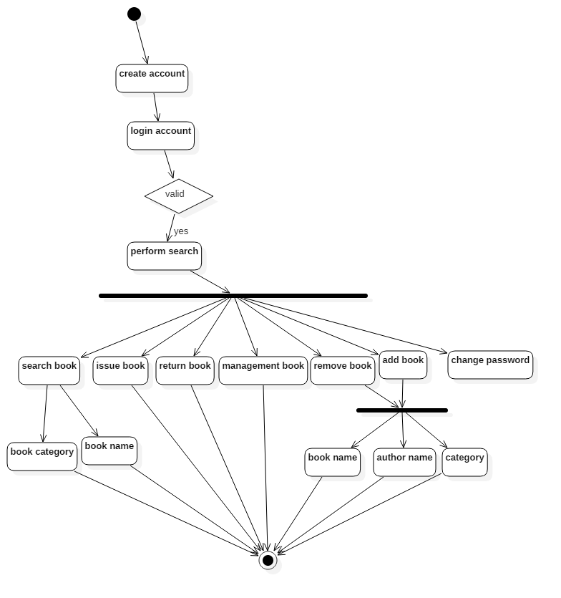

Figure : system architecture

The architecture diagram shows that user can make account, and can search book by book name and book category. It can also request for the issue book, return book and management of the books by library management team, they can also remove books which are outdated or removed from library. They can add book by adding its name, author name and category is also added or removed.

## search a book state chart

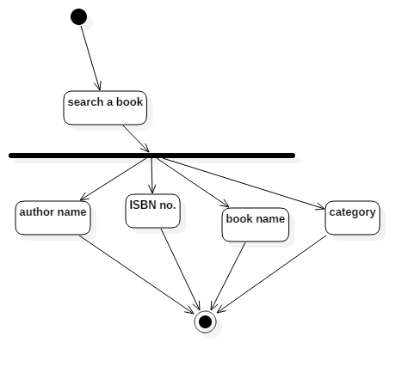

Figure : search a book

The search a book module can be done through different checks like search by author name, search by ISBN, and book name and category type of the book. This module can enable user to search through different categories.

# Design and implementation

## Functional requirements implementation

This section describes the system requirements specification. It mainly lists each user requirements definition in more detailed way using more technical language.

### Functional Requirements

*Requirement-1 validation: true:* The system shall enable a user to create a user account.

* 1. The user shall be given a link on the front page of the application to create a new account.
  2. The user will be able to pick a username.
     1. If the username is already taken, the system will ask the user to pick another username.
  3. The user will be asked to provide some personal information.
     1. The information will include first name, last name, date of birth, major, and expected graduation date.
     2. The user will be asked to upload a photo.
  4. The user will be asked to pick an initial password.
     1. The password will consist of at least 8 characters consisting of at least one capital letter, one digit, and one lowercase letter.

*Requirement-2 validation: true:*  The system shall enable a user to create books records.

2.1 The user shall be given a link on the front page of the application to create a new book.

2.2 The user will be able to pick a book title.

2.2.1 If the book title is already taken, the system will ask the user to pick another book title.

2.3 The user will be asked to provide some book information.

2.2.1 The information will include book ISBN, Author name, date of publishing, book edition, book title, book category.

2.2.2 The user will be asked to upload a photo of book.

*Requirement-3 validation: true:* The system shall enable a user to create racks having books.

3.1 The user shall be given a link on the front page of the application to create a new book racks.

3.2 The user will be asked to provide some rack information

3.2.1 The information will include rack number, rack blocks, rack name

*Requirement-4 validation: true:* The system shall enable a user to search a specific book

4.1 The user shall be given a link on the front page of the application to search the specific book

4.2 The system will give the option to the user for searching

4.2.1 The user can be searched by name of the book, title of the book author of the book.

4.2.2 After successful search user will see search results in the proper manner with book title and image

*Requirement-5 validation: true:* The system shall enable a user to manage the student record

5.1 The user shall be given a link on the front page of the application to manage the student record.

5.2 The system will give the option to the user for managing the student record

5.2.1 The user will be asked to provide some student information

5.2.2 The information will include student roll number, student name, student semester, student department, and student status

5.3 The system will give the option to the user for update the student record

5.4 The system will give the option to the user for remove the specific record

*Requirement-6 validation: true:* The system shall enable a user to issue a book to specific student

6.1 The user shall be given a link on the front page of the application to issue the book to the specific student.

6.2 The system will give the option to the search the student by its roll number

6.3 The system will give the option to the user to search the book

6.4 After verify the student issue the book to the student with some information.

6.4.1 The information will include date of issue, date of return, book information and student information

*Requirement-7 validation: true:* The system shall enable a user to authenticate yourself to use the system.

7.1 The user shall be given a link on the front page of the application to login to the system and do some functionality.

7.2 The system will give the option to the user for log in to the system

7.2.1 The user will enter the username and password to log in to the system

7.2.2 After successful login the user will see other functionality.

*Requirement-8 validation: true:* The system shall enable a user to calculate the fine if the book will be late.

8.1 The system shall provide the alerts and notifications if the book will be late and also calculate the automatic fine.

*Requirement-9 validation: true:* The system shall enable a user to add the category of the books.

9.1 The user shall be given a link on the front page of the application to create a new category.

9.2 The user will be asked to provide some category information.

9.2.1 The information will include category code, category name, and category short name

*Requirement-10 validation: true:* The system shall have report generation utility. The report will include, total numbers of book available in the library, issue books, issue to which student, late books detail, student detail, which student contain which books.

9.1 The user shall be given a link on the front page of the application to view the different reports.

9.2 The user will see several types of reports according to the need.

9.2.1 The report can be list of all available books in the library

9.2.2 The report can be list of all issue books

9.2.3 The report can be list of all due date books in the library

9.2.4 The report can be list of all issue books to related students in the library

### Non-Functional Requirements

*Requirement-1 validation: true:* The system shall be a web-based application that will enable users to access the system using latest versions of Internet Explorer, Safari, or Firefox browsers.

Rationale: The system is expected to be used over the browsers like Firefox, Safari and Internet Explorer. So the system should support every browser and not limited to one of them.

*Requirement-2 validation: true:* The system shall support at least 10,000 simultaneous connections/users.

Rationale: The system is expected to be used by various medical personnel in Nashville, TN, USA. Based on the size of healthcare industry in Nashville, it is expected that 10,000 simultaneous user handling should be sufficient. However, the system later may be used in other cities. Therefore, the system should be scalable to support up to 50,000 simultaneous connections in future.

*Requirement-3 validation: true:* The system shall be running on a Windows Operating System based server.

Rationale: The system should be running on Windows OS as the development model will be based on Windows OS.

*Requirement-4 validation: true:* The system shall be developed using .NET technology and use ASP.NET framework.

Rationale: the .Net and ASP.net will be used as the core programming languages so both languages should be supported by system and all resources required to get the result should be allocated.

*Requirement-5 validation: true:* The system shall be available for 99.9% of time.

Rationale: the system should response to the user request 99.9% of times, and it should have internet connectivity available.

*Requirement-6 validation: true:* The system shall be secure so that the user profiles will be encrypted.

Rationale: system should store user information and don’t share it with third party at any cost.

*Requirement-7 validation: true:* The system shall be robust and in case of the system failure the user data will not be lost. Due to database backup

Rationale: System should respond to user queries immediately within 0.005 n-sec.

*Requirement-8 validation: true:* The system should accurately provide real time information taking into consideration various concurrency issues.

Rationale: system should address all issues with real time information and it should be concurrent with them.

# Testing

## Login Screen

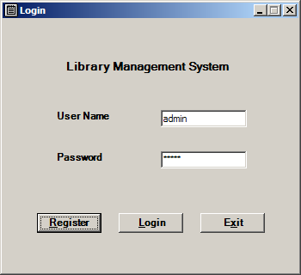

* If user logon with valid id and password he gets action screen
* Manage Categories and Add/Remove Books is available for admin user which exists in system after installation. As of now no new user created will be admin.
* Admin user available in system at start is admin with password as admin

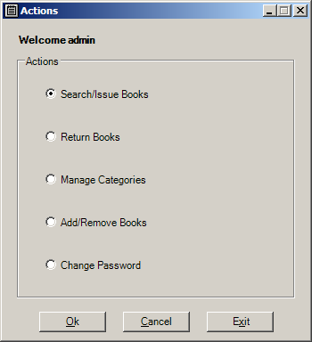

* Search/Issue Books screen accessed from actions screen, in this screen search and issue is done. First user enters the criteria for book searching and a book is successfully find than user can select the book he wishes to get issued in grid and get it issued.
* Maximum number of books allowed for issue is 3

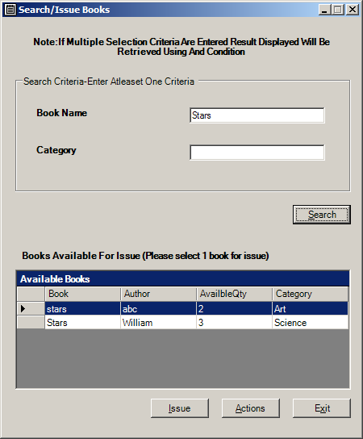

## Return book shows all books issued to user and user can select book that he wishes to return

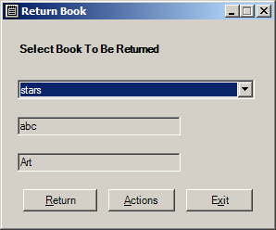

## Add category

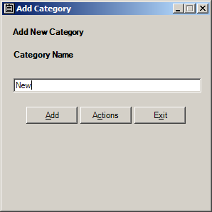

## Add Books or remove books

For adding there should be at least one category

Books can be removed, all books in system are shown in Remove books section user can use Remove button to remove books after setting Quantity to be removed of book selected.

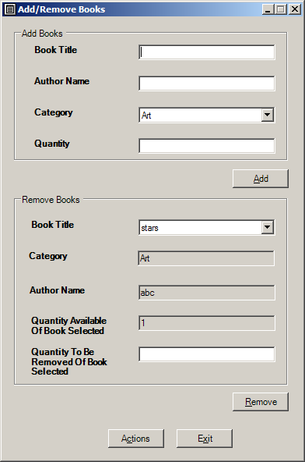

## Register a new user

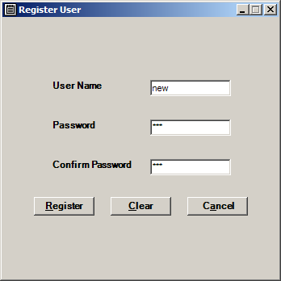

## Change user password

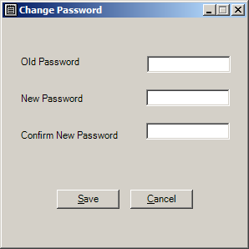

**TASK DISTRIBUTION**

|  |  |
| --- | --- |
| **Name** | **Tasks** |
| Student 1 | Functional Requirements 1 - 10  Non-Functional Requirements 1 - 10  Introduction  Application Design  Coding for Login Page & Create Account  Testing  Created Access Database  PowerPoint |
| Student 2 | Functional Requirements 11 - 15  Non-Functional Requirements 11 - 15  Preface  Table of Figures  Table of Contents  Architectural Design  Application Coding  Testing Explanation |
| Student 3 | Functional Requirements 16 - 20  Non-Functional Requirements 16 - 20  Design and Implementation  Connection for Microsoft Access Database to the Application  Coding for Database to the Application |