Table of contents
Step 1: Generate our project
Step 2: Publish/read messages from the Kafka topic
Step 3: Configure Kafka through application.yml configuration file
Step 4: Create a producer
Step 5: Create a consumer
Step 6: Create a REST controller

Step 1: Generate our project
First, let’s go to Spring Initializr to generate our project. Our project will have Spring MVC/web support and Apache Kafka support.
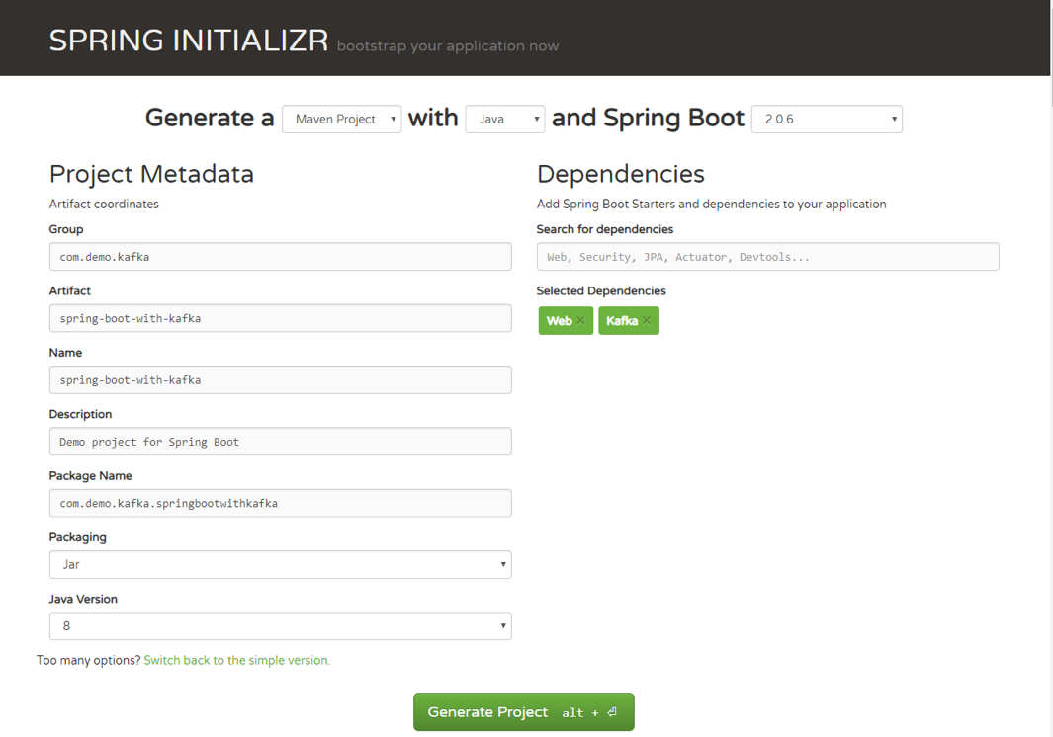
Once you have unzipped the project, you’ll have a very simple structure. I’ll show you how the project will look like at the end of this article so you can easily follow the same structure. I’m going to use Intellij IDEA, but you can use any Java IDE.

Step 2: Publish/read messages from the Kafka topic
Now, you can see what it looks like. Let’s move on to publishing/reading messages from the Kafka topic.
Start by creating a simple Java class, which we will use for our example: package com.demo.models;
Copy
public class User {
private String name;
private int age;
public User(String name, int age) {
this.name = name;
this.age = age;
}
}

Step 3: Configure Kafka through application.yml configuration file
Next, we need to create the configuration file. We need to somehow configure our Kafka producer and consumer to be able to publish and read messages to and from the topic. Instead of creating a Java class, marking it with @Configuration annotation, we can use either application.properties file or application.yml. Spring Boot allows us to avoid all the boilerplate code we used to write in the past, and provide us with much more intelligent way of configuring our application, like this:
Copy
server: port: 9000
spring:
kafka:
consumer:
bootstrap-servers: localhost:9092
group-id: group_id
auto-offset-reset: earliest
key-deserializer: org.apache.kafka.common.serialization.StringDeserializer
value-deserializer: org.apache.kafka.common.serialization.StringDeserializer
producer:
bootstrap-servers: localhost:9092
key-serializer: org.apache.kafka.common.serialization.StringSerializer
value-serializer: org.apache.kafka.common.serialization.StringSerializer
If you want to get more about Spring Boot auto-configuration, you can read this short and useful article. For a full list of available configuration properties, you can refer to the official documentation.

Step 4: Create a producer
Creating a producer will write our messages to the topic.
Copy
@Service
public class Producer {
private static final Logger logger = LoggerFactory.getLogger(Producer.class);
private static final String TOPIC = "users";
@Autowired
private KafkaTemplate<String, String> kafkaTemplate;
public void sendMessage(String message) {
logger.info(String.format("#### -> Producing message -> %s", message));
this.kafkaTemplate.send(TOPIC, message);
}
}
We just auto-wired KafkaTemplate and will use this instance to publish messages to the topic—that’s it for producer!

Step 5: Create a consumer
Consumer is the service that will be responsible for reading messages processing them according to the needs of your own business logic. To set it up, enter the following:
Copy
@Service
public class Consumer {
private final Logger logger = LoggerFactory.getLogger(Producer.class);
@KafkaListener(topics = "users", groupId = "group_id")
public void consume(String message) throws IOException {
logger.info(String.format("#### -> Consumed message -> %s", message));
}
}
Here, we told our method void consume (String message) to subscribe to the user’s topic and just emit every message to the application log. In your real application, you can handle messages the way your business requires you to.

Step 6: Create a REST controller
If we already have a consumer, then we already have all we need to be able to consume Kafka messages.
To fully show how everything that we created works, we need to create a controller with single endpoint. The message will be published to this endpoint, and then handled by our producer.
Then, our consumer will catch and handle it the way we set it up by logging to the console.
Copy
@RestController
@RequestMapping(value = "/kafka")
public class KafkaController {
private final Producer producer;
@Autowired
KafkaController(Producer producer) {
this.producer = producer;
}
@PostMapping(value = "/publish")
public void sendMessageToKafkaTopic(@RequestParam("message") String message) {
this.producer.sendMessage(message);
}
}
Let’s send our message to Kafka using cURL:
Copy
curl -X POST -F 'message=test' http://localhost:9000/kafka/publish
