PARALLEL PROGRAMMING
Assignment Report

Student Name | Asmaa Ali Abdelwahab Ali  Rana Hegazy Sedky
Course | Parallel Programming

OpenMP π (Pi) Approximation — Lecture 2

1. Problem Description

The is to approximate the mathematical constant π (Pi) using numerical integration via the Midpoint Rule, implemented with OpenMP for shared-memory parallelism. The integral used is:
π = ∫₀¹ 4 / (1 + x²) dx
This integral is approximated by dividing [0, 1] into num_steps sub-intervals and summing the area of rectangles:
step = 1.0 / num_steps;
π ≈ Σ 4/(1 + xᵢ²) * step, where xᵢ = (i + 0.5) * step

Five different OpenMP parallelization strategies are implemented and compared, each addressing correctness and performance challenges differently.

2. Parallelization Approach

All five versions share a common structure: the integration domain is split among threads using cyclic distribution. The key difference between versions is how partial sums from each thread are safely combined into the final result.

Key Parallelism Challenges
- Race conditions — multiple threads writing to the same shared variable simultaneously.
- False sharing — threads writing to adjacent memory locations that share a cache line, causing costly cache invalidations.

3. Solution Explanation

Version 1 — Basic Parallel (Race Condition) [Parallel_PI.cpp]
Uses a single shared sum and pi variable updated inside the parallel region without any synchronization. All threads read and write the same memory location simultaneously, producing a data race. The result is non-deterministic and typically incorrect. This version serves as a baseline to illustrate why synchronization is necessary.
- Result: Incorrect (race condition)

Version 2 — Array Partitioning (False Sharing) [Parallel_PI_Array.cpp]
Each thread writes its partial sum to a unique slot in a shared array (sum[id]). The final pi is accumulated serially. This eliminates the race condition, but since all sum[id] elements are adjacent doubles (8 bytes each), they may reside on the same 64-byte cache line. When one thread updates its slot, the entire cache line is invalidated for all other processors — a phenomenon called false sharing — degrading performance.
- Result: Correct, but may suffer false sharing

Version 3 — Padded Array [Parallel_PI_Pad.cpp]
Solves the false sharing problem of Version 2 by declaring the array as sum[NUM_THREADS][PAD], where PAD = 8 (sizeof cache_line / sizeof double = 64 / 8). Each thread's slot (sum[id][0]) is now separated by 8 doubles = 64 bytes, ensuring each thread's data occupies its own cache line. This is the most cache-friendly version without using compiler directives for reduction.
- Result: Correct, best cache behavior

Version 4 — Critical Section [Parallel_PI_Critical.cpp]
Each thread computes a local sum entirely in a private variable (no sharing during computation). At the end, each thread enters a #pragma omp critical section to safely add its partial result to pi. Only one thread executes the critical block at a time, ensuring mutual exclusion. The overhead is minimal since the critical section is entered only once per thread.
- Result: Correct

Version 5 — OpenMP Reduction [Parallel_PI_Reduction.cpp]
Uses the #pragma omp for reduction(+:sum) clause, the cleanest and most idiomatic OpenMP solution. The compiler automatically creates private copies of sum for each thread, performs the loop in parallel, and combines partial results at the end. This achieves the same effect as the padded array but with minimal code and maximum portability. The loop index and x are also automatically handled correctly.
- Result: Correct, idiomatic OpenMP

4. Source Code & Execution Result

Version 1 — Parallel_PI.cpp (Race Condition — Incorrect)
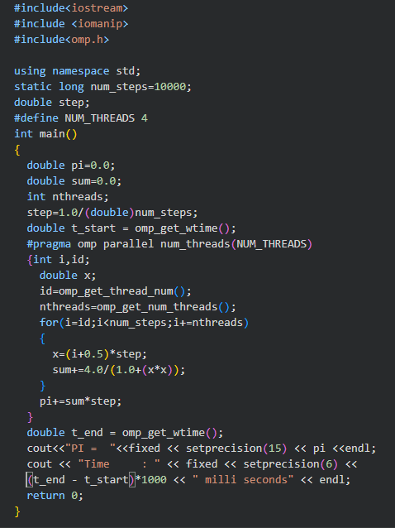
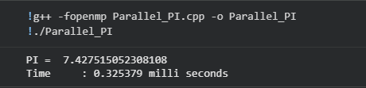

Version 2 — Parallel_PI_Array.cpp (Array Partitioning)
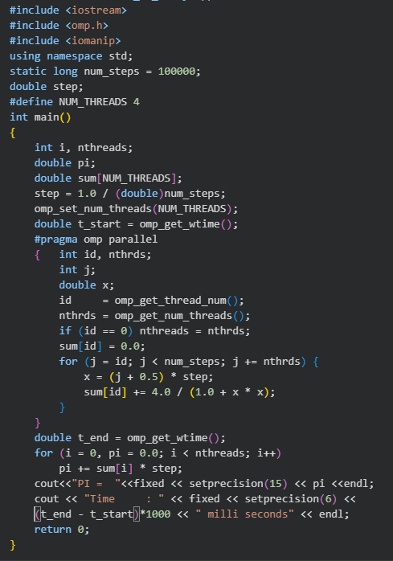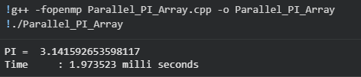

Version 3— Parallel_PI_Pad.cpp (Cache-Line Padding)
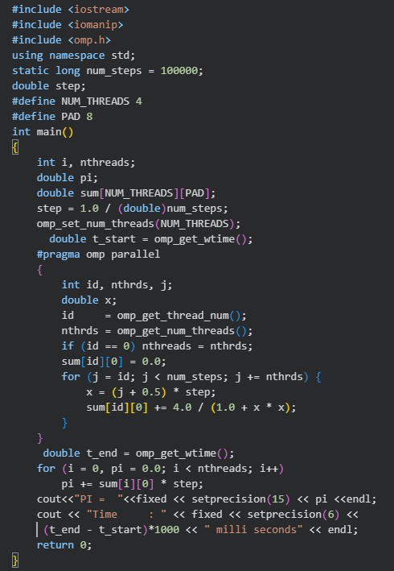
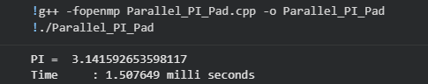

Version 4 — Parallel_PI_Critical.cpp (Critical Section)

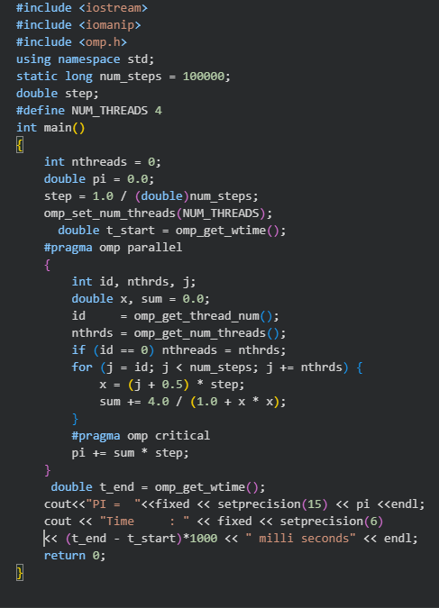
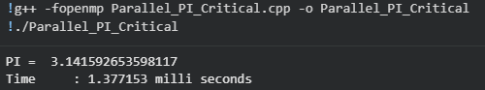

Version 5 — Parallel_PI_Reduction.cpp (OMP Reduction)
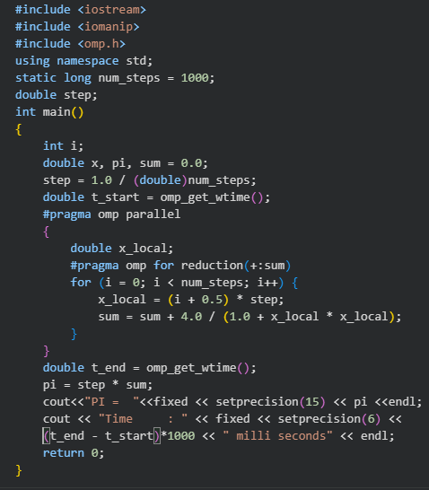
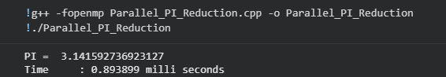

5. Version Comparison Summary

Version | Synchronization Method | Performance | Correctness
Parallel_PI.cpp | Race condition on sum & pi | Low | Incorrect
Parallel_PI_Array.cpp | Array partitioning (false sharing) | Medium | Correct
Parallel_PI_Padl.cpp | Padded array (cache-line aligned) | Highest | Correct
Parallel_PI_Critica.cpp | Critical section | High | Correct
Parallel_PI_Reduction.cpp | OpenMP reduction clause | Highest | Correct

6. Conclusion

This assignment demonstrated five progressively improved approaches to parallelizing numerical integration with OpenMP, each highlighting a different aspect of parallel programming:

- Correctness first: Unprotected shared variables (Version 1) cause race conditions and must always be guarded.
- False sharing matters: Even a correct array-based approach (Version 2) can underperform due to cache-line contention.
- Cache-aware design: Padding (Version 3) is a manual but effective technique for eliminating false sharing.

- Synchronization granularity: Critical sections (Version 4) work well when entered infrequently.
- OpenMP idioms: The reduction clause (Version 5) is the most concise, portable, and typically best-performing solution.

The OpenMP reduction approach is recommended for production use as it is clean, compiler-optimized, and free of both race conditions and false sharing. Understanding the pitfalls demonstrated by the earlier versions builds the intuition needed to write correct and efficient parallel programs.

