Cairo University

Faculty of Engineering

Computer Engineering Department

ELC3252 Project

Group No. 8

Asmaa Mohamed Sec: 1 ID: 9220154

Rawan Ahmed Sec: 1 ID: 9220302

Somaya Saad Sec: 1 ID: 9202666

Shehab Khaled Sec: 1 ID: 9220393

1. Transfer Functions (Hand analysis):
2. Transfer functions (Matlab):
3. System stability:
4. Step responses:

1. Tracking input Hd:
2. H1 & H2 for Hd = 5m:

1. H2 response calculations:
2. Effect of Kp on tracking hHHd:

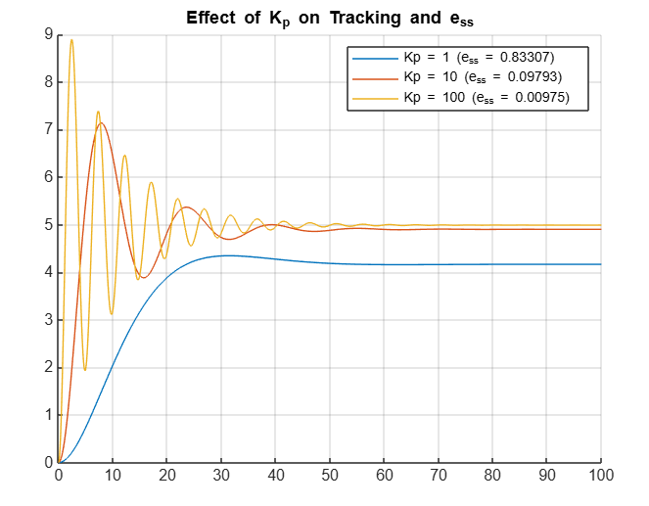

1. Void
2. Eliminate ess: