Lab1:
1-configure TCP/IP as following:
Static IP
IP add:192.168.1.30 / 24
Class:………C……….
NID : 192.168.1.0/24
2-check Connection between your PC and yahoo site.
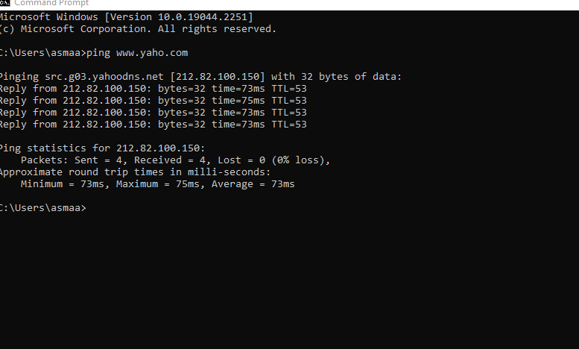
3-get IP address and Mac address from CMD with one command .
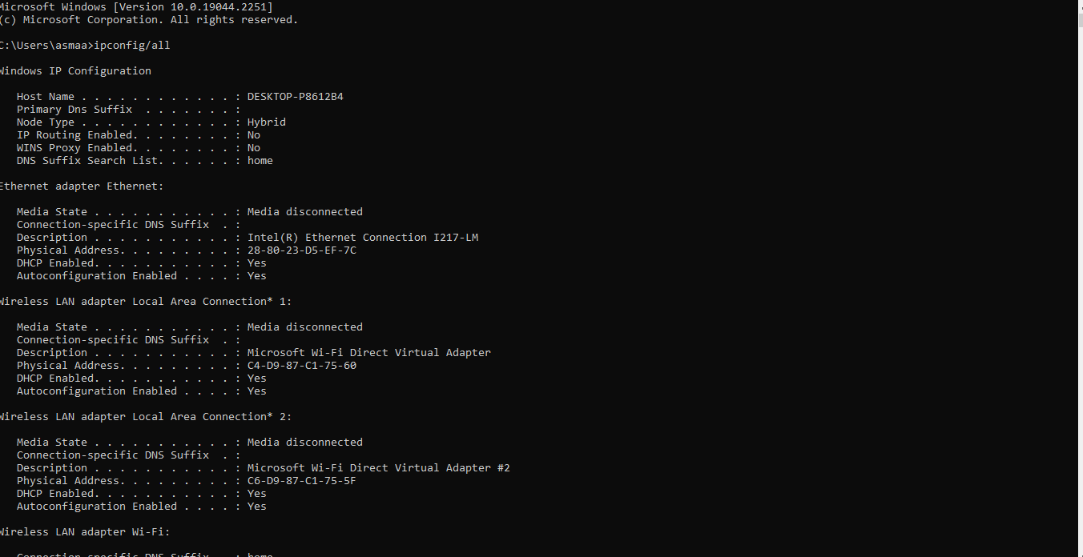
4- try to control your pc from your smartphone with team viewer program. Or anydisk


