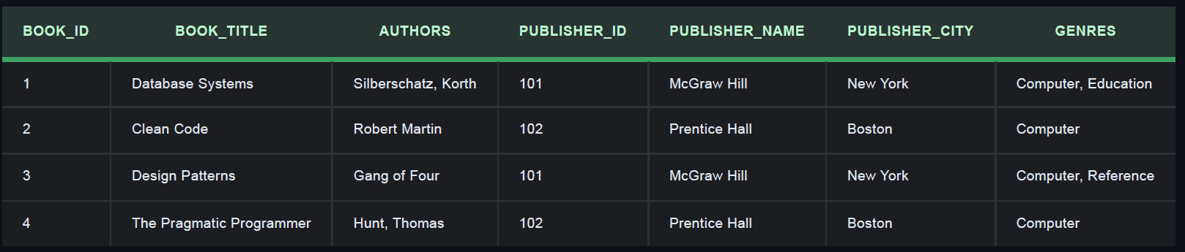

Book_ID | Book_Title | Authors | Publisher_ID | Pupbisher_Name | Publisher_City | Genres
1 | Database System | Siberschatz | 101 | McGraw Hill | New York | Computer
1 | Database System | korth | 101 | McGraw Hill | New York | Education
2 | Clean Code | Robert Martin | 102 | Prentice Hall | Boston | Computer
3 | Design Patterns | Gang of Four | 101 | McGraw Hill | New York | Computer
3 | Design Patterns | Gang of Four | 101 | McGraw Hill | New York | Reference
4 | The Pragmatic Programmer | Hunt | 102 | Prentice Hall | Boston | Computer
4 | The Pragmatic Programmer | Thomas | 102 | Prentice Hall | Boston | Computer

Book_ID | Book_Title | Publisher_ID
1 | Database System | 101
2 | Clean Code | 102
3 | Design Patterns | 101
4 | The Pragmatic Programmer | 102

Book_ID | Author
1 | Siberschatz
1 | Korth
2 | Robert Martin
3 | Gang of Four
4 | Hunt
4 | Thomas

Book_ID | Genre
1 | Computer
1 | Education
2 | Computer
3 | Computer
3 | Reference
4 | Computer

Publisher_ID | Publisher_Name | Publisher_City
101 | McGraw Hill | New York
102 | Prentice Hall | Boston

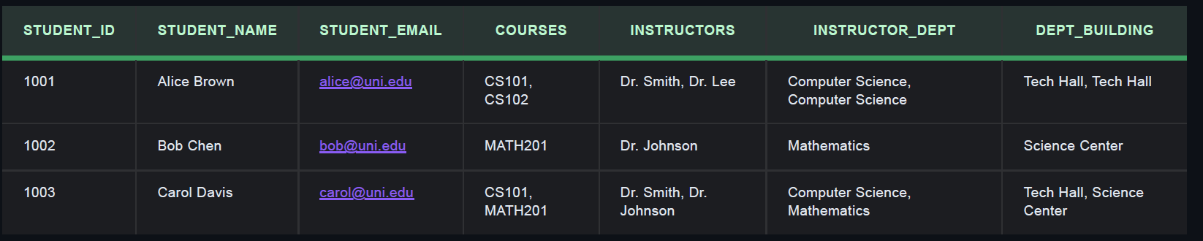
1NF
Student_id | Student_name | Student_Email | Course | Instructor | Instructor_Dept | Dept_Building
1001 | Alice Brown | alice@uni.edu | CS101 | Dr.Smith | Computer Science | Tech Hall
1001 | Alice Brown | alice@uni.edu | CS102 | Dr.Lee | Computer Science | Tech Hall
1002 | Bob Chen | bob@uni.edu | MATH201 | Dr.Johnson | Mathematics | Science Center
1003 | Carol Davis | carol@uni.edu | CS101 | Dr.Smith | Computer Science | Tech Hall
1003 | Carol Davis | carol@uni.edu | MATH201 | Dr.Johnson | Mathematics | Science Center

2NF
Student_id | Student_name | Student_Email
1001 | Alice Brown | alice@uni.edu
1002 | Bob Chen | bob@uni.edu
1003 | Carol Davis | carol@uni.edu

Course | Instructor | Instructor_Dept | Dept_Building
CS101 | Dr.Smith | Computer Science | Tech Hall
CS102 | Dr.Lee | Computer Science | Tech Hall
MATH201 | Dr.Johnson | Mathematics | Science Center

Student_id | Course
1001 | CS101
1001 | CS102
1002 | MATH201
1003 | CS101
1003 | MATH201

3NF
Instructor | Dept
Dr.Smith | Computer Science
Dr.Lee | Computer Science
Dr.Johnson | Mathematics

Dept | Dept_Building
Computer Science | Tech Hall
Mathematics | Science Center

Course | Instructor
CS101 | Dr.Smith
CS102 | Dr.Lee
MATH201 | Dr.Johnson

Student_id | Student_name | Student_Email
1001 | Alice Brown | alice@uni.edu
1002 | Bob Chen | bob@uni.edu
1003 | Carol Davis | carol@uni.edu

Student_id | Course
1001 | CS101
1001 | CS102
1002 | MATH201
1003 | CS101
1003 | MATH201

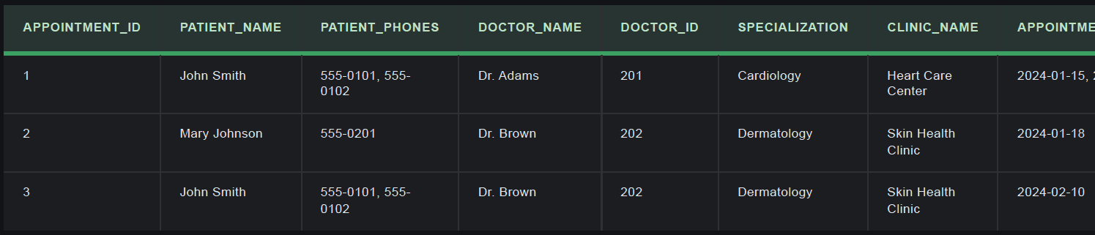

APPOINTMENT_ID | PATIENT_NAME | PATIENT_PHONES | DOCTOR_NAME | DOCTOR_ID | SPECIALIZATION | CLINIC_NAME | APPOINTMENT_DATE
1 | John Smith | 555-0101, 555-0102 | Dr Adams | 201 | Cardiology | Heart Care Center | 2024-01-15
2 | Mary Johnson | 555-0201 | Dr Brown | 202 | Dermatology | Skin Health Clinic | 2024-01-18
3 | John Smith | 555-0101, 555-0102 | Dr Brown | 202 | Dermatology | Skin Health Clinic | 2024-02-10

1NF

APPOINTMENT_ID | PATIENT_NAME | PATIENT_PHONE | DOCTOR_ID | DOCTOR_NAME | SPECIALIZATION | CLINIC_NAME | APPOINTMENT_DATE
1 | John Smith | 555-0101 | 201 | Dr Adams | Cardiology | Heart Care Center | 2024-01-15
1 | John Smith | 555-0102 | 201 | Dr Adams | Cardiology | Heart Care Center | 2024-01-15
2 | Mary Johnson | 555-0201 | 202 | Dr Brown | Dermatology | Skin Health Clinic | 2024-01-18
3 | John Smith | 555-0101 | 202 | Dr Brown | Dermatology | Skin Health Clinic | 2024-02-10
3 | John Smith | 555-0102 | 202 | Dr Brown | Dermatology | Skin Health Clinic | 2024-02-10

2NF
APPOINTMENT_ID | PATIENT_NAME | DOCTOR_ID | APPOINTMENT_DATE
1 | John Smith | 201 | 2024-01-15
2 | Mary Johnson | 202 | 2024-01-18
3 | John Smith | 202 | 2024-02-10

PATIENT_NAME | PATIENT_PHONE
John Smith | 555-0101
John Smith | 555-0102
Mary Johnson | 555-0201

DOCTOR_ID | DOCTOR_NAME | SPECIALIZATION | CLINIC_NAME
201 | Dr Adams | Cardiology | Heart Care Center
202 | Dr Brown | Dermatology | Skin Health Clinic

3NF
DOCTOR_ID | DOCTOR_NAME | SPECIALIZATION
201 | Dr Adams | Cardiology
202 | Dr Brown | Dermatology

CLINIC_NAME | SPECIALIZATION
Heart Care Center | Cardiology
Skin Health Clinic | Dermatology

APPOINTMENT_ID | PATIENT_NAME | DOCTOR_ID | APPOINTMENT_DATE
1 | John Smith | 201 | 2024-01-15
2 | Mary Johnson | 202 | 2024-01-18
3 | John Smith | 202 | 2024-02-10

PATIENT_NAME | PATIENT_PHONE
John Smith | 555-0101
John Smith | 555-0102
Mary Johnson | 555-0201

