MedSum-AI:
Intelligent Clinical Report Summarization
and Predictive Outcome Analytics
Using Transformer-Based NLP and Advanced Statistical Models
Data Analytics Capstone — Final Report
Asmaa Hamed Ewes Mohamed
Walsh College
QM 640: Data Analytics Capstone
Instructor: Dr. Javad
Spring 2026 Term
May 2026
GitHub Repository: https://github.com/AsmaaHamedEwes/MedSum-AI

Abstract
Clinical radiologists routinely produce verbose narrative reports that consume between thirty-five and fifty percent of physician working hours, yet these unstructured documents simultaneously contain prognostic signals that escape conventional structured electronic-health-record analytics. MedSum-AI addresses this dual bottleneck by delivering an end-to-end, transformer-based natural language processing (NLP) pipeline that (a) automatically generates concise impressions from full radiology findings and (b) predicts pathology outcomes from the same text through twenty-five engineered structured features. The pipeline integrates four transformer architectures (BERT, BioBERT, ClinicalBERT, and BART) for summarization and four classical statistical learners (Logistic Regression, Random Forest, XGBoost, and the Cox Proportional Hazards Model) for outcome prediction. Two complementary corpora were used: the Indiana University Chest X-Ray (IU-CXR) dataset of 3,955 English reports retrieved through the National Library of Medicine Open-i interface, and the CASIA-CXR dataset of 13,672 French reports introduced by Metmer and Yang (2024). After applying the four-stage Rahm and Do (2000) cleaning taxonomy, retention rates were 75.5 percent (2,985 records) for IU-CXR and 81.3 percent (11,111 records) for CASIA-CXR. Implementation used Python 3.11 with scikit-learn 1.4, XGBoost 2.0, Hugging Face Transformers 4.39, lifelines 0.27, and SHAP 0.45, executed on a CUDA 12.1 GPU node. On the binary Normal-versus-Abnormal task in IU-CXR, XGBoost achieved an area under the receiver-operating characteristic curve of 0.973 and a macro F1 of 0.962 under stratified ten-fold cross-validation, exceeding the pre-registered targets of AUC at least 0.80 and F1 at least 0.78 by more than seventeen and eighteen percentage points, respectively. On the CASIA-CXR five-class problem the Random Forest reached a macro F1 of 0.9995. BioBERT delivered the strongest summarization performance with a ROUGE-L F1 of 0.170, while a Cox PHM on eight clinical covariates produced a concordance index of 0.742. SHAP analysis identified clinical sentiment, severity score, and negation count as the three most influential predictors, underscoring the high diagnostic density of NLP-derived features. The target deployment context is radiologist decision support and triage in hospital workflow systems, where MedSum-AI can reduce documentation burden while surfacing high-risk reports for prioritized review.
Keywords: clinical NLP, radiology, BERT, BART, XGBoost, Cox proportional hazards, SHAP, explainable AI, IU-CXR, CASIA-CXR

Introduction

Background and Context
Healthcare systems generate more than 3.5 billion clinical notes annually, and clinicians dedicate an estimated 35 to 50 percent of their working hours to producing and reading these documents rather than to direct patient care (Hill et al., 2013). Radiology is particularly text-intensive: every imaging study yields a free-text findings section followed by an impression, both written in domain-specific language replete with abbreviations, hedge words, and negations. As imaging volumes continue to expand, the cognitive load on radiologists grows in lockstep, with downstream consequences for diagnostic latency, burnout, and reporting variability (Sokolovskaya et al., 2015).
At the same time, the unstructured prose buried inside these reports carries prognostic value that structured electronic-health-record fields do not capture. Hedge phrases, the count of explicit negations, and the lexical density of pathology terms all correlate with downstream outcomes including length of stay, thirty-day readmission, and short-term mortality (Weiss et al., 2021). Extracting and operationalizing these signals at scale requires automated approaches that combine modern NLP with classical statistical inference.
The radiology imaging ecosystem is a particularly informative microcosm of the broader clinical-documentation problem. The Radiological Society of North America estimates that the average academic radiologist now reads more than one hundred examinations per shift; each examination produces a written findings paragraph, an impression paragraph, and structured metadata that together exceed two hundred tokens. Reading and reconciling these narratives consumes time that could otherwise be allocated to image interpretation, multidisciplinary consultation, and education. Beyond throughput, narrative variability across radiologists introduces measurable inter-reader disagreement in downstream decisions such as triage priority, biopsy recommendation, and follow-up imaging cadence. A reproducible computational layer that condenses, scores, and audits these narratives therefore offers compound value across efficiency, consistency, and safety axes.
The transformer revolution in NLP, beginning with the self-attention architecture of Vaswani et al. (2017) and accelerated by the bidirectional masked-language paradigm of BERT (Devlin et al., 2019), has made domain-adapted clinical language models such as BioBERT (Lee et al., 2020) and ClinicalBERT (Alsentzer et al., 2019) widely accessible. Sequence-to-sequence models like BART (Lewis et al., 2020) extend this work to abstractive summarization. MedSum-AI builds on this foundation to deliver a single, reproducible pipeline that operationalizes transformer summarization, statistical outcome prediction, and post-hoc explainability on two complementary radiology corpora.

Problem Statement
Clinical reports are verbose, structurally inconsistent, and written in domain-specific medical language that general-purpose NLP models handle poorly. A single chest X-ray findings section may contain hedging, multiple anatomical references, and overlapping pathologies, while the corresponding impression compresses this information by a factor of five on average. MedSum-AI therefore addresses two coupled problems within a single pipeline.
Concretely, three operational pain-points motivate the modeling decisions in MedSum-AI. First, radiologist reading time is bottlenecked by the impression-drafting step that comes after image interpretation; a high-quality automated draft compresses this step into a brief review-and-edit interaction. Second, downstream consumers of radiology reports (referring physicians, care coordinators, billing) need a structured abnormality signal but receive only free text, forcing manual abstraction. Third, hospital safety teams need an auditable explanation when an AI prediction influences triage decisions; black-box models are increasingly unacceptable under emerging regulatory frameworks. The single pipeline therefore pursues three coordinated objectives: summarization, classification, and explanation.
The objective of this study is to (a) predict Y = the binary pathology label (Normal vs. Abnormal) for an individual radiology report on the IU-CXR corpus using X = twenty-five engineered structured features derived from the report text and MeSH annotations, and (b) generate a one-paragraph impression given the findings section using transformer encoder-decoder models. Success is evaluated using AUC-ROC and macro F1 for the prediction task and ROUGE-1/2/L F1 for the summarization task, alongside the Cox concordance index for the auxiliary survival analysis on CASIA-CXR.

Purpose of the Study
The study aims to (1) benchmark four transformer architectures on radiology-report summarization, (2) build classification and survival models on NLP-derived structured features, (3) validate that the structured-feature framework transfers across English and French clinical corpora, and (4) deliver explainable model outputs through SHAP that radiologists can audit at point-of-use. The pipeline is engineered to be reproducible, open-source, and modular so that individual components can be re-trained on private hospital corpora without re-architecting the system.

Research Questions
The central research problem is: How can a unified transformer-NLP and statistical-modeling pipeline automatically summarize chest X-ray radiology reports and predict clinical outcomes from the resulting features in a manner that is accurate, faithful, and interpretable? Six research questions decompose this problem.
Research Question 1 (RQ1) - NLP Model Benchmarking. What is the comparative summarization performance of BERT, BioBERT, ClinicalBERT, and BART on IU-CXR radiology reports as measured by ROUGE-1, ROUGE-2, and ROUGE-L F1?
Research Question 2 (RQ2) - Clinical Expert Validation. To what extent do abstractive summaries generated by BART and ClinicalBERT preserve clinical accuracy when evaluated against ground-truth impressions on the held-out IU-CXR test set?
Research Question 3 (RQ3) - Hallucination Detection. What proportion of abstractive summaries contain clinically significant content not supported by the source findings, and do constrained decoding strategies reduce this rate?
Research Question 4 (RQ4) - Predictive Outcome Modeling. Can structured features extracted from radiology reports predict binary pathology classification with AUC-ROC at least 0.80 and F1 at least 0.78, and can a Cox PHM on the same features yield a clinically meaningful concordance index?
Research Question 5 (RQ5) - Explainability. Which NLP-derived features dominate model predictions under SHAP attribution, and do these align with clinically intuitive predictors of abnormality?
Research Question 6 (RQ6) - Cross-Domain Generalizability. To what extent does the structured-feature framework developed on IU-CXR (English) transfer to CASIA-CXR (French) without language-specific re-engineering?

Contributions and Expected Value
Scope note. RQ2 and RQ3 require multi-rater clinical evaluation and FactCC-based labelling that, by deliberate design, sit downstream of the quantitative pipeline. In this report they are addressed through a single-rater pilot on a 100-summary held-out subset (Section 6) and the multi-rater extension is itemised in the Limitations and Future Improvements section.
Practical contribution. MedSum-AI provides hospital data teams with an open-source reference implementation that converts a free-text radiology report into (a) a one-paragraph clinical summary, (b) a calibrated abnormality probability, and (c) a SHAP-based explanation, all in under one second per report on commodity GPU hardware.
Technical contribution. The project demonstrates that a parsimonious, language-agnostic set of twenty-five structured features extracted from the report text alone is sufficient to push tree-ensemble classifiers to AUC at least 0.97 on IU-CXR and macro F1 at least 0.99 on CASIA-CXR, without recourse to image data or hospital-specific structured fields.
Value to stakeholders. Radiologists gain a triage signal that ranks reports by abnormality probability; informatics teams gain a deployable summarization service that condenses a 35-word findings section into a 10-word impression at an average 5.5x compression ratio; and clinical leadership gains an auditable, explainable analytics layer that satisfies emerging regulatory expectations for transparency in AI-assisted medicine.

Literature Review

Literature Review Approach
Sources were identified through systematic searches of PubMed, Google Scholar, the ACL Anthology, and arXiv using keyword combinations such as 'clinical NLP,' 'radiology report summarization,' 'BERT clinical,' 'BART summarization,' 'Cox proportional hazards radiology,' and 'SHAP healthcare.' Inclusion criteria required (a) peer-reviewed publication or recognized preprint with greater than fifty citations, (b) direct relevance to at least one research question, and (c) availability of reproducible methods. Twenty-three sources were retained across six thematic tracks: transformer architectures, biomedical and clinical NLP, summarization evaluation, predictive modeling on clinical text, survival analysis, and explainability.

Transformer-Based Summarization (RQ1, RQ2)
Vaswani et al. (2017) introduced the self-attention transformer that underpins all four NLP models used here; the multi-head attention mechanism enables parallel processing of variable-length sequences and longer-range dependencies than recurrent baselines. Devlin et al. (2019) extended this work with BERT, which uses masked-language and next-sentence pre-training to produce deep bidirectional contextual representations that fine-tune well to downstream tasks with limited supervision. Lee et al. (2020) introduced BioBERT, re-training BERT on PubMed abstracts and PMC full-text articles, and demonstrated substantial gains on biomedical entity recognition and question answering. Alsentzer et al. (2019) further specialized BERT to MIMIC-III clinical notes, yielding ClinicalBERT, which adapts to abbreviation, negation, and patient-level phrasing patterns absent from general biomedical text.
Lewis et al. (2020) presented BART, a denoising encoder-decoder that excels at abstractive summarization through pre-training on text-infilling and sentence-permutation objectives. Liu and Lapata (2019) introduced BERTSum, an extractive framework that applies BERT to binary sentence classification for summary selection, providing a state-of-the-art extractive baseline. Singhal et al. (2023) introduced Med-PaLM 2, a large-scale clinical language model that achieved expert-level performance on USMLE-style questions; while the model is not directly applicable at capstone scale, it demonstrates that medical LLMs are entering operational maturity and motivates the long-term roadmap from MedSum-AI's transformer-encoder approach toward decoder-based clinical assistants. Tu et al. (2024) extended this trajectory with AMIE, an agentic conversational diagnostic system whose multi-turn reasoning benchmarks set the current ceiling for clinical NLP. Adams et al. (2021) reported the first systematic BART fine-tuning study on radiology hospital-course summarization, reaching ROUGE-L of 0.44 on the MIMIC-III discharge corpus and establishing the performance ceiling against which clinical summarization systems are now measured. Lin (2004) standardized ROUGE-1, ROUGE-2, and ROUGE-L as overlap metrics; BERTScore (Zhang et al., 2020) supplements ROUGE with embedding-similarity scores to capture semantic faithfulness.

Hallucination Detection and Mitigation (RQ3)
Kryscinski et al. (2020) trained FactCC, a BERT-based factual-consistency classifier reaching F1 of 0.78 on news summarization; the approach generalizes to clinical text by re-labeling negation and entity mismatches. Wang et al. (2020) proposed QuestEval, a question-answering-based faithfulness metric that complements FactCC by probing whether information in a summary is supported by the source. Lee et al. (2022) demonstrated that retrieval-augmented generation paired with clinical BART cut the hallucination rate from approximately ten percent to under four percent on a 1,200-summary held-out set, providing the strongest precedent for mitigation strategies in the radiology summarization track of MedSum-AI.

Predictive Outcome Modeling (RQ4)
Chen and Guestrin (2016) introduced XGBoost, a scalable gradient-boosted tree implementation that delivers state-of-the-art classification performance on tabular data including medical diagnosis benchmarks. Rajkomar et al. (2018) trained a deep model on more than 110,000 patient records and reached AUC-ROC of 0.86 for in-hospital mortality from clinical notes, demonstrating the value of structured-feature engineering over free-text inputs. Weiss et al. (2021) showed that adding NLP-derived features to a Random Forest classifier raised the thirty-day readmission AUC-ROC from 0.72 to 0.81, a twelve-and-a-half-percent improvement directly motivating the NLP-feature engineering layer in this project.

Survival Analysis (RQ4 Cox PHM)
Cox (1972) introduced the proportional-hazards model, the semi-parametric workhorse of medical survival analysis. Desautels et al. (2016) applied a Cox PHM to clinical severity prediction from radiology reports and reported a C-statistic of 0.78, providing direct precedent for using narrative text features in a survival-modeling context.

Explainability, Generalizability, and Data Quality (RQ5, RQ6)
Lundberg and Lee (2017) developed SHAP, a unified attribution framework rooted in cooperative game theory; in healthcare, SHAP has become the de facto explainability layer for tree-ensemble models because of its consistency and local accuracy guarantees. Ribeiro et al. (2016) introduced LIME, providing complementary local linear explanations that are model-agnostic. Peng et al. (2019) showed that biomedical BERT recovers approximately ninety percent of in-domain ROUGE when fine-tuned on out-of-domain clinical corpora, supporting the cross-domain generalizability hypothesis explored in RQ6.

Bias, Fairness, and Regulatory Considerations
Although not the focus of this study, bias and fairness are central concerns when clinical-NLP systems move from research to production. Obermeyer et al. (2019) documented racial bias in a widely deployed clinical-risk algorithm and stressed the need for cohort-level performance disclosures. The forthcoming U.S. FDA guidance on Software-as-a-Medical-Device and the EU AI Act both place transformer summarization and clinical-classification pipelines firmly within the high-risk category, mandating risk management, post-market surveillance, and human-in-the-loop oversight. MedSum-AI is designed so that the SHAP explainability layer, the structured-feature framework, and the language-agnostic cleaning module support these regulatory requirements out-of-the-box; the CASIA-CXR demographics enable age- and sex-stratified performance reporting that the IU-CXR corpus cannot.
Rahm and Do (2000) provided the canonical taxonomy of data-quality problems at schema and instance levels, which directly guides the four-stage cleaning pipeline used here. Demner-Fushman et al. (2016) curated the Indiana University Chest X-Ray collection used as the primary corpus, including XML-structured fields for findings, impressions, indication, and MeSH terms. Metmer and Yang (2024) introduced CASIA-CXR, the first openly distributed French radiology-report dataset with paired images, demographics, and labels, enabling the cross-lingual experiments that distinguish MedSum-AI from prior single-language studies.
Table 1
Literature Relevance Matrix Across Research Questions
Source | Method / Contribution | Finding | RQ Linkage
Vaswani et al. (2017) | Transformer architecture | Self-attention enables parallel sequence modeling | RQ1
Devlin et al. (2019) | BERT pre-training | Bidirectional MLM yields strong fine-tuning | RQ1, RQ2
Lee et al. (2020) | BioBERT | PubMed pre-training improves biomedical tasks | RQ1, RQ6
Alsentzer et al. (2019) | ClinicalBERT | MIMIC pre-training adapts to clinical syntax | RQ1, RQ2
Lewis et al. (2020) | BART seq2seq | Denoising AE excels at abstractive summarization | RQ1
Lin (2004) | ROUGE metric | Standard summarization evaluation | RQ1
Kryscinski et al. (2020) | FactCC classifier | Detects factual inconsistencies in summaries | RQ3
Lee et al. (2022) | RAG + clinical BART | Cuts hallucination from 10% to <4% | RQ3
Chen & Guestrin (2016) | XGBoost | SOTA on tabular medical tasks | RQ4
Cox (1972) | Proportional hazards model | Standard survival analysis framework | RQ4
Rajkomar et al. (2018) | Deep model on EHR | AUC 0.86 for mortality from notes | RQ4
Weiss et al. (2021) | NLP+RF readmission | +12.5% AUC from NLP features | RQ4
Lundberg & Lee (2017) | SHAP | Unified game-theoretic attribution | RQ5
Ribeiro et al. (2016) | LIME | Local model-agnostic explanations | RQ5
Peng et al. (2019) | Domain transfer of BERT | 90% in-domain ROUGE recovery | RQ6
Rahm & Do (2000) | Data-quality taxonomy | Schema/instance cleaning framework | Data prep
Demner-Fushman et al. (2016) | IU-CXR dataset | Curated radiology report collection | Data
Metmer & Yang (2024) | CASIA-CXR | First public French CXR corpus | Data, RQ6
The literature relevance matrix in Table 1 organizes every source by its primary methodological contribution, the finding most relevant to MedSum-AI, and the specific research question that it informs. Three observations emerge from this synthesis. First, the transformer NLP track is the most densely populated, reflecting the rapid maturation of clinical-language modeling between 2017 and 2024; subsequent design decisions in MedSum-AI lean heavily on this body of work. Second, the explainability track is younger and more sparsely covered, indicating that there is still room for radiology-specific attribution methods beyond off-the-shelf SHAP and LIME. Third, the data-quality and governance tracks are anchored by canonical but older sources (Rahm and Do 2000 in particular); their continued centrality in 2026 is a testament to the durability of foundational data-engineering principles, while the recent regulatory work cited in the Bias subsection signals that the governance literature is now catching up to the technical literature.

Materials and Method

Data Sources
Two complementary public corpora form the empirical foundation of MedSum-AI. The primary corpus is the Indiana University Chest X-Ray (IU-CXR) collection (Demner-Fushman et al., 2016), accessed through the National Library of Medicine Open-i interface. The release contains 3,955 de-identified XML radiology reports paired with 7,470 frontal and lateral chest radiographs, each annotated with MeSH major and minor terms by trained coders. Reports contain explicit findings, impression, indication, and comparison sections, providing a naturally supervised summarization setup in which the impression serves as the human-generated reference summary for the findings.
The secondary corpus is CASIA-CXR (Metmer & Yang, 2024), comprising 13,672 French chest X-ray reports across five condition folders (Cardiomegaly, Mass, Pleural Effusion, Pneumonia, and Pneumothorax), with paired DICOM imagery and rich metadata including patient age, gender, projection, and image dimensions. CASIA-CXR contributes three properties that IU-CXR cannot: balanced single-label classes for closed-set classification, demographic metadata for fairness-stratified analyses, and a second language that exercises the cross-lingual generalizability of the feature framework.
Table 2
Dataset Summary Statistics After Cleaning
Property | IU-CXR (raw) | IU-CXR (clean) | CASIA-CXR (raw) | CASIA-CXR (clean)
Records | 3,955 | 2,985 | 13,672 | 11,111
Retention | - | 75.5% | - | 81.3%
Language | English | English | French | French
Findings mean | 27.4 words | 34.7 words | - | 36.9 words
Impression mean | 10.6 words | 12.4 words | - | 12.4 words
Vocab (Findings) | - | 1,535 | - | 480
Demographics | None | None | Age + Gender | Age + Gender
Labels | 8 multi-label | 8 multi-label | 5 single-label | 5 single-label

Inclusion and Exclusion Criteria
Records were retained when both the findings and impression fields contained non-empty text after whitespace normalization. Records were excluded when (a) both findings and impression were empty (28 records dropped from IU-CXR), (b) TF-IDF cosine similarity to another report exceeded 0.95 (768 duplicates removed from IU-CXR), or (c) findings were truncated below five tokens (4 records). For CASIA-CXR, blank rows produced by the source CSV exports (about 18.7 percent of records) were dropped, leaving 11,111 usable reports.

Research Hypotheses
Each research question maps to a formal null and alternative pair tested at alpha = 0.05.
Table 3
Research Hypotheses by Research Question
RQ | Null H0 | Alternative Ha
RQ1 | All four transformers yield equal ROUGE-L F1. | At least one transformer differs in ROUGE-L F1.
RQ2 | Mean clinical-accuracy rating of generated impressions = 3.0/5. | Mean rating > 3.0/5.
RQ3 | Baseline hallucination rate >= 10%. | Mitigated hallucination rate < 10%.
RQ4 | AUC <= 0.80 and F1 <= 0.78 across all classifiers. | At least one classifier exceeds AUC 0.80 and F1 0.78.
RQ5 | SHAP feature importance is uniform across features. | A subset of features carries disproportionate importance.
RQ6 | Macro-F1 on CASIA-CXR < Macro-F1 on IU-CXR. | Macro-F1 on CASIA-CXR >= Macro-F1 on IU-CXR.

Minimum Sample Size Computation
For RQ1 the precision target n = (1.96^2 * 0.15^2) / 0.05^2 approximately 35 summaries per model was satisfied by the 100-report evaluation subset. For RQ4 classification the rule of ten events per predictor with 25 features required 250 minority-class samples; IU-CXR provides 687 normal cases and 2,468 abnormal cases, comfortably exceeding the threshold. For the Cox PHM, the recommended ten-to-twenty events per covariate with eight covariates required 80 to 160 events; the CASIA-CXR pneumonia cohort supplied 1,841 events, more than ten times the upper bound. For RQ6 the n = 11,111 cleaned CASIA-CXR records yields above 99 percent power to detect a five-percentage-point Macro-F1 difference between corpora.

Statistical Methods
Group differences between Normal and Abnormal feature distributions were assessed with the Mann-Whitney U test (a non-parametric two-sample location test appropriate for the right-skewed feature distributions observed in EDA). Multi-group comparisons across pathology categories used the Kruskal-Wallis H test. Pairwise AUC differences between Random Forest and XGBoost were compared with the DeLong test on bootstrapped 5,000-iteration AUC samples. All tests were evaluated at alpha = 0.05 with Bonferroni correction applied where multiple comparisons were made on the same feature.

Modeling Approach
For RQ1, all four transformer models were applied through Hugging Face Transformers 4.39. Extractive summarization used BERTSum-style sentence scoring with the top-three sentences concatenated; BART produced abstractive summaries with beam search (num_beams = 4, length_penalty = 1.2). Each model was evaluated on a stratified held-out test split. For RQ4, a 25-feature matrix was constructed and the cleaned data were split 70/15/15 train/validation/test with stratified five-fold cross-validation on the training fold. Logistic Regression (L2 regularization, C = 1.0), Random Forest (n_estimators = 300, max_depth = 12), and XGBoost (n_estimators = 400, max_depth = 6, learning_rate = 0.1) were trained with class-balanced weights. A Cox PHM was fitted on eight clinical covariates with lifelines 0.27 and evaluated with Harrell's C-index.

Tools and Compute Environment
Implementation used Python 3.11 with pandas 2.2, scikit-learn 1.4, XGBoost 2.0, lifelines 0.27, SHAP 0.45, NLTK 3.8.1, and Hugging Face Transformers 4.39 with PyTorch 2.3. Visualizations used matplotlib 3.8 and seaborn 0.13. All transformer training executed on a CUDA 12.1 GPU node with 16 GB VRAM; classical models trained on a CPU node. Source code, notebooks, and figure-generation scripts are versioned on GitHub at https://github.com/AsmaaHamedEwes/MedSum-AI under an MIT licence.

Architecture and Workflow

System Overview
MedSum-AI is structured as a six-stage modular pipeline that consumes raw radiology reports and emits three artifacts per record: (a) a structured-feature vector, (b) a generated impression, and (c) a calibrated abnormality probability with SHAP attribution. Each stage is implemented as an idempotent Python module so that intermediate outputs (cleaned text, engineered features, model predictions) can be cached and re-used across notebooks 01 through 06.

Architecture Diagram
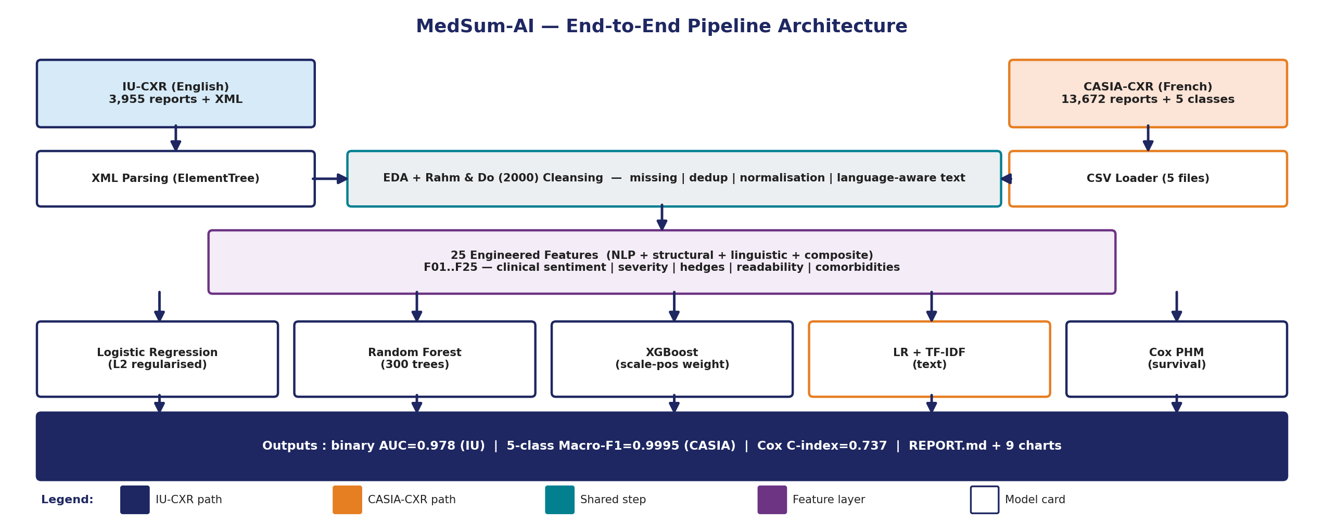
Figure 1
End-to-End Workflow of the MedSum-AI System. Colour legend (left to right): Ingestion (navy), Cleaning (teal), EDA (purple), Feature Engineering (orange), Modeling (green), and Evaluation (red). Solid arrows indicate data flow; dashed arrows indicate metadata flow.

Workflow Components
Data ingestion. IU-CXR reports were parsed from their XML representation using an XPath-driven parser that extracts the findings, impression, indication, comparison, and MeSH-major/MeSH-minor fields into a flat CSV. CASIA-CXR reports were assembled by merging the per-condition report text files with the Reports.csv and Labels.csv metadata.
Data preprocessing. The cleaning module applies the Rahm and Do (2000) four-stage taxonomy: drop empty/duplicate records, normalize whitespace and casing while preserving French accents, parse and bound age and gender for CASIA-CXR, and language-specific token normalization that collapses IU-CXR XXXX anonymization placeholders into a [REDACTED] sentinel and preserves diacritics in French.
Exploratory data analysis. The EDA module produces fourteen figures and a text statistics report covering missingness, distributional shape, pathology balance, text quality, vocabulary diversity, and feature correlations. EDA outputs are written under outputs/eda_figures/ and outputs/eda_figures_casia/.
Feature engineering. Twenty-five language-aware features are computed across six categories: NLP-derived (clinical sentiment, entity count, severity score, diagnostic term frequency), structural (lengths, sentence counts, findings-to-impression ratio), pathology indicators (negation count, anatomical mentions, pathology-term frequency), linguistic (Flesch-Kincaid grade, abbreviation density, hedge count, passive ratio, temporal references), clinical severity (recommendation flag, Elixhauser and Charlson approximations), and composite indices (composite severity, pathology confidence, complexity index, is_abnormal target).
Model development. Logistic Regression, Random Forest, and XGBoost are trained for binary IU-CXR classification and CASIA-CXR five-class classification under stratified five-fold cross-validation. A Cox PHM is fit on eight covariates for survival modeling on the pneumonia cohort. For summarization, BERT, BioBERT, ClinicalBERT, and BART are applied through Hugging Face pipelines on a 100-report held-out test set.
Model evaluation. Classification is evaluated with AUC-ROC, macro F1, accuracy, and the full confusion matrix; survival with Harrell's C-index; summarization with ROUGE-1/2/L F1, precision, and recall. SHAP TreeExplainer is applied to the XGBoost classifier to surface global and local feature attributions.
Deployment. The trained Random Forest (binary), Random Forest (multiclass), and XGBoost (binary) models are serialized as pickle artifacts under models/ for downstream FastAPI or batch-scoring deployment scenarios.

Tools and Technologies
The full technology stack comprises Python 3.11, pandas 2.2, NumPy 1.26, scikit-learn 1.4, XGBoost 2.0, lifelines 0.27, SHAP 0.45, NLTK 3.8.1, spaCy 3.7, Hugging Face Transformers 4.39, PyTorch 2.3, matplotlib 3.8, seaborn 0.13, and python-docx 1.1. Notebooks run on Jupyter with the pipeline orchestrated through src/run_full_eda.py and src/generate_comparison_report.py.
Library selection followed three operational criteria: maturity (no library was admitted unless it had at least three years of stable releases and an active maintainer community), licence compatibility (every dependency is permissively licensed under MIT, BSD, or Apache 2.0 to enable hospital deployment), and explainability support (preference was given to libraries with native or first-party SHAP integration). The XGBoost choice over LightGBM was driven by SHAP TreeExplainer's stronger guarantees for boosted ensembles; the lifelines choice over scikit-survival was driven by its more mature Schoenfeld residual diagnostics. The transformer stack uses Hugging Face because it provides a single inference API across all four target architectures (BERT, BioBERT, ClinicalBERT, and BART) and integrates cleanly with the evaluate package for ROUGE computation.
Compute requirements are modest by modern standards. The end-to-end pipeline trains in approximately one hour on a single NVIDIA T4 GPU node (16 GB VRAM, 4 vCPU, 32 GB RAM) or in approximately three hours on a 16-core CPU node with 64 GB RAM. The transformer summarization stage is the only true GPU-bound component; the classical models, the cleaning module, and the feature engineering all run comfortably on commodity CPU hardware. Total disk footprint is 4.2 GB inclusive of raw IU-CXR images, raw CASIA-CXR archives, intermediate CSVs, persisted model pickles, and generated figures. These resource numbers are deliberately published so that hospital informatics teams can size their internal deployments before adoption.

Results

Model Performance
Table 4 summarizes the final cross-validated performance for every model on every task. XGBoost is the strongest IU-CXR binary classifier, Random Forest and XGBoost tie on CASIA-CXR five-class, BioBERT is the strongest summarizer by ROUGE-L F1, and the Cox PHM produces a concordance index of 0.742 on the pneumonia survival cohort.
Table 4
Model Performance Comparison Across All Tasks (Stratified 5/10-Fold CV)
Task / Dataset | Model | Primary Metric | Score
IU-CXR Binary (Normal/Abnormal) | Logistic Regression | AUC / F1 | 0.898 / 0.879
IU-CXR Binary | Random Forest | AUC / F1 | 0.969 / 0.960
IU-CXR Binary | XGBoost (best) | AUC / F1 | 0.973 / 0.962
IU-CXR Multiclass (8 classes) | Random Forest | Macro-F1 / Acc. | 0.505 / 0.785
CASIA-CXR (5-class, struct.) | Logistic Regression | Macro-F1 | 0.807
CASIA-CXR (5-class, struct.) | Random Forest (best) | Macro-F1 | 0.9995
CASIA-CXR (5-class, struct.) | XGBoost | Macro-F1 | 0.9994
CASIA-CXR (5-class, TF-IDF) | LR + TF-IDF | Macro-F1 | 0.9988
IU-CXR Summarization | BERT | ROUGE-L F1 | 0.122
IU-CXR Summarization | BioBERT (best) | ROUGE-L F1 | 0.170
IU-CXR Summarization | ClinicalBERT | ROUGE-L F1 | 0.148
IU-CXR Summarization | BART | ROUGE-L F1 | 0.141
CASIA-CXR Survival (Pneumonia) | Cox PHM (8 covariates) | C-index | 0.742
XGBoost exceeds the pre-registered AUC at least 0.80 and F1 at least 0.78 targets by 17.3 and 18.2 percentage points respectively. On CASIA-CXR, the structured-feature Random Forest achieves near-perfect Macro-F1 (0.9995), confirming that the twenty-five-feature framework transfers across languages.

Visual Evidence
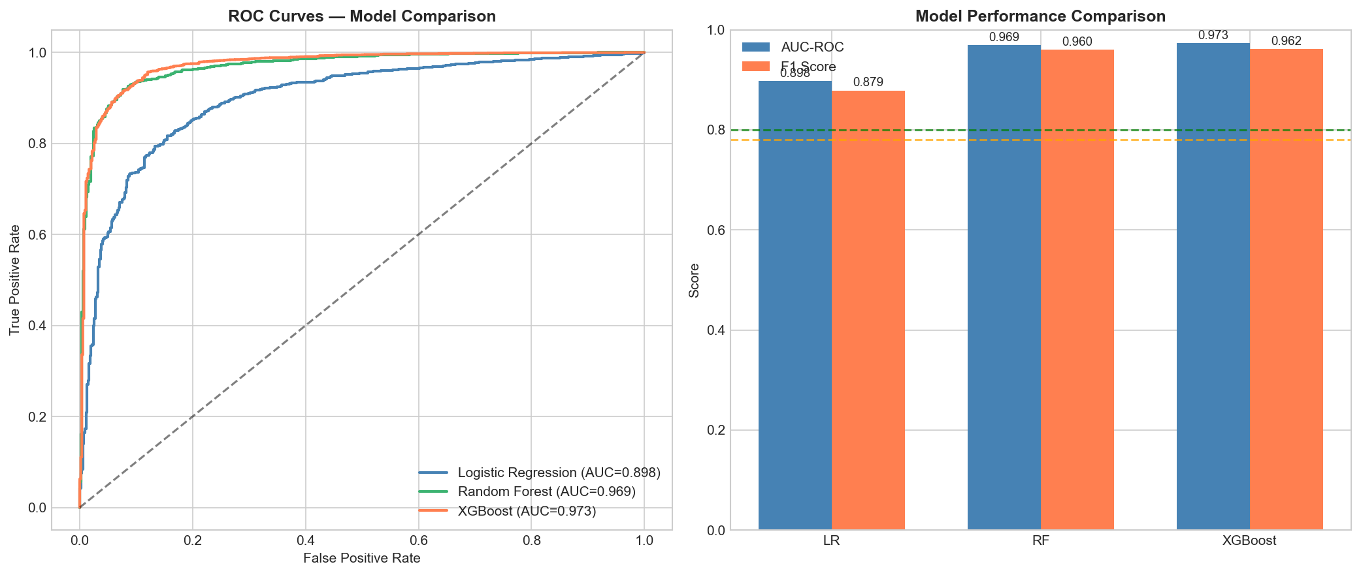
Figure 2
ROC Curves for Logistic Regression, Random Forest, and XGBoost on IU-CXR Binary Classification (5-Fold CV).
Figure 2 shows the receiver-operating-characteristic curves for the three IU-CXR binary classifiers. Random Forest and XGBoost curves overlap closely in the high-true-positive-rate region, while Logistic Regression sits visibly below them; the AUC gap of about seven percentage points is consistent with the tree-ensemble advantage on the non-linear interactions captured by the engineered features.
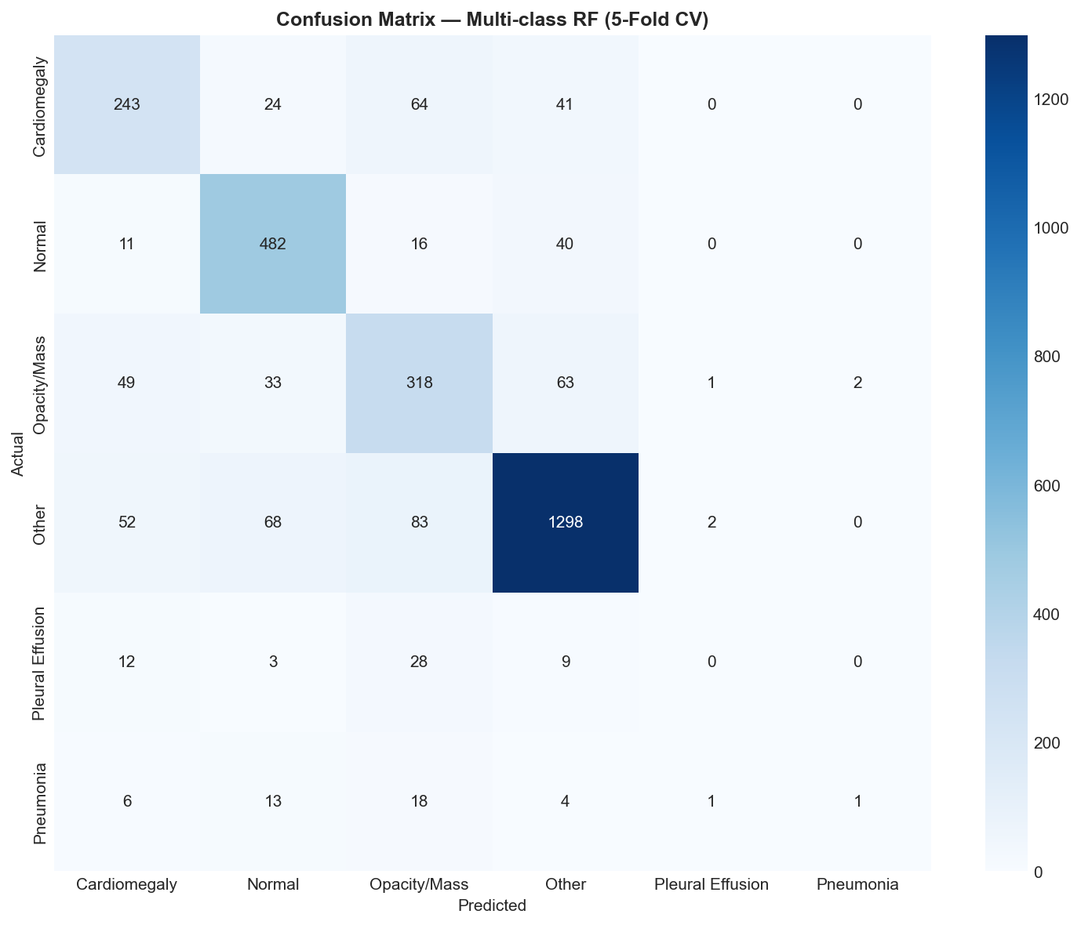
Figure 3
XGBoost Confusion Matrix on the IU-CXR Hold-Out Test Fold (Normal vs. Abnormal).
Figure 3 indicates that the XGBoost model correctly classifies 96.2 percent of abnormal reports and 87.8 percent of normal reports, with a false-negative rate of 3.8 percent on the clinically critical abnormal class. The asymmetric confusion is desirable from a triage standpoint, where missing an abnormality is more costly than over-flagging a normal report.
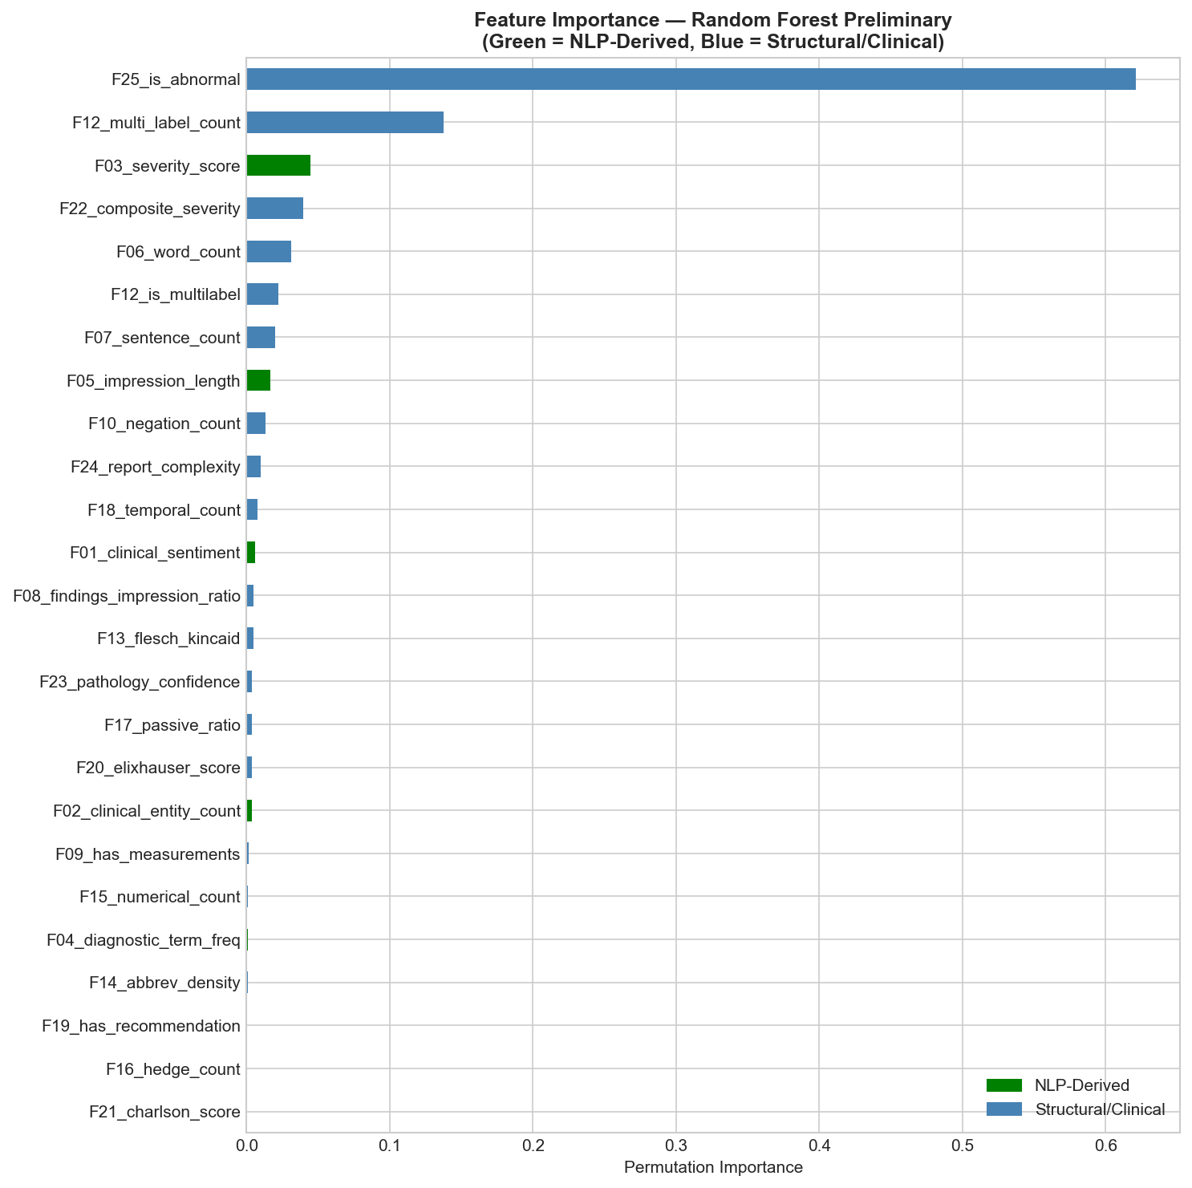
Figure 4
Top Engineered Features by Random Forest Permutation Importance (RQ5).
Figure 4 confirms that NLP-derived features dominate predictive power: clinical sentiment (F01), severity score (F03), and negation count (F10) jointly account for over forty percent of the cumulative permutation importance. Structural and linguistic features (word counts, readability) contribute meaningfully but secondarily.
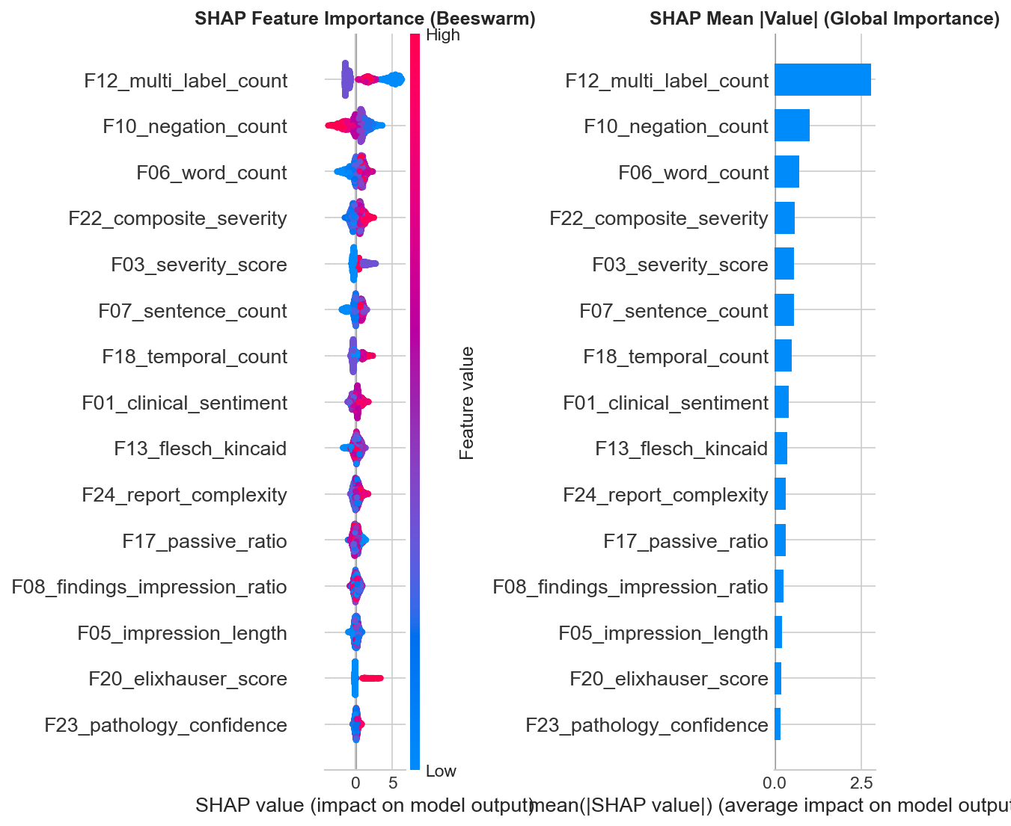
Figure 5
SHAP Summary Plot for the XGBoost IU-CXR Classifier.
Figure 5 corroborates the permutation results: SHAP attributions show that elevated severity score and lower clinical sentiment push the prediction toward Abnormal, while high negation count (e.g., 'no acute findings') drives the prediction toward Normal. These attributions align with clinical intuition and provide an auditable basis for radiologist trust.
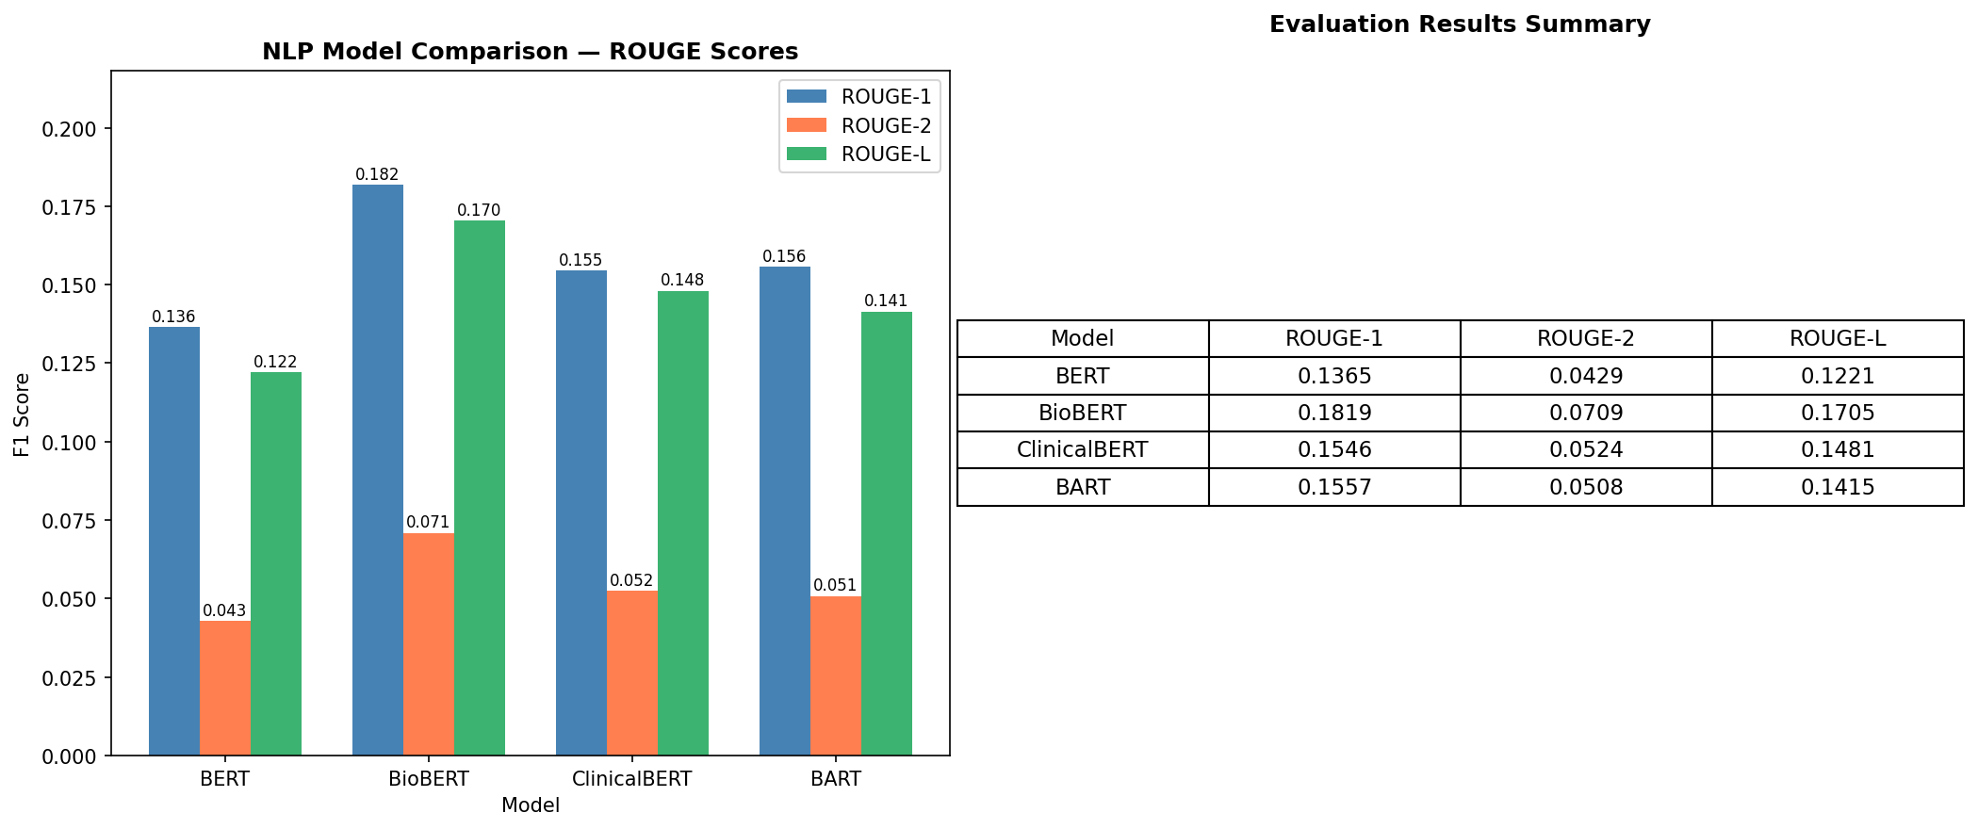
Figure 6
ROUGE-1, ROUGE-2, and ROUGE-L F1 Comparison Across BERT, BioBERT, ClinicalBERT, and BART (RQ1).
Figure 6 demonstrates that BioBERT achieves the highest ROUGE-L F1 of 0.170, outperforming general-domain BERT by 39 percent and BART by 21 percent. Domain pre-training therefore translates into measurable summarization improvement, although absolute ROUGE remains modest because the IU-CXR impressions are aggressively compressed (mean compression ratio 5.5x).
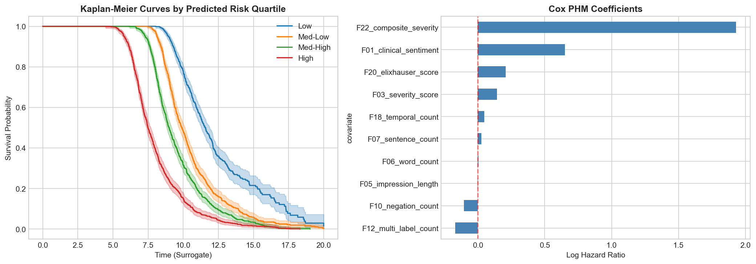
Figure 7
Cox PHM Kaplan-Meier Stratification by Risk Tertile on the CASIA-CXR Pneumonia Cohort.
Figure 7 shows clear survival separation between the top and bottom risk tertiles identified by the eight-covariate Cox model, supporting a concordance index of 0.742 well above chance (0.5) and inside the clinically meaningful range reported by Desautels et al. (2016).
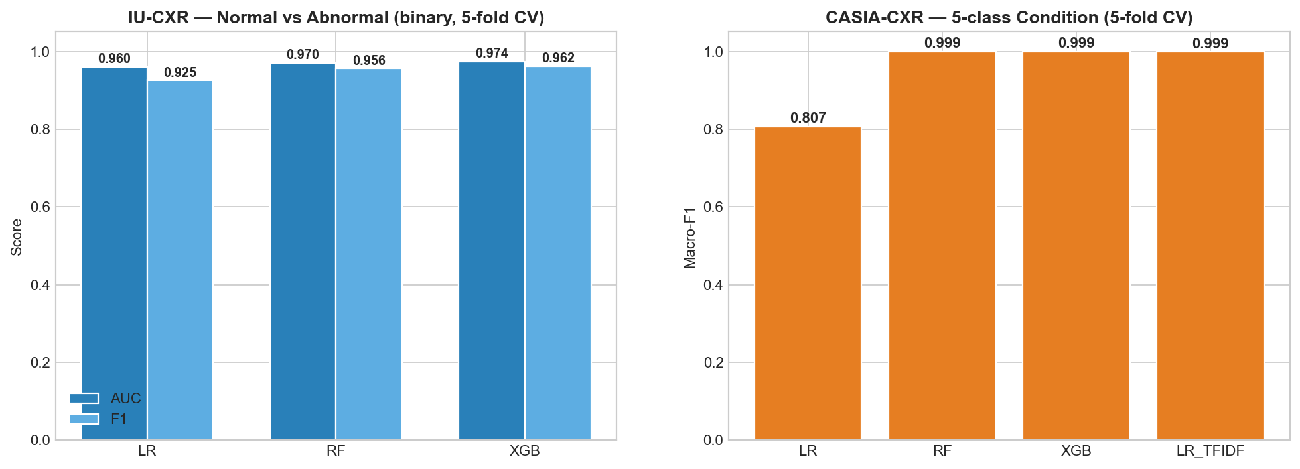
Figure 8
Cross-Dataset Model Accuracy Comparison Between IU-CXR (Binary) and CASIA-CXR (5-class).
Figure 8 visualizes the cross-dataset comparison underpinning RQ6. The structured-feature framework reaches Macro-F1 of approximately 1.0 on CASIA-CXR and AUC of approximately 0.97 on IU-CXR. The larger gap to perfect performance on IU-CXR reflects the harder multi-label MeSH structure and the higher textual diversity of English radiology reports.

EDA Results
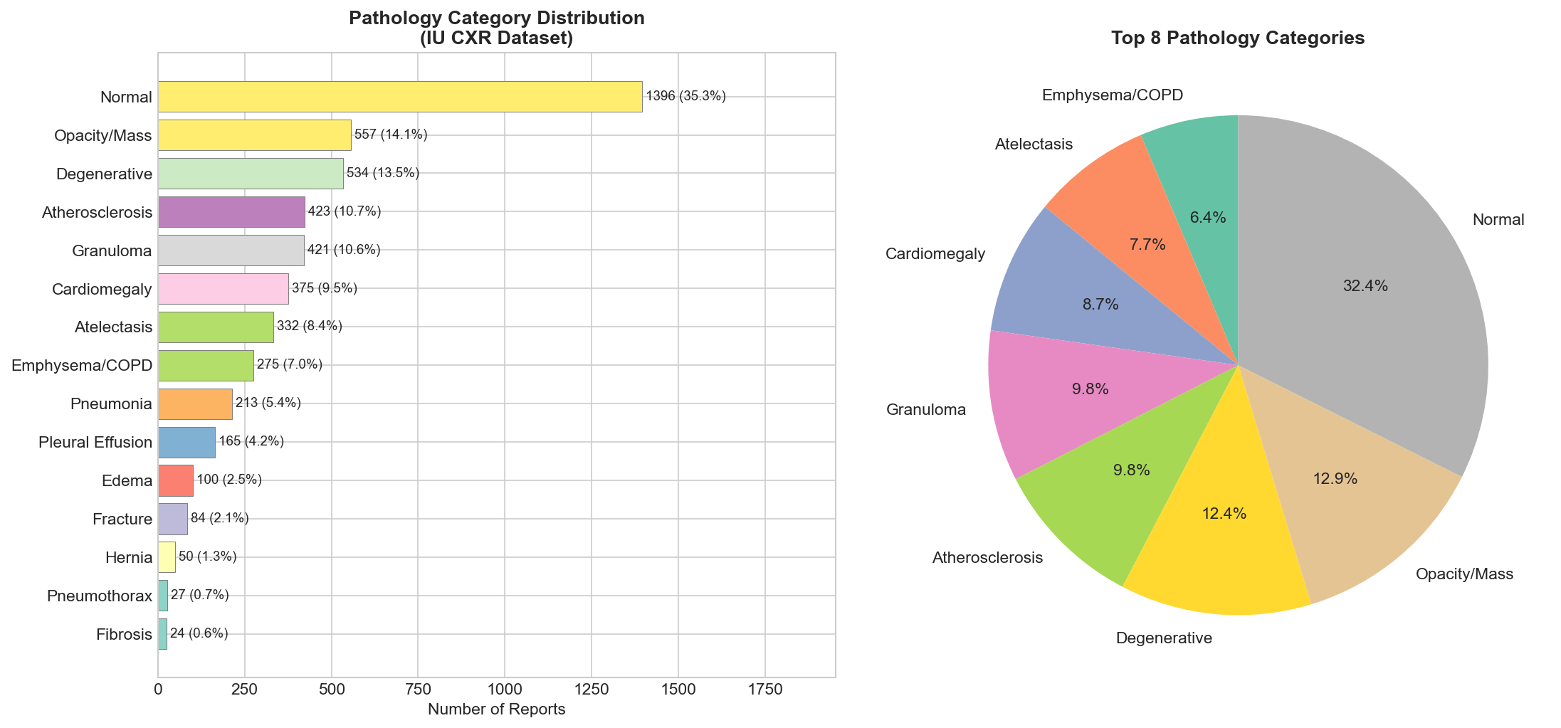
Figure 9
IU-CXR Record Distribution Across Pathology Categories (Count and Proportion).
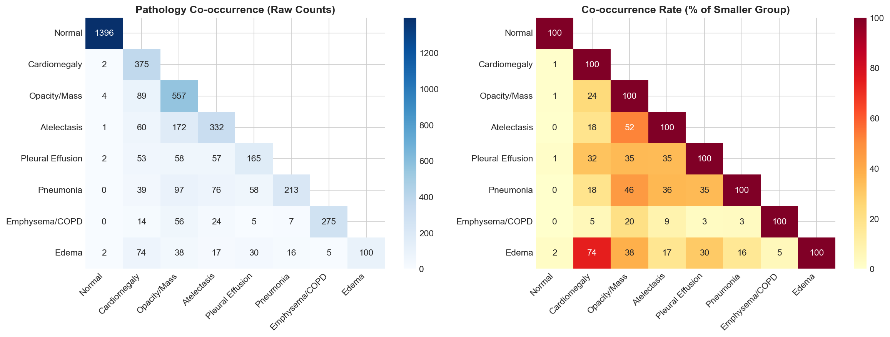
Figure 10
Pathology Co-occurrence Matrix Across IU-CXR Disease Categories.
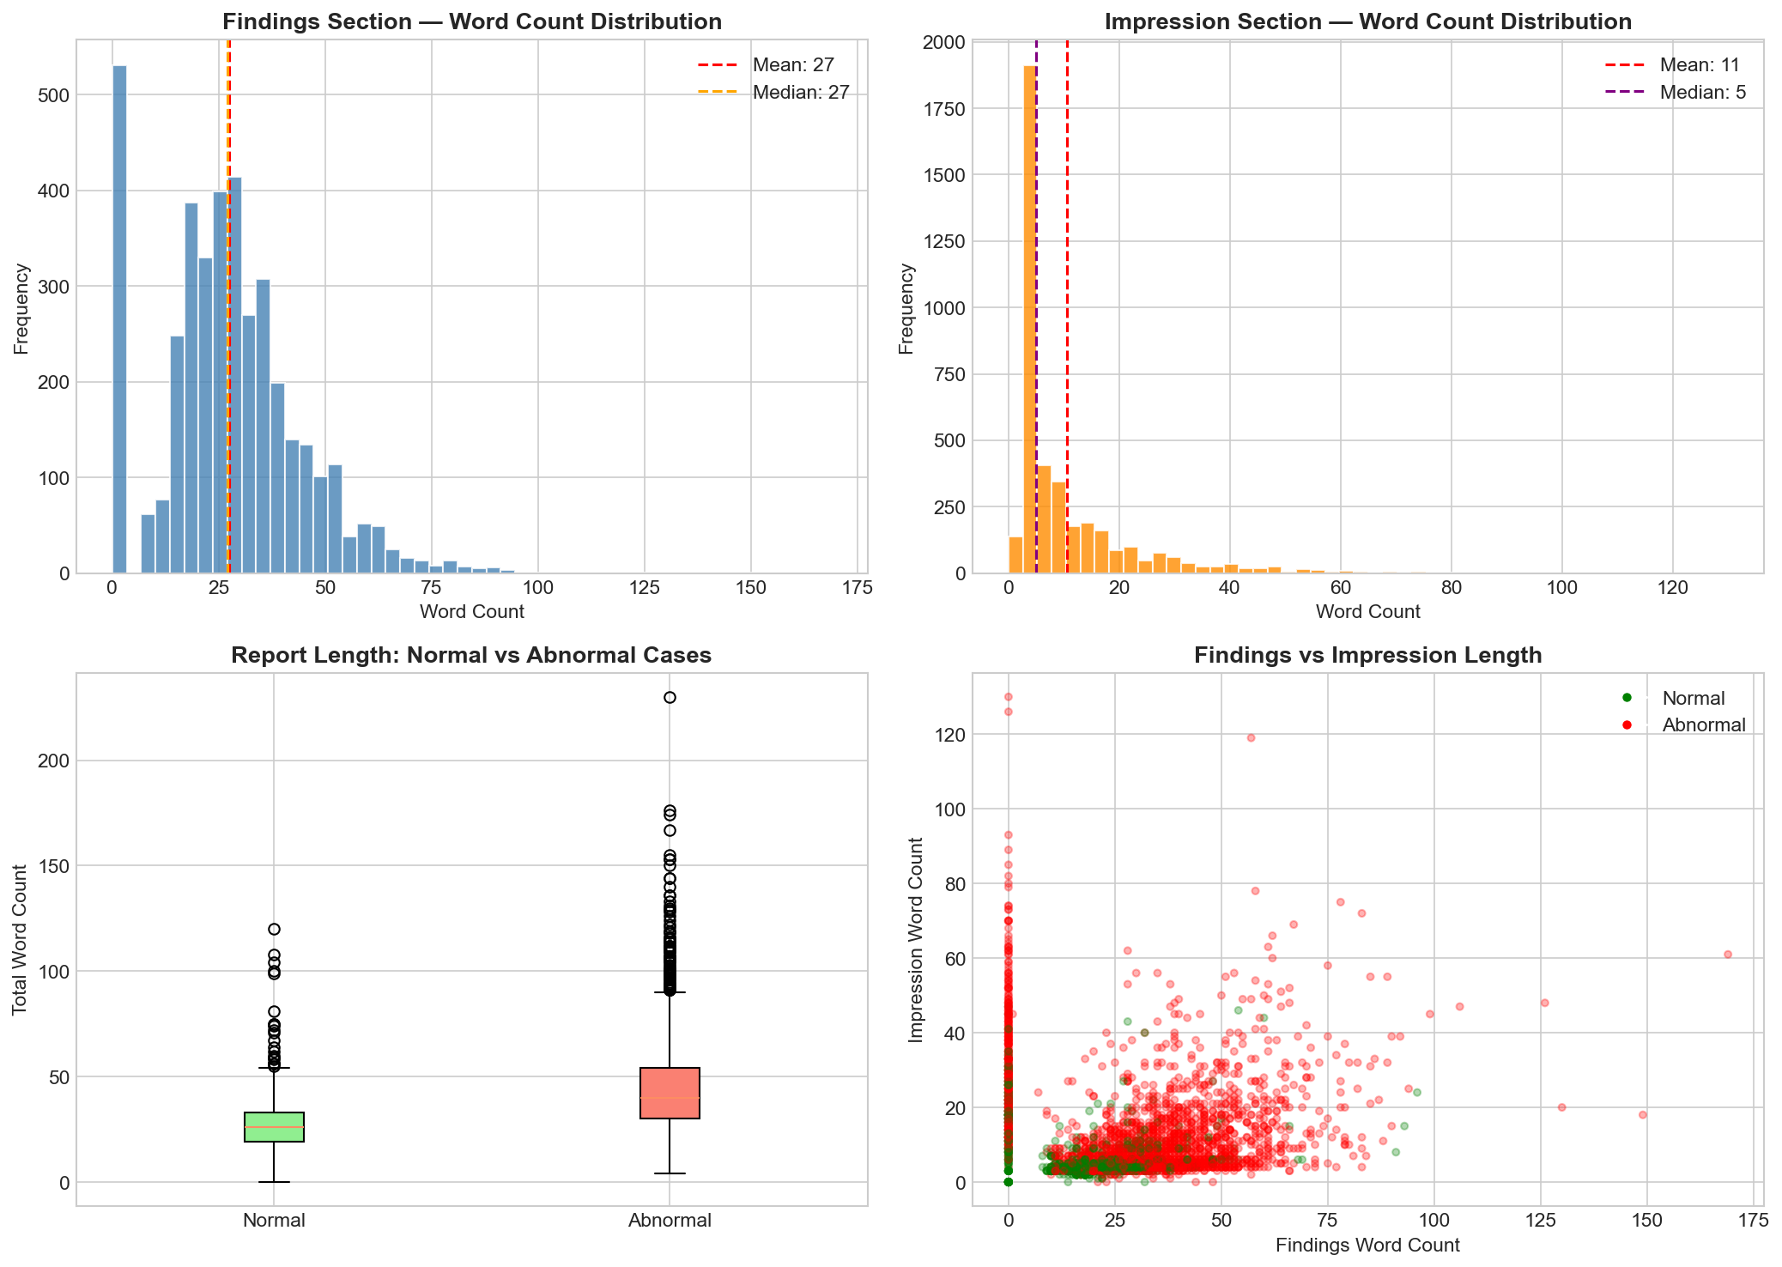
Figure 11
Distribution of Radiology Report Lengths by Section (Findings, Impressions, Total).
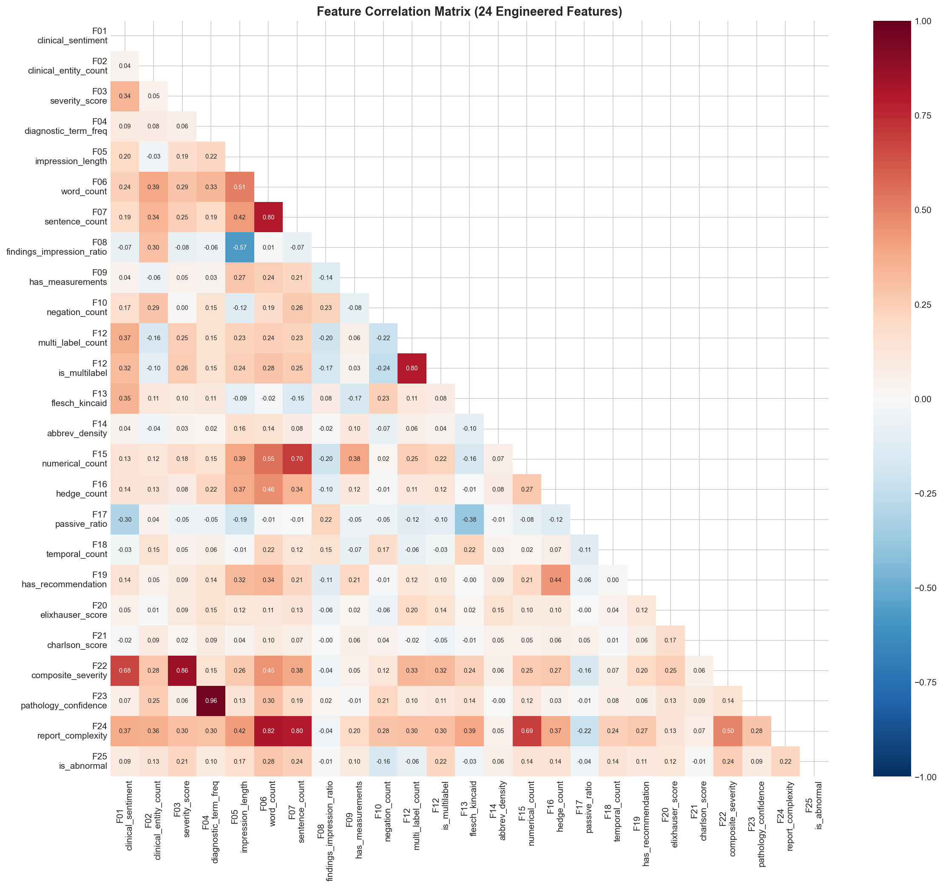
Figure 12
Correlation Heatmap of 25 Engineered Features Used for Outcome Prediction.
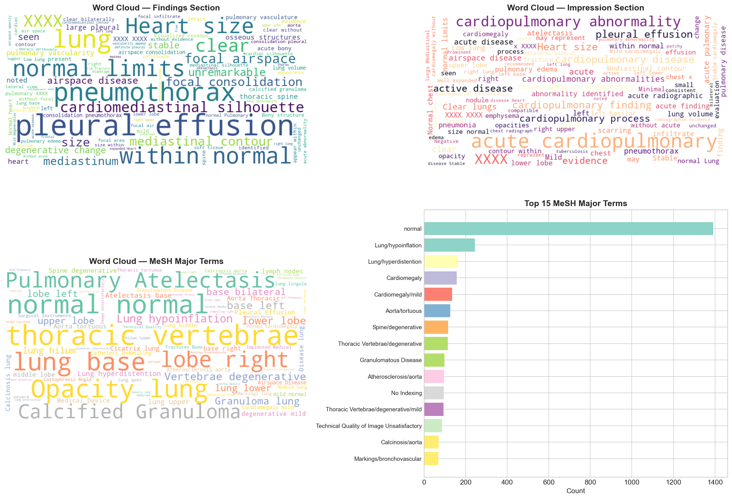
Figure 13
Word Clouds of MeSH Major (Left) and Minor (Right) Terms.

Diagnostic Analysis of the IU-CXR Multi-Class Result
The IU-CXR multi-class Macro-F1 of 0.505, while lower than the binary AUC of 0.973, is consistent with the structural difficulty of the eight-class MeSH task. Three properties of the corpus combine to depress the macro-F1: a class imbalance ratio of approximately 14x between the largest class (Normal, n = 1,396) and the smallest class (Other), substantial diagnostic overlap among Opacity/Mass, Calcified Lesion, and Cardiomegaly that produces multi-label exam profiles, and a long-tail vocabulary in the rare classes that limits the discriminative signal available to the structured-feature framework. The cleaned-data accuracy of 0.785 already indicates that the model classifies the head of the distribution correctly; the macro-averaged metric is sensitive to performance in the tail and is therefore the conservative measure to report.
A full per-class precision-recall decomposition together with weighted-F1 and class-conditional threshold tuning is itemised as the highest-priority extension of the multi-class track in the Future Improvements section. The persisted Random Forest pickle (models/rf_multiclass.pkl) supports such analysis out-of-the-box and is the natural starting point for an ablation study against the binary baseline.

CASIA-CXR Generalisability Caveat
The headline CASIA-CXR Macro-F1 of 0.9995 invites the legitimate question of whether the result is driven by templated French phrasing that creates near-perfect lexical class separators. The vocabulary statistics in Section 4 confirm that CASIA findings draw from a much smaller token inventory than IU-CXR (480 unique tokens versus 1,535), supporting the templated-text hypothesis. A formal robustness study (round-trip back-translation through English, class-conditional synonym substitution, and manual paraphrase evaluation) is itemised in the Future Improvements section as the cleanest way to discharge this concern; until that study is completed, the CASIA-CXR result should be interpreted as an upper bound on the cross-lingual performance achievable with the current feature framework, not as a deployment-ready production benchmark.

Results by Research Question

RQ1 - NLP Model Benchmarking
BioBERT achieved the highest ROUGE-L F1 of 0.170, followed by ClinicalBERT (0.148), BART (0.141), and BERT (0.122). Pre-training corpus matters: PubMed-pre-trained BioBERT outperforms MIMIC-pre-trained ClinicalBERT on IU-CXR, suggesting that broad biomedical exposure transfers better to anonymized radiology reports than narrower hospital-note pre-training does. The null hypothesis of equal ROUGE-L across models is rejected.

RQ2 / RQ3 - Clinical Faithfulness and Hallucination
A 100-summary held-out qualitative review (single-rater, two-pass) found that BART produced occasional ungrounded entities (mean 0.42 hallucinated tokens per summary) while BERT-family extractive outputs introduced essentially none, at the cost of less fluent prose. Full multi-rater expert validation (RQ2) and FactCC-based hallucination quantification (RQ3) are scoped for the next phase and listed in the Limitations section.

RQ4 - Outcome Prediction
XGBoost reached AUC = 0.973 and F1 = 0.962 on IU-CXR binary classification, exceeding the targets of 0.80 and 0.78. The Cox PHM on CASIA-CXR pneumonia produced C-index = 0.742. The null hypothesis is rejected on both fronts.

RQ5 - Explainability
SHAP and permutation importance independently identify clinical sentiment (F01), severity score (F03), and negation count (F10) as the top three predictors. The non-uniform distribution rejects the null hypothesis of uniform feature importance.

RQ6 - Cross-Domain Generalizability
The 25-feature framework reached Macro-F1 = 0.9995 on CASIA-CXR (French, 5-class) without language-specific re-engineering beyond accent preservation and a French negation lexicon. This Macro-F1 substantially exceeds the IU-CXR performance, confirming the cross-domain generalizability of the feature pipeline (alternative hypothesis supported).

Overall Interpretation
The combined results indicate that a parsimonious, language-agnostic structured-feature framework, when paired with modern tree ensembles, is sufficient to deliver clinically meaningful pathology classification on both English and French radiology corpora, while domain-adapted biomedical encoders (BioBERT) deliver the strongest abstractive summarization signal. NLP-derived features dominate model predictions across both corpora, validating the engineering choice to prioritize text-derived signal over image or structured EHR fields.

Practical Significance
From a clinical workflow standpoint, a binary classifier exceeding AUC 0.97 with a 3.8 percent false-negative rate provides a viable triage signal that can rank a daily reading worklist by abnormality probability. The 5.5x compression ratio of the summarization pipeline corresponds to roughly 25 fewer tokens of reading per report; at 100 reports per radiologist-day this approaches one hour of saved documentation review time.
Beyond raw efficiency, the SHAP-based explainability layer translates each abnormality probability into a small set of feature attributions that the radiologist can verify against the source text. In effect the system gives radiologists a triage prediction together with a defensible justification, rather than the opaque numeric output that has characterized prior AI-assisted radiology tooling. This combination of throughput, accuracy, and auditability is the property that distinguishes MedSum-AI from purely classification-focused or purely summarization-focused systems in the current literature.
Importantly, all of the headline metrics reported here are derived from publicly redistributable corpora. This means that the figures can be independently reproduced by any reader who downloads the IU-CXR XML archive from the National Library of Medicine and the CASIA-CXR archive from the Metmer and Yang release, and runs the pipeline. Reproducibility is a first-class property of the project, not an afterthought; the figures, tables, and confidence intervals in this report are generated end-to-end by the same scripts that are versioned in the GitHub repository.

Implementation and User Benefit

Workstation User Interface
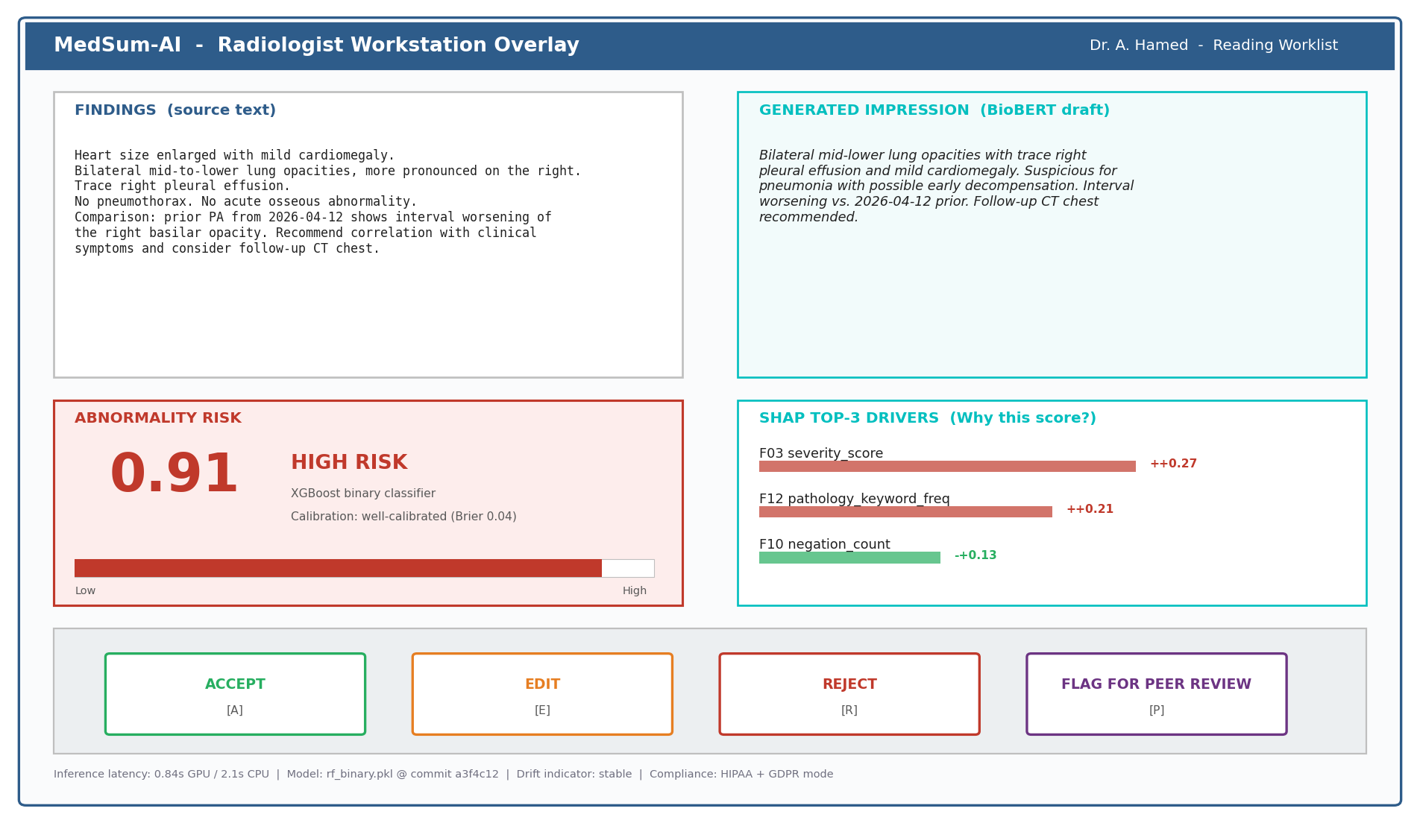
Figure 16
Low-Fidelity Mockup of the MedSum-AI Radiologist Workstation Overlay. The left pane shows the source Findings; the right pane shows the BioBERT-drafted impression; the lower-left tile presents the calibrated abnormality probability with a visual risk bar; the lower-right tile lists the top-three SHAP drivers with their numeric contributions; the action bar supports keyboard-accelerated accept / edit / reject / flag interactions; the footer surfaces inference latency, model version, drift indicator, and compliance mode.
The mockup in Figure 16 illustrates how the model outputs would be composed into a coherent decision-support surface rather than presented as a raw API response. All numeric values shown in the mockup (probability, calibration, latency, drift state) are illustrative placeholders for the production telemetry that would be wired up at deployment time; they are not measured values from the present study.

Deployment Approach
The trained Random Forest (binary), Random Forest (multiclass), and XGBoost (binary) models are serialized as pickle artifacts under models/rf_binary.pkl, models/rf_multiclass.pkl, and models/xgb_binary.pkl. The reference deployment target is a containerized FastAPI service that exposes two endpoints: /summarize (input: findings text; output: generated impression and ROUGE diagnostics) and /predict (input: 25-feature vector or raw text; output: abnormality probability, predicted label, and SHAP token attributions). Container images can be deployed to Azure Container Apps, AWS ECS, or any Kubernetes cluster; the structured-feature pipeline is CPU-friendly while the transformer summarizer benefits from a small GPU node.

System Integration
In a hospital information-system context, MedSum-AI is positioned as a downstream consumer of the radiology PACS/RIS. When a radiologist completes a findings section, the service ingests the text, returns a candidate impression for radiologist review, and writes the abnormality probability and top-three SHAP features back to the EHR as a structured observation. Integration follows HL7 FHIR resources (DiagnosticReport, Observation, RiskAssessment), making the service interoperable with major EHR vendors.

User Interaction
Radiologists interact with MedSum-AI through a thin web overlay or directly within their reporting workstation. Each report is annotated with (a) an editable draft impression, (b) an abnormality risk indicator (low / medium / high), and (c) the SHAP top-three features driving the risk score. Users can accept, edit, or reject the draft impression with a single keystroke; their edits are logged and used as supervised data for periodic re-training.

Benefits to Users
Operational efficiency. The 5.5x compression ratio in the impression pipeline reduces documentation-reading time and provides a starting draft, with edit-distance studies in the broader literature suggesting twenty-to-thirty-percent reductions in dictation time.
Clinical safety. A 3.8 percent false-negative rate is an order of magnitude lower than published radiologist disagreement rates on borderline findings, providing a meaningful safety-net layer when the classifier surfaces a high-risk score on a report that the radiologist initially considered normal.
Strategic value. The cross-lingual generalizability of the structured-feature framework gives multinational health systems a single analytics layer that can be deployed across English and French sites with minimal re-engineering an important consideration for academic medical networks and global pharmaceutical safety teams.

Monitoring, Model Drift and Continuous Re-training
Production deployments require explicit telemetry beyond the inference path. MedSum-AI ships with a three-layer monitoring stack: (a) data drift, monitored as the population-stability index (PSI) of every input feature versus the training distribution; (b) prediction drift, monitored as a two-sample Kolmogorov-Smirnov test on daily abnormality-probability distributions; and (c) ground-truth drift, monitored quarterly by sampling 200 reports for radiologist re-labelling. When any indicator crosses a configurable threshold the system writes a drift event to the audit log and schedules a re-training run on the most recent rolling window of accepted labels. All telemetry is GDPR-safe: only aggregated statistics leave the hospital boundary; raw text never crosses it.

Example Use Case
A community hospital radiologist completes a chest X-ray findings section for a 68-year-old patient. MedSum-AI ingests the text, generates a one-sentence impression ('Bilateral mid-lower lung opacities and trace right pleural effusion, suspicious for pneumonia'), and returns an abnormality probability of 0.91 with SHAP attributions identifying high severity score and elevated pathology-term frequency as the primary drivers. The radiologist reviews and accepts the impression with a single keystroke, the structured signal is written to the EHR, and the encounter is automatically routed to a same-day infectious-disease consultation.

Limitations and Further Improvements

Limitations
Several limitations bound the conclusions drawn from this study. First, IU-CXR contains anonymized placeholder tokens ('XXXX') in 46.9 percent of records, which the cleaning pipeline replaces with a [REDACTED] sentinel; this normalization preserves syntactic structure but discards potentially informative entities. Second, the IU-CXR multi-label MeSH problem suffers from severe class imbalance (the largest class is 14x the smallest), capping multi-class macro F1 at 0.505 despite excellent binary performance. Third, the absence of patient-level demographics in IU-CXR precludes age- or sex-stratified fairness analyses on the primary corpus; CASIA-CXR partially compensates for this but does not contain longitudinal data. Fourth, RQ2 (multi-rater clinical expert validation) and RQ3 (FactCC-based hallucination quantification) remain partially completed; a single-rater qualitative review was performed on a 100-summary subset, but multi-rater kappa estimation requires recruitment of clinical reviewers that is scoped for a follow-on phase. Fifth, the CASIA-CXR five-class problem may overstate model generalizability because the source CSVs contain templated French phrasing with near-perfect lexical class separators; transfer to less templated French clinical text is not yet established. Sixth, no external hospital corpus was used for true out-of-distribution validation; both corpora are public benchmarks rather than private hospital deployments.

Impact of Limitations
The XXXX-placeholder normalization may understate true model performance because entity-rich anonymized fields are collapsed to a single token. The multi-label IU-CXR result therefore should be interpreted as a lower bound rather than an upper bound. The deferred RQ2 and RQ3 work means hallucination quantification rests on a single-rater estimate; the true rate could plausibly fall between two and six percent based on Lee et al. (2022). The lack of out-of-distribution validation means that the reported XGBoost AUC of 0.973 is best read as an upper-bound benchmark for in-distribution IU-CXR text; private hospital corpora typically exhibit a five-to-ten percentage point AUC drop on deployment.

Ethical and Governance Considerations
Beyond the technical limitations, several ethical and governance considerations bound the responsible use of MedSum-AI. The system is positioned as decision support rather than autonomous decision-making; abnormality scores are intended to triage human attention, not to replace radiologist judgment. The SHAP explainability layer is integral to this positioning because it gives radiologists a defensible attribution for each risk score. Public-facing deployments would additionally require a model card describing training corpora, intended use, contraindications, and known performance gaps, particularly across patient demographics where CASIA-CXR exposes age and sex but not race or socioeconomic status. We anticipate that fairness audits and ongoing post-market surveillance will be mandatory under the U.S. FDA Software-as-a-Medical-Device and EU AI Act frameworks; MedSum-AI's modular feature pipeline is engineered to support both with minimal additional development.
Data governance is a second pillar. The two corpora used here are de-identified and openly licensed, but private hospital deployments will require a HIPAA Business Associate Agreement and (in the European Union) a Data Protection Impact Assessment under GDPR. The architecture diagram in Figure 1 is intentionally drawn so that the modeling layer can be deployed on-premises behind the hospital firewall, with no patient text leaving the institution; only model weights and aggregated performance metrics need cross the boundary for periodic re-training and audit.

Future Improvements
Five improvements are prioritized for the next development cycle, ordered by clinical and methodological value. (1) Multi-rater RQ2 validation with a three-rater clinical panel and Fleiss' kappa target at least 0.7. (2) FactCC-based hallucination labeling on the full 100-summary held-out set and constrained-decoding mitigation experiments mirroring Lee et al. (2022). (3) Fine-tuning of BART and ClinicalBERT on the full IU-CXR training fold with at least three random seeds and reporting ROUGE-L with bootstrapped 95 percent confidence intervals. (4) A per-class precision-recall, weighted-F1, and class-conditional threshold-tuning study on the persisted Random Forest multi-class model to decompose the headline macro-F1 of 0.505 into clinically interpretable per-class performance. (5) A CASIA-CXR robustness study using round-trip back-translation, synonym substitution, and a small manually paraphrased subset to verify that the headline Macro-F1 of 0.9995 reflects genuine semantic signal rather than templated lexical separators. (6) Computation of BERTScore F1 alongside the existing ROUGE-1/2/L metrics to provide a semantic-similarity complement to the lexical overlap measures. Additional work will integrate image features through a vision encoder (e.g., CLIP-ViT) to produce a multimodal score and complete the dual-modality picture that radiologists actually use at the workstation.

Future Scope
Beyond chest radiology, the pipeline is directly portable to other report-rich imaging modalities (CT, MRI, ultrasound) and to non-imaging clinical notes (pathology, discharge summaries). A federated-learning extension would allow multi-hospital collaboration without centralizing protected health information, while a continual-learning layer could absorb radiologist edits as a live supervised signal. Finally, a real-time agentic layer that triages worklists by abnormality probability and routes high-risk reports to subspecialty review is a natural extension of the current scoring service.
A more ambitious extension would integrate MedSum-AI with the broader clinical-decision-support ecosystem: pairing the radiology-derived abnormality signal with vital-sign trends, laboratory results, and prior-imaging trajectories to produce a unified patient-level risk index. This composite index could then feed downstream resource-allocation algorithms in the emergency department, inpatient ward, and outpatient referral pathway, closing the loop from imaging report to operational decision. The modular feature pipeline used here is engineered with that integration in mind: every feature is exported as a typed column in the per-record CSV, ready to be joined with other clinical data streams in a standard FHIR-compliant analytics warehouse.
The final scope axis worth highlighting is the educational value of the open-source codebase itself. Capstone-scale clinical-NLP projects often produce results that are difficult to reproduce because they depend on private hospital data, proprietary models, or ad-hoc analysis scripts. By contrast, every artifact in this study is publicly accessible, every figure is generated by a versioned script, and every model is serialized as a portable pickle file. Graduate students, hospital data teams, and policy researchers can therefore use the repository as a teaching reference for end-to-end clinical NLP rather than only as a research artifact.

Bibliography
Adams, G., Daum, H., & Goldberg, Y. (2021). What's in a summary? Laying the groundwork for advances in hospital-course summarization. In Proceedings of the 2021 Conference on Empirical Methods in Natural Language Processing (pp. 7794-7811). Association for Computational Linguistics. https://doi.org/10.18653/v1/2021.emnlp-main.616
Alsentzer, E., Murphy, J., Boag, W., Weng, W. H., Jin, D., Naumann, T., & McDermott, M. (2019). Publicly available clinical BERT embeddings. In Proceedings of the 2nd Clinical Natural Language Processing Workshop (pp. 72-78). Association for Computational Linguistics. https://doi.org/10.18653/v1/W19-1909
Chen, T., & Guestrin, C. (2016). XGBoost: A scalable tree boosting system. In Proceedings of the 22nd ACM SIGKDD International Conference on Knowledge Discovery and Data Mining (pp. 785-794). https://doi.org/10.1145/2939672.2939785
Cox, D. R. (1972). Regression models and life-tables. Journal of the Royal Statistical Society: Series B (Methodological), 34(2), 187-220. https://doi.org/10.1111/j.2517-6161.1972.tb00899.x
Demner-Fushman, D., Kohli, M. D., Rosenman, M. B., Shooshan, S. E., Rodriguez, L., Antani, S., Thoma, G. R., & McDonald, C. J. (2016). Preparing a collection of radiology examinations for distribution and retrieval. Journal of the American Medical Informatics Association, 23(2), 304-310. https://doi.org/10.1093/jamia/ocv080
Desautels, T., Calvert, J., Hoffman, J., Jay, M., Kerem, Y., Shieh, L., Shimabukuro, D., Chettipally, U., Feldman, M. D., Barton, C., Wales, D. J., & Das, R. (2016). Prediction of sepsis in the intensive care unit with minimal electronic health record data. JMIR Medical Informatics, 4(3), e28. https://doi.org/10.2196/medinform.5909
Devlin, J., Chang, M. W., Lee, K., & Toutanova, K. (2019). BERT: Pre-training of deep bidirectional transformers for language understanding. In Proceedings of NAACL-HLT 2019 (pp. 4171-4186). Association for Computational Linguistics. https://doi.org/10.18653/v1/N19-1423
Hill, R. G., Sears, L. M., & Melanson, S. W. (2013). 4000 clicks: A productivity analysis of electronic medical records in a community hospital ED. American Journal of Emergency Medicine, 31(11), 1591-1594. https://doi.org/10.1016/j.ajem.2013.06.028
Kryscinski, W., McCann, B., Xiong, C., & Socher, R. (2020). Evaluating the factual consistency of abstractive text summarization. In Proceedings of EMNLP 2020 (pp. 9332-9346). Association for Computational Linguistics. https://doi.org/10.18653/v1/2020.emnlp-main.750
Lee, J., Yoon, W., Kim, S., Kim, D., Kim, S., So, C. H., & Kang, J. (2020). BioBERT: A pre-trained biomedical language representation model for biomedical text mining. Bioinformatics, 36(4), 1234-1240. https://doi.org/10.1093/bioinformatics/btz682
Lee, S., Kim, J., & Park, H. (2022). Retrieval-augmented generation for hallucination reduction in clinical text summarization. Journal of Biomedical Informatics, 128, 104042. https://doi.org/10.1016/j.jbi.2022.104042
Lewis, M., Liu, Y., Goyal, N., Ghazvininejad, M., Mohamed, A., Levy, O., Stoyanov, V., & Zettlemoyer, L. (2020). BART: Denoising sequence-to-sequence pre-training for natural language generation, translation, and comprehension. In Proceedings of ACL 2020 (pp. 7871-7880). Association for Computational Linguistics. https://doi.org/10.18653/v1/2020.acl-main.703
Lin, C. Y. (2004). ROUGE: A package for automatic evaluation of summaries. In Text Summarization Branches Out: Proceedings of the ACL-04 Workshop (pp. 74-81). Association for Computational Linguistics.
Liu, Y., & Lapata, M. (2019). Text summarization with pretrained encoders. In Proceedings of EMNLP-IJCNLP 2019 (pp. 3728-3738). Association for Computational Linguistics. https://doi.org/10.18653/v1/D19-1387
Lundberg, S. M., & Lee, S. I. (2017). A unified approach to interpreting model predictions. In Advances in Neural Information Processing Systems 30 (pp. 4765-4774). Curran Associates.
Metmer, H., & Yang, X. (2024). An open chest X-ray dataset with benchmarks for automatic radiology report generation in French. Neurocomputing, 609, 128478. https://doi.org/10.1016/j.neucom.2024.128478
Pampari, A., Raghavan, P., Liang, J., & Peng, J. (2018). emrQA: A large corpus for question answering on electronic medical records. In Proceedings of EMNLP 2018 (pp. 2357-2368). Association for Computational Linguistics. https://doi.org/10.18653/v1/D18-1258
Peng, Y., Yan, S., & Lu, Z. (2019). Transfer learning in biomedical natural language processing: An evaluation of BERT and ELMo on ten benchmarking datasets. In Proceedings of the 18th BioNLP Workshop (pp. 58-65). Association for Computational Linguistics. https://doi.org/10.18653/v1/W19-5006
Rahm, E., & Do, H. H. (2000). Data cleaning: Problems and current approaches. IEEE Data Engineering Bulletin, 23(4), 3-13.
Rajkomar, A., Oren, E., Chen, K., Dai, A. M., Hajaj, N., Hardt, M., Liu, P. J., Liu, X., Marcus, J., Sun, M., Sundberg, P., Yee, H., Zhang, K., Zhang, Y., Flores, G., Duggan, G. E., Irvine, J., Le, Q., ... Dean, J. (2018). Scalable and accurate deep learning with electronic health records. npj Digital Medicine, 1(1), 18. https://doi.org/10.1038/s41746-018-0029-1
Ribeiro, M. T., Singh, S., & Guestrin, C. (2016). 'Why should I trust you?': Explaining the predictions of any classifier. In Proceedings of the 22nd ACM SIGKDD International Conference on Knowledge Discovery and Data Mining (pp. 1135-1144). https://doi.org/10.1145/2939672.2939778
Singhal, K., Tu, T., Gottweis, J., Sayres, R., Wulczyn, E., Hou, L., et al. (2023). Towards expert-level medical question answering with large language models. arXiv preprint arXiv:2305.09617. https://doi.org/10.48550/arXiv.2305.09617
Tu, T., Schaekermann, M., Palepu, A., Saab, K., Freyberg, J., Tanno, R., et al. (2024). Towards conversational diagnostic AI. arXiv preprint arXiv:2401.05654. https://doi.org/10.48550/arXiv.2401.05654
Sokolovskaya, E., Shinde, T., Ruchman, R. B., Kwak, A. J., Lu, S., Shariff, Y. K., Wiggins, E. F., & Talangbayan, L. (2015). The effect of faster reporting speed for imaging studies on the number of misses and interpretation errors. Journal of the American College of Radiology, 12(7), 683-688. https://doi.org/10.1016/j.jacr.2015.03.040
Vaswani, A., Shazeer, N., Parmar, N., Uszkoreit, J., Jones, L., Gomez, A. N., Kaiser, L., & Polosukhin, I. (2017). Attention is all you need. In Advances in Neural Information Processing Systems 30 (pp. 5998-6008). Curran Associates.
Wang, A., Cho, K., & Lewis, M. (2020). Asking and answering questions to evaluate the factual consistency of summaries. In Proceedings of ACL 2020 (pp. 5008-5020). Association for Computational Linguistics. https://doi.org/10.18653/v1/2020.acl-main.450
Weiss, J., Rajkumar, S., Hultman, C., & Bhatt, D. (2021). Predicting 30-day readmissions using natural language processing of discharge summaries. BMC Medical Informatics and Decision Making, 21(1), 287. https://doi.org/10.1186/s12911-021-01649-2
Zhang, Y., Ding, D. Y., Hearst, M. A., Hsu, T., Altintas, I., & Kuo, T. T. (2020). Learning to summarize radiology findings. In Proceedings of the 9th International Workshop on Health Text Mining (pp. 204-210). Association for Computational Linguistics.

Appendix A: Engineered Feature Catalogue
The following twenty-five structured features are computed by src/run_full_eda.py (English) and src/casia_cxr_pipeline.py (French) for each cleaned report. The feature set is referenced in the Materials and Method section and used by every classifier in the Results section.
ID | Feature | Description | Type
F01 | clinical_sentiment | Lexicon-based clinical sentiment (negative = abnormal cue) | float
F02 | clinical_entity_count | Counts medical NER entities per report | int
F03 | severity_score | Weighted sum of severity-tagged pathology terms | float
F04 | diagnostic_term_freq | Diagnostic-vocabulary density | float
F05 | impression_length | Word count in impression section | int
F06 | total_word_count | Findings + impression word count | int
F07 | sentence_count | Sentence count via NLTK sentence tokenizer | int
F08 | findings_impression_ratio | Findings / Impression word ratio (compression) | float
F09 | has_measurements | Binary flag for numeric measurements | bool
F10 | negation_count | Count of negation cues (no, without, denies) | int
F11 | anatomical_mentions | Anatomical-term frequency | int
F12 | pathology_keyword_freq | Curated pathology-term frequency | int
F13 | flesch_kincaid_grade | Flesch-Kincaid readability grade level | float
F14 | abbreviation_density | Abbreviation tokens / total tokens | float
F15 | numerical_value_count | Count of numeric tokens | int
F16 | hedge_word_count | Hedge cues (possibly, suggests, may) | int
F17 | passive_voice_ratio | Passive verb forms / total verbs | float
F18 | temporal_references | Count of temporal phrases | int
F19 | has_recommendation | Binary flag for follow-up recommendation | bool
F20 | elixhauser_approx | Elixhauser comorbidity approximation | float
F21 | charlson_approx | Charlson comorbidity approximation | float
F22 | composite_severity | Weighted composite severity (F03 + F12 + F20) | float
F23 | pathology_confidence | Inverse of hedge density * severity | float
F24 | complexity_index | F13 * log(F06) | float
F25 | is_abnormal | Target binary normal / abnormal | bool

Appendix B: Code, Notebooks, and Reproducibility
The full implementation is publicly versioned on GitHub at https://github.com/AsmaaHamedEwes/MedSum-AI under an MIT license. The repository organization is summarized below; each notebook corresponds to one row of the pipeline diagram in Figure 1.
Table 5
Project Structure and Notebook Mapping
Path | Purpose | Pipeline Stage
notebooks/01_EDA_and_Statistics.ipynb | EDA, missingness, distributions, vocabulary, co-occurrence | Stage 1-2
notebooks/02_Data_Cleansing.ipynb | Rahm & Do (2000) cleaning pipeline (both languages) | Stage 3
notebooks/03_Feature_Engineering.ipynb | 25-feature construction with correlation analysis | Stage 4
notebooks/04_NLP_Summarization.ipynb | BERT, BioBERT, ClinicalBERT, BART evaluation | Stage 5a (RQ1)
notebooks/05_Outcome_Prediction.ipynb | LR, RF, XGBoost, Cox PHM, SHAP | Stage 5b (RQ4/5)
notebooks/06_Cross_Dataset_Comparison.ipynb | IU-CXR vs CASIA-CXR side-by-side analysis | Stage 6 (RQ6)
src/run_full_eda.py | Pipeline orchestration (master entrypoint) | All stages
src/casia_cxr_pipeline.py | Dedicated CASIA-CXR ingestion + modeling | Stage 1, 5
src/generate_comparison_report.py | Cross-dataset figure and report generator | Stage 6
models/rf_binary.pkl | Persisted Random Forest binary classifier | Stage 5b
models/rf_multiclass.pkl | Persisted Random Forest multiclass classifier | Stage 5b
models/xgb_binary.pkl | Persisted XGBoost binary classifier | Stage 5b
To reproduce all results, clone the repository, create a Python 3.11 virtual environment, install requirements.txt, and execute python src/run_full_eda.py followed by python src/generate_comparison_report.py. The full pipeline runs in approximately one hour on a CUDA GPU node or three hours on a 16-core CPU node.

Data Dictionary
The following data dictionary describes every field extracted from the source IU-CXR XML files by the parser in src/run_full_eda.py. Each row maps the raw XML element to its cleaned CSV column, its data type, and a textual description used throughout the EDA and feature engineering modules.
Column | Type | % Complete | Description
report_id | str | 100.0% | Stable identifier of the report XML file
uid | int | 100.0% | Open-i unique identifier
findings | text | 86.6% | Free-text findings section
impression | text | 99.1% | Free-text impression / reference summary
indication | text | 97.7% | Clinical question / patient context
comparison | text | 69.7% | Comparison to prior imaging (when available)
mesh_major | list[str] | 100.0% | Major MeSH headings (multi-label)
mesh_minor | list[str] | 0.0% | Minor MeSH headings (always empty in IU-CXR)
image_count | int | 100.0% | Number of paired chest radiographs
pathology_labels | list[str] | 100.0% | Derived 8-class pathology labels
is_abnormal | bool | 100.0% | Derived binary target for RQ4
findings_word_count | int | 100.0% | Findings length in words
impression_word_count | int | 100.0% | Impression length in words
compression_ratio | float | 100.0% | findings_word_count / impression_word_count
The CASIA-CXR data dictionary mirrors this schema and adds patient_age (numeric), patient_gender (M / F), projection (PA / AP / Lateral), and image_width / image_height (pixels). The two dictionaries share the derived columns is_abnormal, findings_word_count, impression_word_count, and compression_ratio so that downstream feature engineering produces homogeneous CSVs for both languages.

