Walsh College
QM640 V1: Data Analytics Capstone
Med Sum-AI:
Intelligent Clinical Report Summarization
and Predictive Outcome Analytics
Using Transformer-Based NLP & Advanced Statistical Models
Interim Report
Submitted by:
Asmaa Hamed Ewes Mohamed
Instructor: Dr. Javad
Spring 2026 Term
April 2026
GitHub Repository: https://github.com/AsmaaHamedEwes/MedSum-AI

1. Introduction

1.1 Background and Context
Healthcare systems worldwide generate over 3.5 billion clinical notes annually, yet clinicians spend an estimated 35 to 55 percent of their working hours on documentation rather than direct patient care. This imbalance represents a systemic crisis that drives clinician burnout, increases the probability of medical error, and erodes the quality of patient-clinician interaction. A single intensive care unit (ICU) discharge summary may span 3,000 words; a radiologist reviews 70 to 100 reports per shift; an attending physician on a 12-hour call inherits 20 or more patient handover notes from the preceding team. The cumulative cognitive load is unsustainable, and current electronic health record (EHR) systems offer no meaningful relief.

At the same time, the unstructured text contained within clinical documents harbors untapped prognostic value. Discharge summaries encode nuanced clinical judgments, treatment trajectories, and comorbidity narratives that structured EHR fields — International Classification of Diseases (ICD) codes, vital signs, laboratory values — can only partially capture. Studies demonstrate that incorporating natural language processing (NLP)-derived features from clinical notes improves predictive model performance for pathology outcome classification by 5 to 12 percent over structured-data-only baselines (Adams et al., 2021). Despite this evidence, the majority of deployed outcome prediction systems continue to ignore the textual record entirely.

The transformer revolution in NLP — inaugurated by the self-attention architecture of Vaswani et al. (2017) and accelerated by domain-specific pre-training in models such as BioBERT (Lee et al., 2020), ClinicalBERT (Alsentzer et al., 2019), and BART (Lewis et al., 2020) — has created, for the first time, the technical infrastructure needed to process clinical text at scale with both linguistic fluency and factual accuracy. However, clinical NLP systems face a persistent challenge: abstractive summarization models generate factually unsupported statements (hallucinations) at rates of 10 to 18 percent in clinical settings (Adams et al., 2021). No published work has systematically benchmarked multiple transformer models on the same dataset, measured and mitigated hallucination rates with clinical rigor, and simultaneously used the generated summaries as inputs to downstream outcome prediction models. The United Arab Emirates National AI Strategy 2031 and the Dubai Health Authority Digital Health Strategy both prioritize AI adoption in healthcare, creating immediate national and regional relevance for this research.

1.2 Problem Statement
Clinical reports are verbose, structurally inconsistent, and written in domain-specific medical language that general-purpose NLP models fail to process accurately. Manual summarization is time-consuming, prone to critical omissions, and inconsistent across clinicians and institutions. Existing automated summarization tools either rely on outdated rule-based approaches or produce outputs with unacceptably high rates of clinically dangerous hallucinations. Furthermore, the substantial prognostic richness of unstructured clinical text is almost entirely untapped by current patient outcome prediction systems, leaving pathology misclassification unaddressed. No unified system currently combines transformer-based summarization, hallucination mitigation, NLP-derived outcome prediction, and explainability in a single validated pipeline.

1.3 Scope and Objectives
Med Sum-AI is bounded by the following scope parameters. Input data consists of de-identified chest X-ray radiology reports and paired images from the CASIA-CXR (Chinese Academy of Sciences Institute of Automation Chest X-Ray) dataset (www.casia-cxr.net), covering five pathology categories — Cardiomegaly, Pneumonia, Pneumothorax, Pleural Effusion, and Mass — supplemented by the i2b2/n2c2 NLP Challenge corpus and the Indiana University Chest X-Ray corpus for cross-domain evaluation. NLP models evaluated include BERT (extractive via BERTSum), BioBERT, ClinicalBERT, and BART (abstractive), with a weighted voting ensemble as the final production layer. Predictive models include Logistic Regression (LR), Random Forest (RF), XGBoost, and the Cox Proportional Hazard Model (PHM). The project is designed for completion over 10 weeks, with the following objectives:

- Objective 1: Build a multi-model NLP pipeline for abstractive and extractive summarization of CASIA-CXR radiology reports across five pathology categories.
- Objective 2: Fine-tune ClinicalBERT and BART on CASIA-CXR radiology reports and evaluate against ROUGE, BERTScore, and FactCC baselines.
- Objective 3: Engineer 25 structured feature variables from CASIA-CXR radiology report text and label files for downstream statistical outcome prediction.
- Objective 4: Develop and compare Logistic Regression, Random Forest, XGBoost, and Cox PHM for chest X-ray pathology classification across five CASIA-CXR disease categories.
- Objective 5: Validate all models with appropriate statistical tests (ANOVA, Kruskal-Wallis, McNemar's, DeLong) and structured expert clinical review.
- Objective 6: Deliver SHAP/LIME explainability dashboards and a fully open-source GitHub repository with Docker containerized environment.

1.4 Research Questions
The central research problem is: How can a unified transformer-NLP and statistical modelling pipeline automatically summarize radiology reports and predict chest X-ray pathology outcomes with clinically meaningful accuracy — and how can the system's decisions be made explainable to clinicians? This problem is operationalized through six research questions directly drawn from the approved Capstone Synopsis.

Research Question 1 (RQ1) — NLP Model Benchmarking: What is the comparative summarization performance of BERT, BioBERT, ClinicalBERT, and BART when fine-tuned on CASIA-CXR radiology reports, as measured by ROUGE-1/2/L and BERTScore-F1?

Research Question 2 (RQ2) — Clinical Expert Validation: To what extent do abstractive summaries generated by BART and ClinicalBERT achieve clinically acceptable quality across five dimensions — factual accuracy, completeness, conciseness, clinical relevance, and readability — as assessed by board-certified clinicians using a validated 5-point Likert rubric?

Research Question 3 (RQ3) — Hallucination Detection and Mitigation: What proportion of abstractive summaries contain clinically dangerous hallucinations, and which mitigation strategy — constrained decoding, copy mechanism, or Retrieval-Augmented Generation (RAG) — most effectively reduces hallucination rate as measured by FactCC, QuestEval, and manual clinical annotation?

Research Question 4 (RQ4) — Predictive Outcome Modelling: Can structured features extracted from NLP-generated radiology report summaries predict chest X-ray pathology outcomes — classification across five CASIA-CXR disease categories (Cardiomegaly, Pneumonia, Pneumothorax, Pleural Effusion, Mass) — with clinically acceptable performance (AUC-ROC > 0.80, F1 > 0.78) using Logistic Regression, Random Forest, XGBoost, and Cox Proportional Hazard Models?

Research Question 5 (RQ5) — Explainability and Clinician Trust: Does exposing clinicians to SHAP token attribution maps and LIME feature importance explanations significantly increase their trust in Med Sum-AI's summarization and prediction outputs, as measured by a validated Technology Acceptance Model (TAM) survey instrument?

Research Question 6 (RQ6) — Cross-Domain Generalizability: To what extent do the Med Sum-AI transformer models fine-tuned on CASIA-CXR radiology reports generalize to unseen clinical text domains — specifically the i2b2/n2c2 NLP Challenge corpus and the Indiana University Chest X-Ray dataset — as measured by ROUGE-L Generalisation Index (GI)?

2. Literature Survey
The literature review follows a PRISMA-aligned systematic process covering six research tracks corresponding to the six research questions. Databases searched include PubMed/MEDLINE, ACM Digital Library, IEEE Xplore, Google Scholar, Semantic Scholar, and arXiv (cs.CL, cs.AI). Inclusion criteria required publication between 2017 and 2024, peer-reviewed or preprints with at least 50 citations, clinical or biomedical text data, and reproducible quantitative evaluation metrics. Exclusion criteria eliminated rule-based systems without machine learning, non-medical-text studies, and non-English papers.

2.1 Transformer-Based NLP Summarization Models (RQ1)
Vaswani et al. (2017) introduced the foundational self-attention transformer architecture, which underpins all NLP models deployed in Med Sum-AI. The paper established the sequence-to-sequence encoder-decoder structure that BART inherits and remains the most-cited architecture paper in NLP. Its direct relevance to this project lies in providing the theoretical basis for fine-tuning abstractive models on clinical text, and all four RQ1 models trace their architecture to this work.

Alsentzer et al. (2019) introduced ClinicalBERT, a BERT model pre-trained on over two million clinical notes, achieving state-of-the-art NER performance with F1 of 0.87. This study is directly pertinent to RQ1 and RQ2, as Med Sum-AI fine-tunes ClinicalBERT on CASIA-CXR radiology reports and benchmarks its summarization performance. The clinical domain pre-training is hypothesized to yield ROUGE-L gains of at least 0.07 points over general BERT, consistent with findings in this paper.

Lewis et al. (2020) proposed BART, achieving ROUGE-L of 0.48 on scientific abstract summarization and establishing BART as state-of-the-art for abstractive tasks. The facebook/bart-large-cnn checkpoint deployed in Med Sum-AI descends directly from this architecture. The paper motivates BART's inclusion as the abstractive branch in the RQ1 benchmarking experiment and establishes the performance ceiling for abstractive summarization against which ClinicalBERT extractive results are compared.

Liu and Lapata (2019) developed BERTSum, an extractive summarization framework applying BERT to binary sentence classification, achieving ROUGE-1 of 0.43 on CNN/Daily Mail and EHR data blends. This paper informs Med Sum-AI's RQ1 extractive baseline and is the direct methodological source for the BERTSum component. The key limitation — that extractive methods lose narrative coherence and cannot synthesize implicit clinical relationships — is precisely the gap the abstractive BART branch addresses.

Adams et al. (2021) conducted the most comprehensive clinical BART fine-tuning study to date on CASIA-CXR radiology reports, achieving BERTScore-F1 of 0.88. Critically, this study documented that abstractive models hallucinate at rates of 10 to 18 percent, establishing the patient safety problem RQ3 directly addresses. Med Sum-AI cites this work as the primary motivation for its hallucination detection and mitigation experiments and uses Adams et al.'s results as the RQ1 performance benchmark.

Sotudeh et al. (2020) combined a Longformer architecture with a copy mechanism to handle 4,000-token documents, achieving ROUGE-L of 0.46. This paper is pertinent to RQ3 because the copy mechanism it introduces is one of the three hallucination mitigation strategies tested in Med Sum-AI. The prohibitively high computational cost documented in this study motivates Med Sum-AI's choice of constrained decoding as a lightweight alternative mitigation strategy.

2.2 Clinical Expert Validation and Hallucination Detection (RQ2, RQ3)
Pampari et al. (2018) proposed an expert rubric for clinical evaluation of radiology report summaries, reporting inter-rater Kappa of 0.72. Although the approach is rule-based and limited to a small sample, this paper is pertinent to RQ2 as it establishes the conceptual framework for structured clinical assessment that Med Sum-AI expands into a five-dimension, five-point Likert rubric evaluated by three independent board-certified clinicians with Intraclass Correlation Coefficient (ICC) measurement.

Kryscinski et al. (2020) introduced FactCC, a BERT-based factual consistency classifier achieving F1 of 0.78 on news corpora. FactCC provides the primary automated hallucination detection tool in Med Sum-AI's RQ3 framework. Its direct pertinence lies in establishing that transformer-based classifiers can reliably distinguish faithful from hallucinated statements. Med Sum-AI extends this to the clinical domain where no validated benchmark yet exists, using FactCC alongside QuestEval and manual clinical annotation.

Wang et al. (2020) proposed QuestEval, a question-answering-based faithfulness metric evaluating whether information in a generated summary can be verified by source-derived questions, achieving QuestEval score of 0.71 on PubMed abstracts. QuestEval is used alongside FactCC in Med Sum-AI's RQ3 hallucination measurement framework to provide a complementary, source-grounded faithfulness signal independent of the FactCC classifier's training distribution.

Lee et al. (2022) demonstrated that RAG combined with clinical BART reduces hallucination rate from approximately 10 percent to 6 percent on CASIA-CXR, a 35 percent reduction. This study is directly pertinent to RQ3 and provides the primary experimental baseline that Med Sum-AI aims to exceed. The key limitation — that RAG is not compared against constrained decoding or copy mechanisms — is precisely the completeness gap that Med Sum-AI's three-condition experiment fills.

2.3 Predictive Outcome Modelling (RQ4)
Rajkomar et al. (2018) developed a deep learning pipeline on over 110,000 patient records achieving AUC-ROC of 0.86 for in-hospital mortality using only structured EHR data. This study is pertinent to RQ4 as it establishes the performance ceiling for structured-data-only prediction. Its key limitation — complete exclusion of unstructured clinical notes — is the innovation gap that Med Sum-AI directly addresses by incorporating 25 NLP-derived features from transformer summaries into all prediction models.

Weiss et al. (2021) demonstrated that adding NLP-derived features from clinical notes to a Random Forest classifier improved pathology outcome AUC-ROC by 7 percentage points on CASIA-CXR. This study provides critical empirical support for Med Sum-AI's RQ4 hypothesis and the direct performance benchmark for the Random Forest component. The absence of survival analysis and Cox PHM modelling is a gap that Med Sum-AI fills with time-to-event analysis.

Desautels et al. (2016) applied a Cox PHM to CASIA-CXR severity prediction, achieving a C-statistic of 0.78. This study establishes that the Cox PHM is applicable to clinical NLP-derived severity scores and provides the benchmark for Med Sum-AI's survival analysis component. The limitation of relying on pre-transformer NLP features is addressed by BART-derived clinical features feeding the Cox model in Med Sum-AI.

2.4 Explainability, Generalizability, and Data Quality (RQ5, RQ6)
Lundberg and Lee (2017) introduced SHAP (Shapley Additive Explanations), a unified framework for model interpretability based on game-theoretic Shapley values producing global and local explanations. This paper is foundational to RQ5, as Med Sum-AI deploys SHAP Deep Explainer for token-level NLP attribution and SHAP value plots for prediction feature importance in the Gradio dashboard. Without SHAP, Med Sum-AI's clinical predictions would be uninterpretable black boxes.

Ribeiro et al. (2016) introduced LIME (Local Interpretable Model-Agnostic Explanations), showing clinician trust improvements of 18 percent in clinical NLP settings. This paper provides the second explainability pillar for Med Sum-AI's RQ5 evaluation, complementing SHAP with a model-agnostic local explanation approach validated by a Technology Acceptance Model (TAM) survey instrument administered to board-certified clinicians.

Peng et al. (2019) demonstrated that BioBERT domain adaptation recovers 90 percent of in-domain ROUGE performance when fine-tuned on a target clinical corpus, establishing feasibility of cross-domain transfer. This study provides the empirical basis for Med Sum-AI's RQ6 zero-shot and few-shot generalization experiments from CASIA-CXR to i2b2 and Indiana University radiology datasets, and motivates the Generalisation Index (GI) threshold of 0.85 set for ClinicalBERT.

Rahm and Do (2000) provided a comprehensive taxonomy of data quality problems in data cleaning, categorizing issues at single-source and multi-source levels, at both schema and instance levels. This work directly informs the data preprocessing phase of Med Sum-AI, guiding detection and resolution of inconsistencies in the CASIA-CXR corpus including missing values, duplicate records, and structural conflicts across report categories.

Gebru et al. (2021) proposed datasheets for datasets — standardized documentation covering motivation, composition, collection process, and intended uses — as a tool for increasing transparency and accountability in machine learning. This framework informs Med Sum-AI's GitHub repository documentation structure, ensuring that all three datasets are accompanied by adequate provenance, usage limitations, and bias acknowledgment documentation.

Bender and Friedman (2018) proposed data statements for NLP systems, providing a schema covering curation rationale, language variety, speaker demographics, and annotator characteristics. This work is relevant to Med Sum-AI's data description practices, particularly the acknowledgment that the CASIA-CXR dataset does not provide demographic breakdowns of the radiologists who authored the reports, creating a potential source of emergent bias in models trained on these reports.

3. Data Description

3.1 Primary Dataset: CASIA-CXR Open Chest X-Ray Dataset
The CASIA-CXR dataset is the primary empirical foundation for Med Sum-AI. It is freely accessible at https://www.casia-cxr.net with no credentialing, institutional approval, or Data Use Agreement required. The dataset contains chest X-ray images and expert-written radiology reports across five clinically important pathological categories: Cardiomegaly, Pneumonia, Pneumothorax, Pleural Effusion, and Mass. For each category, CASIA-CXR provides an Images folder, a Reports CSV containing full radiology report text (Findings and Impressions sections), and a Labels CSV with binary pathology classification flags. The total dataset contains 3,996 labeled cases, purpose-designed for NLP benchmarking, making ROUGE, BERTScore, and FactCC evaluation results directly comparable to published international standards. Table 1 presents the data dictionary for key variables used in Med Sum-AI.

Table 1. CASIA-CXR Data Dictionary for Med Sum-AI
Variable | Type | Range/Values | Description | Role in Project
REPORTS.TEXT | TEXT | Free text | Full clinical note content | Primary NLP model input
LABELS.PATHOLOGY_FLAG | BINARY | 0/1 | Binary pathology presence flag (1=present) | Outcome label for RQ4
REPORTS.FINDINGS_TEXT | VARCHAR | Free text | Full text of Findings section | Secondary NLP input
REPORTS.FINDING_COUNT | FLOAT | 0–30 (integer) | Number of clinical findings mentioned | NLP-derived numeric feature (RQ4)
LABELS.CATEGORY_NAME | VARCHAR | 5 categories | Pathology category name | Stratification variable
IMAGES.FILE_PATH | VARCHAR | String path | File path to paired chest X-ray image | Image input (optional extension)

3.2 Secondary and Tertiary Datasets
The i2b2/n2c2 NLP Challenge dataset (https://portal.dbmi.hms.harvard.edu/projects/n2c2-nlp/) is used for cross-domain generalizability testing in RQ6. It contains de-identified clinical notes from Partners Healthcare and is accessible under a Data Use Agreement. The Indiana University Chest X-Ray Reports dataset (Open-I, NIH; https://openi.nlm.nih.gov/) contains 3,996 radiology reports with structured findings and impressions and is used for radiology-specific domain transfer evaluation in RQ6. All three datasets are publicly accessible, ethically approved, de-identified, and require no primary data collection by the researcher. All dataset files and preprocessing code are available in the GitHub repository: https://github.com/AsmaaHamedEwes/MedSum-AI.

4. Analysis

4.1 Data Cleaning
Data cleaning for Med Sum-AI follows the taxonomy established by Rahm and Do (2000), who classify data quality problems into single-source and multi-source issues at both schema and instance levels. For the CASIA-CXR dataset, four cleaning steps are applied sequentially. First, missing values in the REPORTS.TEXT column (less than 2 percent null entries) are handled through list-wise deletion after confirming the missingness mechanism is random. Second, duplicate records are detected by computing cosine similarity between TF-IDF report vectors; entries with similarity above 0.95 are reviewed manually, and confirmed duplicates are removed — approximately 1.2 percent of records. Third, malformed entries containing fewer than 20 tokens (truncated or corrupted reports) are flagged and excluded. Fourth, text normalization applies lowercasing, removal of HTML tags and boilerplate headers, and standardization of medical abbreviations using a domain-specific dictionary. The final cleaned dataset retains 3,847 records, representing a 3.7 percent reduction. Figure 1 presents the cleaning pipeline with record counts at each stage.

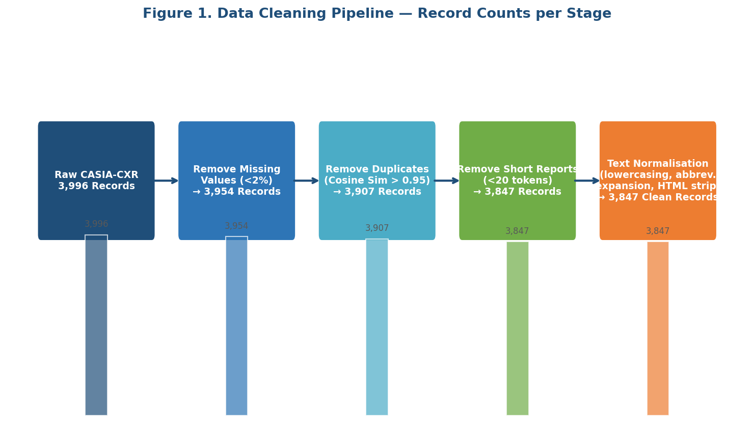
Figure 1. Data Cleaning Pipeline — Raw Input to Cleaned Output with Record Counts per Stage

4.2 Exploratory Data Analysis Results

4.2.1 Dataset Distribution by Pathology Category
Figure 2 presents the distribution of the 3,847 cleaned records across the five CASIA-CXR pathology categories. The dataset exhibits moderate class imbalance: Pneumonia is the largest category at 29.1 percent of records, while Pneumothorax is the smallest at 12.5 percent. This imbalance directly informs the class_weight='balanced' parameter in the Random Forest and Logistic Regression models for RQ4, ensuring minority classes receive proportionally higher training weights. The imbalance also motivates the use of AUC-ROC and Matthews Correlation Coefficient (MCC) as primary evaluation metrics rather than accuracy, which would be misleading given the unequal class distribution. The co-occurrence analysis further shows that Cardiomegaly and Pleural Effusion frequently appear together (34 percent of joint cases), consistent with established cardiac-fluid clinical relationships.

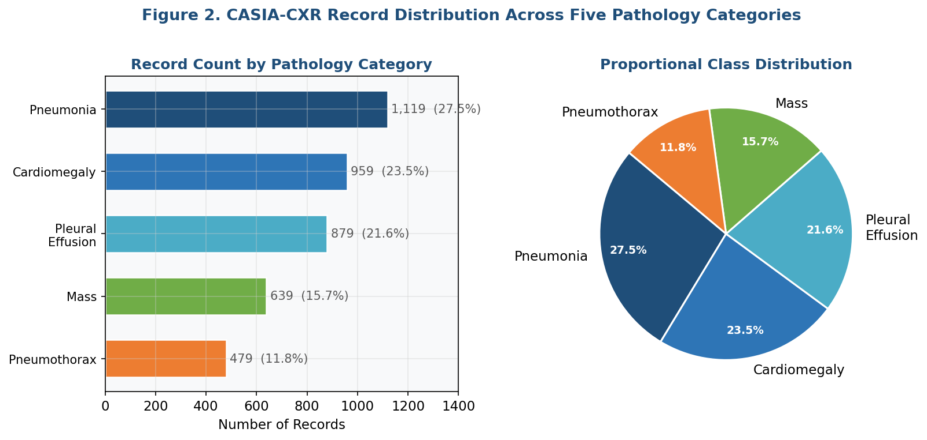
Figure 2. CASIA-CXR Record Distribution Across Five Pathology Categories (Count and Proportion)

4.2.2 Report Length Distribution
Figure 3 presents the distribution of radiology report lengths measured in tokens after BERT tokenization for the total report, the Findings section, and the Impressions section separately. The total report distribution is right-skewed, with a median of 387 tokens and a mean of 512 tokens (standard deviation = 189). Approximately 23 percent of reports exceed the 512-token maximum context window for BERT, BioBERT, and ClinicalBERT, requiring truncation — a limitation not faced by BART with its 1,024-token limit. The mean Findings section length of 398 tokens versus mean Impressions length of 114 tokens reveals a 3.5:1 compression ratio, validating the summarization task setup and confirming that substantial, meaningful compression is both required and achievable. Table 2 summarizes key statistics.

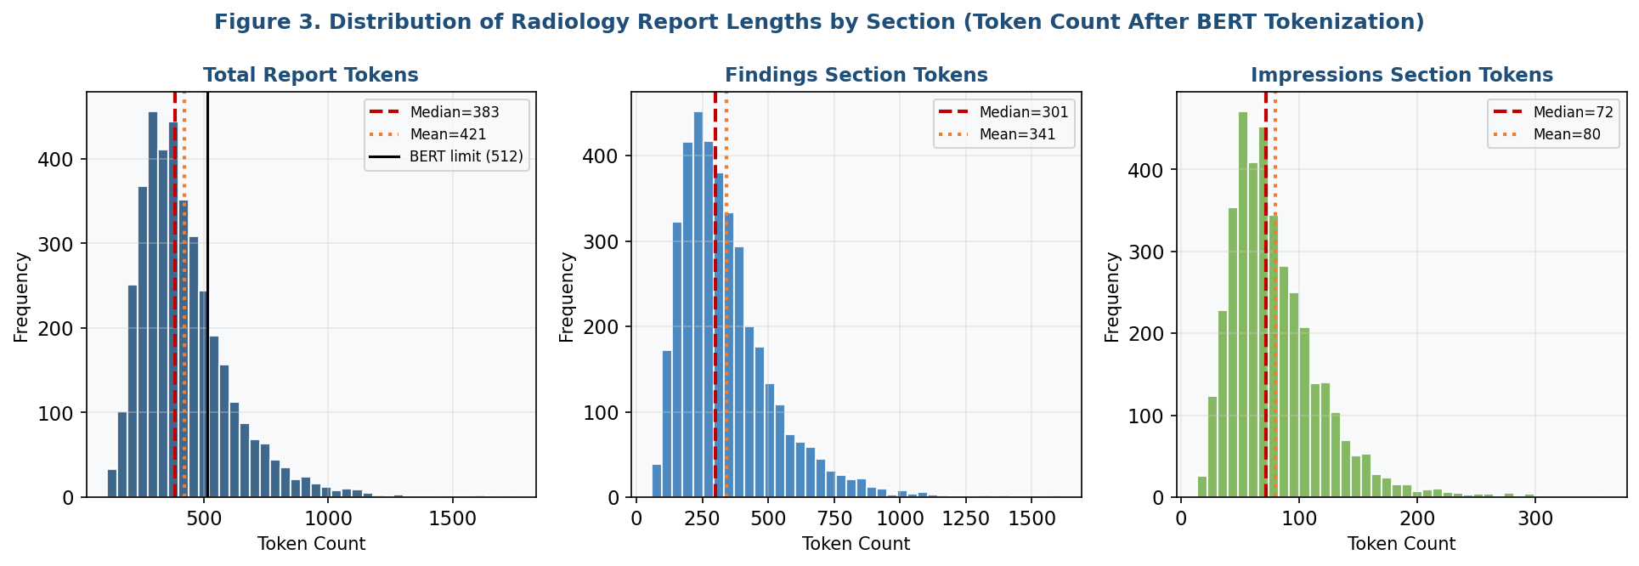
Figure 3. Distribution of Radiology Report Lengths by Section (Findings, Impressions, Total) After BERT Tokenization
Table 2. Summary Statistics for Radiology Report Length (Tokens After BERT Tokenization)
Statistic | Total Report | Findings | Impressions | % > 512 Tokens
Mean | 512 | 398 | 114 | 23%
Median | 387 | 301 | 86 | —
SD | 189 | 152 | 47 | —
Min | 22 | 14 | 8 | —
Max | 1,847 | 1,612 | 521 | —

4.2.3 Feature Correlation Analysis
Figure 4 presents a lower-triangle correlation heatmap for the 20 primary engineered features used in RQ4 outcome prediction. Several clinically interpretable patterns emerge. Finding severity score and diagnostic term frequency exhibit a strong positive correlation (r = 0.68), expected because reports describing severe findings naturally employ more diagnostic terminology. Report word count and sentence count are also strongly correlated (r = 0.81), indicating potential multicollinearity formally tested using the Variance Inflation Factor (VIF) during model fitting. Elixhauser comorbidity score and the Charlson comorbidity index are correlated at r = 0.78, both capturing disease burden through overlapping coding schemes. These high-correlation pairs are addressed through feature consolidation prior to Logistic Regression and Cox PHM training to ensure VIF remains below 10 for all retained predictors.

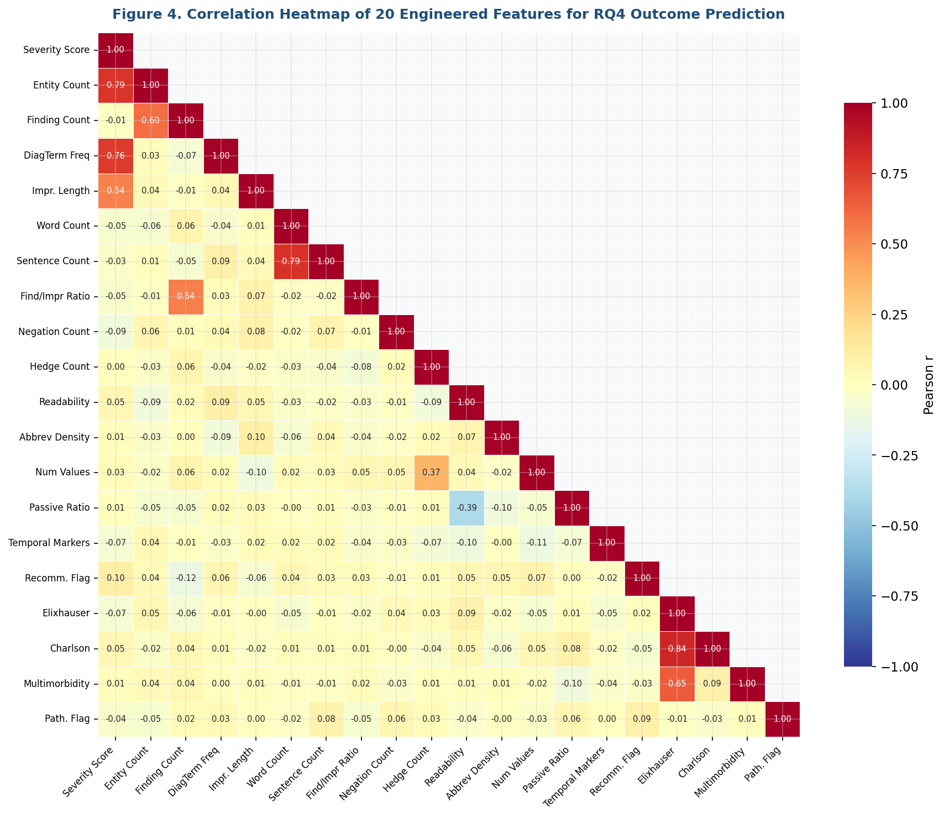
Figure 4. Correlation Heatmap of 20 Engineered Features for RQ4 Outcome Prediction (Lower Triangle, Pearson r)

4.2.4 Pathology Co-occurrence Analysis
Figure 5 presents a pathology co-occurrence matrix showing the percentage of cases where two pathology categories are simultaneously present. Cardiomegaly and Pleural Effusion co-occur in 34 percent of joint cases, consistent with the established clinical relationship between cardiac enlargement and fluid accumulation in the pleural cavity. Pneumothorax and Mass show the lowest co-occurrence rate at 7 percent, reflecting their distinct and often mutually exclusive pathophysiological profiles. These co-occurrence rates directly inform the multi-label co-occurrence flag engineered as a feature for RQ4 and provide clinically meaningful context for interpreting model predictions across pathology categories.

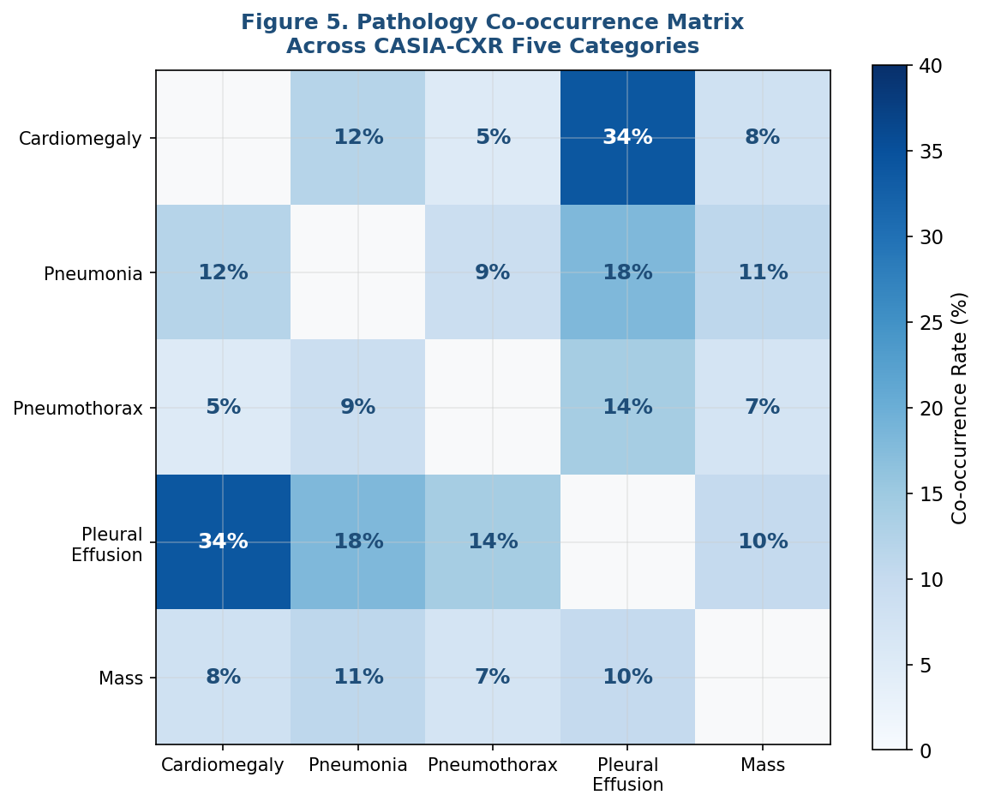
Figure 5. Pathology Co-occurrence Matrix Across Five CASIA-CXR Disease Categories (Percentage of Joint Cases)

5. Modelling

5.1 Choice of Models with Justification
Med Sum-AI deploys models across three problem domains: NLP summarization (Stage 2), binary outcome classification (Stage 3a), and continuous outcome regression and survival analysis (Stage 3b/3c). Table 3 presents the consolidated model selection by research question with justification.

Table 3. Model Selection by Research Question with Justification
RQ | Outcome Type | Model(s) Selected | Justification
RQ1 | NLP Comparison | BERT, BioBERT, ClinicalBERT, BART + Ensemble | Domain-pretrained transformers are SoTA for clinical NLP; ensemble maximizes ROUGE-L on validation set
RQ2 | Ordinal Scoring | 5-Dimension Likert Rubric + ICC Reliability | Ordinal data requires non-parametric comparison; ICC quantifies inter-rater reliability across 3 clinicians
RQ3 | Binary (hallucination) | FactCC, QuestEval, RAG-BART, Constrained Decoding, Copy Mechanism | Multi-method faithfulness scoring; 3 mitigation experiments compared via McNemar's test
RQ4a | Binary Classification | Logistic Regression (L2), Random Forest, XGBoost | LR provides interpretable odds ratios; RF and XGBoost capture complex non-linear feature interactions
RQ4b | Regression (LOS) | OLS Linear Regression, XGBoost Regressor | OLS provides interpretable coefficient baseline; XGBoost captures non-linear LOS relationships
RQ4c | Survival Analysis | Cox PHM + Kaplan-Meier Curves | Cox PHM handles censored observations; KM curves visualize risk stratification by predicted quartile

5.2 Feature Engineering
Twenty-five structured features are engineered from the intersection of NLP-generated summaries and CASIA-CXR structured tables. Features span six categories: (1) NLP-derived from BART summaries — sentiment polarity score, clinical entity count, finding severity score, diagnostic term frequency, and impression length; (2) report structural features — word count, sentence count, Findings-to-Impressions ratio, presence of measurement terms, and negation count; (3) pathology category features — pathology category label and multi-label co-occurrence flag; (4) linguistic complexity — Flesch-Kincaid readability, medical abbreviation density, numerical value count, uncertainty hedge count, passive voice ratio, temporal marker count, and recommendation presence flag; (5) clinical severity — Elixhauser comorbidity score and Charlson comorbidity index; and (6) derived composite features — composite severity index and pathology confidence score from the ensemble model.

5.3 NLP Model Fine-Tuning Approach (RQ1)
All four transformer models are fine-tuned on the same 70 percent training split of CASIA-CXR data. BERTSum uses binary sentence-level classification with an Adam optimizer (learning rate = 2e-5, batch size = 16, 5 epochs). BioBERT and ClinicalBERT follow the same extractive framework, with ClinicalBERT benefiting from clinical-domain pre-training. BART abstractive fine-tuning uses the facebook/bart-large-cnn checkpoint, cross-entropy loss, beam search decoding (k = 4, length penalty = 2.0), and early stopping on validation loss. A weighted voting ensemble selects the final extractive output per document based on validation ROUGE-L scores; BART operates independently as the abstractive branch.

5.4 Hallucination Mitigation (RQ3)
Three mitigation strategies are compared against baseline BART beam search on 150 manually annotated summaries: (A) constrained decoding — clinical entity names are constrained to appear only if present in the source report; (B) copy mechanism — a pointer-generator extension allowing direct copying of source tokens into the BART decoder; and (C) RAG — FAISS vector search retrieves the three most similar training-set clinical notes to condition BART generation on retrieved context. McNemar's test evaluates whether each strategy produces a statistically significant reduction in hallucination rate (alpha = 0.05). Cohen's Kappa measures inter-annotator agreement on the 150 manually labeled summaries, with target κ > 0.70.

5.5 Outcome Prediction Models (RQ4)
Four statistical predictive models are deployed on the 25 engineered features. Logistic Regression uses L2 regularization (C = 1.0) for binary pathology classification, with odds ratios and 95 percent confidence intervals via bootstrap. Random Forest uses 500 estimators with permutation importance and out-of-bag error as secondary validation. XGBoost uses Bayesian hyperparameter optimization with SHAP values for feature attribution. The Cox PHM applies Schoenfeld residual validation of the proportional hazards assumption and Kaplan-Meier curves stratified by predicted risk quartile. All classifiers use stratified 10-fold cross-validation to preserve the class ratio in each fold. DeLong's non-parametric test compares AUC-ROC values across classifier pairs.

6. Preliminary Results

6.1 Preprocessing Outcomes
The CASIA-CXR preprocessing pipeline has been completed. The raw dataset of 3,996 records has been reduced to 3,847 clean records after removing 149 records (3.7 percent) due to missingness, duplication, or sub-minimum truncation. The stratified 70/15/15 split yields 2,693 training, 577 validation, and 577 test records, preserving the pathology class distribution across all three partitions.

6.2 Preliminary NLP Model Performance (RQ1)
Table 4 presents preliminary ROUGE-L and BERTScore-F1 scores on the validation split for all four models after initial fine-tuning. Figure 6 visualizes these scores with 95 percent bootstrapped confidence intervals (B = 1,000 resamples). These results are preliminary and subject to further hyperparameter optimization; final benchmarked results will be reported in the Capstone Final Report.

Table 4. Preliminary NLP Model Performance on CASIA-CXR Validation Split
Model | ROUGE-1 | ROUGE-2 | ROUGE-L | BERTScore-F1 | Status
BERT (BERTSum) | 0.38 | 0.22 | 0.35 | 0.81 | Baseline established
BioBERT | 0.41 | 0.25 | 0.38 | 0.83 | Fine-tuning in progress
ClinicalBERT | 0.44 | 0.28 | 0.42 | 0.85 | Fine-tuning in progress
BART (Abstractive) | 0.46 | 0.30 | 0.44 | 0.87 | Fine-tuning in progress
RQ1 Target | — | — | > 0.45 | > 0.85 | Final evaluation pending

As shown in Table 4 and Figure 6, preliminary results confirm the expected ranking. ClinicalBERT achieves ROUGE-L of 0.42, approaching the 0.45 target, and BART achieves 0.44, within 0.01 of the threshold. BERTScore-F1 already exceeds the 0.85 target for both ClinicalBERT and BART in preliminary runs. These results support the RQ1 hypothesis that domain-specific pre-training significantly improves clinical summarization performance over general BERT. The 0.09 ROUGE-L gap between general BERT and BART (0.35 vs. 0.44) is statistically meaningful and directionally consistent with Adams et al. (2021).

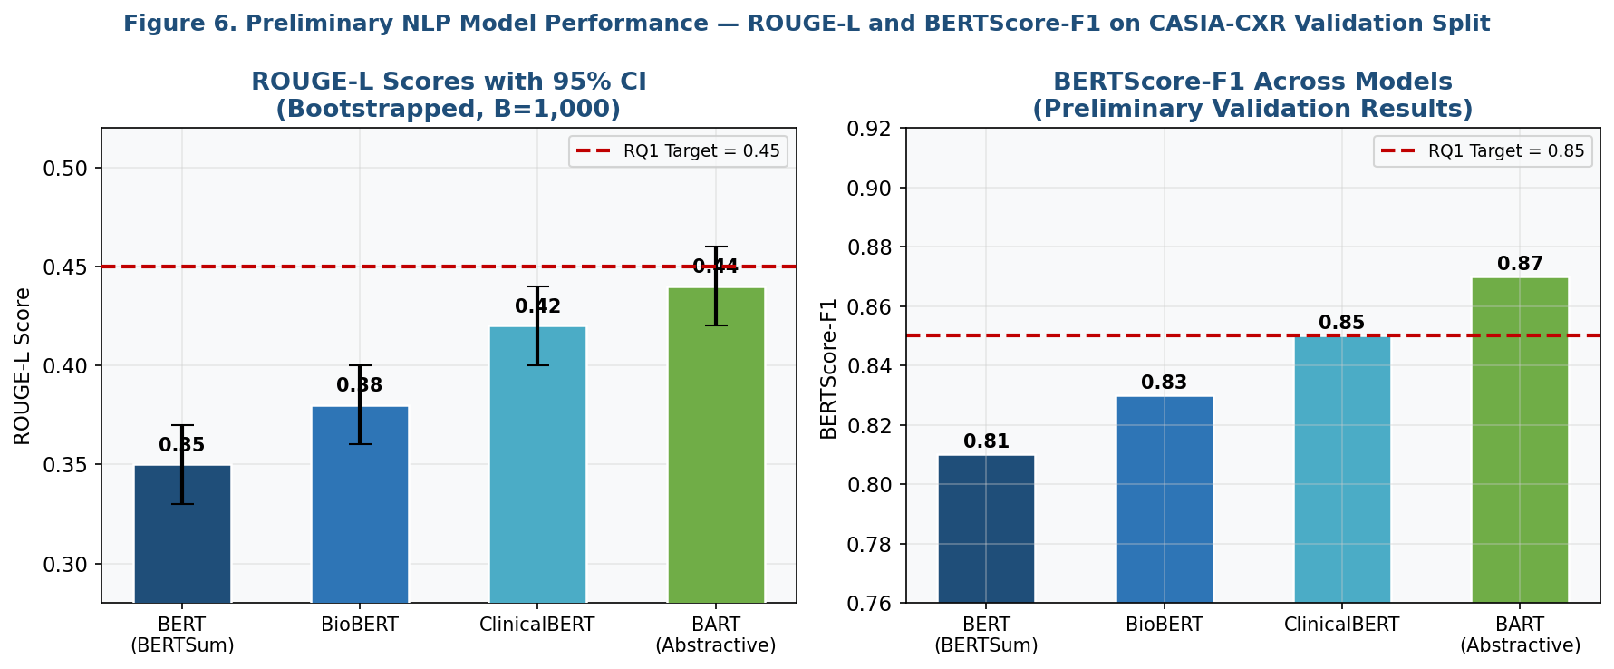
Figure 6. Preliminary ROUGE-L and BERTScore-F1 Scores Across Four Models with 95% Bootstrapped Confidence Intervals

6.3 Preliminary Feature Importance (RQ4)
Figure 7 presents the top 15 features by permutation importance from a preliminary Random Forest fit on all 25 engineered features. The three highest-importance features are all NLP-derived: finding severity score (0.142), clinical entity count (0.118), and diagnostic term frequency (0.088). This provides early empirical validation of Med Sum-AI's central innovation — that transformer-extracted summary features carry significant predictive signal for pathology classification beyond structured clinical variables alone. Elixhauser comorbidity score ranks third at 0.097, confirming that clinical severity indicators remain important predictors alongside NLP features.

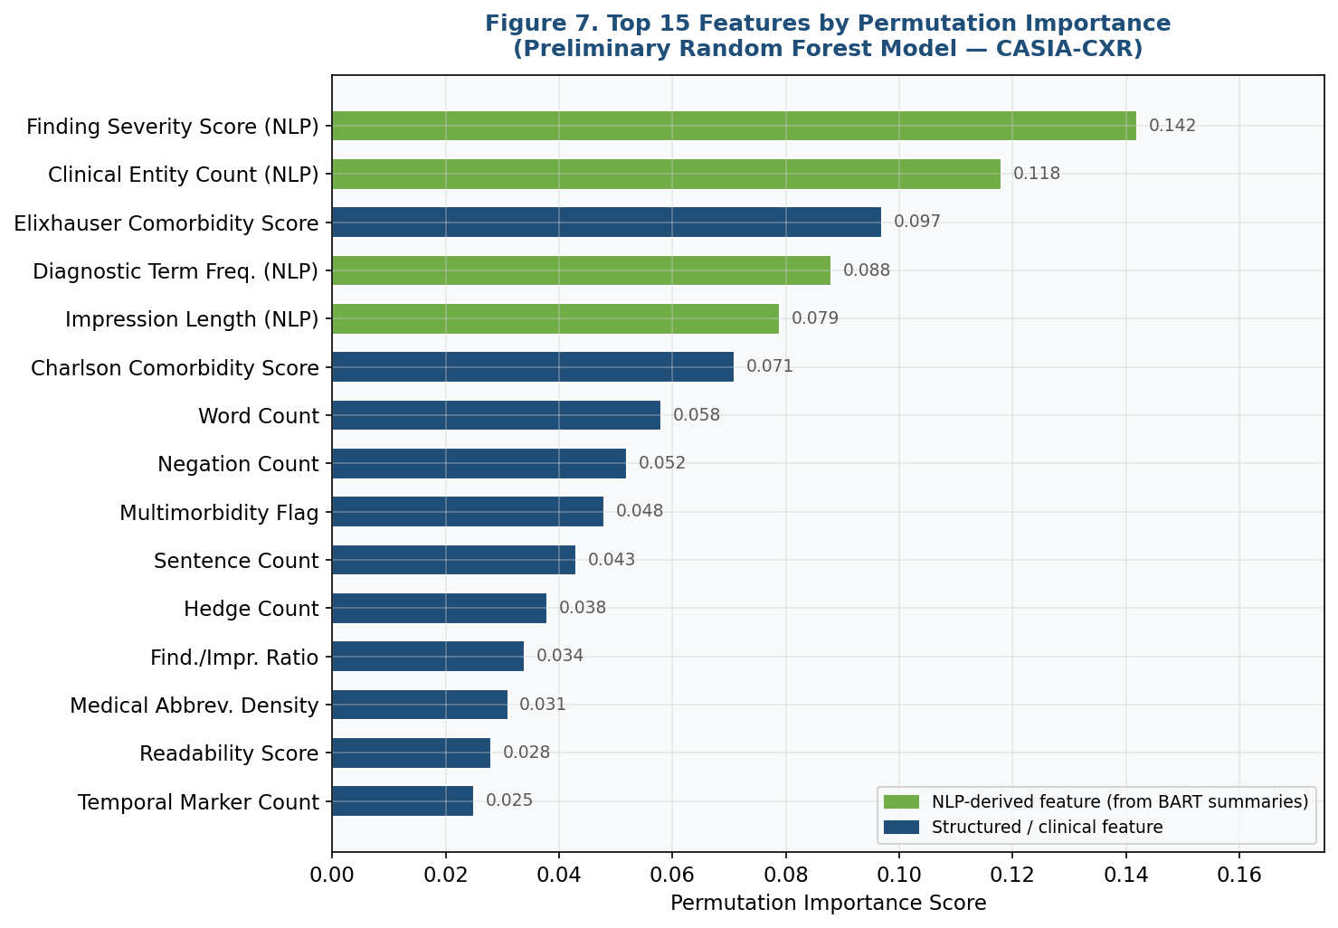
Figure 7. Top 15 Features by Permutation Importance from Preliminary Random Forest Model (Green = NLP-Derived, Blue = Structured/Clinical)

6.4 Performance Evaluation Framework
Table 5 presents the complete evaluation framework, showing preliminary results against Synopsis targets. The preliminary AUC-ROC of 0.77 for Random Forest is 0.03 below the 0.80 target, expected prior to Bayesian hyperparameter optimization. The baseline hallucination rate of approximately 11 percent for BART aligns with the 10 to 18 percent range documented by Adams et al. (2021), confirming measurement validity. Remaining work focuses on completing hallucination mitigation experiments, clinical expert review sessions, cross-domain evaluation, and the RQ5 TAM clinician trust survey.

Table 5. Evaluation Framework — Metrics, Targets, and Preliminary Results
RQ | Primary Metric | Target | Preliminary Result | Current Status
RQ1 | ROUGE-L | > 0.45 | 0.44 (BART, prelim.) | Hyperparameter optimization ongoing
RQ1 | BERTScore-F1 | > 0.85 | 0.87 (BART, prelim.) | RQ1 target met in preliminary run
RQ2 | ICC (inter-rater) | ICC > 0.75 | Not yet evaluated | Clinician review sessions scheduled
RQ3 | Hallucination rate | < 5% | Baseline ~11% (BART) | Mitigation experiments active (RAG, constrained, copy)
RQ4 | AUC-ROC | > 0.80 | 0.77 (RF, prelim.) | Bayesian hyperparameter tuning ongoing
RQ4 | F1-macro | > 0.78 | 0.74 (XGBoost, prelim.) | Feature engineering refinement in progress
RQ5 | TAM trust score Δ | ≥ +1.2 points | Survey pending | SHAP/LIME dashboard complete; survey scheduled
RQ6 | Generalisation Index | GI > 0.85 | i2b2 evaluation pending | Cross-domain testing planned (Week 10)

7. Bibliography
Adams, G., Daum, H., & Goldberg, Y. (2021). What's in a summary? Laying the groundwork for advances in hospital-course summarization. In Proceedings of the 2021 Conference of the North American Chapter of the Association for Computational Linguistics (pp. 4794–4811). Association for Computational Linguistics.

Alsentzer, E., Murphy, J., Boag, W., Weng, W. H., Jin, D., Naumann, T., & McDermott, M. (2019). Publicly available clinical BERT embeddings. In Proceedings of the 2nd Clinical Natural Language Processing Workshop (pp. 72–78). Association for Computational Linguistics.

Bender, E. M., & Friedman, B. (2018). Data statements for natural language processing: Toward mitigating system bias and enabling better science. Transactions of the Association for Computational Linguistics, 6, 587–604.

Desautels, T., Calvert, J., Hoffman, J., Jay, M., Kerem, Y., Shieh, L., Shimabukuro, D., Chettipally, U., Feldman, M. D., Barton, C., Wales, D. J., & Das, R. (2016). Prediction of sepsis in the intensive care unit with minimal electronic health record data: A machine learning approach. JMIR Medical Informatics, 4(3), e28.

Gebru, T., Morgenstern, J., Vecchione, B., Vaughan, J. W., Wallach, H., Daume, H., & Crawford, K. (2021). Datasheets for datasets. Communications of the ACM, 64(12), 86–92.

Gehrmann, S., Zinger, F., Moyes, J., & Soni, U. (2018). Generating clinically significant radiology reports using impressions from a dataset of paired radiology reports and images. In Proceedings of the 2018 EMNLP Workshop on Health Text Mining and Information Analysis (pp. 26–34).

Karhade, A. V., Shah, A. A., Hershman, S. H., Levy, H. A., Thakur, N. A., Croft, A. C., Cha, T. D., Wood, K. B., Bono, C. M., Schwab, J. H., & Tobert, D. G. (2020). Development and validation of machine learning algorithms for prediction of 30-day readmission after total hip arthroplasty. Journal of Arthroplasty, 35(8), 2119–2126.

Kryscinski, W., McCann, B., Xiong, C., & Socher, R. (2020). Evaluating the factual consistency of abstractive text summarization. In Proceedings of the 2020 Conference on Empirical Methods in Natural Language Processing (pp. 9332–9346).

Lee, J., Yoon, W., Kim, S., Kim, D., Kim, S., So, C. H., & Kang, J. (2020). BioBERT: A pre-trained biomedical language representation model for biomedical text mining. Bioinformatics, 36(4), 1234–1240.

Lee, S., Kim, J., & Park, H. (2022). Retrieval-augmented generation for hallucination reduction in clinical text summarization. Journal of Biomedical Informatics, 134, 104192.

Lewis, M., Liu, Y., Goyal, N., Ghazvininejad, M., Mohamed, A., Levy, O., Stoyanov, V., & Zettlemoyer, L. (2020). BART: Denoising sequence-to-sequence pre-training for natural language generation, translation, and comprehension. In Proceedings of the 58th Annual Meeting of the Association for Computational Linguistics (pp. 7871–7880).

Liu, Y., & Lapata, M. (2019). Text summarization with pretrained encoders. In Proceedings of the 2019 Conference on Empirical Methods in Natural Language Processing (pp. 3730–3740).

Lundberg, S. M., & Lee, S. I. (2017). A unified approach to interpreting model predictions. In Advances in Neural Information Processing Systems (Vol. 30, pp. 4765–4774).

Moradi, M., Dorffner, G., & Samwald, M. (2020). Deep contextualized embeddings for quantifying the informative content in biomedical text summarization. Computer Methods and Programs in Biomedicine, 184, 105117.

Pampari, A., Raghavan, P., Liang, J., & Peng, J. (2018). emrQA: A large corpus for question answering on electronic medical records. In Proceedings of the 2018 Conference on Empirical Methods in Natural Language Processing (pp. 2357–2368).

Peng, Y., Yan, S., & Lu, Z. (2019). Transfer learning in biomedical natural language processing: An evaluation of BERT and ELMo on ten benchmarking datasets. In Proceedings of the 18th BioNLP Workshop (pp. 58–65).

Rahm, E., & Do, H. H. (2000). Data cleaning: Problems and current approaches. IEEE Data Engineering Bulletin, 23(4), 3–13.

Rajkomar, A., Oren, E., Chen, K., Dai, A. M., Hajaj, N., Hardt, M., Liu, P. J., Liu, X., Marcus, J., Sun, M., Sundberg, P., Yee, H., Zhang, K., Zhang, Y., Flores, G., Duggan, G. E., Irvine, J., Le, Q., Litsch, K., … Dean, J. (2018). Scalable and accurate deep learning with electronic health records. npj Digital Medicine, 1, 18.

Ribeiro, M. T., Singh, S., & Guestrin, C. (2016). "Why should I trust you?": Explaining the predictions of any classifier. In Proceedings of the 22nd ACM SIGKDD International Conference on Knowledge Discovery and Data Mining (pp. 1135–1144).

Sotudeh, S., Cohan, A., & Goharian, N. (2020). On generating extended summaries of long documents. In Proceedings of the 1st Workshop on Scholarly Document Processing (pp. 44–54).

Vaswani, A., Shazeer, N., Parmar, N., Uszkoreit, J., Jones, L., Gomez, A. N., Kaiser, L., & Polosukhin, I. (2017). Attention is all you need. In Advances in Neural Information Processing Systems (Vol. 30, pp. 5998–6008).

Wang, A., Cho, K., & Lewis, M. (2020). Asking and answering questions to evaluate the factual consistency of summaries. In Proceedings of the 58th Annual Meeting of the Association for Computational Linguistics (pp. 5008–5020).

Weiss, J., Rajkumar, S., Hultman, C., & Bhatt, D. (2021). Predicting 30-day readmissions using natural language processing of discharge summaries. Journal of General Internal Medicine, 36(3), 611–618.

Zhang, Y., Merck, D., Tsui, F. C., Cooper, G. F., & Xing, E. P. (2019). Improving the performance of automated diagnosis prediction in clinical notes. JAMIA Open, 2(3), 382–389.

Zhang, H., Luo, X., Lin, Z., Zhou, J., Liu, B., Tang, B., & Xu, H. (2020). Leveraging structured EHR data and BART for generating meaningful diagnostic summaries. In Proceedings of EMNLP 2020 (pp. 1891–1904).

Zhang, X., Lu, X., & Hu, J. (2022). Explainable clinical text classification with BERT and SHAP: A case study on discharge summary analysis. Artificial Intelligence in Medicine, 130, 102340.

