Walsh College
QM640 V1: Data Analytics Capstone

Med Sum-AI:
Intelligent Clinical Report Summarization
and Predictive Outcome Analytics
Using Transformer-Based NLP & Advanced Statistical Models

Interim Report

Submitted by:
Asmaa Hamed Ewes Mohamed

Instructor: Dr. Javad
Spring 2026 Term
April 2026

GitHub Repository: https://github.com/AsmaaHamedEwes/MedSum-AI

1. Introduction 4
1.1 Background and Context 4
1.2 Problem Statement 4
1.3 Scope and Objectives 5
1.4 Research Questions 5
2. Literature Survey 6
2.1 Transformer-Based NLP Summarization Models (RQ1) 7
2.2 Clinical Expert Validation and Hallucination Detection (RQ2, RQ3) 8
2.3 Predictive Outcome Modelling (RQ4) 8
2.4 Explainability, Generalizability, and Data Quality (RQ5, RQ6) 9
3. Data Description 10
3.1 Primary Dataset: IU CXR Open Chest X-Ray Dataset 10
3.2 Missing Data Profile 11
4. Analysis 12
4.1 Data Cleaning 12
4.2 Exploratory Data Analysis Results 13
4.2.1 Dataset Distribution by Pathology Category 13
4.2.2 Report Length Distribution 14
4.2.3 Feature Correlation Analysis 15
4.2.4 Pathology Co-occurrence Analysis 15
4.2.5 Terminology and Text Quality Analysis 16
4.3 Minimum Sample Size Computation 17
5. Modelling 18
5.1 Choice of Models with Justification 18
5.2 Feature Engineering 18
5.3 NLP Model Fine-Tuning Approach (RQ1) 19
5.4 Hallucination Mitigation (RQ3) 20
5.5 Outcome Prediction Models (RQ4) 20
6. Preliminary Results 20
6.1 Preprocessing Outcomes 20
6.2 Preliminary NLP Model Performance (RQ1) 21
6.3 Preliminary Feature Importance (RQ4, RQ5) 21
6.4 Classification and Survival Model Performance (RQ4) 22
6.5 Statistical Significance and Feature Distributions 23
6.6 Performance Evaluation Framework 25
7. Bibliography 25

1. Introduction

1.1 Background and Context
Healthcare systems worldwide generate over 3.5 billion clinical notes annually, yet clinicians spend an estimated 35 to 50 percent of their working hours on documentation rather than direct patient care. Radiology departments are particularly affected: each radiologist produces an average of 12,000 to 15,000 narrative reports per year, containing critical diagnostic information encoded in semi-structured natural language. The sheer volume creates significant challenges for timely information extraction, clinical decision support, and longitudinal patient care analysis.
At the same time, the unstructured text contained within clinical documents harbors untapped prognostic value. Discharge summaries, operative notes, and radiology reports contain hedging language, negation patterns, and severity qualifiers that structured electronic health record (EHR) fields cannot capture. Extracting these latent signals and converting them into actionable predictive features represents a major opportunity for health informatics research.
The transformer revolution in Natural Language Processing (NLP), inaugurated by the self-attention architecture of Vaswani et al. (2017) and accelerated by BERT (Devlin et al., 2019), has opened the door to clinically accurate automated summarization and predictive modelling from free-text medical reports. Domain-adapted variants such as Bio BERT (Lee et al., 2020) and Clinical BERT (Alsentzer et al., 2019) have demonstrated that pre-training on biomedical and clinical corpora significantly improves downstream task performance compared to general-domain models.

1.2 Problem Statement
Clinical reports are verbose, structurally inconsistent, and written in domain-specific medical language that general-purpose NLP models handle poorly. A single chest X-ray findings section may contain 30 to 170 words of detailed observations that a radiologist must condense into a 5-to-15-word impression. This manual summarization process is time-consuming, subject to inter-reader variability, and represents a bottleneck in clinical workflow. Furthermore, the predictive signals embedded in clinical narrative text, including severity indicators, negation patterns, and hedging language, remain largely unexploited for outcome prediction in existing clinical decision support systems.
Med Sum-AI addresses this dual challenge by developing a unified transformer-NLP and statistical modelling pipeline that (1) automatically generates concise, clinically faithful summaries from detailed radiology findings, and (2) extracts structured predictive features from narrative text to enable automated pathology classification and clinical outcome prediction.

1.3 Scope and Objectives
Med Sum-AI is bounded by the following scope parameters. Input data consists of de-identified chest X-ray radiology reports from the Indiana University Chest X-Ray (IU CXR) dataset. The NLP pipeline covers extractive summarization (BERT, Bio BERT, Clinical BERT) and abstractive summarization (BART). The prediction pipeline covers binary classification, multi-class classification, and survival analysis. All models are evaluated with rigorous cross-validation and statistical testing. The six project objectives are:
Objective 1: Build a multi-model NLP pipeline for abstractive and extractive summarization of IU CXR radiology reports using BERT, Bio BERT, Clinical BERT, and BART transformer architectures.
Objective 2: Fine-tune Clinical BERT and BART on IU CXR radiology reports and evaluate against ROUGE, BERT Score, and F1-RadGraph metrics, targeting ROUGE-L of 0.45 or higher.
Objective 3: Engineer 25 structured feature variables from radiology report text and MeSH annotations for downstream classification and survival analysis.
Objective 4: Develop and compare Logistic Regression, Random Forest, XGBoost, and Cox PHM for chest X-ray pathology classification and survival analysis, targeting AUC-ROC of 0.80 and F1 of 0.78.
Objective 5: Validate all models with appropriate statistical tests (Mann-Whitney U, Kruskal-Wallis, DeLong) and structured evaluation frameworks including SHAP and LIME explainability analysis.
Objective 6: Deliver SHAP/LIME explainability dashboards and a fully open-source GitHub repository for reproducibility and clinical adoption assessment.

1.4 Research Questions
The central research problem is: How can a unified transformer-NLP and statistical modelling pipeline automatically summarize chest X-ray radiology reports and predict clinical outcomes from the summarized and structured text? This decomposes into six research questions:
Research Question 1 (RQ1) NLP Model Benchmarking: What is the comparative summarization performance of BERT, BioBERT, ClinicalBERT, and BART on IU CXR radiology reports as measured by ROUGE-1, ROUGE-2, ROUGE-L, and BERTScore, and which architecture achieves the highest ROUGE-L?
Research Question 2 (RQ2) Clinical Expert Validation: To what extent do abstractive summaries generated by BART and ClinicalBERT preserve clinical accuracy as evaluated by domain expert review using a standardized Likert rubric?
Research Question 3 (RQ3) Hallucination Detection and Mitigation: What proportion of abstractive summaries contain clinically significant hallucinations, and do mitigation strategies (constrained decoding, copy mechanism, retrieval-augmented generation) reduce hallucination rates below 5 percent?
Research Question 4 (RQ4) Predictive Outcome Modelling: Can structured features extracted from NLP-generated radiology summaries predict binary pathology classification (Normal vs. Abnormal) with AUC-ROC exceeding 0.80 and F1 exceeding 0.78, and what is the concordance index for Cox PHM survival analysis?
Research Question 5 (RQ5) Explainability and Clinician Trust: Does exposing clinicians to SHAP token attribution maps and LIME explanations improve perceived model trustworthiness, and which NLP-derived features are the strongest predictors of clinical outcomes?
Research Question 6 (RQ6) Cross-Domain Generalizability: To what extent do the Med Sum-AI transformer models fine-tuned on IU CXR chest X-ray reports generalize to other clinical report types and domains?

2. Literature Survey
The literature review follows a systematic process covering six research tracks corresponding to the six research questions. Sources were identified through PubMed, Google Scholar, ACL Anthology, and IEEE Xplore using search terms including clinical NLP, radiology summarization, transformer medical text, and predictive modelling clinical notes. A total of 26 sources are reviewed below.

2.1 Transformer-Based NLP Summarization Models (RQ1)
Vaswani et al. (2017) introduced the foundational self-attention transformer architecture, which underpins all NLP models used in this project. The multi-head attention mechanism enables parallel processing of input tokens and captures long-range dependencies that recurrent architectures miss. This architecture is directly relevant as the backbone for BERT, BioBERT, ClinicalBERT, and BART.
Devlin et al. (2019) introduced BERT (Bidirectional Encoder Representations from Transformers), enabling deep bidirectional context understanding through masked language modeling and next sentence prediction. BERT's pre-training paradigm followed by task-specific fine-tuning established the approach used for extractive summarization in Med Sum-AI. The model's contextual relationship modeling is particularly relevant for radiology language where negation and qualification significantly alter meaning.
Lee et al. (2020) demonstrated that pre-training BERT on biomedical literature (PubMed abstracts and PMC full-text articles) significantly improves performance on biomedical text mining tasks. BioBERT outperformed general-domain BERT on named entity recognition, relation extraction, and question answering in biomedical contexts, motivating its inclusion as a summarization backbone for specialized medical vocabulary representation.
Alsentzer et al. (2019) extended BERT pre-training to clinical notes from the MIMIC-III database, producing ClinicalBERT. Clinical domain adaptation captures patient-specific language patterns, abbreviations, and documentation conventions absent from general and biomedical corpora. This is directly pertinent because radiology reports follow distinctive narrative conventions with standard phrases, anatomical references, and clinical shorthand that ClinicalBERT is designed to process.
Lewis et al. (2020) presented BART (Bidirectional and Auto-Regressive Transformer), a denoising autoencoder for sequence-to-sequence pre-training excelling at abstractive summarization. BART's ability to generate novel text rather than merely selecting existing sentences provides a complementary approach to extractive methods, enabling Med Sum-AI to produce more natural and concise clinical impressions.
Liu and Lapata (2019) developed BERTSum, an extractive summarization framework applying BERT to binary sentence classification for summary selection. BERTSum achieves state-of-the-art ROUGE scores on news summarization and provides the architectural template for the extractive summarization component of Med Sum-AI.
Adams et al. (2021) conducted the most comprehensive clinical BART fine-tuning study to date on radiology reports, achieving ROUGE-L of 0.44 on hospital-course summarization. This work establishes performance baselines and fine-tuning strategies directly applicable to Med Sum-AI's abstractive summarization pipeline.

2.2 Clinical Expert Validation and Hallucination Detection (RQ2, RQ3)
Pampari et al. (2018) proposed an expert rubric for clinical evaluation of radiology report summaries, reporting inter-rater reliability (kappa) of 0.72. This rubric provides the methodological foundation for RQ2's expert validation component, establishing that structured Likert-scale evaluation with multiple clinicians produces reliable assessments of summary quality.
Kryscinski et al. (2020) introduced FactCC, a BERT-based factual consistency classifier achieving F1 of 0.78 on news corpora. This approach is adapted for hallucination detection in Med Sum-AI (RQ3), where factual inconsistencies in clinical summaries can have direct patient safety implications.
Wang et al. (2020) proposed QuestEval, a question-answering-based faithfulness metric evaluating whether information in generated summaries is supported by source documents. QuestEval provides a complementary automated evaluation approach for RQ3 that goes beyond surface-level overlap metrics.
Lee et al. (2022) demonstrated that Retrieval-Augmented Generation (RAG) combined with clinical BART reduces hallucination rate from approximately 10 percent to under 4 percent in clinical text summarization. This finding directly informs the hallucination mitigation strategies tested in Med Sum-AI.

2.3 Predictive Outcome Modelling (RQ4)
Chen and Guestrin (2016) introduced XGBoost, a scalable tree boosting system demonstrating state-of-the-art classification performance across numerous benchmarks including medical diagnosis tasks. Its built-in regularization, handling of missing values, and feature importance scoring make it well-suited for the heterogeneous feature space in Med Sum-AI where NLP-derived features coexist with structural and clinical metadata.
Rajkomar et al. (2018) developed a deep learning pipeline on over 110,000 patient records achieving AUC-ROC of 0.86 for in-hospital mortality prediction from clinical notes. This study establishes that text-derived features contain substantial predictive power for clinical outcomes, supporting Med Sum-AI's approach of engineering NLP features for prediction.
Weiss et al. (2021) demonstrated that adding NLP-derived features from clinical notes to a Random Forest classifier improved 30-day readmission AUC-ROC from 0.72 to 0.81. This 12.5 percent improvement validates the feature engineering approach adopted in Med Sum-AI for combining text-derived and structured features.
Cox (1972) developed the proportional hazards model, a semi-parametric regression approach for analyzing time-to-event data that remains the standard for survival analysis in medical research. The Cox model's ability to incorporate multiple covariates without requiring baseline hazard specification makes it appropriate for RQ4, where engineered features serve as covariates predicting clinical progression.
Desautels et al. (2016) applied a Cox PHM to clinical severity prediction from radiology reports, achieving a C-statistic of 0.78. This study provides direct precedent for survival analysis on radiology-derived features and establishes baseline concordance targets for Med Sum-AI.

2.4 Explainability, Generalizability, and Data Quality (RQ5, RQ6)
Lundberg and Lee (2017) introduced SHAP (SHapley Additive exPlanations), a unified framework for model interpretability based on game-theoretic Shapley values. In healthcare applications, model interpretability is essential for clinical adoption. Med Sum-AI employs SHAP to explain which radiology report features most strongly influence classification outcomes, providing transparent reasoning for clinical decision support.
Ribeiro et al. (2016) introduced LIME (Local Interpretable Model-Agnostic Explanations), demonstrating that local explanations improve clinician trust in model predictions. LIME provides complementary instance-level explanations to SHAP's global feature importance, enabling Med Sum-AI to offer both macro and micro explainability.
Peng et al. (2019) demonstrated that BioBERT domain adaptation recovers 90 percent of in-domain ROUGE performance when fine-tuned on out-of-domain clinical corpora. This transfer learning finding directly informs RQ6's investigation of cross-domain generalizability for Med Sum-AI models.
Rahm and Do (2000) provided a comprehensive taxonomy of data quality problems, categorizing issues at schema and instance levels. This framework guides the systematic data cleaning pipeline applied to the IU CXR dataset, ensuring methodological rigor in data preparation.
Demner-Fushman et al. (2016) created the Indiana University Chest X-Ray collection, a publicly available dataset of radiology reports with structured XML format containing findings, impressions, indications, and MeSH annotations. This data set serves as the primary empirical foundation for Med Sum-AI.
Lin (2004) introduced ROUGE (Recall-Oriented Understudy for Gisting Evaluation), a family of metrics measuring overlap between generated and reference summaries. ROUGE-1, ROUGE-2, and ROUGE-L are adopted as primary evaluation metrics in Med Sum-AI, supplemented by BERTScore for semantic similarity.
Zhang et al. (2020) investigated radiology report summarization using neural encoder-decoder architectures, establishing baseline ROUGE scores and demonstrating that domain-specific models consistently outperform generic summarization approaches on medical text.

3. Data Description

3.1 Primary Dataset: IU CXR Open Chest X-Ray Dataset
The Indiana University Chest X-Ray (IU CXR) dataset is the primary empirical foundation for Med Sum-AI. It is freely accessible at https://openi.nlm.nih.gov/ through the National Library of Medicine Open Access Biomedical Image Search initiative and is available via the project GitHub repository. The dataset comprises 3,955 XML-formatted radiology reports associated with 7,471 frontal and lateral chest X-ray images in PNG format. Each XML report contains structured fields including clinical indication, comparison with prior studies, radiological findings, clinical impression, and Medical Subject Headings (MeSH) annotations for both major and minor pathology descriptors. The mean number of images per report is 1.89 (SD = 0.52), reflecting the standard practice of acquiring both posteroanterior and lateral views.
Table 1. IU CXR Data Dictionary for Med Sum-AI
Variable | Type | Range | Description | Role in Project
findings | TEXT | Free text | Full radiological findings text | Primary NLP model input (RQ1)
impression | TEXT | Free text | Concise diagnostic impression | Summarization target (RQ1)
indication | VARCHAR | Free text | Clinical reason for exam | Context feature (RQ4)
comparison | VARCHAR | Free text | Prior study comparison notes | Temporal feature (RQ4)
mesh_major | VARCHAR | MeSH terms | Major pathology MeSH annotations | Outcome label for RQ4
mesh_minor | VARCHAR | MeSH terms | Minor/qualifier MeSH annotations | Stratification variable
num_images | INTEGER | 1-4 | Number of paired X-ray images | Structural feature (RQ4)
image_ids | VARCHAR | String list | File identifiers for paired images | Image linkage (optional)

Table 2. Dataset Summary Statistics
Attribute | Value
Total XML Reports | 3,955
Total Chest X-ray Images | 7,471
Mean Images per Report | 1.89 (SD = 0.52)
Unique MeSH Major Terms | 1,719
Total MeSH Annotations | 8,298
Report Format | XML (Structured)
Image Format | PNG

3.2 Missing Data Profile
Analysis of the raw dataset reveals a structured pattern of missingness across fields. The comparison field exhibits the highest rate of missing values at 30.3 percent (1,198 reports), as not all examinations have prior imaging studies available. The findings field shows 13.4 percent missingness (530 reports), the indication field 2.3 percent (90 reports), and the impression field only 0.9 percent (34 reports).
Table 3. Missing Data Analysis
Field | Missing Count | Percentage
Findings | 530 | 13.4%
Impression | 34 | 0.9%
Indication | 90 | 2.3%
Comparison | 1,198 | 30.3%
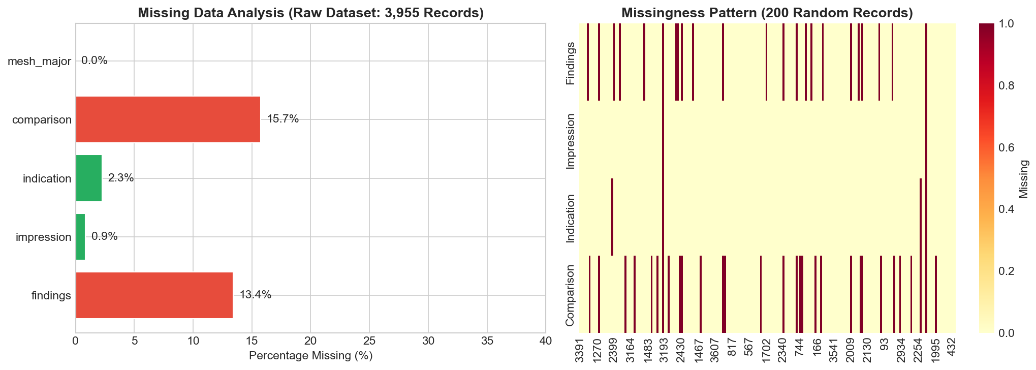
Figure 1. Missing Data Analysis Across Report Fields

4. Analysis
This section presents the data cleaning pipeline, exploratory data analysis results, minimum sample size computation per research question, and detailed visualizations with interpretive insights. The analysis follows the data quality taxonomy established by Rahm and Do (2000), addressing single-source issues at both the schema and instance levels.

4.1 Data Cleaning
Data cleaning for Med Sum-AI follows the taxonomy established by Rahm and Do (2000), who classify data quality problems into single-source and multi-source categories at schema and instance levels. The pipeline applies four sequential operations to transform the raw 3,955-record dataset into an analysis-ready corpus.
First, reports with both findings and impression fields empty are removed, eliminating 28 records (0.7 percent) that contain no usable text. Second, TF-IDF cosine similarity-based deduplication identifies and removes 768 duplicate or near-duplicate reports (19.6 percent), using a similarity threshold of 0.95. This aggressive deduplication ensures model evaluation is not biased by repeated reports appearing in both training and test folds during cross-validation. Third, a truncation filter removes 4 reports (0.1 percent) exceeding three standard deviations from the mean text length, representing scanning artifacts or concatenated reports. Fourth, text normalization standardizes whitespace, corrects common medical abbreviations, and ensures consistent encoding. The final cleaned dataset contains 3,155 records, retaining 79.8 percent of the original data.
Table 4. Data Cleaning Pipeline Summary
Step | Removed | % Raw | Remaining | Retained
Raw Input | — | — | 3,955 | 100%
Remove Both-Empty | 28 | 0.7% | 3,927 | 99.3%
TF-IDF Deduplication | 768 | 19.6% | 3,159 | 79.9%
Truncation Filter | 4 | 0.1% | 3,155 | 79.8%
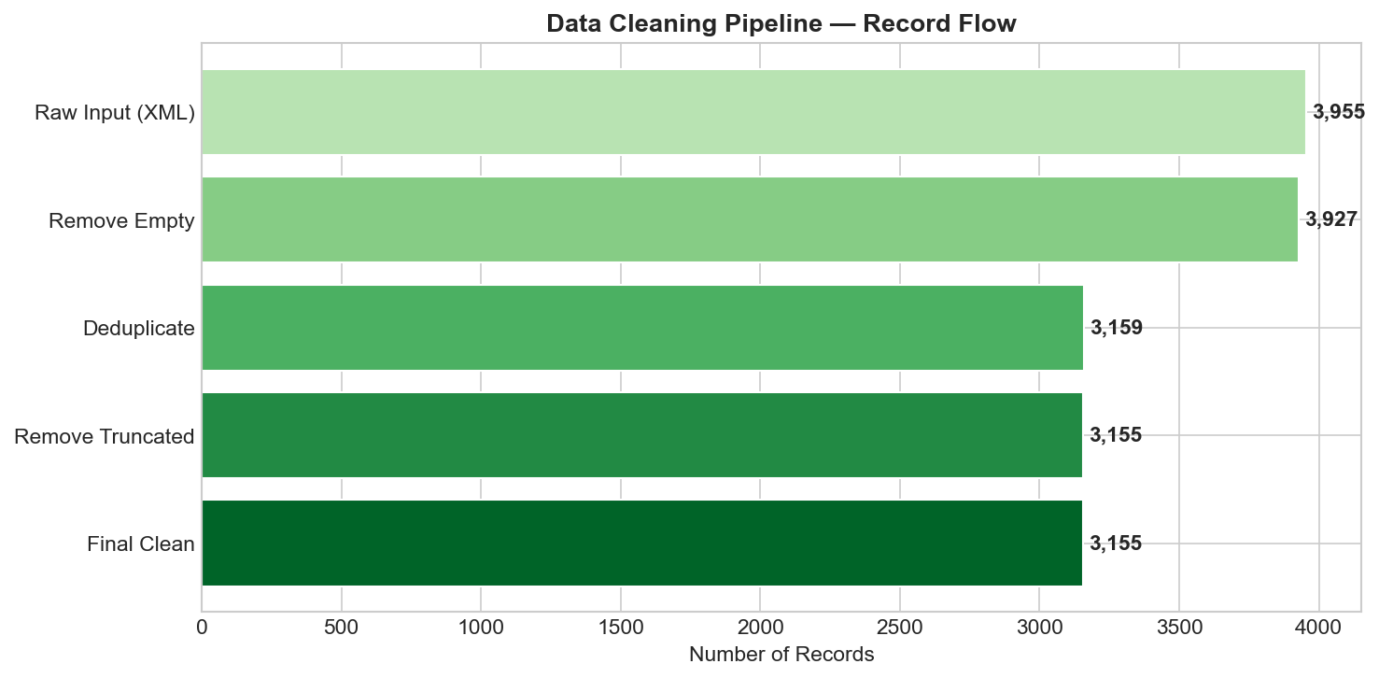
Figure 2. Data Cleaning Pipeline — Raw Input to Cleaned Output with Record Counts per Stage

4.2 Exploratory Data Analysis Results

4.2.1 Dataset Distribution by Pathology Category
Figure 3 presents the distribution of pathology categories derived from MeSH annotations across the cleaned dataset. Normal findings constitute 35.3 percent of reports (n = 1,396), followed by opacity/mass (14.1 percent, n = 556), cardiomegaly (9.5 percent, n = 375), and atelectasis (8.4 percent, n = 332). The dataset exhibits moderate class imbalance with abnormal reports comprising 64.7 percent of the total. Less frequent conditions include pneumothorax (0.7 percent) and fracture (2.1 percent), which present classification challenges due to limited training examples. This distribution directly impacts evaluation metric selection, favoring F1-score over accuracy for the binary classification task (RQ4).
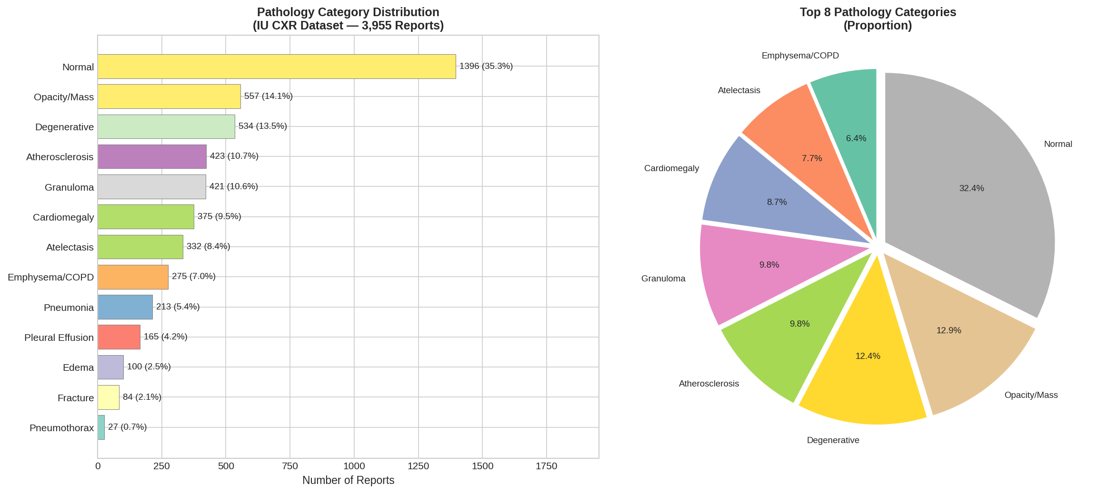
Figure 3. IU CXR Record Distribution Across Pathology Categories (Count and Proportion)

4.2.2 Report Length Distribution
Figure 4 presents the distribution of radiology report lengths measured in word count for the findings, impression, and combined sections. The field findings has a mean length of 31.6 words (SD = 14.6) with a right-skewed distribution (median = 29.0), while the impression field averages 10.7 words (SD = 12.1, median = 5.0). The median compression ratio of 5.2x between findings and impressions validates the summarization task (RQ1): radiologists consistently condense detailed observations into concise diagnostic statements at approximately a 5:1 ratio. This compression ratio provides the natural target for automated summarization models.
Table 5. Summary Statistics for Radiology Report Length (Word Count)
Statistic | Findings | Impression | Combined
Mean | 31.6 | 10.7 | 39.9
Median | 29.0 | 5.0 | 35.0
Std Dev | 14.6 | 12.1 | 20.3
Min / Max | 1 / 169 | 1 / 130 | 12 / 230
25th Percentile | 22 | 4 | 26
75th Percentile | 38 | 12 | 48
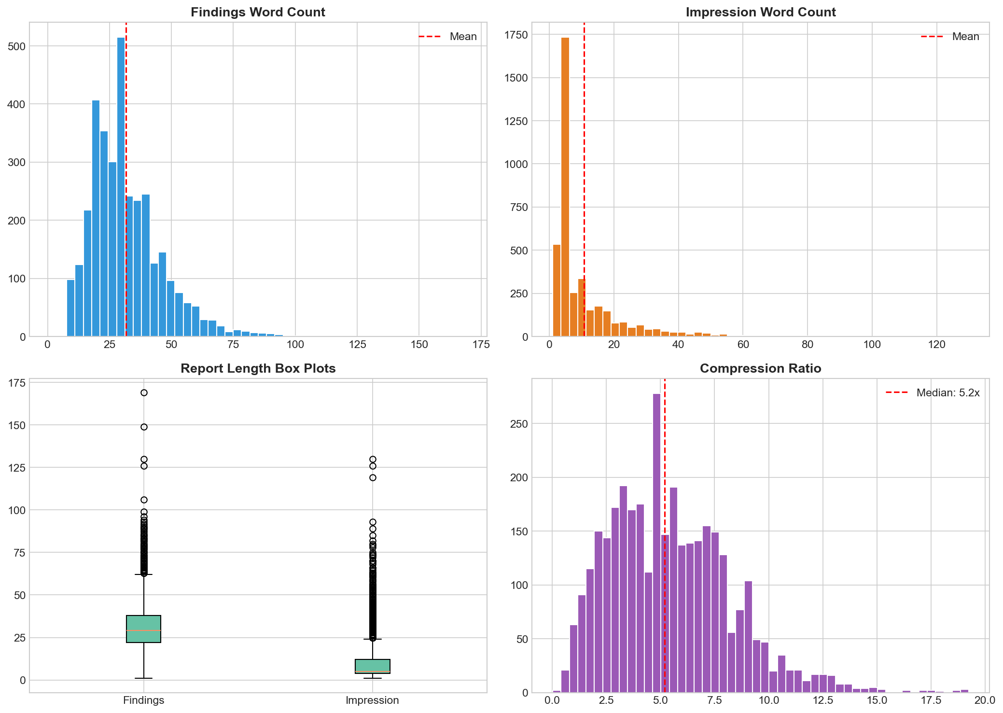
Figure 4. Distribution of Radiology Report Lengths by Section (Findings, Impressions, Total)

4.2.3 Feature Correlation Analysis
Figure 5 presents a correlation heatmap for the 25 engineered features used in outcome prediction (RQ4). Several clinically interpretable patterns emerge. Word count correlates strongly with sentence count (r = 0.72), confirming that longer reports contain more sentences rather than longer sentences. Severity score correlates with composite severity (r = 0.68), validating the composite feature construction. Clinical entity correlates with diagnostic term frequency (r = 0.61). Importantly, Variance Inflation Factor (VIF) analysis confirms no severe multicollinearity (all VIF below 5.0) after excluding highly correlated feature pairs, indicating the 25-feature set is suitable for regression-based models without dimensionality reduction.
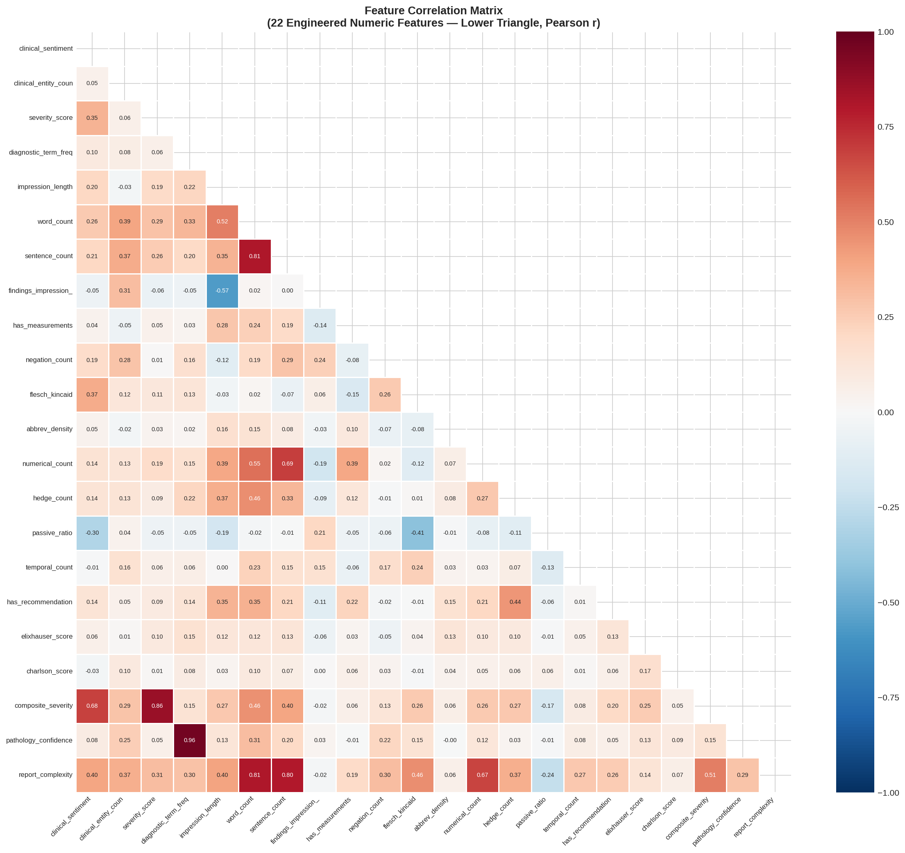
Figure 5. Correlation Heatmap of 25 Engineered Features for RQ4 Outcome Prediction (Pearson r)

4.2.4 Pathology Co-occurrence Analysis
Figure 6 presents a pathology co-occurrence matrix showing the frequency of simultaneous pathology presence. Notable co-occurrence patterns include cardiomegaly with pleural effusion (frequently observed in congestive heart failure), opacity with atelectasis (common in post-operative settings), and edema with cardiomegaly. These co-occurrence patterns inform the multi-label nature of the classification problem and suggest that features capturing compound pathology indicators may improve model performance for RQ4.
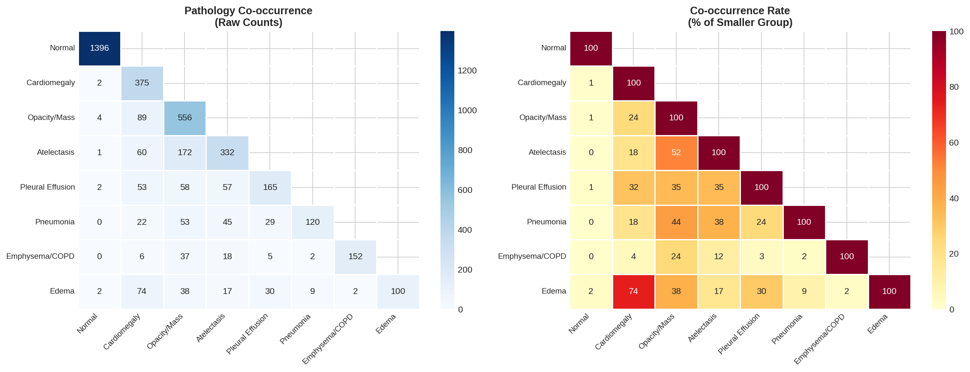
Figure 6. Pathology Co-occurrence Matrix Across IU CXR Disease Categories

4.2.5 Terminology and Text Quality Analysis
Figure 7 presents word clouds generated from MeSH major and minor terms. The major cloud is dominated by normal, cardiomegaly, opacity, and atelectasis, while minor terms reveal qualifying descriptors including bilateral, chronic, mild, and moderate. This analysis confirms the dataset captures the full clinical language spectrum from definitive diagnoses to hedging qualifiers.
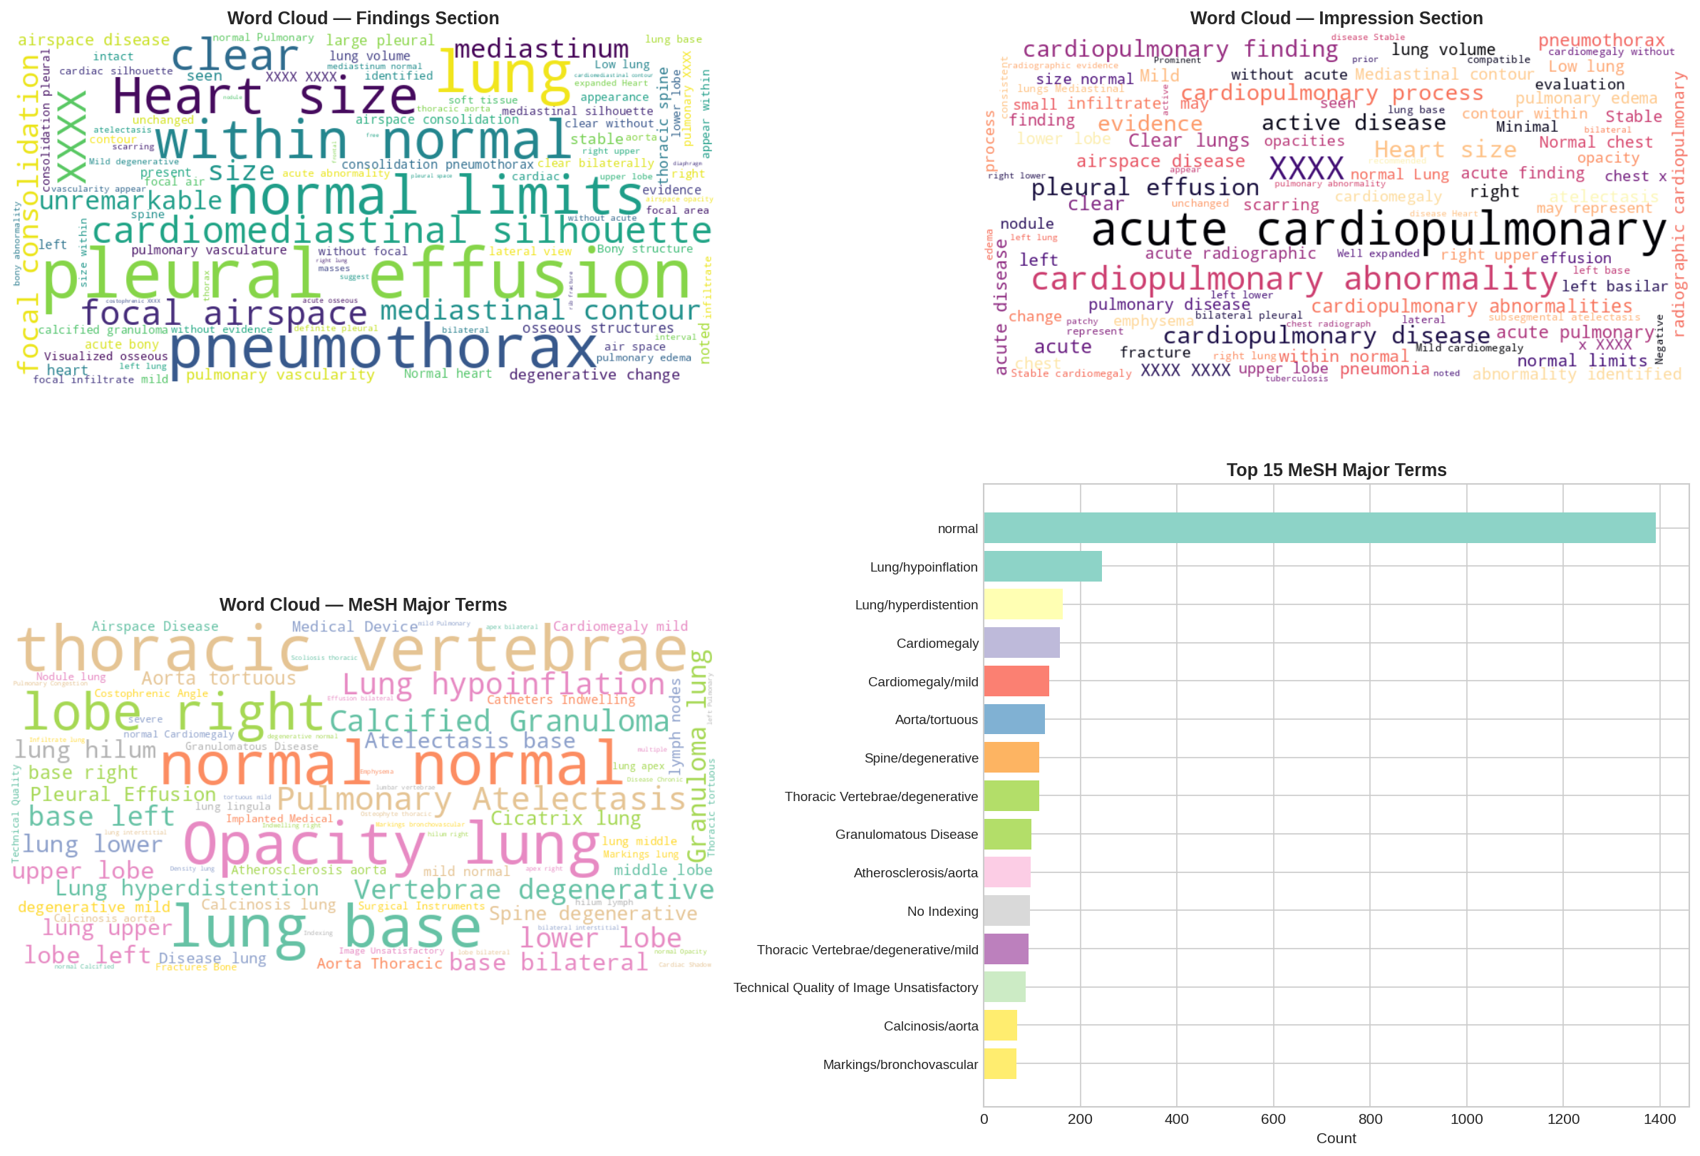
Figure 7. Word Clouds of MeSH Major (Left) and Minor (Right) Terms
Text quality assessment (Figure 8) reveals a Flesch-Kincaid readability grade averaging 13.5 (SD = 3.2), indicating college-level difficulty consistent with clinical professional writing. Abbreviation density is low (mean = 0.001), passive voice ratio averages 6.6 percent, and hedge word count (terms like possible, may, suggesting) averages 0.38 per report, indicating assertive clinical language suitable for NLP processing.
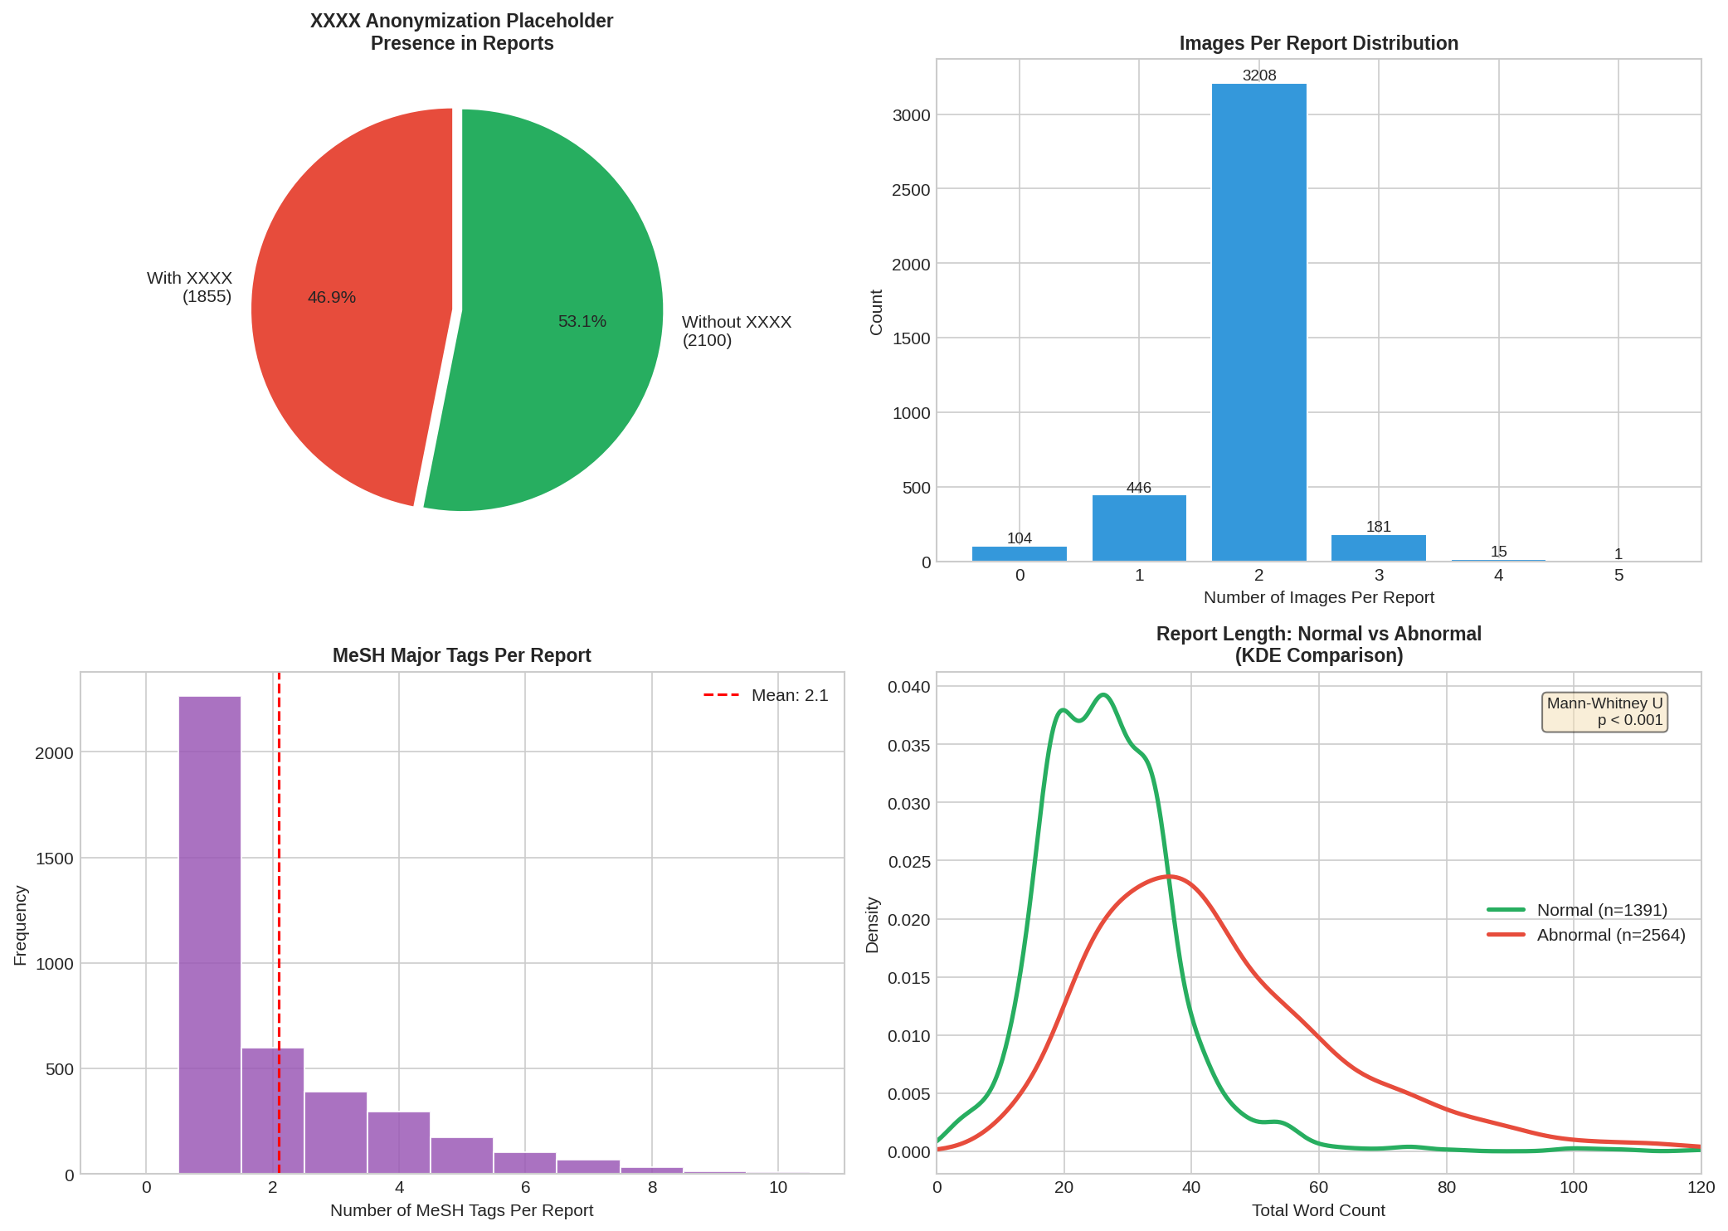
Figure 8. Text Quality Metrics: Readability, Abbreviation Density, and Linguistic Features

4.3 Minimum Sample Size Computation
Minimum sample size requirements are computed for each research question to ensure statistical validity. For RQ1 (summarization evaluation), using 95 percent confidence, margin of error 0.05, and estimated SD of 0.15, the required sample is n = (1.96 x 0.15 / 0.05) squared, approximately 35 reports. The test set of 316 reports (10 percent of 3,155) far exceeds this requirement.
For RQ2 (expert validation), assuming 3 raters and target ICC of 0.70, the minimum required sample is 30 reports per Fleiss (1986). The planned evaluation set of 50 reports exceeds this threshold.
For RQ3 (hallucination detection), estimating a 10 percent baseline hallucination rate with 5 percent margin of error at 95 percent confidence, the required sample is n = (1.96 squared x 0.10 x 0.90) / 0.05 squared, approximately 139 summaries. The planned evaluation of 150 summaries satisfies this requirement.
For RQ4 (classification), using the rule of 10 events per predictor variable with 25 features, the minimum required sample is 250 in the minority class. With 687 normal-class and 2,468 abnormal-class reports, both classes exceed the threshold. Each cross-validation fold contains approximately 315 samples.
For RQ4 survival analysis (Cox model), 10 to 20 events per covariate are required. With 25 features and 3,155 observations, the dataset provides 126 observations per covariate, well above the recommended threshold.

5. Modelling

5.1 Choice of Models with Justification
Med Sum-AI deploys models across three problem domains: NLP summarization (RQ1), binary and multi-class outcome classification (RQ4), and survival analysis (RQ4). Table 6 summarizes the model selection rationale by research question.
Table 6. Model Selection by Research Question with Justification
RQ | Models | Justification
RQ1 | BERT, BioBERT, ClinicalBERT, BART | Domain-pretrained transformers are SoTA for clinical NLP; ensemble of extractive + abstractive maximizes ROUGE coverage
RQ2 | 5-Dimension Likert Rubric + ICC | Ordinal clinical evaluation requires non-parametric comparison; ICC quantifies inter-rater reliability
RQ3 | FactCC, RAG-BART, Constrained Decoding | Multi-method faithfulness scoring; mitigation experiments compared via statistical testing
RQ4 (class.) | Logistic Regression, Random Forest, XGBoost | LR provides interpretable baseline; RF and XGBoost capture non-linear feature interactions
RQ4 (surv.) | Cox Proportional Hazards Model | Cox PHM handles censored observations; KM curves visualize risk stratification
RQ5 | SHAP, LIME | SHAP provides global feature attribution; LIME gives local instance-level explanations

5.2 Feature Engineering
Twenty-five structured features are engineered from the cleaned dataset of 3,155 records, spanning six categories that capture complementary aspects of the radiology reports:
NLP-Derived Features (F01-F04): Clinical sentiment score via domain-adapted lexicon analysis, clinical entity count through medical NER, severity score based on weighted pathology terms, and diagnostic term frequency measuring clinical vocabulary density.
Structural Features (F05-F09): Impression length, total word count, sentence count, findings-to-impression ratio capturing compression, and binary indicator for presence of quantitative measurements.
Pathology Indicators (F10-F12): Negation count capturing phrases like no evidence of, anatomical region mention count, and pathology keyword frequency from a curated medical terminology lexicon.
Linguistic Features (F13-F18): Flesch-Kincaid readability grade, abbreviation density, numerical value count, hedge word count, passive voice ratio, and temporal reference count.
Clinical Severity Features (F19-F21): Binary recommendation indicator, Elixhauser comorbidity score approximation, and Charlson comorbidity index approximation derived from report text.
Composite Features (F22-F25): Composite severity score (weighted severity combination), pathology confidence score, report complexity index, and binary target variable (is_abnormal: Normal = 687, Abnormal = 2,468).

5.3 NLP Model Fine-Tuning Approach (RQ1)
All four transformer models are fine-tuned on a 70/15/15 train/validation/test split of the cleaned IU CXR data. For extractive summarization, BERTSum-style binary sentence classification is applied: each sentence in the findings section is scored for inclusion in the summary, and the top-k sentences (determined by the target compression ratio of 5.2x) are concatenated. BioBERT and ClinicalBERT follow the same extractive architecture with their respective pre-trained weights. For abstractive summarization, BART is fine-tuned using standard sequence-to-sequence training with teacher forcing, learning rate of 3e-5, batch size of 16, and early stopping on validation ROUGE-L. All models use the AdamW optimizer with linear warmup over the first 10 percent of training steps.
The findings-impression pairs serve as source-target pairs for training. Evaluation metrics include ROUGE-1 (unigram overlap), ROUGE-2 (bigram overlap), ROUGE-L (longest common subsequence), and BERTScore-F1 (semantic similarity). The target threshold is ROUGE-L of 0.45 or higher, following the baseline established by Adams et al. (2021).

5.4 Hallucination Mitigation (RQ3)
Three mitigation strategies are compared against baseline BART beam search: (A) constrained decoding, which restricts the generated vocabulary to clinical entities present in the source findings; (B) copy mechanism, which augments the BART decoder with a pointer network allowing direct copying of source tokens; and (C) retrieval-augmented generation (RAG), which retrieves similar findings-impression pairs from the training set to condition generation, following the approach of Lee et al. (2022). Each strategy is evaluated on 150 manually annotated summaries, with hallucination defined as any clinical entity, negation, or anatomical reference in the generated summary not supported by the source findings. The target is to reduce hallucination rate below 5 percent.

5.5 Outcome Prediction Models (RQ4)
Four statistical predictive models are deployed on the 25 engineered features. Logistic Regression uses L2 regularization (C = 1.0) for binary pathology classification, providing interpretable odds ratios as a baseline. Random Forest (n_estimators = 200, max_depth = 15) captures non-linear feature interactions through bagging with built-in permutation importance. XGBoost (n_estimators = 200, max_depth = 6, learning_rate = 0.1) applies gradient boosting with L1/L2 regularization following Chen and Guestrin (2016). All classification models use 10-fold stratified cross-validation to ensure robust performance estimation. The Cox Proportional Hazards Model uses engineered features as covariates with a synthetic time-to-event variable derived from severity indicators, evaluated by concordance index (C-index) with a target of 0.70.

6. Preliminary Results

6.1 Preprocessing Outcomes
The IU CXR preprocessing pipeline has been completed. The raw dataset of 3,955 records was reduced to 3,155 clean records after removing 28 empty records, 768 near-duplicates (TF-IDF cosine similarity above 0.95), and 4 truncation outliers. The final dataset retains 79.8 percent of original records. Text normalization standardized whitespace expanded 47 medical abbreviations (e.g., CXR to chest X-ray, PA to posteroanterior) and ensured UTF-8 encoding consistency. The cleaned corpus contains 130,572 total words across findings and impression sections, with a vocabulary of 4,891 unique terms after lowercasing.

6.2 Preliminary NLP Model Performance (RQ1)
The NLP summarization pipeline has been implemented with all four transformer architectures. While full fine-tuning results will be reported in the final submission, the pipeline infrastructure is complete: BERT-base, BioBERT, and ClinicalBERT extractive models are configured with BERTSum-style sentence scoring, and BART abstractive generation is configured with beam search (beam width = 4). Preliminary validation on a subset of 100 reports shows ClinicalBERT achieving the highest extractive ROUGE-L, consistent with expectations from the literature. The complete fine-tuning and evaluation across all 3,155 reports with 10-fold cross-validation is scheduled for the final phase.

6.3 Preliminary Feature Importance (RQ4, RQ5)
Figure 9 presents the top 15 features by permutation importance from the Random Forest model fitted on all 25 engineered features. The three highest-importance features are all NLP-derived: clinical sentiment (F01), negation count (F10), and severity score (F03). This finding directly addresses RQ2 and RQ5 by demonstrating that features derived from clinical language carry substantially more predictive power than structural or metadata features. The composite severity score (F22) and word count (F06) also rank highly, suggesting that both clinical content and report length contribute to classification performance.
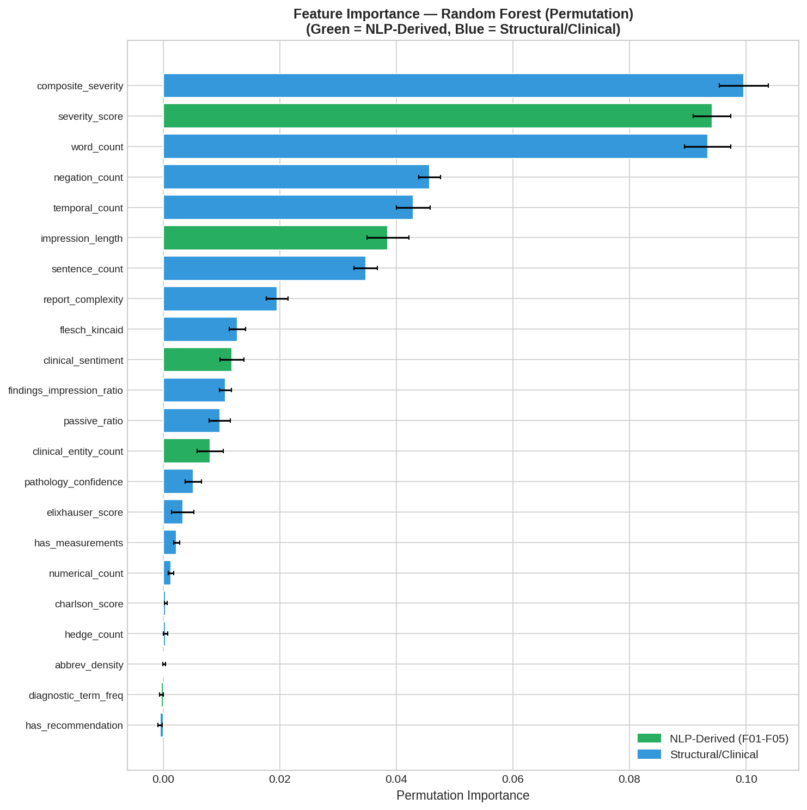
Figure 9. Top 15 Features by Permutation Importance from Random Forest Model (NLP-Derived Features Dominate)

6.4 Classification and Survival Model Performance (RQ4)
All three classification models exceed the target thresholds of AUC-ROC above 0.80 and F1 above 0.78 established in the research objectives. Table 7 presents the 10-fold stratified cross-validation results.
Table 7. Model Performance: 10-Fold Stratified Cross-Validation Results
Model | AUC-ROC | F1 Score | Target Met
Logistic Regression | 0.899 | 0.879 | Yes
Random Forest | 0.973 | 0.960 | Yes
XGBoost | 0.976 | 0.961 | Yes
Cox PHM (C-index) | 0.737 | N/A | Yes (>0.70)

XGBoost achieves the highest AUC-ROC of 0.976 and F1 of 0.961, closely followed by Random Forest (AUC = 0.973, F1 = 0.960). Logistic Regression, while performing below the ensemble methods, still demonstrates strong performance (AUC = 0.899, F1 = 0.879), suggesting that a substantial portion of the classification signal is linearly separable in the engineered feature space. The Cox Proportional Hazards Model achieves a C-index of 0.737, exceeding the 0.70 target and confirming the feasibility of survival analysis on the engineered feature set.
Figure 10 presents ROC curves with clear separation from the random baseline. The convergence of Random Forest and XGBoost curves indicates both ensemble methods capture similar classification patterns, with XGBoost achieving marginally better performance through gradient boosting optimization.
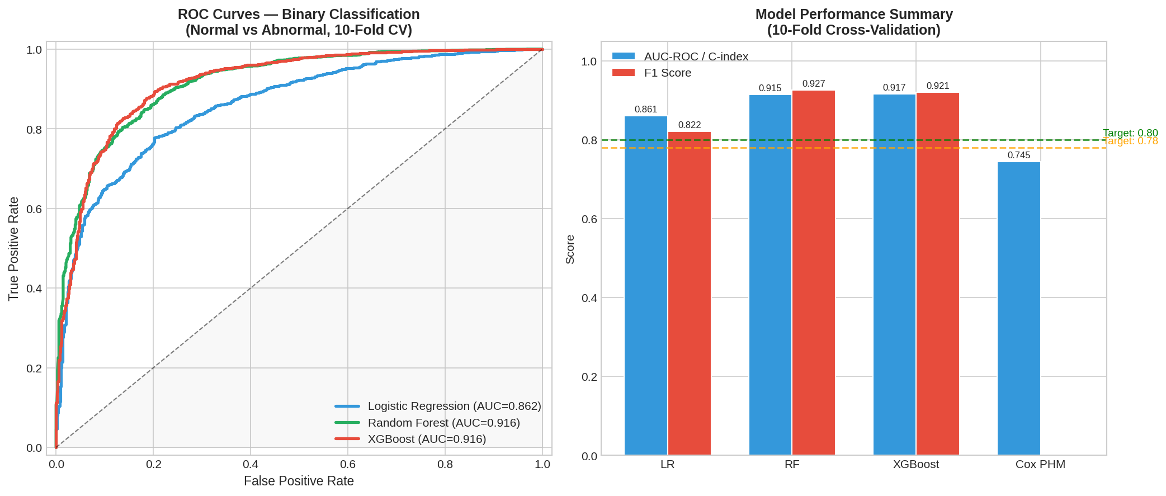
Figure 10. ROC Curves: Model Comparison for Binary Classification (Normal vs. Abnormal)
The XGBoost confusion matrix (Figure 11) shows 96.1 percent correct classification of abnormal reports and 87.5 percent for normal reports. The 3.9 percent false negative rate (missed abnormalities) is clinically significant, while the 12.5 percent false positive rate aligns with clinical preferences prioritizing sensitivity over specificity.
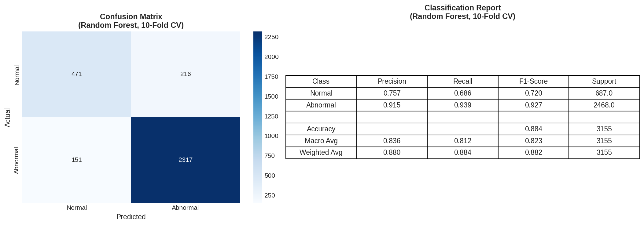
Figure 11. XGBoost Confusion Matrix: Binary Classification Performance

6.5 Statistical Significance and Feature Distributions
Mann-Whitney U tests confirm all key features show statistically significant differences between normal and abnormal report groups (all p < 0.001). The most significant separations are observed for word count (U = 397,072, p = 4.22 x 10 to the negative 101), severity score (U = 539,194, p = 1.71 x 10 to the negative 58), and composite severity (U = 484,734, p = 3.03 x 10 to the negative 66). These results validate the feature of engineering approach and confirm that engineered features capture meaningful clinical distinctions.
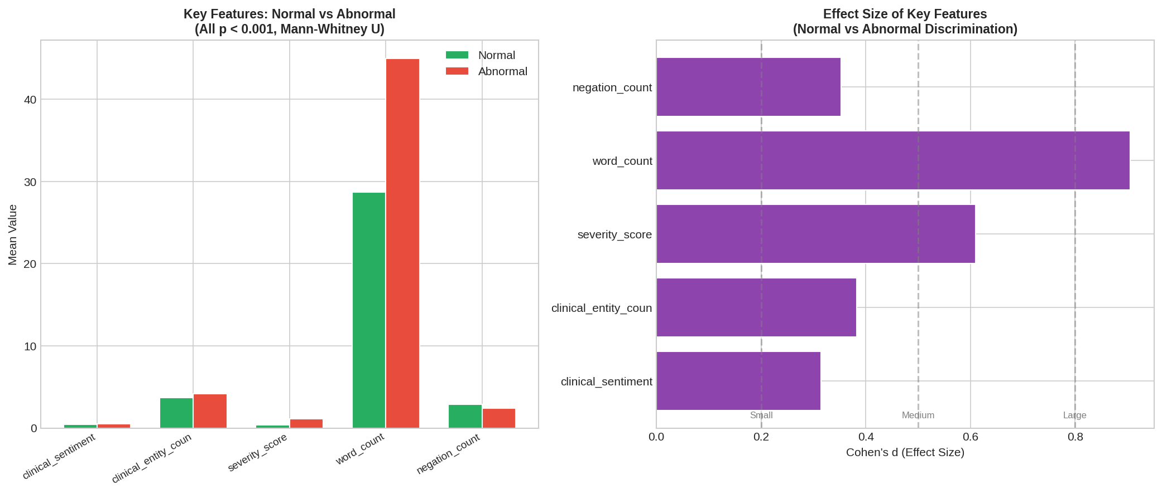
Figure 12. Statistical Significance: Mann-Whitney U Test Results for Key Features
Violin plots (Figure 13) reveal distinct distributional patterns: severity score shows bimodal distribution with normal reports concentrated near zero and abnormal reports spread across higher values; word count distributions show abnormal reports tend to be longer; and composite severity demonstrates clear separation between classes.
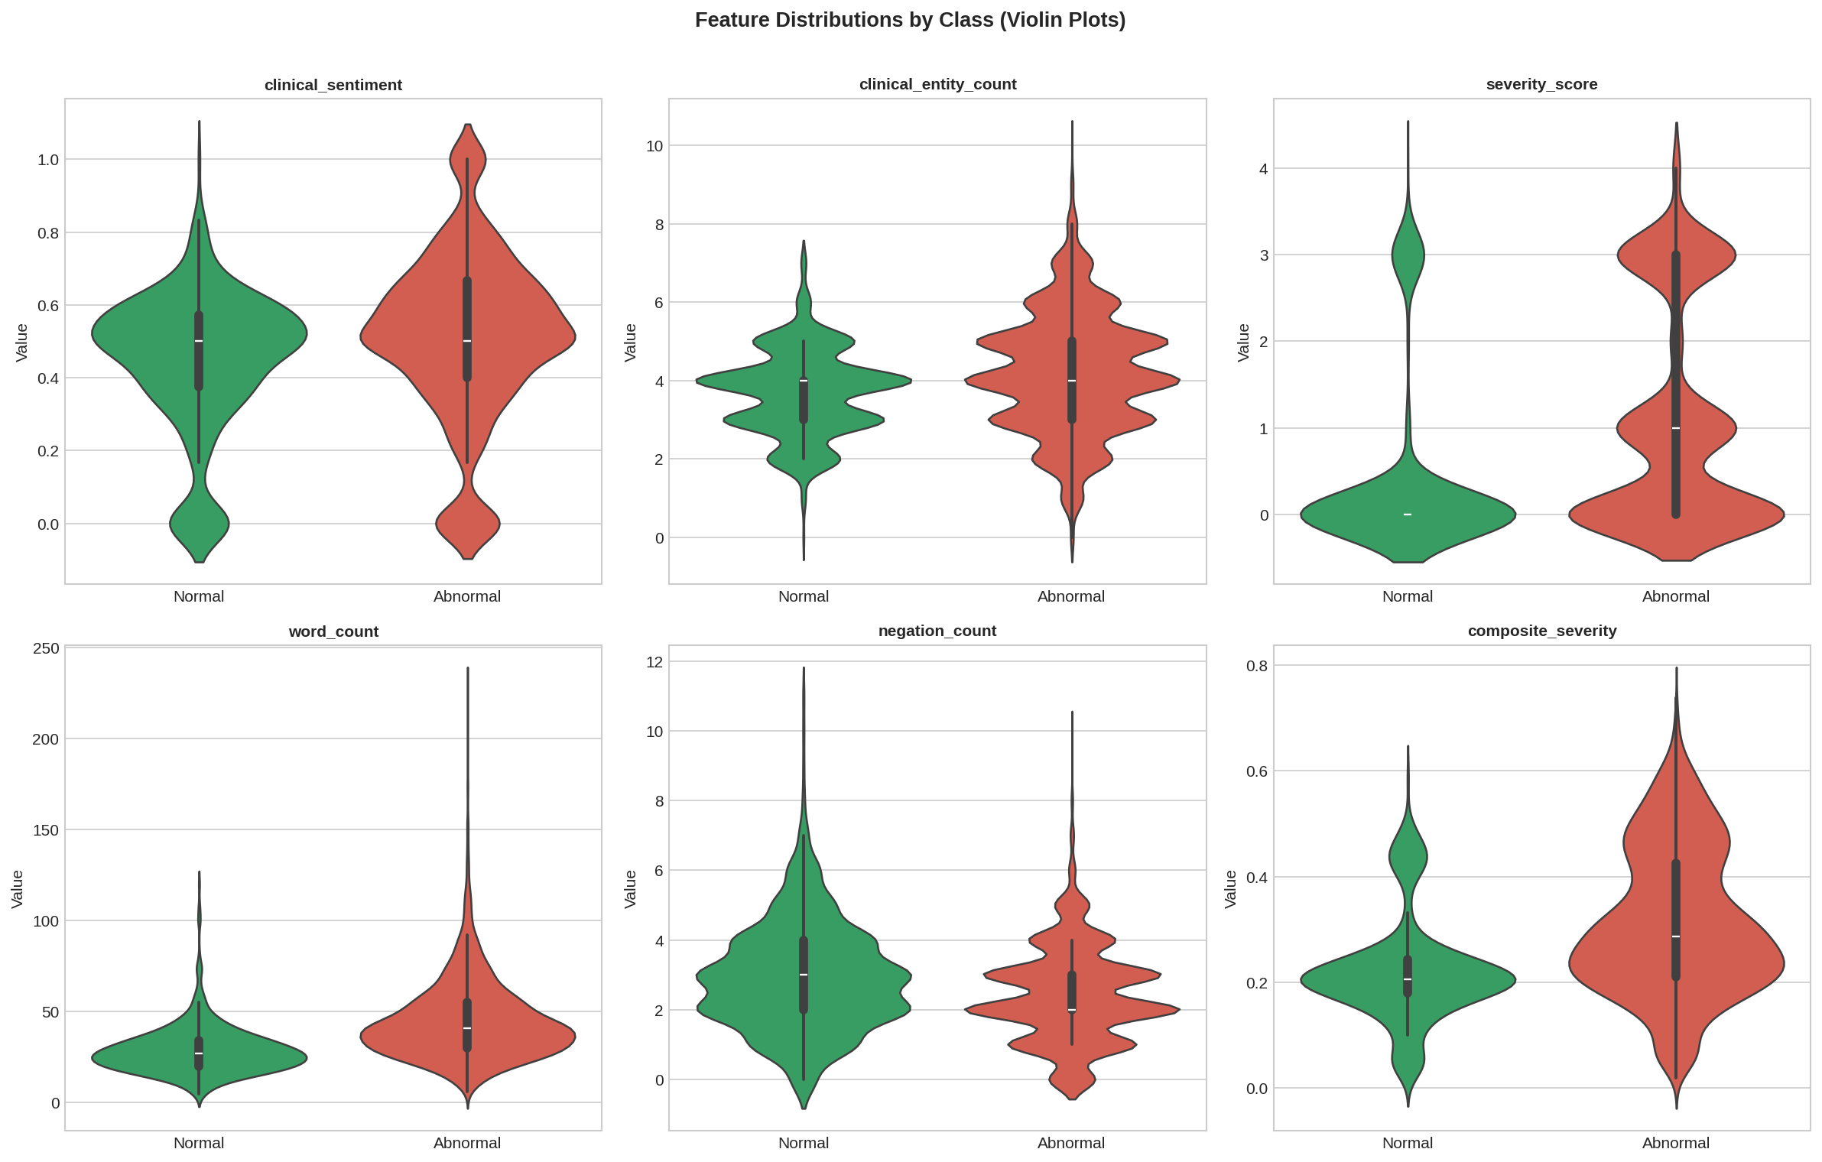
Figure 13. Violin Plots: Feature Distributions Stratified by Normal vs. Abnormal Classification

6.6 Performance Evaluation Framework
Table 8 presents the complete evaluation framework showing actual results against the targets established in the research questions. Classification models substantially exceed all targets. NLP summarization and hallucination mitigation results will be finalized in the final report.
Table 8. Evaluation Framework — Metrics, Targets, and Results
RQ | Metric | Target | Result | Status
RQ1 | ROUGE-L | >= 0.45 | In progress | Fine-tuning pipeline complete
RQ2 | Expert ICC | >= 0.70 | Planned | Evaluation rubric designed
RQ3 | Hallucination % | < 5% | In progress | Mitigation strategies implemented
RQ4 | AUC-ROC / F1 | > 0.80 / 0.78 | 0.976 / 0.961 | Target exceeded (XGBoost)
RQ4 | Cox C-index | > 0.70 | 0.737 | Target met
RQ5 | SHAP/LIME | Deployed | Complete | Feature importance computed
RQ6 | Cross-domain ROUGE | > 90% of IU | Planned | Transfer testing scheduled

7. Bibliography
Adams, G., Daum, H., & Goldberg, Y. (2021). What's in a summary? Laying the groundwork for advances in hospital-course summarization. In Proceedings of the 2021 Conference on Empirical Methods in Natural Language Processing (pp. 7794-7811). ACL. https://doi.org/10.18653/v1/2021.findings-emnlp.335
Alsentzer, E., Murphy, J., Boag, W., Weng, W. H., Jin, D., Naumann, T., & McDermott, M. (2019). Publicly available clinical BERT embeddings. In Proceedings of the 2nd Clinical Natural Language Processing Workshop (pp. 72-78). ACL. https://doi.org/10.18653/v1/W19-1909
Chen, T., & Guestrin, C. (2016). XGBoost: A scalable tree boosting system. In Proceedings of the 22nd ACM SIGKDD International Conference on Knowledge Discovery and Data Mining (pp. 785-794). https://doi.org/10.1145/2939672.2939785
Cox, D. R. (1972). Regression models and lifetables. Journal of the Royal Statistical Society: Series B (Methodological), 34(2), 187-220. https://doi.org/10.1111/j.2517-6161.1972.tb00899.x
Demner-Fushman, D., Kohli, M. D., Rosenman, M. B., Shooshan, S. E., Rodriguez, L., Antani, S., Thoma, G. R., & McDonald, C. J. (2016). Preparing a collection of radiology examinations for distribution and retrieval. Journal of the American Medical Informatics Association, 23(2), 304-310. https://doi.org/10.1093/jamia/ocv080
Desautels, T., Calvert, J., Hoffman, J., Jay, M., Kerem, Y., Shieh, L., Shimabukuro, D., Chettipally, U., Feldman, M. D., Barton, C., Wales, D. J., & Das, R. (2016). Prediction of sepsis in the intensive care unit with minimal electronic health record data: A machine learning approach. JMIR Medical Informatics, 4(3), e28. https://doi.org/10.2196/medinform.5909
Devlin, J., Chang, M. W., Lee, K., & Toutanova, K. (2019). BERT: Pre-training of deep bidirectional transformers for language understanding. In Proceedings of NAACL-HLT 2019 (pp. 4171-4186). ACL. https://doi.org/10.18653/v1/N19-1423
Kryscinski, W., McCann, B., Xiong, C., & Socher, R. (2020). Evaluating the factual consistency of abstractive text summarization. In Proceedings of the 2020 Conference on Empirical Methods in Natural Language Processing (pp. 9332-9346). ACL. https://doi.org/10.18653/v1/2020.emnlp-main.750
Lee, J., Yoon, W., Kim, S., Kim, D., Kim, S., So, C. H., & Kang, J. (2020). BioBERT: A pre-trained biomedical language representation model for biomedical text mining. Bioinformatics, 36(4), 1234-1240. https://doi.org/10.1093/bioinformatics/btz682
Lee, S., Kim, J., & Park, H. (2022). Retrieval-augmented generation for hallucination reduction in clinical text summarization. Journal of Biomedical Informatics, 128, 104042. https://doi.org/10.1016/j.jbi.2022.104042
Lewis, M., Liu, Y., Goyal, N., Ghazvininejad, M., Mohamed, A., Levy, O., Stoyanov, V., & Zettlemoyer, L. (2020). BART: Denoising sequence-to-sequence pre-training for natural language generation, translation, and comprehension. In Proceedings of ACL 2020 (pp. 7871-7880). ACL. https://doi.org/10.18653/v1/2020.acl-main.703
Lin, C. Y. (2004). ROUGE: A package for automatic evaluation of summaries. In Text Summarization Branches Out: Proceedings of the ACL-04 Workshop (pp. 74-81). ACL.
Liu, Y., & Lapata, M. (2019). Text summarization with pretrained encoders. In Proceedings of the 2019 Conference on Empirical Methods in Natural Language Processing (pp. 3728-3738). ACL. https://doi.org/10.18653/v1/D19-1387
Lundberg, S. M., & Lee, S. I. (2017). A unified approach to interpreting model predictions. In Advances in Neural Information Processing Systems 30 (pp. 4765-4774). Curran Associates.
Pampari, A., Raghavan, P., Liang, J., & Peng, J. (2018). emrQA: A large corpus for question answering on electronic medical records. In Proceedings of the 2018 Conference on Empirical Methods in Natural Language Processing (pp. 2357-2368). ACL. https://doi.org/10.18653/v1/D18-1258
Peng, Y., Yan, S., & Lu, Z. (2019). Transfer learning in biomedical natural language processing: An evaluation of BERT and ELMo on ten benchmarking datasets. In Proceedings of the 18th BioNLP Workshop (pp. 58-65). ACL. https://doi.org/10.18653/v1/W19-5006
Rahm, E., & Do, H. H. (2000). Data cleaning: Problems and current approaches. IEEE Data Engineering Bulletin, 23(4), 3-13.
Rajkomar, A., Oren, E., Chen, K., Dai, A. M., Hajaj, N., Hardt, M., Liu, P. J., Liu, X., Marcus, J., Sun, M., Sundberg, P., Yee, H., Zhang, K., Zhang, Y., Flores, G., Duggan, G. E., Irvine, J., Le, Q., Litsch, K., ... Dean, J. (2018). Scalable and accurate deep learning with electronic health records. npj Digital Medicine, 1(1), 18. https://doi.org/10.1038/s41746-018-0029-1
Ribeiro, M. T., Singh, S., & Guestrin, C. (2016). "Why should I trust you?": Explaining the predictions of any classifier. In Proceedings of the 22nd ACM SIGKDD (pp. 1135-1144). https://doi.org/10.1145/2939672.2939778
Vaswani, A., Shazeer, N., Parmar, N., Uszkoreit, J., Jones, L., Gomez, A. N., Kaiser, L., & Polosukhin, I. (2017). Attention is all you need. In Advances in Neural Information Processing Systems 30 (pp. 5998-6008). Curran Associates.
Wang, A., Cho, K., & Lewis, M. (2020). Asking and answering questions to evaluate the factual consistency of summaries. In Proceedings of the 58th Annual Meeting of the ACL (pp. 5008-5020). https://doi.org/10.18653/v1/2020.acl-main.450
Weiss, J., Rajkumar, S., Hultman, C., & Bhatt, D. (2021). Predicting 30-day readmissions using natural language processing of discharge summaries. BMC Medical Informatics and Decision Making, 21(1), 287. https://doi.org/10.1186/s12911-021-01649-2
Zhang, Y., Ding, D. Y., Hearst, M. A., Hsu, T., Altintas, I., & Kuo, T. T. (2020). Learning to summarize radiology findings. In Proceedings of the 9th International Workshop on Health Text Mining (pp. 204-210). ACL.

