Asmaa Kishk

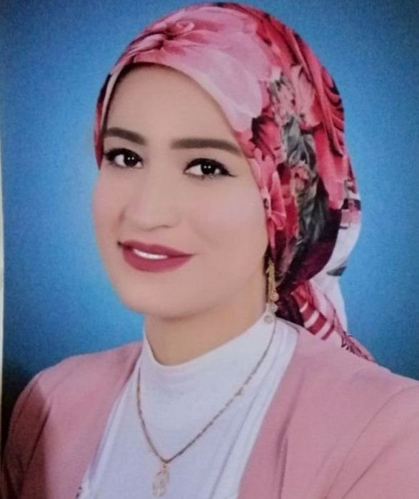

Web developer

Trilingual/Multilingual and a Self-taught programmer, driven by starting new projects from scratch and maintaining up to date on the most recent technology trends and developments.

core competencies

|  |  |
| --- | --- |
| * HTML5 * CSS3 * JavaScript + ES6 * python | * React (in progress) * Bootstrap * Problem Solving |

Projects

* **CRUDS** project with JavaScript
* **Quiz** **App** with JavaScript
* (**Twitter- YouTube**) Clone using HTML, CSS, CSS Flexbox, CSS Grid, and JavaScript.
* **Gym website** using HTML-CSS JS.
* **Courses website** using Bootstrap.

Internship

* Software Engineer Intern, Albanian ELmarsos, April 2022 until 30 August.

Certification

* **JavaScript Algorithms and Data Structures,** Freecodecamp.org.
* **Programming Foundation:** linkedin learning, 2022.
* **Modern React with Redux**, Udemy, 2022.
* **The Complete JavaScript Course with projects,** Udemy, 2022.
* **The modern JavaScript course for everyone,** Udemy, 2022.
* **modern HTML5, CSS3 and web design,** Udemy, 2022.

Education

* **Business adminstration,** School of Continuing Education (SCE), The American University in Cairo (AUC), "2020- 2021".
* **Masters in political science**, faculty of commerce, Suez Canal University, 2020.
* **Pre-Master in political science**, faculty of commerce, Suez Canal University, 2013.
* **Bachelor of Political Science**, faculty of commerce, Suez Canal University, 2012.

Contact

**Address:**

El-Nours city, Ismailia

**Phone:**

+201222728375

+201019140345

**Email:**

[asmaakishk@gmail.com](mailto:asmaakishk@gmail.com)

**GitHub:**

<https://github.com/AsmaaKishk>

**LinkedIn:**

<https://www.linkedin.com/in/asmaa-kishk-b1a17b16b/>

Languages

Arabic – C2

English – B2

German – A2