# Manual Testing:

Task1:

TEST cases for search and register student function in Excel sheet (school _test cases)

# Task2:

The valid data in Excel sheet (VALID DATA)

# Code Assessment

Q1-

if(Card.Type == "Master")

Accept Transaction;

else if(Card.Type == "Youth"||"Premium")

return false;

else

return Error;

Q2-

public static void main(String[] args) {

int n = 0;

while( n<10)

{

int a =n+2;

int b =a+n;

System.out.println("a = "+a);

System.out.println("b = "+b);

System.out.println("n = "+n);

n+=5;

}

}

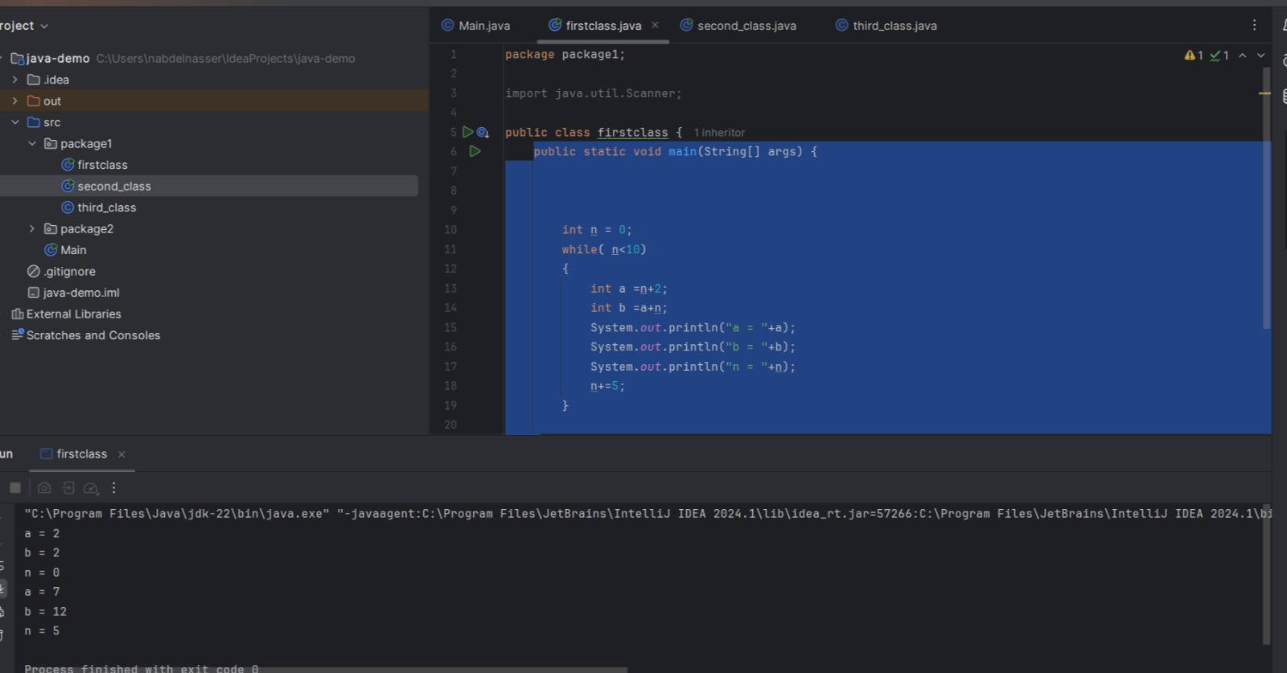

**API Manual Testing**

**TC1**:

Verify that the API returns accurate weather information for a valid city name.

Test Steps:

1-Choose a known city with widely available weather data (e.g., New York, London, Tokyo).

2-Send a GET request to the API endpoint with the chosen city name.

3- Verify that the response status code is 200 OK.

4- validate the response body to ensure it contains relevant weather information such as temperature, humidity, wind speed, etc.

Expected Result: The API response body includes weather information matching the chosen city.

**TC2:**

Validate the behavior of the API when an invalid city name

Test Steps:

1-Choose invalid city name (e.g., "dsdsd123", "xyzzz").

2-Send a GET request to the API endpoint with the chosen invalid city name.

3-Verify that the response status code is appropriate (404 Not Found or 400 Bad Request).

Expected Result: response status code is appropriate (404 Not Found or 400 Bad Request) and city name is invalid or not found.

**TC3:**

Test the API behavior when an empty city name

Test Steps:

1-Send a GET request to the API endpoint with an empty city name parameter.

2-Verify that the response status code is appropriate ( 400 Bad Request).

Expected Result: The API returns an error response includes that the city name parameter is required.

**DB Assessment**

Q1. Write SQL statement to retrieve applicant’s history whose names begin with A?

SELECT * FROM Applicant  
WHERE First-name LIKE 'A%';

Q2. What are constraints?

SQL constraints are used to specify rules for the data in a table.

Constraints are commonly used in SQL:

NOT NULL

UNIQUE

PRIMARY KEY

FOREIGN KEY

CHECK

DEFAULT

Q3. What’s the difference between different types of Join?

* (INNER) JOIN: Returns records that have matching values in both tables
* LEFT (OUTER) JOIN: Returns all records from the left table, and the matched records from the right table
* RIGHT (OUTER) JOIN: Returns all records from the right table, and the matched records from the left table
* FULL (OUTER) JOIN: Returns all records when there is a match in either left or right table

Q6. What are the main differences between HAVING and WHERE SQL clauses?

The HAVING clause was added to SQL because the WHERE keyword cannot be used with aggregate functions.