Tutorial 10 Exception Handling

MUST READ - Put all the source code and answers into a word file, and upload the word file (just ONE Word file! name it with “your ID+date”, e.g. 202512340001_20250930.doc).  Note: there’s a deadline for uploading. | NAME: | BEQUI ASMAA
 | STU ID: | 312024704012
 | DATE: | 2025-12-17

Attempt ALL questions. DO NOT COPY CODE FROM THE OTHERS!

1. (NumberFormatException)Write a program that prompts the user to read two integers and displays their sum. Your program should prompt the user to read the number again if the input is incorrect.

- SOURCE CODE (TEXT)
package Task1;
import java.util.Scanner;

public class SumOfIntegers {
public static void main(String[] args) {
Scanner input = new Scanner(System.in);

int a = readInt(input, "Enter first integer: ");
int b = readInt(input, "Enter second integer: ");

System.out.println("Sum = " + (a + b));
input.close();
}

private static int readInt(Scanner input, String prompt) {
while (true) {
System.out.print(prompt);
String s = input.nextLine().trim();
try {
return Integer.parseInt(s);
} catch (NumberFormatException e) {
System.out.println("Incorrect input!! Please enter an integer again.");
}
}
}
}

- EXECUTION RESULTS (TEXT OR SNAPSHOTS)
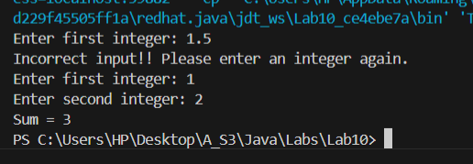
- DISCUSSION AND CONCLUSION
This program safely reads two integers from the user and prints their sum. It uses a loop with try-catch to handle invalid input: if the user enters something that isn’t an integer, a NumberFormatException occurs, and the program shows an error message and asks again. This way, the program never crashes due to wrong input and only continues once both valid integers are entered.

2. (ArrayIndexOutBoundsException) Write a program that meets the following requirements:
■ Create an array with 100 randomly chosen integers. (Note: method nextInt() in class Random can be used.)
■ Prompt the user to enter an int value as the index of the array, and then display the corresponding element from the array. If the specified index is out of bounds, display the message Out of Bounds.

- SOURCE CODE (TEXT)
package Task2;
import java.util.Random;
import java.util.Scanner;

public class ArrayIndexOutOfBoundsDemo {
public static void main(String[] args) {
Random rand = new Random();
int[] arr = new int[100];

for (int i = 0; i < arr.length; i++) {
arr[i] = rand.nextInt();
}

Scanner input = new Scanner(System.in);
System.out.print("Enter an index (0 - 99): ");

try {
int index = input.nextInt();
System.out.println("Element at index " + index + " = " + arr[index]);
} catch (ArrayIndexOutOfBoundsException e) {
System.out.println("Out of Bounds");
}

input.close();
}
}

- EXECUTION RESULTS (TEXT OR SNAPSHOTS)
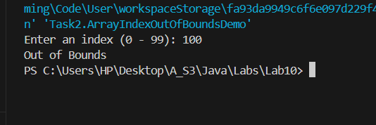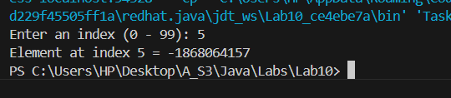
- DISCUSSION AND CONCLUSION
This program creates an array of 100 random integers, then asks the user for an index and prints the value stored at that position. It uses a try-catch block to handle ArrayIndexOutOfBoundsException, so if the user enters an index outside 0–99, the program doesn’t crash and instead displays “Out of Bounds.”

3. Write a Java program called ArithmeticTest that takes three command-line arguments: two integers and in between an arithmetic operator (+, ‐, *, /). The program shall perform the corresponding operation on the two integers and display the result.
Note that you need to deal with the nonnumeric input as operands (one of the two integers) using exception handler (try-catch statements) - the program terminates if any operand is nonnumeric, and it should display a message with the wrong operand input before exiting. Besides, the program should also handle the wrong input for operator. Example runs:
java ArithmeticTest 12 + 34
12 + 34 = 46.0
java ArithmeticTest 12 x 34
12 * 34 = 408.0
java ArithmeticTest 7/8 – 34
Wrong Input: 7/8
java ArithmeticTest 78 – 3;4
Wrong Input: 3;4

- SOURCE CODE (TEXT)
package Task3;
public class ArithmeticTest {
public static void main(String[] args) {
if (args.length != 3) {
System.out.println("Usage: java ArithmeticTest <integer1> <operator> <integer2>");
return;
}

try {
int num1 = Integer.parseInt(args[0]);
int num2 = Integer.parseInt(args[2]);
String operator = args[1];

int result = 0;

if (operator.equals("+")) {
result = num1 + num2;
} else if (operator.equals("-")) {
result = num1 - num2;
} else if (operator.equals("*") || operator.equals("x")) {
result = num1 * num2;
} else if (operator.equals("/")) {
if (num2 == 0) {
System.out.println("Error: Division by zero");
return;
}
result = num1 / num2;
} else {
System.out.println("Error: Invalid operator '" + operator + "'");
return;
}

System.out.println(num1 + " " + operator + " " + num2 + " = " + result + ".0");

} catch (NumberFormatException e) {
try {
Integer.parseInt(args[0]);
System.out.println("Wrong Input: " + args[2]);
} catch (NumberFormatException e2) {
System.out.println("Wrong Input: " + args[0]);
}
}
}
}

- EXECUTION RESULTS (TEXT OR SNAPSHOTS)
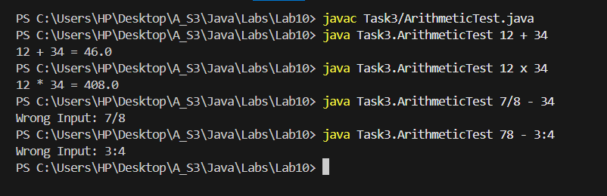
- DISCUSSION AND CONCLUSION
This program reads three command-line arguments (operand, operator, operand), validates the operands using a try-catch to catch nonnumeric input, and validates the operator using a switch. If any input is invalid, it prints “Wrong Input: …” and stops; otherwise it performs the correct arithmetic operation (including x for multiplication) and prints the full expression with the result in the same format as the teacher.

4. Design a class extends Exception, called MinusAgeException, as a custom exception class. Design another class Person, in which properties as name and age are included, together with a method setAge(). When the age is less than 0, an exception with type MinusAgeException would thrown.
Implement MinusAgeException, Person and the test class TestPerson, to test all the methods.

- SOURCE CODE (TEXT)
package Task4;

public class MinusAgeException extends Exception {
public MinusAgeException() {
super("Age cannot be less than 0");
}

public MinusAgeException(String message) {
super(message);
}
}

package Task4;

public class Person {
private String name;
private int age;

public Person(String name, int age) throws MinusAgeException {
this.name = name;
setAge(age); // reuse validation
}

public String getName() {
return name;
}

public int getAge() {
return age;
}

public void setAge(int age) throws MinusAgeException {
if (age < 0) {
throw new MinusAgeException("Minus age is not allowed: " + age);
}
this.age = age;
}

@Override
public String toString() {
return "Person{name='" + name + "', age=" + age + "}";
}
}

package Task4;

public class TestPerson {
public static void main(String[] args) {
try {
Person p1 = new Person("Alice", 20);
System.out.println(p1);

p1.setAge(25);
System.out.println("After setAge(25): " + p1);

} catch (MinusAgeException e) {
System.out.println("Caught exception: " + e.getMessage());
}

try {
Person p2 = new Person("Bob", -5);
System.out.println(p2); // won't run
} catch (MinusAgeException e) {
System.out.println("Caught exception (constructor): " + e.getMessage());
}

try {
Person p3 = new Person("Charlie", 10);
System.out.println(p3);

p3.setAge(-1);
} catch (MinusAgeException e) {
System.out.println("Caught exception (setAge): " + e.getMessage());
}
}
}

- EXECUTION RESULTS (TEXT OR SNAPSHOTS)
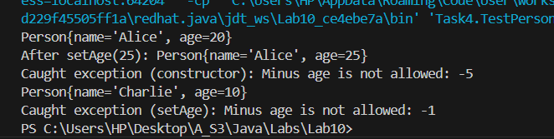
- DISCUSSION AND CONCLUSION
This task creates a custom checked exception MinusAgeException and uses it in the Person class to enforce valid ages. The setAge() method throws MinusAgeException whenever a negative age is provided, preventing invalid data from being stored. TestPerson demonstrates both normal behavior (valid ages) and exception handling when an invalid (negative) age is entered.

5. Write a program, to calculate the equation: sum = a + aa + aaa + aaaa + … + aa...a, in which a is a digit, input by the user. E.g.: 2 + 22 + 222 + 2222+ 22222 (five numbers to be added), is a calculation when user input 2 (as a) and 5 (as numbers of value to be added).
There might be exception caused when user input is not following the requirements. Please handle the possible exceptions properly.

- SOURCE CODE (TEXT)
package Task5;

import java.util.Scanner;

public class DigitPatternSum {
public static void main(String[] args) {
Scanner input = new Scanner(System.in);

int a = readDigit(input, "Enter a digit (0-9): ");
int n = readPositiveInt(input, "Enter how many numbers to add (positive integer): ");

long sum = 0;
long term = 0;

// build: a, aa, aaa, ...
for (int i = 1; i <= n; i++) {
term = term * 10 + a; // e.g., 2 -> 22 -> 222 ...
sum += term;
}

System.out.println("Sum = " + sum);
input.close();
}

private static int readDigit(Scanner input, String prompt) {
while (true) {
System.out.print(prompt);
String s = input.nextLine().trim();
try {
int val = Integer.parseInt(s);
if (val < 0 || val > 9) {
System.out.println("Invalid input. Please enter a single digit 0-9.");
} else {
return val;
}
} catch (NumberFormatException e) {
System.out.println("Invalid input. Please enter a number (0-9).");
}
}
}

private static int readPositiveInt(Scanner input, String prompt) {
while (true) {
System.out.print(prompt);
String s = input.nextLine().trim();
try {
int val = Integer.parseInt(s);
if (val <= 0) {
System.out.println("Invalid input. Please enter a positive integer.");
} else {
return val;
}
} catch (NumberFormatException e) {
System.out.println("Invalid input. Please enter an integer.");
}
}
}
}

- EXECUTION RESULTS (TEXT OR SNAPSHOTS)
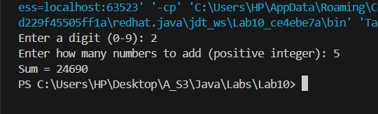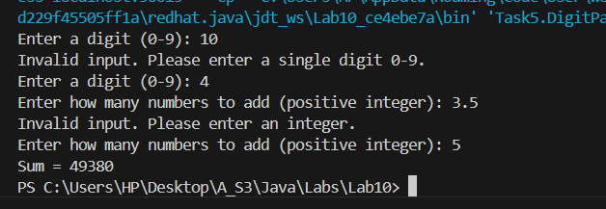
- DISCUSSION AND CONCLUSION
This program calculates the series for a user-chosen digit a and number of terms n by building each term step-by-step (e.g., 2 → 22 → 222). It uses input validation with try-catch to handle non-numeric input and checks the rules (a must be 0–9 and n must be positive), repeatedly prompting until valid values are entered, then prints the final sum.

