
SSIGNMENT - CSNW3204 Cloud Computing Fundamentals-25 FL

Deploy and configure a secure AWS cloud
Environment

Students:
Asma Mohamed Ali Borghan-116S2338000

VPC Configuration
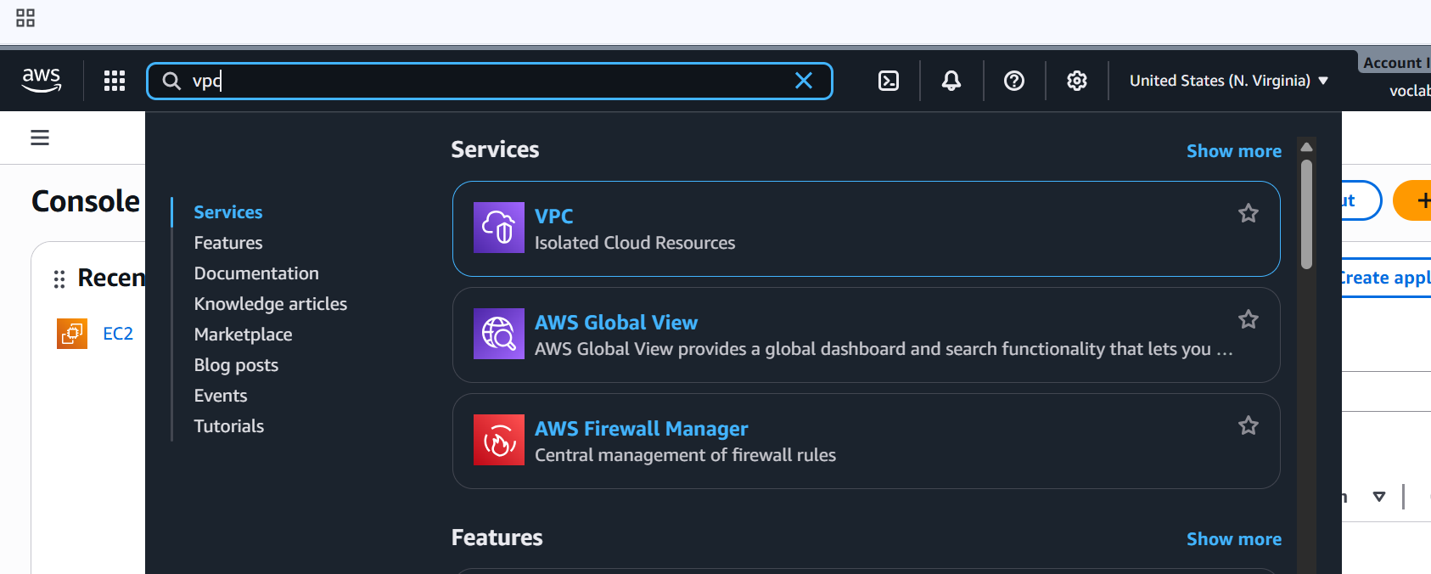
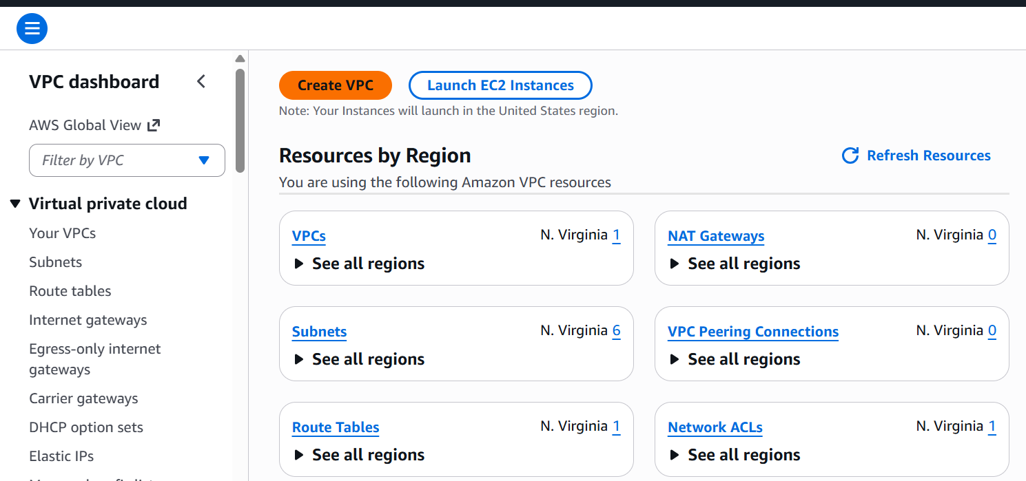
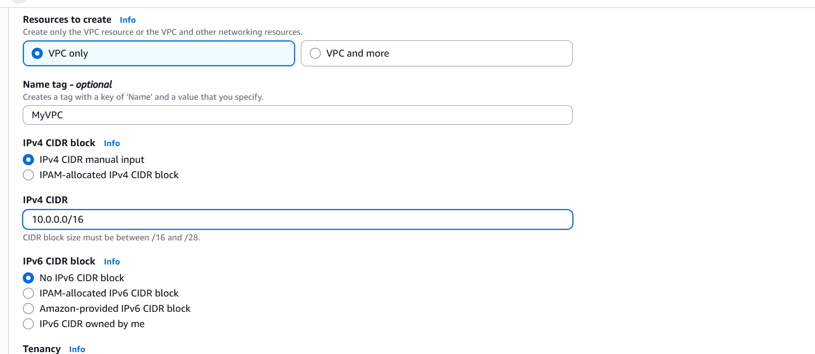
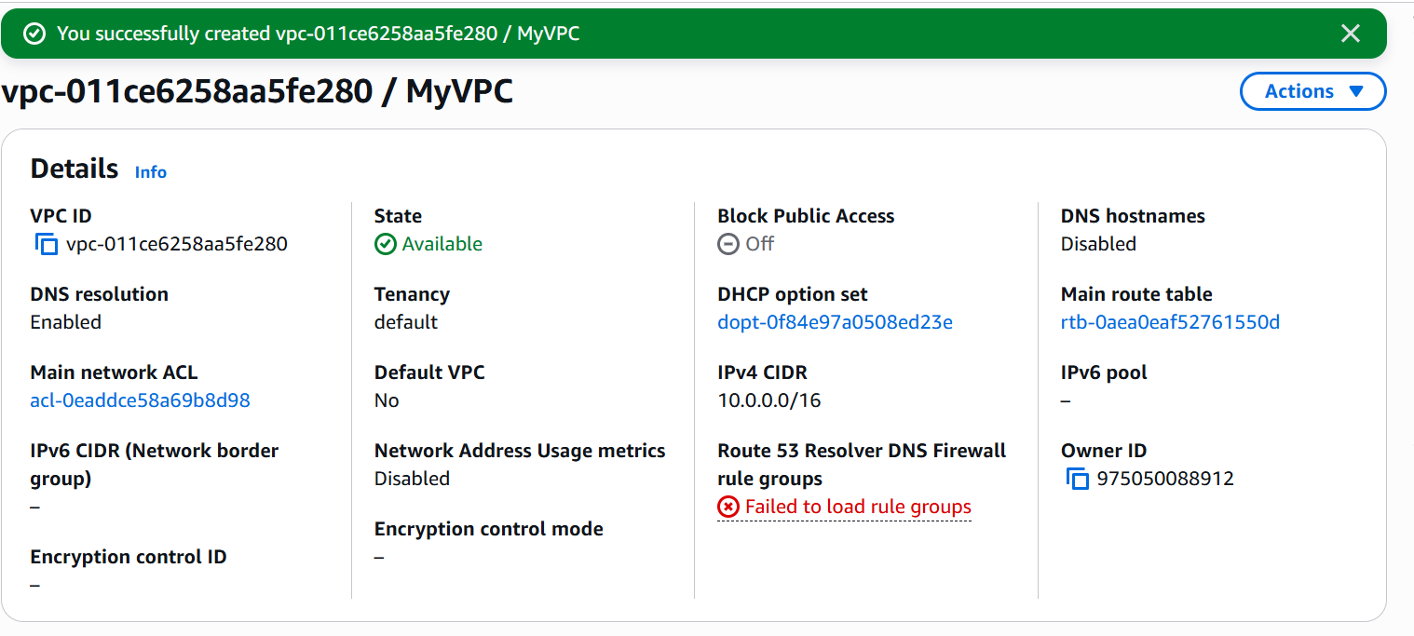
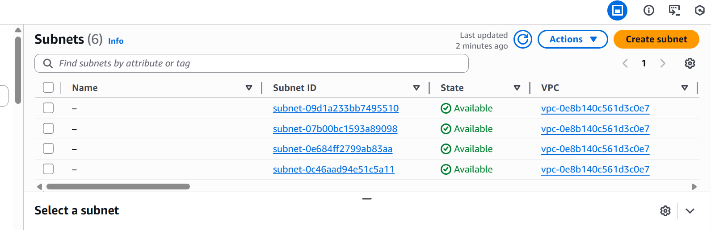
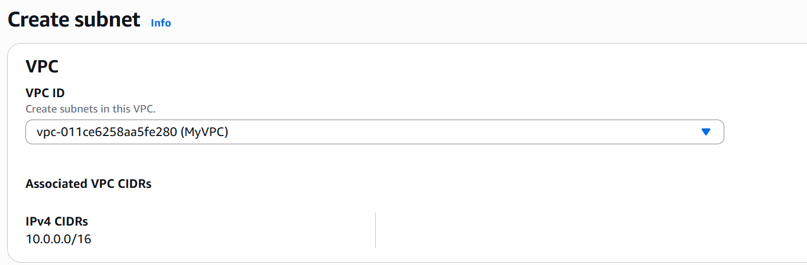
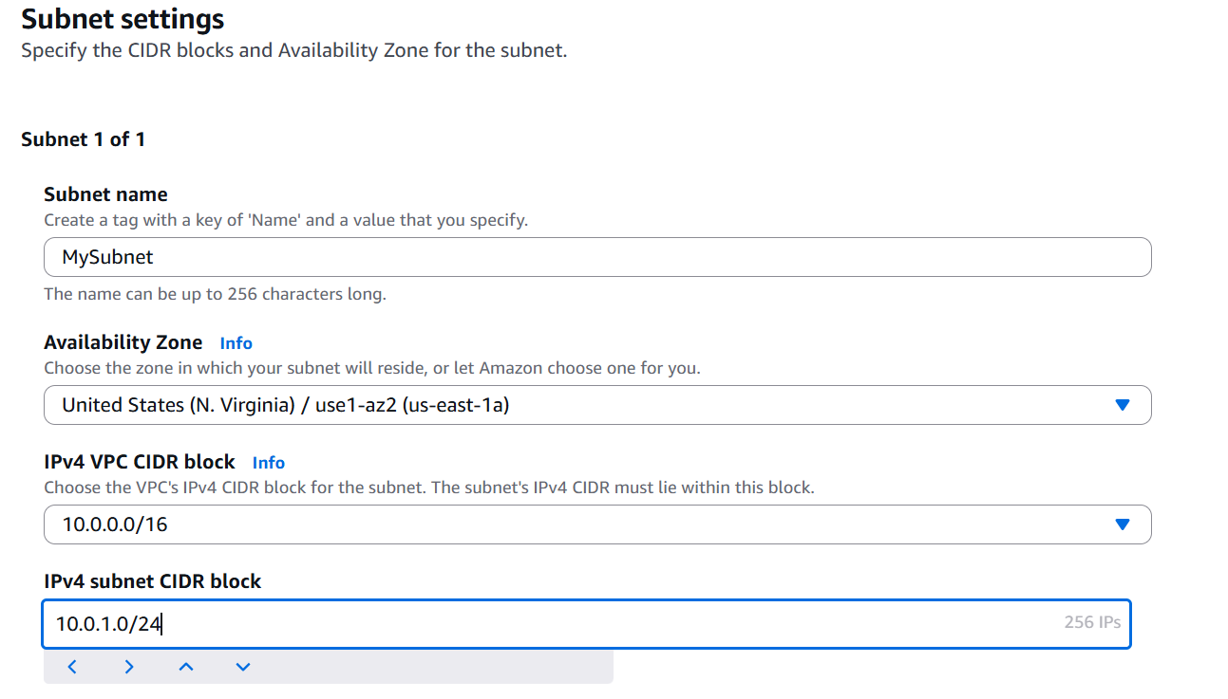
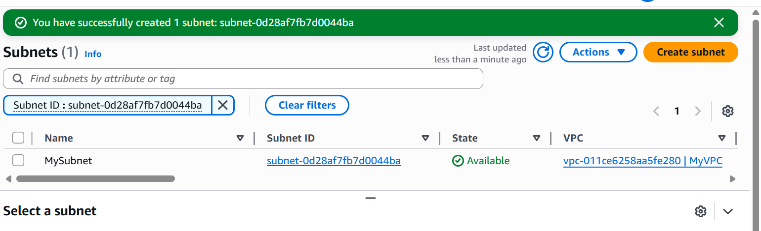
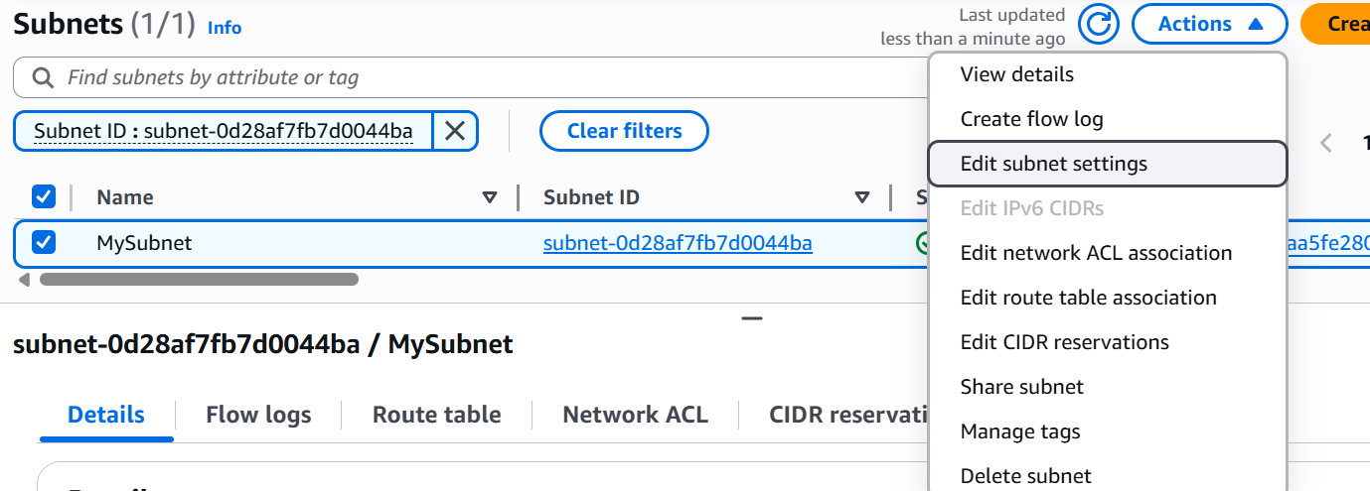
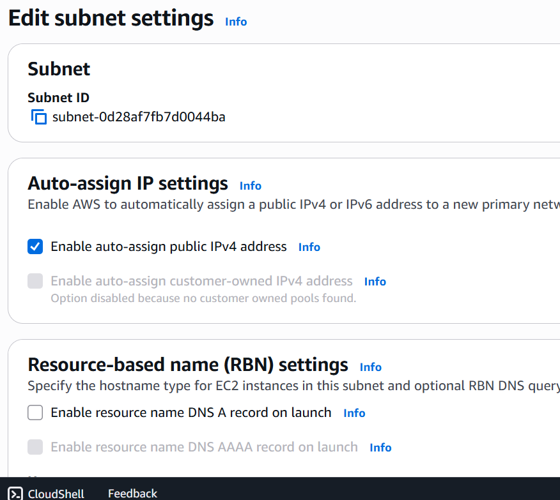
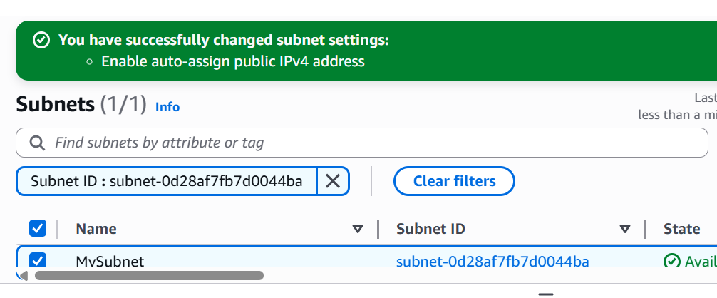
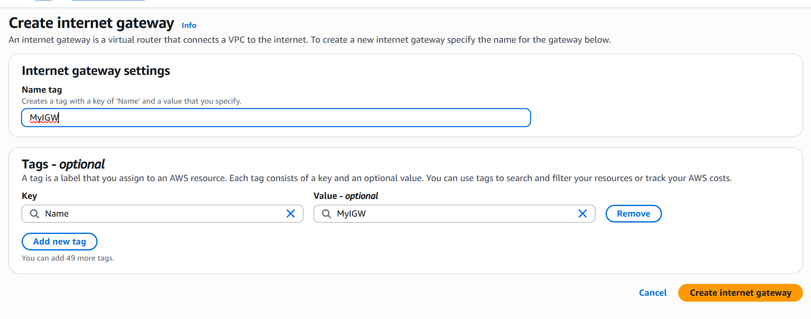
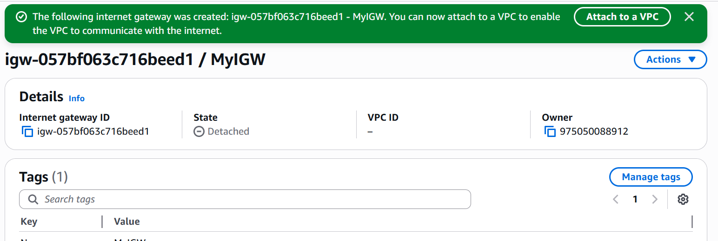
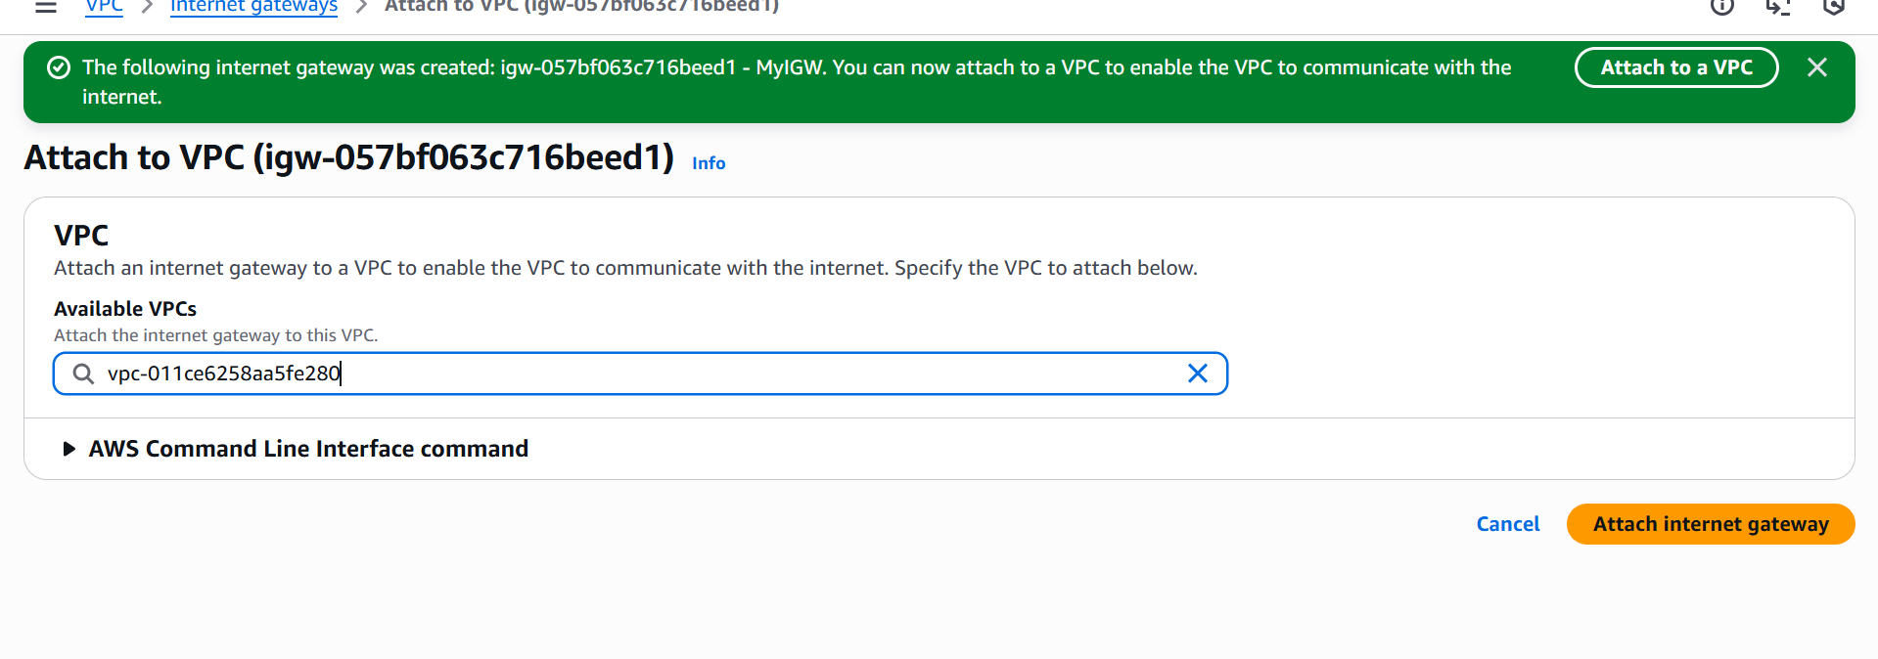
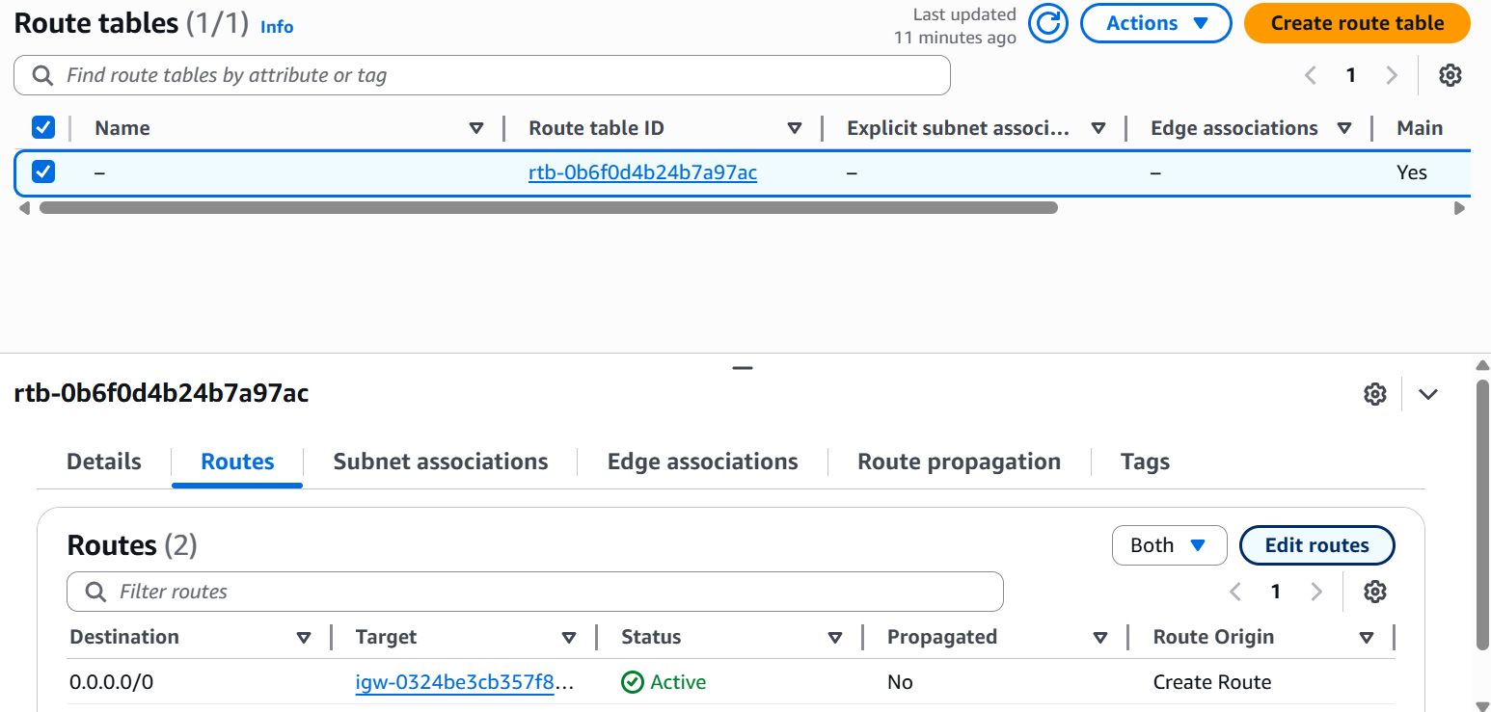
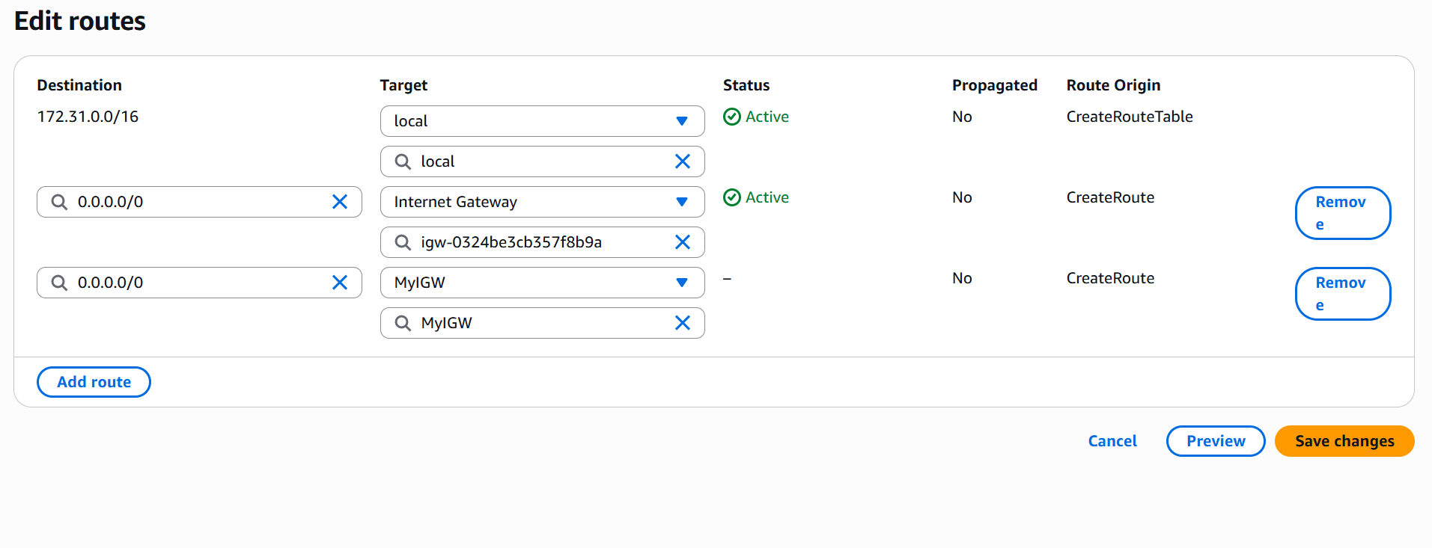
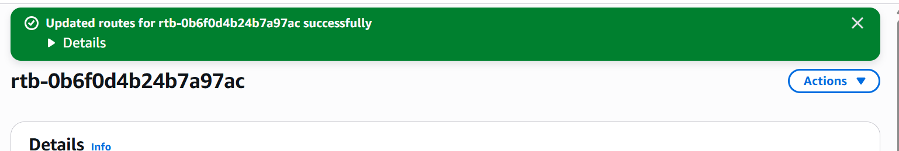
EC2 Deployment
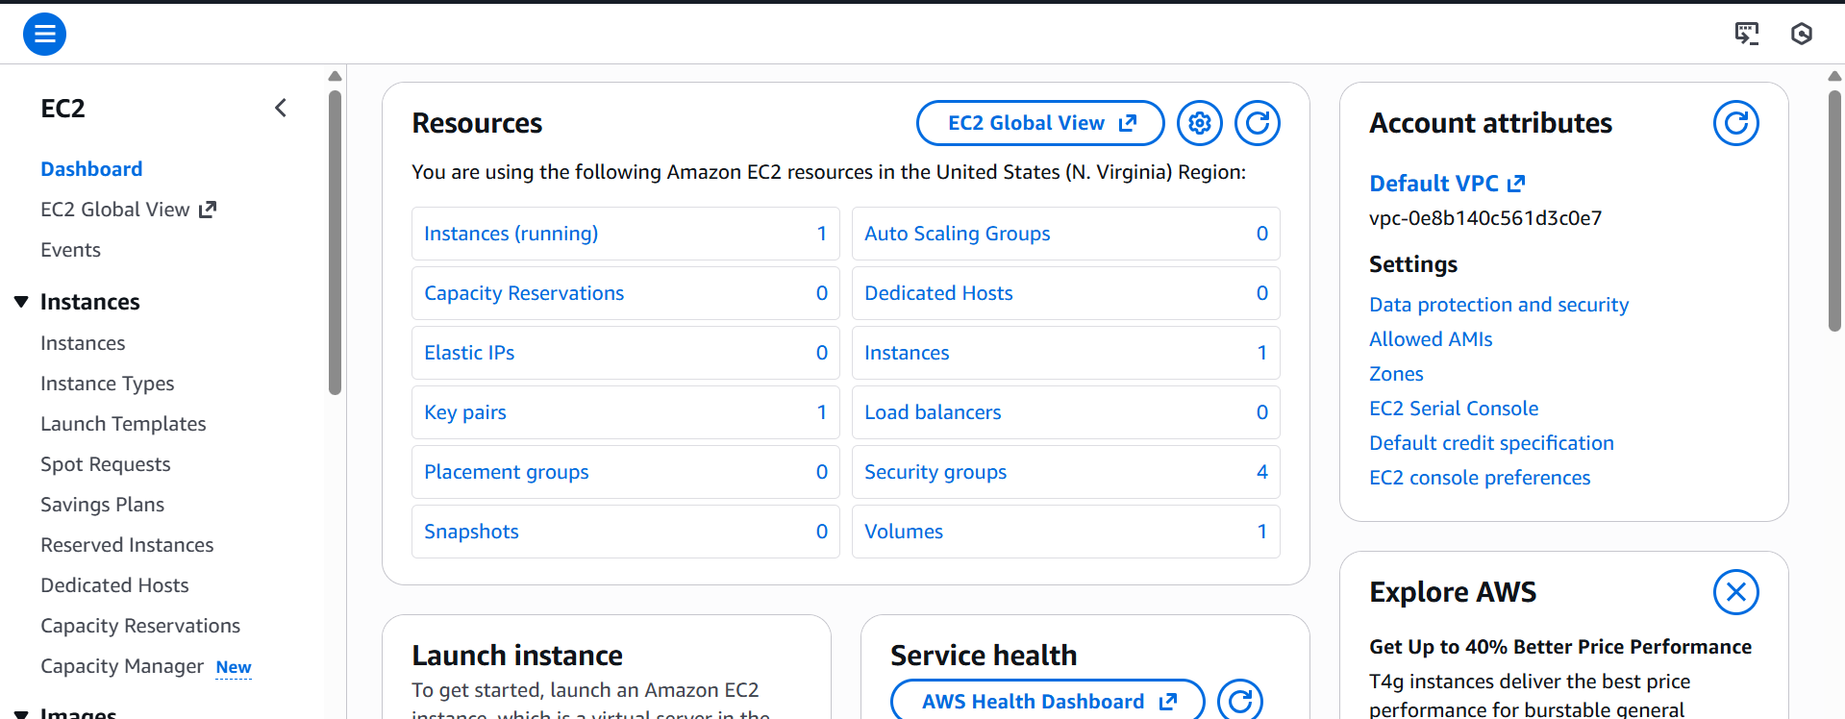
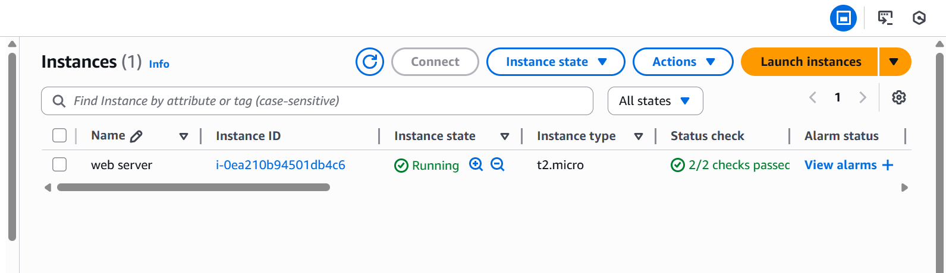
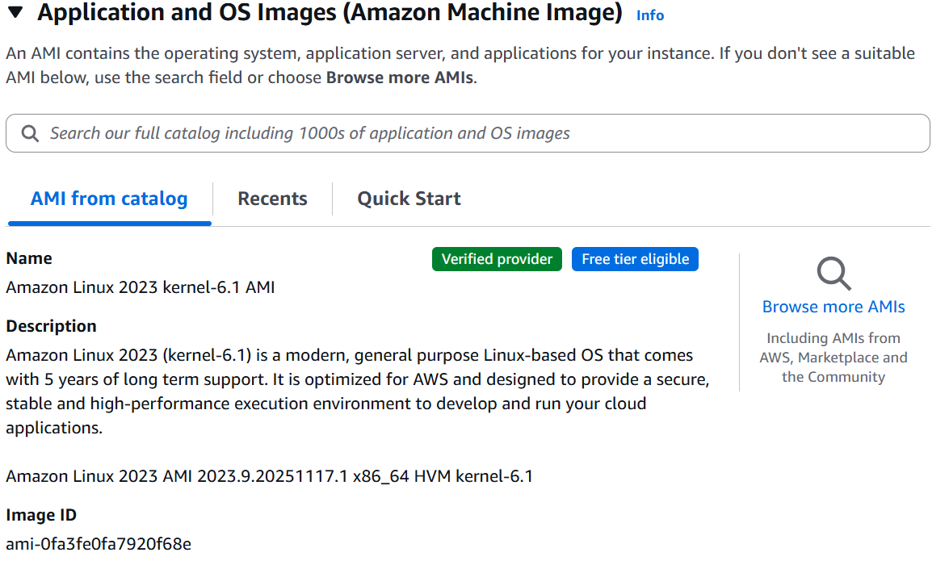
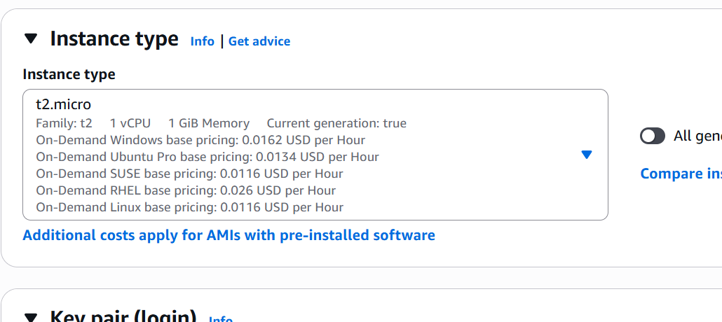
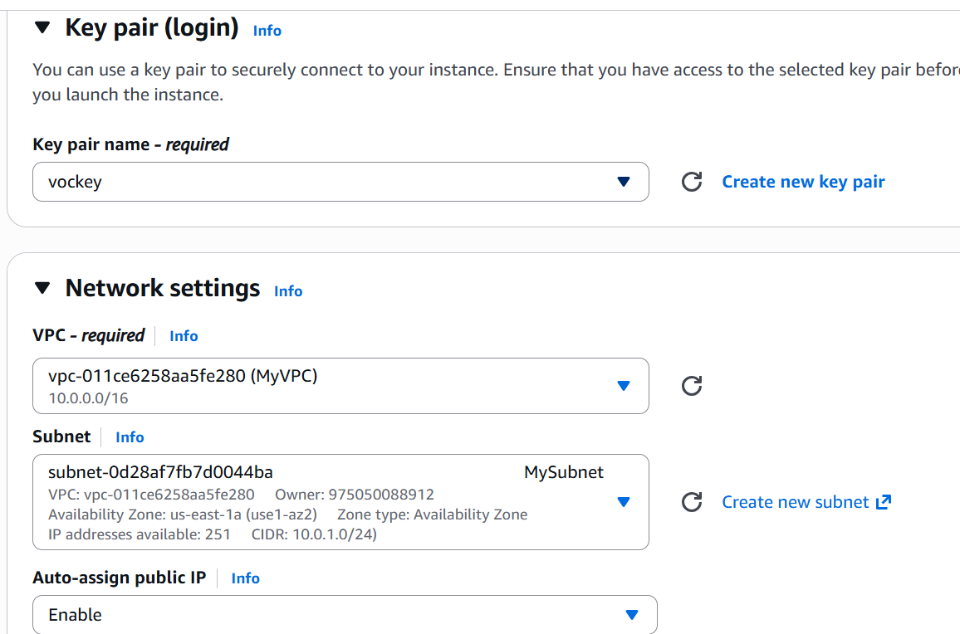
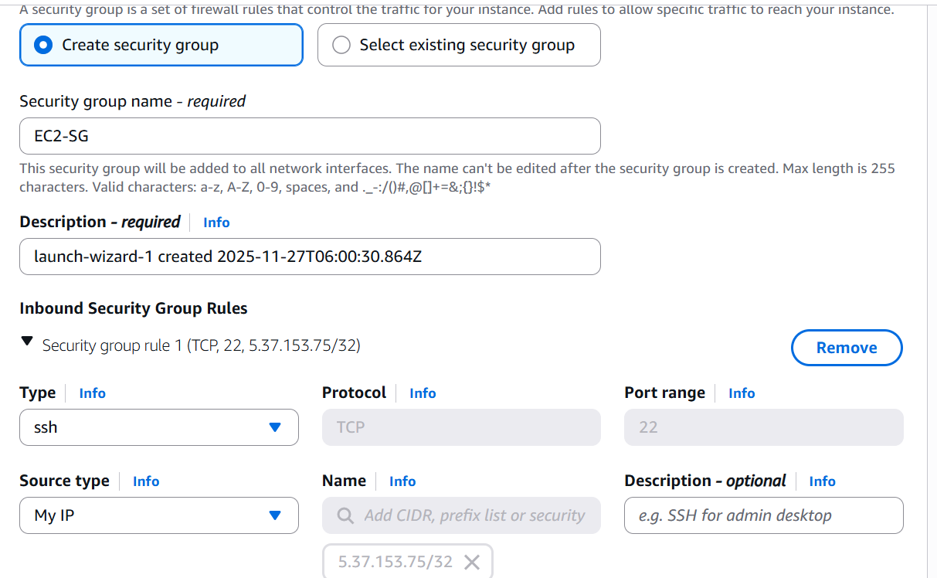
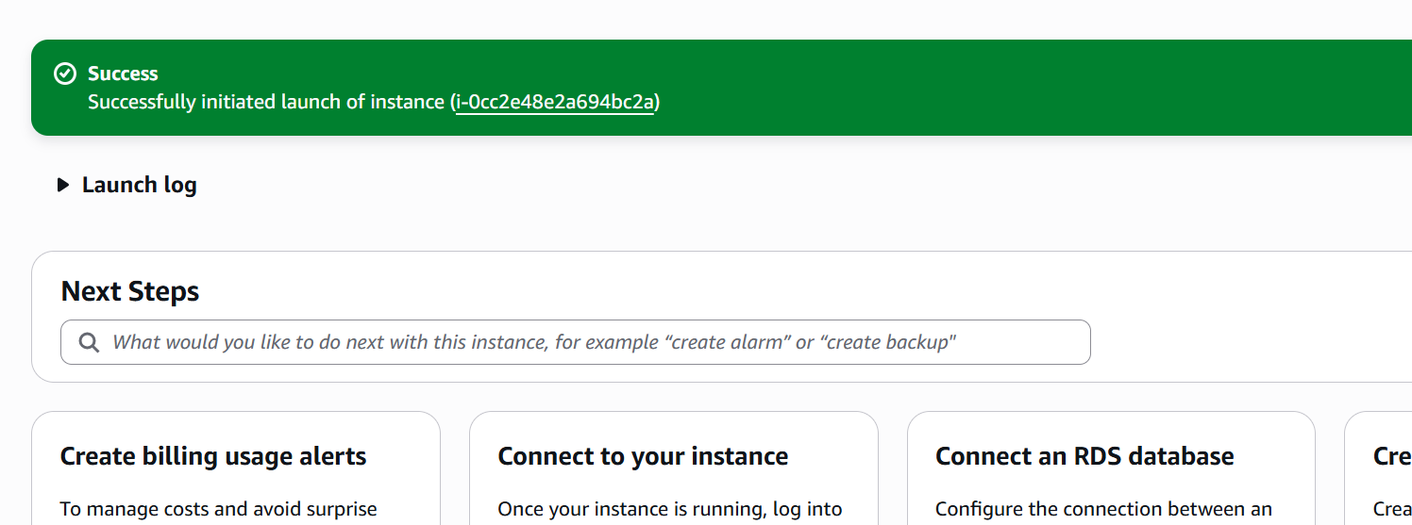
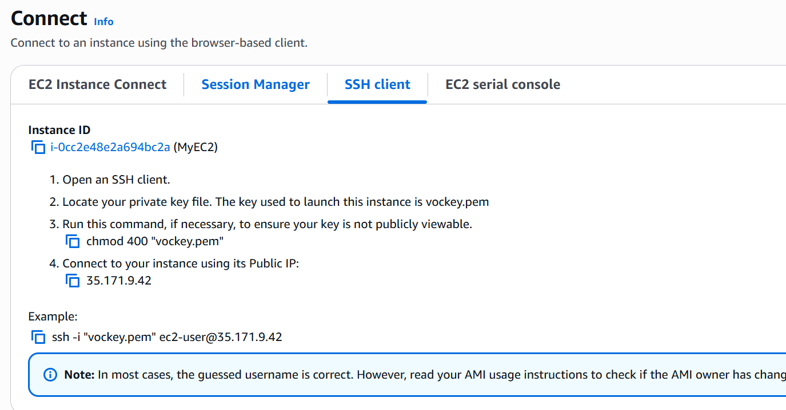
EBS Management
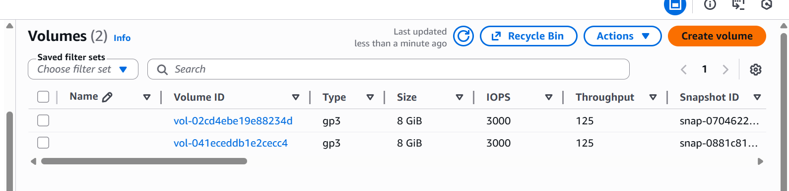
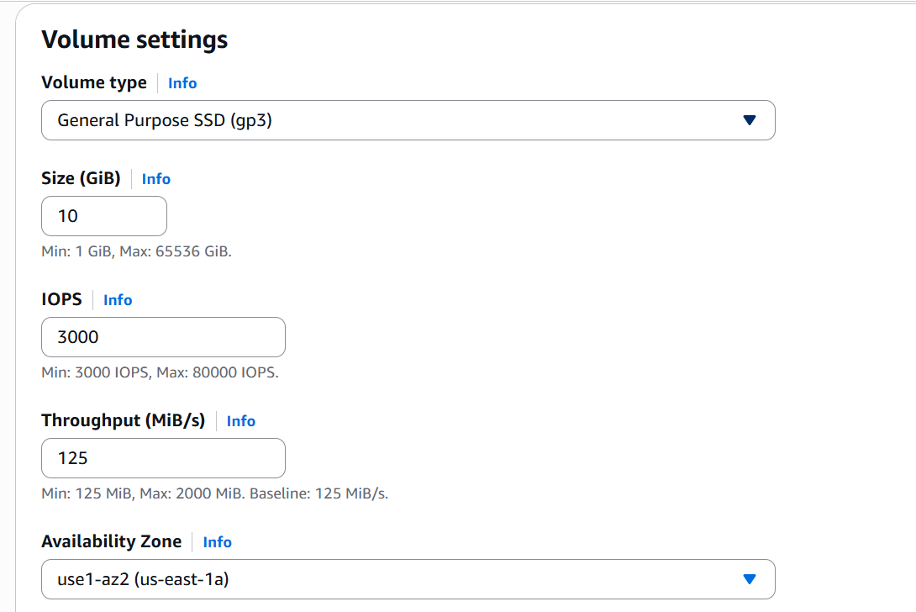
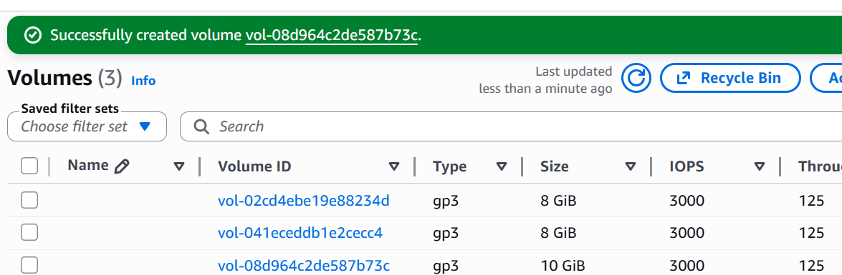
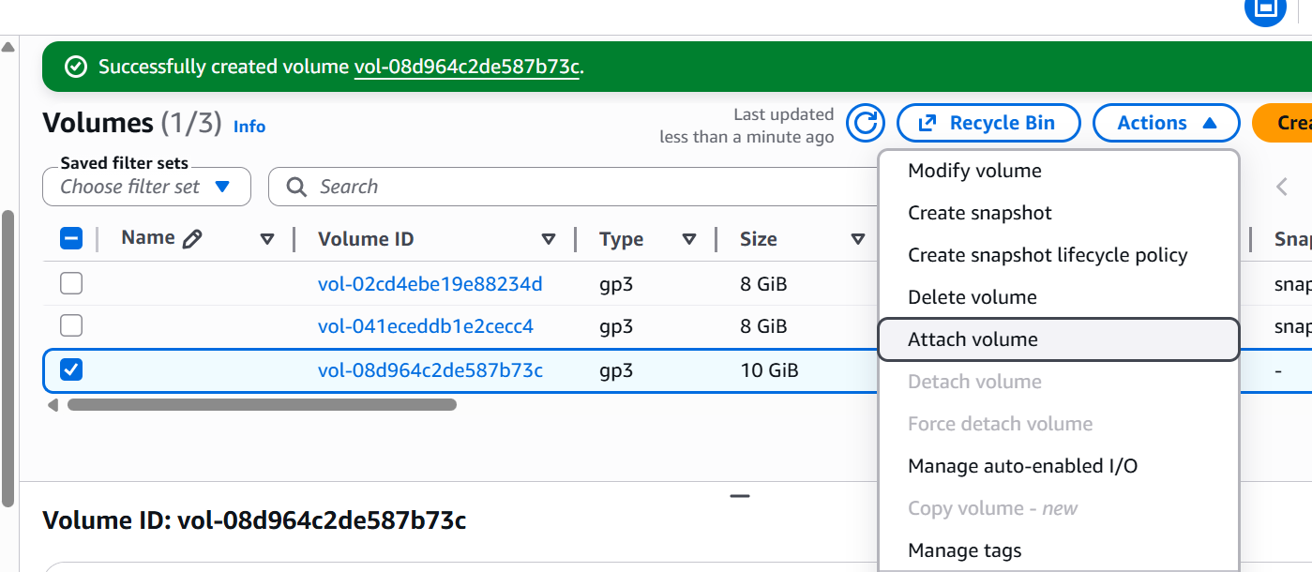
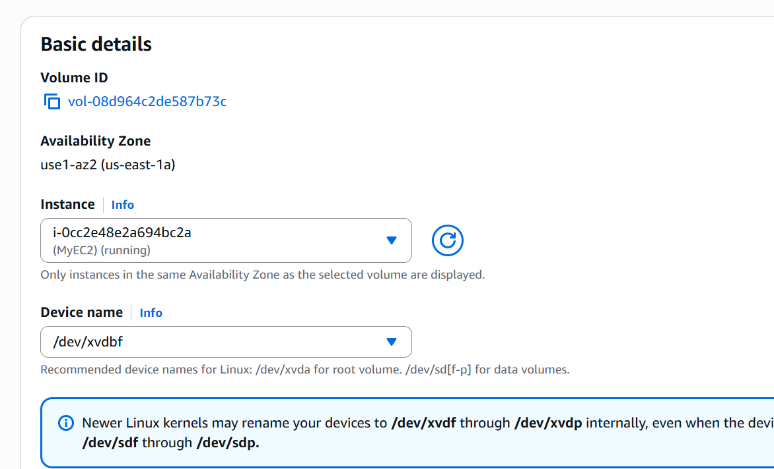
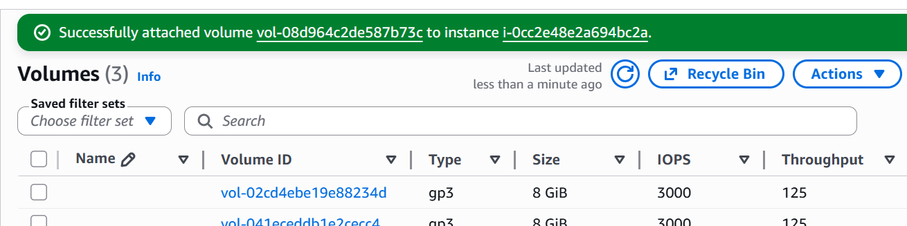
IAM Policy / Security Groups
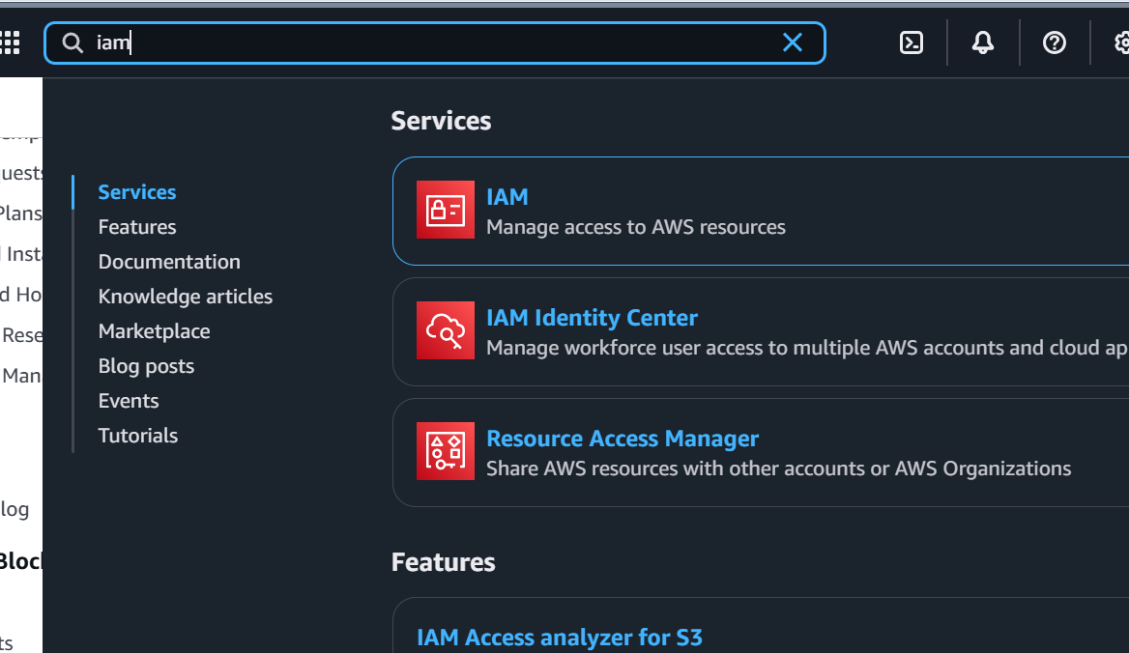
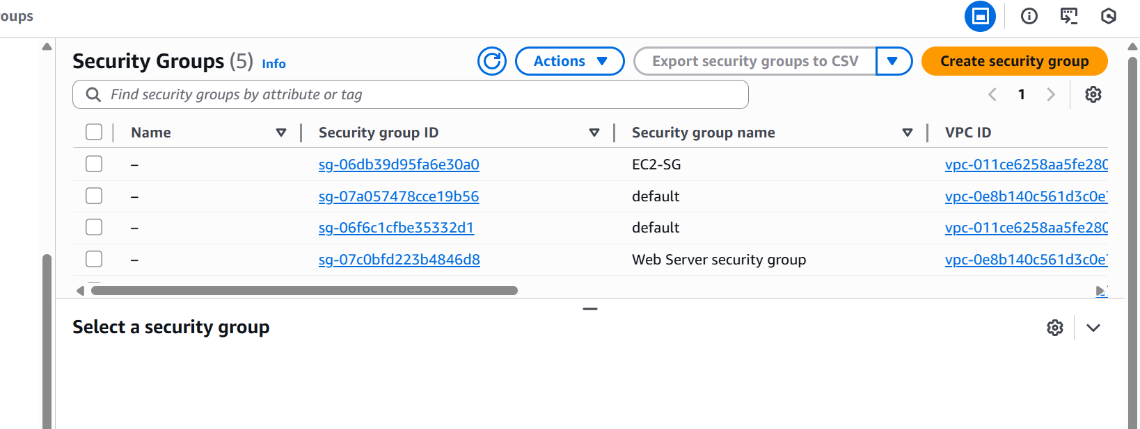
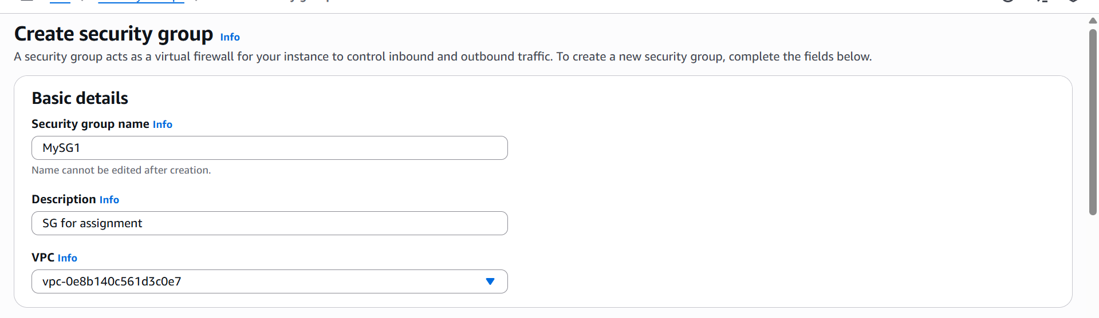
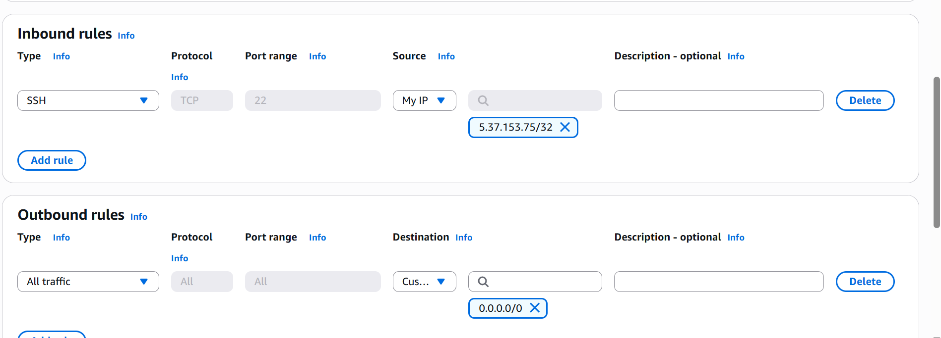
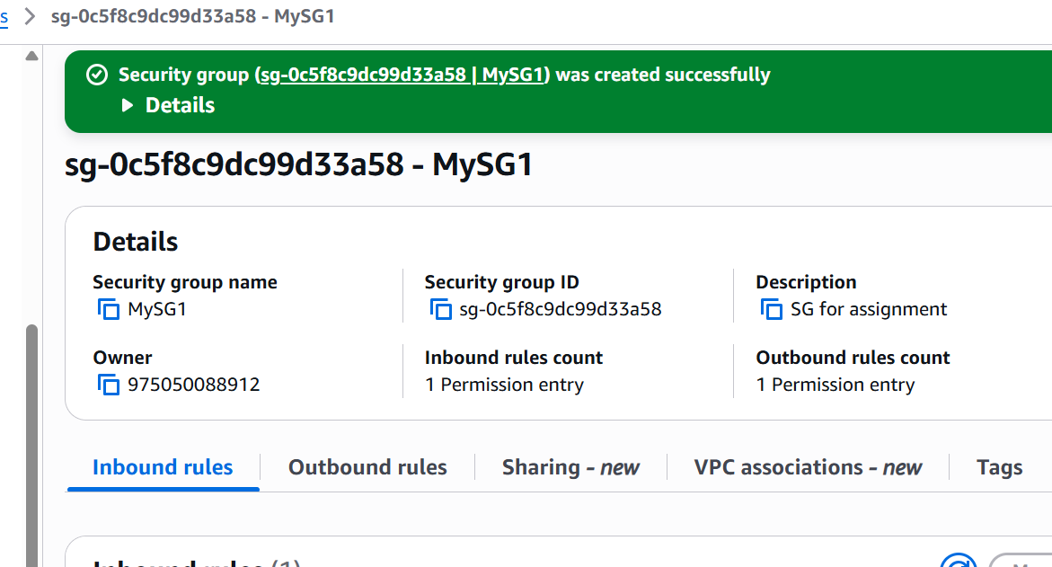
Verify steps:
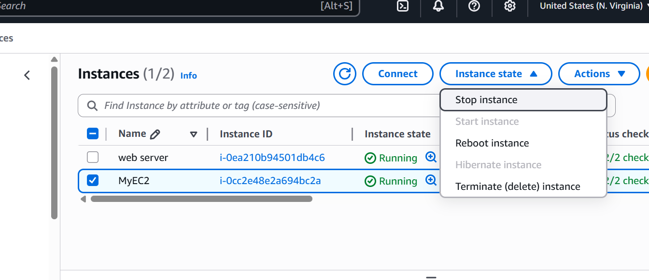
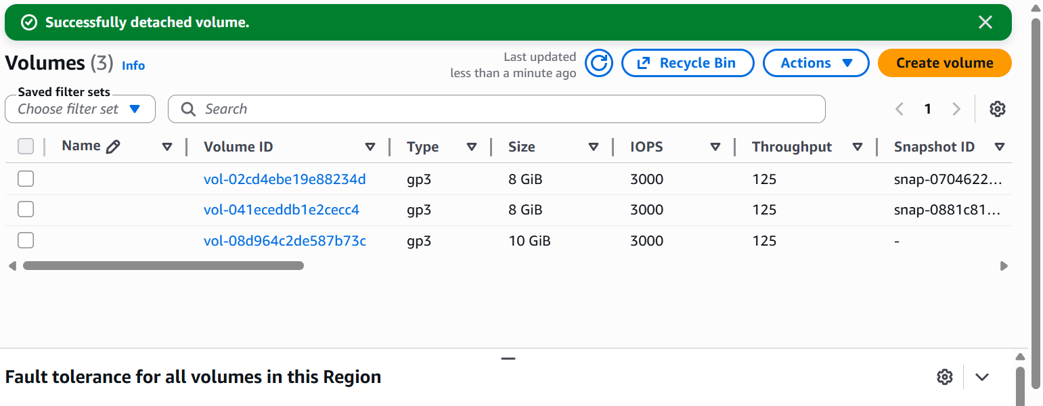
Reflection
Why is the least important privilege in cloud environments?
Because it restricts the permissions granted to users and services to those that are necessary, the principle of least privilege is crucial in cloud systems. This lowers the possibility of unintentional modifications, security lapses, or resource abuse. Organizations can stop attackers from taking complete control, even if one account is hacked, by limiting access. Additionally, least privilege aids in upholding auditing standards and compliance. All things considered, it makes cloud resource management safer and more regulated.
How do VPC, EC2, EBS, and IAM work together to form a secure architecture?
The fundamental network layer that separates cloud resources in a private and secure setting is provided by a VPC. EC2 instances run apps inside the VPC while adhering to security groups and restricted network restrictions. To offer dependable and secure data storage, EBS volumes are attached to EC2 instances. By specifying who can manage or communicate with VPC, EC2, and EBS resources, IAM is used to restrict access. These services come together to form a secure architecture that protects the cloud environment by coordinating networking, computation, storage, and rights.

