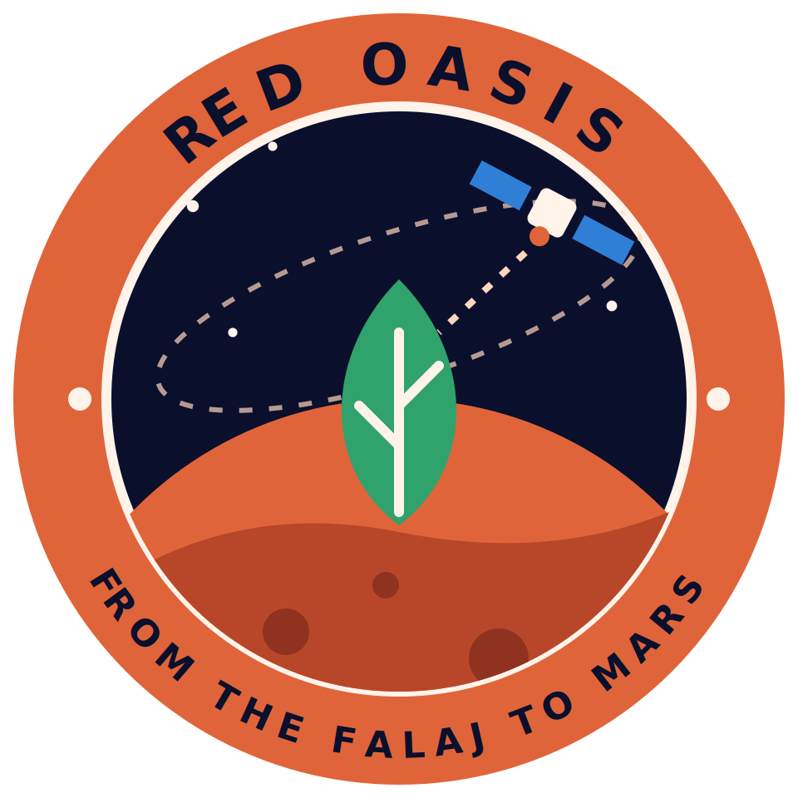
Red Oasis: Project Description and Submission Checklist
From the Falaj to Mars
NASA International Space Apps Challenge 2026 · The Next Frontier

1. Project Description (draft for the submission page)

Summary
Red Oasis is a web app that uses NASA satellite data and AI to tell farmers when to irrigate and why, with a Mars Mode that adapts the same system to closed greenhouses for future Moon and Mars missions.

The problem
In Oman and other dry regions, water is limited, yet many farms irrigate by estimate or on a fixed schedule. This wastes water or stresses crops. On long space missions, food cannot rely on Earth, so every liter of water and every plant matters. The problem is the same in both places: how do we grow food with the least water and the highest efficiency?

Our solution
Red Oasis collects NASA open data for a farm area, uses a machine learning model to predict crop water stress for the coming days, and turns the result into a clear recommendation, for example “irrigate today” or “wait two days”. Each recommendation is explained with SHAP, so the farmer sees the reason, for example low soil moisture and high temperature. The interface has a map, a simple dashboard, and advice in Arabic and English.

NASA data used
- SMAP: soil moisture
- VIIRS / MODIS: vegetation index (NDVI)
- GPM: rainfall
- NASA POWER: temperature and solar radiation
- ECOSTRESS: plant water stress
Final list to be confirmed from the official challenge text.

How it was built
Data processing in Python, a prediction model ([XGBoost or LSTM: final choice]), SHAP for explanations, and a web interface for the map and dashboard. Pilot area: [farm or region in Oman]. Result: [metric: XX], tested on [period].

How we will estimate water saving
We will compare two irrigation plans over the same test period, using historical data for the pilot area: a fixed schedule (the baseline) and the Red Oasis plan, which irrigates only when predicted water stress is high. Estimated water saving = (irrigation events in the baseline − irrigation events in the Red Oasis plan) ÷ irrigation events in the baseline × 100. We assume the same amount of water for each event, because the app does not calculate volumes, and we check that predicted crop stress does not get worse. This is an estimate from a back-test, not a measurement on a real farm.

Mars Mode
A button switches the settings to a closed greenhouse with recycled water, artificial light and Mars conditions. It is a conceptual prototype with simulated sensors, not a flight-ready product.

Impact
Our aim is to reduce wasted water and crop stress, with one system that serves farmers on Earth and crews on the Moon and Mars. Estimated water saving: [XX] percent, to be added only after we calculate it with the method above.

2. Submission Checklist
Submission opens on 14 November at 9:00 AM and closes on 15 November before 11:59 PM, local time. Check the exact requirements on the official project page after 28 October.

Required items
Item | Owner | Done
Working prototype: a live link (or a recording of it running) | Asmaa | ☐
Clear description of the problem, the solution and the data used (Part 1) | Jumana | ☐
Two-minute presentation of the story (the scenario file) | Jumana | ☐
GitHub link with a simple README that explains the project | Asmaa, Yaqeen | ☐
Final slide deck, if requested (template is ready) | Jumana | ☐

Information to fill in before submitting
Item | Owner | Done
Pilot area name and location in Oman | Sharifa | ☐
Final list of NASA datasets with a source link for each | Amna | ☐
Final model choice and accuracy numbers, with the metric named | Yaqeen | ☐
Water-saving estimate calculated with the method in Part 1, and labelled as an estimate | Yaqeen | ☐
App screenshots and a SHAP chart for the slides | Asmaa, Yaqeen | ☐
Team member names for the cover slide | Jumana | ☐

Final checks
Item | Owner | Done
Everything matches the official challenge text (published 28 October) | Sharifa | ☐
Every NASA dataset is named with its source | Amna | ☐
Mars Mode is described honestly as a concept | Jumana | ☐
Every placeholder in brackets is replaced or removed | Everyone | ☐
Submitted before the deadline | Amna | ☐

