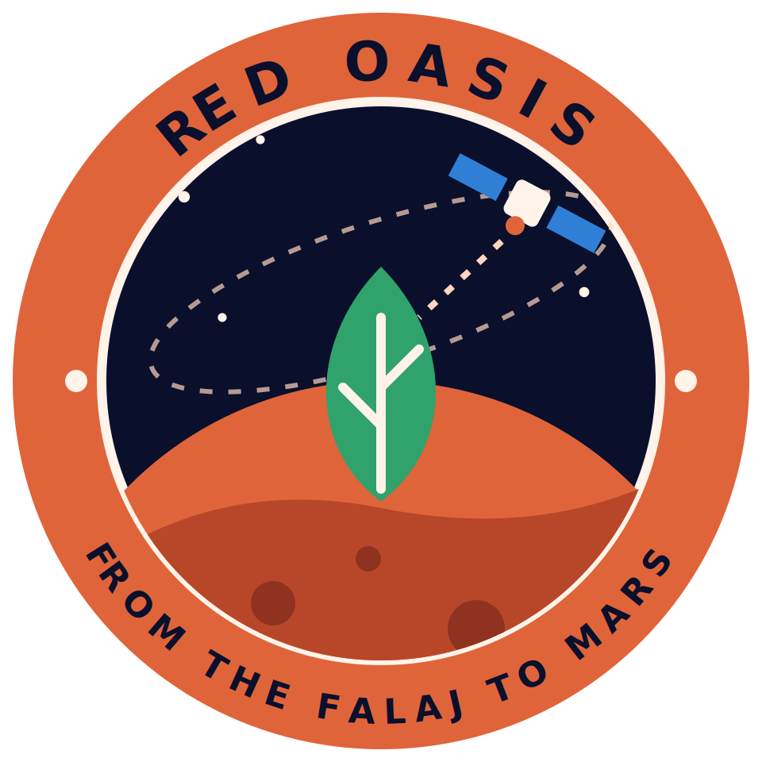
Red Oasis: Scenario
From the Falaj to Mars
NASA International Space Apps Challenge 2026 · The Next Frontier
In Oman, water has always meant life. For centuries, the falaj carried it from the mountains to the palms. Today, a farmer like Saeed still decides by eye. Water too much, and he wastes it. Water too little, and his crop suffers. In a desert, both cost him.
Far above him, NASA satellites measure soil moisture, plant health, rainfall and heat. But that data rarely reaches the farmer as a simple answer.
Red Oasis reads NASA data for his farm and predicts crop water stress for the coming days. Then it tells him when to irrigate: today. And it explains why: soil moisture is low, and the temperature is high. We tested it on historical data from [farm or region] in Oman. The model reached [metric: XX]. Compared with a fixed schedule, we estimate it would save [XX] percent of water.
Now imagine the same system on Mars: recycled water, artificial light, no resupply from Earth. This is a concept with simulated sensors, but the question is the same. How do we grow more with less? Red Oasis. From the Falaj to Mars.

