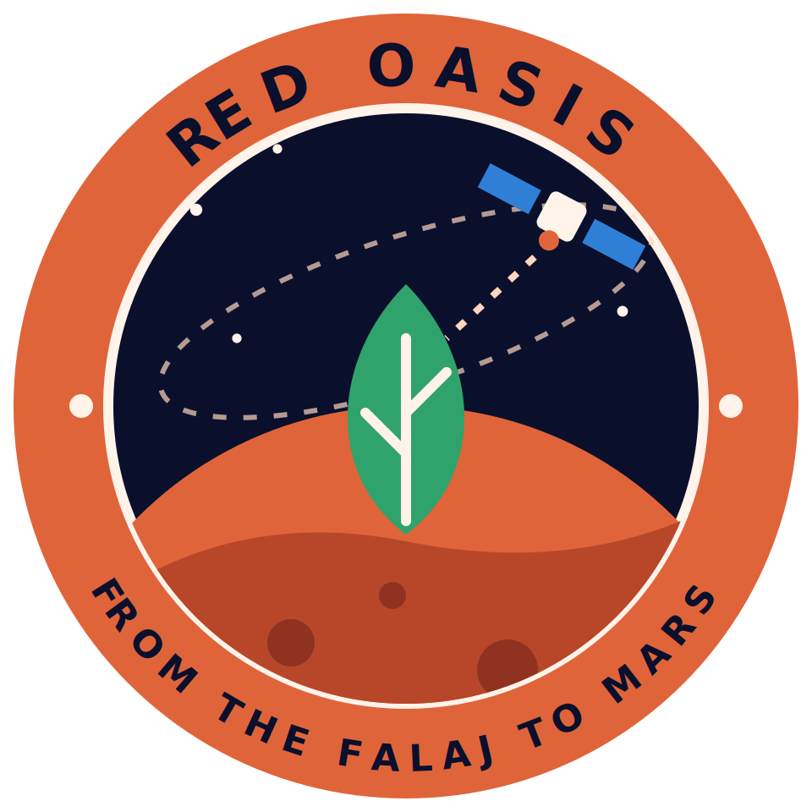
Red Oasis: Judge Questions and Answers
Team Red Oasis: Asma, Amna, Yaqeen, Shareefa, Jumana · NASA International Space Apps Challenge 2026 · Field Shift: Adapting Farms with NASA Data
Eleven hard questions with short, honest answers. Numbers: final test 122 days, model 1.20 vs no-change 1.31; cross-validation 1.18 vs 1.03 (points of soil moisture).

1. Is your model accurate?
We do not claim that. On the final test (122 days) its error was 1.20 percentage points of soil moisture against 1.31 for a "no change" forecast, which is better by about 8%. In cross-validation on the training period it was 1.18 against 1.03, which is worse. So we call it experimental.

2. Why is it still useful if it barely beats "no change"?
The forecast is one part. The app also shows why with SHAP, a provisional rule that compares today and the forecast with the site's own record, and a clear label that it is experimental. Our aim is a transparent method that improves with more data, not a finished product.

3. What exactly does the model predict?
Soil moisture three days ahead, in percent. It does not predict crop stress, yield, or how much water to apply.

4. How are the irrigation levels decided?
By a provisional rule (irrigate, monitor, no irrigation) that compares soil moisture now, the forecast, recent rain and ET0 with the site's own satellite record. It is not validated irrigation advice, so a grower should confirm before acting.

5. A SMAP pixel is about 9 km wide. How can it describe one grove?
It cannot give field-level truth. It gives regional context for the Ad Dariz agricultural area. Better local data, such as a field sensor, is the next improvement we would need.

6. How much data did you use and from where?
1,004 daily rows from January 2024 to September 2026 for the Dariz point: SMAP soil moisture, MODIS/VIIRS vegetation index, GPM IMERG rainfall and NASA POWER weather. Of these, 608 rows had a three-day target; 484 were used for training and 122 for the final test. A longer 2015 to 2026 file (4,314 days) was also assembled and tested; it did not change the conclusion.

7. How much water does Red Oasis save?
We do not have a number. The 3,620 vs 3,235 mm figures are from a published 2002 to 2003 study and show a shortfall, not our saving. We plan to estimate saving by simulation and will label it an estimate.

8. What does SHAP add?
It shows how much each input raised or lowered a forecast. For example, after 40 mm of rain, rainfall raised the forecast by 2.54 points. It shows how the model uses inputs, not proof of cause.

9. Why Mars, and is it real?
It is a concept. It shows how the same logic could apply to a closed greenhouse with recycled water. The 50%, 75% and 100% make-up water levels are team assumptions and simple arithmetic, not a simulation or NASA values. We do not claim date palms can grow on Mars.

10. What would you do with another month?
Test the rule with a grower and field sensors, calibrate palm-specific soil-moisture thresholds on the plot, estimate water saving by simulation, and confirm the grove boundary.

11. The challenge is about crop rotation. Where is it?
Date palm is a perennial tree crop, so rotation does not apply at our site, and we say so. We address the challenge's goals of water conservation and adaptation through irrigation decisions, and a strategy explorer where the farmer sets the yield loss they would accept, using a published Omani trial. A rotation module for annual crops is the natural next step.

