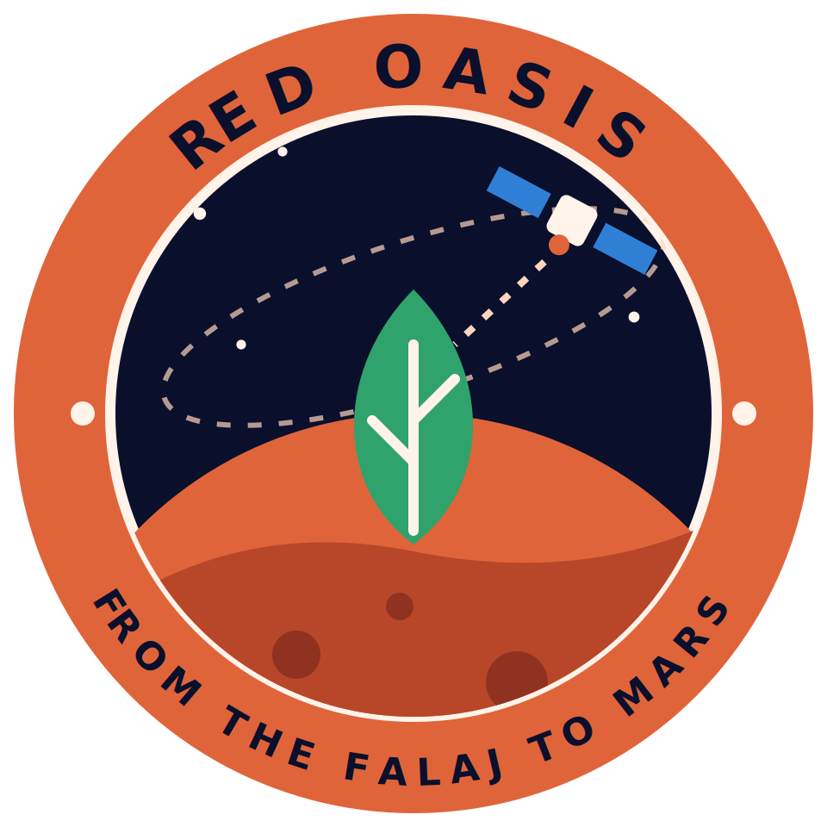
Red Oasis: Presentation Script
From the Falaj to Mars
NASA International Space Apps Challenge 2026 · Field Shift: Adapting Farms with NASA Data
Timed for the two-minute presentation: 310 words at a natural pace of about 150 words per minute. Slide times are guides. Italic grey lines are stage cues and are not spoken. The same text is in the speaker notes of the slides.

Slide 1 · Cover 0:00–0:10
Stand together; logo on screen.
Hello, judges. We are Team Red Oasis, from Oman, working on Field Shift. Our idea is simple: help farmers use every drop of water wisely, from the falaj to Mars.

Slide 2 · The Problem 0:10–0:29
Point to the red bars, then the green bars.
At Falaj al-Dariz, a published study found that date palms needed more water than arrived from April to November, with a surplus from December to February. Over the year, demand was 3,620 millimetres against 3,235 supplied. Astronauts will face the same question: how to grow food with less water?

Slide 3 · Our Solution 0:29–0:39
Point to the three cards and their status tags.
So we built Red Oasis. It forecasts soil moisture, suggests when to irrigate, and shows why. The same logic is adapted for a greenhouse on Mars.

Slide 4 · Pilot Site: Ad Dariz Area 0:39–0:46
Point to the satellite image.
Our pilot site is the Ad Dariz agricultural area in Ibri, where real published research already exists.

Slide 5 · NASA Data 0:46–0:57
Run down the table; stress “Used”.
We use four NASA sources for Dariz, from 2024 to 2026: SMAP for soil moisture, MODIS and VIIRS for plant health, GPM for rain, and NASA POWER for weather.

Slide 6 · How It Works 0:57–1:10
Trace the top row; then point to the dashed boxes.
NASA data feeds a Random Forest model, SHAP explains it, and the app shows it. The model forecasts soil moisture three days ahead. It is experimental, and the dashed boxes are not done yet.

Slide 7 · The Prototype 1:10–1:22
Point to the dry case, then the after-rain case.
Here is the running app. In a dry case it says irrigate today. After heavy rain it says no irrigation needed. These levels come from a provisional rule, not validated advice.

Slide 8 · Explainable Advice 1:22–1:39
Point to the SHAP bars, then the two error numbers.
SHAP shows why the model gave each forecast. On our final test of 122 days, its error was 1.20 points against 1.31 for a no-change forecast. But in cross-validation it was 1.18 against 1.03. So we call it experimental, and we say so openly.

Slide 9 · Mars Mode (Concept) 1:39–1:48
Slow down; be clear it is a concept.
Mars mode is a concept. Our water what-if tests fifty, seventy-five and one hundred percent make-up water. These are team assumptions, not NASA values.

Slide 10 · Evidence and Next Steps 1:48–2:00
Point to the four steps; end on the tagline.
Next: test the rule with growers, calibrate palm-specific thresholds in the field, estimate water saving by simulation, and confirm the grove boundary. Red Oasis: from the falaj to Mars. Thank you.

