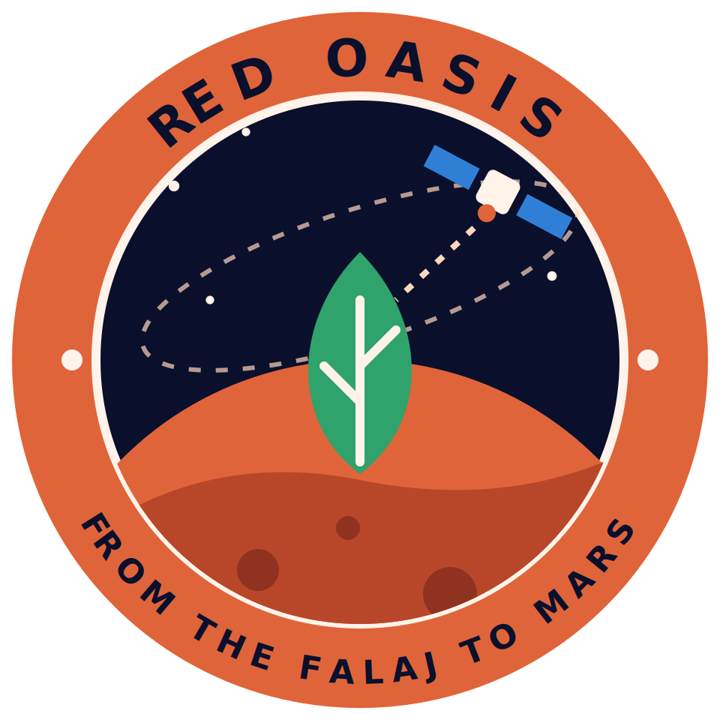
Red Oasis: An Explainable Irrigation Advisor for Date-Palm Oases, from the Omani Falaj to Mars
Team Red Oasis: Asma, Amna, Yaqeen, Shareefa, Jumana
NASA International Space Apps Challenge 2026 · Field Shift: Adapting Farms with NASA Data

Abstract
Water is the limiting resource for farming in arid regions such as Oman, yet irrigation is often scheduled by habit rather than by measured crop need, which can waste water in some months and leave the trees short of water in others. A published study of Falaj al-Dariz, a date-palm oasis in Ibri, found that annual crop water demand (3,620 mm) exceeded field supply (3,235 mm) by about 10.6% (demand/supply ratio 1.12; 2002-2003 data). Demand was above supply from April to November, with a surplus from December to February. Long space missions face the same question: how to grow food with the least water.
Red Oasis answers the Field Shift challenge, which asks for a decision-support tool that combines NASA observations, local soil and crop information and farmer priorities. It is a bilingual (English and Arabic) web app that advises farmers when to irrigate and explains why, and a strategy explorer lets the farmer set how much yield loss is acceptable in order to save water, using a published Omani irrigation trial. Date palm is a perennial tree crop, so crop rotation does not apply to our site; we address the challenge's goals of water conservation and adaptation through irrigation decisions. Its objectives are to turn satellite observations into a simple recommendation, to make every recommendation transparent, and to show how the same logic could serve a closed-environment greenhouse for Moon and Mars missions.
The system uses NASA open data for a pilot site in the Ad Dariz agricultural area, Ibri: SMAP soil moisture, MODIS/VIIRS vegetation index, GPM IMERG rainfall, and NASA POWER temperature and evaporative demand, covering 1,004 days from January 2024 to September 2026. A Random Forest model forecasts soil moisture three days ahead, and SHAP shows how each input moved the forecast. On a chronological final test of 122 days, the model's mean absolute error was 1.20 percentage points of soil moisture against 1.31 for the simple "no change" forecast; in cross-validation on the training period it was 1.18 against 1.03. We therefore label the model experimental.
Implemented so far are the working app with its English and Arabic interface, the trained model with SHAP explanations, a provisional irrigation rule that compares the forecast, today's soil moisture, recent rain and ET0 with the site's own record, and a Mars water what-if at 50%, 75% and 100% make-up water, which is illustrative arithmetic. The irrigation levels are not validated advice, and a SMAP pixel (about 9 km) gives regional rather than field-level information. A longer 2015 to 2026 record was assembled and tested and did not change the conclusion that the model is experimental. Next steps are field validation with growers, palm-specific soil-moisture thresholds calibrated on the plot, a water-saving estimate by simulation, and confirmation of the grove boundary. If these steps succeed, Red Oasis can offer a transparent approach that adapts from Omani oases to closed-loop farming beyond Earth.
Keywords: irrigation advisor; NASA Earth observation; explainable AI; SHAP; soil moisture forecast; date palm; Oman; Mars greenhouse

