|  |
| --- |
|  |

|  |
| --- |
|  |
|  |
|  |
|  |
|  |
|  |
|  |
|  |

XO-Game using

TM4C123G LaunchPad

|  |  |
| --- | --- |
| Student name | B.N |
| Asmhan Rashed Alioa | 11 |
| Nada Saeed Hassan | 66 |
| Marina Bedir Gabra | 41 |
| Dina Mohamed Abdalhalim | 16 |
| Demiana Samir Soliman | 15 |
| Sara Mohamed | 20 |
| Yasmin Attia | 74 |

Report : at pages 3&4.

Circuit diagram : page 4

Report XO-Game

In our project , we use codes which we do it in our labs including (Interrupt , Driver , Timer , Switches , leds , Nokia5110).

First, we split Nokia Screen 2/3 : 1/3 , 2/3 for playing game and 1/3 for writing which person will play.

We make 3photos as we learn in lab one for back ground second for X third for O.

Then we try to run our code using Launchpad and using PortF only but we know that's not allowed to use Launchpad switching so we use 3external switch at PortE(0,4,2) and 2external led at PortF(1,2) so , we make three drivers one called Portf_cfg.h which contain configuration of 3external switches ,second called Port.h has function definitions which we use in our programme third called Port.c has body of some of function which we use in our project.

At first choice when we try to run it on Kit and simulation we make printXO function to return all XO steps which player played it on Nokia5110 screen to become not allowed play here again, we make another function called loc to save all right location of player which we decide to play in this place , we make another function called cordnokia to know right place of X or O and return right place of X,O and use it in printXO function ,finally we make function to search about winner player in our game.

Final step we add interrupt and timer to our code.

Here this is our circuit

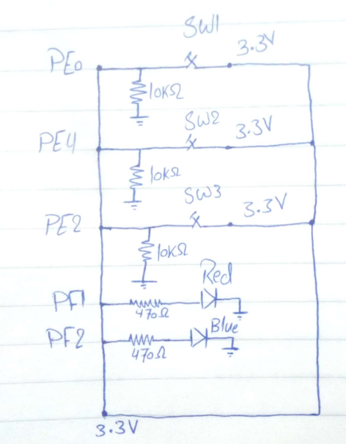

Link video in youtube:- <https://www.youtube.com/watch?v=bv6em1mHLgI>

Link Gihtub repository of our project:

<https://github.com/MarinaBeder/XO_Gaming>