Methodology Plan
Compact convolutional transformers for respiratory sound classification
CCT (final) and FreqCCT (variant), 7 classes, 68,915 frames. One stratified split, one seed, one recipe; ablations on 5 folds.

1. Purpose
This plan sets out how CCT and FreqCCT are trained and evaluated on respiratory sounds, and how the trained models are explained. CCT is the final model because it has the highest accuracy in the first sweep: 97.55% validation and 96.86% test, against 95.36% and 96.31% for FreqCCT. FreqCCT stays as a cheaper variant (83.0 against 124.2 MFLOPs). The two are separate models. The final model is CCT alone, not FreqCCT and not a combination of the two; no prediction is ever averaged across models. If FreqCCT should be the final model instead, only the label changes and the headline test accuracy becomes 96.31%.
The test score is the main focus and cost is secondary. The training recipe is already fixed, so nothing is tuned and nothing is ensembled. Every run uses one seed. The main results use one stratified split. The four ablations use five folds of the same stratified split.
No patient-level split is used anywhere. Frames of one recording can fall on both sides of the split, so the scores describe frames like the training frames and do not measure performance on unseen patients. The paper keeps one sentence saying so. Section 10 lists what changed in this revision and in the earlier notebook edits.

2. Pipeline
Recordings are cut into frames, the non-COPD classes are augmented, and each frame becomes three time-frequency maps stacked into one 3 × 64 × 40 tensor. The tensor goes into CCT or FreqCCT, each trained once with the locked recipe. The final CCT checkpoint then feeds the post-hoc analysis, the ablations and the cost comparison.

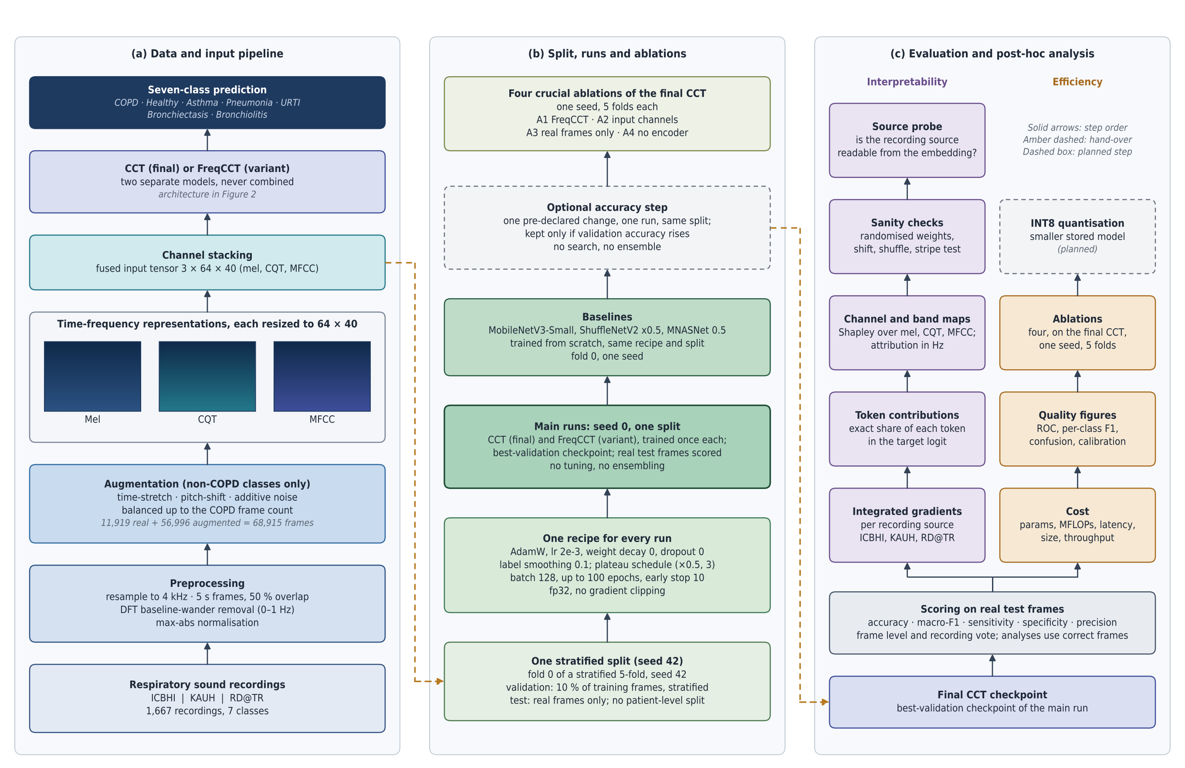
Figure 1. Panel (b) runs once on the one split, except the four ablations, which are trained on each of the five folds. Panel (c) starts from the final CCT checkpoint. Thumbnails are schematic. Test frames are real, non-augmented frames.

3. Decisions
Item | Decision
Software | PyTorch; scikit-learn for the split
Classes and input | 7 classes: COPD, Healthy, Asthma, Pneumonia, URTI, Bronchiectasis, Bronchiolitis. Input 3 × 64 × 40 (mel, CQT, MFCC)
Data | ICBHI, KAUH and RD@TR; 1,667 recordings; 68,915 frames, of which 11,919 are real and 56,996 are augmented copies
Split | One stratified split, seed 42: about 72% train, 8% validation, 20% test. It is the same split as fold 0 of the earlier stratified 5-fold. Validation is 10% of the training part. The test part holds 13,783 frames and the 2,360 real ones are scored. No patient-level split
Models | CCT, final: 173,128 parameters, 124.2 MFLOPs. FreqCCT, variant: 158,023 parameters, 83.0 MFLOPs
Recipe | Locked: AdamW, learning rate 0.002, weight decay 0, dropout 0, label smoothing 0.1, ReduceLROnPlateau (factor 0.5, patience 3), batch 128, up to 100 epochs, early stopping on validation loss (patience 10), fp32, no gradient clipping
Tuning | None. The recipe is the best-accuracy run of the first sweep (trial 6)
Seeds and folds | One seed (0) for every run. Main results and baselines: the one split (fold 0). The four ablations and the CCT they are compared with: 5 folds
Ensembling | None
Metrics | Accuracy, macro-F1, sensitivity, specificity and precision on real test frames; recording-level vote
Explanation methods | Integrated gradients, token contributions, channel Shapley, band attribution in Hz, sanity checks, source probe
Efficiency | Parameters, MFLOPs, CPU latency (1 thread), throughput, stored size, peak activation; three small baselines (MobileNetV3-Small, ShuffleNetV2 ×0.5, MNASNet 0.5) trained from scratch with the same recipe

4. Data and input

4.1 Source data
The recordings come from three sources: ICBHI, KAUH and RD@TR, 1,667 recordings in total. Each belongs to one of 7 classes. In the scored test frames, 1,386 come from ICBHI, 719 from RD@TR and 255 from KAUH.

4.2 Preprocessing
- Resample each recording to 4 kHz.
- Cut it into 5 s frames with 50% overlap.
- Remove baseline wander with a DFT filter (0 to 1 Hz).
- Normalise by the maximum absolute value.
- Compute the mel spectrogram, the CQT and the MFCC, resize each to 64 × 40 and stack them as three channels.

4.3 Augmentation and frame set
Only the non-COPD classes are augmented, with time-stretch, pitch-shift and additive noise, until each class has as many frames as COPD. This gives 68,915 frames, of which 56,996 are augmented copies. The test part of the split holds 13,783 frames, and 11,423 of them are augmented copies. Only the 2,360 real frames are scored.
Those 2,360 frames are strongly unbalanced, and 83.4% are COPD. A model that always answers COPD therefore scores 0.834, and every accuracy figure in this plan is read against that value. Macro-F1 rests on 17 to 140 frames in each small class, so it moves more than accuracy does.
Class | Real test frames | Note
COPD | 1,969 | 83.4% of the scored frames
Healthy | 140
Asthma | 106
Pneumonia | 64
URTI | 36
Bronchiectasis | 28
Bronchiolitis | 17 | Smallest class
Total | 2,360

5. Models

5.1 Architecture
Both models share one tokenizer and one encoder. They differ in the second tokenizer convolution, the positional embedding and the head.
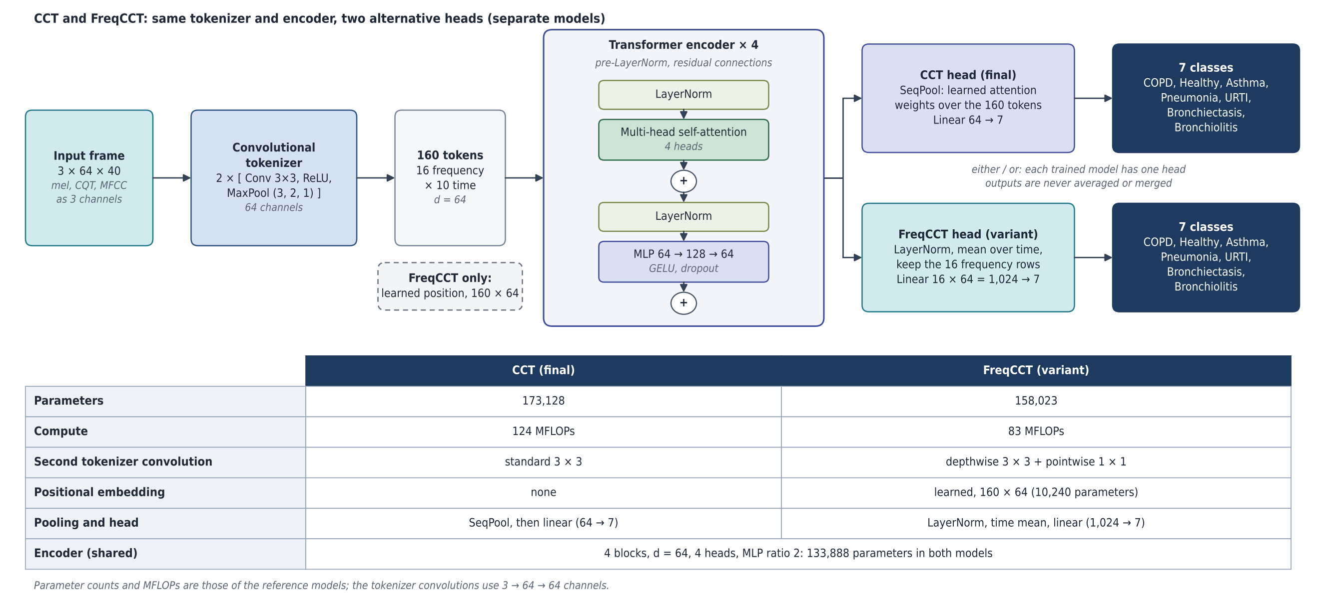
Figure 2. CCT (final) and FreqCCT (variant). The two heads are alternatives: each trained model has exactly one head and its own 7-class output. They are never combined, averaged or merged.

5.2 Components
Component | Setting
Tokenizer | Two blocks of 3 × 3 convolution, ReLU and max-pool (kernel 3, stride 2, padding 1), 64 channels. The output is 160 tokens (16 frequency × 10 time) of dimension 64
Encoder | 4 pre-LayerNorm blocks, 4 attention heads, MLP 64 → 128 → 64 with GELU. 133,888 parameters, the same in both models
CCT | Standard second convolution, no positional embedding. SeqPool (learned attention weights over the 160 tokens), then a linear layer 64 → 7. 173,128 parameters, 124.2 MFLOPs
FreqCCT | Depthwise 3 × 3 plus pointwise 1 × 1 second convolution, learned positional embedding (160 × 64). LayerNorm, mean over time, the 16 frequency rows kept, then a linear layer 1,024 → 7. 158,023 parameters, 83.0 MFLOPs

6. Split, training and run plan

6.1 Split
- One stratified split by class, seed 42. It uses the same frames as fold 0 of the earlier stratified 5-fold, so the first-sweep results stay comparable.
- Validation is 10% of the training part, drawn stratified. It includes augmented copies, so it is class-balanced and its chance level is about 14%.
- The test part is scored on its real frames only.
- A check at the start asserts that train, validation and test share no frame, and prints the COPD share of the real test frames (0.834).
- The other four folds of the same 5-fold are used only for the ablations.

6.2 Locked recipe
Setting | Value
Optimiser | AdamW, learning rate 0.002, weight decay 0
Regularisation | Dropout 0, label smoothing 0.1; no mixup, masks, EMA or stochastic depth
Schedule | ReduceLROnPlateau on validation loss (factor 0.5, patience 3)
Batch and length | Batch 128, up to 100 epochs, early stopping with patience 10 on validation loss
Numerics | fp32, no gradient clipping
Seed | torch.manual_seed(42 + fold + seed); the main runs use seed 0
Checkpoint | Epoch with the best validation loss; chosen on validation, never on test

Under this recipe the first sweep gave 97.55% validation and 96.86% test accuracy with macro-F1 0.944 (CCT). Across three seeds of a related setting, test accuracy had a standard deviation of 0.80 points. One run therefore leaves about one point of uncertainty on the test figure. The ablations use five folds, and differences below about one point are within the fold-to-fold spread.

6.3 Run plan
- Lock. Use the recipe in Section 6.2 for both models. Nothing is searched.
- Train once. Train CCT and FreqCCT on the one split (fold 0) and score the real test frames.
- Baselines. Three small networks (MobileNetV3-Small, ShuffleNetV2 ×0.5, MNASNet 0.5), trained from scratch with the same recipe on the same split.
- Post-hoc analysis. Run the analyses in Section 8 on the final CCT checkpoint. No retraining.
- Optional accuracy step. Section 6.4, one run.
- Ablations. Run the four ablations in Section 7 on 5 folds.
There is no tuning stage and no seed ensemble. The notebook trains 33 runs in total: 2 main, 3 baselines and 28 ablation runs (the ablation base reuses the main CCT and FreqCCT runs).

6.4 Raising the test score without tuning
The saved predictions of trial 6 show where the errors are. Of 2,360 real test frames, 74 are wrong. 36 are COPD frames labelled Healthy (24) or Asthma (12), and 23 are Healthy or Asthma frames labelled COPD. The four smallest classes have recall 1.00. Healthy (F1 0.865) and Asthma (F1 0.880) pull macro-F1 down because of their confusion with the large COPD class.
No change is guaranteed to help, and one run cannot show a gain smaller than about 0.8 points. The plan therefore allows exactly one pre-declared step, run once on the same split: choose the checkpoint on validation accuracy instead of validation loss (the monitor already used in the later trials of the reference notebook). Keep it only if validation accuracy rises, and report the test score whichever way it goes. There is no search and no ensemble. To run it, add one entry with monitor set to val_acc to the run list of the notebook.
One idea was checked on saved predictions and rejected. Shifting the output logits by the real-frame class prior raised test accuracy to 97.4% for CCT at one setting, but the best setting differed between CCT and FreqCCT and was found on test frames, so it is not a valid result. A full correction dropped macro-F1 to 0.67. A proper version needs a validation set with the real class mix, which this split does not have.

7. Ablations

7.1 The four ablations (one seed, 5 folds each)
Only the four ablations that carry the paper's claims are run. Each changes one thing in the final CCT and keeps the recipe. Results are reported on real test frames as mean and standard deviation over the 5 folds, with the paired difference to the base on the same fold.
ID | Change to the final CCT | Question | Runs
Base | None: the final CCT (fold 0 is the main run) | Reference for every row below | 4 new
A1 | FreqCCT: depthwise second convolution, learned position, frequency-preserving head (158,023 parameters, 83.0 MFLOPs) | What does the cheaper variant cost or gain in accuracy? | 4 new
A2 | Input channels: mel only (171,976 parameters), and mel + CQT (172,552 parameters) | Does the three-channel fusion help? | 10
A3 | Train on real frames only, no augmented copies | How much do the augmented copies add? | 5
A4 | No transformer encoder: tokenizer, SeqPool and linear head only (39,240 parameters, 56.1 MFLOPs) | Does the transformer add anything over the convolutions? | 5
Total |  |  | 28 new runs

The first sweep took 13 to 27 minutes per run (median 17). The 28 ablation runs plus 5 main and baseline runs need about 9 GPU hours in total. Other first-sweep variants stay single-run side results and are not repeated.

7.2 Single-run side results already available
These exist from the first sweep and can be quoted as single runs without new training.
Variant | Real test accuracy | First-sweep trial
Label smoothing off (plateau schedule kept) | 96.19% | Trial 3, against 96.86% for trial 6
Plateau schedule off (smoothing 0.1 kept) | 92.67% | Trial 5
3 encoder layers (139,656 parameters) | 95.08% | Trial 9
Embedding 48 (98,360 parameters) | 91.10% | Trial 10

7.3 Analyses that need no retraining
- Masking ablation: remove the regions with the highest attribution and compare with removing random regions.
- Randomisation check: re-score attributions with randomised weights.
- Shift, shuffle and stationary-stripe tests on the final checkpoint.

8. Evaluation and post-hoc analysis

8.1 Scoring
All models are scored on real test frames with accuracy, macro-F1, sensitivity, specificity and precision, per frame and per recording (majority of frame outputs). Confusion matrices and a cost-versus-score plot are drawn for CCT and FreqCCT.
The evaluation cell of the notebook writes these figures and tables for CCT and FreqCCT, with the three baselines for context: cost bars (parameters, MFLOPs, latency, size), accuracy against cost with 95% intervals over recordings, quality bars (accuracy, macro-F1, balanced accuracy, MCC, AUC), per-class F1, confusion matrices, one-vs-rest ROC curves, training curves, five-fold stability and the ablation chart. It also reports calibration error and recording-level accuracy.

8.2 Interpretability
- Integrated gradients per recording source (ICBHI, KAUH, RD@TR).
- Token contributions: the exact share of each token in the target logit, from the pooling weights.
- Channel Shapley values over mel, CQT and MFCC, and band attribution in Hz.
- Sanity checks: randomised weights, shift and shuffle tests, and a stationary-stripe test.
- Source probe: whether the recording source can be read from the frozen embedding. The probe uses patient-grouped cross-validation inside itself. It is an analysis, not a model split.

8.3 Efficiency
- Parameters, MFLOPs (counted and from formula), CPU latency on one thread, and peak activation.
- Three small baselines trained from scratch with the same recipe (MobileNetV3-Small 1,525,031 parameters, 9.1 MFLOPs; ShuffleNetV2 ×0.5 348,967 parameters, 5.1 MFLOPs; MNASNet 0.5 946,479 parameters, 13.4 MFLOPs). They need less compute than CCT, so the case for CCT and FreqCCT rests on accuracy, per-class results and stability, not on being the cheapest.
- Stored size in fp32 and the theoretical INT8 size (one byte per parameter); INT8 quantisation itself has not been run.

9. Parameter check
Every number in this plan was traced to a file or to the model code. The last column says how.
Item | Value | Check
Parameters | CCT 173,128; FreqCCT 158,023; encoder 133,888 | Recomputed by building both models. Matches the first-sweep summary (trials 0 and 14)
Compute | CCT 124.2 and FreqCCT 83.0 MFLOPs | Recomputed with the library formula. The summary lists 124.205 for trial 12 and 82.999 for trial 14; it has no value for trial 6 itself
Locked recipe | Learning rate 0.002, batch 128, weight decay 0, dropout 0, embedding 64, 4 layers, plateau schedule, smoothing 0.1 | Matches the trial 6 row of the summary and the notebook settings
Schedule and stopping | Factor 0.5, patience 3; 100 epochs; stop after 10 | Matches the notebook settings text
Reference results | Validation 97.55%, test 96.86%, macro-F1 0.944 | Matches the summary (val_acc, orig_accuracy, orig_macro_f1)
Test part | 13,783 frames; 2,360 real; 11,423 augmented; 1,969 COPD (83.4%) | Counted from the saved predictions of trial 6. 13,783 × 5 equals 68,915
Seed spread | Test SD 0.80 points, validation SD 0.18 points | Recomputed from trials 0 to 2
Run time | 13 to 27 minutes, median 17 | Recomputed from the summary
Frame totals | 11,919 real, 56,996 augmented | From the notebook output of the earlier run. The raw data is not available here; the two numbers add up to 68,915
Recordings and sources | 1,667 recordings; ICBHI, KAUH, RD@TR | From the study figure. Not checked against the data
Split shares | About 72 / 8 / 20% | Follows from 5-fold and a 10% validation draw; the test share matches 13,783 of 68,915

One correction to the previous version of this plan. It quoted 98.43% for "15 earlier trials" as if they were one model. Those trials include FreqCCT and two other variants. The same average over the ten CCT runs of the same size gives 98.09%, and CCT plus FreqCCT gives 97.42%. No ensemble is part of this plan.

10. Changes made

10.1 This revision
Area | Change
Ensembling | Removed. The plan has no seed ensemble and no CCT plus FreqCCT ensemble
Tuning | Removed. The locked recipe is the best-accuracy run (trial 6). Search stages S1 to S3 are dropped
Split, seeds, folds | One stratified split and one seed for every run. The four ablations use 5 folds
Final model | CCT, because it has the highest validation and test accuracy. FreqCCT is the cheaper variant. Say so if FreqCCT should be the final model
Run plan | Sections 6.3 and 6.4: train once, three baselines, post-hoc analysis, one optional accuracy step, ablations
Ablations | Section 7: four crucial ablations, one seed, 5 folds (28 new runs, about 9 GPU hours in total with the main runs and baselines)
Parameters | Rechecked (Section 9). Added the test-part counts and the per-class table, which show how unbalanced the scored frames are
Diagrams | Original-style diagrams kept and updated to this plan (used in the figures); modern card versions supplied alongside. In both, the two heads have separate outputs
Notebooks | New notebook CCT_FreqCCT_final_pipeline.ipynb: 8 cells, one recipe, no tuning, no ensemble, three baselines, four ablations on 5 folds, and a cell that writes cost and quality tables and figures. Not run on a GPU; the model code was checked for the parameter counts and the new variants

10.2 Earlier changes, kept for the record
The earlier tuning notebook reached 0.838 validation at best, and three CCT runs sat at exactly 0.8223. Those values are the share of COPD in its validation set, not a model result.
Item | Earlier tuning notebook | Reference protocol
Validation set | Real frames of held-out patients, about 82% COPD, so always answering COPD scores 0.82 | 10% of the training frames, stratified, with augmented copies; balanced, chance level about 14%
Goal | Macro-F1 | Accuracy
Regularisation | Mixup 0.4, time mask 4, EMA 0.99, stochastic depth, cosine schedule | None; dropout 0, weight decay 0, plateau schedule
Model size | Cost cap on FreqCCT; locked models of 143,960 and 74,264 parameters | Reference size, 173,128 and 158,023 parameters
Numerics | fp16 autocast, gradient clipping at 1.0 | fp32, no clipping
Split | Patient-disjoint split for tuning and a patient phase | Paper split only

File | Earlier change
RespCCT_BSPC_paper_split.ipynb | Patient split removed; paper split only; fp32 without clipping; tuning on validation accuracy from the reference recipe; adoption margin 0.18 points; seed ensemble added; Table 10 removed. Ran from the first to the last cell on a CPU in a reduced test mode. Superseded by the new notebook
full_process_clean_v3_accuracy.ipynb | Patient split removed; tie penalty 0; per-trial monitor, patience and epochs; trials 33 to 41; FINAL_TRIAL 6 with FINAL_ARCH cct; ensemble cell; setup checks; results check cell; optional tuning cell. Not run on a GPU. Superseded by the new notebook
full_process_clean_fixed.ipynb | Superseded by v3; delete it
Accuracy audit report, version 5 | Findings from the tuning log, a work plan with gates, and the list of what is still needed
Explainer page, version 3 | Interactive panel on the tuning log; corrected trial list

11. Limits and open items
- Nothing here has been run on the real data in this session. The reference figures come from your first-sweep files.
- Frames of one recording can sit in both training and test, and augmented copies stay with the frames they came from. Accuracy under this split does not measure performance on new patients.
- One seed carries about one point of uncertainty on test accuracy. Differences below that between single runs, and between ablation means over 5 folds, should not be reported as findings.
- The scored test frames hold 17 to 140 examples in each of the six small classes. Per-class results and macro-F1 are noisy.
- The source probe keeps its patient-grouped cross-validation. It can be removed if the study should contain no patient grouping at all.
- The notebook has not been run on a GPU. The three baselines have less compute than CCT and FreqCCT, so the efficiency argument is about accuracy per cost and stability, not lowest cost.
- INT8 quantisation is planned only.

