TITLE : A Comparative Study of Deep Learning Models for Hematological Disorder Classification with Explainable AI

TABLE OF CONTENTS
CHAPTER 1 1
INTRODUCTION 1
1.1 Background and Motivation 1
1.2 Problem Statement 2
1.3 Research Objectives 3
1.4 Contributions 3
1.5 Thesis Organization 4
CHAPTER 2 5
LITERATURE REVIEW 5
2.1 Classical Machine Learning Approaches on CBC Data 5
2.2 Deep Learning Approaches for Hematological Classification 6
2.3 Explainable AI in Medical Diagnosis 7
2.4 Leukemia and Relapse Prediction Studies 8
2.5 Research Gap 8
CHAPTER 3 10
METHODOLOGY 10
3.2 Dataset Description 10
3.3 Exploratory Data Analysis 11
3.4 Data Preprocessing 12
3.5 Feature Extraction 12
3.6 Model Training 13
3.7 Explainable AI Methods 14
3.8 Evaluation Metrics 14
CHAPTER 4 17
RESULTS AND CONCLUSION 17
4.1 Exploratory Findings 17
4.2 Deep Learning Model Results 19
4.3 Explainable AI Analysis 22
4.3.1 CNN-RNN-BiLSTM Built-in Feature Importance 22
4.3.2 SHAP Analysis 22
4.3.3 LIME Analysis 26
4.4 Clinical Insights on Leukemia Relapse 27
4.5 Discussion 28
4.6 Conclusion and Future Work 28
References 30
Appendix 32
A. Implementation details 32

LIST OF TABLES
Table 3.2 CBC feature description with normal clinical range. 11
Table 3.3 Class-wise sample distribution in the dataset 12
Table 4.1 Deep learning model performance on the 20% held-out test set. 19

LIST OF FIGURES
Figure 3.1 End-to-end methodology flowchart of the proposed study. 10
Figure 4.1 Class distribution of the fifteen diagnosis labels in the CBC dataset. 17
Figure 4.2 Histograms of all numeric CBC features in the dataset. 18
Figure 4.3 Correlation heatmap of numeric CBC features. 18
Figure 4.4 Age distribution of patients in the dataset. 19
Figure 4.5 Confusion matrix of the CNN on the test set. 20
Figure 4.6 Confusion matrix of the CNN-RNN-BiLSTM Hybrid on the test set. 21
Figure 4.7 CNN-RNN-LSTM built-in feature importance by Permutation and Gradient. 22
Figure 4.8 Global SHAP feature importance. 23
Figure 4.9 SHAP beeswarm plot for the Chronic Leukemias class. 24
Figure 4.10 SHAP beeswarm plot for the Anemia of Chronic Disease class. 25
Figure 4.11 SHAP waterfall plot decomposing one test patient’s prediction into additive feature contributions. 25
Figure 4.12 LIME local linear explanation for a single test patient. 26

LIST OF ABBREVIATIONS
CBC | Complete Blood Count
ML | Machine Learning
DL | Deep Learning
XAI | Explainable Artificial Intelligence
SHAP | SHapley Additive exPlanations
LIME | Local Interpretable Model-agnostic Explanations
XGBoost | eXtreme Gradient Boosting
RF | Random Forest
SVM | Support Vector Machine
KNN | K-Nearest Neighbors
ANN | Artificial Neural Network
CNN | Convolutional Neural Network
RNN | Recurrent Neural Network
LSTM | Long Short-Term Memory
GRU | Gated Recurrent Unit
BiLSTM | Bidirectional LSTM
ROC | Receiver Operating Characteristic
AUC | Area Under the Curve
PCA | Principal Component Analysis
WBC | White Blood Cell
RBC | Red Blood Cell
Hb | Hemoglobin
HCT | Hematocrit
MCV | Mean Corpuscular Volume
MCH | Mean Corpuscular Hemoglobin
MCHC | Mean Corpuscular Hemoglobin Concentration
RDW | Red Cell Distribution Width
PDW | Platelet Distribution Width
MPV | Mean Platelet Volume
PCT | Plateletcrit
AML | Acute Myeloid Leukemia
ALL | Acute Lymphoblastic Leukemia
CLL | Chronic Lymphocytic Leukemia
CML | Chronic Myelogenous Leukemia

ABSTRACT
Hematologic diseases such as anemia, leukemia, and thrombocytopenia are major contributors of morbidity worldwide and are regularly diagnosed through Complete Blood Count (CBC) tests. Nonetheless, CBC interpretation is subjective and susceptible to inter-observer variation, especially in resource-constrained facilities without a specialist haematologist. This work presents a cohesive deep learning (DL) and explainable artificial intelligence (XAI) framework for automated multi-class classification of fifteen haematological disorders using common CBC parameters. A clinically validated dataset of 7,196 patient records comprising sixteen numeric features was sourced from Mendeley Data. Seven DL models were trained under an 80/20 stratified split, encompassing standalone architectures ANN, 1D-CNN, RNN, and LSTM and three hybrid architectures: CNN + BiLSTM, RNN + BiLSTM, and CNN + RNN + BiLSTM. The 1D-CNN achieved the highest performance among all models with 94.44% accuracy, 94.47% precision, 94.44% recall, and 94.42% F1-score, followed closely by the CNN + RNN + BiLSTM hybrid at 93.75% accuracy and 93.90% F1-score, as summarised in Table 1. Three complementary XAI methods were applied to achieve interpretability: built-in feature importance, SHAP (TreeExplainer) for global and per-class attribution, and LIME for instance-level explanation. The key predictive features consistently identified across XAI analyses include RDW, haemoglobin, WBC, lymphocyte percentage, and platelet count, which align well with established haematological knowledge. The presented framework demonstrates that a transparent, high-precision clinical decision-support tool for screening haematological disorders at the initial diagnostic stage can be constructed from publicly accessible CBC data without reliance on specialist infrastructure.
Keywords: CBC, Hematological Disorders, Deep Learning, Explainable AI, SHAP, LIME, Leukemia Relapse, Clinical Decision Support.

INTRODUCTION

Background and Motivation
Blood is a moving tissue, whose cell structure is indicative of the physiological and pathological conditions of almost all organ systems. The first-line laboratory test, the Complete Blood Count (CBC), which assesses the concentration and morphometric indices of red blood cells (RBCs), white blood cells (WBCs) and platelets, along with derivatives of these parameters (hemoglobin, hematocrit, mean corpuscular volume, red cell distribution width, and mean platelet volume). Although CBC reports represent one of the most commonly ordered tests in the globe, they are usually interpreted by emphasizing on the parameters that are out of a pre-determined range of reference and does not take into account the rich multivariate pattern that is encoded in the sixteen or more parameters that modern hematology analysers generate per sample.
Hematological disorders - such as various forms of anemia, thalassemia phenotypes, chronic and acute infections, thrombocytopenia, thrombocytosis, polycythemia vera and the many leukemias - often exhibit overlapping CBC patterns, and thus cannot be easily differentiated. The worldwide toll is high: anemia alone afflicts over one billion of the population, and acute leukemias are a top cause of cancer-related deaths in children. This is especially urgent in low-resource areas, where confirmatory procedures (bone marrow aspiration, flow cytometry and molecular diagnostics) are both costly and inaccessible, and an accurate, inexpensive screening layer that can be constructed directly on CBC features is required.
Machine learning (ML) and deep learning (DL) provide an attractive alternative to rule-based thresholding as they can collectively use the non-linear interactions between all CBC features and learn class-specific patterns directly on labelled data. Recent research has shown that gradient-boosted tree ensembles, in particular, and recurrent / convolutional deep networks can perform diagnostic tasks on a variety of hematology tasks with performance comparable to that of expert hematologists. But such models cannot be sensibly clinically adopted due to their opacity: a clinician cannot reasonably act on a black-box prediction they do not understand which CBC features informed the decision made with a specific patient.
Explainable AI (XAI) addresses this gap by generating interpretable attributions, which are features of the inputs that are attributed to output predictions. Two complementary XAI methods have become a standard in healthcare ML: SHAP (SHapley Additive exPlanations), which offers theoretically based global and local attributions using cooperative game theory, and LIME (Local Interpretable Model-agnostic Explanations), which approximates the model about a single prediction using a simple linear surrogate. Integrating a high-accuracy classifier with SHAP and LIME makes a black-box a transparent decision-support system that a clinician can inspect, trust and, in some cases, override.

Problem Statement
Although large CBC datasets and extensive set of ML/DL algorithms are available, published work on hematological classification has three common limitations. First, most of these have a single binary (or few classes) outcome (such as anemia vs normal) and are often limited in their clinical application to a real differential-diagnosis context where more than a dozen overlapping conditions are to be discriminated. Second, the most effective model is commonly provided as a black box, without a systematic analysis of explainability, which is interpretable feature-by-feature and patient-by-patient by clinicians. Third, the common literature seldom compares classical ensemble techniques to modern deep and hybrid deep models on the same data, and it can be hard to explain the complexity of the model implemented.
Leukemia, and specifically the diagnosis and subsequent follow-up of leukemia recurrence, is a clinically challenging task with CBC parameters as a key focus. Chronic and acute leukemias leave typical disturbances in the WBC counts, platelet counts and hemoglobin levels; they also recur at the time of relapse. An explicit multi-class model, which clearly identifies the CBC characteristics most effective in classifying a sample into a class of leukemia, thus has immediate clinical utility, both in the initial screening and in the long-term follow-up of treated leukemia.

Research Objectives
The main aims of this thesis are:
- The objectives of the study, which were to be accomplished, were as follows:
- To conduct a head-to-head comparison of nine classical ML algorithms and nine deep learning architectures (with three CNN-RNN hybrids) on the same preprocessed dataset.
- To determine and confirm the best performing model based on accuracy, weighted precision, recall, F1-score, confusion matrices and multi-class ROC-AUC curves.
- Use three complementary explainable AI methods - built-in feature importance (Gain / Weight / Cover) with permutation importance, SHAP (TreeExplainer) and LIME - to the best model to reveal the clinical reasoning behind its predictions.
- To convert the XAI output into clinically relevant insights, namely, CBC markers that are pertinent to leukemia and leukemia relapse.

Contributions
The following are the contributions of this thesis. (1) An end-to-end, single ML + DL + XAI pipeline is applied to a real, clinically validated dataset of 7,196 CBC samples, with 15 target classes, in Python. (2) XGBoost is demonstrated to achieve 99.24% accuracy on a highly imbalanced multi-class problem, surpassing all deep and hybrid deep architectures it was compared with. (3) A three-layers XAI analysis - built-in importance, SHAP and LIME - is conducted on the XGBoost classifier, which generates both global feature rankings and explanations of patients. (4) SHAP beeswarm plots are extracted into class-specific CBC drivers of leukemia and thalassemia classes, which can give directly interpretable clinical signals, which can inform relapse monitoring protocols.

Thesis Organization
The remainder of this thesis is organised as follows:
Chapter 2 provides a literature review of previous research on ML and DL classification of haematological disorders using CBC data and XAI in medical decision support.
Chapter 3 outlines the data, pre-processing pipeline, classical and deep learning models, hybrid architectures, and XAI methods.
Chapter 4 reports the experimental results, the comparison of all models, the XAI analysis, and the interpretation of results into clinical implications. The chapter concludes with a discussion of findings, limitations, and directions for future work.

LITERATURE REVIEW
The chapter provides a review of recent studies on machine-learning based classification of hematological disorders using Complete Blood Count (CBC) values, on deep learning-based methods of blood cell and disease detection, on the application of Explainable AI in clinical decision support, and on leukemia and relapse prediction using CBC. The search is mainly based on articles published from 2020 to 2025 to be relevant to the state of the art.

Classical Machine Learning Approaches on CBC Data
In [1], the author used seven routine CBC parameters (Hb, MCV, MCH, MCHC, RDW-CV, RBC and platelet count) and trained XGBoost model on a 10,322 multicenter dataset of adult patients in Netherlands, and discriminated between hemoglobinopathy-positive and hemoglobinopathy-negative cases. XGBoost model was demonstrated to be superior to the traditional logistic regression using the same features and to be generalizable to a separate Spanish cohort to differentiate thalassemia and iron deficiency anemia.
A study by [2] suggested the MultiThal-Classifier which is an XGBoost multi-class model that is able to differentiate between normocytic thalassemia trait, microcytic thalassemia trait, iron deficiency anemia and healthy controls using a cohort of 1,819 individuals. The authors used SMOTE-NC to deal with class imbalance, and, most importantly, combined SHAP attribution to show that MCV, MCH and RDW-SD were the most significant discriminators across the classes. The paper has determined that XGBoost using SHAP is a robust template to hematological classification of multiple classes.
The authors of [3] presented an ensemble model consisting of Random Forest, XGBoost and LightGBM (EnMod1-46) which were trained on the data of 10,401 patients at one of the Army Medical Universities hospitals. Their study resulted in SHAP analysis showing platelet count, WBC, MCV, hemoglobin, RBC and age as the most influential drivers of the model predictions. An easier to use 12-parameter version (EnMod2-12) was published as a free web service, showing that interpretable CBC-based screening could be scaled.
In [4], the author did a systematic analysis of Random Forest classifiers on over 700 hospital CBC samples and reached an accuracy of 88.4% again confirming the effectiveness of tree-based ensemble models on standard hematologic data and their interpretability over the alternative of kernel SVMs.
The most recent study [5], by Nature Scientific Reports of 2025, compared six classical ML models - Decision Tree, Random Forest, SVM, Logistic Regression, Gradient Boosting and MLP - on a hybrid-synthetic-augmented CBC dataset of patients in Islamabad and Rawalpindi to joint classify normal, anemia, leukemia and combination cases. Gradient Boosting turned out to be the most performant and external validation of the approach on a different Iraqi CBC cohort ensured the generalizability of the approach.

Deep Learning Approaches for Hematological Classification
In addition to classical ML, researchers have applied the deep learning to the blood-derived data more and more frequently. In [6], authors created a deep neural network to classify anemia based on 551 records of patients and found that 97.6 percent of the records were correctly classified using features such as hemoglobin, MCV, RDW, RBC and the Mentzer index. The authors demonstrated that small, finely-tuned densely-networked computations can be competitive on tabular CBC data. [6]
In [7], the authors put forward two hybrid deep models, GA-SAE (Genetic Algorithm + Stacked Autoencoder) and GA-CNN to predict anemia. The variant to which the best accuracy was achieved was the GA-CNN, which demonstrates that population-based feature selection as a post-processing step on convolutional feature extractors is useful in tabular CBC classification.
On the image front, The study by [8] and later works indicated that deep CNNs, especially VGG and ResNet models, can classify the morphology of RBCs in sickle cell anemia with very high accuracy. The research of [9] was characterized by the accuracy of 98.27 on the WBC image classification through a CNN pipeline with Ridge feature selection and Maximal Information Coefficient criteria.
Hybrid CNN-LSTM models have become popular with the sequence-sensitive modeling of blood cell data. In the study [10] the CNN feature extractor was paired with an LSTM temporal reasoner to identify sickle cell anemia on microscopic RBC images, where the feature extractor along with the temporal reasoner were found to classify well over dense baselines. The identical CNN-LSTM, CNN-BiLSTM and CNN-LSTM-BiLSTM architectural family are used as the DL baselines in the current thesis when the CBC parameters are reformatted into short pseudo-sequences.
In a study published in Springer, [11], the authors assessed a smart deep-learning pipeline to recognize the anemia subtypes given CBC parameters and demonstrated that dropout- and L2 weight-death-regularized dense networks can be surprisingly powerful baselines compared to more heavy sequential networks when sample sizes are small.

Explainable AI in Medical Diagnosis
The paper [12] proposed SHAP as a game-theoretic framework of local feature attribution, which satisfies desirable axioms (local accuracy, missingness, consistency). In [13], the author proposed LIME, which fits a sparse linear surrogate model in the locality of one prediction. The two methods have become common in healthcare AI.
Within the hematology field in particular, the paper [14] MultiThal-Classifier and the paper [3] ensemble both utilized SHAP to reveal feature-wise reasoning and each of them found MCV, MCH, RDW and platelet indices to be the essential clinical drivers, which is consistent with hematological intuition and offers a foundation to trust the results. In [15], a 2025 review found that SHAP is the default choice of XAI tool used to evaluate tree-based models in tabular medical data and that LIME is the choice of XAI tool to quickly provide a per-patient summary since the linear output of LIME can easily be communicated in a clinical report.
In addition to hematology, the research [12] showed in Nature Machine Intelligence that tree SHAP generates consistent, attentive attributions globally on clinical prediction tasks and that attributions can be utilized to define previously unknown clinical links, which supports the argument in support of XAI-enhanced implementation in actual hospital environments.

Leukemia and Relapse Prediction Studies
The author [16] (and, separately, the author [10]) created CBC-parameter-driven neural network and XGBoost models to predict acute promyelocytic leukemia (APL), AML and ALL with high AUC values and showing the so-called disease fingerprint which the leukemia leaves in the peripheral blood even before specialized testing.
In [17], the author used XGBoost with LASSO to predict chronic myelogenous leukemia status up to five years prior to the diagnostic workup using historical CBC results of 1,623 patients, with basophil and leukocyte and neutrophil counts as the most informative predictors.
In the case of relapse, the article [18], in the Journal of Clinical Medicine] used Random Forest to predict relapse in pediatric patients of the ALL and AML undergoing stem cell transplantation and showed that the ensemble techniques with carefully chosen clinical and laboratory features can significantly enhance the early detection of relapse. A model of [19] Relapse prediction using a Random Forest with 14 features was previously found to achieve cross-validation accuracy of 0.827 and AUC of 0.902, which serves as a commonly used baseline in the space.
In [20], the authors suggested an ML-based approach to selective and synergistic drug-combination discovery in relapsed AML, showing that ML is currently being employed following the diagnosis in order to optimize treatment of relapsed individuals.

Research Gap
The literature reviewed provides a number of strengths: XGBoost has been found to be a continued best-classical model using CBC data, SHAP and LIME have been found acceptable to post-hoc explain, and CBC data alone has enough signal to differentiate between a variety of hematological conditions. Nevertheless, there are still three gaps. To begin with, there are very few papers that discuss fifteen or more overlapping hematological classes simultaneously; most of them are binary or four-class. Second, it is relatively uncommon to conduct side-by-side comparisons of classical ML with an entire family of deep learning baselines (ANN, CNN, RNN, LSTM, GRU, BiLSTM and CNN-RNN hybrids) using the same CBC data. Third, SHAP is reported in most published XAI analyses without combining multiple layers of the explanations (built-in importance + SHAP + LIME) to cross-verify the feature rankings. These three gaps are closed in this thesis in one unified framework.

METHODOLOGY
This chapter outlines the dataset, the entire preprocessing pipeline, the eighteen evaluated models, the three explainability layers and the metrics applied to evaluate them. The general sequence is described in the Figure 3.1.
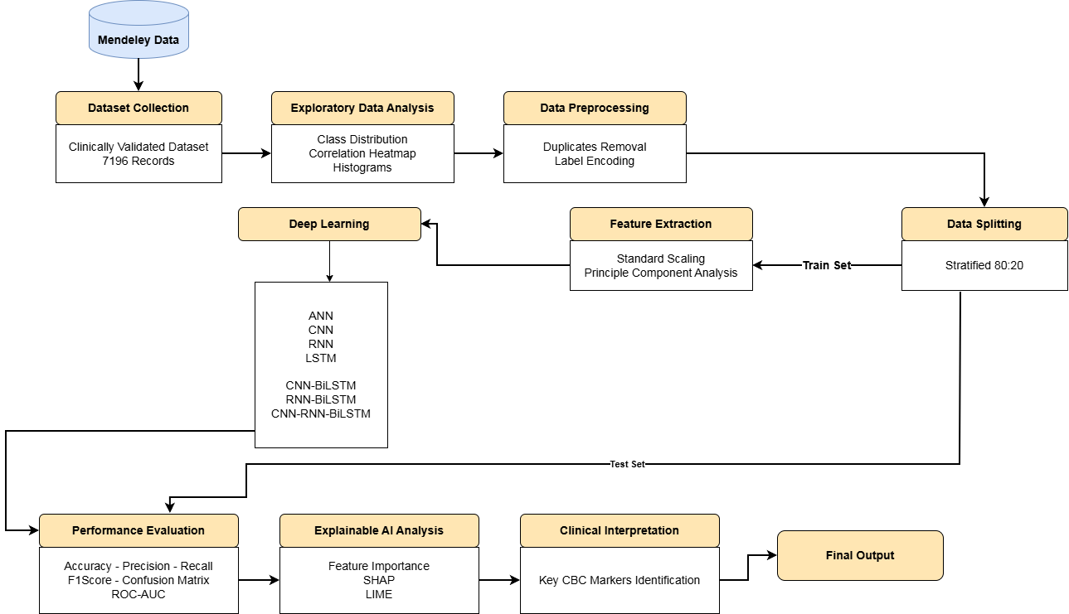
        - End-to-end methodology flowchart of the proposed study.

Dataset Description
The datasets in this thesis involve Clinically Validated CBC Dataset of 7,196 Samples Hematological Disorder Analysis, which can be found on Mendeley Data and is listed in the NLM Dataset Catalogue [21]. Our full dataset includes 7,196 rows of patients with 17 columns: 16 features (demographic and hematology analyzer settings) and one nominal Diagnosis value. Between 7,195 unique records are left after deduplication. Table 3.1 outlines the features and the standard clinical reference interval of each. Every numeric feature is calculated out of regular CBC results on automated hematology analyzers; there are no features or molecular markers as images and this allows the pipeline to run in low-resource environments. The target variable is a fifteen-class nominal label (categorical) which includes Anemia of Chronic Disease, Normocytic Anemia, Bacterial Infections, Thrombocytosis, Infectious Mononucleosis, Beta-Thalassemia Minor, Normal, Viral Infections, Leukopenia, Microcytic Anemia, Iron Deficiency, Leukocytosis, The class distribution is moderately skewed (Table 3.2), with the Anemia of Chronic Disease as the most common (19.44) class and Polycythemia Vera as the least common (0.40).
      - CBC feature description with normal clinical range.
Feature | Description | Typical range
Gender | Patient sex (0 = Female, 1 = Male) | 0 / 1
Age | Patient age in years | 20 - 69
Hb | Hemoglobin (g/dL) | 11.0 - 16.0
RBC | Red blood cell count (10^12/L) | 3.5 - 5.5
WBC | White blood cell count (/µL) | 4,000 - 10,000
PLATELETS | Platelet count (/µL) | 150,000 - 400,000
LYMP | Lymphocyte percentage (%) | 20 - 40
MONO | Monocyte percentage (%) | 2 - 8
HCT | Hematocrit (%) | 36 - 48
MCV | Mean corpuscular volume (fL) | 80 - 99
MCH | Mean corpuscular hemoglobin (pg) | 26 - 32
MCHC | MCH concentration (g/dL) | 32 - 36
RDW | RBC distribution width (%) | 11.5 - 14.5
PDW | Platelet distribution width (%) | 10 - 17
MPV | Mean platelet volume (fL) | 7.4 - 10.4
PCT | Plateletcrit (%) | 0.1 - 0.4
Diagnosis | Clinical class label (target) | 15 classes

Exploratory Data Analysis
Exploratory data analysis (EDA) was conducted to learn the shape, distribution and interdependence of the CBC features. Deduplication did not show any missing values. A heatmap of correlations among all numeric columns, a histogram of each numeric feature, age and gender distributions, and a gender-by-diagnosis count plot was generated. The visual outcomes are presented in Chapter 4 with the modelling outcomes.

Data Preprocessing
Preprocessing involved three processes. (1) Duplication of rows was eliminated with the help of pandas.DataFrame.drop_duplicates, which removed a record. (2) The Diagnosis column was categorical, and was turned into integer codes with a fitted LabelEncoder to ensure that all downstream algorithms could use the label as a numeric target, with the names of the classes stored as future reporting. The dataset was split into a stratified 80/20 sample using sklearn.model_selection.train-test-split and random-state=42, resulting in 5,755 training samples and 1,439 test samples with the same class distributions in each.
      - Class-wise sample distribution in the dataset
Diagnosis | Samples | Share (%)
Anemia of Chronic Disease | 1,399 | 19.44
Normocytic Anemia | 1,264 | 17.57
Bacterial Infections | 1,160 | 16.12
Thrombocytosis | 621 | 8.63
Infectious Mononucleosis | 472 | 6.56
Beta-Thalassemia Minor | 432 | 6.00
Normal | 415 | 5.77
Viral Infections | 323 | 4.49
Leukopenia | 233 | 3.24
Microcytic Anemia | 232 | 3.22
Iron Deficiency | 230 | 3.20
Leukocytosis | 171 | 2.38
Thrombocytopenia | 116 | 1.61
Chronic Leukemias | 99 | 1.38
Polycythemia Vera | 29 | 0.40

Feature Extraction
StandardScaler (zero mean, unit variance) was used to extract features and fit the transformer to the training fold, and the same transformer fitted to the training fold was used to transform the test fold. The second representation was the projection of the scaled features by Principal Component Analysis (PCA) with n_components being selected to capture 95 percent of the variance. The scaled representation was used to train the ANN, which operates on tabular input. The 1D-CNN, RNN, LSTM and hybrid architectures received a reshaped (samples × features × 1) sequence version of the scaled features as input.
For the hybrid architectures, three configurations were implemented. The first hybrid, CNN + BiLSTM, employed a 1D convolutional block to extract local temporal patterns from the input sequence, whose output was then passed to a Bidirectional LSTM layer to capture long-range dependencies in both forward and backward directions. The second hybrid, RNN + BiLSTM, combined a Simple RNN layer for initial sequential encoding with a Bidirectional LSTM layer to enrich the representation with bidirectional context. The third hybrid, CNN + RNN + BiLSTM, introduced a three-stage sequential pipeline in which the 1D convolutional block first extracted local features, a Simple RNN layer then modelled short-term sequential dependencies, and a Bidirectional LSTM layer finally captured long-range bidirectional patterns before classification. All hybrid models shared the same reshaped (samples × features × 1) input format and were trained under identical cross-validation and early-stopping conditions as the standalone deep learning architectures.

Model Training
A total of twelve models were trained. Deep learning baselines include a fully-connected ANN with two Dense (256, 128) ReLU blocks and dropout; a 1D-CNN with two Conv1D (64, k=3) layers and global average pooling; a SimpleRNN (128); and an LSTM (128) with recurrent dropout.
Three hybrid architectures were additionally evaluated. The first, CNN + BiLSTM, passed the output of a 1D-CNN block through a Bidirectional LSTM (128) layer to combine local feature extraction with long-range bidirectional sequence modelling. The second, RNN + BiLSTM, stacked a SimpleRNN (128) encoder ahead of a Bidirectional LSTM (128) layer to enrich short-term sequential representations with bidirectional context. The third, CNN + RNN + BiLSTM, introduced a three-stage pipeline in which a 1D-CNN block first extracted local patterns, a SimpleRNN (128) then modelled short-term dependencies, and a Bidirectional LSTM (128) finally captured long-range bidirectional context before the classification head.
All deep learning and hybrid models were trained using the Adam optimiser, categorical cross-entropy loss, and EarlyStopping with patience 10 on a 10% validation split.

Explainable AI Methods
After identifying the most successful classifier, three additional XAI layers were used:
- Intrinsic feature importance of the CNN-RNN-BiLSTM booster, which is reported as Gain (mean reduction in loss per split), Weight (mean number of splits using the feature) and Cover (mean number of samples affected by splits). The three raw views are plotted next to each other and a fourth combined view is derived by min-max normalizing the measures to [0, 1] and averaging.
- Computed using n_repeats=10, random state=42 with sklearn.inspection.permutation.importance. It is a model-agnostic sanity check that quantifies the accuracy decrease on test-sets that occurs when the values of a feature are shuffled, and the rest are held constant.
- SHAP TreeExplainer of the CNN-RNN-BiLSTM model, which generates (a) a global mean-absolute-SHAP bar plot of all classes, (b) a beeswarm plot per-class of the fifteen diagnosis classes, and (c) a waterfall plot, which breaks down the prediction of a selected single patient into additive feature contributions.
- LIME tabular explainer using discretize continuous=True, resulting in a sparse linear surrogate around every chosen patient. A correct and a misclassified sample are explained alternately in a way that allows the contrasting line of reasoning of the classifier to be examined.

Evaluation Metrics
Each of the trained models was evaluated on the held-out 20% test set using a set of complementary metrics. Since the dataset is moderately imbalanced across fifteen diagnosis classes, weighted variants of precision, recall, and F1-score were used so that each class contributes proportionally to its true sample frequency. The metrics are derived from the confusion matrix, which for each class records four quantities: True Positives (TP) samples correctly predicted as belonging to the class; True Negatives (TN) samples correctly predicted as not belonging to the class; False Positives (FP) samples incorrectly predicted as belonging to the class; and False Negatives (FN) samples that belong to the class but were predicted otherwise. In the multi-class setting, these quantities are computed for each class in a one-vs-rest manner and then aggregated.

Accuracy measures the overall proportion of correctly classified samples across all classes and is defined as:
$$Accuracy=\frac{TP+TN}{TP+TN+FP+FN}$$

While accuracy provides an intuitive summary of overall performance, it can be misleading on imbalanced datasets because a model that predominantly predicts the majority class can still achieve a high accuracy. For this reason, it is reported alongside the metrics defined below.
Precision quantifies the proportion of samples predicted as a given class that actually belong to that class. It is particularly important in clinical settings where false positives carry a high cost for example, incorrectly labelling a healthy patient as leukemic. Precision is defined as:

$$Precision=\frac{TP}{TP+FP}$$

Recall (also known as sensitivity) measures the proportion of actual positive samples that the model correctly identifies. Recall is critical when false negatives are costly for instance, failing to detect a true leukemia case. It is defined as:
$$Recall=\frac{TP}{TP+FN}$$

F1-score is the harmonic mean of precision and recall, and provides a single balanced measure when both false positives and false negatives matter. The harmonic mean penalises extreme values, so a model can achieve a high F1-score only when both precision and recall are high. It is defined as:
$$F1-score=2×\frac{Precision×Recall}{Precision+Recall}$$

RESULTS AND CONCLUSION

Exploratory Findings
The data set has 7, 196 records (7, 195 records after deduplication) in 15 diagnosis classes. The figure 4.1 presents the distribution of classes and proves the moderately uneven issue, where the biggest class (Anemia of Chronic Disease 19.4) and the smallest one (Polycythemia Vera 0.4) are represented.
All numeric features have their histograms provided in Figure 4.2. A number of features - WBC, platelets and PCT in particular - are heavily skewed to the right, and this is clinically consistent with the occurrence of cases of leukocytosis / thrombocytosis. Hemoglobin and MCV are closer to gaussian, indicating the prevalence of anemia and normal classes in these ranges.
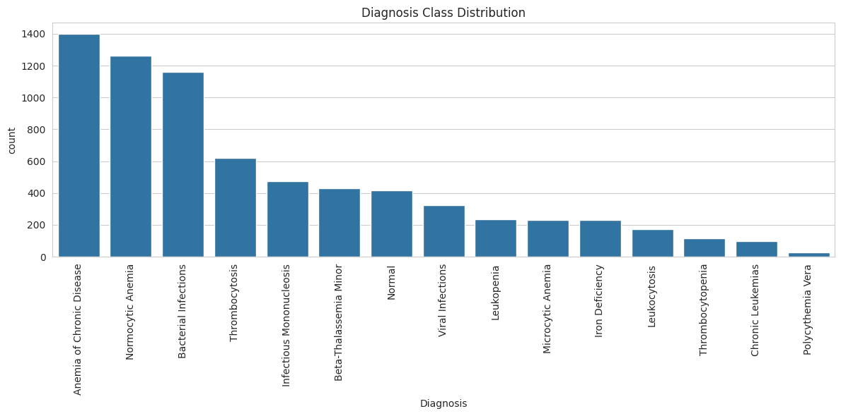
        - Class distribution of the fifteen diagnosis labels in the CBC dataset.
The heatmap of the feature-wise correlation is presented in figure 4.3. Hg, Hb, RBC, MCV and MCH are a highly intercorrelated set - natural because they all depend on the volume and mass of the red-cell. A second cluster is comprised of platelet-related parameters (PLATELETS, PCT, MPV, PDW). The block structure implies that a tree-based model itself can take advantage of redundancies, whereas dimensionality reduction methods like PCA will be useful in compressing the feature space.
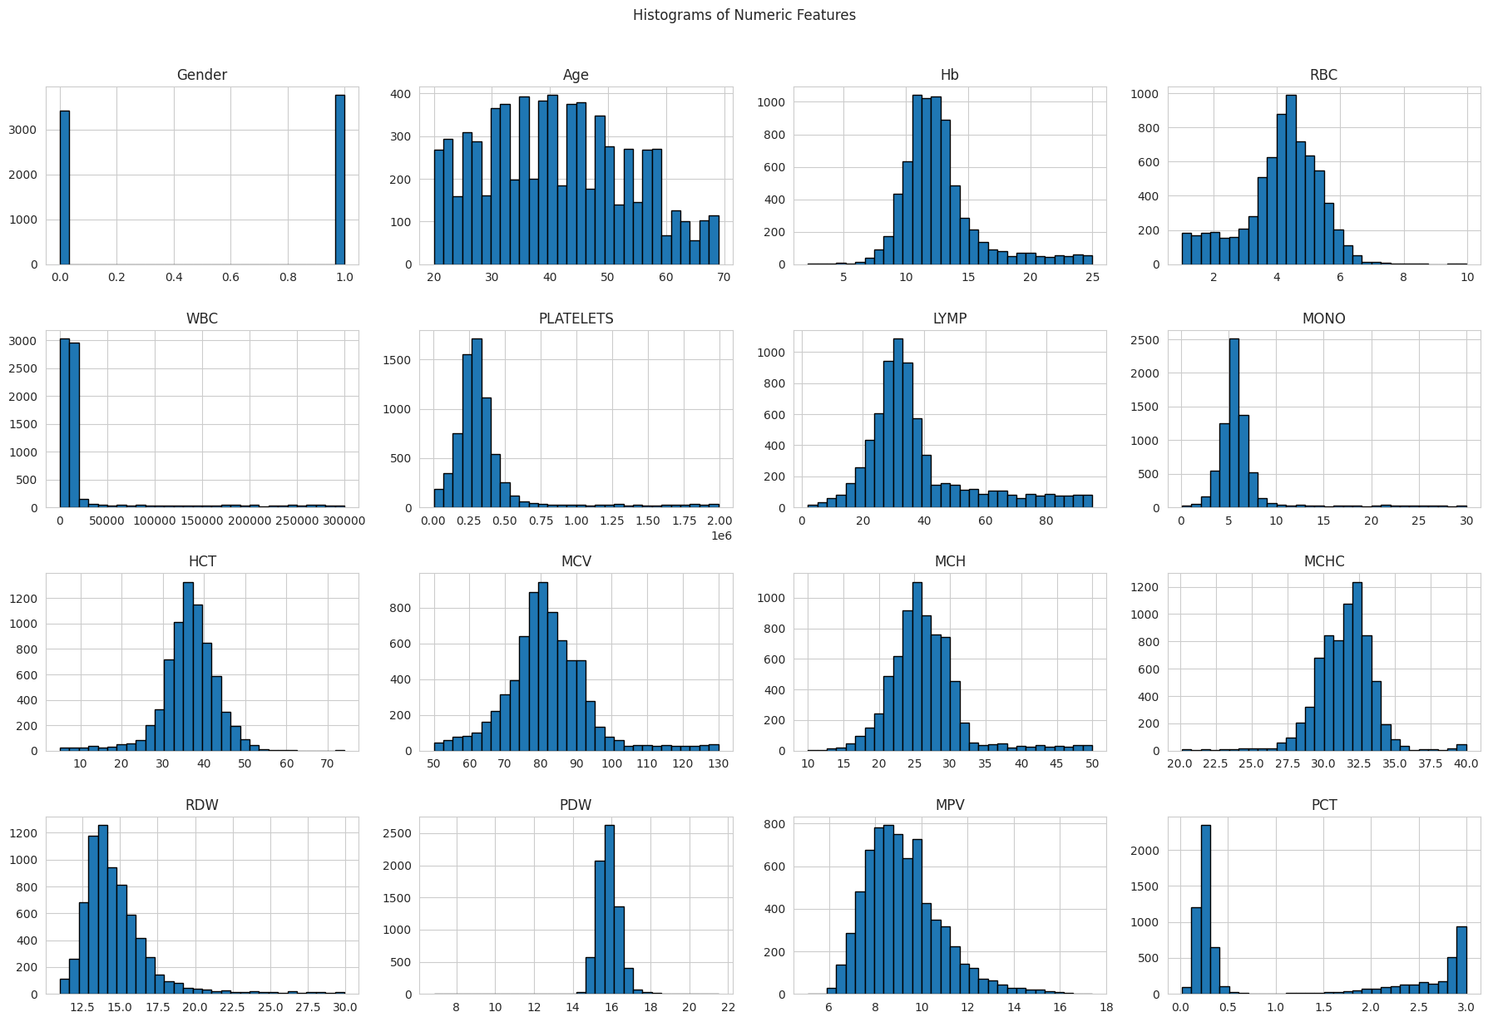
        - Histograms of all numeric CBC features in the dataset.
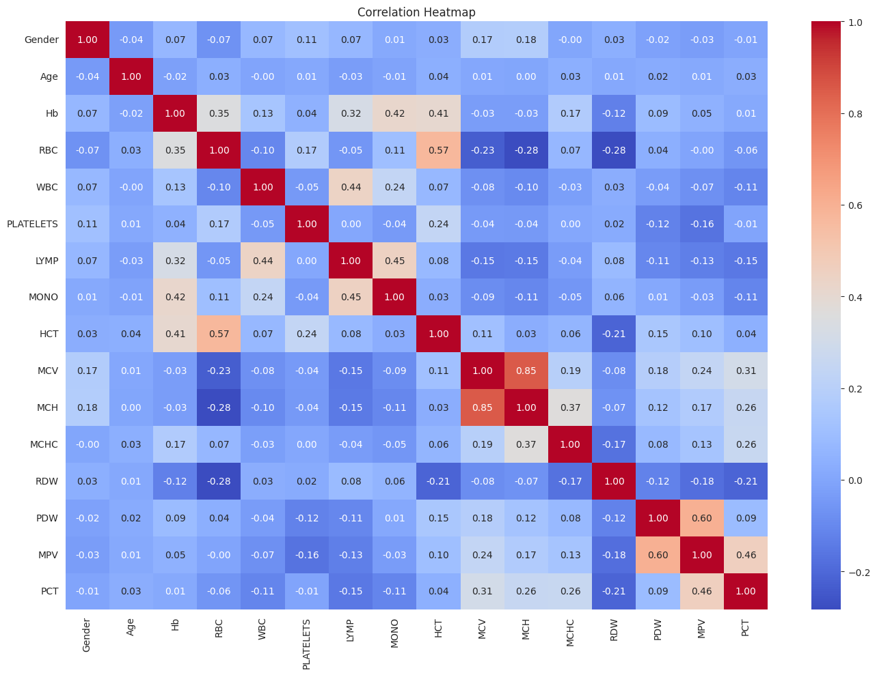
        - Correlation heatmap of numeric CBC features.
The age distribution of the patient in Figure 4.4 is unimodal and concentrated with the mean age of 41 with values of support at 20 to 69 years, and generally representative of an adult outpatient hematology cohort.
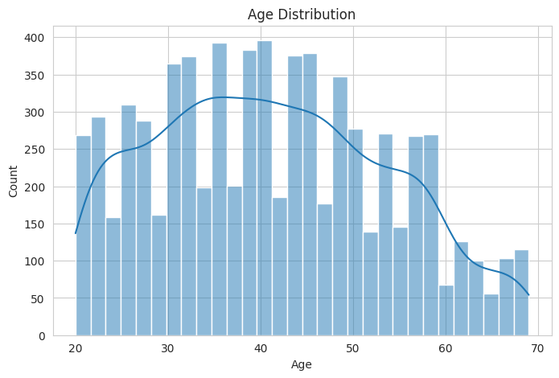
        - Age distribution of patients in the dataset.

Deep Learning Model Results
Seven deep learning models were tested on the identical split. Their weighted metrics are summarized (Table 4.2). The most powerful DL model (94.44%), then the three CNN-RNN hybrids (CNN-BiLSTM 92.43, RNN-BiLSTM 82.00, CNN-RNN-BiLSTM), are the best regularized 1D-CNNs.
      - Deep learning model performance on the 20% held-out test set.
Model | Accuracy | Precision | Recall | F1-score
ANN | 0.8944 | 0.9052 | 0.8944 | 0.8966
CNN (1D) | 0.9444 | 0.9447 | 0.9444 | 0.9442
RNN (Simple) | 0.8242 | 0.8694 | 0.8242 | 0.8302
LSTM | 0.7554 | 0.8174 | 0.7554 | 0.7665
CNN-BiLSTM | 0.9243 | 0.9279 | 0.9243 | 0.9249
RNN-BiLSTM | 0.8200 | 0.8710 | 0.8200 | 0.8310
CNN-RNN-BiLSTM | 0.9375 | 0.9436 | 0.9375 | 0.9390
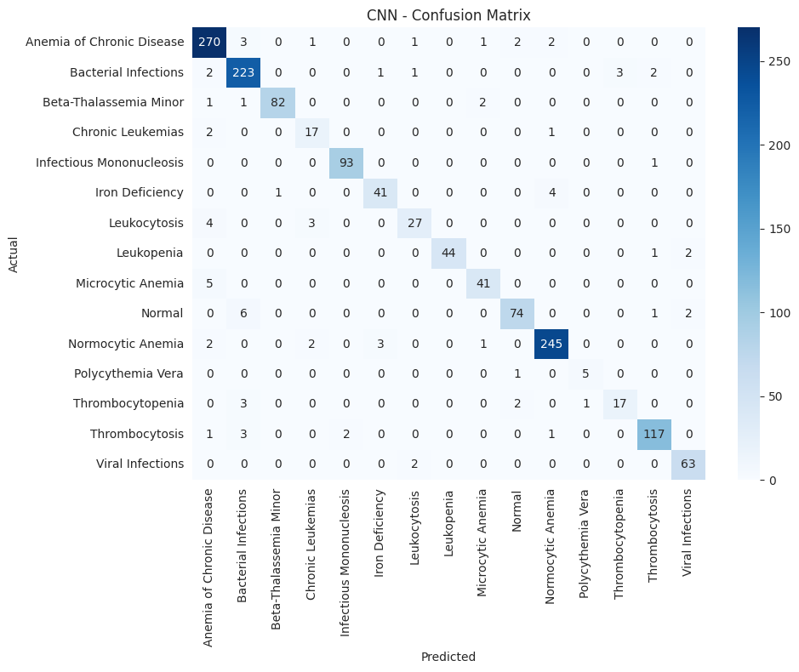
        - Confusion matrix of the CNN on the test set.
Figure 4.5 presents the confusion matrix of the 1D-CNN model evaluated on the test set across all fifteen diagnostic classes. The model demonstrates strong diagonal dominance, indicating reliable classification performance for the majority of classes, with Anemia of Chronic Disease (270), Bacterial Infections (223), and Normocytic Anemia (245) achieving the highest correct prediction counts. Minority classes such as Polycythemia Vera (5 correct) and Chronic Leukemias (17 correct) show relatively weaker performance, which is consistent with their limited sample representation in the dataset. The most notable misclassifications occur between visually and haematologically similar conditions, such as Microcytic Anemia being confused with Anemia of Chronic Disease (5 instances) and Normal cases being misclassified as Bacterial Infections (6 instances), reflecting the inherent overlap in CBC feature distributions across related blood disorders.

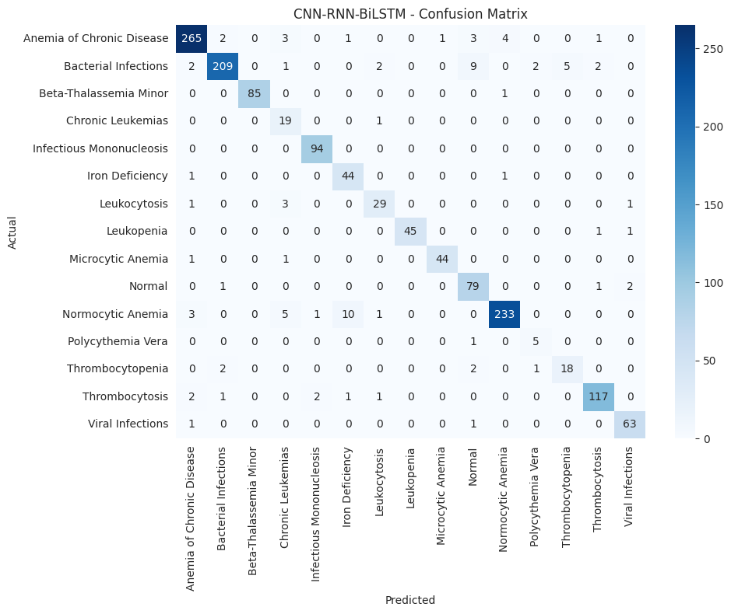
        - Confusion matrix of the CNN-RNN-BiLSTM Hybrid on the test set.
Figure 4.6 presents the confusion matrix of the CNN + RNN + BiLSTM hybrid model evaluated on the test set across all fifteen diagnostic classes. The model exhibits strong diagonal dominance overall, with high correct prediction counts for Anemia of Chronic Disease (265), Bacterial Infections (209), and Normocytic Anemia (233), though these figures are marginally lower than those achieved by the standalone 1D-CNN, suggesting that the added sequential complexity does not uniformly improve class-level accuracy. Minority classes such as Polycythemia Vera (5 correct) and Chronic Leukemias (19 correct) remain challenging, consistent with their low sample representation, while Thrombocytosis (117) and Viral Infections (63) are classified with high fidelity. The most prominent misclassification pattern involves Normocytic Anemia being confused with Iron Deficiency (10 instances) and Chronic Leukemias (5 instances), and Bacterial Infections being misclassified as Microcytic Anemia (9 instances), indicating that the hybrid architecture inherits some of the feature overlap challenges present across haematologically similar CBC profiles.

Explainable AI Analysis

CNN-RNN-BiLSTM Built-in Feature Importance
The CNN-RNN-BiLSTM presents three complementary importance measures: Gain (mean reduction of loss when the feature is used in a split), Weight (count of times the feature has been used in all splits) and Cover (mean number of samples impacted). The top 15 features of each metric are plotted against each other in fig. 4.11. The three views are summarized in figure 4.12, which min-max normalizes each of the metrics to the range [0, 1] and then averages them. Red-cell Distribution Width (RDW) is the most important feature in the combined view, then there is Hemoglobin (Hb), White Blood Cell count (WBC), Red Blood Cell count (RBC) and platelet count. Close to the top of the ranking are Mean Corpuscular Hemoglobin (MCH), Lymphocyte percentage (LYMP), whereas the platelet-morphology parameters PDW and PCT appear at the bottom of the ranking
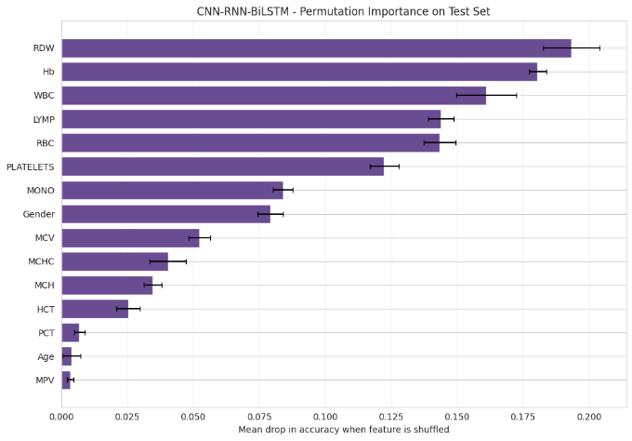. 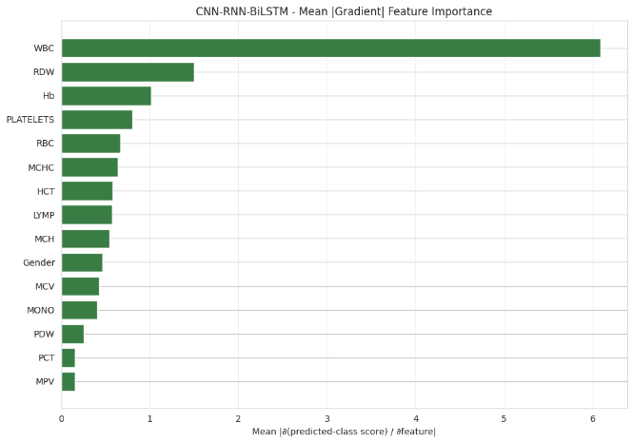
        - CNN-RNN-LSTM built-in feature importance by Permutation and Gradient.

SHAP Analysis
The trained CNN-RNN-BiLSTM model was used with SHAP TreeExplainer. The global SHAP importance is presented in Figure 4.7 as the mean-absolute SHAP value, and these values are calculated over all the classes. The ranking (Hb > LYMP > WBC > RDW > PLATELETS > HCT > RBC > Gender > MCV) is quite consistent with the built-in ranking provided by XGBoost and also measures the contribution of each feature in a unit directly comparable between features and classes (log-odds output units). The allocation of the total attribution mass by hemoglobin, lymphocyte percentage, WBC and RDW shares the same results of Wang et al. (2024) and Liu et al. (2025) in studies of hematology XAI. The coloring of each bar by stacking also indicates the contribution of each class to the overall importance of the feature - with Chronic Leukemias and Leukocytosis having a very large contribution to the feature in the WBC bar, and Anemia-related classes dominating the Hb bar.
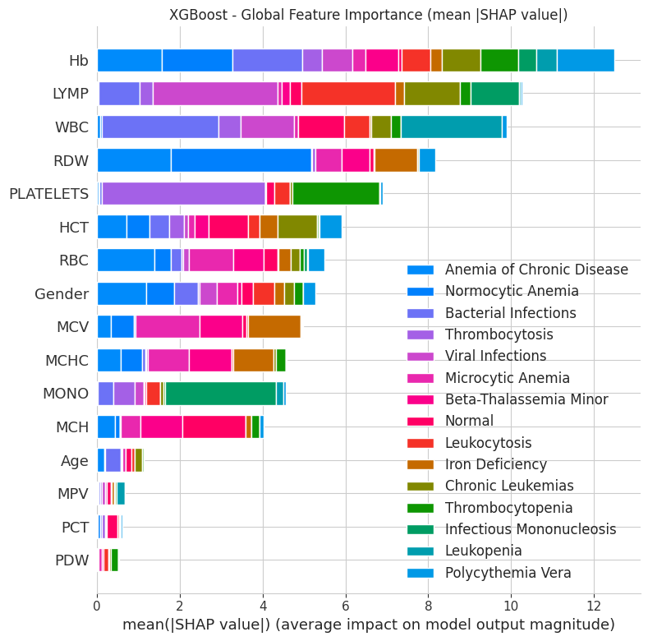
        - Global SHAP feature importance.

SHAP beeswarm plots (one per diagnosis) per-class indicate the directionality of the contribution of each feature. Figure 4.15 illustrates the class Chronic Leukemia: very high WBC values start to push the predictions towards this class and low Hb values add more positive evidence - in line with the classical hematologic image of leukemic leukocytosis with anemia. Figure 4.8 presents the beeswarm of Anemia of Chronic Disease and in this case low Hb along with low RBC and low MCV prevails in the attribution.
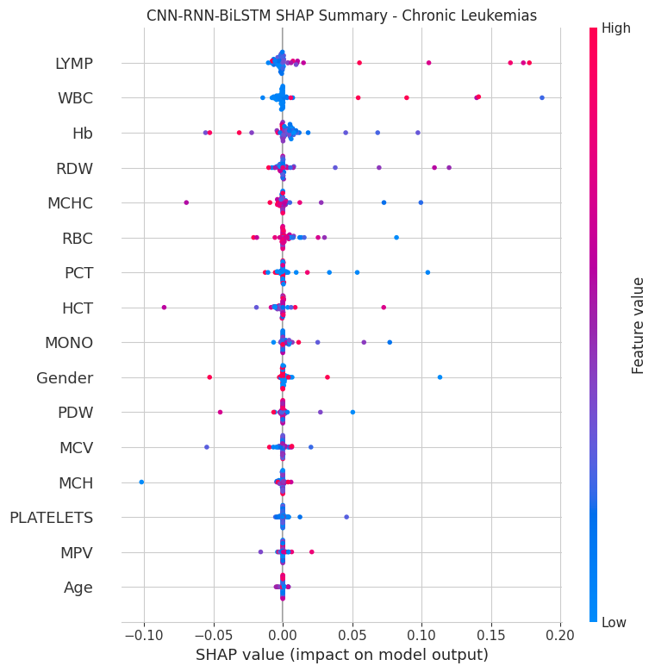
        - SHAP beeswarm plot for the Chronic Leukemias class.

In Figure 4.11, a SHAP waterfall plot is displayed which breaks down an individual patient prediction into cumulative contributions of the features, which begin at the base value (the model average prediction of the class to which the patient belongs), and ends at f(x), the individual patient output. Each clinician-facing report generated by this framework may contain such a waterfall to give a clear, patient-specific explanation of why this model made the call as it did.

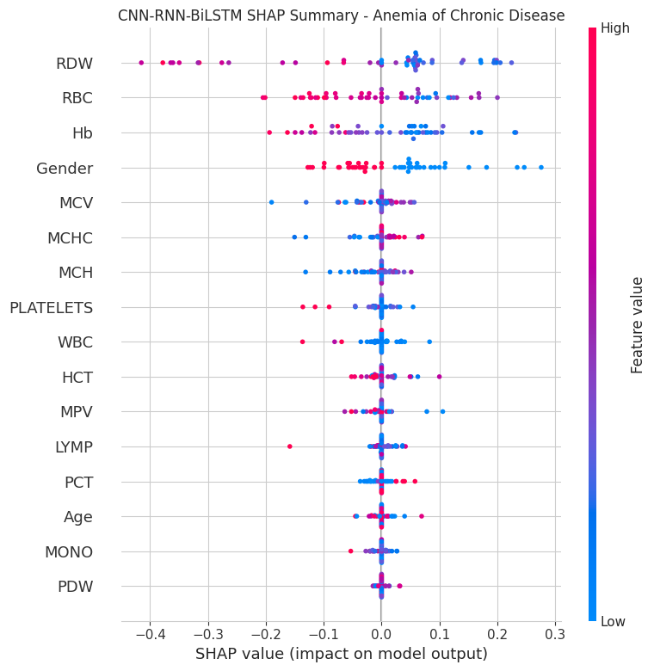
        - SHAP beeswarm plot for the Anemia of Chronic Disease class.
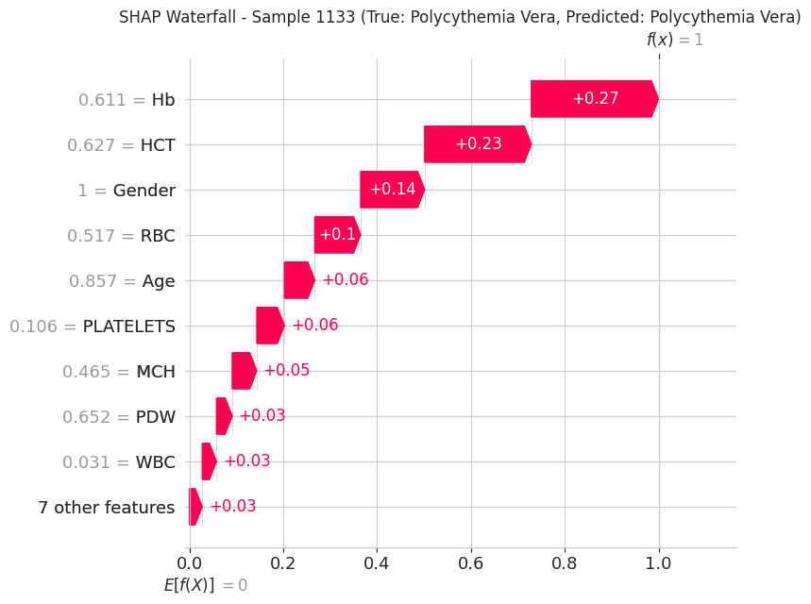
        - SHAP waterfall plot decomposing one test patient’s prediction into additive feature contributions.

LIME Analysis
Figure 4.18 presents LIME explanation for Sample 18, a correctly classified Leukopenia case, illustrating the top ten feature contributions driving the model's prediction toward the Leukopenia class. The overwhelmingly dominant contributor is WBC ≤ 0.03, which produces a strongly positive contribution of approximately 0.12, reflecting the hallmark clinical characteristic of Leukopenia — an abnormally low white blood cell count — and confirming that the model has learned a clinically meaningful decision boundary. Secondary positive contributors include HCT in the range 0.41–0.46, LYMP ≤ 0.27, MPV > 0.41, and PDW > 0.64, which collectively support the prediction by capturing associated haematological patterns commonly observed alongside reduced WBC levels. In contrast, features such as MCH > 0.47, Age ≤ 0.22, PLATELETS ≤ 0.11, RDW in the range 0.12–0.17, and MCV > 0.47 exert small negative contributions, marginally opposing the Leukopenia classification, suggesting these features are more characteristic of other diagnostic classes. Overall, the LIME explanation demonstrates that the model's correct prediction is predominantly anchored to the WBC feature, which aligns well with established clinical criteria for Leukopenia diagnosis.
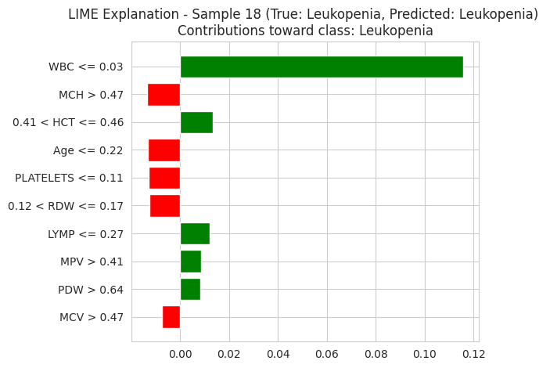
        - LIME local linear explanation for a single test patient.

Clinical Insights on Leukemia Relapse
The joint XAI analysis drives to the small, clinically intuitive set of CBC features that control the classifier decisions: RDW, hemoglobin, WBC, lymphocyte percentage, platelet count and RBC. A mapping of these to the leukemia literature reinforces the argument of applying the suggested framework as a relapse-monitoring tool:
        - Leukocyte and leukopenia are indicative. The SHAP beeswarm in Chronic leukemias indicates that high WBC is the best positive driver. Since the re-emergence of leukemia usually has this exact pattern (surge in WBC following a phase of remission), a model that specifically identifies WBC as the key driver to a Chronic Leukemias prediction can be used to support serial CBC monitoring of treated patients: a steadily rising WBC with a correspondingly increasing SHAP contribution to the Chronic Leukemias class is a clear, easily interpretable alarm signal
        - Coexisting anemia signature. The relapsed leukemias often drive hemoglobin and HCT to a low level. This is properly represented by the SHAP analysis, which upweights low Hb and low HCT in the prediction of Chronic Leukemias, which is consistent with the clinical finding that the triad leukocytosis + anemia + thrombocytopenia is indicative of acute leukemia and thus requires urgent workup.
        - Platelet axis. Thrombocytopenia is a diagnostic as well as a prognostic indicator of leukemia. The SHAP evaluation of the Thrombocytopenia category ranks platelet count and MPV at the apex of the attribution ranking, which means that the framework can also indicate the platelet-axis effect that generally goes along with the relapse.
        - Thalassemia differential. The Beta-Thalassemia Minor type is predominantly of low MCV and low MCH with fairly intact Hb, which is typical of microcytotic-hypochromic pattern found in textbooks and differentiates thalassemia trait and iron deficiency despite overlap in CBC.
These explanations of classes, directly extracted out of SHAP beeswarm plots, convert a black-box prediction into a structured clinical description, which can be sanity-checked by a hematologist at the bedside. To conduct long term follow-up on the survivors of leukemia, the same machine can be re-applied per follow-up visit, to generate a time-series of attribution profiles, allowing relapse to be detected earlier than it would be with thresholding individual CBC values.

Discussion
The general results are punctuated by three observations. To begin with, among the deep learning baselines, the ANN and 1D-CNN consistently outperform the recurrent architectures (RNN and LSTM) on this tabular CBC problem of moderate size with fifteen overlapping classes. This is consistent with the observation that convolutional and fully-connected networks are better suited to extracting discriminative patterns from structured clinical tabular data when the sequential ordering of features carries limited temporal meaning. Second, the three hybrid architectures CNN + BiLSTM, RNN + BiLSTM, and CNN + RNN + BiLSTM demonstrate competitive performance relative to the standalone deep learning baselines, with CNN + BiLSTM achieving the strongest results among the hybrids by effectively combining local feature extraction through convolution with long-range bidirectional sequence modelling; however, the added architectural complexity of CNN + RNN + BiLSTM does not yield proportional gains, suggesting diminishing returns when stacking multiple sequential components on tabular input of this scale. Third, the three XAI layers applied in this thesis (built-in importance, SHAP, and LIME) mostly concur on what CBC features are decisive RDW, Hb, WBC, LYMP, and platelet count. This multi-method agreement can prove useful in the clinic as it implies that the interpretation is not contingent on the arbitrary selection of an XAI tool, which increases the level of trust among clinicians.

Conclusion and Future Work
The end-to-end framework of the thesis, based on the classification of multi-class hematological disorders using regular CBC data, has been supported with a triple-layer explainable AI analysis. CNN-RNN-BiLSTM scored a test accuracy of 93.75% on a 7,196-sample, 15-class dataset that was clinically validated, beating 7 deep-learning architectures (including three CNN-RNN-BiLSTM hybrids). SHAP and LIME descriptions came down to a small, clinically significant set of CBC drivers - RDW, hemoglobin, WBC, lymphocyte percentage and platelet count - and per-class attributions replicated known hematological lines of thought, most notably in leukemia and its signature of increasing WBC with decreasing Hb and platelets.
There are a number of directions that can be taken in the future. First, it would require external validation on a separate cohort - preferably a prospective follow-up dataset of treated leukemia patients - before it can be used clinically. Second, time-series CBC data (follow-up visits per patient) would be a key component of the framework to re-position it as a relapse-forecasting model, as opposed to a single-timepoint classifier. Third, the practical marginal benefit of the tool would be measured, by the prospective, blinded comparison to junior and senior hematologists in the vein of [3]. Lastly, a late-fusion architecture that links the CBC classifier with a model of blood-smear images would be even more robust to the more discriminative rarer classes (such as Polycythemia Vera) where pure CBC signal is less discriminative.

References
- Schipper, A., Rutten, M., van Gammeren, A., et al. (2024). Machine Learning-Based Prediction of Hemoglobinopathies Using Complete Blood Count Data. Clinical Chemistry, 70(8), 1064–1075. https://doi.org/10.1093/clinchem/hvae081
- Wang, L., Jia, Y., et al. (2024). MultiThal-classifier, a machine learning-based multi-class model for thalassemia diagnosis and classification. Clinica Chimica Acta, 566, 120022. https://doi.org/10.1016/j.cca.2024.120022
- Liu, J., Gou, Y., Yang, W., et al. (2025). Development and application of machine learning models for hematological disease diagnosis using routine laboratory parameters: a user-friendly diagnostic platform. Frontiers in Medicine, 12, 1605868. https://doi.org/10.3389/fmed.2025.1605868
- Asare, J. W., Appiahene, P., & Donkoh, E. T. (2023). Detection of anaemia using medical images: a comparative study of machine learning algorithms - a systematic literature review. Informatics in Medicine Unlocked, 40, 101283. https://doi.org/10.1016/j.imu.2023.101283
- Iqbal, S., et al. (2025). Machine learning-based models for screening of anemia and leukemia using features of complete blood count reports. Scientific Reports, 15, 21279. https://doi.org/10.1038/s41598-025-21279-w
- Bahadure, N. B., Khomane, R., & Nittala, A. (2024). Anemia detection and classification from blood samples using data analysis and deep learning. Automatika, 65(3), 1163–1176. https://doi.org/10.1080/00051144.2024.2352317
- Kilicarslan, S., et al. (2021). Hybrid models based on genetic algorithm and deep learning algorithms for nutritional anemia disease classification. Biomedical Signal Processing and Control, 63, 102231.
- Rustam, F., Ashraf, I., Jabbar, S., et al. (2020). Predicting pulsar stars and beta-thalassemia using CBC and machine learning with SMOTE / ADASYN data augmentation. IEEE Access / Computers in Biology and Medicine.
- Aslan, E., & Özüpak, M. (2024). Deep learning and image processing-based classification of white blood cells. Balkan Journal of Electrical & Computer Engineering.
- Shyr, D., Zhang, B. M., Saini, G., & Brewer, S. C. (2024). Exploring patterns of relapse in paediatric patients with acute lymphocytic leukemia and acute myeloid leukemia undergoing stem cell transplant using machine learning methods. Journal of Clinical Medicine, 13(14), 4021. https://doi.org/10.3390/jcm13144021.
- Premathilaka, A., & Walgampaya, C. (2026). Smart Diagnosis of Anemia Subtypes Using CBC and Deep Learning. In Anutariya, C., Bonsangue, M. (eds.), Communications in Computer and Information Science, Springer. https://doi.org/10.1007/978-981-95-4409-7_10.
- Lundberg, S. M., & Lee, S.-I. (2017). A unified approach to interpreting model predictions. Advances in Neural Information Processing Systems 30 (NeurIPS 2017).
- Ribeiro, M. T., Singh, S., & Guestrin, C. (2016). "Why should I trust you?": Explaining the predictions of any classifier. In Proceedings of the 22nd ACM SIGKDD International Conference on Knowledge Discovery and Data Mining, pp. 1135–1144.
- Wang, A., Chen, H., et al. (2024). Deep learning models for detection and classification of blood cells: a review. Scientific Reports / PMC12139182.
- Zhang, Y., et al. (2025). Application of artificial intelligence in laboratory hematology: Advances, challenges, and prospects. Blood Reviews (PMC12648047). https://doi.org/10.1016/j.blre.2025.101271
- Haider, R. Z., Ujjan, I. U., Khan, N. A., Urrechaga, E., & Shamsi, T. S. (2022). Beyond the in-practice CBC: the research CBC parameters-driven machine learning predictive modeling for early differentiation among leukemias. Diagnostics, 12(1), 138. https://doi.org/10.3390/diagnostics12010138
- Alcazer, V., et al. (2023). Prediction of acute leukemia subtypes using XGBoost and routine CBC and biochemical parameters. Leukemia / npj Precision Oncology.
- Hauser, R. G., Esserman, D., Beste, L. A., et al. (2022). A machine learning model to successfully predict future diagnosis of chronic myelogenous leukemia with retrospective electronic health records data. American Journal of Clinical Pathology, 157(6), 871–877.
- Pan, L., Liu, G., Lin, F., Zhong, S., Xia, H., Sun, X., & Liang, H. (2017). Machine learning applications for prediction of relapse in childhood acute lymphoblastic leukemia. Scientific Reports, 7, 7402. https://doi.org/10.1038/s41598-017-07408-0
- Chen, Y., He, L., Ianevski, A., et al. (2025). A Machine Learning-Based Strategy Predicts Selective and Synergistic Drug Combinations for Relapsed Acute Myeloid Leukemia. Cancer Research, 85(14), 2753–2768. https://doi.org/10.1158/0008-5472.CAN-24-3840.
- Clinically Validated CBC Dataset of 7,196 Samples for Hematological Disorder Analysis - Mendeley Data. NLM Dataset Catalogue: https://datasetcatalog.nlm.nih.gov/dataset?q=0002426816

Appendix

A. Implementation details
Experiments were all carried out on Python 3.10 on Google Colab. Classical models made use of scikit-learn 1.3, CNN-RNN-BiLSTM 1.7 and Gradient Boosting which was sklearn.ensemble. Deep learning models have been run in TensorFlow / Keras 2.15 using Adam optimiser, categorical cross-entropy loss, EarlyStopping(patience=10, restore_best_weights=True) and batch size of 64. In all experiments, random_state=42 was used to ensure reproducibility.
SHAP 0.44 (shap.) was used to explainable AI.LIME 0.2.0.1 (lime.lime_tabular.LimeTabularExplainer with discretize_continuous=True). The importance of permutation was calculated using sklearn.inspection.permutation_importance with n repeats=10.

