SNAKE GAME PROJECT DOCUMENTATION
TO
Sir Ehtisham Rasheed
By
Asmat Zahra
Ilsa Khalid
Roll No.
23021519-094
23021519-063
Section: B
Course Code: CS_303
Course Title
Advance Programming Techniques
BS COMPUTER SCIENCES


Snake Game, Project Documentation

1. Project Overview
Project Name: Snake Game
Developed Using: C#, Windows Forms (.NET Framework)
Purpose:
The Snake Game is a classic arcade-style game where the player controls a snake to eat fruits and grow longer. The player must avoid colliding with walls or the snake’s own body. This project demonstrates event-driven programming, graphical user interface design, object-oriented programming, and timer-based game logic in C#.
Key Highlights:
- User-friendly graphical interface.
- Supports multiple game modes and difficulty levels.
- Real-time score and high score tracking.
- Includes splash screen with loading progress.
- Handles pause, stop, and restart functionality.
- Provides visual instructions with food images for guidance.

2. System Requirements
Requirement Type | Details
Operating System | Windows 7 / 8 / 10 / 11
Framework | .NET Framework 4.7.2 or higher
IDE | Visual Studio 2017/2019/2022
RAM | Minimum 8 GB
Screen Resolution | 1366 x 768 or higher recommended

3. Installation and Running the Project

3.1 Installation Steps
1. Ensure Visual Studio is installed with Windows Forms workload.
2. Download or clone the Snake Game project folder.
3. Open `snakeClean.sln` or `Form1.csproj` in Visual Studio.
4. Ensure the `Resources` folder with all fruit and icon images is included.

3.2 Running the Project
1. Set `Form1` as the startup form.
2. Press F5 or click Start in Visual Studio.
3. The splash screen will appear with a loading progress bar.
4. After loading, the game instructions panel will appear.
5. Press any arrow key to start the game.

4. User Interface (UI) Design

4.1 Main Form
- Form Name: frmSnake
- Size: 1166 x 633 pixels
- Background Color: Dark (RGB: 32, 32, 32)
- Start Position: CenterScreen
- KeyPreview: Enabled (Allows arrow keys for snake movement)

4.2 Panels and Controls

4.2.1 Game Panel (gamePanel)
Anchored to all sides of the form.
Contains:
- Instructions panel (pnlInstructions)
- Game over panel (pnlGameOver)
- Splash screen (pbSplash)
- Progress bar (progressBarLoad)
- Loading percentage label (lblPercent)

4.2.2 Instructions Panel (pnlInstructions)
Background: LightGreen, bordered.
Displays game instructions and fruit icons.
Labels:
- lblTitle: Game title “🐍 Snake Game Instructions 🐍”
- lblMovement: “▶ Use Arrow Keys to move the snake.”
- lblRules: “⚠ Avoid walls and your own body!”
- lblFood: Shows fruit points and info
- lblStart: “Press any Arrow Key to start!”
- lblSettings: Instructions for difficulty and settings
PictureBoxes for Fruits:
pbApple, pbBanana, pbCherry, pbGrapes, pbPineApple, pbOrange, pbWatermelon

4.2.3 Game Over Panel (pnlGameOver)
Background: Semi-transparent black (ARGB: 200,0,0,0)
Visible when the game ends.
Controls:
- lblGameOverTitle: “Game Over”
- lblGameOverScore: Displays final score
- btnGameOverRestart: Restart button

4.2.4 Icon Panel (pnlIcon)
Docked to the right of the form.
Contains interactive picture boxes for game control:
- pbStart: Start game
- pbPause: Pause game
- pbStop: Stop game
- pbSetttings: Open settings panel
- pbRestart: Restart game
- pbExit: Exit game

4.2.5 Difficulty Panel (pnlDifficulty)
Contains:
- Label lblDifficulty
- ComboBox cmbDifficulty (Easy, Medium, Hard)

4.2.6 Mode Panel (panel1)
Contains:
- Label lblMode
- ComboBox cmbMode (Classic, Hurdles)

4.3 Other UI Elements
- Score Label: lblScore
- High Score Label: lblHighScore
- Splash Screen: pbSplash
- Progress Bar: progressBarLoad
- Loading Percentage: lblPercent

5. Game Features

5.1 Game Controls
Control | Type | Function
Arrow Keys | Keyboard | Move snake
pbStart / btnStart | PictureBox / Button | Start game
pbPause / btnPause | PictureBox / Button | Pause game
pbRestart | PictureBox | Restart game
pbStop / btnStop | PictureBox / Button | Stop game
pbSetttings / btnSettings | PictureBox / Button | Open settings panel
pbExit / btnExit | PictureBox / Button | Exit game

5.2 Game Modes
Classic: Standard snake game.
Hurdles: Includes obstacles to avoid.

5.3 Difficulty Levels
Easy: Slow snake speed.
Medium: Moderate speed.
Hard: Fast snake speed.

5.4 Snake Mechanics
Snake grows when it eats a fruit.
Game over when:
- Snake hits the wall.
- Snake collides with itself.

5.5 Scoring
- Score increases with each fruit eaten.
- High score persists during the session.

5.6 Timers
  - gameTimer: Controls snake movement and game logic updates.
  - timer1: Handles progress bar and splash screen animations.

5.7 Splash Screen
Full-screen image (pbSplash) with loading progress bar (progressBarLoad) and percentage (lblPercent).

6. Event Handling
Event | Description
Form1_Load | Initializes game elements, splash screen, and panels
Form1_KeyDown | Handles snake movement using arrow keys
gamePanel_Paint | Draws the snake, fruits, and obstacles
gameTimer_Tick | Updates snake movement and game state
timer1_Tick | Updates splash screen progress
btnGameOverRestart_Click | Restarts the game after game over
cmbDifficulty_SelectedIndexChanged | Updates snake speed according to difficulty
pbStart_Click / pbPause_Click / pbStop_Click, pbReStartClick | Handle game start, pause, restart and stop
pbSetttings_Click | Opens settings panel
pbExit_Click | Exits the game

7. Game Resources
Images: Stored in project Resources folder.
Fruits: Apple, Banana, Cherry, Grapes, Pineapple, Orange, Watermelon
Buttons: Play, Pause, Stop, Settings, Exit
Splash screen: snakeGreen

8. Screenshots
Splash Screen
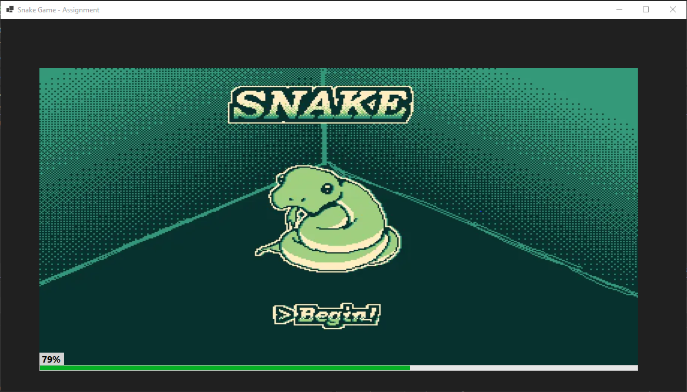

Main Game Screen
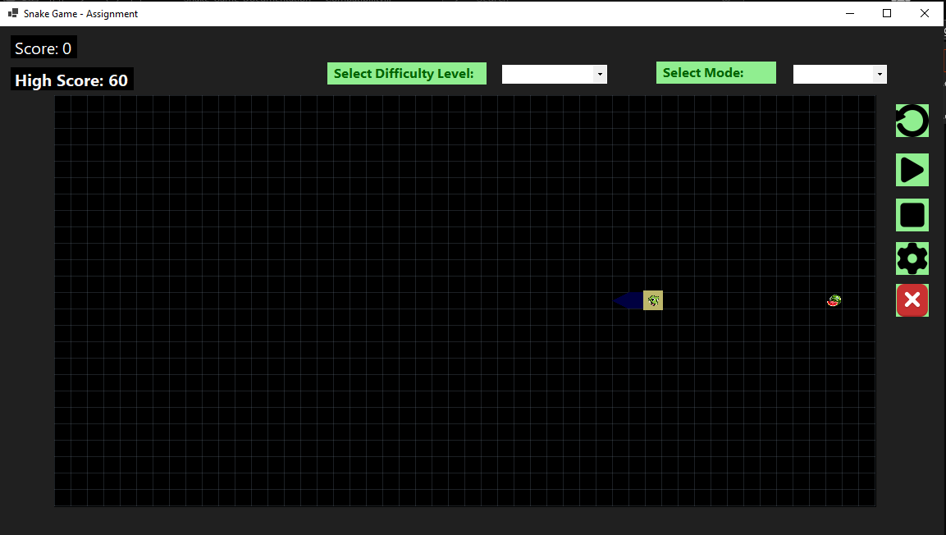
Instructions Panel
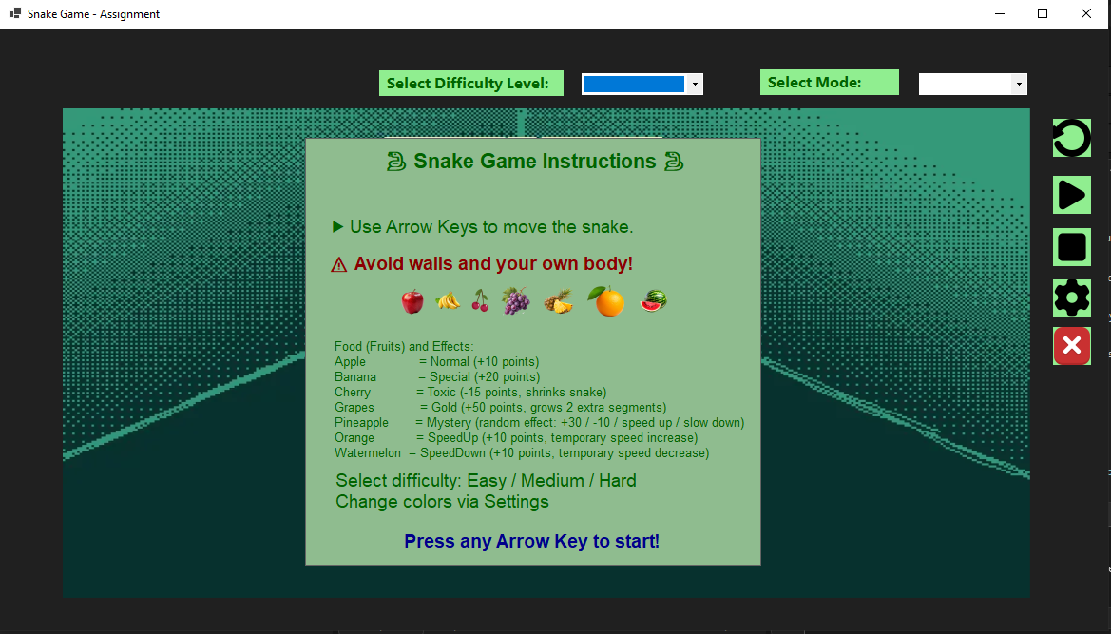
Game Over Screen
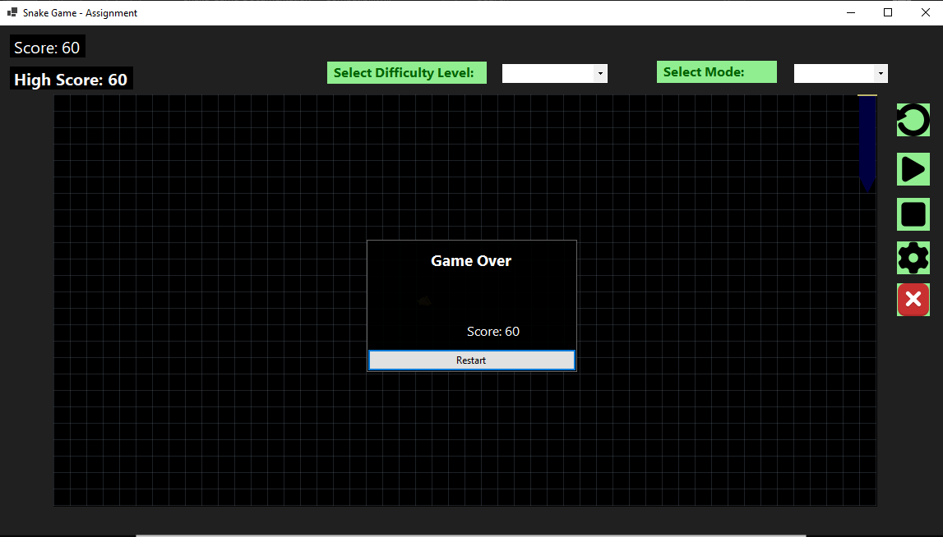
Settings Panel
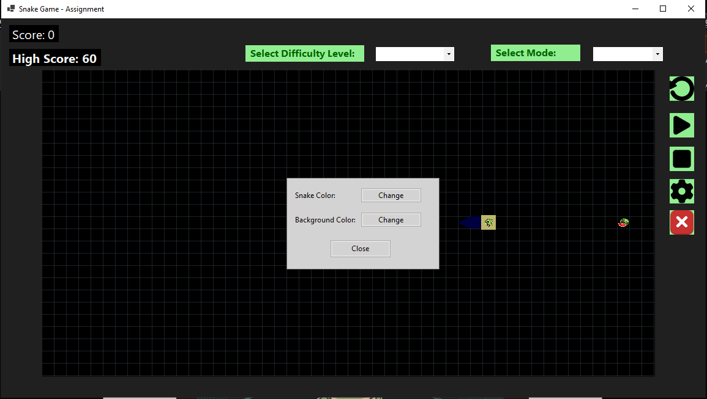

9. Running Instructions
1. Open project in Visual Studio.
2. Build the solution to ensure all resources are loaded.
3. Run the project (F5).
4. Observe the splash screen with loading progress.
5. Follow instructions on the instructions panel.
6. Use arrow keys to move the snake.
7. Use icon panel or buttons for Pause, Stop, Settings, and Exit.

10. Conclusion
This Snake Game demonstrates a full Windows Forms application with interactive UI, game logic, and resource management. It combines OOP concepts, event-driven programming, and graphical programming. The project is suitable for educational purposes and showcases professional UI design, modular coding practices, and game development fundamentals in C#.

