**NORTHERN UNIVERSITY**

B A N G L A D E S H

**Project Name: Database of Restaurant Management System**

**GROUP MAMBER:**

**Name: Asmaul Haider**

**Student ID: 42220100090**

**Name:Amiri Azam**

**Student ID: 42220100064**

**Name:Khadija Akter**

**Student ID: 42220100080**

**Name:Mohsina Bilkis**

**Student ID: 42220100096**

**Name:Masuma Akter**

**Student ID: 42220100068**

**Subject Code: 2291**

**Subject Name: Software development 2(Database Programming)**

**Semester: Spring 2023 (4B)**

**Program Name: ECSE**

**Course Teacher : Tamanna Afroz**

RESTAURANT MANAGEMENT SYSTEM

* ***Information About Restaurant management system:*** **The restaurant database will store information of the following; Customer Information. Menu Items and Pricing. Employee Work Schedules based on job position.**
* **A restaurant management system is a software that helps the restaurant industry streamline their food business operations. It provides a complete set of features including Point of Sales system, payment processing, table reservations, inventory management , accounting and employee management.**
* ***Information of the database:*** A restaurant has a unique restaurant ID (R_ID), Name (R_Name), Contact Number (Contact_Number), and address.

Many Customers can go to one restaurant.A customer has unique customer ID(customer_ID), Name (customer_ Name), Contact (C_Phone).

One waiter can serve more than one customers . A waiter has a unique ID(W_ID), Name(W_Name), waiter salary hire date.

A customer places order via waiter and the order is prepared by chef .

An order has unique order number (Or_No),order quantity order time and date .

A chef has unique ID(chef_id),Name(chef_Name) all information chef .An order contains food which has unique food number (f_id) , (f_name) , price quantity and discrimination.

Customer pay bill that order id (or_id) , customer Id(C_Id), Waiter id (w_id), order details and vat.

* **The Database of Restaurant Management System ER Diagram:**

**Next page**

C_Name chef_id

C_id Salary hair_date m_id m_name price

Chaff prepare meal

R_Name

Has Restaurant R_Add

W_id R_phone c_id

W_N waiter served customer c_n

Salary h_date c_add c_ph waiter_id

order gives

or_Id

c_d time date

w_Id m_id quantity status

**REASTAURANT MANAGEMENT SYSTEM**

**SCHEMA DIAGRAM**

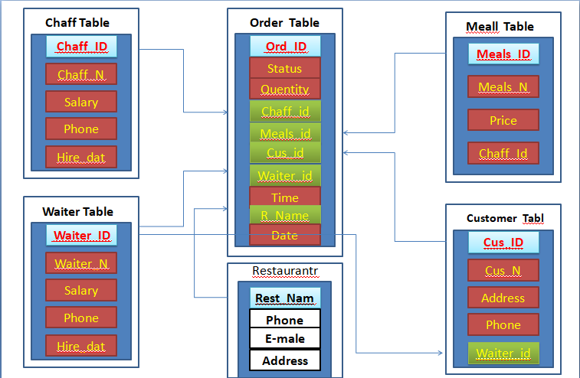

* **The Database of Restaurant Management System Schema:**

**Entity Attribute**

* Chef (chef_id, name, salary, hire date)
* Meal (m_id, m_name, price, chef_id)
* Waiter (W_id,w_name,salary, heir date)
* Customer (c_id,c_name,c_p, c_add, w_id)
* Restaurant (R_name,R_add, R_ph, R_email)
* Order (O_id,c_id,w_id,m_id,quantity,time,status,date)

Yellow Color are = Primary Key and Read Color are Foreign Key