CASE STUDY
Library Management system

Case Study Description
This case study describes a simple library management system coded in C. The system supports common operations such as adding and removing books, issuing books to students, returning books, calculating the overdue fine, and maintaining a database of students and available books.
List of Functions
- edit() – Adds or removes books from the library's inventory based on user selection.
- issue() - Issues a book to a student.
- re() – Records when a student returns the issued book.
- inventory() - Displays all books in the library.
- studentDatabase() - Displays all students in the library's database.
- addStud() - Adds a student to the library's database.
- main() – Calls all the functions based on user choice.
Function Details:
1. edit()
Purpose:
Manage library inventory by adding or removing books.
a. All Possible Inputs
- Adding a book:
  - Book Title (string)
  - Book Author (string)
  - Book ID (integer)
  - Number of Copies (integer)
- Removing a book:
  - Book ID (integer)
b. All Possible Outputs
- Success messages:
  - "The entry has been added successfully!"
  - "The entry has been erased."
- Error messages:
  - "Library FULL!"
  - "Book not found..."
  - "Invalid entry. Try a valid choice."
c. All Possible Constraints
- The maximum number of books (bcount >= max) cannot be exceeded.
- Book IDs must be unique.
- Valid integer inputs are required for book ID and number of copies.
d. Assumptions
- The user provides a unique book ID for each book.
- Only one copy of each book record can exist per unique ID.

2. issue()
Purpose
Issues a book to a student.
a. All Possible Inputs
- Student ID (integer)
- Book ID (integer)
b. All Possible Outputs
- Success message:
  - "The book was issued on: [Date]"
- Error messages:
  - "Student not found..."
  - "Book not found..."
  - "Insufficient copies..."
c. Constraints
- The book ID must exist in the inventory.
- The student ID must be registered in the database.
- There should be at least one copy of the book available.
d. Assumptions
- Each student can borrow only one book at a time.
e. Flowchart:
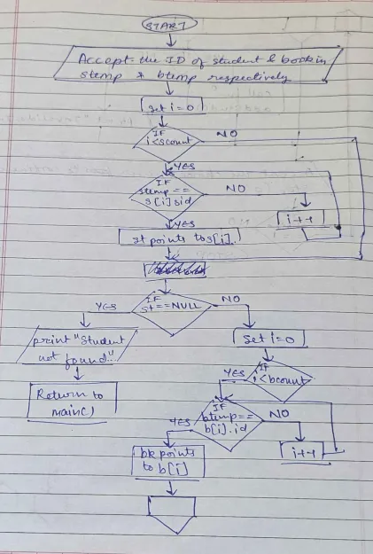
3. re()
Purpose
To allow students to return a book they previously borrowed and calculate any overdue fine based on the time elapsed since the issue date.
a. All Possible Inputs
- Student ID (integer)
- Book ID (integer)
b. All Possible Outputs
- Success messages:
  - "The book was returned on: [Date]"
  - "Thank you for returning the book on time! No late fees to be paid."
- Fine message (if late):
  - "You have passed the deadline by [days past due], hence you have to pay: [fine amount]"
- Error messages:
  - "Student not found..."
  - "Book was not issued to this student..."
  - "Book not found..."
c. Constraints
- The student ID must exist in the system.
- The book ID must exist and match the book currently issued to the student.
- The system assumes a 7-day return period, with a daily fine of 100 currency units if returned late.
d. Assumptions
- A book can only be issued once to a student, and only one book can be issued to each student at a time.
e. Flowchart:

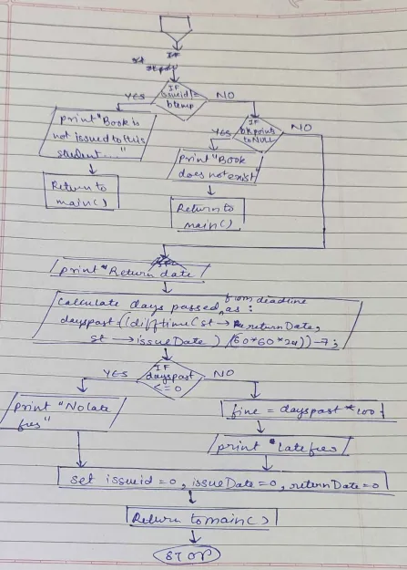

4. inventory()
Purpose
Display all books currently available in the library.
a. All Possible Inputs
- None (no input required from the user, as it simply displays inventory).
b. All Possible Outputs
- A formatted list of all books with:
  - Book ID
  - Title
  - Author
  - Number of Copies available
c. Constraints
- The system should not display any books if bcount is 0, meaning there are no books in the library.
d. Assumptions
- Only valid data has been entered in the inventory and is displayed accurately.
e. flowchart:
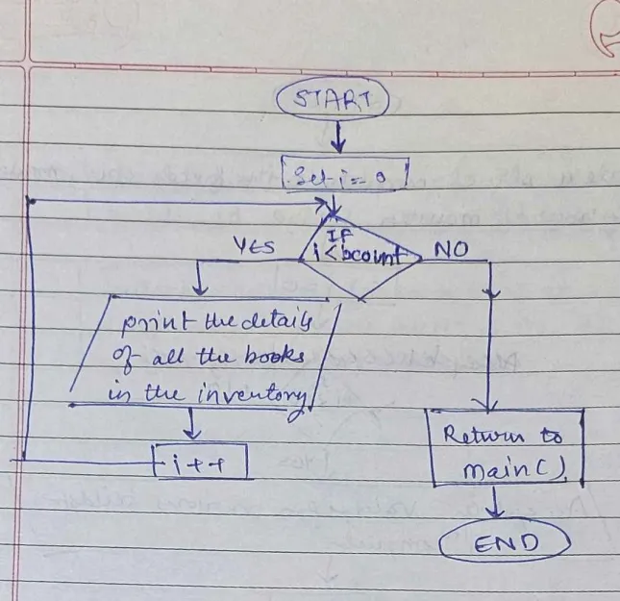

5. studentDatabase()
Purpose
Display a list of all students registered in the library system.
a. All Possible Inputs
- None (simply displays the student database).
b. All Possible Outputs
- A formatted list of all students with:
  - Student ID
  - Name
  - Class
  - Book ID (if they have a book issued)
c. Constraints
- The function should handle cases where no students are registered (i.e., scount == 0).
d. Assumptions
- Each student in the database has valid, accurate information entered.
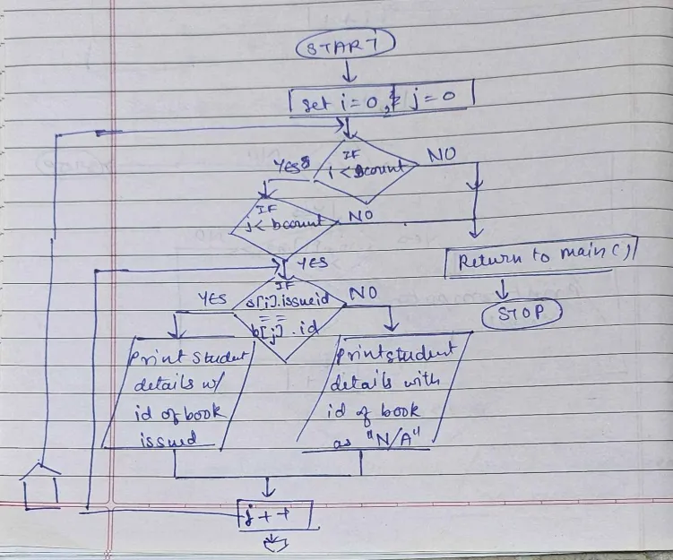
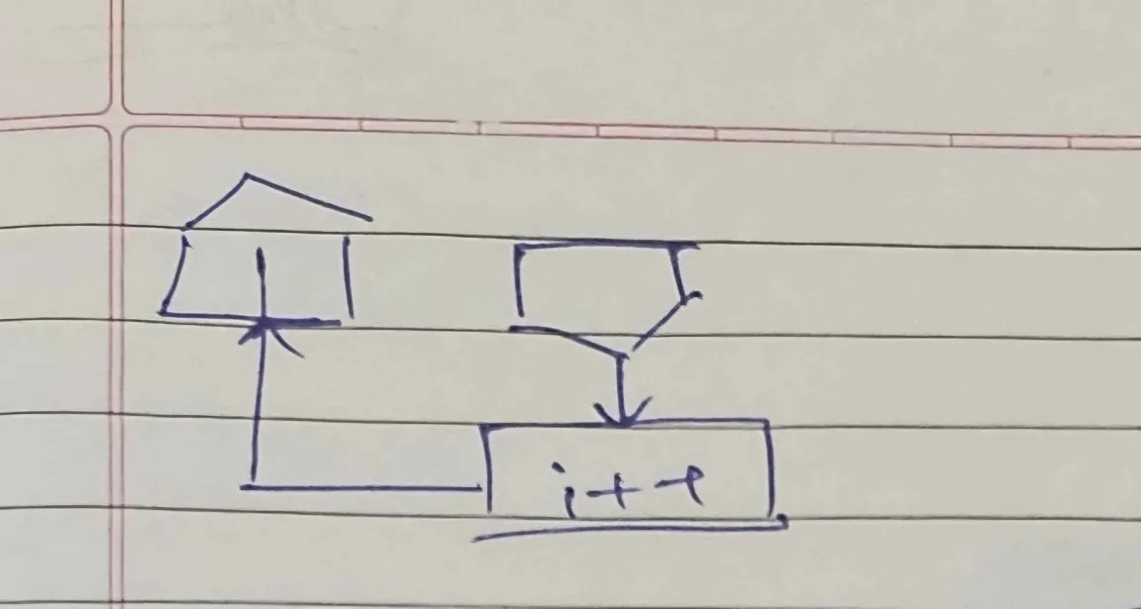
6. addStud()
Purpose
To add a new student to the library's student database.
a. All Possible Inputs
- Student ID (integer)
- Student Name (string)
- Student Class (string)
b. All Possible Outputs
- Success message:
  - "The student was added successfully!"
- Error message:
  - "Student is already in database..."
c. Constraints
- Each student ID must be unique.
d. Assumptions
- The student ID entered is unique and has not been previously registered.
e. Flowchart:
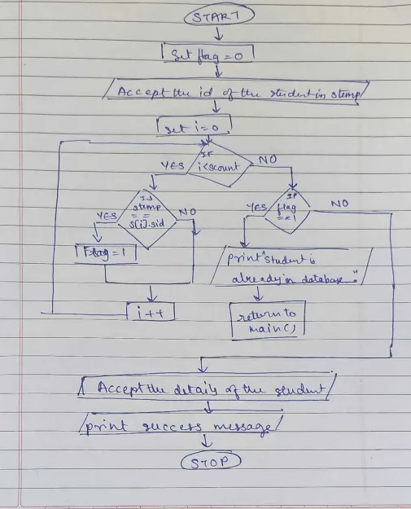

7. main()
a. All Possible Inputs:
- Number of books (max).
- User inputs for operations like student ID, book ID, etc.
b. All Possible Outputs:
- Menus for operations.
- Success or failure messages (e.g., book not found, fine calculated).
c. All Possible Constraints:
- Max of 100 books and students.
- Insufficient copies for issuing a book.
- Fine is calculated based on late return days.
d. Assumptions:
- Book/student data is limited to 100.
- Fine is 100 units per day for overdue books.
- Students must be registered before issuing or returning books.
e. Flowchart:
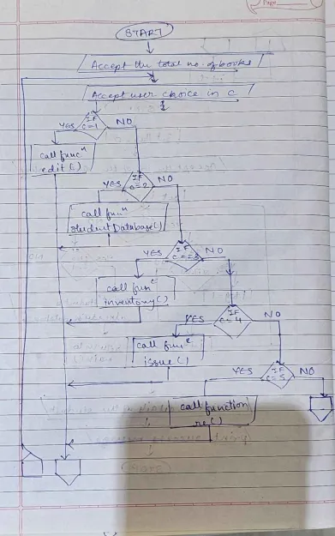
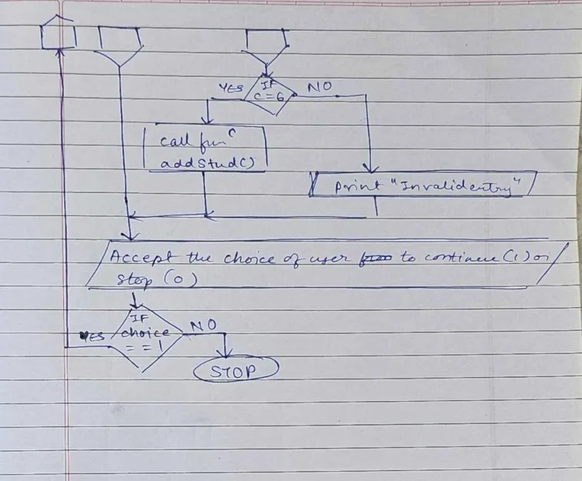

CODE:
#include <stdio.h>
#include <time.h>
#include <string.h>

typedef struct
{
int id, copyno;
char title[30], author[30];
} books;

typedef struct
{
int sid, issueid;
time_t issueDate, returnDate;
char name[50], cl[5];
} student;

books b[100];
student s[100];
int bcount = 0, scount = 0, i, j, max = 100;

void edit()
{
int c, btemp, flag = 0;
while (1)
{
printf("What changes would you like to make to the list?\n 1: Add books\n 2: Remove books\n");
scanf("%d", &c);
switch (c)
{
case 1:
if (bcount >= max)
{
printf("Library FULL!");
return;
}
else //adding the book to the database fr
{
printf("Enter the Title of the book: ");
scanf(" %[^\n]", b[bcount].title);
printf("Enter the Author of the book: ");
scanf(" %[^\n]", b[bcount].author);
printf("Enter the ID of the book: ");
scanf("%d", &b[bcount].id);
printf("Enter the number of copies of the book: ");
scanf("%d", &b[bcount].copyno);
bcount++;
printf("The entry has been added successfully!\n");
}
return;

case 2:
printf("Enter the ID of the book: ");
scanf("%d", &btemp);
for (i = 0; i < bcount; i++)
{
if (btemp == b[i].id)
{
flag = 1;
for (j = i; j < bcount - 1; j++)
{
b[j] = b[j + 1];
}
bcount--;
break;
}
}

if (flag == 1)
printf("The entry has been erased.\n");
else
printf("Book not found...\n");
return;

default:
printf("Invalid entry. Try a valid choice.\n");
}
}
}

void issue()
{
int stemp, btemp;
books *bk = NULL;
student *st = NULL;

printf("Enter the ID of the student: ");
scanf("%d", &stemp);
printf("Enter the ID of the book: ");
scanf("%d", &btemp);

//find student by id
for (i = 0; i < scount; i++)
{
if (stemp == s[i].sid)
{
st = &s[i];
break;
}
}
if (st == NULL)
{
printf("Student not found...\n");
return;
} //in case student is not registered

//find book by id
for (i = 0; i < bcount; i++)
{
if (btemp == b[i].id)
{
bk = &b[i];
break;
}
}

if (bk == NULL)
{
printf("Book not found...\n");
return;
}

if (bk->copyno < 1)
{
printf("Insufficient copies...\n");
return;
}

//issue the book
st->issueid = btemp;
bk->copyno--;
time(&st->issueDate);
printf("The book was issued on: %s", ctime(&st->issueDate));
}

void re()
{
int stemp, btemp;
double dayspast, fine;
books *bk = NULL;
student *st = NULL;
printf("Enter the ID of the student: ");
scanf("%d", &stemp);
printf("Enter the ID of the book: ");
scanf("%d", &btemp);

for (i = 0; i < scount; i++) //checking if the student exists in database
{
if (stemp == s[i].sid)
{
st = &s[i];
break;
}
}
if (st == NULL)
{
printf("Student not found...\n");
return;
}

for (i = 0; i < bcount; i++)
{
if (btemp == b[i].id)
{
bk = &b[i];
break;
}
}
if (st->issueid != btemp) //Checking if book was issued to student
{
printf("Book was not issued to this student...\n");
return;
}

if (bk == NULL) //checking if book exists in database
{
printf("Book not found...\n");
return;
}

//if book does exist and is returned by student
bk->copyno++;
time(&st->returnDate);
printf("The book was returned on: %s\n", ctime(&st->returnDate));
dayspast = (difftime(st->returnDate, st->issueDate) / (60 * 60 * 24)) - 7;

if (dayspast <= 0)
printf("Thank you for returning the book on time!\nNo late fees to be paid.\n");
else
{
fine = dayspast * 100;
printf("You have passed the deadline by %0.2f, hence you have to pay: %0.2f\n", dayspast, fine);
}
st->issueid = 0;
st->issueDate = 0;
st->returnDate = 0;
}

void inventory() //Display all books in library
{
printf("\nID | TITLE | AUTHOR | COPIES\n");
for (i = 0; i < bcount; i++)
{
printf("%d | %s | %s | %d\n", b[i].id, b[i].title, b[i].author, b[i].copyno);
}
}

void studentDatabase() //display students in database
{
printf("\nID | NAME | CLASS | BOOK ID\n");
for (i = 0; i < scount; i++)
{
printf("%d | %s | %s | ", s[i].sid, s[i].name, s[i].cl);
if (s[i].issueid > 0)
printf("%d\n", s[i].issueid);
else
printf("N/A\n");
}
}

void addStud() //add student to database
{
int flag = 0, stemp;
printf("Enter the ID of the student: ");
scanf("%d", &stemp);

for (i = 0; i < scount; i++)
{
if (stemp == s[i].sid)
{
flag = 1;
}
}

if (flag == 1)
{
printf("Student is already in database...\n");
return;
}

s[scount].sid = stemp;
printf("Enter the Name of the student: ");
scanf(" %[^\n]", s[scount].name);
printf("Enter the class of the student: ");
scanf("%s", s[scount].cl);
s[scount].issueid = 0;
scount++; //student count goes up
printf("The student was added successfully!\n");
}

int main()
{
int choice = 0, c;
printf("Welcome :D\n");
printf("Enter the total max capacity of books: ");
scanf("%d", &max);

do
{
printf("\n1: Edit book list\n2: Student Database\n3: Check inventory\n4: Issue a book\n5: Return a book\n6: Add Student\n");
scanf("%d", &c);

switch (c)
{
case 1:
edit();
break;
case 2:
studentDatabase();
break;
case 3:
inventory();
break;
case 4:
issue();
break;
case 5:
re();
break;
case 6:
addStud();
break;
default:
printf("Invalid entry. Try a valid choice.\n");
}

printf("Return to menu? 1: yes 0: no : ");
scanf("%d", &choice);

} while (choice == 1);

printf("Thank you for using the system! :D\n");
return 0;
}

