**Remote Sensing – Plot-Level ET Estimation**

## **1. Abstract**

## Objectives -

* To estimate daily evapotranspiration (ET) for 30 plots using WaPOR data.
* Deal with spatial resolution and temporal interpolation challenges.
* Compare satellite-based ET with ground-truth water usage from meters.

### **2.1. WaPOR Data**

* Source: FAO WaPOR Level-1 (Dekadal ET, 300m resolution).
* Units: mm/day (dekadal sums provided).

### **2.2. Plot Information**

* 30 plots across different farm management types:
  + TPR (Transplanted Rice)
  + DSR (Direct Seeded Rice)
  + AWD (Alternate Wetting and Drying)
* Plots are smaller than pixel resolution (100–200 m in size or 2-5 acres).

Link to Sample plots - <https://docs.google.com/spreadsheets/d/1UrMY4plAIWYo_-UX7tvCAZfd4BBbuUAYrSaKru6elbY/edit?usp=sharing>

## **3. Methodology**

### **3.1. Pixel-Plot Overlap Resolution**

#### **Problem:**

WaPOR pixels (300m) are coarser than plot boundaries, causing multiple pixel overlaps.

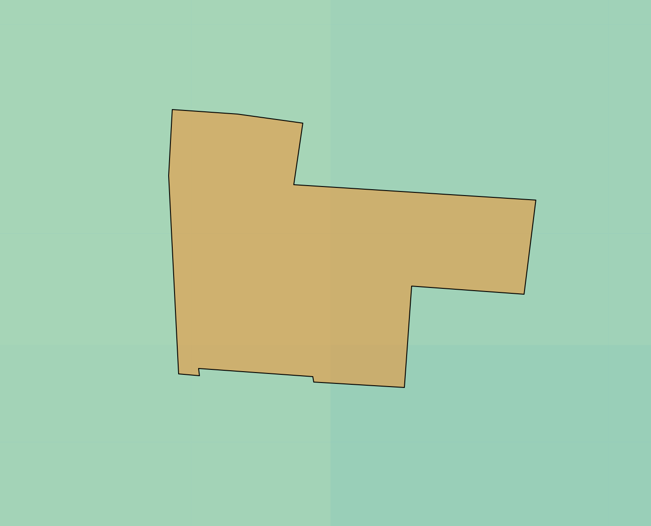

(plot id = LA_PA_PA_HARPA_PLT_5052)

#### **Solution: Area-weighted averaging**

* Overlay plot polygons on WaPOR raster.
* Calculate intersection area of each pixel with plot using **Shoelace Algorithm** (Green’s Theorem) or GIS tools.
* Multiply pixel ET by area fraction and sum:  
  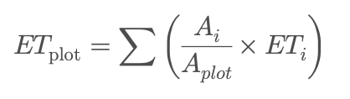

Output -

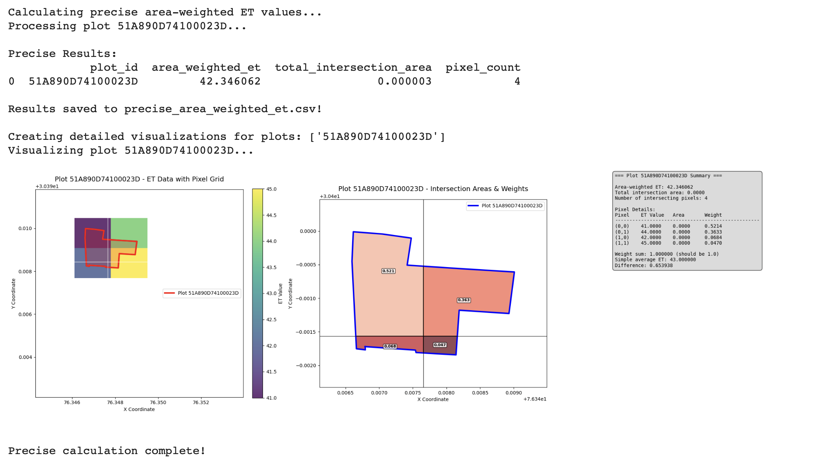

#### **Validation:**

* **Area-weighted averaging** is widely used in downscaling satellite data to field level.
* Similar approach used in:
  + FAO’s WaPOR methodology documentation:

<https://wapor.apps.fao.org/home/WAPOR_Methodology>

* + NASA Land Data Assimilation Systems (LDAS) - Downscaling

*“For point or plot-scale validation, the average value of the intersecting pixels weighted by the fraction of coverage should be used.”*

<https://ldas.gsfc.nasa.gov/>

* + QGIS Documentation – Zonal Statistics

<https://docs.qgis.org/>

### **3.2. Temporal Interpolation**

#### Problem:

ET data is dekadal (e.g., 12 mm every 10 days) — coarse for daily water analysis.

#### Solution: Cubic Spline Interpolation

Instead of assuming constant ET/day = total/10 (which is unrealistic), cubic spline interpolation was applied to smooth values across time.

Cubic spline interpolation is a method to construct a **smooth curve** that passes through a series of known data points. Unlike linear or polynomial interpolation, a **cubic spline** stitches together **piecewise cubic polynomials** between each pair of points, ensuring smooth transitions at the joints.

**Spline interpolation creates daily or finer-resolution estimates** from coarse data while maintaining realistic trends.This method better captures temporal variability, aligns with weather-induced ET shifts.

Validation:

* Cubic splines are commonly used for temporal interpolation in environmental datasets.
* Used in ET studies like:
  + [Zhang et al., 2017 – Journal of Hydrology](https://doi.org/10.1016/j.jhydrol.2017.06.005)
  + NASA EarthData and MODIS preprocessing pipelines.

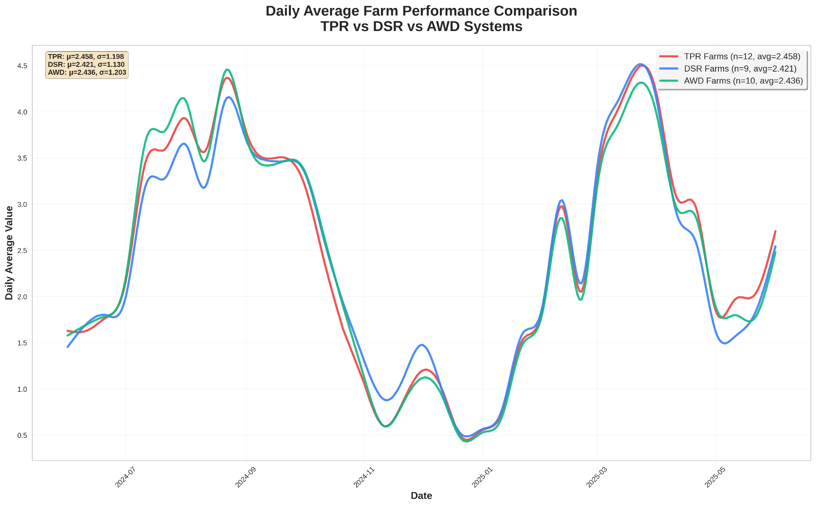

(all values in mm/day)

## **4. Visualizations and Analysis**

* Daily ET curves per plot.
* Boxplots comparing ET distributions across TPR, DSR, and AWD.
* Whisker plots to show variability across seasons or plots.
* Comparative bar charts showing peak vs. low ET periods.

### **Tools Used:**

* Python (Matplotlib, Seaborn, Scipy for interpolation)

**SUM UP**

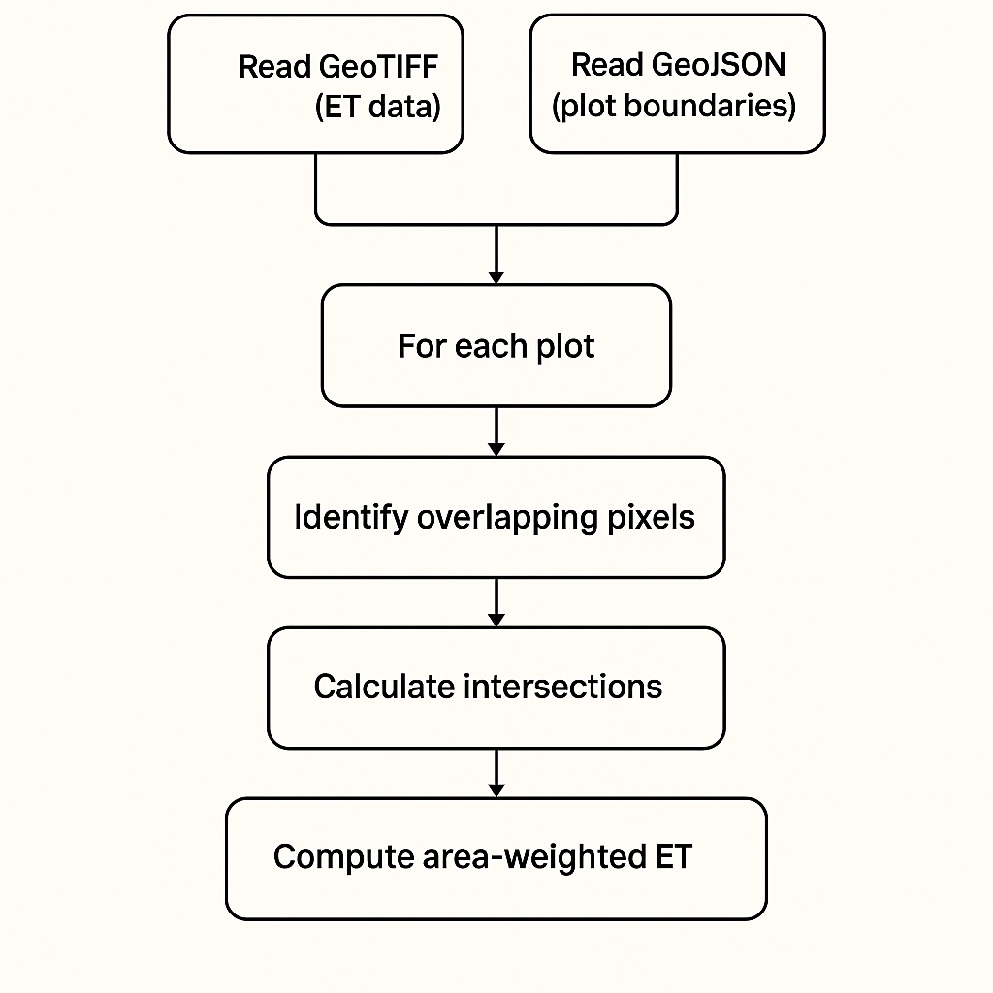

Flowchart of logic

Link to the final data (1 JUNE 2024 - 1 JUNE 2025) : <https://docs.google.com/spreadsheets/d/1BIZ1y6_kQP5UEn6RG4NCZykfGErjCuwx8VpyyTQAMPo/edit?usp=sharing>

## **5. Code Snippets**

### **5.1 Area weighted average**

import rasterio

import geopandas as gpd

import numpy as np

from rasterio.features import rasterize

from rasterio.transform import from_bounds

from shapely.geometry import box, Polygon

from shapely.ops import unary_union

import pandas as pd

from typing import Dict, List, Tuple, Optional

import warnings

import matplotlib.pyplot as plt

from matplotlib.patches import Polygon as MPLPolygon

warnings.filterwarnings('ignore')

def shoelace_area(coordinates: List[Tuple[float, float]]) -> float:

"""

Calculate polygon area using the shoelace formula.

Parameters:

-----------

coordinates : List[Tuple[float, float]]

List of (x, y) coordinate tuples forming the polygon

Returns:

--------

float

Area of the polygon

"""

if len(coordinates) < 3:

return 0.0

# Ensure polygon is closed

if coordinates[0] != coordinates[-1]:

coordinates = coordinates + [coordinates[0]]

n = len(coordinates) - 1 # Exclude the duplicate closing point

area = 0.0

for i in range(n):

j = (i + 1) % n

area += coordinates[i][0] * coordinates[j][1]

area -= coordinates[j][0] * coordinates[i][1]

return abs(area) / 2.0

def get_pixel_coordinates(pixel_row: int, pixel_col: int, transform: rasterio.Affine) -> List[Tuple[float, float]]:

"""

Get the corner coordinates of a pixel.

Parameters:

-----------

pixel_row : int

Row index of the pixel

pixel_col : int

Column index of the pixel

transform : rasterio.Affine

Raster transform

Returns:

--------

List[Tuple[float, float]]

List of corner coordinates [(x, y), ...]

"""

# Get pixel bounds in geographic coordinates

left = transform * (pixel_col, pixel_row)

right = transform * (pixel_col + 1, pixel_row)

bottom_left = transform * (pixel_col, pixel_row + 1)

bottom_right = transform * (pixel_col + 1, pixel_row + 1)

# Return corners in order: top-left, top-right, bottom-right, bottom-left

return [

left, # top-left

right, # top-right

bottom_right, # bottom-right

bottom_left # bottom-left

]

def get_intersection_coordinates(plot_geometry, pixel_coords: List[Tuple[float, float]]) -> Optional[List[Tuple[float, float]]]:

"""

Get the coordinates of intersection between plot geometry and pixel.

Parameters:

-----------

plot_geometry : shapely.geometry

Plot geometry

pixel_coords : List[Tuple[float, float]]

Pixel corner coordinates

Returns:

--------

Optional[List[Tuple[float, float]]]

Intersection coordinates or None if no intersection

"""

try:

# Create pixel polygon

pixel_polygon = Polygon(pixel_coords)

# Calculate intersection

intersection = plot_geometry.intersection(pixel_polygon)

if intersection.is_empty:

return None

# Handle different geometry types

if hasattr(intersection, 'exterior'):

# Single polygon

return list(intersection.exterior.coords[:-1]) # Exclude duplicate last point

elif hasattr(intersection, 'geoms'):

# MultiPolygon or GeometryCollection

all_coords = []

for geom in intersection.geoms:

if hasattr(geom, 'exterior'):

all_coords.extend(list(geom.exterior.coords[:-1]))

return all_coords if all_coords else None

else:

return None

except Exception as e:

print(f"Error calculating intersection: {e}")

return None

def calculate_precise_area_weighted_et(geotiff_path: str, geojson_path: str,

plot_id_column: str = 'id') -> pd.DataFrame:

"""

Calculate area-weighted ET values using precise coordinate-based area calculation.

Parameters:

-----------

geotiff_path : str

Path to the GeoTIFF file containing ET values

geojson_path : str

Path to the GeoJSON file containing plot boundaries

plot_id_column : str

Column name in GeoJSON that contains plot identifiers

Returns:

--------

pd.DataFrame

DataFrame with plot IDs and their area-weighted ET values

"""

# Read the GeoJSON file

plots_gdf = gpd.read_file(geojson_path)

# Read the GeoTIFF file

with rasterio.open(geotiff_path) as src:

et_data = src.read(1) # Read first band

transform = src.transform

crs = src.crs

nodata = src.nodata

# Ensure both datasets have the same CRS

if plots_gdf.crs != crs:

plots_gdf = plots_gdf.to_crs(crs)

results = []

for idx, plot in plots_gdf.iterrows():

plot_id = plot[plot_id_column] if plot_id_column in plot else idx

geometry = plot.geometry

print(f"Processing plot {plot_id}...")

# Get the bounding box of the plot

minx, miny, maxx, maxy = geometry.bounds

# Convert bounds to pixel coordinates

ul_col, ul_row = ~transform * (minx, maxy) # Upper left

lr_col, lr_row = ~transform * (maxx, miny) # Lower right

# Round to get pixel indices

ul_col, ul_row = int(np.floor(ul_col)), int(np.floor(ul_row))

lr_col, lr_row = int(np.ceil(lr_col)), int(np.ceil(lr_row))

# Ensure indices are within raster bounds

ul_col = max(0, ul_col)

ul_row = max(0, ul_row)

lr_col = min(et_data.shape[1], lr_col)

lr_row = min(et_data.shape[0], lr_row)

if ul_col >= lr_col or ul_row >= lr_row:

print(f"Warning: Plot {plot_id} is outside raster bounds")

results.append({

'plot_id': plot_id,

'area_weighted_et': np.nan,

'total_intersection_area': 0,

'pixel_count': 0,

'intersection_details': []

})

continue

# Store intersection details for each pixel

intersection_details = []

total_intersection_area = 0

# Process each pixel in the bounding box

for row in range(ul_row, lr_row):

for col in range(ul_col, lr_col):

# Get pixel value

pixel_value = et_data[row, col]

# Skip nodata pixels

if nodata is not None and pixel_value == nodata:

continue

if np.isnan(pixel_value):

continue

# Get pixel corner coordinates

pixel_coords = get_pixel_coordinates(row, col, transform)

# Get intersection coordinates

intersection_coords = get_intersection_coordinates(geometry, pixel_coords)

if intersection_coords and len(intersection_coords) >= 3:

# Calculate intersection area using shoelace formula

intersection_area = shoelace_area(intersection_coords)

if intersection_area > 0:

intersection_details.append({

'pixel_row': row,

'pixel_col': col,

'pixel_value': pixel_value,

'intersection_area': intersection_area,

'intersection_coords': intersection_coords,

'pixel_coords': pixel_coords

})

total_intersection_area += intersection_area

# Calculate area-weighted ET

if total_intersection_area > 0 and intersection_details:

area_weighted_sum = 0

# Calculate weights and weighted sum

for detail in intersection_details:

weight = detail['intersection_area'] / total_intersection_area

detail['weight'] = weight

area_weighted_sum += detail['pixel_value'] * weight

area_weighted_et = area_weighted_sum

else:

area_weighted_et = np.nan

results.append({

'plot_id': plot_id,

'area_weighted_et': area_weighted_et,

'total_intersection_area': total_intersection_area,

'pixel_count': len(intersection_details),

'intersection_details': intersection_details

})

# Create DataFrame with main results

main_results = pd.DataFrame([{

'plot_id': r['plot_id'],

'area_weighted_et': r['area_weighted_et'],

'total_intersection_area': r['total_intersection_area'],

'pixel_count': r['pixel_count']

} for r in results])

# Store detailed results for visualization

main_results._detailed_results = results

return main_results

def visualize_precise_plot_coverage(geotiff_path: str, geojson_path: str, plot_id: str,

results_df: pd.DataFrame, plot_id_column: str = 'id'):

"""

Visualize precise plot coverage with coordinate-based intersections.

"""

# Get detailed results

detailed_results = getattr(results_df, '_detailed_results', None)

if detailed_results is None:

print("No detailed results available. Please run calculate_precise_area_weighted_et first.")

return

# Find the specific plot results

plot_result = None

for result in detailed_results:

if str(result['plot_id']) == str(plot_id):

plot_result = result

break

if plot_result is None:

print(f"Plot {plot_id} not found in results.")

return

# Read data

plots_gdf = gpd.read_file(geojson_path)

plot = plots_gdf[plots_gdf[plot_id_column] == plot_id].iloc[0]

with rasterio.open(geotiff_path) as src:

et_data = src.read(1)

transform = src.transform

crs = src.crs

nodata = src.nodata

# Ensure same CRS

if plots_gdf.crs != crs:

plots_gdf = plots_gdf.to_crs(crs)

plot = plots_gdf[plots_gdf[plot_id_column] == plot_id].iloc[0]

# Create visualization

fig, (ax1, ax2, ax3) = plt.subplots(1, 3, figsize=(24, 8))

# Get plot bounds with buffer

minx, miny, maxx, maxy = plot.geometry.bounds

buffer = max((maxx - minx), (maxy - miny)) * 0.2

plot_minx, plot_miny = minx - buffer, miny - buffer

plot_maxx, plot_maxy = maxx + buffer, maxy + buffer

# Convert to pixel coordinates for cropping

ul_col, ul_row = ~transform * (plot_minx, plot_maxy)

lr_col, lr_row = ~transform * (plot_maxx, plot_miny)

ul_col, ul_row = int(np.floor(ul_col)), int(np.floor(ul_row))

lr_col, lr_row = int(np.ceil(lr_col)), int(np.ceil(lr_row))

ul_col = max(0, ul_col)

ul_row = max(0, ul_row)

lr_col = min(et_data.shape[1], lr_col)

lr_row = min(et_data.shape[0], lr_row)

# Create extent

extent = [plot_minx, plot_maxx, plot_miny, plot_maxy]

# Crop raster

subset = et_data[ul_row:lr_row, ul_col:lr_col]

subset_masked = np.copy(subset).astype(float)

if nodata is not None:

subset_masked[subset == nodata] = np.nan

# Plot 1: ET data with plot overlay

im1 = ax1.imshow(subset_masked, extent=extent, origin='upper', alpha=0.8, cmap='viridis')

# Plot plot boundary

if hasattr(plot.geometry, 'exterior'):

x, y = plot.geometry.exterior.xy

ax1.plot(x, y, color='red', linewidth=3, label=f'Plot {plot_id}')

ax1.fill(x, y, color='red', alpha=0.2)

# Add pixel grid

for row in range(ul_row, lr_row + 1):

for col in range(ul_col, lr_col + 1):

pixel_coords = get_pixel_coordinates(row, col, transform)

if pixel_coords:

pixel_x = [coord[0] for coord in pixel_coords] + [pixel_coords[0][0]]

pixel_y = [coord[1] for coord in pixel_coords] + [pixel_coords[0][1]]

ax1.plot(pixel_x, pixel_y, color='white', alpha=0.5, linewidth=1)

ax1.set_title(f'Plot {plot_id} - ET Data with Pixel Grid', fontsize=14)

ax1.set_xlabel('X Coordinate')

ax1.set_ylabel('Y Coordinate')

ax1.legend()

plt.colorbar(im1, ax=ax1, label='ET Value', fraction=0.046, pad=0.04)

# Plot 2: Intersection areas

ax2.set_xlim(plot_minx, plot_maxx)

ax2.set_ylim(plot_miny, plot_maxy)

# Plot plot boundary

if hasattr(plot.geometry, 'exterior'):

x, y = plot.geometry.exterior.xy

ax2.plot(x, y, color='blue', linewidth=3, label=f'Plot {plot_id}')

# Plot intersection areas with different colors based on weights

colors = plt.cm.Reds(np.linspace(0.3, 1.0, len(plot_result['intersection_details'])))

for i, detail in enumerate(plot_result['intersection_details']):

# Plot pixel boundary

pixel_coords = detail['pixel_coords']

pixel_x = [coord[0] for coord in pixel_coords] + [pixel_coords[0][0]]

pixel_y = [coord[1] for coord in pixel_coords] + [pixel_coords[0][1]]

ax2.plot(pixel_x, pixel_y, color='black', linewidth=1, alpha=0.5)

# Plot intersection area

intersection_coords = detail['intersection_coords']

if len(intersection_coords) >= 3:

intersection_x = [coord[0] for coord in intersection_coords]

intersection_y = [coord[1] for coord in intersection_coords]

# Create matplotlib polygon

polygon = MPLPolygon(list(zip(intersection_x, intersection_y)),

facecolor=colors[i], alpha=0.7, edgecolor='black', linewidth=1)

ax2.add_patch(polygon)

# Add weight text

centroid_x = np.mean(intersection_x)

centroid_y = np.mean(intersection_y)

ax2.text(centroid_x, centroid_y, f'{detail["weight"]:.3f}',

ha='center', va='center', fontsize=8, fontweight='bold',

bbox=dict(boxstyle='round,pad=0.2', facecolor='white', alpha=0.8))

ax2.set_title(f'Plot {plot_id} - Intersection Areas & Weights', fontsize=14)

ax2.set_xlabel('X Coordinate')

ax2.set_ylabel('Y Coordinate')

ax2.legend()

ax2.set_aspect('equal')

# Plot 3: Summary statistics

ax3.axis('off')

# Prepare summary data

summary_text = f"=== Plot {plot_id} Summary ===\n\n"

summary_text += f"Area-weighted ET: {plot_result['area_weighted_et']:.6f}\n"

summary_text += f"Total intersection area: {plot_result['total_intersection_area']:.4f}\n"

summary_text += f"Number of intersecting pixels: {plot_result['pixel_count']}\n\n"

summary_text += "Pixel Details:\n"

summary_text += f"{'Pixel':<8} {'ET Value':<10} {'Area':<10} {'Weight':<10}\n"

summary_text += f"{'-'*50}\n"

for i, detail in enumerate(plot_result['intersection_details']):

pixel_pos = f"({detail['pixel_row']},{detail['pixel_col']})"

summary_text += f"{pixel_pos:<8} {detail['pixel_value']:<10.4f} "

summary_text += f"{detail['intersection_area']:<10.4f} {detail['weight']:<10.4f}\n"

# Verification

total_weight = sum(detail['weight'] for detail in plot_result['intersection_details'])

summary_text += f"\nWeight sum: {total_weight:.6f} (should be 1.0)\n"

# Simple average for comparison

pixel_values = [detail['pixel_value'] for detail in plot_result['intersection_details']]

if pixel_values:

simple_avg = np.mean(pixel_values)

summary_text += f"Simple average ET: {simple_avg:.6f}\n"

summary_text += f"Difference: {abs(plot_result['area_weighted_et'] - simple_avg):.6f}"

ax3.text(0.05, 0.95, summary_text, transform=ax3.transAxes, fontsize=10,

verticalalignment='top', fontfamily='monospace',

bbox=dict(boxstyle='round,pad=0.5', facecolor='lightgray', alpha=0.8))

plt.tight_layout()

plt.show()

return fig

def compare_methods(geotiff_path: str, geojson_path: str, plot_id_column: str = 'id'):

"""

Compare the original and precise methods.

"""

print("Running original method...")

# Note: You'll need to import your original function

# original_results = calculate_area_weighted_et(geotiff_path, geojson_path, plot_id_column)

print("Running precise method...")

precise_results = calculate_precise_area_weighted_et(geotiff_path, geojson_path, plot_id_column)

print("\nPrecise method results:")

print(precise_results.head())

return precise_results

# Example usage

if __name__ == "__main__":

# File paths

geotiff_path = "/content/5052_01_04_25"

geojson_path = "/content/plot_5052.json"

print("Calculating precise area-weighted ET values...")

# Calculate using precise coordinate-based method

results = calculate_precise_area_weighted_et(

geotiff_path,

geojson_path,

plot_id_column='id'

)

# Display results

print("\nPrecise Results:")

print(results)

# Save results to CSV

results.to_csv('precise_area_weighted_et.csv', index=False)

print("\nResults saved to precise_area_weighted_et.csv!")

# Visualize specific plots

if len(results) > 0:

plot_ids = results['plot_id'].head(2).tolist()

print(f"\nCreating detailed visualizations for plots: {plot_ids}")

for plot_id in plot_ids:

print(f"Visualizing plot {plot_id}...")

visualize_precise_plot_coverage(geotiff_path, geojson_path, str(plot_id),

results, plot_id_column='id')

print("\nPrecise calculation complete!")

### **5.2 Temporal Interpolation (Cubic spline)**

import pandas as pd

import numpy as np

from scipy.interpolate import CubicSpline

import matplotlib.pyplot as plt

import matplotlib.dates as mdates

from datetime import datetime

import warnings

import os

# Suppress warnings for cleaner output

warnings.filterwarnings('ignore')

def test_file_access():

"""Test if the Excel file is accessible"""

test_file = '/content/june-oct.xlsx'

print("="*60)

print("CHECKING FILE ACCESS...")

print("="*60)

if os.path.exists(test_file):

print(f"✓ File found: {test_file}")

return test_file

else:

print(f"✗ File not found: {test_file}")

# Check for other Excel files

try:

files = os.listdir('/content/')

excel_files = [f for f in files if f.endswith(('.xlsx', '.xls'))]

if excel_files:

print("\nAvailable Excel files in /content/:")

for f in excel_files:

print(f" - {f}")

# Use the first Excel file found

return f'/content/{excel_files[0]}'

else:

print("No Excel files found in /content/")

print("Please upload your Excel file to the Colab environment")

return None

except:

print("Could not access /content/ directory")

return None

def load_farm_type_tables(file_path):

"""Load the three farm type tables (TPR, DSR, AWD) from Excel file."""

# Try to read from different sheet names

try:

df_raw = pd.read_excel(file_path, sheet_name='Sheet1', header=None)

except:

try:

df_raw = pd.read_excel(file_path, sheet_name='Sheet2', header=None)

except:

df_raw = pd.read_excel(file_path, header=None)

# Find table boundaries automatically

table_starts = []

for idx, row in df_raw.iterrows():

if any(str(val).lower().strip() == 'date' for val in row.values if pd.notna(val)):

table_starts.append(idx)

print(f"Found {len(table_starts)} table headers at rows: {[x+1 for x in table_starts]}")

# Define table configurations

farm_type_names = ['TPR', 'DSR', 'AWD']

farm_tables = {}

for i, start_row in enumerate(table_starts):

farm_type = farm_type_names[i] if i < len(farm_type_names) else f'Table_{i+1}'

# Determine end row

if i + 1 < len(table_starts):

end_row = table_starts[i + 1]

else:

end_row = len(df_raw)

for j in range(start_row + 1, len(df_raw)):

if df_raw.iloc[j].isna().all():

has_more_data = False

for k in range(j + 1, min(j + 5, len(df_raw))):

if not df_raw.iloc[k].isna().all():

has_more_data = True

break

if not has_more_data:

end_row = j

break

# Extract headers and data

headers = df_raw.iloc[start_row].values

headers = [str(h) if pd.notna(h) else f'col_{i}' for i, h in enumerate(headers)]

data_start = start_row + 1

data_rows = df_raw.iloc[data_start:end_row].copy()

data_rows = data_rows.dropna(how='all')

if not data_rows.empty:

data_rows.columns = headers[:len(data_rows.columns)]

table_df = process_farm_table(data_rows, farm_type)

if not table_df.empty:

farm_tables[farm_type] = table_df

print(f"✓ {farm_type}: {len(table_df)} dekadal periods, {len(table_df.columns)} farms")

return farm_tables

def process_farm_table(table_data, farm_type):

"""Process individual farm table."""

table_data = table_data.copy()

# Find date column

date_col = None

for col in table_data.columns:

if 'date' in str(col).lower():

date_col = col

break

if date_col is None:

date_col = table_data.columns[0]

# Convert date column

try:

table_data[date_col] = pd.to_datetime(table_data[date_col], errors='coerce')

except:

try:

# Handle Excel serial numbers

table_data[date_col] = pd.to_datetime(table_data[date_col], origin='1899-12-30', unit='D', errors='coerce')

except:

print(f"Warning: Could not convert dates for {farm_type}")

return pd.DataFrame()

# Remove rows with invalid dates

table_data = table_data.dropna(subset=[date_col])

if table_data.empty:

return pd.DataFrame()

# Set date as index

table_data.set_index(date_col, inplace=True)

# Convert other columns to numeric

numeric_columns = []

for col in table_data.columns:

if col != date_col:

try:

if isinstance(table_data[col], pd.Series):

table_data[col] = pd.to_numeric(table_data[col], errors='coerce')

if table_data[col].notna().sum() > 0:

numeric_columns.append(col)

except:

continue

if not numeric_columns:

return pd.DataFrame()

table_data = table_data[numeric_columns]

table_data = table_data.dropna(axis=1, how='all')

return table_data

def interpolate_to_daily(dekadal_df, farm_type):

"""Convert dekadal data to daily using cubic spline interpolation."""

if dekadal_df.empty:

return pd.DataFrame()

dekadal_df = dekadal_df.sort_index()

start_date = dekadal_df.index.min()

end_date = dekadal_df.index.max()

daily_dates = pd.date_range(start=start_date, end=end_date, freq='D')

dekadal_numeric = (dekadal_df.index - start_date).days.values

daily_numeric = (daily_dates - start_date).days.values

daily_df = pd.DataFrame(index=daily_dates)

print(f" Interpolating {farm_type}: {len(dekadal_df)} → {len(daily_dates)} days")

successful_farms = []

for col in dekadal_df.columns:

try:

valid_mask = dekadal_df[col].notna()

if valid_mask.sum() < 2:

continue

x_vals = dekadal_numeric[valid_mask]

y_vals = dekadal_df[col][valid_mask].values

if len(x_vals) >= 4:

cs = CubicSpline(x_vals, y_vals, bc_type='natural')

interpolated = cs(daily_numeric)

else:

interpolated = np.interp(daily_numeric, x_vals, y_vals)

interpolated = np.maximum(interpolated, 0)

# Round interpolated values to 2 decimal places

interpolated = np.round(interpolated, 2)

daily_df[col] = interpolated

successful_farms.append(col)

except Exception as e:

continue

print(f" {farm_type}: ✓ {len(successful_farms)} farms interpolated")

return daily_df

def calculate_daily_averages(daily_dfs):

"""Calculate daily average ET values for each farm type."""

avg_df = pd.DataFrame()

for farm_type, daily_df in daily_dfs.items():

if not daily_df.empty:

daily_avg = daily_df.mean(axis=1, skipna=True)

avg_df[farm_type] = daily_avg

print(f" {farm_type}: {daily_avg.min():.2f} - {daily_avg.max():.2f} mm/day")

return avg_df

def plot_et_comparison(avg_df, period_name="Analysis Period", save_png=True):

"""Create comparison plot of ET trends across farm types."""

plt.figure(figsize=(14, 8))

colors = {'TPR': '#2E86C1', 'DSR': '#28B463', 'AWD': '#F39C12'}

line_styles = {'TPR': '-', 'DSR': '--', 'AWD': '-.'}

for farm_type in avg_df.columns:

plt.plot(avg_df.index, avg_df[farm_type],

color=colors.get(farm_type, 'black'),

linestyle=line_styles.get(farm_type, '-'),

linewidth=3,

label=f'{farm_type} (Avg: {avg_df[farm_type].mean():.2f} mm/day)',

marker='o', markersize=5, alpha=0.8)

plt.title(f'Evapotranspiration (ET) Trends Comparison\n{period_name}',

fontsize=16, fontweight='bold', pad=20)

plt.xlabel('Date', fontsize=12, fontweight='bold')

plt.ylabel('ET Value (mm/day)', fontsize=12, fontweight='bold')

plt.gca().xaxis.set_major_formatter(mdates.DateFormatter('%Y-%m-%d'))

plt.gca().xaxis.set_major_locator(mdates.WeekdayLocator(interval=2))

plt.xticks(rotation=45)

plt.grid(True, alpha=0.3, linestyle=':', linewidth=0.5)

plt.legend(loc='upper left', frameon=True, fancybox=True, shadow=True, fontsize=11)

# Statistics box

stats_text = f"""Statistics Summary:

Total Days: {len(avg_df)}

Date Range: {avg_df.index.min().strftime('%Y-%m-%d')} to {avg_df.index.max().strftime('%Y-%m-%d')}

Farm Type Comparison:"""

for farm_type in avg_df.columns:

stats_text += f"\n {farm_type}: {avg_df[farm_type].mean():.2f} ± {avg_df[farm_type].std():.2f} mm/day"

plt.text(0.02, 0.98, stats_text, transform=plt.gca().transAxes,

verticalalignment='top', bbox=dict(boxstyle='round', facecolor='wheat', alpha=0.8),

fontsize=9, fontfamily='monospace')

plt.tight_layout()

# Save plot as PNG

if save_png:

plot_filename = 'ET_Farm_Types_Comparison_Nov2024_Apr2025.png'

plt.savefig(plot_filename, dpi=300, bbox_inches='tight', facecolor='white', edgecolor='none')

print(f"✓ Plot saved as: {plot_filename}")

plt.show()

def generate_summary_statistics(avg_df, daily_dfs):

"""Generate detailed summary statistics."""

summary_stats = []

for farm_type in avg_df.columns:

if farm_type in daily_dfs:

daily_df = daily_dfs[farm_type]

avg_values = avg_df[farm_type]

stats = {

'Farm_Type': farm_type,

'Num_Farms': len(daily_df.columns),

'Days_Analyzed': len(daily_df),

'Mean_ET': round(avg_values.mean(), 3),

'Std_ET': round(avg_values.std(), 3),

'Min_ET': round(avg_values.min(), 3),

'Max_ET': round(avg_values.max(), 3),

'Total_ET': round(avg_values.sum(), 3),

'CV_Percent': round((avg_values.std() / avg_values.mean()) * 100, 2)

}

summary_stats.append(stats)

return pd.DataFrame(summary_stats)

def main():

"""Main analysis function"""

print("🌾 ET TREND COMPARISON ANALYSIS")

print("="*60)

# Test file access

input_file = test_file_access()

if input_file is None:

return

period_name = "November 2024 - April 2025"

try:

print("\n📊 LOADING DATA...")

farm_tables = load_farm_type_tables(input_file)

if len(farm_tables) == 0:

print("❌ No valid tables found")

return

print("\n🔄 APPLYING SPLINE INTERPOLATION...")

daily_dfs = {}

for farm_type, dekadal_df in farm_tables.items():

daily_df = interpolate_to_daily(dekadal_df, farm_type)

if not daily_df.empty:

daily_dfs[farm_type] = daily_df

if len(daily_dfs) == 0:

print("❌ No daily data generated")

return

print("\n📈 CALCULATING AVERAGES...")

avg_df = calculate_daily_averages(daily_dfs)

print("\n📋 SUMMARY STATISTICS:")

summary_stats = generate_summary_statistics(avg_df, daily_dfs)

print(summary_stats.to_string(index=False))

print("\n📊 CREATING PLOT...")

plot_et_comparison(avg_df, period_name)

print("\n💾 SAVING RESULTS...")

# Save files

try:

avg_df.reset_index().to_excel('nov_april_daily_averages.xlsx', index=False)

summary_stats.to_excel('nov_april_statistics.xlsx', index=False)

with pd.ExcelWriter('nov_april_all_farms.xlsx') as writer:

for farm_type, daily_df in daily_dfs.items():

daily_df.reset_index().to_excel(writer, sheet_name=f'{farm_type}_Daily', index=False)

print("✓ Files saved successfully!")

except Exception as e:

print(f"⚠ Could not save files: {e}")

print("\n" + "="*60)

print("🎉 ANALYSIS COMPLETED!")

print("="*60)

# Key findings

print(f"\n🔍 KEY FINDINGS for {period_name}:")

mean_ets = {}

for farm_type in avg_df.columns:

mean_et = avg_df[farm_type].mean()

mean_ets[farm_type] = mean_et

print(f"• {farm_type}: {mean_et:.2f} mm/day")

if len(mean_ets) > 1:

highest_et = max(mean_ets, key=mean_ets.get)

lowest_et = min(mean_ets, key=mean_ets.get)

print(f"\n🏆 Highest ET: {highest_et} ({mean_ets[highest_et]:.2f} mm/day)")

print(f"🥉 Lowest ET: {lowest_et} ({mean_ets[lowest_et]:.2f} mm/day)")

print(f"📏 Difference: {mean_ets[highest_et] - mean_ets[lowest_et]:.2f} mm/day")

except Exception as e:

print(f"❌ Error: {str(e)}")

import traceback

traceback.print_exc()

# Run the analysis

if __name__ == "__main__":

main()

# If running in Jupyter/Colab, execute directly

main()