Z.R.Estate

Software documentation refers to written or electronic materials that describe the design, use, and functionality of a software application or system. The purpose of software documentation is to provide information and guidance to users, developers, and other stakeholders to ensure they can effectively use, maintain, and update the software.

Description:

It is final project for **Qstation course.**

My idea is to mastering HTML,CSS and Javascript to build dynamic user interfaces and interactive web pages. This is the first stage in the further learning of front end technologies.

Acquiring proficiency in Css and its advanced features such as flexbox,grid,also developing a solid understanding of JS and its syntax including objects arrays functions and conditional statements.

TECH STACK:

--- **Tech stack,** also known as technology stack, refers to the combination of programming languages, tools, frameworks, and software systems used to develop and run a particular software application or website-----

In this project,I used:

**HTML**

**CSS**

**JavaScript(with some libraries)**

BASIC STRUCTURE

HTML (Hypertext Markup Language) is the standard language used for creating the structure and content of web pages. In the context of a real estate website, HTML is used to define the layout and content of the website, such as headers, footers, navigation menus, property listings, sign up form and contact forms.

A basic **HTML** structure for a real estate website include:

• A header with the website logo and navigation menu

• A main section for property listings, including title, images, and descriptions

Consists of 5 sections:header,main,contact,agents and footer section.

**CSS** (Cascading Style Sheets) is a language used to style and layout web pages. In the context of a real estate website, CSS is used to define the visual appearance of the website, such as colors, fonts, and spacing.

In this project , keyframes are used for **animations**.

It gives you more control over the animation you want to perform

Also used the transform CSS property lets you rotate, scale, skew, or translate an element.

The position property is used to specify the type of positioning used for an element.

**JavaScript** is a programming language that is commonly used to add dynamic behavior to websites.

In context of project,they are description of functions:

**1)**

This code is a JavaScript script that interacts with a webpage using jQuery. The code is used to create a grid of products with two different display styles: "large" and "small."

There are two main functions defined in this script:

The first function is triggered when the user clicks on an element with the class "largeGrid." This function adds the class "large" to the products and adds the class "active" to the link within the clicked "largeGrid" element. The "info-large" element is then shown after a 200-millisecond delay and the "view_gallery" element is triggered after a 400-millisecond delay.

The second function is triggered when the user clicks on an element with the class "smallGrid." This function removes the class "large" from the products, removes the "animate" class from the "make3D" element, fades out the "info-large" element, and triggers the "flip-back" element after a 400-millisecond delay. The "active" class is added to the link within the clicked "smallGrid" element.

There is also a hover function defined for elements with the class "make3D." This function sets the parent element's z-index to 20, adds the "animate" class to the hovered "make3D" element, and adds the class "visible" to the "carouselNext" and "carouselPrev" elements within the "make3D" element.

The script also has functions to flip the card between the front and back sides using various CSS classes and timeouts.

**2)**

**The Sliders function** is a JavaScript function that creates a slider component. It takes an object o as an argument that contains various properties and values to control the slider's behavior**.**

The Sliders function first declares several variables and then defines two functions css and anonimFunc within its scope. The css function sets the same style property for a given element using different browser-specific style properties. The anonimFunc function is responsible for creating the slider component. It takes a slider element as an argument and sets the styles and event listeners for the slider's components. The function creates the buttons for the slider and sets the active slide, and defines the functions left and right to handle the slider's animation when the buttons are clicked.

Finally, the Sliders function loops over all the sliders selected by the selector and calls the anonimFunc function on each one.

**3)**

This parto f code creates an instance of the Sliders function, which creates a slider from a set of HTML elements with the class .slider.

The animation time for each slide transition is set to 500ms, the time between each auto-transition is set to 3000ms, and the width to height ratio of each slider is set to 350 / 250.

The function sets up event listeners for the left and right buttons within each slider, which trigger the corresponding slide transitions when clicked.

The function also sets an auto-transition for each slider, which cycles through the slides every autoTime milliseconds.

**4)**

CHECK FUNCTION

The checkValues function checks the values entered by the user in the loan amount, interest rate, and loan tenure input fields. It uses regular expressions to verify if the entered values match the expected format of a number.

If the value does not match the expected format, the function sets the input field value to an error message string.

**5)**

DISPLAY CHART

This is a function that creates the split between the "Total Interest" and "Principal Loan Amount".

The function takes in the "totalInterestPayableValue" as an argument which is used as the value for the "Total Interest" in the chart data.

**6)**

CALCULATE EMI

An equated monthly instalment (EMI) is a set monthly payment provided by a borrower to a creditor on a set day, each month.

The function calculateEMI calculates the monthly instalment (EMI) that a borrower needs to pay to the lender to repay a loan.

The function starts by calling the checkValues function to validate the input values. Then, it updates the values of loanAmount, interestRate, loanTenure and interest by calling the refreshInputValues function.

Finally, it calculates the EMI using the formula:

EMI = (Loan amount * interest * (1 + interest)^loan tenure) / ((1 + interest)^loan tenure - 1)

Loan amount is the amount of loan taken

Interest rate is the interest rate charged by the lender

Loan tenure is the number of months for which the loan is taken

Interest is the monthly interest rate, calculated by dividing the interest rate by 12 and then by 100.

The function returns the calculated EMI.

**7)**

UPDATE DATE

This function updateData takes one argument emi and updates the values of different loan related details such as EMI, total amount, and total interest payable.

It first sets the value of EMI in the HTML element with class name loan-emi .value using the innerHTML property and rounding the value of emi to its nearest integer.

Finally, it calculates the total interest payable by subtracting the loan amount from the total amount and sets the value in the HTML element with class name total-interest .value rounded to its nearest integer.

**8)**

INIT

This code is defining an init function that first calculates the EMI value and then updates the data in the HTML with the calculated values.

Additionally, the "click" event listener is added to the calculateBtn, so that when it's clicked, the init function will be called and the values will be updated.

**9)**

VALIDATE

The Validate function is used to validate the user inputs in a form. The function starts by defining constants that store the values of the input fields after trimming the leading and trailing spaces. The function then checks the validity of each field and sets the appropriate error or success message based on the result of the validation.

The function first checks if the username field is blank. If it is, it sets an error message using the setErrorMsg function. If it is not blank, it checks if the length is less than or equal to 2 characters. If so, it sets an error message. Otherwise, it sets a success message using the setSuccessMsg function. The same process is repeated for the other fields (lastname, email, password, cpassword) with slightly different validation checks.

**10)**

SETSUCCES MSG

The setSuccessMsg function takes an input element as its argument and updates the styling of its parent element.

**11)**

SEND DATA

The function sendData takes three parameters: usernameVal, sRate, and Count. The function compares the value of sRate and Count. If they are equal, then the function redirects the user to a website located at the URL 'https://sportklub.com/' using the window.location.href property.

In simple words, if the condition sRate === Count is met, the user will be redirected to a new website 'https://sportklub.com/

**12)**

IS EMAIL

The function isEmail takes an input parameter emailVal which is a string representing an email address.

The function then uses the indexOf and lastIndexOf methods to check the validity of the email address.

It looks for the @ symbol in the string, and if it doesn't find one or it finds it in the first position, the function returns false.

If all checks pass, the function returns true.

**MOCKUP**

A mockup is a high-fidelity render of project design that showcases how the finished product will look.

Carousel-front slider,with several realestate

EMI CALCULATOR-

Display of functionality/calculations with correct input

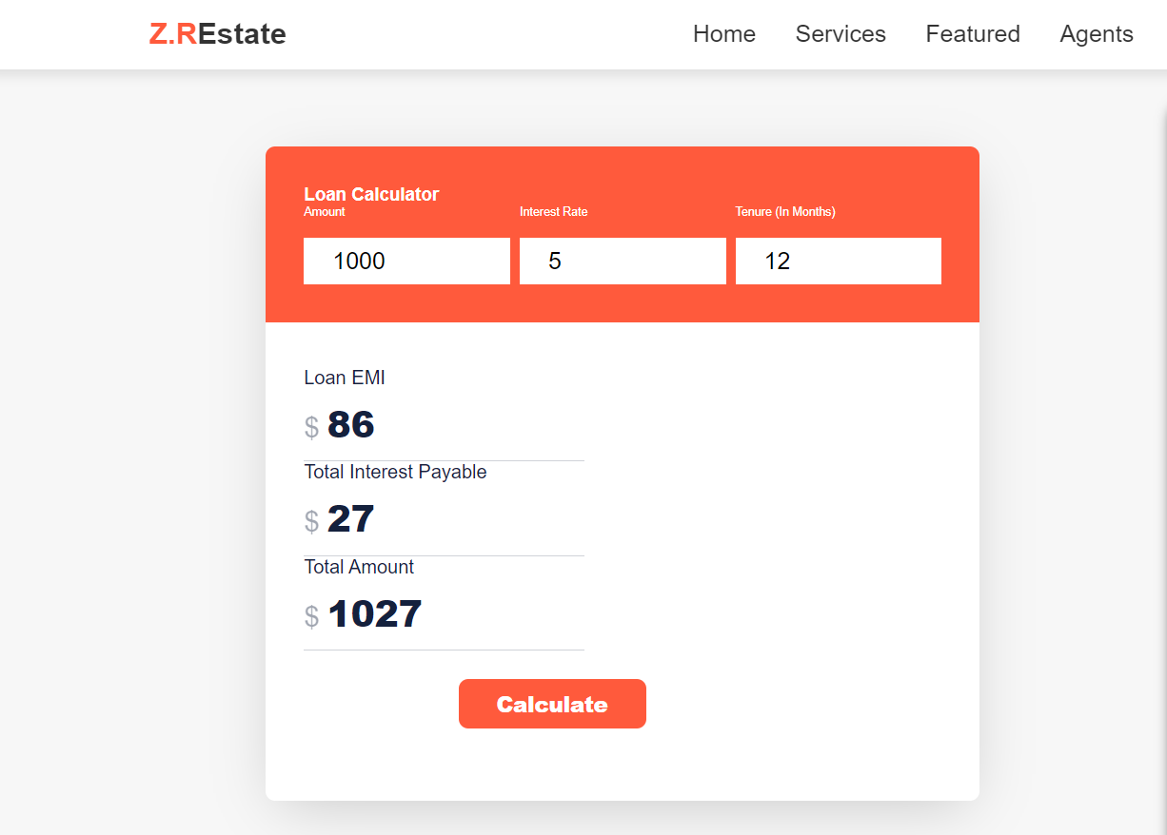

EMI CALCULATOR-

Display of functionality/calculations with incorrect

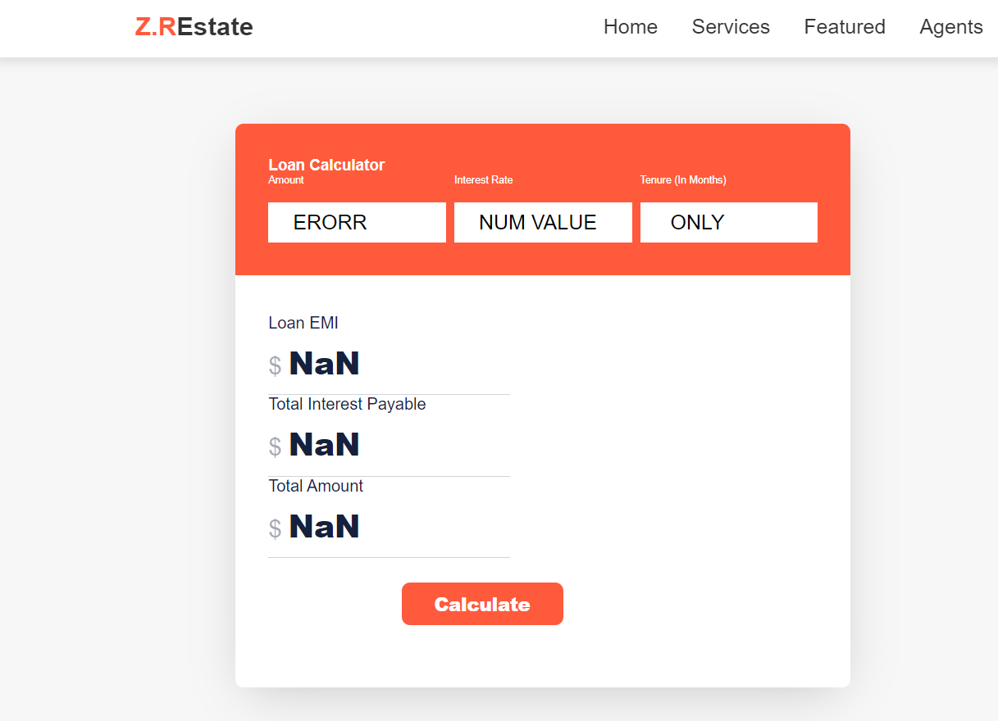

Sign Up form with correct and incorrect input

Correct input -open a new tab

Incorrect input-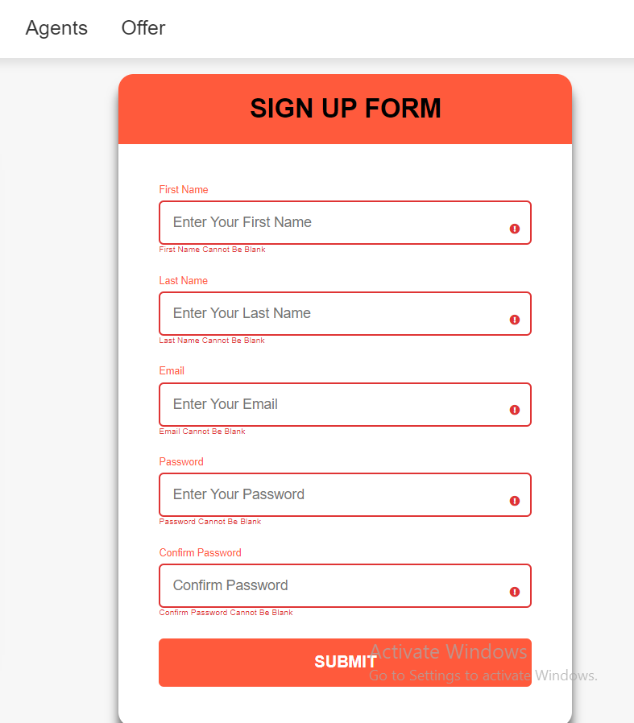

SERVICES with location and simple contact form includes:name,subject,number and message.

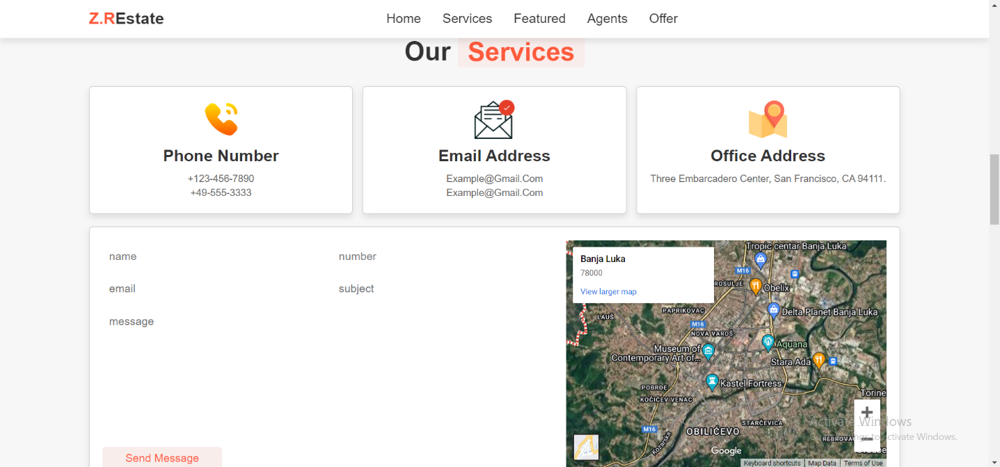

Agents-description with button wich leads to link location



Offer-Small and Large grid, every property can be added to favorites and removes.

Small- with details about the number of rooms, size, etc,button to add and remove realestate

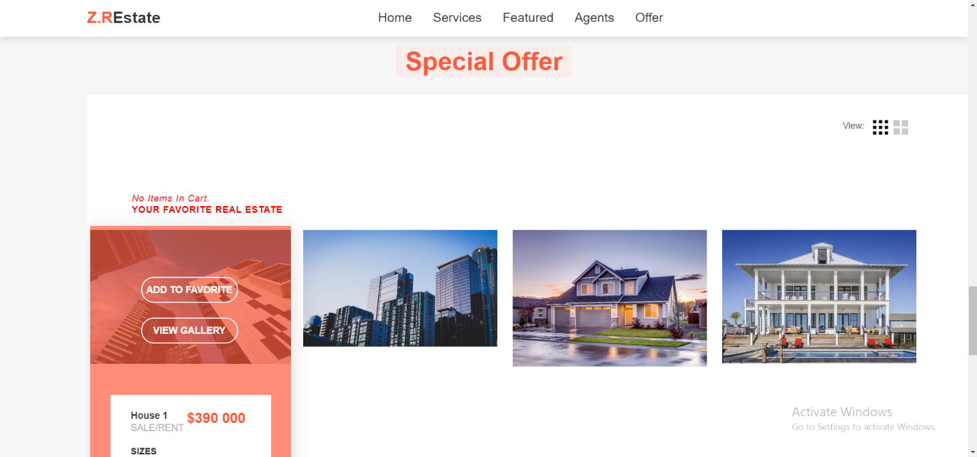

Large-- with details about the number of rooms, size, etc,button to add and remove realestate

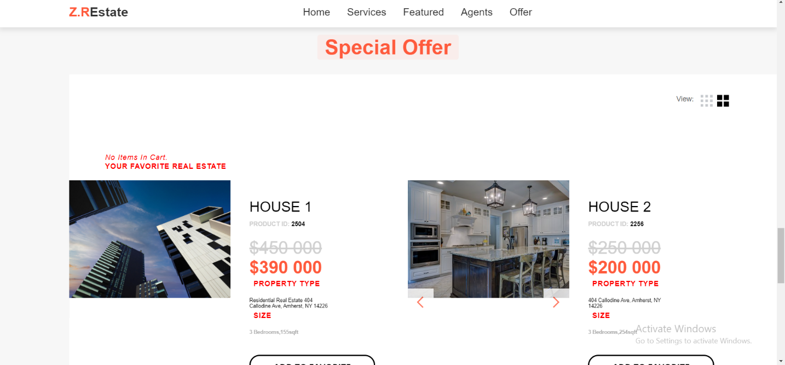

Footter section-links to social media from site.

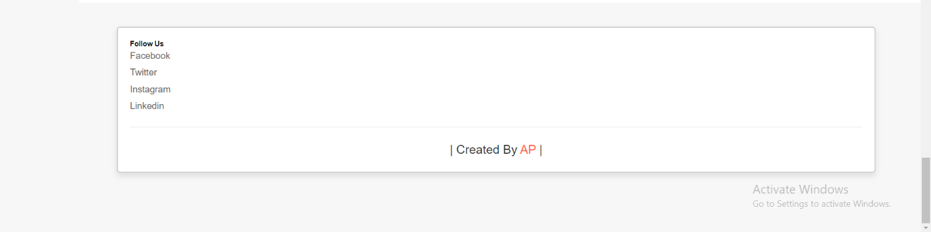

Conclusion:

In my opinion a successful course is one that achieves its objectives, engages and motivates students, and results in a positive impact on their learning and knowledge.

This course is characterized by effective teaching methods, clear and concise content, and meaningful assessments that measure student understanding and progress.

For me provides opportunities to develop critical thinking and problem-solving skills.