**Create an Ec2 instance using configuration management tool Ansible.**

Created two servers – one is working as a control plane, and another is the worker node.

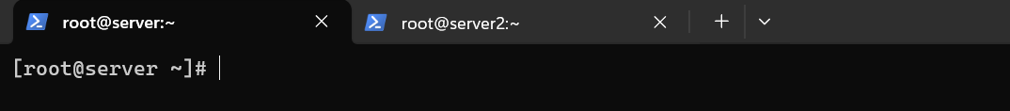

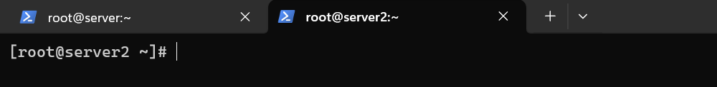

Connection is built between both nodes.

Copied ssh key in the both the nodes

Installed Ansible in the control plane.

Ansible connection is successful.

Wrote a playbook code to create an ec2 instance

The instance named ansible-new-server got created.

**Deploy a Ngnix application on your Kubernetes cluster and it should be available across the cluster on port 80.**

Created an ec2 instance and a user with policy **administrator access** and generated access key

Created a role with below permissions and attached it to the instance.



Installed eks tool, kubectl and generated ssh-keys.

Created a cluster and a nodegroup.

We can see here a cluster is created

Wrote the yaml code to deploy a nginx application on port 80

Copied the external Ip link and ran it with :80 (I allowed port 80 in my security group)

**Deploy a web application in the Kubernetes pod and create a replica set. In any case load is going to increase on your replica set, increase the number of replicas of the pods.**

Created an ec2 instance and a user with policy **administrator access** and generated access key

Created a role with below permissions and attached it to the instance.



Installed eks tool, kubectl and generated ssh-keys.

Created a cluster and a nodegroup.

We can see here a cluster is created

Till here I have already done all these things for the above question that was to deploy a nginx application on Kubernetes.

So, after this I created 3 yaml files – deployment, service and an autoscaler.

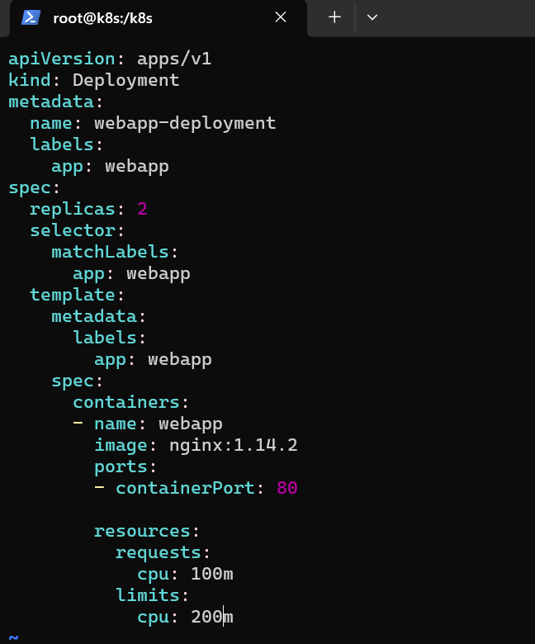

Applied all three of these.

New instances got created

**Create an EC2 instance using of terraform us-east-1a zone in North Virginia region and create of your security group which name is web_access and allow port 22 and 80 in the ingress. This security group should be attached with your EC2 instance**.

Launched an instance and connected to the terminal.

Configured aws on the terminal



Installed Terraform.

Wrote the terraform code

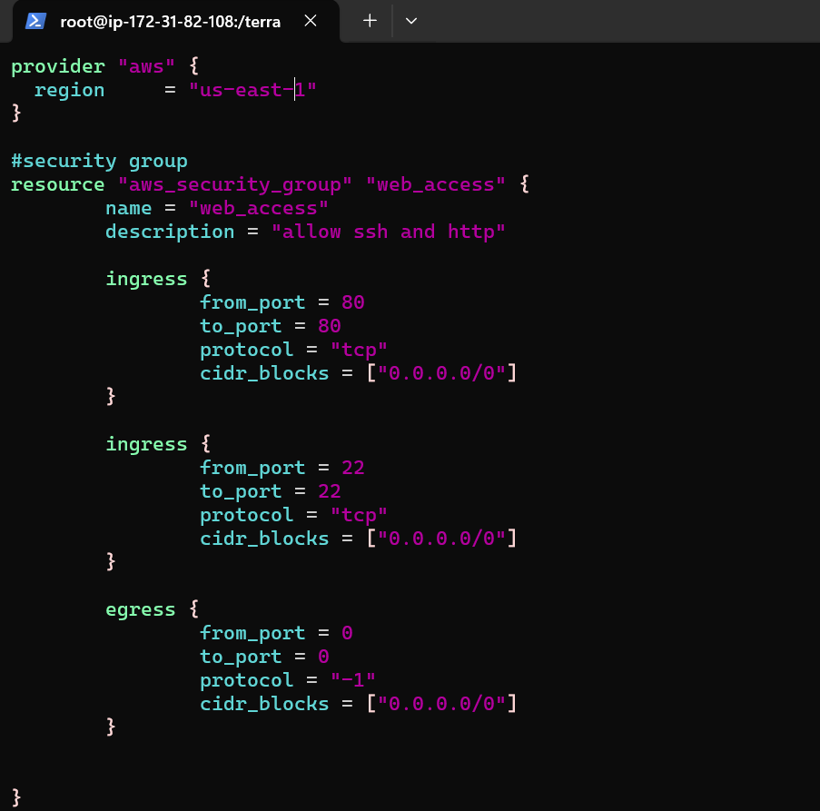

Initialized and validated Terraform

Ran terraform apply command and it’s successful.

An ec2 instance and a security group with name “web_access” is created.

EC2 instance:

Security Group:

