**Asmit Kumar – 10840047 - Weekly Assessment 1**

**Create a user jack and assign a password alberto, This user should be member of wheel group as well as nobody group**

First I created an instance in aws

Then I assigned the hostname and logged as a root user

After that I created a user named Jack and set the password alberto, then I checked if wheel and nobody group already existed, then I added jack to both the groups.

**Put a new Java project on GitHub. Create a Jenkins project and integrate it with GitHub. Now add the maven package goal in the Jenkins project. Also make sure the artifacts which are built are saved in the pipeline.**

At first I installed git in my terminal

Then I generated ssh keys and pasted it in the gtihub

Connected git to my github repository

Then I installed java, maven and jenkins



In aws instance I added a new inbound rule with port 8080 which is the default port of jenkins so that jenkins can run in the browser.

After opening jenkins, it was saying that the disk space is low.

So I increased the tmp space to 2 gb.

Then this problem got solved.

Then I ran a command to display the path of java and maven

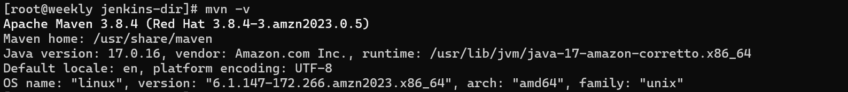

In jenkins, I went to manage jenkins then tools, add jdk and add maven and add java and maven paths to their respective given space

Then I added webhooks and generated token under profile then security and copied the token and pasted it in the github repo – security – webooks

Webhooks is succesfully added.

Now I created a job with maven project named **weekly-assm1.**

Then I added my github repository url so that the job can read from my repository.

Then I added trigger – Github hook trigger for GITScm polling so that whenever any changes is done by the developer in github it will automatically build the project.

At first I clicked build now and the project got built successfully.

Then I did some changes in the file inside my repository and in second time jenkins built it automatically.

