**Configure an AWS cross zone loadbalancer. And where my web-app is going to expose on port number 80.**

Created two ec2 instances in different zones and allowed port 80 in both.

Wrote script in advanced settings.

Both working fine in port 80.

Created a target group.

Included both the instances.

Created a load balancer with above target group.

Copied DNS name and pasted on the browser.

By refreshing the page the content got changed.

Hence the load balancer is working fine and it’s exposed on port 80.

**Create an Ec2 instance in Mumbai region and attach a new security group. Where port number 22 and 80 should be allow. Using of the IAC tool terraform.**

Created an instnace and connected to terminal.

Created an IAM user with administrator access policy and generated access keys.

Configured aws in the terminal.

Installed terraform.

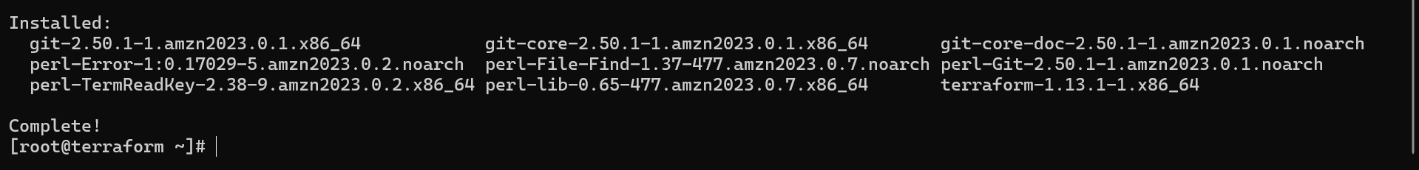

Created a directory and a .tf file

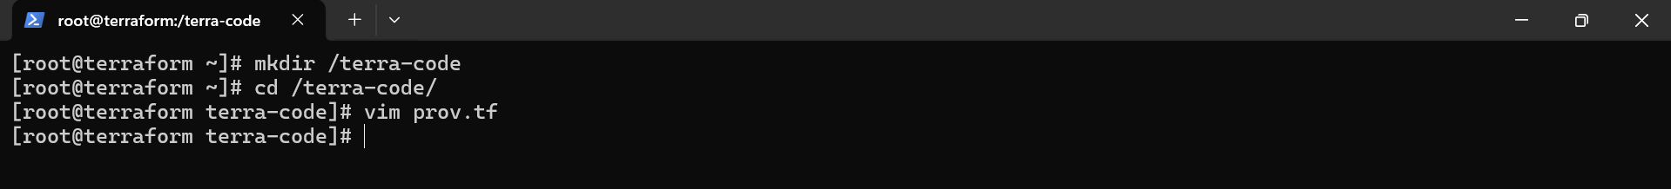

Wrote the code to create a security group and an ec2 instance.

Then initialized terraform in the directory.

Validated and applied it.

In aws console a new security group named “asmit-sg” and an ec2 instance named “new-server” that I defined in the code is craeted.

