INDUSTRY INTERNSHIP
SUMMARY REPORT
Exploratory Data Analysis and Visualization of Web-Scraped Book Market Data
BACHELOR OF TECHNOLOGY
in
COMPUTER SCIENCE AND ENGINEERING
(Specialization: Data Analytics)
Submitted by
Asmit Singh (24SCSE1011226)

SCHOOL OF COMPUTING SCIENCE AND ENGINEERING
GREATER NOIDA, UTTAR PRADESH
SUMMER 2026-2027

OFFER LETTER
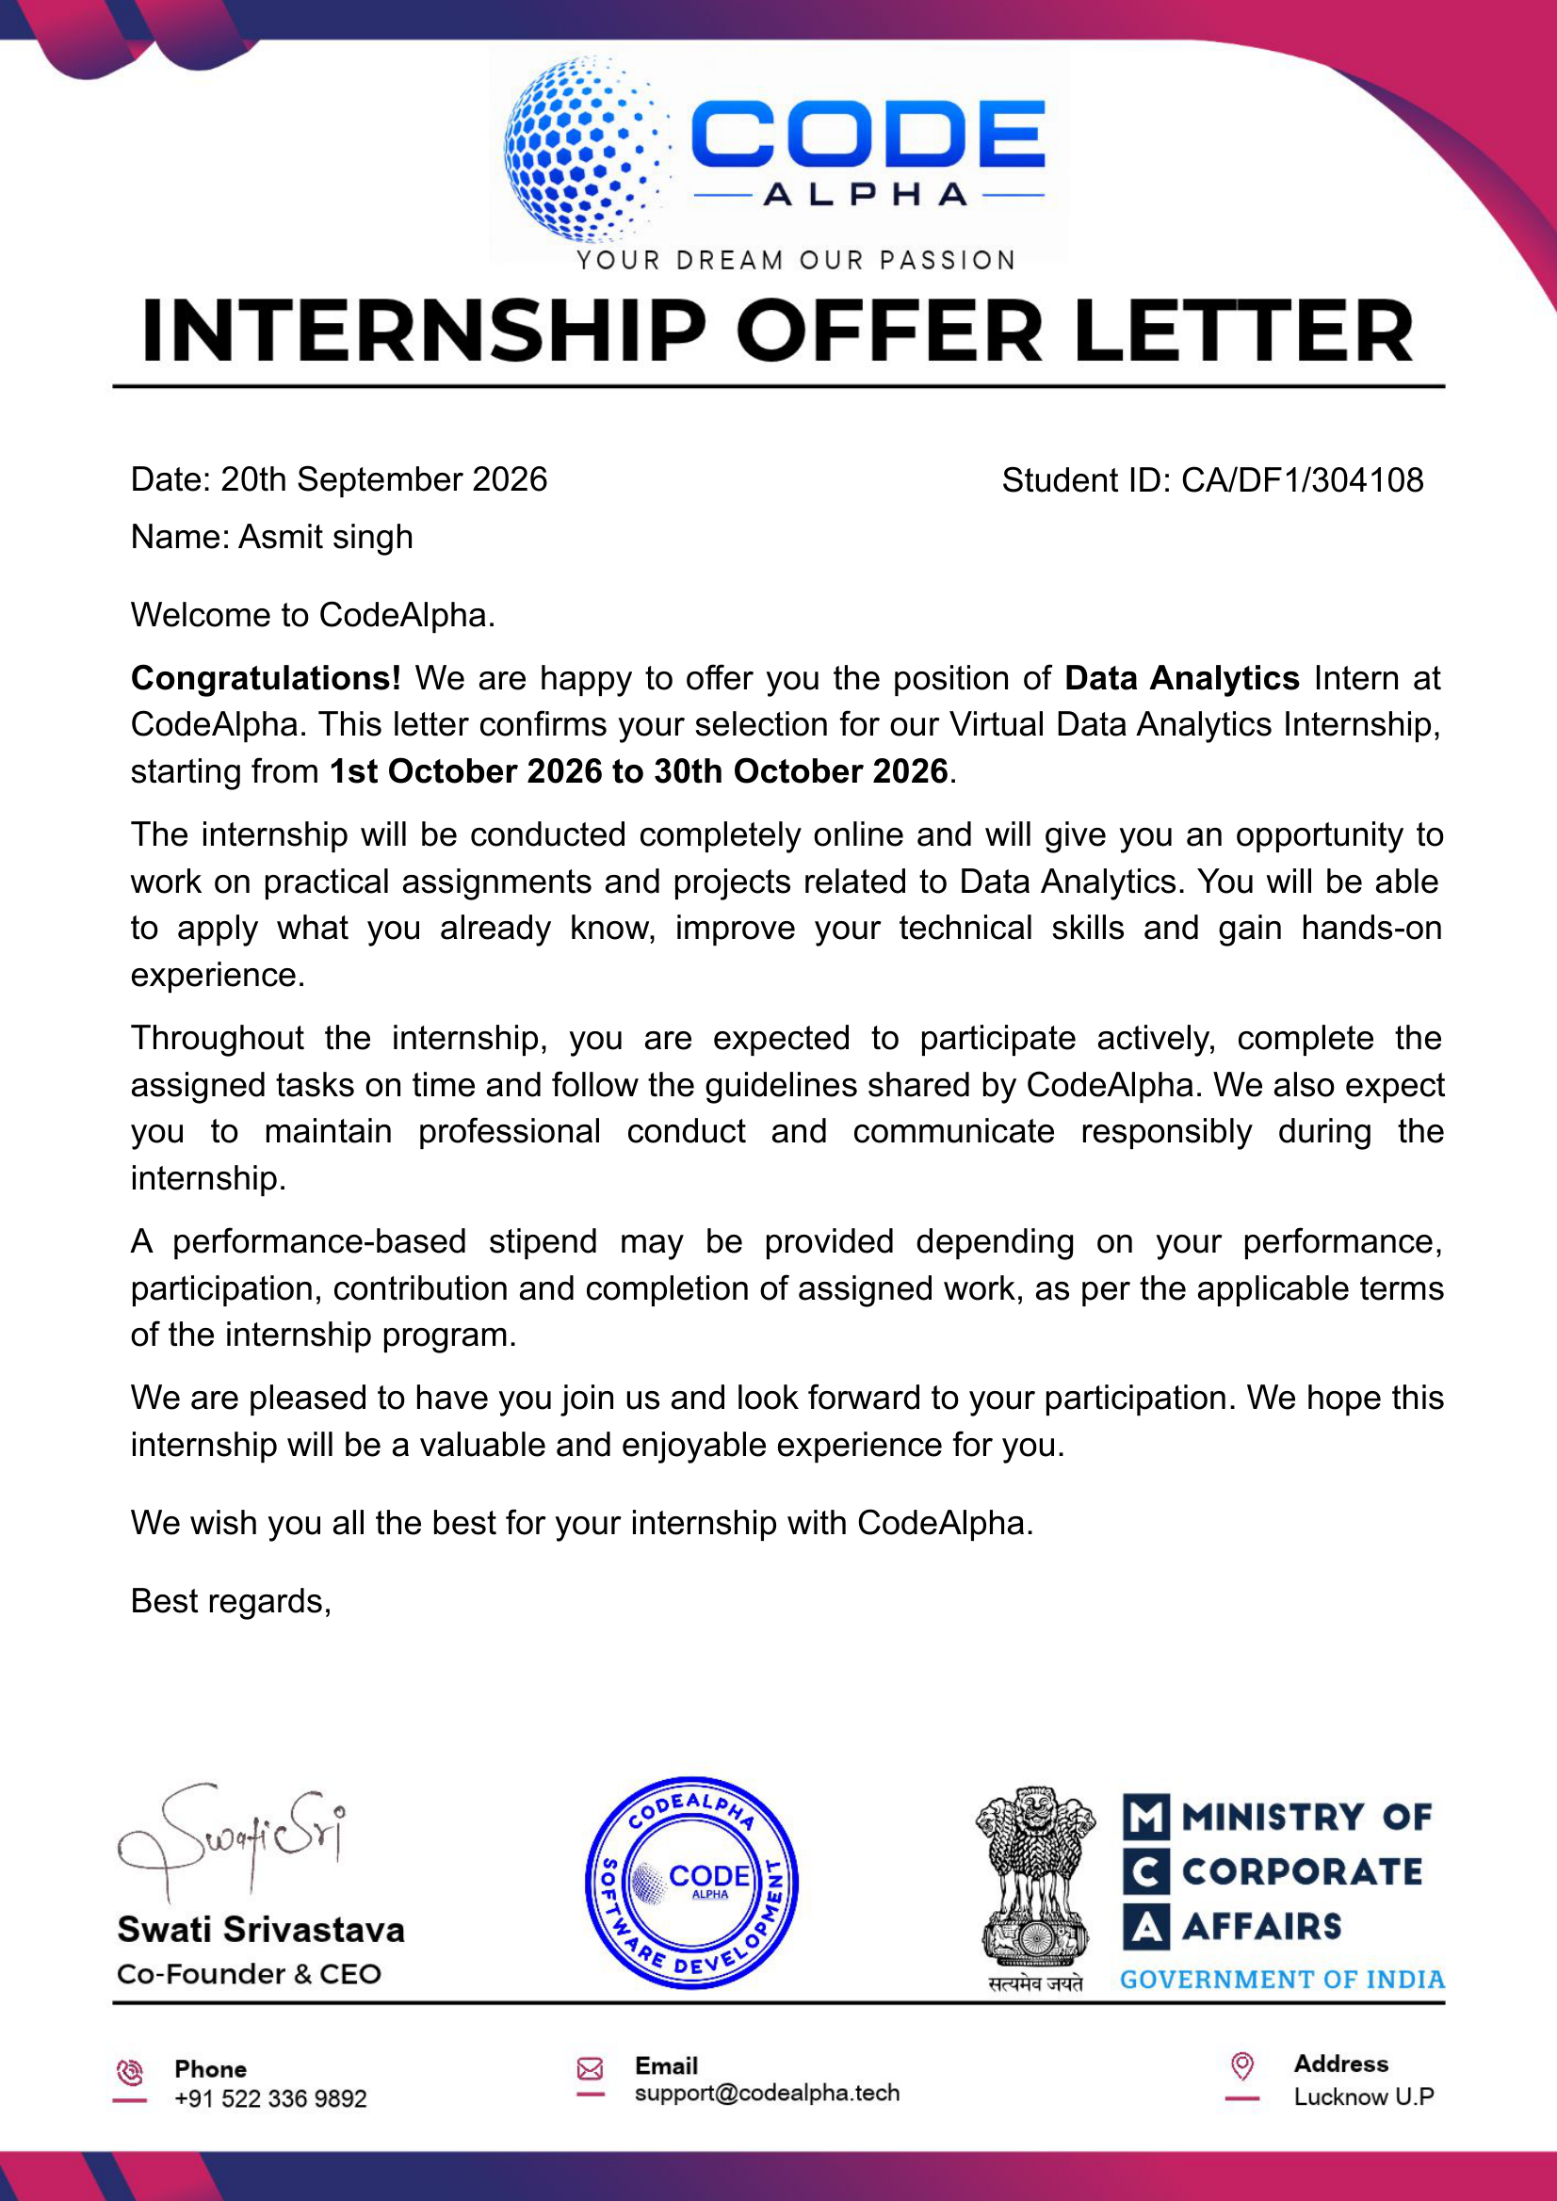
TABLE OF CONTENTS
Abstract
List of Figures
List of Tables
List of Abbreviations
1 Introduction
1.1 Objective of the Internship
1.2 Problem Statement and Research Objectives
1.3 Description of Domain
1.4 A Brief Introduction about the Organization
2 Technical Description
3 System Design
3.1 General Architecture
3.2 Design Phase
3.2.1 Data Flow Diagram
3.2.2 UML Diagrams
3.3 Methodology
4 System Implementation
5 Results and Discussions
6 Conclusion and Future Work
7 Appendices
7.1 Source Code
7.2 Learning Experiences
7.3 SWOT Analysis

ABSTRACT
This report documents the Data Analytics internship carried out at CodeAlpha. The objective was to apply the complete data analytics lifecycle - from data acquisition to insight communication - using the Python ecosystem. Three tasks were completed. First, a custom dataset of 1,000 books spanning 50 categories was collected from the public website books.toscrape.com using the requests and BeautifulSoup libraries (Web Scraping). Second, the dataset was profiled and analysed to understand its structure, distributions and statistical relationships using pandas, NumPy and SciPy (Exploratory Data Analysis). Third, seven charts and a consolidated dashboard were produced with Matplotlib and Seaborn to communicate the findings visually (Data Visualization). The analysis revealed an average book price of GBP 35.07 with no statistically significant relationship between rating and price (Pearson r = 0.028, p = 0.37) and no significant difference in price across categories (one-way ANOVA, p = 0.74). The report presents the methodology, system design, implementation, results and the skills gained during the internship.

LIST OF FIGURES
Figure 3.1: System Architecture - Data Analytics Pipeline
Figure 3.2: Data Flow Diagram (Level 0 and Level 1)
Figure 3.3: UML Use-Case Diagram
Figure 5.1: Distribution of Book Prices
Figure 5.2: Average Book Price by Rating
Figure 5.3: Top 10 Categories by Number of Books
Figure 5.4: Price Distribution Across Ratings
Figure 5.5: Count of Books per Rating
Figure 5.6: Stock Availability
Figure 5.7: Consolidated Insights Dashboard

LIST OF TABLES
Table 1.1: Tasks Completed
Table 2.1: Tools and Libraries Used
Table 3.1: Dataset Schema
Table 5.1: Summary Statistics
Table 5.2: Hypothesis Test Results

LIST OF ABBREVIATIONS
API - Application Programming Interface
BS4 - BeautifulSoup 4 (HTML parsing library)
CSV - Comma-Separated Values
DFD - Data Flow Diagram
EDA - Exploratory Data Analysis
HTML - HyperText Markup Language
IQR - Interquartile Range
NLP - Natural Language Processing
SCSE - School of Computing Science and Engineering
UML - Unified Modeling Language

CHAPTER 1
INTRODUCTION
1.1 Objective of the Internship
The objective of this internship was to gain practical, hands-on experience in the field of data analytics. Specifically, the internship aimed to: (i) acquire and prepare real-world data from public web sources; (ii) explore and validate that data using statistical techniques; and (iii) communicate the resulting insights through effective visualizations. The internship was designed to bridge the gap between the theoretical concepts learned in the classroom and their application in a professional setting.
1.2 Problem Statement and Research Objectives
A large volume of useful information is available on the web in unstructured HTML form, which cannot be analysed directly. The problem addressed by this project is the extraction, cleaning, exploration and visualization of such data to support data-driven decision making. The research objectives were: (1) to build an automated pipeline that collects structured data from a website; (2) to perform an exploratory data analysis to identify trends, patterns and anomalies; and (3) to present those findings using clear, well-designed visualizations that support decision making.
1.3 Description of Domain
The domain of this internship is Data Analytics, an interdisciplinary field that combines statistics, programming and domain knowledge to extract insights from data. Core sub-domains covered include: web scraping (data acquisition), data cleaning and wrangling, exploratory data analysis, statistical inference and data visualization. These techniques are widely applied in e-commerce, finance, healthcare, marketing and business intelligence.
1.4 A Brief Introduction about the Organization
CodeAlpha is a software development and technology organization that specializes in data-driven decision making and business intelligence. The organization provides internship programs that give students practical exposure to modern tools such as Python, SQL and visualization libraries. Interns work on real-world projects in a collaborative environment, guided by experienced mentors, and develop the skills required to support data-driven strategies. The organization's activities span software development, analytics, reporting and business intelligence services.

CHAPTER 2
TECHNICAL DESCRIPTION
The project was implemented entirely in Python 3.13 using the standard data analytics stack. Web scraping was performed with the requests library for HTTP communication and BeautifulSoup for HTML parsing. Data manipulation and aggregation were handled with pandas and NumPy, while statistical hypothesis testing was carried out with SciPy. Visualization was produced using Matplotlib and Seaborn. The complete pipeline was developed in Jupyter Notebook, and the source code is version-controlled with Git and hosted on GitHub.
Table 2.1: Tools and Libraries Used
Tool / Library | Purpose
Python 3.13 | Core programming language
requests | HTTP requests to fetch web pages
BeautifulSoup4 | HTML parsing and data extraction
pandas | Tabular data manipulation and analysis
NumPy | Numerical computing
SciPy | Statistical tests (Pearson, ANOVA)
Matplotlib | Base plotting library
Seaborn | Statistical data visualization
Jupyter Notebook | Interactive development environment
Git & GitHub | Version control and code hosting

Web scraping was implemented as an automated crawler that navigates the category tree of the target website, extracts the required fields from each product page, and handles pagination. The EDA module computes descriptive statistics, distribution profiles and inferential tests. The visualization module renders charts to PNG files and assembles a summary dashboard.

CHAPTER 3
SYSTEM DESIGN
3.1 General Architecture
The system follows a linear, modular pipeline architecture. Each stage is independent and produces an artefact consumed by the next stage, which makes the system easy to test and extend.
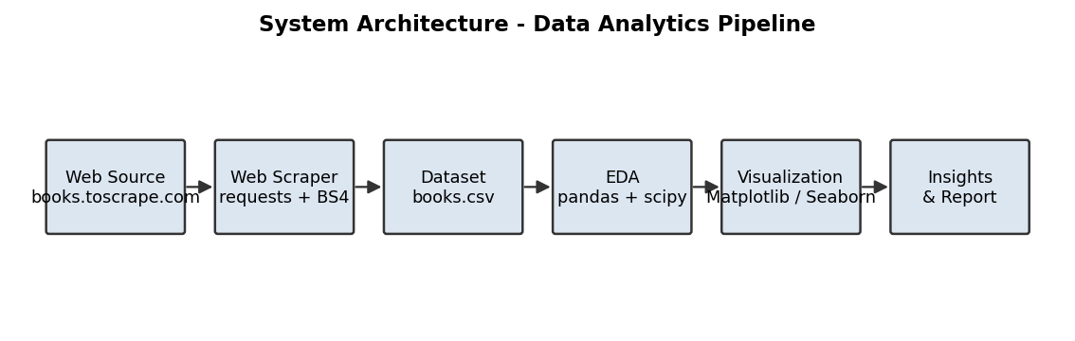
Figure 3.1: System Architecture - Data Analytics Pipeline
3.2 Design Phase
The design phase decomposed the problem into four logical modules: data acquisition, data storage, data analysis and data presentation. The data flow and interaction between the user and the system were modelled using a Data Flow Diagram and a UML use-case diagram.
3.2.1 Data Flow Diagram
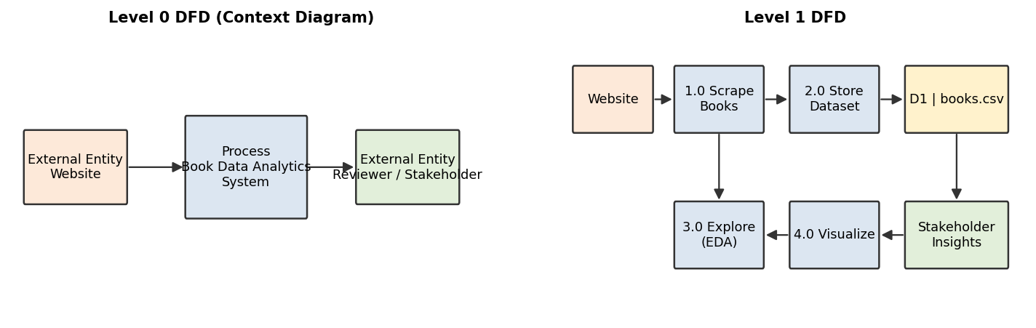
Figure 3.2: Data Flow Diagram (Level 0 and Level 1)
3.2.2 UML Diagrams
The use-case diagram below shows the primary actor (the data analyst/intern) and the use cases supported by the system, from scraping data through to interpreting insights.
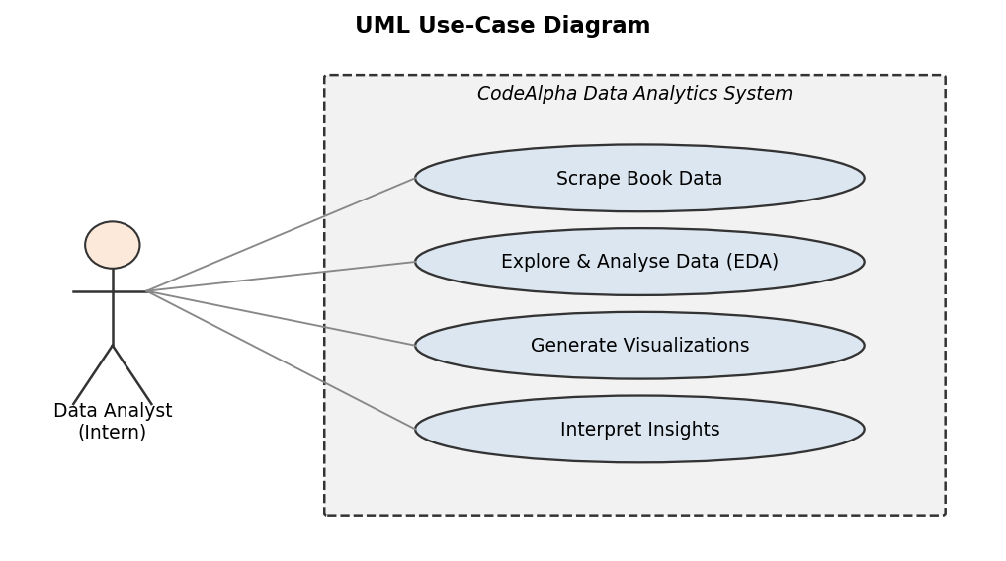
Figure 3.3: UML Use-Case Diagram
3.3 Methodology
The methodology followed the standard data analytics lifecycle: (1) Problem definition - the analytics questions were framed before any analysis; (2) Data acquisition - data was scraped from a public website; (3) Data preparation - the dataset was validated for missing values, duplicates and type consistency; (4) Exploratory analysis - descriptive statistics, distributions and correlations were examined and hypotheses were tested; (5) Visualization - charts and a dashboard were created to communicate findings; and (6) Reporting - results were documented and published to GitHub.

CHAPTER 4
SYSTEM IMPLEMENTATION
The pipeline was implemented as three independent Python scripts (also provided as Jupyter notebooks). The web scraping script crawls the target site, extracts title, price, rating, availability, stock count and category for each book, and writes the result to dataset/books.csv. The EDA script loads this CSV, prints and saves a structured report (dataset/eda_summary.txt), and runs hypothesis tests. The visualization script reads the CSV and saves seven charts to the images/ folder, including a consolidated dashboard.
Table 3.1: Dataset Schema
Field | Type | Description
title | string | Name of the book
price | float | Price in GBP
rating | int | Star rating (1-5)
in_stock | bool | Availability flag
stock_count | int | Number of copies in stock
category | string | Book category

All modules are deterministic and re-runnable. The complete source code is available in the Appendices and on GitHub at
https://github.com/Asmit1434/CodeAlpha_DataAnalytics.

CHAPTER 5
RESULTS AND DISCUSSIONS
The pipeline successfully scraped 1,000 books across 50 categories. The summary statistics below describe the quantitative variables.
Table 5.1: Summary Statistics
Statistic | Price (GBP) | Rating | Stock Count
Count | 1000 | 1000 | 1000
Mean | 35.07 | 2.92 | -
Median | 35.98 | 3.00 | -
Min | 10.00 | 1 | 0
Max | 59.99 | 5 | -

Two hypotheses were tested. The first examined whether the rating of a book is related to its price; the second examined whether prices differ significantly across categories.
Table 5.2: Hypothesis Test Results
Hypothesis | Test | Statistic | p-value | Conclusion
Rating vs. Price | Pearson correlation | r = 0.028 | 0.37 | Not significant
Price across categories | One-way ANOVA | F = 0.839 | 0.74 | Not significant

No price outliers were detected using the IQR rule (upper fence = GBP 85.48). The most expensive categories on average were Suspense (58.33), Novels (54.81) and Politics (53.61). The following figures present the key visualizations.
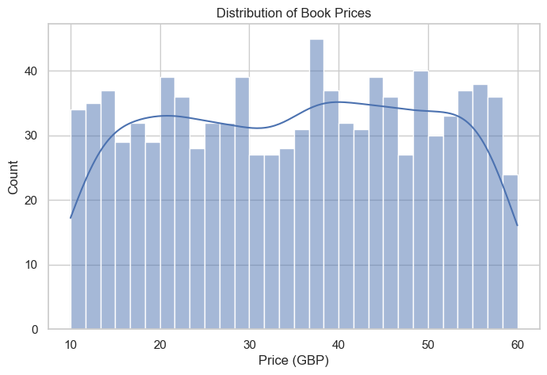
Figure 5.1: Distribution of Book Prices
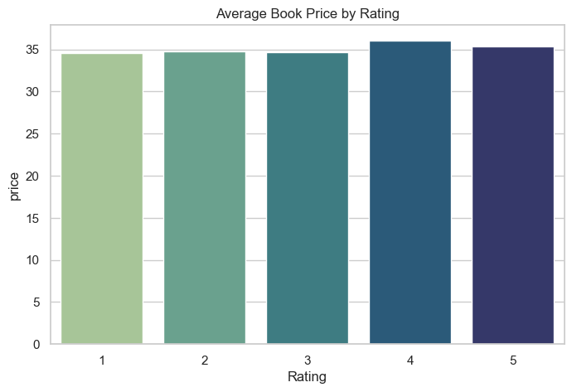
Figure 5.2: Average Book Price by Rating
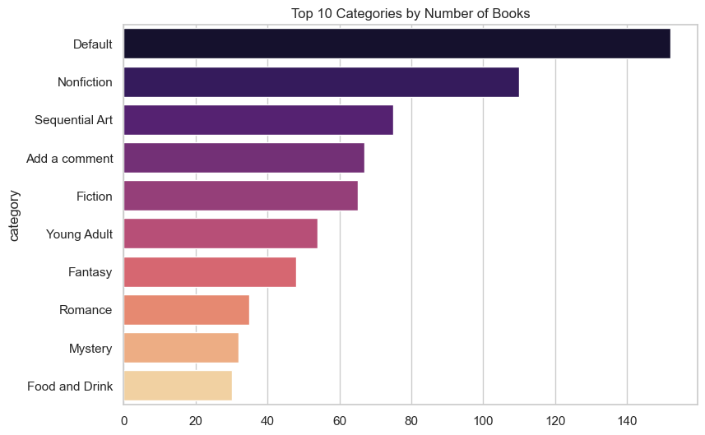
Figure 5.3: Top 10 Categories by Number of Books
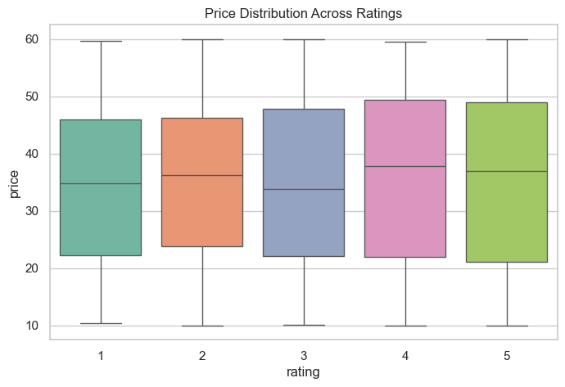
Figure 5.4: Price Distribution Across Ratings
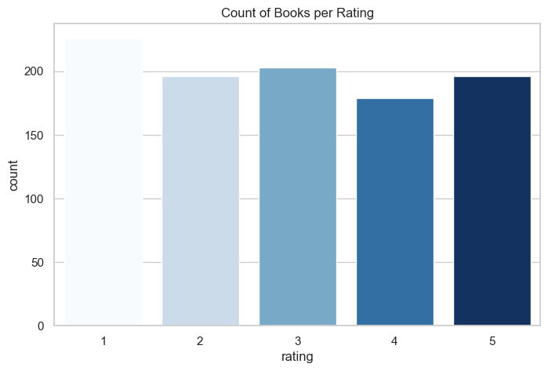
Figure 5.5: Count of Books per Rating
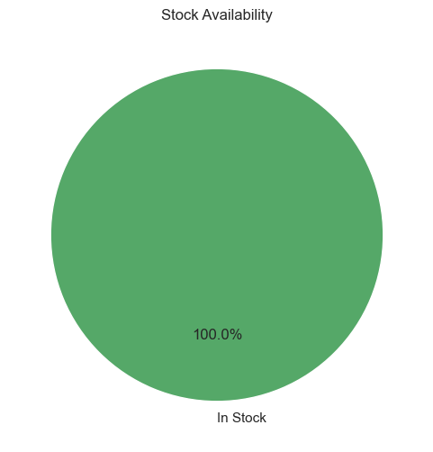
Figure 5.6: Stock Availability
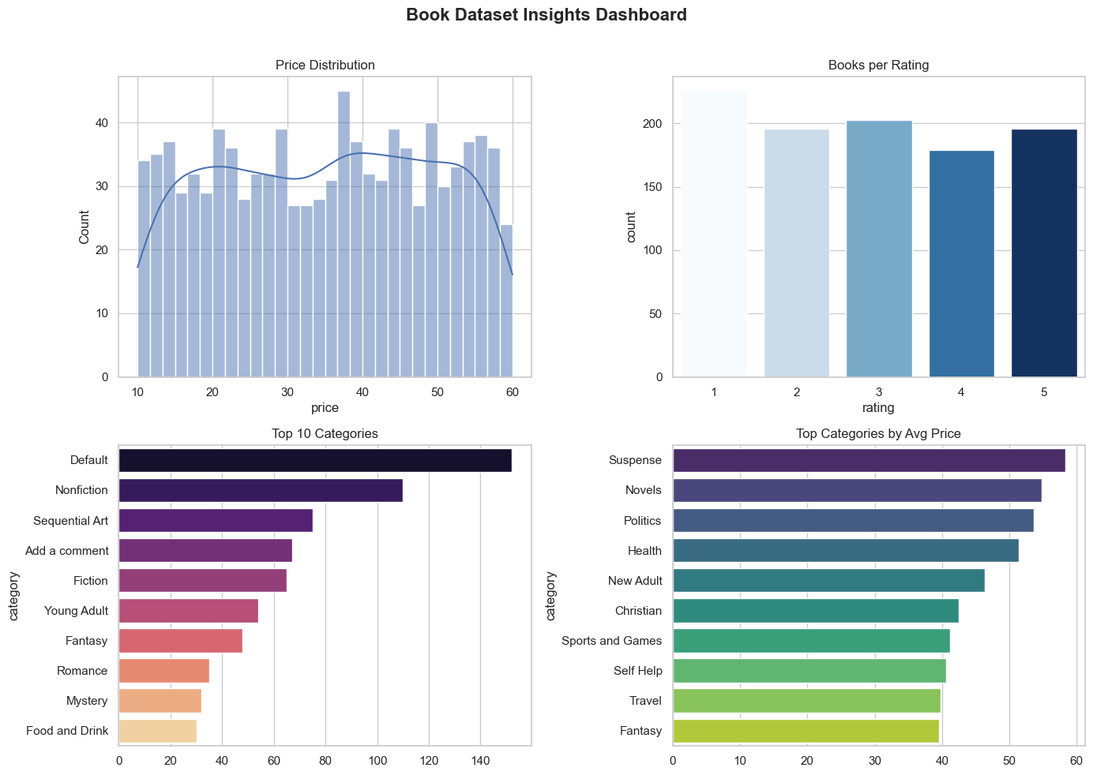
Figure 5.7: Consolidated Insights Dashboard
Discussion: The absence of a strong rating-price correlation indicates that customer ratings are not driven by price, suggesting that quality perception is independent of cost in this market. The uniform distribution of ratings further implies a balanced product catalogue. From a business perspective, categories such as Suspense and Novels generate higher average revenue per unit and could be prioritized for marketing and inventory investment.

CHAPTER 6
CONCLUSION AND FUTURE WORK
This internship successfully demonstrated the complete data analytics lifecycle using Python. A custom dataset was acquired by web scraping, analysed statistically and presented through effective visualizations. The project reinforced core skills in data acquisition, cleaning, exploratory analysis, statistical inference, visualization and reporting. The findings provide actionable insight into the pricing and rating behaviour of the book market.
Future work could extend the project by: (i) scraping additional attributes such as review text and publication date; (ii) applying sentiment analysis to customer reviews; (iii) automating the pipeline with a scheduler; and (iv) deploying the dashboard as an interactive web application using Plotly Dash or Streamlit.

CHAPTER 7
APPENDICES
7.1 Source Code
Excerpt - Task 1: Web Scraping (scripts/task1_web_scraping.py)
def get_soup(url):
headers = {"User-Agent": "Mozilla/5.0 (CodeAlpha Scraper)"}
r = requests.get(url, headers=headers, timeout=20)
r.raise_for_status()
r.encoding = "utf-8"
return BeautifulSoup(r.text, "html.parser")

def scrape_category(url, name):
rows = []
while url:
soup = get_soup(url)
for a in soup.select("article.product_pod"):
avail = a.select_one("p.instock.availability").text
nums = re.findall(r"\d+", avail)
rows.append({
"title": a.h3.a["title"],
"price": float(a.select_one("p.price_color").text[1:]),
"rating": parse_rating(a.select_one("p.star-rating")["class"]),
"in_stock": "In stock" in avail,
"stock_count": int(nums[0]) if nums else 0,
"category": name,
})
nxt = soup.select_one("li.next > a")
url = url.rsplit("/", 1)[0] + "/" + nxt["href"] if nxt else None
return rows

Excerpt - Task 2: EDA (scripts/task2_eda.py)
corr, p = stats.pearsonr(df["rating"], df["price"])
groups = [g["price"].values for _, g in df.groupby("category")
if len(g) > 2]
f_stat, p_anova = stats.f_oneway(*groups)
q1, q3 = df["price"].quantile([0.25, 0.75])
upper = q3 + 1.5 * (q3 - q1)
outliers = df[df["price"] > upper]

Excerpt - Task 3: Visualization (scripts/task3_visualization.py)
sns.histplot(df["price"], kde=True, bins=30)
sns.barplot(data=df, x="rating", y="price", estimator="mean")
top = df["category"].value_counts().head(10)
sns.barplot(x=top.values, y=top.index)
plt.savefig("images/chart.png", bbox_inches="tight")

Full source code: https://github.com/Asmit1434/CodeAlpha_DataAnalytics
7.2 Learning Experiences
Knowledge acquired:
I gained a clear understanding of the end-to-end data analytics workflow. This connected directly to coursework in Python programming, probability and statistics, and database systems. I learned how HTML documents are structured and how to navigate them programmatically, how to clean and reshape tabular data with pandas, and how to apply statistical tests such as Pearson correlation and one-way ANOVA.
Skills learned:
I developed practical skills in writing web scrapers, handling HTTP requests and pagination, and dealing with real-world data quality issues. I also strengthened my ability to interpret reports, translate raw numbers into business insights, and present findings visually. Version control with Git and documentation of a project were additional skills acquired.
Observed attitudes and gained values:
The internship reinforced the value of patience, attention to detail and dependability. Debugging scrapers and validating data required persistence, while meeting task deadlines required discipline and time management. I learned the importance of honesty in reporting results - including negative findings.
The most challenging task performed:
The most challenging task was building the web scraper to reliably handle pagination and inconsistent HTML. The site returned results across multiple pages and the availability text varied in format. I overcame this by inspecting the HTML structure, writing a reusable parsing function, and using regular expressions to extract numerical stock counts. Testing on a small subset before running the full crawl prevented large-scale errors.

7.3 SWOT Analysis
The following SWOT analysis is presented for CodeAlpha, the organization where the internship was carried out.
Strengths:
- Focus on data-driven decision making and business intelligence.
- Structured internship programs providing real-world project exposure.
- Use of industry-standard tools (Python, SQL, BI libraries).
- Mentorship and a collaborative learning environment.
Weaknesses:
- As a growing organization, brand recognition is lower than large established firms.
- Internship tasks are time-constrained, limiting depth of exploration.
Opportunities:
- Rapidly growing demand for analytics and BI services.
- Potential to expand into AI/ML and cloud-based analytics.
- Strong pipeline of skilled interns as future talent.
Threats:
- Intense competition from larger analytics and consulting firms.
- Rapidly changing technology requiring continuous upskilling.
- Data privacy and compliance risks in data handling.

REFERENCES
- [1] Python Software Foundation, “Python 3 Documentation.” [Online]. Available: https://docs.python.org/3/. [Accessed: Oct. 12, 2026].
- [2] Requests Contributors, “Requests: HTTP for Humans.” [Online]. Available: https://docs.python-requests.org/en/latest/. [Accessed: Oct. 12, 2026].
- [3] Leonard Richardson, “Beautiful Soup Documentation.” [Online]. Available: https://www.crummy.com/software/BeautifulSoup/bs4/doc/. [Accessed: Oct. 12, 2026].
- [4] The pandas Development Team, “pandas Documentation.” [Online]. Available: https://pandas.pydata.org/docs/. [Accessed: Oct. 12, 2026].
- [5] NumPy Developers, “NumPy Documentation.” [Online]. Available: https://numpy.org/doc/stable/. [Accessed: Oct. 12, 2026].
- [6] SciPy Community, “SciPy Documentation: Statistical Functions.” [Online]. Available: https://docs.scipy.org/doc/scipy/reference/stats.html. [Accessed: Oct. 12, 2026].
- [7] SciPy Community, “scipy.stats.pearsonr.” [Online]. Available: https://docs.scipy.org/doc/scipy/reference/generated/scipy.stats.pearsonr.html. [Accessed: Oct. 12, 2026].
- [8] NIST/SEMATECH, “e-Handbook of Statistical Methods.” National Institute of Standards and Technology. [Online]. Available: https://www.itl.nist.gov/div898/handbook/. [Accessed: Oct. 12, 2026].
- [9] NIST/SEMATECH, “One-Way ANOVA.” [Online]. Available: https://www.itl.nist.gov/div898/handbook/ppc/section2/ppc231.htm. [Accessed: Oct. 12, 2026].
- [10] Matplotlib Development Team, “Matplotlib Documentation.” [Online]. Available: https://matplotlib.org/stable/. [Accessed: Oct. 12, 2026].
- [11] Michael L. Waskom, “Seaborn: Statistical Data Visualization.” [Online]. Available: https://seaborn.pydata.org/. [Accessed: Oct. 12, 2026].
- [12] Project Jupyter, “Jupyter Documentation.” [Online]. Available: https://docs.jupyter.org/en/latest/. [Accessed: Oct. 12, 2026].
- [13] GitHub, Inc., “GitHub Documentation.” [Online]. Available: https://docs.github.com/en. [Accessed: Oct. 12, 2026].
- [14] ToScrape, “Books to Scrape: A Fictional Bookstore for Web Scraping Practice.” [Online]. Available: https://books.toscrape.com/. [Accessed: Oct. 12, 2026].

