## Homework # 3 - Transposing and E-R Diagram

DUE: Sunday, September 12, 2021 by 11:59pm EDT

**Name: ____Asmita Shelke_____**

**Submit this document edited to include your answers, for the two parts, to the HW#3 Assignment folder by the stated deadline.**

**Part #1 - 50 points**

1. (45 points) Transpose the E-R diagram below into relations, implementing all relationships. Denote primary keys and foreign keys appropriately. Use proper relation notation. You need to provide reference statements. There is a distinction between identifying and non-identifying relationships.

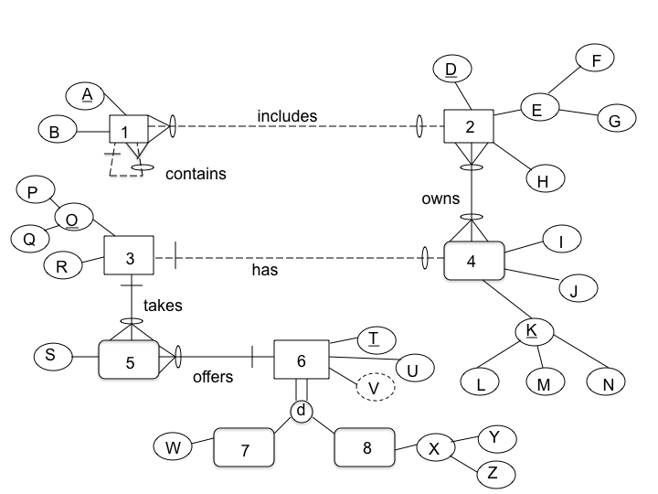

1(A, B, *D, Ab*)

1(D) mei 2(D)

1(Ab) mei 1(A)

2(D, F, G, H)

4(L, M, N, I, J, *P, Q, D*)

4(P) mei 3(P)

4(Q) mei 3(Q)

4(D) mei 2(D)

2_4(*D, L, M, N*)

2_4(D) mei 2(D)

2_4(L) mei 4(L)

2_4(M) mei 4(M)

2_4(N) mei 4(N)

3(P, Q, R)

5(*P, Q, T*, S)

5(P) mei 3(P)

5(Q) mei 3(Q)

5(T) mei 6(T)

6(T, U)

7(*T,* W)

7(T) mei 6(T)

8(*T*, Y, Z)

8(T) mei 6(T)

**YOUR TRANSPOSED RELATIONS:**

2. (2 points) Using the E-R diagram above, please explain why entity 7 is weak and what the specific term for that type of entity is.

**REASON:** Since 7 is a sub type entity, hence an entry in 7 cannot exist without an entry in 6. That means it cannot be present independently. Hence it is a weak entity.

**TERM:** Sub Type Entity

3. (2 points) Using the E-R diagram above, please explain why entity 5 is weak and what the specific term for that type of entity is.

**REASON:** Since this entity implements a M:N relationship and stores attributes of the relationship, this cannot be present without an instance of 3 and 6. Hence it is a weak entity.

**TERM:** Associative Entity

4. ( 1 point) Using the E-R diagram above, please explain what relationship makes entity 4 weak and what about that relationship causes it to be weak.

**EXPLANATION:** Since relation 2 to 4 is an identifying relationship, hence in order to form a complete primary key for 4, foreign key from 2 will be needed. Hence 4 is a weak entity

**Part 2 - RIT Savings and Loan (50 points)**

1. (50 points) Transpose the E-R diagram below into relations, implementing all relationships. Denote primary keys and foreign keys appropriately. Use proper relation notation. You need to provide reference statements. There is a distinction between identifying and non-identifying relationships.

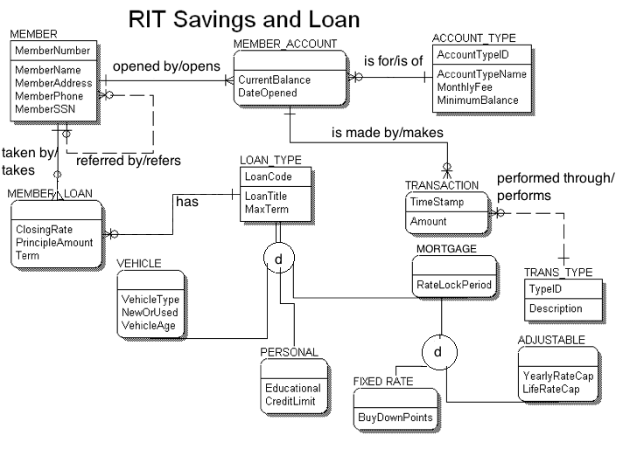**YOUR TRANSPOSED RELATIONS:**

MEMBER(MemberNumber, MemberName, MemberAddress, MemberPhone, MemberSSN, *RefereMemberNumber*)

MEMBER(RefereMemberNumber) mei MEMBER(MemberNumber)

MEMBER_ACCOUNT(CurrentBalance, DateOpened, *MemberNumber, AccountTypeId*)

MEMBER_ACCOUNT(MemberNumber) mei MEMBER(MemberNumber)

MEMBER_ACCOUNT(AccountTypeId) mei ACCOUNT_TYPE(AccountTypeId)

ACCOUNT_TYPE(AccountTypeID, AccountTypeName, MonthlyFee, MinimumBalance)

TRANSACTION(TimeStamp, Amount, *MemberNumber, AccountTypeId, TypeId*)

TRANSACTION(TypeId) mei TRANS_TYPE(TypeId)

TRANSACTION(MemberNumber) mei MEMBER_ACCOUNT(MemberNumber)

TRANSACTION(AccountTypeId) mei MEMBER_ACCOUNT(AccountTypeId)

LOAN_TYPE(LoanCode, LoanTitle, MaxTerm)

TRANS_TYPE(TypeId, Description)

MEMBER_LOAN(ClosingRate, PrincipleAmount, Term, *MemberNumber*, *LoanCode*)

MEMBER_LOAN(MemberNumber) mei MEMBER(MemberNumber)

MEMBER_LOAN(LoanCode) mei LOAN_TYPE(LoanCode)

VEHICLE(VehicleType, NewOrUsed, VehicleAge, *LoanCode*)

VEHICLE(LoanCode) mei LOAN_TYPE(LoanCode)

PERSONAL(Educational, CreditLimit, *LoanCode*)

PERSONAL(LoanCode) mei LOAN_TYPE(LoanCode)

MORTGAGE(RateLockPeriod, *LoanCode*)

MORTGAGE(LoanCode) mei LOAN_TYPE(LoanCode)

FIXED RATE(BuyDownPoints, *LoanCode*,)

FIXED RATE(LoanCode) mei MORTGAGE(LoanCode)

ADJUSTABLE(YearlyRateCap, LifeRateCap, *LoanCode*,)

ADJUSTABLE(LoanCode) mei MORTGAGE(LoanCode)