ISTE-608 Database Design and Implementation

## Homework #2 - Entity-Relationship Modeling

DUE: Sunday, September 5, 2021 by 11:59pm EDT

**Name: ____Asmita Shelke___**

**Submit this document, edited to include your answers, to the Homework #2 Assignment folder by the due date specified.**

**Part 1 – 20 points**

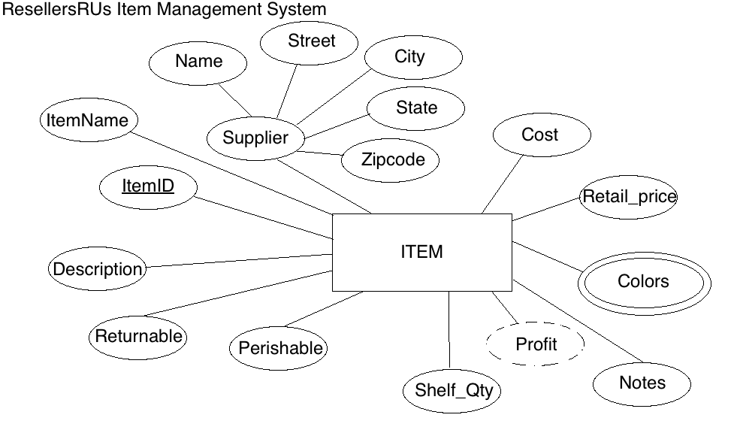

For the table below, please classify each attribute specified based on the E-R diagram above. Please place the best answer for each column that best describes the attribute.

|  |  |  |  |  |
| --- | --- | --- | --- | --- |
| Attribute | **Composite or Simple** | **Single-valued or Multi-valued** | **Stored or Derived** | **Identifier ? (Yes or No)** |
| Profit | Simple | Single valued | Derived | No |
| Street | Simple | Single valued | Stored | No |
| ItemID | Simple | Single valued | Stored | Yes |
| Supplier | Composite | Single valued | Stored | No |
| Colors | Simple | Multi valued | Stored | No |

**Part 2 – 80 points**

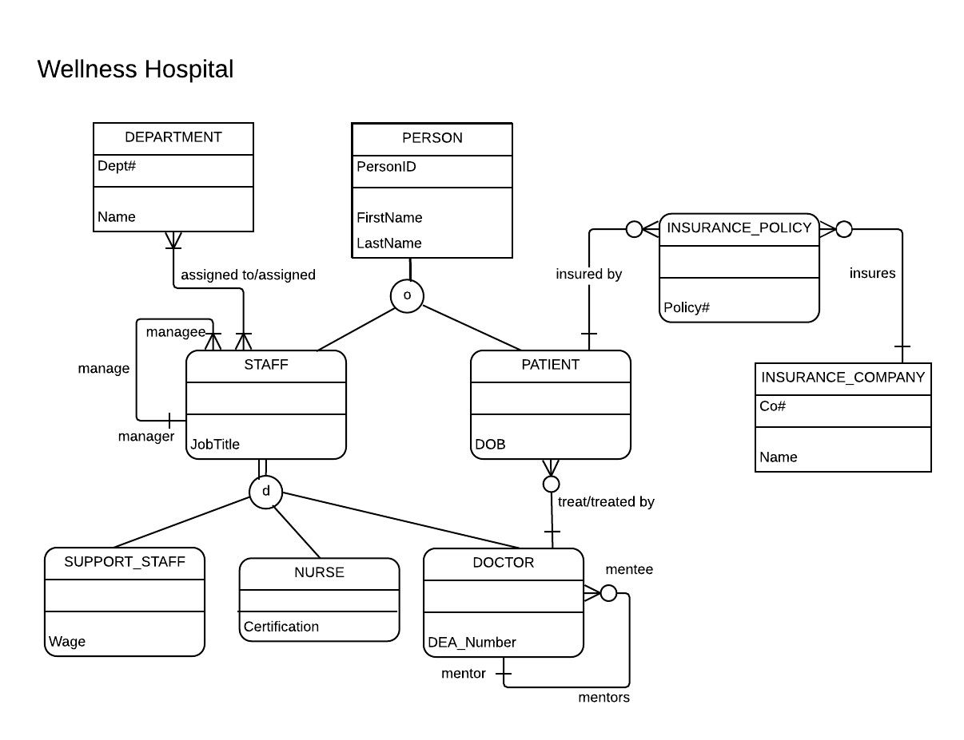

Using the E-R diagram for Wellness Hospital, please provide your answer to the following 22 questions.

1. (4 points) List the relationship verb phrase for each 'HAS-A' relationship that appears in the diagram.

**YOUR ANSWER:** assigned/assigned to, treated by/treat, insured by, insures, manage, mentors

1. (3 points) List the relationship verb phrase for each binary relationship that appears in the diagram.

**YOUR ANSWER:** assigned/assigned to, treated by/treat, insured by, insures

1. (3 points) List the relationship verb phrase for each recursive relationship that appears in the diagram.

**YOUR ANSWER:** manage, mentors

1. (3 points) List the name of each supertype entity that appears in the diagram.

**YOUR ANSWER:** Person, Staff

1. (4 points) List the name of each subtype entity that appears in the diagram.

**YOUR ANSWER:** Support staff, nurse, doctor, staff, patient

1. (3 points) List the name of each associative entity that appears in the diagram.

**YOUR ANSWER:** Insurance_Policy

1. (3 points) Provide an example of an entity instance of PERSON.

**YOUR ANSWER:** PersonID = 01

FirstName = Asmita

LastName = Shelke

JobTitle = Support_staff

Wage = $1000

1. (3 points) List the relationship verb phrase for every 1:1 relationship that appears in the diagram.

**YOUR ANSWER:** There is no 1:1 relationship in the diagram

1. (3 points) List the relationship verb phrase for every 1:N (N:1) relationship that appears in the diagram.

**YOUR ANSWER:** manage, mentors, treat/treated by, insures, insured by

1. (3 points) List the relationship verb phrase for every M:N relationship that appears in the diagram.

**YOUR ANSWER:** assigned/assigned to

1. (3 points) List the name of each strong entity that appears in the diagram.

**YOUR ANSWER:** Department, Person, Insurance_Company

1. (4 points) List the name of each weak entity that appears in the diagram.

**YOUR ANSWER:** Insurance policy, Staff, Support staff, nurse, doctor, patient

1. (4 points) Must a STAFF:managee be managed by a manager? Explain how you determined your answer from the E-R diagram provided.

**YOUR ANSWER:** Yes. There is a recursive relationship from staff manager to manage in the E-R diagram. The cardinality of manager is one, so the staff:manage must be managed by a manager.

1. (4 points) Can there be an instance of DOCTOR that is not an instance of STAFF? Explain your answer.

**YOUR ANSWER:** No. Since staff is a supertype entity and doctor is a subtype entity. Moreover, it is a case of total specialization. Hence, every doctor must be an instance of staff.

1. (4 points) Can a DOCTOR treat more than one PATIENT? Explain how you determined your answer from the E-R diagram provided.

**YOUR ANSWER:** Yes. Since there is 1:N relationship from doctor to patient with the crows foot notation pointing towards patient. This implies one doctor can treat many patients.

1. (4 points) Must every instance of PERSON belong to a subtype? Fully explain how you determined your answer from the E-R diagram provided.

**YOUR ANSWER:** No. Since the person entity is a type of partial specialization i.e. denoted by a single line from the supertype entity to the subtype entity, a PERSON can just be a person. There is no compulsion for it to belong to a subtype.

1. (4 points) Could an instance of PERSON be both a STAFF and a PATIENT? Fully explain how you determined your answer from the E-R diagram provided.

**YOUR ANSWER:** Yes. Considering the overlapping constraint, since o is written inside the relationship indicator in the ER diagram, an instance of person can either be staff or patient or both.

1. (4 points) Must every instance of STAFF belong to a subtype? Fully explain how you determined your answer from the E-R diagram provided.

**YOUR ANSWER:** Yes. Since it is a total specialization case i.e. denoted by double lines between the supertype and subtype, hence every instance of staff must belong to a subtype.

1. (4 points) Could an instance of STAFF be both a SUPPORT_STAFF and a DOCTOR? Fully explain how you determined your answer from the E-R diagram provided.

**YOUR ANSWER:** No. Considering the disjointedness constraint, since d is written inside the relationship indicator in the ER diagram, an instance of staff can either be support staff or doctor. It cannot be both.

1. (4 points) If a discriminator were to be added to PERSON, fully explain what that would entail and why?

**YOUR ANSWER:** Since PERSON is an overlapping entity, hence each subtype i.e. staff and patient, will be used as a discriminator. Since a person can just be a person, can be a staff or a patient or can be both. Hence a Y or N notation will be used to denote whether the person is a staff/ patient. So two attributes would be needed representing staff and patient each.

1. (4 points) If a discriminator were to be added to STAFF, fully explain what that would entail and why?

**YOUR ANSWER:** Since STAFF is a disjoint entity, hence a single attribute (let’s say staff_type) can be used as a discriminator. Suppose the staff is a doctor, then in the attribute staff_type we can add an entry which says ‘doctor’.

1. (5 points) Fully state the business rules for the **assigned to/assigned** relationship without using technical terms.

**YOUR ANSWER:** Every department consists of staff members. A department can have more than one staff member. A staff can work in more than one department.