**Predicting restaurant tips using predictive analytics on Excel.**

Use excel to predict restaurant tips.

**Description:**

The dataset in file ***Restaurant tips dataset.xlsx***contains tips data for different customers. The following are the features in the dataset:

|  |  |
| --- | --- |
| sex | Gender of the customer |
| smoker | Indicates if the customer is a smoker or not |
| day | Day of the restaurant visit |
| time | Indicates whether the tip was for lunch or dinner |
| size | Number of members dining |
| total bill | Bill amount in USD |
| tip | Tip amount in USD |

The following project tasks are required to be performed in excel:

* **Use the restaurant tips file for the analytics using Excel**
* **Find out if there are any missing values and clean the data**
* Process followed:

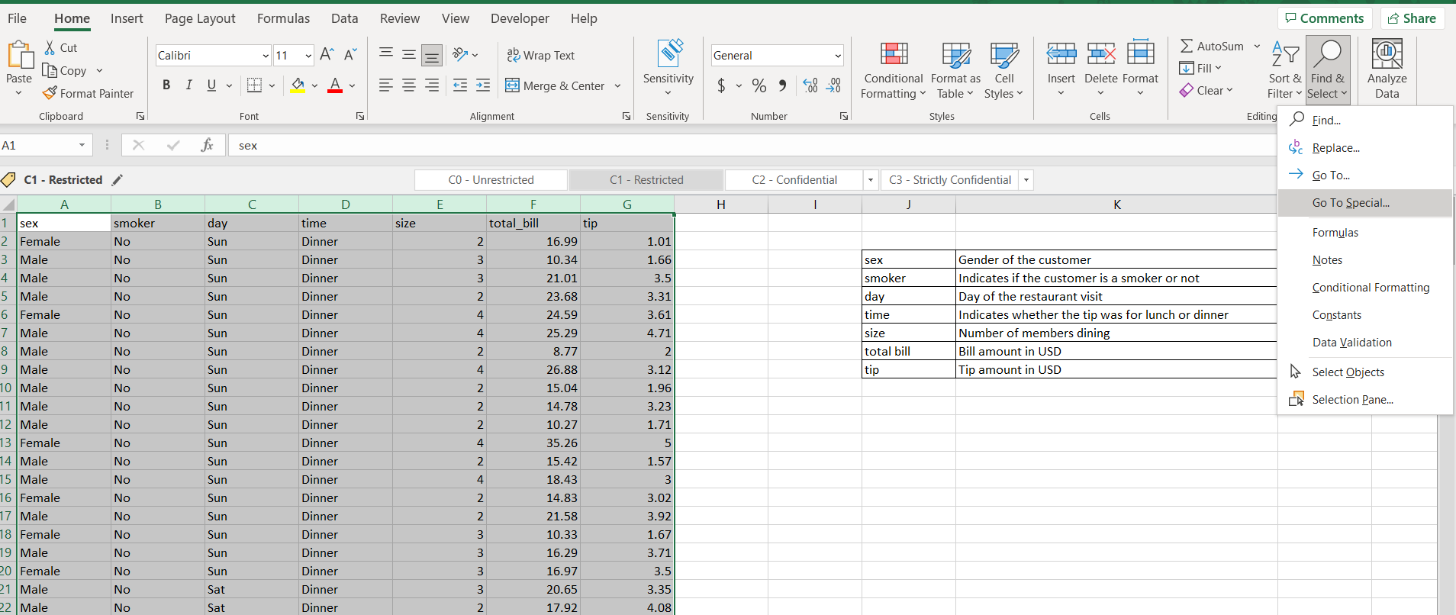

No missing value found.

* **Find the features that are independent and dependent**
* Process followed:

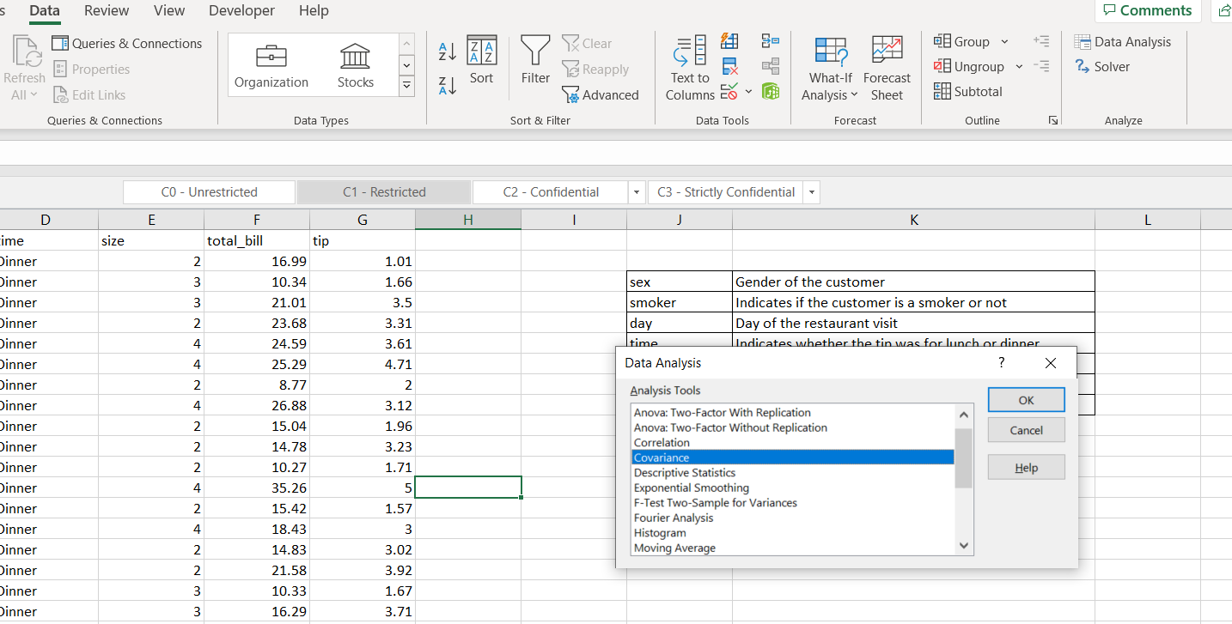

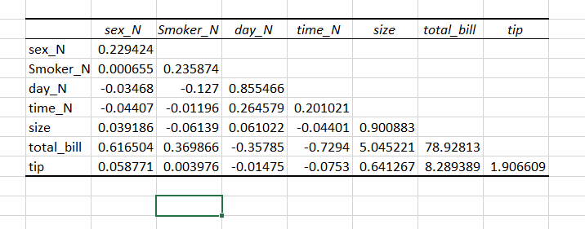

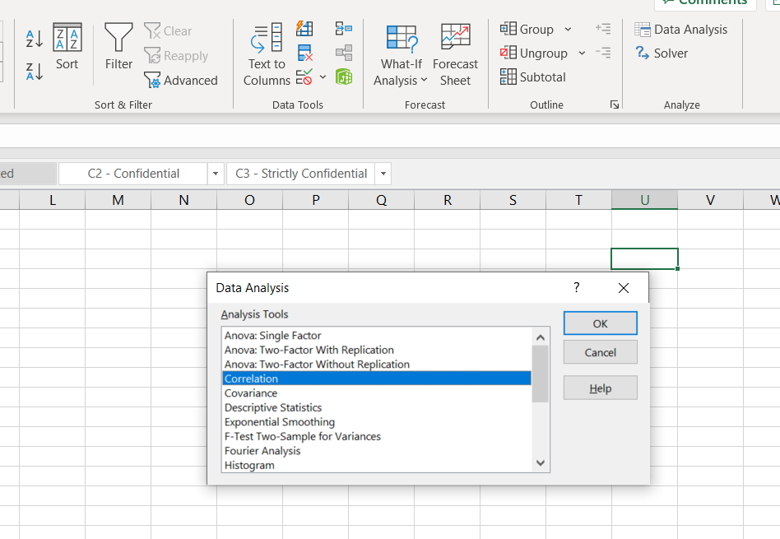

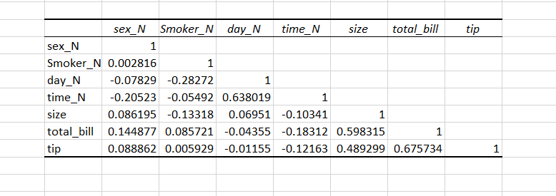

* **Identify which predictive problem is needed.**
* Process followed:

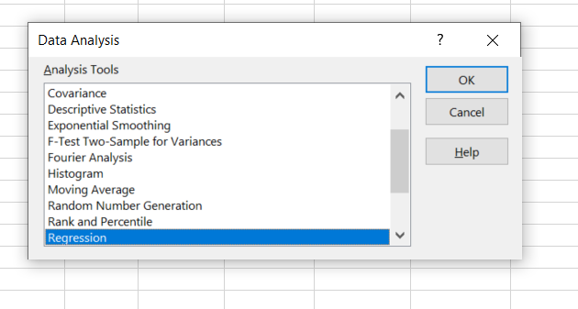

* **Encode the categorical variables to numeric values using IF conditions**
* Process followed:

