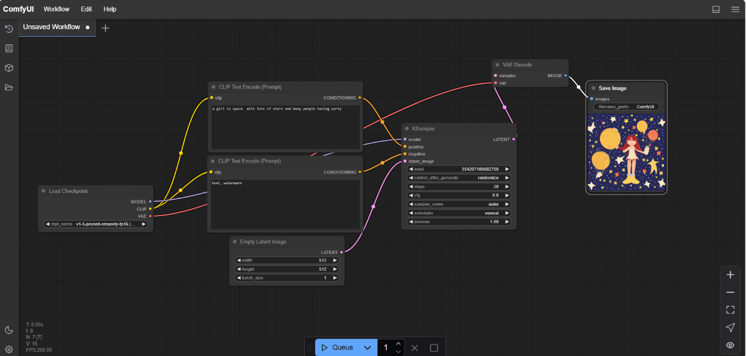

Fig 1 - ComfyUI Stable Diffusion Workflow



Fig 1.1 – output

The image shows a **ComfyUI workflow for Stable Diffusion**, where a text prompt is processed through nodes like **CLIP Text Encode, KSampler, and VAE Decode** to generate and save an AI-generated image.