­A Minor Project I Proposal On



**reReads**

Submitted in partial fulfillment of the requirements for the degree of

Bachelor of Engineering in Software Engineering at Pokhara University

***By***

**Anmol Regmi**

**Asmita Paudel**

**Simran Tamang**



**Department of Research and Development**

**GANDAKI COLLEGE OF ENGINEERING AND SCIENCE**

Lamachaur, Kaski, Nepal

**(May, 2023)**

A Minor Project I Proposal On

**reReads**

Submitted in partial fulfillment of the requirements for the degree of

Bachelor of Engineering in Software Engineering at Pokhara University

***By***

**Anmol Regmi**

**Asmita Paudel**

**Simran Tamang**

***Supervisor***

**ER.Tara Bahadur Thapa**



**Department of Research and Development**

**GANDAKI COLLEGE OF ENGINEERING AND SCIENCE**

Lamachaur, Kaski, Nepal

**(May, 2023)**

# APPROVAL CERTIFICATE

The project entitled **“reReads”** prepared by **“Simran Tamang, Asmita Paudel, Anmol Regmi”** under the supervision of **“ER.Tara Bahadur Thapa”** in partial fulfillment of the requirements for the Degree of Bachelor of Engineering in Software Engineering has been examined and is recommended for approval and acceptance.

**Date of Evaluation** : 18 May,2023

…………………………..

**ER.Tara Bahadur Thapa**

**(Project Supervisor)**

**…………………………………**

**Er. Rajendra Bahadur Thapa**

(Acting Coordinator)

**Research Management Committee**

**Gandaki College of Engineering and Science**

# ABSTRACT

The project "**reReads**" will be a web app that provides a platform to sell, buy, and donate used Nobel books. Our web app will make it easier for book lovers to sell and buy their favorite books at reasonable prices. Users can upload photos of their used books on our platform to sell or donate. Our project aims to provide a seamless and convenient experience for both buyers and sellers. We want to make it easier for sellers to get the best value for their books and for buyers to find the books they need at affordable prices. Additionally, our platform will have a donation feature that allows users to donate their used books to others who may not be able to afford them. Our website is not responsible for the delivery of books. We only provide the interface for communication between the buyer and seller.

.

**TABLE OF CONTENTS:**

APPROVAL CERTIFICATE i

ABSTRACT ii

CHAPTER 1 INTRODUCTION 1

1.1 BACKGROUND 1

1.2 PROBLEM STATEMENT 2

1.3 OBJECTIVES 3

1.4 IMPLICATION 3

CHAPTER 2 LITERATURE REVIEW 4

CHAPTER 3 TOOLS AND METHODOLOGIES 6

3.1 REQUIRED TOOLS 6

Table 1 : Required Tools 6

3.2 APPROACH USED 7

Figure 1 : The Waterfall Model 7

3.3 USE CASE DIAGRAM 8

Figure 2: Use Case Diagram of reReads 8

3.4 USE CASES : 9

3.5 ENTITY RELATIONSHIP DIAGRAM 12

Figure 3: Entity Relationship Diagram of reReads 12

3.6 SYSTEM SEQUENCE DIAGRAM 13

Figure 4 : System Sequence Diagram for Seller, Buyer and Admin 13

3.7 WIREFRAMES 14

Figure 5 : Sign Up and Login Form 14

Figure 6: Home Page 15

Figure 7 : Single page View 16

CHAPTER 4 EXPECTED OUTCOMES 17

CHAPTER 5 TIMELINE CHART 18

Figure 8 : Timeline Chart 18

Bibliography 19

**LIST OF FIGURES:**

FIGURE 1 : THE WATERFALL MODEL [4] 6

FIGURE 2: USE CASE DIAGRAM OF REREADS 7

FIGURE 3: ENTITY RELATIONSHIP DIAGRAM OF REREADS 11

FIGURE 4 : SYSTEM SEQUENCE DIAGRAM FOR SELLER, BUYER AND ADMIN 12

FIGURE 5 : SIGN UP AND LOGIN FORM 13

FIGURE 6: HOME PAGE 14

FIGURE 7 : SINGLE PAGE VIEW 15

FIGURE 8 : TIMELINE CHART 17

**LIST OF TABLES :**

TABLE 1 : REQUIRED TOOLS 5

# 

# CHAPTER 1 INTRODUCTION

## BACKGROUND

Second-hand book selling, buying, and donating markets have been around for a long time. They have gained significant popularity among book lovers, students, and people looking for affordable reading materials. In recent years, the demand for second-hand books has increased due to various reasons such as rising book prices, environmental concerns, and the desire to reuse and recycle.

Moreover, the internet has revolutionized the way people buy and sell goods, including second hand books. Online marketplaces and websites have made it easier for sellers to reach a wider audience and for buyers to find the books they want at affordable prices.

Furthermore, second-hand book markets have a positive impact on the environment. The recycling and reuse of books reduce the need for new book production, which results in a decrease in the use of resources such as paper and ink. This is especially important as the world becomes more conscious of the need to protect the environment.

In conclusion, the second-hand book market is a growing industry that benefits both buyers and sellers. It offers an affordable option for people to obtain their desired reading materials, while also promoting the reuse and recycling of books. Additionally, the option to donate used books provides an opportunity to give back to the community and help others gain access to educational and entertainment resources.

## 1.2 PROBLEM STATEMENT

1. Users are facing problem of right market to sell their products with appropriate price.

2. There is no direct connection between buyers and sellers.

3.Many readers cannot afford new books due to their high prices.

## 

## 1.3 OBJECTIVES

The main objective of our project will be :

* To provide a web app to help users to buy, sell, and donate their used books.

## 1.4 IMPLICATION

* Second-hand books are typically cheaper than brand new ones, making them more affordable for students and book lovers.
* Providing free books can aid people who may not have the financial means to purchase them.

.

* Some books may be out of print or difficult to find, and buying them second- hand may be the only way to get them.

# CHAPTER 2 LITERATURE REVIEW

A present, Nepalese use the following platform for the purpose of trading used books:

**SajhaKitab:**

SajhaKitab is an online platform which connects buyers and seller directly for buying and selling used as well as new books. It was founded in 2020 with the aim of making books more accessible to people in Nepal. The website allows users to browse and purchase books from a wide range of categories, including fiction, non-fiction, textbooks, and more.

Sajhakitab also allows users to sell their own used books on the platform. To sell a book, users simply need to create a listing on the website with detail about the books, including its condition and price. (SajhaKitab, 2023)

**SastoBooks:**

Sastobooks is an online bookstore based in Nepal that offers a wide range of books at affordable prices.

On the Sastobooks website, customers can browse and purchase books in various categories such as fiction, non-fiction, textbooks, children’s books and more. They offer both new and used books, and often have discounted prices on many titles.

But in this website currently none of the books are shown. (SastoBooks, 2023)

**Bizzpur:**

Similar to Sajhabooks, sastobooks. Bizzpur is Nepal’s student community, build to make lives of students easier. Here, we can buy and sell second hand books and save money. We can browse through available notes and solved question to assist our study. (Bizzpur, 2023)

**Kitabkinbech.com:**

KitabKinBech.com is also an online platform to buy and sell second hand and old books. The platform offers a user-friendly interface that allows customers to easily browse books based on their preferences, and also provides sellers with an opportunity to showcase their books to a wide audience. They also offers handwritten notes as well as online notes. (KitabKinbech.com, 2023)

# CHAPTER 3 TOOLS AND METHODOLOGIES

## 3.1 REQUIRED TOOLS

Following are the tools needed throughout the development of the project for different purposes.

## Table 1 : Required Tools

|  |  |
| --- | --- |
| TOOLS | PURPOSE |
| HTML , CSS And JAVASCRIPT | For front end |
| PHP | For back end |
| MySQL | For managing database |
| Git Hub | To store source code and collaboration with teams |
| VS Code | For writing source code |
| MS Word | Documentation |
| Draw.io | Diagram |
| Figma | Wireframe design |

## 3.2 APPROACH USED

As the requirements of our projects are well defined, we will be using the waterfall model approach for the development of our project. In a waterfall model, each phase must be completed before the next phase can begin and there is no overlapping in the phases. Waterfall model was first SDLC Model to be used widely in Software Engineering to ensure the success of the project. In Waterfall Model, the whole process of software development is divided into separate phases. In this model, the outcome of one phase acts as input for the next phase sequentially.

The following illustration is a representation of the different phases of the Waterfall Model. (Waterfall Model, 2023)

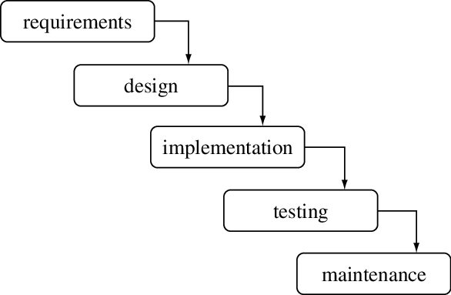

## Figure : The Waterfall Model

## 3.3 USE CASE DIAGRAM

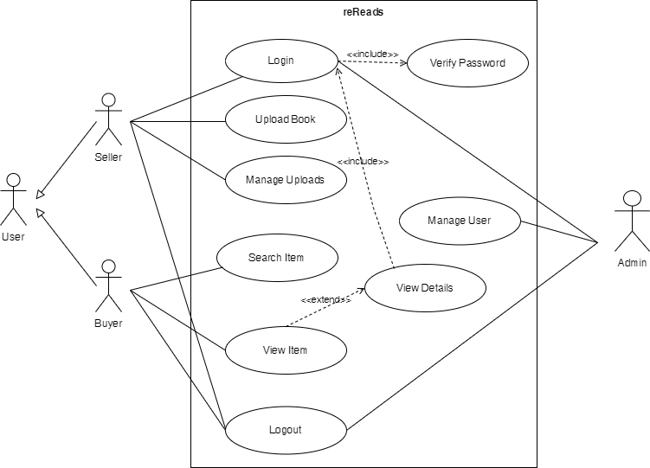

## Figure 2: Use Case Diagram of reReads

## 3.4 USE CASES :

**Use Case UC1 : Sign Up**

**Primary Actor** : Seller and Buyer

**Stakeholders and interests :**

* Seller and Buyer : Wants to create a new account
* System : Store user information and update the database

**Preconditions** : User must have a valid e-mail address

**Postconditions** : The user is registered.

**Use Case UC2 : Login**

**Primary Actor** : Seller and Buyer

Stakeholders and interests :

* + Seller and Buyer : Wants to login to the system
  + System : Verifies the entered credentials

Preconditions : The user must have account

Postconditions : The user is logged in.

Use Case UC3 : Logout

Primary Actor : Seller and Buyer

Stakeholders and interests :

* + Seller and Buyer : Wants to log out from the website
  + System : Logs the user out

Preconditions : The user must be logged in.

Postconditions : The user is able to log out from the website

Use Case UC4 : Search Books

Primary Actor : Buyer

Stakeholders and interests :

* + Buyer : Wants to explore product related to their searches.

Preconditions : The inventory of books should be carefully cataloged.

Postconditions : Buyer are now able to see their searches product.

Use Case UC5 : Sell Books

Primary Actor : Seller

Stakeholders and interests :

* + Seller : Wants to upload the image of products with detailed information
  + System : Adds information to the database

Preconditions : The information about the products should be appropriate.

Postconditions : The products is listed on the sale page and stored on the database

Use Case UC6 : Delete Listed Books

Primary Actor : Seller

Stakeholders and interests :

* + Seller: Wants to delete the listed products
  + System : Deletes the listed products from database and sale page

Preconditions : The products must be listed on the website

Postconditions : The products is deleted from the sale page and database

Use Case UC7 : Manage Sellers and Buyers

Primary Actor : Admin

Stakeholders and interests :

* + Admin: Wants to manage the the user account and information
  + System : Perform management operations

Preconditions : The admin must be logged in.

Postconditions : The admin is able to manage the user’s details and account

Use Case UC8 : Manage listed Books

Primary Actor : Admin

Stakeholders and interests :

* + Admin: Wants to manage the listed Books
  + System : Updates or deletes the Books Details

Preconditions : The products must be listed.

Postconditions : The products details are updated or deleted.

## 3.5 ENTITY RELATIONSHIP DIAGRAM

## Figure : Entity Relationship Diagram of reReads

## 

## 3.6 SYSTEM SEQUENCE DIAGRAM

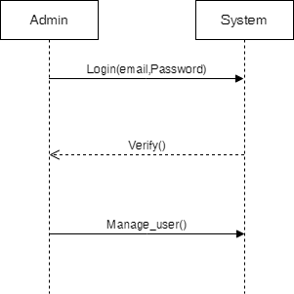

## Figure : System Sequence Diagram for Seller, Buyer and Admin

## 3.7 WIREFRAMES

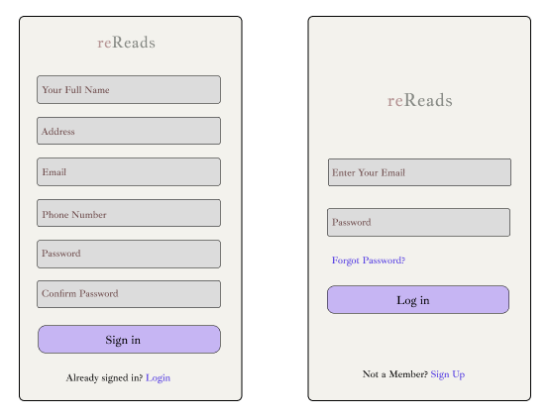

## Figure : Sign Up and Login Form

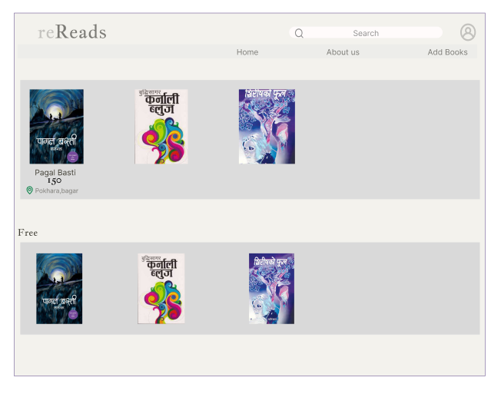

## Figure : Home Page

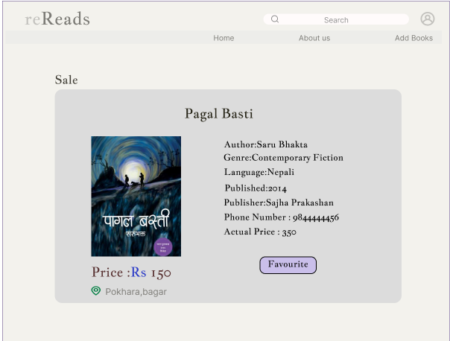

## Figure : Single page View

# CHAPTER 4 EXPECTED OUTCOMES

1. Seller can list their books with accurate descriptions and appealing prices.
2. Buyers have access to a wide range of books, categorized and searchable based on their preferences.
3. Facilitating book donations to those in need.
4. Promoting environmental sustainability through book reuse.

# CHAPTER 5 TIMELINE CHART

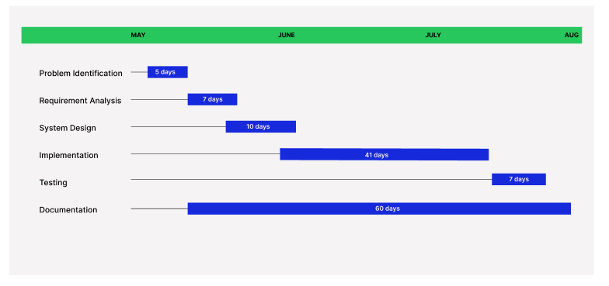

## Figure : Timeline Chart

# Bibliography

Bizzpur. (2023, 5 15). *About us*. Retrieved from Bizzpur: https://www.bizzpur.com/

KitabKinbech.com. (2023, 5 15). *About us*. Retrieved from KitabKinbech.com: https://kitabkinbech.pythonanywhere.com/

Mr. Arnab Chakraborty. (2023, 5 21). *DBMS - Mapping Cardinalities in ER-Diagram*. Retrieved from https://www.youtube.com/watch?v=qUcscgWNJYM

Mr. Arnab Chakraborty,. (2023, 5 21). *UML - Use case diagram introduction*. Retrieved from https://www.youtube.com/watch?v=_jb0cyGbdbk

SajhaKitab. (2023, 5 15). *About us*. Retrieved from SajhaKItab: https://sajhakitab.com/about-us-2/

SastoBooks. (2023, 5 15). *About us*. Retrieved from SastoBooks: https://sastobooks.com/

*Waterfall Model*. (2023, 5). Retrieved from Medium: https://www.researchgate.net/figure/A-standard-waterfall-model-for-software-creation_fig2_23142609