Blackjack: Does the House Always Win?

**By: Austin Smith, Stefano Battisto, and Chris Walker**

**Abstract**

Arkansas Legislature recently approved of large-scale casino gaming operations. One of the “easiest” casino games is believed to be Blackjack. During our study we calculated the probability of someone actually making a profit from participating in Blackjack. Once our results were in we determined that even in the most ideal circumstances, the player is still at a disadvantage. In order to make a profit it is best to avoid, casinos altogether.

**Introduction**

In November of 2018, a referendum in the state of Arkansas allowed for the legalization of large-scale casino gaming operations in the state for the first time. The referendum allowed for the construction and operation of four new casinos, many of which have been built and are set to begin operation soon. With this new opportunity for Arkansans to “try their luck” at these casinos, it becomes necessary, as responsible and math-minded citizens, to take a critical look at casino gaming and analyze the risk associated with engaging in casino gambling.

One of the most popular casino table games is blackjack. Blackjack is the perfect game to analyze because the whole game is, at its core, simply a complicated conditional probability problem. In the game of blackjack, the player is dealt two cards (face-up), with the option after that to accept more cards to increase their score (called “hitting”) or to hold the score they have (called “standing”). Each card is worth the value of the number on it with face cards (K,Q, and J) being worth ten, and aces being worth either one or eleven, whichever is advantageous to the player. The goal of the game is to get as close to 21 without going over, while also getting a higher number than the dealer. It is important to note that players in blackjack are not playing each other, just the dealer (however, as we’ll show later, this does *not* mean that the actions of other players will not affect you). Although it commonly thought of as one of the least complicated, easy to win, casino games, we will show through mathematical analysis and simulation that, even using the best strategies, under ideal conditions, the “house” still holds an enormous advantage.

**Analysis**

If one considers a standard 52 card deck being used for a game of blackjack, then the probability of getting any one card at the beginning of play is $\frac{1}{52} ≈ 1.92\%$. If we group cards by value, then the probability of getting any one valued card at the beginning of play is $\frac{4}{52}≈7.69\%$ for any card not equal to ten, and $\frac{16}{52} ≈30.77\%$ for cards equal to ten. However, blackjack is a game of conditional probabilities. As cards are dealt, the probabilities change based on what has already been dealt and what is still in the deck. In general, the formula for the probabilities of getting any one specific card in a game with $m$ decks game are represented by the following equations:

$$P\left(x\right)=\frac{4m-n_{x}}{52m-d} for x ≠10$$

$$P\left(x\right)= \frac{16m-n_{x}}{52m-d} for x=10$$

$$x represents desired card value$$

$$m is number of 52-card decks$$

$$n_{x} is number of cards of that value already dealt$$

$$d is the number of cards dealt total$$

The most important decision the player makes while playing blackjack comes down to when to hit versus when to stand. To illustrate this, let’s walk through a simple scenario:

*Sally is playing a one deck game of blackjack. There is nobody else at the table. She is dealt a 10 and a 4. The dealer’s card showing is a 9 (for the sake of simplicity, we will assume the dealer’s behavior will not influence her choice to hit/stand)*

For this scenario, the value of Sally’s hand is a 14. If you recall, the goal of blackjack is to get as close to 21 without going over while also having a higher number than the dealer. In this scenario, there are seven card values that will result in not “busting”, or going over 21, and three that will result in a bust. So, to determine whether or not to hit, we must compare the probability of busting to the probability of not busting.

$$P\left(Bust\right)=P\left(10\right)∪P(9)∪P(8)$$

$$P\left(10\right)= \frac{16-1}{52-3}≈ .306 ;P\left(9\right)= \frac{4-1}{52-3}≈ .061 ;P\left(8\right)= \frac{4-0}{52-3}≈ .082$$

$$P\left(Bust\right)=\frac{22}{49} ≈ .449$$

Since the probability of busting and the probability of not busting are mutually exclusive, then:

$$P\left(Not Busting\right)=P\left(Bust^{c}\right)=1-\frac{22}{49}≈ .551$$

So, in the case of our example, it would be in the player’s best interest to “hit” and accept another card given that $P\left(Bust\right)<P(Not Busting)$.

The previous example, however, is not complete. Recall the caveat that stated we would treat dealer behavior as if it had no effect on player behavior. In reality, the dealer’s behavior has a big impact on play, since blackjack revolves around not beating other players at the table, but instead around beating the dealer. So, let’s revisit the exact same scenario, but this time consider the dealer’s play as well. Let’s use a casino standard rule that dealers “stand” on 16.

First, recall that the dealer is showing a 9 as their first card. We do not know their second card (it is dealt face down), but if we do an expected value problem for the deck in the scenario we get:

$$E\left(x\right)=\sum_{x=2}^{11}{}xP(x)=\left(2*\frac{4}{49}\right)…+\left(10*\frac{15}{49}\right)+\left(11*\frac{4}{49}\right) =\frac{359}{49}≈7.28$$

Since the value must be a whole number, we round down to seven. Now, the question of whether to hit or stand must also take into account the dealer’s hand, since our objective is to beat the dealer. If we assume the dealer’s second card to be a seven, the dealer’s current hand is valued at 16. In this scenario, it would now be in our best interest to hit, not just because $P\left(Bust\right)<P(Not Busting)$, but because our objective is to beat the dealer, and our current hand is only valued at 14, meaning we cannot beat the dealer without increasing our score. We also note that since the dealer must stand on 16, their score may not go higher than that.

This goes to show how many constantly changing probabilities go into a single hand of blackjack. Although the premise of the preceding example was simple, one could easily see how the scenarios could quickly evolve into much more complex probability problems. This is where the modern miracle of computing has allowed data scientist to crunch the numbers and create data tables that aggregate a large amount of information into a simple-to-read chart that claims to show to user when to hit or stand based on the probabilities associated with each scenario. These charts, often sold in Casino gift shops are known as “strategy cards” (pictured below), they code for the best action to take for any given hand and are the basis for our simulation.

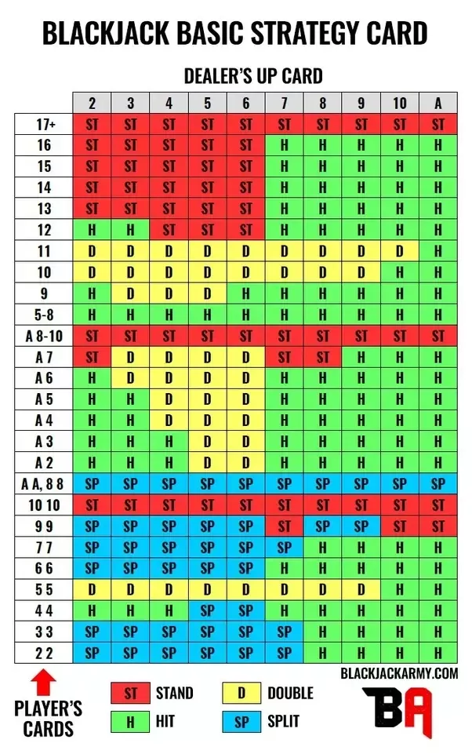

Blackjack Basic Strategy card, courtesy of *blackjackarmy.com*

The best indicator of whether a casino game is worth it to play is the house edge associated with it. House edge is the percentage of a player’s bet they are expected to lose per time they bet. House edge is impacted by a multitude of different variables and can’t be calculated by an equation, but instead can be determined through analysis of data from recorded blackjack rounds. The way we collected this data was through simulation. The simulation we wrote simulates a player playing any number of blackjack rounds under the tweakable probabilistic conditions (rule sets, etc.), using any coded player strategy. We just determined the best poker strategy to code for, but what of what probabilistic conditions to code under? The main two factors manipulated by casinos that possibly affect house edge are dealer strategy and shoe size. The change in dealer strategy is whether the dealer hits or stands on a soft 17 and the adjustment of shoe size is how many decks are in the shoe. What we are trying to prove is whether blackjack is profitable under the best possible player conditions, so knowing how these factors affect house edge was important for our simulation. Unfortunately, however, effect on dealer strategy and shoe size isn’t well documented and has been a debatable topic in the community. In order to circumvent this, we built simulations in multiple different environments (combinations of different shoe size and dealer strategy) and compared the data, to determine the best simulation to use for final analysis. To compare the data, the different simulations were ran over 1,000,000 round and the number of wins, loses, pushes, double down wins, double down loses, and black jack wins were collected. From here the probability of each outcome and the overall expected return from each round was calculated.

The main data analysis was over data from the simulated environment with the best expected return per round, which was ran over 1,000,000,000 hands this time and similar statistics were ran. As a bonus bit of narrative, we graphed a running total of 10 different simulated player’s money balance over 100 rounds. This is meant to demonstrate how a player’s balance changes over time.

The “simulation” referenced through-out this section was coded in python.

**Results**

*Comparison of Environments:*

Example of calculations done on each specific environment

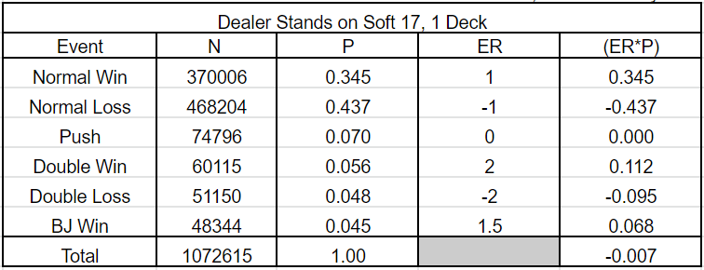

$$\begin{aligned}N=Occurances of event P=\frac{N}{N_{total}} ER=Return based on a \$1 bet, \end{aligned}$$

$Total\left(ER*P\right)=Expected return per round$

Overview comparing each environment

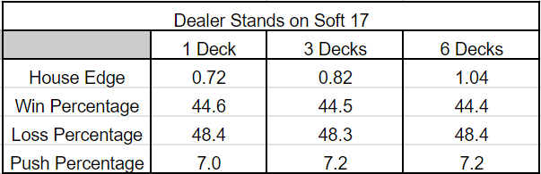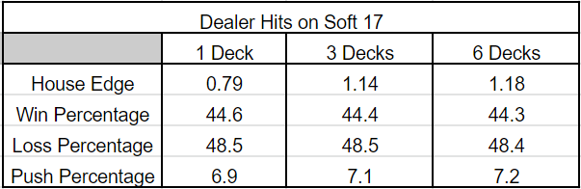

$$House Edge=\left(ER*P\right)*100*-1$$

As seen house edge is the lowest when the dealer is standing on a soft 17 and the shoe size is minimized. This leads to our final analysis using the dealer standing on soft 17 and 1 deck as the shoe size.

*Final Analysis*

Data from 1 Billion Rounds Simulated Under the Lowest House Edge Possible



This shows us that even under the best condition, the player is set up to probabilistically lose 0.72% of his bet in Blackjack every time he bets.

Running Money Balance for 10 Players Over 100 Rounds

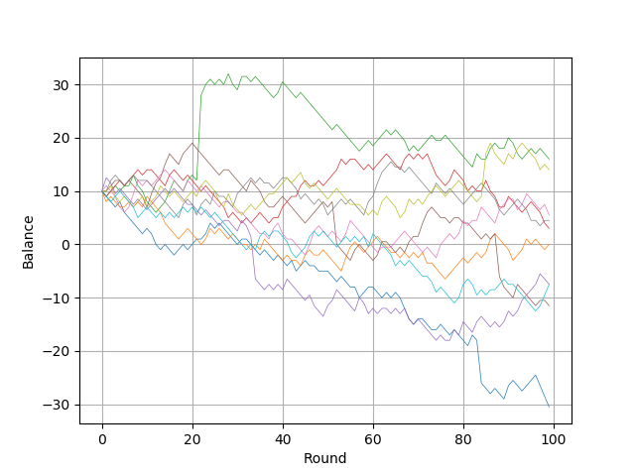

As seen in the graph the change in players balance’s is spiritic in whether it is positive or negative. Also, the state of a player’s balance is seen to be unpredictable and as more rounds are played highly variant. These are important factors to consider when thinking about whether a money-making scheme is worth it.

**Discussion**

Our research considers many variables that can affect the player. Such as, how many decks the dealer is using. This study does not consider if the players are using card counting strategies. Card counting is a technique that informs the player when the advantage shifts in their favor. When this occurs, players usually increase their bets to make a profit. If we were to consider whether the players use this technique, then it could change the amount of percentage of players who can make a profit. This technique would not significantly improve the profit margin, but it would cause a slight increase. We decided to research this topic because of the new legislature that was passed last year. Since this has occurred for the first time in Arkansas, people may try to capitalize on this new opportunity and try to increase their revenue. As this study proves, it is unwise to invest in Blackjack. This project is meant to raise awareness of the likelihood of winning big in Blackjack and to encourage our classmates to be responsible with their income.

**Conclusion**

During our research we determined that is best to avoid casinos if you are hoping to substantially increase your revenue. In one of the easiest games within the casino it is still more likely that you will lose money. Even under the most idealistic circumstance for the player, the house still has an advantage. If you do decide to go to a casino, it would behoove you to go with an idea of how much money you would like to spend. If your endgame is to make money, then you should consider other options.