**CSC**

Hotel Booking Website Using

HTML,CSS,PHP And JS

Prepared by

Asmitha.Sa

GUIDED BY CENTER HEAD

M.Aisha Sidhika S.Navamani, M.Sc

M.Sc[cs] M.Phil.,

Webpage Output

Homepage:



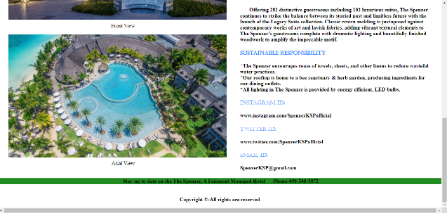

Gallery:



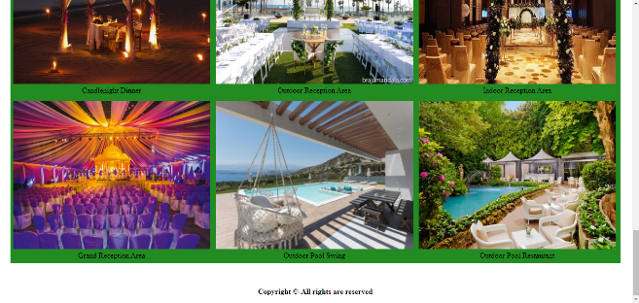

Services:

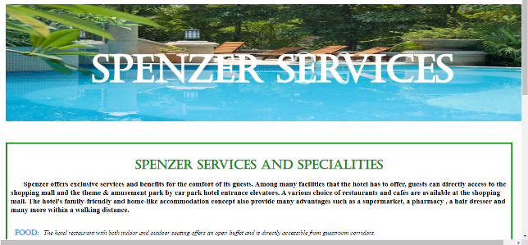

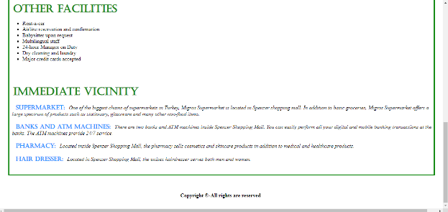

Booking form:

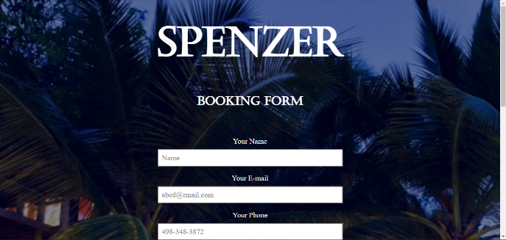

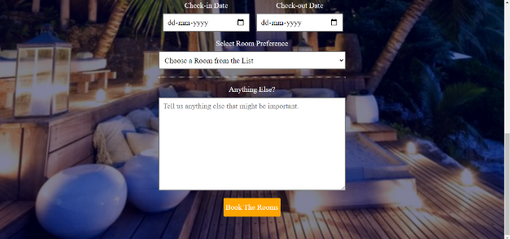

Contact form:

