**CONTENTS**

1. Introduction
   1. Purpose
   2. Scope
   3. Definitions, Acronyms, and Abbreviations
   4. References
   5. Overview
2. Overall Description
   1. Product Perspective
      1. System Interfaces
      2. User Interfaces
      3. Hardware Interfaces
      4. Software Interfaces
      5. Communication Interfaces
      6. Memory Constraints
      7. Operations
      8. Site Adaptation Requirements
   2. Product Functions
   3. User Characteristics
   4. Constraints
   5. Assumptions and Dependencies
   6. Apportioning of Requirements
3. Specific Requirements
   1. External Interface Requirements
      1. User Interfaces
      2. Hardware Interfaces
      3. Software Interfaces
      4. Communication Interfaces
   2. Functional Requirements

3.2.1 Login

3.2.2 Maintain Item Details

3.2.3 Maintain Customer Details

3.2.4 Maintain Seller Details

3.2.5 Maintain cart Details

3.2.6 Maintain payment Details

* 1. Performance Requirements
  2. Design Constraints
  3. Software System Attributes
  4. Logical Database Requirements
  5. Other Requirements

**Software Requirements Specification Document for Online Shopping System**

**1.Introduction**

An online shopping system revolutionizes the way consumers and sellers interact, offering a digital marketplace accessible anytime, anywhere. This system provides a virtual storefront where sellers can showcase their products or services, and consumers can browse, select, and purchase items with ease.

Through a user-friendly interface, customers can explore a wide range of products, compare prices, read reviews, and make informed buying decisions. Meanwhile, sellers can efficiently manage their inventory, track orders, and engage with customers to enhance their shopping experience. With secure payment processing and robust order management capabilities, an online shopping system streamlines the entire buying process, from product discovery to delivery, offering convenience and flexibility to both buyers and sellers in the digital age.

**1.1. Purpose**

The Online Shopping System (OSS) is designed to facilitate the buying and selling of products or services over the internet. It maintains information about the products available for purchase, including details such as product descriptions, prices, and availability. Customers can browse the online store, add items to their shopping cart, and complete transactions securely. Sellers can list their products, manage inventory, and process orders through the system.

**1.2. Scope**

The proposed Online Shopping System shall perform the following functions:

* Registration and login for users (customers and sellers).
* Display and management of product listings.
* Shopping cart functionality for customers to add and manage items.
* Secure payment processing for transactions.
* Order management and tracking.
* Customer support features such as FAQs and contact forms.
* Inventory management for sellers.
* Reporting and analytics for both customers and sellers.

**1.3. Definitions, Acronyms, and Abbreviations**

OSS: Online Shopping System User: Any user (Customer or Seller) HTTPS: Hypertext Transfer Protocol Secure SKU: Stock Keeping Unit Payment Gateway: Service that authorizes payment for e-commerce transactions Customer: Individual purchasing goods or services online Seller: Entity selling goods or services online Product: Item or service available for purchase Inventory: Stock of goods available for sale Transaction: Exchange of goods or services for payment Shipping: Delivery of purchased items to customers

**1.4. References**

(a) 'E-commerce 2021: Business, Technology and Society' by Kenneth C. Laudon and Carol Guercio Traver, Pearson.

(b) 'Electronic Commerce: A Managerial and Social Networks Perspective' by Efraim Turban et al., Springer.

(c) IEEE Recommended Practice for Software Requirements Specifications – IEEE Std 830-1998.

(d) IEEE Standard for Software Test Documentation – IEEE Std. 829-1998.

**1.5. Overview**

The Online Shopping System aims to provide a seamless and secure platform for buying and selling products or services online. The following sections of the SRS document will detail the system requirements, interfaces, features, and functionalities of the OSS.

**2. Overall Description**

The Online Shopping System (OSS) provides a platform for buyers to browse, select, and purchase products or services from sellers. The system assumes that both buyers and sellers have registered and created accounts. Sellers list their products or services, manage inventory, and fulfill orders. Buyers can view product details, add items to a shopping cart, and complete transactions securely.

The system administrator manages user accounts, resolves disputes, and ensures the smooth functioning of the platform. The administrator also maintains product listings, handles payments, and manages customer feedback and reviews.

Users can access the OSS through the internet on their devices. Buyers can add, remove, or modify items in their shopping cart and proceed to checkout. Sellers can add new products, update existing listings, and track orders.

The administrator maintains the following information:

* User account details
* Product listings
* Inventory details
* Order details
* Payment information
* Customer feedback and reviews

The administrator requires the following reports from the system:

* Sales reports
* Inventory reports
* Order fulfilment reports
* Customer satisfaction reports

The OSS aims to provide a seamless and secure online shopping experience for both buyers and sellers, enhancing convenience and accessibility in the digital marketplace.

**2.1. Product Perspective**

The Online Shopping System (OSS) will be developed using a client/server architecture and will be compatible with various operating systems, including Microsoft Windows, macOS, and Linux. The front end of the system will be developed using HTML, CSS, and JavaScript, while the backend will be developed using PHP and MySQL for database management.

**2.1.1. System Interfaces**

The OSS will interact with users through web browsers, providing a user-friendly interface for browsing products, managing shopping carts, and completing transactions. The system will also integrate with payment gateways for secure payment processing.

**2.1.2. User Interfaces**

The OSS will include the following user interfaces:

a) Homepage: Displays featured products, promotions, and categories for easy navigation. b) Product Listing: Allows users to view detailed product information, images, and prices. c) Shopping Cart: Allows users to add, remove, or modify items in their cart before checkout. d) Checkout: Guides users through the payment process, including selecting shipping options and entering payment details. e) Account Management: Allows users to create an account, log in, view order history, and update personal information. f) Seller Dashboard: Allows sellers to manage product listings, view orders, and track sales.

The software will generate the following viewable and printable reports:

a) Order Confirmation: Sent to customers after a successful purchase, confirming the details of their order. b) Sales Report: Provides sellers with an overview of their sales performance, including total revenue and best-selling products. c) Inventory Report: Helps sellers track their inventory levels and manage restocking. d) Customer Feedback: Allows customers to leave reviews and ratings for products, which can be viewed by other users.

**2.1.3. Hardware Interfaces**

The OSS will require a computer or mobile device with internet access to access the system. It will also support printing capabilities for printing order confirmations and reports.

**2.1.4. Software Interfaces**

a) Operating Systems: Compatible with Microsoft Windows, macOS, and Linux. b) Web Browsers: Compatible with popular web browsers such as Google Chrome, Mozilla Firefox, and Safari. c) Programming Languages: HTML, CSS, JavaScript, PHP for front-end and backend development. d) Database Management System: MySQL for storing product, user, and order information.

**2.1.5. Communication Interfaces**

The OSS will communicate with users through HTTP/HTTPS protocols for secure data transmission over the internet.

**2.1.6. Memory Constraints**

The system will require a minimum of 1GB of RAM and 500MB of hard disk space to run smoothly.

**2.1.7. Operations**

The OSS will be a multi-user system, supporting concurrent user access for browsing, shopping, and managing accounts.

**2.1.8. Site Adaptation Requirements**

Client terminals will need to support the hardware and software interfaces specified in sections 2.1.3 and 2.1.4, respectively, for optimal performance of the OSS.

**2.2. Product Functions**

The Online Shopping System (OSS) will provide the following major functions:

* User Authentication: Allow only authorized users (buyers and sellers) to access the system.
* Account Management: Allow users to create, modify, and delete their accounts.
* Product Management: Allow sellers to add, edit, and remove product listings.
* Shopping Cart: Enable buyers to add, remove, and manage items in their shopping cart.
* Checkout Process: Guide buyers through the payment process and order confirmation.
* Order Management: Allow sellers to view and manage orders, including order processing and fulfillment.
* Reporting: Generate reports for sales, inventory, and customer feedback.

The OSS will support the following use cases:

Use Case Description

User Authentication Login Change Password

Account Management Create Account Edit Account Delete Account

Product Management Add Product Edit Product Delete Product View Product

Shopping Cart Add to Cart Remove from Cart Modify Cart Checkout Process Checkout

Payment Processing Order Management View Orders Process Orders Fulfil Orders

Reporting Generate Sales Report Generate Inventory Report Generate Customer Feedback Report

**2.3. User Characteristics**

Buyers and sellers using the OSS should have the following characteristics:

* Qualification: No specific qualification required, but should be able to navigate and use a web-based system.
* Experience: Basic understanding of online shopping processes.
* Technical Experience: Basic knowledge of using a web browser and online forms.

**2.4. Constraints**

* The OSS will have a single system administrator with full control over the system.
* Deletion of products or accounts will be restricted to the system administrator to maintain data consistency.

**2.5. Assumptions and Dependencies**

* Users will have access to a computer or mobile device with internet connectivity.
* Users will have basic knowledge of using a web browser and online forms.
* Payment processing will be handled securely through third-party payment gateways.
* Inventory availability will be updated in real-time to prevent overselling.

**2.6. Apportioning of Requirements**

Not applicable for the Online Shopping System.

Specific Requirements

The following section will detail the specific software requirements and interface designs for the OSS.

3.1 External Interface Requirements

3.1.1 User Interfaces

The Online Shopping System (OSS) will provide the following user interfaces:

i) Login Page

* Description: The homepage will display featured products, promotions, and categories for easy navigation.
* Features: Search bar, product categories, featured products, promotional banners.
* Use: Users can browse and search for products.

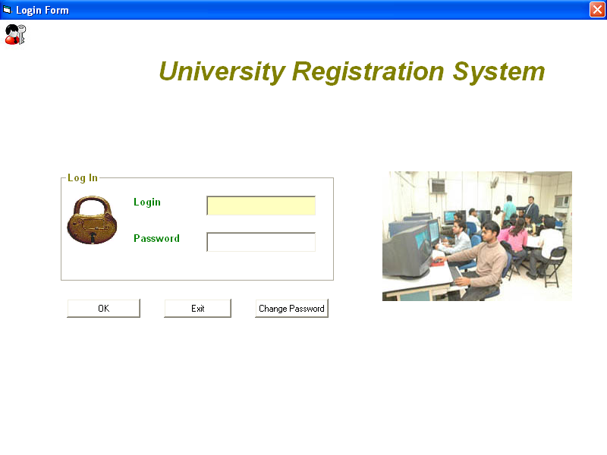

*Online shopping system*

ii) Product Listing Page

* Description: This page will display detailed information about a specific product.
* Features: Product images, descriptions, prices, reviews, add to cart button.
* Use: Users can view and select products for purchase.

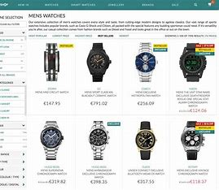

iii) Shopping Cart

* Description: This page will display a summary of items in the shopping cart.
* Features: List of products in the cart, quantity selection, total price calculation, checkout button.
* Use: Users can review and manage items in their cart before checkout.



iv) Checkout Page

* Description: This page will guide users through the checkout process.
* Features: Shipping information form, payment method selection, order summary, place order button.
* Use: Users can enter shipping details and complete the purchase.

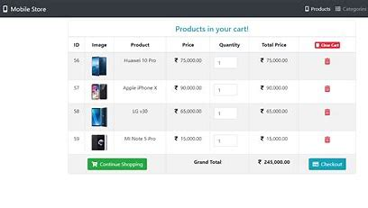

v) Account Management Page

* Description: This page will allow users to manage their account settings.
* Features: Profile information editing, order history, address book, change password option.
* Use: Registered users can update their account details and view past orders.

vi) Seller Dashboard

* Description: This page will allow sellers to manage their products and orders.
* Features: Product listing management, order processing, sales analytics.
* Use: Sellers can add new products, update inventory, and track sales.

vii) Administrator Dashboard

* Description: This page will provide the system administrator with control over the entire system.
* Features: User management, product management, order management, reporting.
* Use: Administrator can manage users, products, and orders, and generate reports.

These interfaces will provide a user-friendly experience for buyers and sellers, facilitating easy navigation and efficient management of the online shopping process.

**3. Specific Requirements**

**3.1 External Interface Requirements**

**3.1.1 User Interfaces**

The following user-interfaces (or screens) will be provided by the system.

**3.1.2 Hardware Interfaces**

The Online Shopping System (OSS) requires standard hardware components commonly found in computers and mobile devices, including:

* Computer or mobile device with internet connectivity: Users will access the OSS through web browsers on their devices.
* Printer: Optional for printing order confirmations or reports, if needed.

**3.1.3 Software Interfaces**

The OSS will interact with various software components to provide its functionality, including:

* Operating System: The system will be compatible with different operating systems such as Windows, macOS, and Linux, ensuring broad accessibility.
* Web Browsers: Users will access the system through web browsers like Google Chrome, Mozilla Firefox, and Safari, ensuring cross-browser compatibility.
* Programming Languages and Frameworks: The system will be developed using HTML, CSS, JavaScript for the front end, and PHP for the back end, ensuring dynamic and interactive user interfaces.
* Database Management System: The system will use MySQL to manage product, user, and order information, ensuring data integrity and reliability.
* Payment Gateway Integration: The system will integrate with third-party payment gateways for secure payment processing, ensuring safe and efficient transactions.

**3.1.4 Communication Interfaces**

The OSS will use standard internet communication protocols, such as HTTP and HTTPS, for secure data transmission between users' devices and the system servers. This ensures that all communication is encrypted and secure, protecting user information and transaction data.

**3.2 Functional Requirements**

**3.2.1 LOGIN:**

1. **USECASE DESCRIPTION**
2. **Introduction:**

This use case describes how a user logs into the Online Shopping Management System.

1. **Actors:**
2. **Administrator**
3. **Customer**
4. **Seller**
5. **Pre-Condition:** None
6. **Post-Condition:**
7. If the sue case is successful, the actor logs into the system.
8. If not, the system state is unchanged.
9. **Basic Flow:**

* Use case starts when the actor wishes to login into the Online shopping system.
* System requests the actor to enter their name and password.
* The actor enters their name and password.
* System validates their name and password and allows the actor to log into the system.

1. **Alternate Flow:**

* **Invalid name and password:**
* In the basic flow, if the actor enters invalid name and/or password, the system displays an error message.
* The actor can choose to either return to the beginning of the basic flow or cancel the login, at that point, the use case ends.

1. **Special Requirements:** None
2. **Use case Relationships:** None
3. **Validity Checks**

* Only registered users will be authorized to access the Login module.
* Username and password are required for login.
* Username must be unique and cannot be blank.
* Password must be at least 6 characters long and cannot be blank.

**C. Sequencing information**

* User registration must be completed before login is allowed.
* Item details must be added before customers can add them to the cart.
* Customer details must be added before they can proceed to checkout.
* Seller details must be added before items can be associated with them.

**D. Error Handling/Response to Abnormal Situations**

* If any validation fails, appropriate error messages will be displayed.
* If the sequencing flow is not followed, users will be prompted to complete the necessary steps.

**3.2.2 MAINTAIN ITEM DETAILS:**

1. **USECASE DESCRIPTION:**
2. **Introduction:**

This use case describes how the system maintains the details of items available for sale in the Online Shopping Management System.

1. **Actor:**
2. Administrator.
3. **Pre-Condition:** None
4. **Post-Condition:**
5. If the use case is successful, the system updates the details of the item.
6. If not, the system state is unchanged.
7. **Basic Flow:**

• The use case starts when the administrator wishes to update the details of an item.

• System requests the administrator to enter the details of the item.

• The administrator enters the details of the item.

• System validates the details and updates the item details in the system.

1. **Alternate Flow:**

* Item details not updated:
* In the basic flow, if the system is unable to update the item details, the system displays an error message.
* The administrator can choose to either retry updating the item details or cancel the operation, at that point, the use case ends.

1. **Special Requirements:** None
2. **Use case Relationships:**
   1. Linked with LOGIN use case as the administrator needs to be logged in to maintain item details.
   2. Linked with SELLER DETAILS use case as the item details are related to the seller.
   3. Linked with CUSTOMER DETAILS use case as the item details are related to the customer's purchases.

**B. Sequencing information**

* User registration must be completed before login is allowed.
* Item details must be added before customers can add them to the cart.
* Customer details must be added before they can proceed to checkout.
* Seller details must be added before items can be associated with them.

**C. Error Handling/Response to Abnormal Situations**

* If any validation fails, appropriate error messages will be displayed.
* If the sequencing flow is not followed, users will be prompted to complete the necessary steps.

**3.2.3 MAINTAIN CUSTOMER DETAILS:**

1. **USECASE DESCRIPTION:**
2. **Introduction:**

This use case describes how the system maintains the details of customers in the

Online Shopping Management System.

1. **Actors:**
   1. Administrator
2. **Pre-Condition:** None
3. **Post-Condition:**
   1. If the use case is successful, the system updates the details of the customer.
   2. ii. If not, the system state is unchanged.
4. **Basic Flow:**
   * The use case starts when the administrator wishes to update the details of a customer.
   * System requests the administrator to enter the details of the customer.
   * The administrator enters the details of the customer.
   * System validates the details and updates the customer details in the system.
5. **Alternate Flow:**
   * Customer details not updated:

* In the basic flow, if the system is unable to update the customer details, the system displays an error message.

1. **Special Requirements:** None
2. **Use case Relationships:** None

**B. Sequencing information**

* User registration must be completed before login is allowed.
* Item details must be added before customers can add them to the cart.
* Customer details must be added before they can proceed to checkout.
* Seller details must be added before items can be associated with them.

**C. Error Handling/Response to Abnormal Situations**

* If any validation fails, appropriate error messages will be displayed.
* If the sequencing flow is not followed, users will be prompted to complete the necessary steps.

**3.2.4 MAINTAIN SELLER DETAILS:**

**A. USECASE DESCRIPTION:**

**a) Introduction:**

This use case describes how the system maintains the details of sellers in the Online

Shopping Management System.

**b) Actors:**

* + Administrator

**c) Pre-Condition:** None

**d) Post-Condition:**

* + If the use case is successful, the system updates the details of the seller.
  + If not, the system state is unchanged.

**e) Basic Flow:**

* The use case starts when the administrator wishes to update the details of a seller.
* System requests the administrator to enter the details of the seller.
* The administrator enters the details of the seller.
* System validates the details and updates the seller details in the system.

**f) Alternate Flow:**

* Seller details not updated:
* In the basic flow, if the system is unable to update the seller details, the system displays an error message.
* The administrator can choose to either retry updating the seller details or cancel the operation, at that point, the use case ends.

**g) Special Requirements:** None

**h) Use case Relationships:** None

**3.2.5 CART DETAILS:**

**A. USECASE DESCRIPTION:**

**a) Introduction:**

This use case describes how the system manages the shopping cart for each customer

in the Online Shopping Management System.

**b) Actors:**

* Customer

**c) Pre-Condition:** None

**d) Post-Condition:**

* If the use case is successful, the system updates the shopping cart for the customer.
* If not, the system state is unchanged.

**e) Basic Flow:**

* The use case starts when a customer wishes to add, remove, or update items in their shopping cart.
* System displays the current items in the customer's shopping cart.
* Customer selects an action (add, remove, update) for an item.
* If adding or updating, customer selects the quantity of the item.
* System validates the action and updates the shopping cart accordingly.

**f) Alternate Flow:**

* Cart not updated:

1. In the basic flow, if the system is unable to update the shopping cart, the system displays an error message.
2. The customer can choose to either retry updating the cart or cancel the operation, at that point, the use case ends.

**g) Special Requirements:** None

**h) Use case Relationships:**

* Linked with LOGIN use case as the customer needs to be logged in to manage their cart.
* Linked with ITEM DETAILS use case as the cart is related to the items being purchased.

**B. Sequencing information**

* User registration must be completed before login is allowed.
* Item details must be added before customers can add them to the cart.
* Customer details must be added before they can proceed to checkout.
* Seller details must be added before items can be associated with them.

**C. Error Handling/Response to Abnormal Situations**

* If any validation fails, appropriate error messages will be displayed.
* If the sequencing flow is not followed, users will be prompted to complete the necessary steps.

**3.2.6 PAYMENT DETAILS:**

**A. USECASE DESCRIPTION:**

**a) Introduction:**

* This use case describes how the system manages the payment process in the Online Shopping Management System.

**b) Actors:**

* Customer

**c) Pre-Condition:**

* Customer has items in their shopping cart.

**d) Post-Condition:**

* If the use case is successful, the system processes the payment for the customer's order.
* If not, the system state is unchanged.

**e) Basic Flow:**

* The use case starts when a customer proceeds to checkout to make a payment.
* System displays the total amount to be paid and available payment methods (e.g., credit card, PayPal).
* Customer selects a payment method and enters the necessary details (e.g., credit card information).
* System validates the payment details and processes the payment securely.
* System updates the payment status for the customer's order.

**f) Alternate Flow:**

* Payment not processed:
* In the basic flow, if the system is unable to process the payment, the system displays an error message.
* The customer can choose to either retry the payment or cancel the operation, at that point, the use case ends.

**g) Special Requirements:** None

**h) Use case Relationships:**

* Linked with LOGIN use case as the customer needs to be logged in to make a payment.
* Linked with CART DETAILS use case as the payment is related to the items in the shopping cart.

1. **Validity Checks**

* Customers can make payments using various payment methods.
* Payment details (such as card information) must be valid and secure.
* Payments must be processed securely and in real-time.

**C. Sequencing information**

* User registration must be completed before login is allowed.
* Item details must be added before customers can add them to the cart.
* Customer details must be added before they can proceed to checkout.
* Seller details must be added before items can be associated with them.

**D. Error Handling/Response to Abnormal Situations**

* If any validation fails, appropriate error messages will be displayed.
* If the sequencing flow is not followed, users will be prompted to complete the necessary steps.

**3.3 Performance Requirements:**

* The system should be able to handle a minimum of 1000 concurrent users.
* The system should be responsive and load pages within 3 seconds under normal load conditions.
* The system should be able to handle peak loads during special events or promotions, with response times not exceeding 5 seconds.
* The server infrastructure should be scalable to accommodate increased traffic during peak periods.
* The system should be able to process a minimum of 100 transactions per minute without performance degradation.
* The system should be able to handle large catalogs of products (up to 100,000 items) without significant impact on performance.
* The system should have monitoring in place to track performance metrics and identify bottlenecks for continuous improvement.

**3.4** **Design Constraints:** None.

**3.5 Software System Attributes**

**Security:**

* The application will implement secure user authentication mechanisms.
* Passwords will be securely stored using hashing algorithms.
* Secure connections (HTTPS) will be used to protect data in transit.

**Maintainability:**

* The application will be designed with modularity and extensibility in mind.
* Changes and updates to the system will be easily implemented without affecting other **modules.**

**Portability:**

* The application will be designed to be platform-independent.
* It should be deployable on various operating systems (Windows, Linux, macOS) with minimal configuration.

**3.6 Logical Database Requirements**

**Brief Description of the Tables**

|  |  |
| --- | --- |
| **Table Name** | **Description** |
| Login | Maintain the details of user. |
| Order Item | Stores information about items in each order. |
| Customer | Records information about customers. |
| Seller | Records details of seller and their items. |
| Cart | Stores the items added to the shopping cart by customers. |
| Payment | Stores the items added to the shopping cart by customers.  Records payment details for orders. |

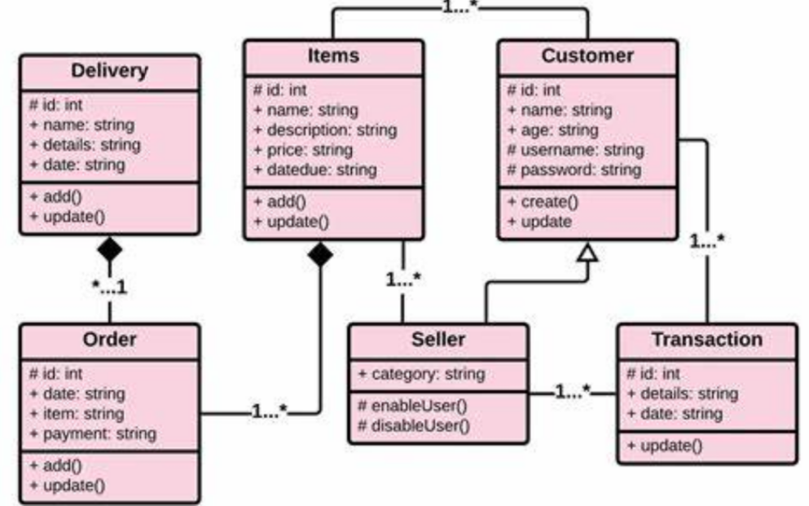

Fig. Class Diagram for Online Shopping System

|  |  |  |  |  |
| --- | --- | --- | --- | --- |
| **Table Name : LOGIN** | **PRIMARY KEY: LOGINID** | |  |  |
| **Field Name** | **Description** | **Type** | **Size** | **Attributes** |
| **LOGINID** | This field contains the login Id of the user. | Alphanumeric | 11 | Primary Key |
| Password | This field contains the password of the user. | Alphanumeric | 15 | Not null |
| Role | This field contains the role of the user (Customer, Seller, and Admin). | Alphanumeric | 13 | Foreign key: Role |

|  |  |  |  |  |
| --- | --- | --- | --- | --- |
| **Table Name : Item details** | **PRIMARY KEY: NAME** | |  |  |
| **Field Name** | **Description** | **Type** | **Size** | **Attributes** |
| Name | This field contains the names of items | String | 11 | Primary Key |
| Description | This field contains the description of item | String | 50 | Not null |
| Price | This field contains the price of each item | Alphanumeric | 9 | Not Null |
| DueDate | This field contains the due date of the item if any | Numeric | 2 | Not Null |

|  |  |  |  |  |
| --- | --- | --- | --- | --- |
| **Table Name : Customer** | **PRIMARY KEY: Role** | |  |  |
| **Field Name** | **Description** | **Type** | **Size** | **Attributes** |
| Role | This field contains the role of the user (Customer, Seller, and Admin). | Alphanumeric | 13 | Primary key: Role |
| CUSID | This field contains the customer code (same as the login Id of the login). | Alphanumeric | 11 | Primary Key |
| CName | This field contains the name of the customer | Alphanumeric | 50 | Not null |
| No. of orders | This field contains the list | Alphanumeric | 9 | Not Null |
| Current_orders | This field contains the no. of current orders. | Numeric | 2 | Foreign key: Current_orders |

|  |  |  |  |  |
| --- | --- | --- | --- | --- |
| **Table Name : Seller** | **PRIMARY KEY: SELID** | |  |  |
| **Field Name** | **Description** | **Type** | **Size** | **Attributes** |
| SELID | This field contains the seller code (same as the login Id of the login). | Alphanumeric | 11 | Primary Key |
| SName | This field contains the name of the seller | Alphanumeric | 50 | Not null |
| No. of orders | This field contains the list | Alphanumeric | 9 | Not Null |
| Current_items | This field contains the no. of current items. | Numeric | 2 | Foreign key: Current_items |

|  |  |  |  |  |
| --- | --- | --- | --- | --- |
| **Table Name : Cart** | **PRIMARY KEY: CUSID** | |  |  |
| **Field Name** | **Description** | **Type** | **Size** | **Attributes** |
| **CUSID** | This field contains the Customer code | Alphanumeric | 11 | Primary Key |
| No_items | This field contains no. of items in that customer cart | Alphanumeric | 50 | Not null |

|  |  |  |  |  |
| --- | --- | --- | --- | --- |
| **Table Name : Payment** | **PRIMARY KEY: CUSID** | |  |  |
| **Field Name** | **Description** | **Type** | **Size** | **Attributes** |
| **CUSID** | This field contains the CUSTOMER ID. | Alphanumeric | 11 | Primary Key |
| Paymethod | This field contains the details of the payment methods that they follow | Alphanumeric | 50 | Not null |
| Amount | This field contains the details of the amount of the money that they pay | Alphanumeric | 9 | Not Null |

**3.7 Other Requirements :** None

**AMITY SCHOOL OF ENGINEERING & TECHNOLOGY**

AMITY UNIVERSITY CAMPUS, SECTOR-125, NOIDA-201303



**Software Engineering Lab**

PRACTICAL FILE

COURSE CODE: IT301

Submitted to: Submitted by:

Dr. Sumit Kumar Boddu Asmitha Bhavya

A2305221386

6CSE-6X

**AMITY SCHOOL OF ENGINEERING & TECHNOLOGY**

AMITY UNIVERSITY CAMPUS, SECTOR-125, NOIDA-201303



**Complier Construction Lab**

PRACTICAL FILE

Submitted to: Submitted by:

Dr. Misha Kakkar Pratyaksha Sharma

A2305221652

6CSE-6X