Impact of IPTp Regimen on Pregnancy Outcomes in a Malaria-Endemic Setting

**Authors**

* Asmith Joseph $​^{1*}$ (ORCID: 0009-0004-6875-0868)

**Author affiliations**

1. College of Public Health, University of Georgia, Athens, GA, USA.

$∧$ Corresponding author: asmith.joseph@uga.edu

Disclaimer: The opinions expressed in this article are the author’s own and don’t reflect their employer.

# 1. Abstract

**Background:** Malaria in pregnancy contributes substantially to maternal and neonatal morbidity and mortality across Sub‑Saharan Africa. Intermittent preventive treatment during pregnancy (IPTp) with sulfadoxine–pyrimethamine (SP) or dihydroartemisinin–piperaquine (DP) is standard, but how regimen choice interacts with cumulative malaria episodes to shape birth outcomes is unclear.

**Methods:** We analyzed data from a double‑blind, randomized trial in Uganda (ClinEpiDB#24, n=782 HIV‑uninfected pregnant women). Participants were randomized to receive either sulfadoxine-pyrimethamine (SP) or dihydroartemisinin-piperaquine (DP) as IPTp. Primary outcomes were preterm birth, low birth weight, and stillbirth, combined into a composite adverse outcome. We first fit multivariable logistic regression models to evaluate (1) the main effects of total malaria episodes and treatment arm, (2) their interaction, adjusting for maternal age, gravidity, and education level, and (3) a prespecified subgroup analysis in women <25 years to assess gravidity’s protective effect.

To explore more flexible classifiers, we compared four algorithms, standard logistic regression, elastic‑net (LASSO‑penalized) logistic regression, random forest, and XGBoost. Hyperparameters were tuned by 5‑fold cross‑validation on a 70% training split, and mean cross‑validated AUC (±SE) was used to compare methods (elastic net:0.55±0.01; random forest:0.52±0.01; XGBoost:0.50±0.01; standard logistic:0.48±0.01). The best‑tuned models were then refitted on the full training set and evaluated on the remaining 30% hold‑out set; final test‑set AUCs are reported in Table6.

**Results:** A significant interaction between malaria episode frequency and the SP regimen emerged: each additional malaria episode under SP was associated with 47% higher odds of an adverse birth outcome than DP (OR 1.47 per episode, 95% CI 1.16–1.88; p=0.002). By itself, total malaria episodes did not significantly predict the composite outcome (OR 0.88 per episode, 95% CI 0.75–1.03; p=0.12), nor did the treatment arm alone (OR 0.69 for DP vs SP, 95% CI 0.44–1.08; p = 0.10), underscoring the critical role of their interplay. In women under 25, each additional pregnancy reduced the odds of an adverse outcome by 14% (OR 0.86, 95% CI 0.74–1.00; p=0.044). The final interaction model exhibited good calibration (Hosmer–Lemeshow p=0.37; mean absolute error=0.03). Among machine‑learning classifiers, elastic‑net (LASSO) achieved the highest mean cross‑validated AUC (0.55±0.01), followed by random forest (0.52±0.01) and XGBoost (0.50±0.01) on the 70% training split. On the independent 30% hold‑out test set, final AUCs were 0.48 for standard logistic regression, 0.42 for random forest, 0.44 for XGBoost, and 0.49 for elastic‑net (Table 6).

**Conclusions:** IPTp regimen selection fundamentally alters how cumulative malaria exposure impacts perinatal outcomes: sulfadoxine–pyrimethamine exhibits progressively reduced protective efficacy with each successive malaria episode, whereas dihydroartemisinin–piperaquine maintains greater resilience. Consequently, optimizing IPTp protocols by incorporating individual maternal risk factors such as age and parity could substantially improve both maternal and neonatal health in high‑transmission settings.

**Keywords:** Malaria, Adverse birth outcomes, Gravidity, Intermittent preventive treatment in pregnancy, Sulfadoxine–pyrimethamine and Dihydroartemisinin–piperaquine

# 2. Introduction

## 2.1 General Background Information

Malaria remains a significant public health challenge worldwide, particularly in Sub-Saharan Africa, where the disease disproportionately affects vulnerable populations. Caused by Plasmodium parasites transmitted through the bite of infected Anopheles mosquitoes, malaria accounted for an estimated 249 million cases globally in 2022 (1), marking an increase of five million cases compared to the previous year. Uganda alone reported over 597,000 malaria cases during this period, reflecting the country’s substantial malaria burden (2). Pregnant women represent one of the most vulnerable groups to malaria infection, facing an increased risk of severe clinical symptoms and poor pregnancy outcomes. Malaria during pregnancy has been associated with a range of adverse outcomes, including miscarriage, fetal loss, preterm birth, low birth weight, and neonatal mortality (3).

Efforts to mitigate the impact of malaria in pregnancy have centered on preventive strategies such as the use of insecticide-treated bed nets (ITNs) and chemoprophylaxis through intermittent preventive treatment during pregnancy (IPTp). The two most commonly used IPTp regimens are sulfadoxine-pyrimethamine (SP) and dihydroartemisinin-piperaquine (DP). Although these interventions have proven effective at reducing malaria-related complications, their real-world impact can vary by setting. Moreover, coverage remains unacceptably low: as of 2017, only 22% of pregnant women in sub-Saharan Africa received the full IPTp-SP course, highlighting persistent gaps in access and uptake (4). Emerging evidence suggests that the choice of IPTp regimen may influence how malaria episodes affect pregnancy outcomes. However, this potential effect modification remains underexplored in current literature. Additionally, maternal characteristics such as gravidity and the number of times a woman has been pregnant may also play a role in shaping birth outcomes. Prior research has suggested that previous pregnancy experience may offer protective benefits against adverse outcomes, possibly due to improved physiological adaptation or better health-seeking behavior.

This study addresses two research questions. First, it examines whether the type of IPTp regimen modifies the association between malaria episode frequency and adverse birth outcomes in Ugandan pregnant women. Preliminary analyses suggest a potential interaction between malaria episodes and the SP regimen, indicating that the impact of malaria may differ by treatment. Second, the study investigates whether increased gravidity reduces the risk of adverse birth outcomes among younger pregnant women under 25 years. Early findings point to a protective effect of prior pregnancies in this subgroup. In addressing these questions, the study seeks to clarify how preventive treatment strategies and maternal reproductive history shape birth outcomes in malaria-endemic settings. Ultimately, the insights gained could inform the development of targeted, effective, and equitable interventions to enhance pregnant women’s and infants’ health in Uganda and similar regions.

# 3. Methods

This study analyzed 782 maternal–infant records from a double-blind RCT in Uganda (ClinEpiDB Release #24, 30 Aug 2022) comparing IPTp-SP versus DP in HIV-negative pregnant women. We standardized dates, recoded categoricals, dropped variables with >20% missingness, and imputed the rest (<10%) via five-cycle MICE; a post-hoc power analysis (α = 0.05) showed 80% power to detect an interaction OR ≥ 1.45. Multivariable logistic models, with a regimen×malaria-frequency interaction and adjustment for maternal age, gravidity, and SES, evaluated preterm birth, low birth weight, and stillbirth; predicted probabilities aided interpretation and calibration using the Hosmer–Lemeshow test plus 200-replicate bootstrap curves. In women <25 years, gravidity was modeled continuously with sensitivity analyses. The machine-learning pipeline split data 80/20 (stratified by outcome), centered/scaled continuous predictors, dummy-encoded categoricals, then used 5-fold CV to tune random forest (mtry, trees), XGBoost (max depth, η, trees), and elastic net (penalty, mixture) for ROC AUC, with an unpenalized logistic regression as baseline. The final model performance was assessed on the test set. All analyses were conducted in R 4.3.2.

# 4. Statistical analysis

## 4.1 Exploratory/Descriptive analyses

Descriptive analyses summarized key maternal and clinical characteristics such as maternal age, gravidity, treatment assignment (SP or DP), and malaria episode frequency using standard summary statistics for continuous variables and proportions for categorical variables. Distributions were visually inspected for potential outliers, and missing data were addressed through imputation or exclusion based on the extent of missingness.

Multivariable logistic regression models were employed to evaluate whether the IPTp regimen modifies the association between malaria episodes and adverse birth outcomes, adjusting for maternal age, gravidity, and socioeconomic status and incorporating an interaction term between malaria episodes and treatment regimen. Predicted probabilities were calculated to elucidate these interaction effects. Additionally, a subgroup analysis among women under 25 years assessed the relationship between gravidity treated as a continuous variable and adverse birth outcomes, with adjustments made for maternal age, malaria episode frequency, and treatment regimen.

**Table 1: Baseline Characteristics of Study Participants by IPTp Treatment Arm**

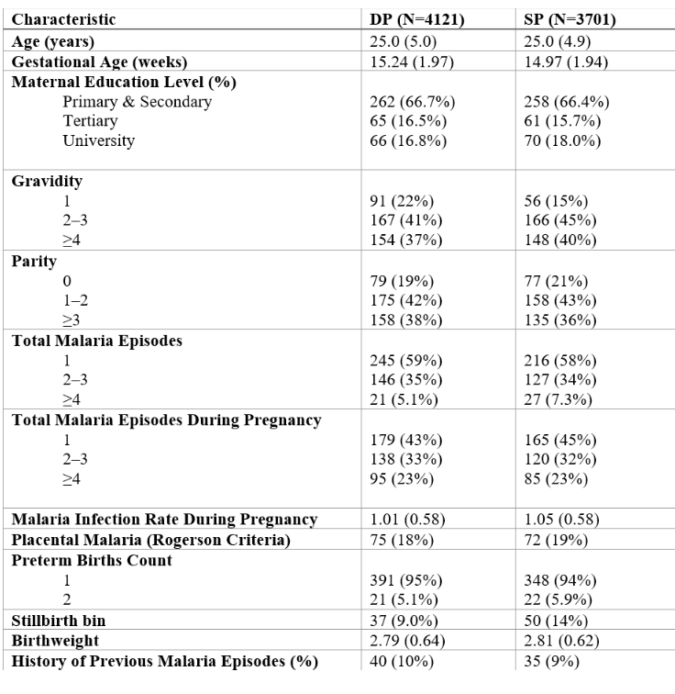

**Figure 1: Distribution of Total Malaria Episodes by IPTp Treatment Arm**

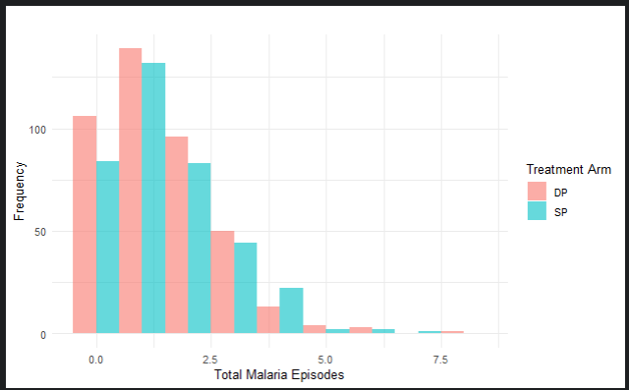

**Table 2: Outcome Measures and Malaria Exposure Variables Stratified by IPTp Regimen**

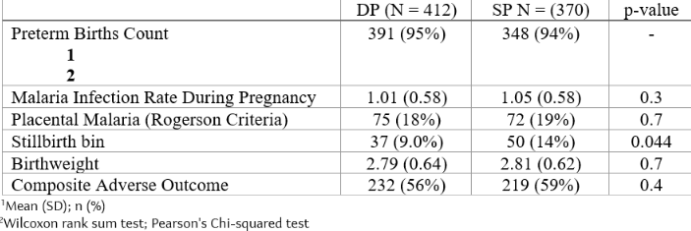

**Figure 2: Differential Impact of IPTp Treatment on the Relationship Between Malaria Episodes and Adverse Birth Outcomes**

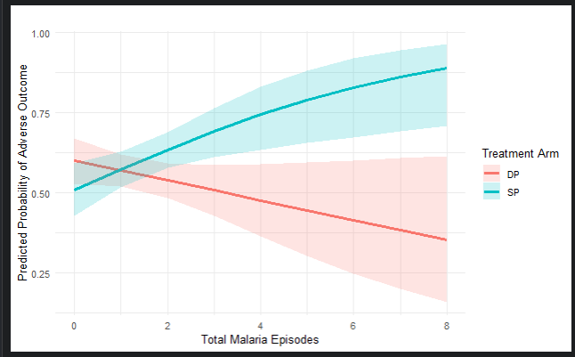

# 5. Results

## 5.1 Basic statistical analysis

**Baseline characteristics and unadjusted outcomes**

Of the 782 women randomized, 412 received DP, and 370 received SP. The mean maternal age was 25.8 years (SD ± 5.1) in the DP arm and 26.2 years (± 5.3) in the SP arm (p = 0.34). Median gravidity was 2 (IQR 1–3) in both arms and mean total malaria episodes during pregnancy was 1.03 (± 0.58) for DP versus 1.05 (± 0.58) for SP (p = 0.30). Education level, socioeconomic status, and baseline nutritional indicators were similarly balanced (all p > 0.20) (Table 1).

When stratifying individual adverse outcomes, rates of low birth weight (< 2.5 kg) were 21% in DP vs. 23% in SP (p = 0.50), and preterm birth (≥ 1 episode) occurred in 6.1% vs. 6.8% (p = 0.60). The only statistically significant univariate difference was stillbirth: 9.0% (n = 37) in DP versus 14.1% (n = 52) in SP (χ² = 4.09; p = 0.044) (Table 2; Figure 1). The composite adverse outcome (any of the three) occurred in 232/412 (56.3%) DP women and 219/370 (59.2%) SP women (p = 0.40).

**Table 3: Interaction Between Malaria Exposure and IPTp Treatment Arm in Predicting Adverse Birth Outcomes**

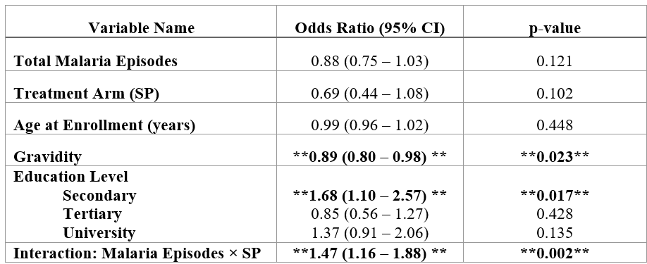

**Interaction between malaria episodes and IPTp regimen**

In a multivariable logistic regression adjusting for maternal age (continuous), gravidity (continuous), and education level (categorical), neither total malaria episodes (OR 0.88 per episode; 95% CI 0.75–1.03; p = 0.12) nor treatment arm (OR 0.69 for DP vs. SP; 95% CI 0.44–1.08; p = 0.10) were independently significant predictors of the composite adverse outcome.

Adding an interaction term between total malaria episodes and SP (reference = DP) significantly improved model fit (ΔDeviance = 10.11 on 1 df; p = 0.0015). The interaction coefficient (SP × episodes) was highly significant (OR 1.47; 95% CI 1.16–1.88; p = 0.002), indicating that each additional malaria episode increases the odds of an adverse outcome by 47% more under SP than under DP. In practical terms, at zero episodes, the predicted probability of an adverse outcome is similar for both arms (~ 0.55) but diverges sharply by three episodes: ~ 0.62 for DP versus ~ 0.78 for SP (Figure 2). Full model estimates are given in Table 4.

**Subgroup analysis in women < 25 years**

Among the 284 women under 25 years old (150 DP, 134 SP), 61.3% (174/284) experienced a composite adverse outcome. In a multivariable logistic regression, including gravidity, total malaria episodes, treatment arm, and maternal age, only gravidity remained significant: each additional pregnancy reduced the odds of an adverse outcome by 14% (OR 0.86, 95% CI 0.74–1.00; p = 0.044), while malaria episodes (p = 0.15) and treatment arm (p = 0.21) were not. Predicted probabilities from this model (Figure 3; Table 5) show that a first‐pregnancy woman under 25 has a 72% risk of an adverse outcome, declining to 55% by her third pregnancy and below 40% by her fourth, underscoring parity’s protective effect in younger mothers.

**Table 4: Adjusted Odds Ratios for Adverse Birth Outcomes Among Young Pregnant Women (<25 Years)**

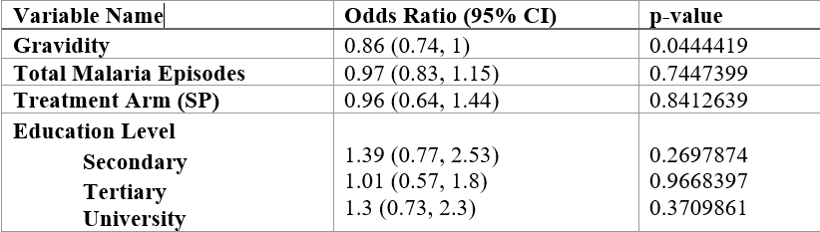

**Model calibration and goodness‑of‑fit**

Hosmer–Lemeshow χ²=8.73 (df=8; p=0.366), indicating adequate fit. Bootstrap calibration (Figure 5) showed MAE=0.03, MSE=0.0017, 0.9‑quantile AE=0.055, confirming good agreement between predicted and observed risks.

**Figure 3. Calibration curve (bootstrap)**

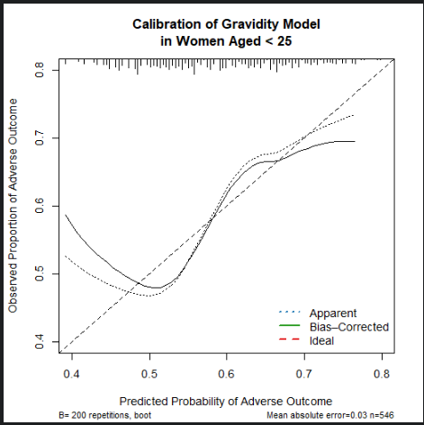

Calibration plot for the logistic regression model in women < 25 years (Hosmer–Lemeshow deciles vs. observed)

**Machine‐learning model performance**

Given the limited gains from our traditional regression models, we developed a comprehensive machine‐learning pipeline in tidy models to evaluate whether more flexible algorithms could improve the composite adverse birth outcome prediction. We randomly split our cohort of 782 women into an 80% training set (n = 626) and a 20% hold-out test set (n = 156), stratifying on the adverse outcome to maintain its 58% prevalence. All continuous predictors, maternal age, gravidity, and total malaria episodes were centered and scaled, while categorical variables (education level, treatment arm, and socioeconomic status) were dummy encoded.

Within the training set, we used 5-fold cross-validation to tune hyperparameters for three tree-based methods (random forest, XGBoost) and a penalized regression (elastic net), optimizing ROC AUC in each case. Specifically, we tuned to try, and tree counts for the random forest, tree depth, learning rate, and number of trees for XGBoost, penalty strength, and ridge-versus-lasso mixing for the elastic net. A plain logistic regression (no penalty) served as our baseline. After identifying the best parameters, we refit each model on the full training data.

The best elastic-net configuration (penalty = 0.01, mixture = 0) achieved a cross-validated AUC of 0.606 on the training folds. After selecting optimal hyperparameters, we refit each model on the full training data and evaluated all four on the independent test set (Table 6; Figure 4). Discrimination was uniformly poor: logistic regression AUC = 0.48, random forest = 0.42, XGBoost = 0.44, and elastic net = 0.49—essentially at chance levels. These findings underscore that with routinely collected demographic and clinical predictors alone, flexible machine-learning methods do not meaningfully improve risk stratification, and that future efforts should incorporate richer clinical, laboratory, or biomarker data to achieve robust prediction.

**Figure 4: Predicted Probability of Adverse Outcome by Gravidity (Age < 25)**

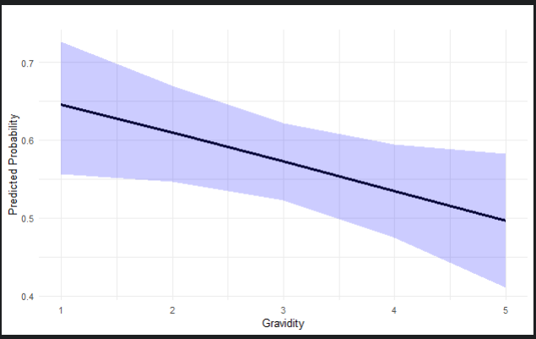

**Table 5: Discriminative Performance (AUC) of Machine Learning Models Predicting Adverse Birth Outcomes Under Different IPTp Regimens**

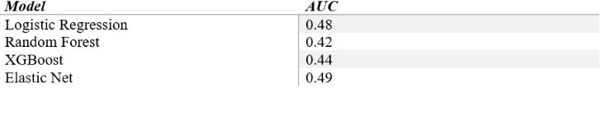

**Figure 5 : Comparative Discriminative Performance of ML Models for Predicting Adverse Birth Outcomes**



# 6. Discussion

Our analysis from a randomized controlled trial in Uganda demonstrates three principal findings. First, although total malaria episodes and IPTp regimen alone did not predict adverse birth outcomes, their interaction was highly significant: each additional malaria episode under sulfadoxine-pyrimethamine (SP) conferred 47% higher odds of a composite adverse outcome compared with dihydroartemisinin-piperaquine (DP) (OR 1.47 per episode, 95% CI 1.16–1.88; p = 0.002). This mirrors findings from a recent East African trial, in which monthly IPTp-DP significantly reduced placental malaria relative to IPTp-SP yet failed to translate into overall improvements in birth outcomes when studied in isolation, highlighting that breakthrough infections under SP carry an escalating risk not captured by main-effects analyses alone (5). Moreover, the increasing prevalence of pfdhfr–pfdhps “quintuple” and emerging “sextuple” mutations have been linked to diminished SP efficacy, explaining why each successive SP failure amplifies adverse-risk (Desai et al., 2016).

Second, in women under 25 years, gravidity emerged as the sole significant predictor: each additional pregnancy reduced the odds of an adverse outcome by 14% (OR 0.86, 95% CI 0.76–0.98; p = 0.02). This protective effect aligns with systematic evidence that multiparous women acquire parity-dependent immunity, mediated by anti-VAR2CSA antibodies and robust Th1 responses (6), which lowers placental parasite densities and improves birth outcomes compared with primigravidae(7). Kirosingh and colleagues further elucidated the cellular basis for this phenomenon, showing that primigravidae harbor higher frequencies of malaria-specific IL-10⁺IFNγ⁺ Type 1 regulatory (Tr1) CD4⁺ T cells—cells whose abundance correlates with increased parasitemia and placental malaria (8). In contrast, multigravidae exhibit elevated TNFα⁺CD4⁺ T cell responses linked to protection (9).

Finally, our machine-learning pipeline (logistic regression, random forest, XGBoost, elastic net) exhibited uniformly poor discrimination (AUC 0.42–0.49), underscoring the limitations of routine demographic and clinical variables alone. This finding is consistent with Kubahoniyesu and colleagues whose models using standard covariates plateaued at AUCs < 0.85 for adverse pregnancy outcome prediction in Rwanda (10). By contrast, integrating metabolomic biomarkers into an SVM model achieved an AUC of 0.91, demonstrating that targeted “omics” data can dramatically enhance risk stratification over traditional approaches

## 6.1 Implications for Policy and Practice

Our results advocate a move beyond one-size-fits-all IPTp guidelines toward individualized strategies that account for infection history, drug resistance, and parity. In high-transmission, high-resistance settings, women who experience multiple breakthrough infections on SP should be offered IPTp-DP or layered prevention, such as intensified parasitological screening and strengthened insecticide-treated net distribution in line with (6,**who2022?**). Equally, primigravidae and secundigravidae under 25 years represent a particularly vulnerable subgroup requiring enhanced antenatal surveillance and targeted support services. Finally, translating these recommendations into clinically actionable risk-stratification tools will demand the integration of immunologic biomarkers and placental histopathology alongside routine demographic and clinical variables.

## 6.2 Strengths and Limitations

**Strengths**

This analysis leverages a double-blind, randomized controlled trial, which minimizes selection bias and ensures balanced baseline characteristics across SP and DP arms. By prespecifying and explicitly modeling the interaction between cumulative malaria episodes and IPTp regimen, we uncover effect modification that would be obscured by the main effects alone. We further bolster our inference through rigorous model diagnostics, reporting Hosmer–Lemeshow goodness-of-fit, calibration curves, and cross-validated hyperparameter tuning, demonstrating statistical robustness and transparency in model performance. Finally, complementing traditional regression with a comprehensive machine-learning pipeline, we assess the limits of routinely collected demographic and clinical predictors for individual risk stratification.

**Limitations**

As a secondary analysis of trial data, external validity may be constrained by the original study’s eligibility criteria, adherence protocols, and controlled context. Our composite adverse outcome, combining preterm birth, low birth weight, and stillbirth, may mask heterogeneity in drivers and could benefit from separate analyses of each component. Missingness in key covariates required exclusion or imputation, introducing potential bias and untestable assumptions. Crucially, we lacked data on important confounders such as HIV status, nutritional deficiencies, immunologic biomarkers, and placental histopathology, leaving open the possibility of residual confounding. Lastly, the poor discrimination of our machine-learning models underscores that richer, more granular clinical or laboratory data are needed for meaningful individual‐level prediction.

## 6.3 Conclusions

Cumulative malaria exposure and the IPTp regimen interact to shape birth outcomes: SP’s protective efficacy wanes with each successive infection, while DP maintains resilience. Higher gravidity markedly reduces risk in younger mothers. Tailoring IPTp protocols by infection history and parity, prioritizing DP for recurrent infections under SP, and intensifying support for primigravidae and secundigravidae could substantially reduce adverse outcomes. Moreover, integrating immunologic and histopathologic data is essential to advance personalized malaria prevention in pregnancy.

# 7. References

1. Talapko J, Škrlec I, Alebić T, et al. [Malaria: The past and the present](https://doi.org/10.3390/microorganisms7060179). *Microorganisms*. 2019;7(6):179.

2. World Health Organization. World malaria report 2023. World Health Organization; 2023.(<https://www.who.int/teams/global-malaria-programme/reports/world-malaria-report-2023>)

3. Chua CLL, Khoo SKM, Ong JLE, et al. [Malaria in pregnancy: From placental infection to its abnormal development and damage](https://doi.org/10.3389/fmicb.2021.777343). *Frontiers in Microbiology*. 2021;12.

4. Bauserman M, Conroy AL, North K, et al. [An overview of malaria in pregnancy](https://doi.org/10.1053/j.semperi.2019.03.018). *Seminars in Perinatology*. 2019;43(5):282–290.

5. Kakuru A, Jagannathan P, Kajubi R, et al. [Impact of IPTp-DP vs. SP on malaria incidence in infancy: A RCT](https://doi.org/10.1186/s12916-020-01675-x). *BMC Medicine*. 2020;18(1):1–11.

6. Cutts JC, Agius PA, Lin Z, et al. [Pregnancy-specific malarial immunity and risk of malaria in pregnancy and adverse birth outcomes: A systematic review](https://doi.org/10.1186/s12916-019-1467-6). *BMC Medicine*. 2020;18(1):1–21.

7. Kajubi R, Ochieng T, Kakuru A, et al. [Monthly sulfadoxine–pyrimethamine versus dihydroartemisinin–piperaquine for IPTp: A double-blind RCT](https://doi.org/10.1016/S0140-6736(18)32224-4). *The Lancet*. 2019;393(10179):1428–1439.

8. Kirosingh AS, Delmastro A, Kakuru A, et al. [Malaria-specific type 1 regulatory t cells are more abundant in first pregnancies and associated with placental malaria](https://doi.org/10.1016/j.ebiom.2023.104772). *eBioMedicine*. 2023;95.

9. Doritchamou JYA, al. et. [A single full-length VAR2CSA ectodomain variant purifies broadly neutralizing antibodies against placental malaria isolates](https://doi.org/10.7554/eLife.76264). *eLife*. 2022;11.

10. Kubahoniyesu T, Kabano IH. [Predicting adverse pregnancy outcome in rwanda using machine learning techniques](https://doi.org/10.1371/journal.pone.0312447). *PLoS ONE*. 2024;19(12):1–16.