Impact of IPTp Regimen on Pregnancy Outcomes in a Malaria-Endemic Setting

**Authors**

* Asmith Joseph $​^{1*}$ (ORCID: 0009-0004-6875-0868)

**Author affiliations**

1. College of Public Health, University of Georgia, Athens, GA, USA.

$∧$ Corresponding author: asmith.joseph@uga.edu

Disclaimer: The opinions expressed in this article are the author’s own and don’t reflect their employer.

# 1. Abstract

Malaria remains a critical public health challenge in Sub-Saharan Africa, with pregnant women at heightened risk of adverse outcomes. This study analyzed data from a double-blind randomized controlled trial in Uganda (ClinEpiDB Release #24, August 30, 2022) to evaluate the impact of intermittent preventive treatment during pregnancy (IPTp) on adverse birth outcomes. A total of 782 HIV-uninfected pregnant women received either sulfadoxine-pyrimethamine (SP) or dihydroartemisinin-piperaquine (DP). Multivariable logistic regression models were used to assess whether the IPTp regimen modifies the association between malaria episode frequency and outcomes such as preterm birth, low birth weight, and stillbirth, while adjusting for confounders including maternal age, gravidity, and socioeconomic status. Although the main effects of malaria episodes and treatment arm were not statistically significant, the interaction between malaria episodes and the SP regimen was significant (OR = 1.47, 95% CI: 1.16–1.88, p = 0.002), suggesting that the impact of malaria differs by treatment. Additionally, a subgroup analysis of women under 25 years revealed that increased gravidity was significantly protective (OR = 0.86, 95% CI: 0.74–1.00, p = 0.044). These findings underscore the importance of tailoring malaria prevention strategies based on individual maternal profiles to improve maternal and neonatal health outcomes in malaria-endemic settings.

# 2. Introduction

## 2.1 General Background Information

Malaria remains a major public health challenge worldwide, particularly in Sub-Saharan Africa, where the disease disproportionately affects vulnerable populations. Caused by Plasmodium parasites transmitted through the bite of infected Anopheles mosquitoes, malaria accounted for an estimated 249 million cases globally in 2022, marking an increase of five million cases compared to the previous year. Uganda alone reported over 597,000 malaria cases during this period, reflecting the country’s substantial malaria burden (World Health Organization, 2023; Talapko et al., 2019). Pregnant women represent one of the most vulnerable groups to malaria infection, facing an increased risk of severe clinical symptoms and poor pregnancy outcomes. Malaria during pregnancy has been associated with a range of adverse outcomes, including miscarriage, fetal loss, preterm birth, low birth weight, and neonatal mortality (Chua et al., 2021).

Efforts to mitigate the impact of malaria in pregnancy have centered on preventive strategies such as the use of insecticide-treated bed nets (ITNs) and chemoprophylaxis through intermittent preventive treatment during pregnancy (IPTp). Two widely used IPTp regimens are sulfadoxine-pyrimethamine (SP) and dihydroartemisinin-piperaquine (DP). While these preventive measures have shown significant benefits in reducing the risk of malaria-related complications, the effectiveness of these regimens may not be uniform across all contexts. In particular, emerging evidence suggests that the choice of IPTp regimen may influence how malaria episodes affect pregnancy outcomes. However, this potential effect modification remains underexplored in current literature. Additionally, maternal characteristics such as gravidity, the number of times a woman has been pregnant may also play a role in shaping birth outcomes. Prior research has suggested that previous pregnancy experience may offer protective benefits against adverse outcomes, possibly due to improved physiological adaptation or better health-seeking behavior.

This study addresses two research questions. First, it examines whether the type of IPTp regimen modifies the association between malaria episode frequency and adverse birth outcomes in Ugandan pregnant women. Preliminary analyses suggest a potential interaction between malaria episodes and the SP regimen, indicating that the impact of malaria may differ by treatment. Second, the study investigates whether increased gravidity reduces the risk of adverse birth outcomes among younger pregnant women under 25 years. Early findings point to a protective effect of prior pregnancies in this subgroup. In addressing these questions, the study seeks to clarify how preventive treatment strategies and maternal reproductive history shape birth outcomes in malaria-endemic settings. Ultimately, the insights gained could inform the development of targeted, effective, and equitable interventions to enhance pregnant women’s and infants’ health in Uganda and similar regions.

# 3. Methods

This study analyzed data from a double-blind, randomized controlled trial conducted in Uganda, sourced from ClinEpiDB (Release #24, August 30, 2022). The trial evaluated intermittent preventive treatment during pregnancy (IPTp) using either sulfadoxine-pyrimethamine (SP) or dihydroartemisinin-piperaquine (DP) in HIV-uninfected pregnant women. The dataset comprised 782 observations detailing maternal, pregnancy, and infant health information, with multiple births recorded separately according to the original trial protocols.

Data preparation involved standardizing date fields, converting categorical variables into factors, and addressing missing data by excluding variables with over 20% missingness and imputing those with lower levels. Descriptive statistics and visual inspections ensured the integrity of the data.

The analysis was designed to evaluate whether the IPTp regimen modifies the association between malaria episode frequency and adverse birth outcomes, specifically, preterm birth, low birth weight, and stillbirth, and to assess whether increased gravidity reduces the risk of these outcomes among women under 25 years. Multivariable logistic regression models were employed to examine the relationship between malaria episodes and adverse outcomes, incorporating an interaction term for the IPTp regimen and adjusting for confounders such as maternal age, gravidity, and socioeconomic status. Predicted probabilities were calculated to facilitate the interpretation of interaction effects. A subgroup analysis among women under 25 years used logistic regression models with gravidity treated as a continuous variable and adjustments for maternal age, malaria episode frequency, and treatment regimen, with sensitivity analyses performed to verify robustness. All statistical analyses were conducted using R (version 4.3.2).

# 4. Statistical analysis

## 4.1 Exploratory/Descriptive analyses

Descriptive analyses summarized key maternal and clinical characteristics such as maternal age, gravidity, treatment assignment (SP or DP), and malaria episode frequency using standard summary statistics for continuous variables and proportions for categorical variables. Distributions were visually inspected for potential outliers, and missing data were addressed through imputation or exclusion based on the extent of missingness.

Multivariable logistic regression models were employed to evaluate whether the IPTp regimen modifies the association between malaria episodes and adverse birth outcomes, adjusting for maternal age, gravidity, and socioeconomic status, and incorporating an interaction term between malaria episodes and treatment regimen. Predicted probabilities were calculated to elucidate these interaction effects. Additionally, a subgroup analysis among women under 25 years assessed the relationship between gravidity treated as a continuous variable, and adverse birth outcomes, with adjustments made for maternal age, malaria episode frequency, and treatment regimen.

**Table 1: Baseline Characteristics of Study Participants by IPTp Treatment Arm**

| Characteristic | Subcategory | DP (N=4121) | SP (N=3701) |
| --- | --- | --- | --- |
| Age (years) |  | 25.0 (5.0) | 25.0 (4.9) |
| Gestational Age (weeks) |  | 15.24 (1.97) | 14.97 (1.94) |
| Maternal Education Level (%) |  |  |  |
|  | Primary | 262 (66.7%) | 258 (66.4%) |
|  | Tertiary | 65 (16.5%) | 61 (15.7%) |
|  | University | 66 (16.8%) | 70 (18.0%) |
| Gravidity |  |  |  |
|  | 1 | 91 (22%) | 56 (15%) |
|  | 2–3 | 167 (41%) | 166 (45%) |
|  | ≥4 | 154 (37%) | 148 (40%) |
| Parity |  |  |  |
|  | 0 | 79 (19%) | 77 (21%) |
|  | 1–2 | 175 (42%) | 158 (43%) |
|  | ≥3 | 158 (38%) | 135 (36%) |
| Total Malaria Episodes |  |  |  |
|  | 1 | 245 (59%) | 216 (58%) |
|  | 2–3 | 146 (35%) | 127 (34%) |
|  | ≥4 | 21 (5.1%) | 27 (7.3%) |
| Total Malaria Episodes During Pregnancy |  |  |  |
|  | 1 | 179 (43%) | 165 (45%) |
|  | 2–3 | 138 (33%) | 120 (32%) |
|  | ≥4 | 95 (23%) | 85 (23%) |
| Malaria Infection Rate During Pregnancy |  | 1.01 (0.58) | 1.05 (0.58) |
| Placental Malaria (Rogerson Criteria) |  | 75 (18%) | 72 (19%) |
| Preterm Births Count |  |  |  |
|  | 1 | 391 (95%) | 348 (94%) |
|  | 2 | 21 (5.1%) | 22 (5.9%) |
| Stillbirth bin |  | 37 (9.0%) | 50 (14%) |
| Birthweight |  | 2.79 (0.64) | 2.81 (0.62) |
| History of Previous Malaria Episodes (%) |  | 40 (10%) | 35 (9%) |

**Figure 1: Distribution of Total Malaria Episodes by IPTp Treatment Arm**

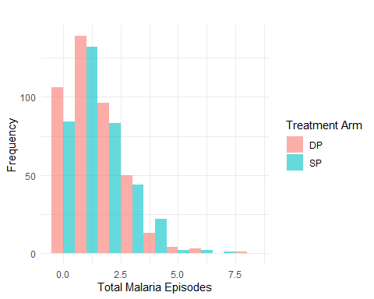

**Table 2: Outcome Measures and Malaria Exposure Variables Stratified by IPTp Regimen**

|  | **DP** N = 412*1* | **SP** N = 370*1* | **p-value***2* |
| --- | --- | --- | --- |
| Malaria Infection Rate During Pregnancy | 1.01 (0.58) | 1.05 (0.58) | 0.3 |
| Placental Malaria (Rogerson Criteria) | 75 (18%) | 72 (19%) | 0.7 |
| Preterm Births Count |  |  | 0.6 |
| 1 | 391 (95%) | 348 (94%) |  |
| 2 | 21 (5.1%) | 22 (5.9%) |  |
| Stillbirth bin | 37 (9.0%) | 50 (14%) | 0.044 |
| Birthweight | 2.79 (0.64) | 2.81 (0.62) | 0.7 |
| Composite Adverse Outcome | 232 (56%) | 219 (59%) | 0.4 |
| *1*Mean (SD); n (%) | | | |
| *2*Wilcoxon rank sum test; Pearson's Chi-squared test | | | |

**Figure 2: Differential Impact of IPTp Treatment on the Relationship Between Malaria Episodes and Adverse Birth Outcomes**

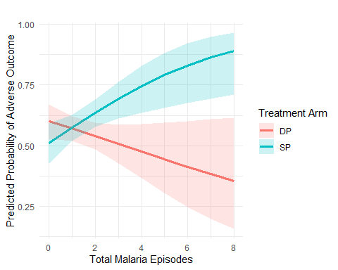

**Table 3: Outcome Measures and Malaria Exposure Variables Stratified by IPTp Regimen**

|  | **DP** N = 412*1* | **SP** N = 370*1* | **p-value***2* |
| --- | --- | --- | --- |
| Malaria Infection Rate During Pregnancy | 1.01 (0.58) | 1.05 (0.58) | 0.3 |
| Placental Malaria (Rogerson Criteria) | 75 (18%) | 72 (19%) | 0.7 |
| Preterm Births Count |  |  | 0.6 |
| 1 | 391 (95%) | 348 (94%) |  |
| 2 | 21 (5.1%) | 22 (5.9%) |  |
| Stillbirth bin | 37 (9.0%) | 50 (14%) | 0.044 |
| Birthweight | 2.79 (0.64) | 2.81 (0.62) | 0.7 |
| Composite Adverse Outcome | 232 (56%) | 219 (59%) | 0.4 |
| *1*Mean (SD); n (%) | | | |
| *2*Wilcoxon rank sum test; Pearson's Chi-squared test | | | |

# 5. Results

## 5.1 Basic statistical analysis

Baseline characteristics were similar across IPTp treatment arms, with comparable maternal age, gestational age, education, gravidity, and parity (Table 1). Although overall malaria exposure was similar between groups, the SP arm exhibited a significantly higher stillbirth rate (14% vs. 9%; p = 0.044) (Table 2).

Multivariable logistic regression analyses, adjusted for maternal age, gravidity, and education revealed that the main effects of total malaria episodes (OR = 0.88, 95% CI: 0.75–1.03, p = 0.121) and treatment arm (OR = 0.69, 95% CI: 0.44–1.08, p = 0.102) were not statistically significant. However, incorporating an interaction term between malaria episodes and the IPTp regimen significantly improved model fit (ΔDeviance = 10.11, p = 0.00148), with the interaction itself reaching significance (OR = 1.47, 95% CI: 1.16–1.88, p = 0.002). These findings suggest that the impact of malaria exposure on adverse birth outcomes is modified by the treatment regimen. Additionally, gravidity demonstrated a protective effect (OR = 0.89, 95% CI: 0.80–0.98, p = 0.023), indicating that prior pregnancy experience reduces the risk of adverse outcomes.

**Table 4: Interaction Between Malaria Exposure and IPTp Treatment Arm in Predicting Adverse Birth Outcomes**

|  | Odds Ratio | Std. Error | z value | p-value | 95% CI Lower | 95% CI Upper |
| --- | --- | --- | --- | --- | --- | --- |
| Total Malaria Episodes | 0.88 | 0.08 | -1.55 | 0.121 | 0.75 | 1.03 |
| Treatment Arm (SP) | 0.69 | 0.23 | -1.64 | 0.102 | 0.44 | 1.08 |
| Age at Enrollment (years) | 0.99 | 0.01 | -0.76 | 0.448 | 0.96 | 1.02 |
| Gravidity | 0.89 | 0.05 | -2.27 | 0.023 | 0.80 | 0.98 |
| Secondary Education | 1.68 | 0.22 | 2.39 | 0.017 | 1.10 | 2.57 |
| Tertiary Education | 0.85 | 0.21 | -0.79 | 0.428 | 0.56 | 1.27 |
| University Education | 1.37 | 0.21 | 1.49 | 0.135 | 0.91 | 2.06 |
| Interaction: Malaria Episodes × SP | 1.47 | 0.12 | 3.13 | 0.002 | 1.16 | 1.88 |

**Table 5: Regression Diagnostics for IPTp Treatment Effect**

| Model | Residual Df | Residual Dev | Df | Deviance | p-value |
| --- | --- | --- | --- | --- | --- |
| No Interaction | 774 | 1045.674 | NA | NA | NA |
| With Interaction | 773 | 1035.565 | 1 | 10.10871 | 0.0014757 |

|  | Variable | GVIF | Df (VIF) | GVIF^(1/(2*Df)) |
| --- | --- | --- | --- | --- |
| total_malaria_episodes | Total Malaria Episodes | 1.798086 | 1 | 1.340927 |
| study_arm | Treatment Arm | 2.368263 | 1 | 1.538916 |
| age_at_enrollment_years | Age at Enrollment | 1.005887 | 1 | 1.002939 |
| gravidity | Gravidity | 1.010161 | 1 | 1.005068 |
| education_level | Education Level | 1.020210 | 3 | 1.003340 |
| total_malaria_episodes:study_arm | Interaction: Malaria Episodes × SP | 3.119000 | 1 | 1.766069 |

**Table 6: Evaluating Effect Modification by IPTp Treatment on Malaria-Related Adverse Birth Outcomes Through Model Comparison**

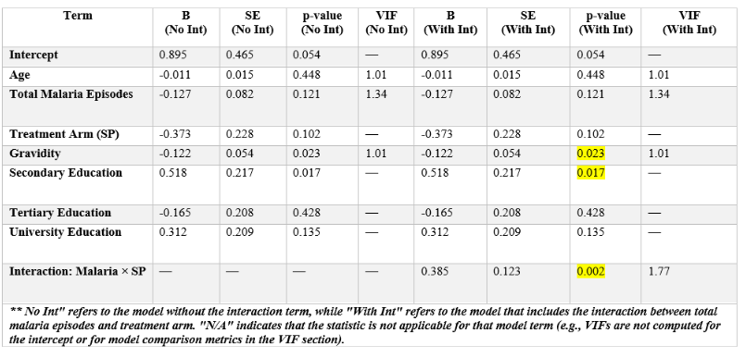

**Table 7: “Incidence Rate Ratios for Malaria Episode Occurrence among Pregnant Women**

| Variable | IRR | X95..CI.Lower | X95..CI.Upper | p.value |
| --- | --- | --- | --- | --- |
| Intercept | 1.6081682 | 1.1297705 | 2.280714 | 0.0080210 |
| Treatment Arm (SP vs. DP) | 1.0552044 | 0.9382987 | 1.186523 | 0.3693644 |
| Age at Enrollment (years) | 0.9942737 | 0.9825662 | 1.006133 | 0.3422319 |
| Gravidity | 1.0095680 | 0.9675647 | 1.053391 | 0.6604499 |
| Education Level: Secondary | 0.9884423 | 0.8348897 | 1.170522 | 0.8926618 |
| Education Level: Tertiary | 0.8900707 | 0.7505115 | 1.055600 | 0.1805472 |
| Education Level: University | 1.0363703 | 0.8805393 | 1.220799 | 0.6680350 |

Baseline characteristics were similar across IPTp treatment arms, with comparable maternal age, gestational age, education, gravidity, and parity (Table 1). Although overall malaria exposure was similar between groups, the SP arm exhibited a significantly higher stillbirth rate (14% vs. 9%; p = 0.044) (Table 2).

Multivariable logistic regression analyses, adjusted for maternal age, gravidity, and education revealed that the main effects of total malaria episodes (OR = 0.88, 95% CI: 0.75–1.03, p = 0.121) and treatment arm (OR = 0.69, 95% CI: 0.44–1.08, p = 0.102) were not statistically significant. However, incorporating an interaction term between malaria episodes and the IPTp regimen significantly improved model fit (ΔDeviance = 10.11, p = 0.00148), with the interaction itself reaching significance (OR = 1.47, 95% CI: 1.16–1.88, p = 0.002). These findings suggest that the impact of malaria exposure on adverse birth outcomes is modified by the treatment regimen. Additionally, gravidity demonstrated a protective effect (OR = 0.89, 95% CI: 0.80–0.98, p = 0.023), indicating that prior pregnancy experience reduces the risk of adverse outcomes.

**Table 8: Adjusted Odds Ratios for Adverse Birth Outcomes Among Young Pregnant Women (<25 Years)**

| Variable | Odds Ratio (95% CI) | p-value |
| --- | --- | --- |
| Gravidity | 0.86 (0.74, 1) | 0.0444419 |
| Total Malaria Episodes | 0.97 (0.83, 1.15) | 0.7447399 |
| Treatment Arm (SP) | 0.96 (0.64, 1.44) | 0.8412639 |
| Secondary Education | 1.39 (0.77, 2.53) | 0.2697874 |
| Tertiary Education | 1.01 (0.57, 1.8) | 0.9668397 |
| University Education | 1.3 (0.73, 2.3) | 0.3709861 |

**Figure 3: Predicted Probability of Adverse Outcome by Gravidity (Age < 25)**

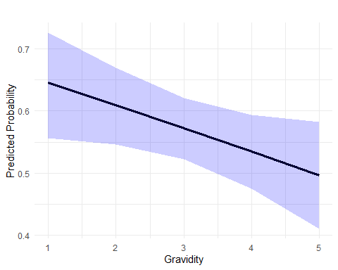

Based on our findings, the impact of malaria on adverse birth outcomes is significantly modified by the IPTp regimen, with a distinct interaction effect observed for the SP regimen. Additionally, increased gravidity appears to offer a protective benefit, particularly among women under 25 years. Detailed results supporting these observations are presented in Tables 3–6 and Figures 1–3.

# 6. Discussion

Our data analysis from a randomized controlled trial in Uganda provides important insights into the interplay between malaria exposure, IPTp regimen, and adverse birth outcomes. Specifically, our findings reveal that while the individual effects of total malaria episodes and the treatment arm were not statistically significant, the interaction between malaria episodes and the SP regimen significantly increased the risk of adverse outcomes. Additionally, increased gravidity emerged as a robust protective factor, particularly among pregnant women under 25 years, with each additional pregnancy associated with a roughly 14% reduction in risk.

These results align with previous studies that have highlighted the complex relationship between maternal characteristics and malaria-related complications during pregnancy. For example, similar protective effects of gravidity have been reported in the literature (Chua et al., 2021), and emerging evidence suggests that the efficacy of IPTp regimens may vary depending on the context and specific treatment used (Talapko et al., 2019 World Health Organization, 2023). Our findings extend these observations by demonstrating that the SP regimen, in particular, modifies the impact of malaria exposure on birth outcomes, emphasizing the need for tailored malaria prevention strategies.

However, our study has several limitations. First, the data were derived from a controlled trial setting, which may limit the generalizability of the findings to broader, real-world populations. Second, the necessity to exclude or impute variables with significant missing data could have influenced the robustness of our estimates. Third, the modest discriminative ability of our models reflected in ROC curves with AUC values near 0.55–0.60 suggests that additional, unmeasured factors might contribute to adverse birth outcomes.

Despite these limitations, our study offers valuable contributions to the field. The evidence that IPTp regimen choice can modify the relationship between malaria episodes and adverse birth outcomes, along with the protective role of gravidity, underscores the importance of developing more personalized intervention strategies. Future research should aim to validate these findings in more diverse settings and explore other potential determinants of maternal and neonatal health in malaria-endemic regions.

In summary, our findings advocate for a nuanced approach to malaria prevention in pregnancy that considers both the specific IPTp regimen and individual maternal reproductive history. Such tailored strategies have the potential to substantially improve maternal and neonatal health outcomes in regions where malaria remains a significant public health challenge.

## 6.1 Summary and Interpretation

*Summarize what you did, what you found and what it means.*

## 6.2 Strengths and Limitations

*Discuss what you perceive as strengths and limitations of your analysis.*

## 6.3 Conclusions

*What are the main take-home messages?*

*Include citations in your Rmd file using bibtex, the list of references will automatically be placed at the end*

This paper (1) discusses types of analyses.

These papers (2,3) are good examples of papers published using a fully reproducible setup similar to the one shown in this template.

Note that this cited reference will show up at the end of the document, the reference formatting is determined by the CSL file specified in the YAML header. Many more style files for almost any journal [are available](https://www.zotero.org/styles). You also specify the location of your bibtex reference file in the YAML. You can call your reference file anything you like.

# 7. References

1. Leek JT, Peng RD. [Statistics. What is the question?](https://doi.org/10.1126/science.aaa6146) *Science (New York, N.Y.)*. 2015;347(6228):1314–1315.

2. McKay B, Ebell M, Billings WZ, et al. [Associations Between Relative Viral Load at Diagnosis and Influenza A Symptoms and Recovery.](https://doi.org/10.1093/ofid/ofaa494) *Open forum infectious diseases*. 2020;7(11):ofaa494.

3. McKay B, Ebell M, Dale AP, et al. [Virulence-mediated infectiousness and activity trade-offs and their impact on transmission potential of influenza patients.](https://doi.org/10.1098/rspb.2020.0496) *Proceedings. Biological sciences*. 2020;287(1927):20200496.