**Idea/Approach Details**

**Technology Bucket:** Software-Web App Development

**Company Name/Ministry Name:** DIPP **Category:** Software

**Problem Code:** DM4

**Team Name:** Strange Snippets

**Team Leader Name**: Ayush Sahu **College Code:** 1-3669181121

**Idea:** To create a web-app that provides a platform to connect a mentee with the right Professional Mentor from various Central Government Departments based on their field of expertise where the match is concluded from factors based on request posted by the mentee resulting in a suggestion of a list of possible mentors with the help of Machine learning. The platform empowers mentors with tools like messaging, resource sharing making the process effortless for them.

**Technology Stack:**

* Django: The web-app is primarily implemented in the Django Python web framework.
* HTML templates, JavaScript, etc. (open source libraries like Jquery etc. will be used) Jinga2 template engine will be used.
* NGINX/Apache can be used in production. We are using Django dev web server for development.
* MySQL is the database that stores all the persistent data.
* ML using Python operated by Spyder console using libraries like Numpy, MatPlotLib, Pandas and ScikitLearn.

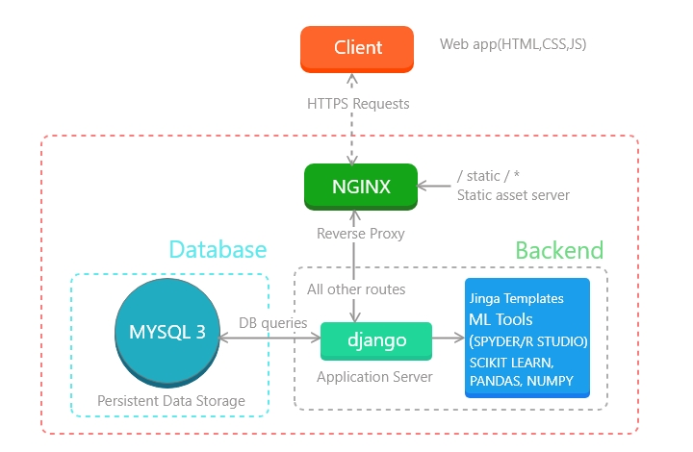

**Use Cases:**

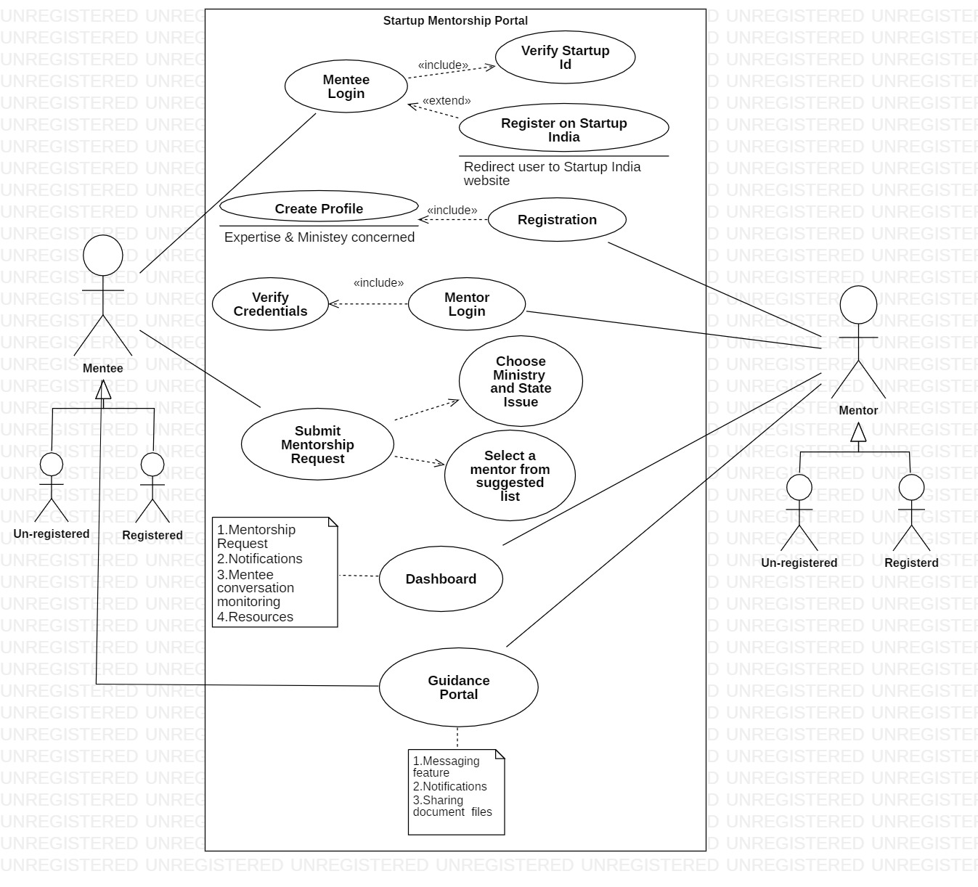

**Mentee** : A startup in need of guidance from government entities.

**Mentor**: Government officials from various central government departments.

**Investors**: Stakeholders suggested to Mentors based on their investment records etc. via ML (A resource tool), which can be further judged and shared to mentee.

**Super Admin**: Startup India, responsible for verification of Mentors from different central government department by validating the form sent through Mentor registration portal.

**Show – Stopper**

We need dataset of Government officials who will be appointed as mentors by the respective ministry for mentorship. At the very least we need to know what are the parameters according to which government appoint these mentors, to create our dummy dataset. This is important because we will further use this data set for our ML algorithm.

**Key Features:**

* Empowers our PM’s Startup India Scheme.
* Matches problem stated by potential startup candidates with the right mentor from designated ministries.
* Establishes better communication between government officials and startups helping both to learn and improve, like former can know the common issues faced my most startups while latter can get to know the schemes, opportunity to pilot.
* Django framework makes integrating tools easy, thus providing an upper hand in embedding features for easing the work of mentors.