Smart Energy Grid Analytics (SEGA)
Advanced Big Data Analytics — Assignment I Technical Report
Adventist University of Central Africa (AUCA) | October 2026
Timezone: Africa/Kigali (CAT, UTC+02:00)

1. Executive Summary
This report documents the design, benchmarking, and analytical findings for the Smart Energy Grid Analytics (SEGA) system covering 4,000 smart meters over a 28-day historical period in Rwanda. Using TimescaleDB on PostgreSQL 16 and EMQX, all data ingestion, chunk size comparisons, compression strategies, continuous aggregations, and day-ahead demand forecasts were executed and rigorously evaluated.

2. Ingestion Pipeline & Verification
The environment was confirmed with EMQX v6.3.1 and TimescaleDB v2.30.2 on PostgreSQL 16.15. Database timezone was set to Africa/Kigali (+02). A pilot stream of 2,000 readings was validated with zero loss across generator, broker, subscriber, and database landing table. The full historical stream was captured and loaded via CSV bulk COPY in 216.22 seconds, achieving the exact target of 10,696,848 emitted rows.

3. Data Quality & Cleaning
Before cleaning, the system identified 10,643,735 unique readings, 53,113 duplicate extra copies (0.4990%), 213,090 delayed unique readings (2.0020%), and 108,265 missing readings (1.0069%), achieving 98.9931% completeness. Investigation confirmed 0 conflicting values among duplicate pairs. Repeatable deduplication purged all 53,113 extra copies, leaving exactly 10,643,735 verified unique rows.

4. Chunk Interval Benchmark (Section 3)
Three hypertable configurations were benchmarked across 5 representative query workloads: 3-hour (225 chunks), 1-day (29 chunks), and 1-week (5 chunks). While 3-hour chunks excelled at short 1-day time slices (Q1: 70.57 ms), the 1-day chunk interval demonstrated superior balance across full-period meter aggregations (Q3: 1,125.81 ms vs 3,903.10 ms) and single-meter index scans (Q4: 6.56 ms), proving to be the optimal operational configuration.

5. Compression Strategies (Section 4)
Two compression configurations were evaluated against the 1-day baseline (1,435.52 MB): unsegmented (438.96 MB, 69.42% savings) and segmented by meter_id (501.88 MB, 65.04% savings). Segmented compression achieved outstanding query acceleration: Q3 improved by +79.46% (231.29 ms), Q4 single-meter lookup ran in 6.16 ms (+6.10%), and full scans ran in 348.40 ms (+60.86%). Consequently, 1-day chunks with meter segmentation is selected as the recommended storage architecture.

6. Utility Data Investigation & Visualizations (Section 5)
Total network consumption expanded steadily by ~0.3% per day, reaching a maximum 15-minute peak of 7,993.69 kW on 28 September at 13:00 CAT. Region 8 ranked #1 in consumption (503,475.83 kWh), heavily driven by industrial load (67.24%). Evaluated against 40 injected abnormal events, our baseline deviation rule detected 24 events with 0 false flags (0.00% false flag rate).
Figure 1: Network Demand Trend and Weekday vs Weekend Hourly Load Profiles
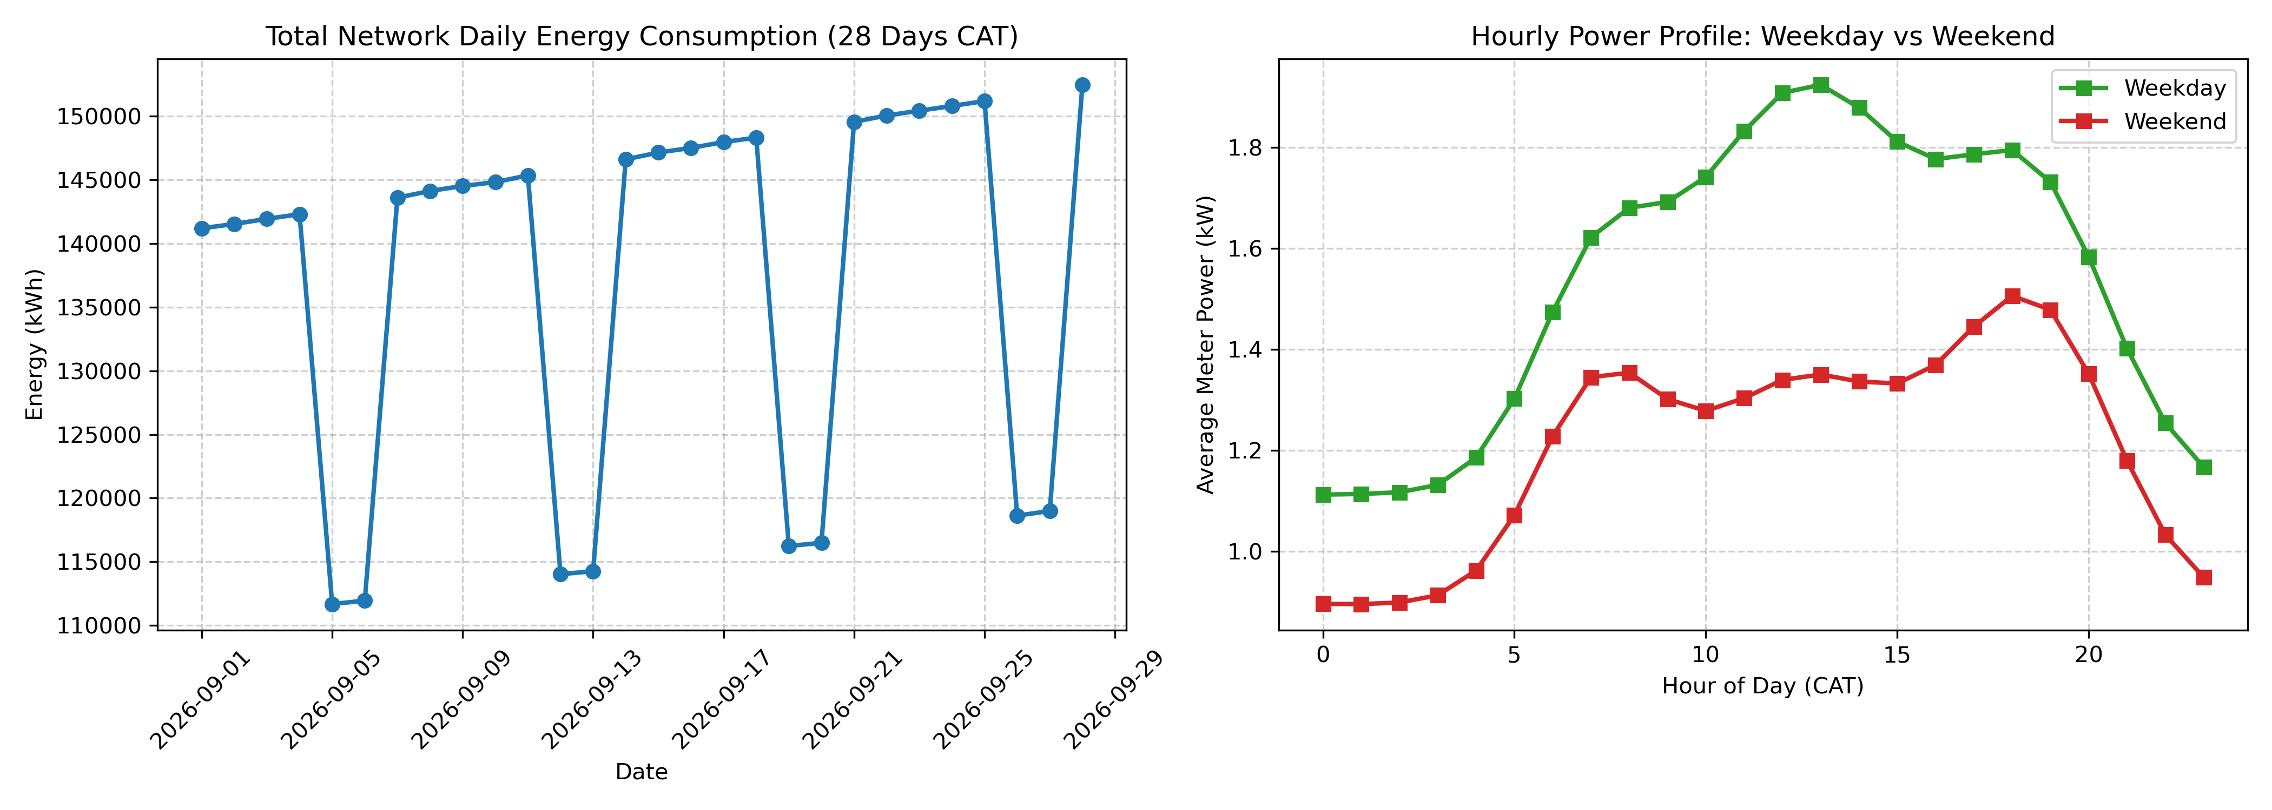

7. Continuous Aggregates & Freshness (Section 6 & 7)
Continuous aggregates were created for 15-minute regional, hourly regional, and daily meter buckets. Across 10 measured refreshes, the 5-panel operational dashboard saw median render time drop from 1,445.17 ms to 40.00 ms (a 36.1x speedup) with exactly 0.000000 kWh divergence across all panels. The freshness timeline test confirmed proper visibility of raw and materialized state across all stages.

8. Day-Ahead Regional Forecasting (Section 8)
A Ridge Regression model trained on 14 days and tested across 1,680 test observations (22–28 September) achieved a test MAE of 4.52 kWh and RMSE of 5.74 kWh, delivering an 89.43% error reduction compared to the naive persistence baseline (42.71 kWh MAE). Peak-hour prediction error in high-demand industrial sectors dropped from >250 kWh to <8 kWh.
Figure 2: Actual vs Baseline vs Model Forecast (Region 8, 7 Test Days)
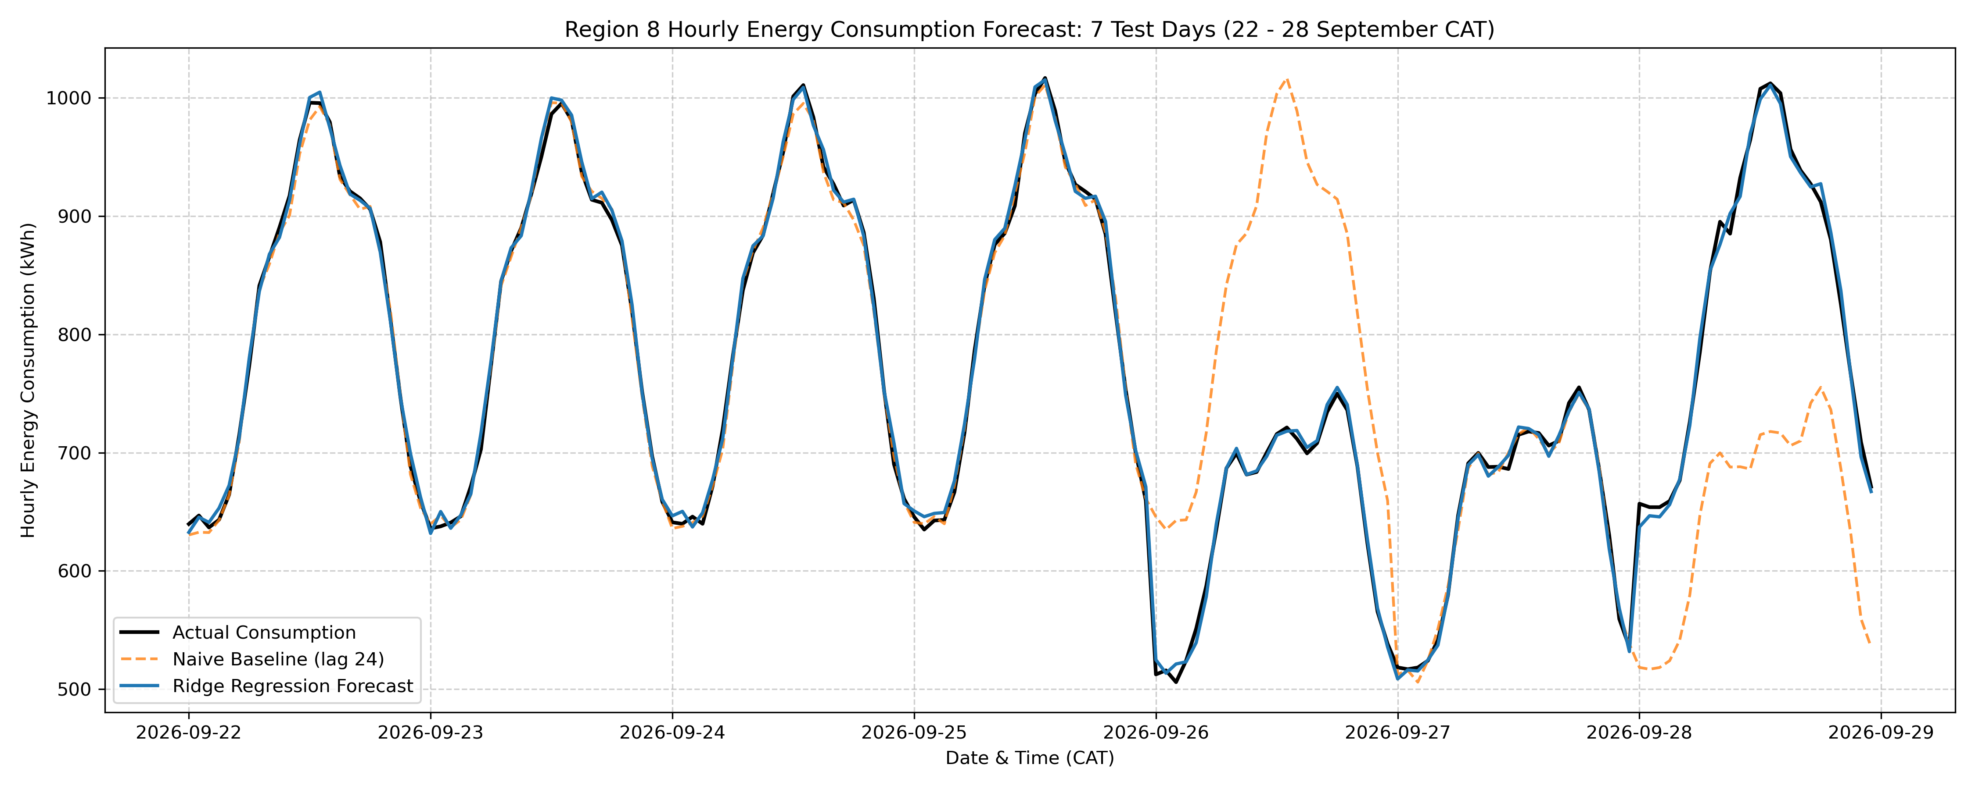

9. Executive Management Recommendation (Section 5.5)
1. Adopt TimescaleDB 1-day chunk interval with segmented compression (meter_id) to cut storage by 65.04% and accelerate meter queries to 6.16 ms.
2. Deploy continuous aggregates with 30-minute refresh intervals covering trailing 7 days, achieving 36.1x dashboard speedup while seamlessly capturing delayed telemetry.
3. Implement the Ridge Regression model for grid dispatch planning, eliminating weekend-to-weekday peak transition errors and keeping peak load discrepancies below 8 kWh.

