Car Price Prediction Analysis

-P. Abirami Soundharya
Data Analytics Sep 2025 Batch
INDEX
1 | INTRODUCTION
2 | DATA DESCRIPTION AND PREPARATION
3 | DAX FORMULA AND CALCULATION
4 | SLICER AND PIVOT CHART
5 | DASHBOARD
6 | KEY INFLUENCERS AND Q&A
9 | INSIGHTS AND RECOMMENDATIONS
10 | CONCLUSION

INTRODUCTION
To perform a comprehensive analysis on car-related data using Power BI to derive meaningful insights, mainly focusing on identifying trends, understand performance, relations, strategies, and other key factors that influence car prices to deliver informative observations and uncover opportunities in order to support data-driven decision-making.
PROJECT OBJECTIVE
• To study car price trends
• To identify important factors such as brand, fuel type, mileage, and condition
• To create an interactive dashboard for decision-making
• To provide insights and recommendations
SCOPE
The emphasis is purely on exploratory analysis and visual storytelling using Power BI. The analysis covers sales dataset focused within the,
• Visualizing distributions and relationships between features
• Identifying influential factors on car price
• Drawing insights from the trends observed in the dashboards
• Price variation based on car attributes (Brand, Model, Condition, etc.)
• Distribution of fuel types, transmissions, and engine sizes
• Mileage and year trends across different vehicle categories
• Outliers that may indicate unusual pricing or misreported features
• Potential predictors of price, helping support future price estimation models
ANALYSIS
DATA COLLECTION: Dataset contains 2500 records of data contributing the collection of car related details like, Car ID, Brand – (Mercedes, Benz, Tesla, Audi, Ford, Toyota, Honda), Year – (2000 - 2023), Engine Size, Fuel Type – (Hybrid, Petrol, Electric, Diesel), Transmission – (Automatic, Manual), Mileage, Condition – (Used, New, Like New), Price, Models. Combination of Luxury, Economy Brands

DATA CLEANING: Cleaning process of this dataset includes,
- Dataset checked for respective datatypes
- Duplicates are removed using Remove Duplicate option
Finally clean and clear dataset ready for analysis.

DAX: Data Analysis Expression, a library of functions and operators that can be combined to build formulas and expressions in Power BI for analysis.
Category | DAX Function | Purpose in Project
Mathematical | SUM | Calculating Total Sales and Total Mileage.
Mathematical | DIVIDE | Safely calculating Average Mileage per Year (handling 0 errors).
Statistical | AVERAGE | Determining the baseline Average Selling Price across the fleet.
Logical | IF | Creating conditional logic for car age and category tagging.
Logical | SWITCH | Categorizing cars into "Budget," "Mid-Range," and "Luxury."
Filter | CALCULATE | Changing filter context to find sales for specific fuel types.
Aggregate | DISTINCTCOUNT | To identify the variety and breadth of your inventory or market coverage.
Date/Time | YEAR | Extracting the year from the current date for age calculations.
Aggregate | MAX | To identify "Flagship" assets and upper-limit performance.
Aggregate | MIN | To identify the "Entry Point" or the most affordable options for customers.

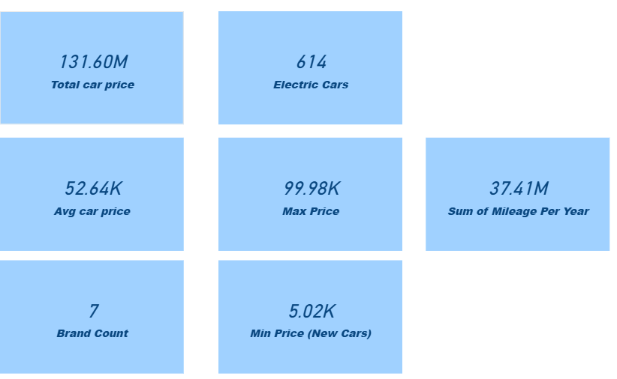

SUM - To get the entire cost of the car, this dax function was developed using
Sum.
Total car price = SUM(car[Price])

AVERAGE- The dax function was developed using average to determine the average
cost of a car.
Avg car price = AVERAGE(car[Price])

DISTINCTCOUNT- Using DISTINCTCOUNT, this dax function determines the count.
Brand Count = DISTINCTCOUNT('car'[Brand])

CALCULATE- Using CALCULATE, this dax function determines the count.
Electric Cars = CALCULATE(COUNT('car'[Car ID]), 'car'[Fuel Type] = "Electric")

SUM OF MILEAGE PER YEAR-Calculates the age of the vehicle by subtracting the manufacturing year from the current year. Divides the total mileage by the age to find the yearly average.
Mileage Per Year =
VAR CarAge = YEAR(TODAY()) - 'car'[Year] RETURN DIVIDE('car'[Mileage], IF(CarAge = 0, 1, CarAge), 0)

MAX- This dax function is used to calculate the maximum car
price using the max function.
Max Price = MAX('car'[Price])

MIN- Using the min function, this dax function determines the minimum cost of a new car.
Min Price (New Cars) = CALCULATE(MIN('car'[Price]), 'car'[Condition] = "New")

IF- Using the formula IF('car'[Mileage] > 100000, "High Mileage", "Low Mileage") and an additional column, this dax function determines the High Mileage Status.

SWTICH- Price Category = SWITCH(TRUE(), 'car'[Total car price] < 20000, "Budget", 'car'[Total car price] <= 60000, "Mid-Range", "Luxury") and an additional column are determined using this dax function.

YEAR- Car Age = YEAR(TODAY()) - 'car'[Year] and additional column are computed using this dax function.

DIVIDE- Mileage Per Year = VAR CarAge = YEAR(TODAY()) - 'car'[Year] is computed using this dax function.
Return the additional column and divide ('car'[Mileage], IF(CarAge = 0, 1, CarAge), 0).
ANALYSIS EXPLANATION
In Power BI, the data - visualized through multiple dashboards, allowing for:
BAR CHART
The chart shows the total value per car brand, ranging narrowly between 18M and 19M.
Toyota and BMW lead the group at 19M, while Ford sits at the low end with 18M. The nearly uniform bar heights indicate a highly competitive market with minimal value gaps between these major manufacturers.
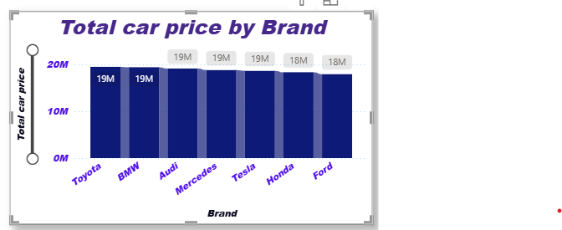
AREA CHART
This chart shows a downward trend in entry-level pricing based on fuel type, with Petrol cars having the highest minimum price (6.3K) and Diesel cars offering the most affordable starting point at (5.0K).
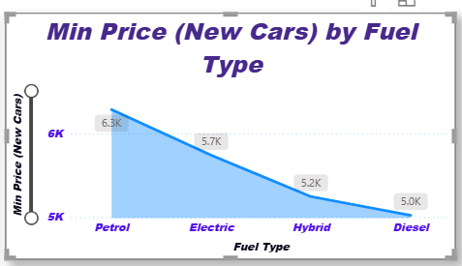
Pie Chart
The market is dominated by the Luxury category, which accounts for 60.13% of the average price value at 80K, while the Budget segment represents the smallest portion at only 9.56% (12.72K).
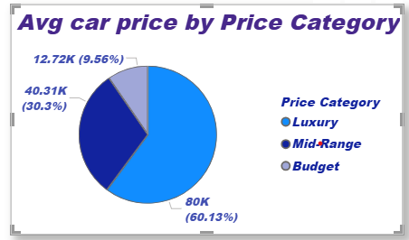
DECOMPOSITION TREE
Fuel Type Distribution: Out of 2,500 total car brand entries, Diesel is the most frequent with 655 units, followed by Petrol (630) and Electric (614).
Minimum Entry Pricing: The minimum price for new cars decreases based on fuel type, starting at its highest with Petrol ($6.3K) and reaching its lowest with Diesel ($5.0K).
Price Category Value: The Luxury segment dominates the average car price, accounting for 60.13% ($80K) of the total value, while the Budget segment represents the smallest share at 9.56% ($12.72K).
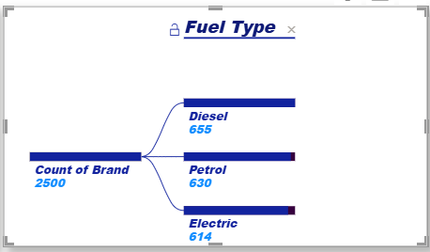
RIBBON CHART
Fuel Type & Pricing: Diesel is the most common engine type with 655 units, yet it offers the lowest entry price point at $5.0K.
Segment Valuation: The Luxury category dominates total value, commanding 60.13% ($80K) of the average car price.

Transmission Trends: Manual transmissions are more prevalent than automatic, with Audi leading manual models (198) and Toyota leading automatic models (187).
Inventory Overview: Out of a total 2,500 brands, the inventory is relatively evenly split across major manufacturers, with model counts per brand ranging from 159 to 198 units.
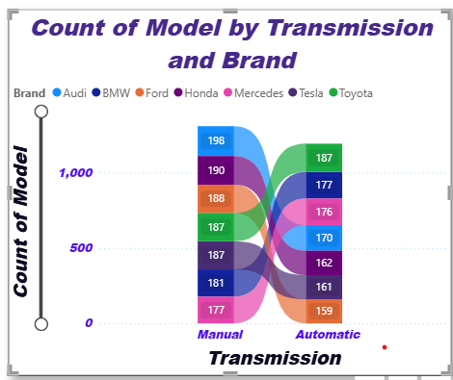
KEY INFULCENERS:
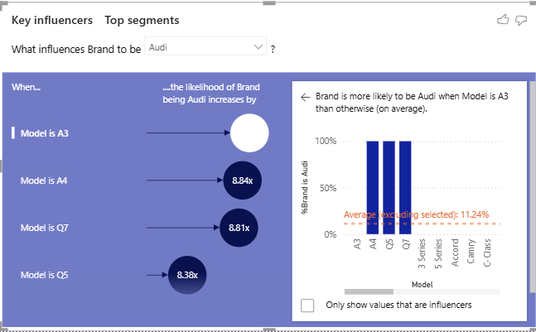

DASHBOARD VIEW 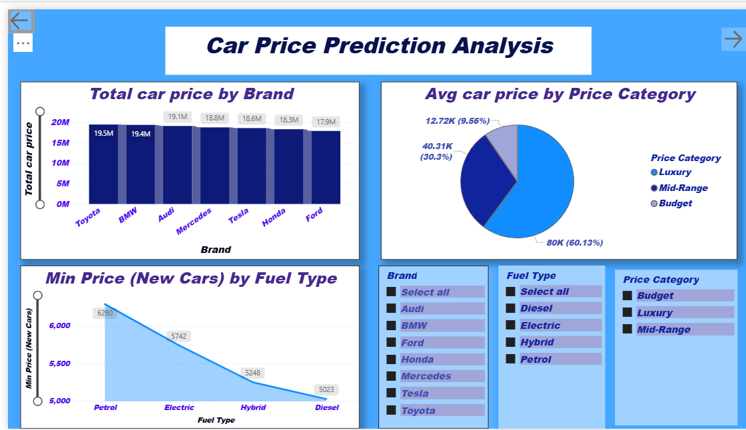
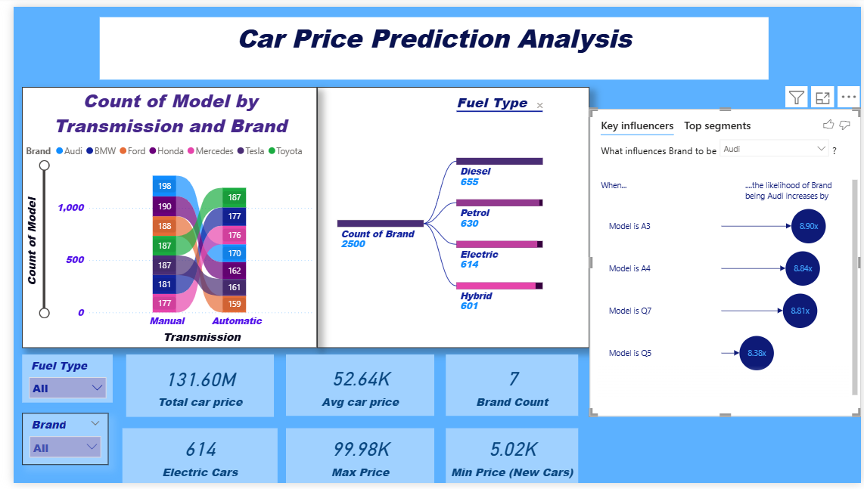

INSIGHTS AND RECOMMENDATIONS
- Key Observations: Identify significant trends, such as high-performing sales months or dominant health indicators in specific regions.
- Recommendations:
- For Sales: Suggest focusing marketing efforts on high-performing product categories.
- For Health: Recommend targeted medical screenings for demographic groups showing high risk.
- For General Businesses: Propose streamlining operations based on identified bottlenecks

BUSINESS BENEFITS
This dashboard helps:
• Car dealers to set better prices
• Customers to compare cars
• Companies to plan inventory
• Management to take data-driven decisions
CONCLUSION
This Power BI solution does more than just display numbers; it provides a framework for predictive decision-making. By leveraging DAX to uncover hidden usage patterns, businesses can optimize their inventory turnover, maximize profit margins, and provide greater transparency to the end consumer.

