我们在方法中lineXXX补充了蛋白纯化的流程，并将其与酶动力学参数测定进行性了合并描述：不同酶反应的时间还需要强调一下
Protein purification and enzyme kinetic assays
Plasmid pETDuet-1 carrying the target gene was introduced into *E. coli* BL21(DE3). The resulting strains were cultivated in 100 mL of LB medium containing ampicillin at 37 °C and 220 rpm. When the culture reached an OD600 of 0.6, IPTG was added to initiate protein expression, and cultivation was continued at 20 °C and 220 rpm for 16 h. His-tagged proteins were purified using Ni-NTA agarose resin (YEASEN, China) according to the manufacturer's standard protocol. The purified proteins were subsequently used for enzyme kinetic assays. Enzyme kinetic assays were performed in 50 mM Tris-HCl buffer (pH 7.5) in a total reaction volume of 0.2 mL. Acetyl-CoA was added at a final concentration of 3 mM to ensure sufficient acyl donor availability, together with 1.5 μM purified target enzyme. p-Aminophenol was used as the substrate at concentrations ranging from 0 to 5000 μM. Reactions were conducted at 37 °C and terminated at predetermined time points selected for each enzyme to ensure that product formation remained within the initial linear phase. Specifically, the reaction time was 1 min for MetAA, ATF1, YokL, and DcsE; 2 min for SAT1 and GlmU; and 5 min for HE and LipB. Following appropriate sample pretreatment, product formation was quantified by HPLC. Initial reaction velocities were calculated from product formation over the corresponding reaction time and used to fit the kinetic parameters.

补充HPLC分析方法的详细信息，包括色谱柱型号、进样体积、样品前处理方法、标准曲线、线性检测范围、回收率以及检测限和定量限等参数。
感谢审稿人提出这一重要建议。根据审稿人的意见，我们已在修订稿Methods部分补充HPLC分析方法及其方法学验证参数，并将详细计算结果汇总于Supplementary Table X中。“HPLC分析采用ShimNex CS C18反相色谱柱（5 μm，4.6 × 250 mm；Shimadzu, Japan），进样体积为20 μL，柱温为30°C，流速为0.8 mL/min。流动相A为含0.2%三氟乙酸的水相，流动相B为甲醇；0–30 min内流动相A由95%线性降低至0%，30–33 min恢复至95%，并维持至38 min。检测波长设置为260和280 nm。发酵液样品经12,000 rpm离心15 min后取上清液，并经0.22 μm尼龙滤膜过滤后进行HPLC分析。采用25、50、100、200、500和1,000 mg/L标准品建立外标标准曲线。对氨基苯酚的回归方程为y = 18377x + 1342（R² = 0.993），对乙酰氨基酚的回归方程为y = 30136x + 3432（R² = 0.995），两种分析物的校准范围均为25–1,000 mg/L。加标回收率在50、500和1,000 mg/L三个水平进行评价。对氨基苯酚的平均回收率为81.33–96.53%，RSD为1.38–5.12%；对乙酰氨基酚的平均回收率为88.67–97.57%，RSD为0.63–6.89%。此外，基于25 mg/L标准品三次重复测定的响应标准差及校准曲线斜率，按照LOD = 3.3σ/S和LOQ = 10σ/S进行估算。对氨基苯酚的LOD和LOQ分别为1.25和3.78 mg/L，对乙酰氨基酚分别为1.31和3.96 mg/L。需要说明的是，25–1,000 mg/L为实际建立并验证的校准范围，而上述LOD和LOQ为基于低浓度标准品重复响应估算得到的参数。此外，为进一步确认反应体系中对氨基苯酚和对乙酰氨基酚的身份，对相关样品进行了质谱分析（UPLC/Xevo G3 QTof, Waters, USA）。质谱检测采用正离子模式，并分别监测对氨基苯酚和对乙酰氨基酚的质子化分子离子 [M+H]⁺，其特征m/z分别为110.06和152.07。相关LC-MS谱图已补充至Supplementary Fig. X中。相关原始数据、计算过程及结果已汇总于Supplementary Table X，并在修订稿Lines XXX–XXX中进行了补充说明。

 | Calibration range (mg/L) | Calibration equation | R² | Spiked level (mg/L) | Measured concentrations (mg/L, n=3) | Mean ± SD (mg/L) | Recovery (%) | RSD (%)
p-Aminophenol | 25–1000 | y = 18,377x + 1,342 | 0.993 | 50 | 40, 43, 39 | 40.67 ± 2.08 | 81.33 | 5.12
 |  |  |  | 500 | 479, 490, 478 | 482.33 ± 6.66 | 96.47 | 1.38
 |  |  |  | 1000 | 950, 967, 979 | 965.33 ± 14.50 | 96.53 | 1.51
Acetaminophen | 25–1000 | y = 30,136x + 3,432 | 0.995 | 50 | 45, 41, 47 | 44.33 ± 3.06 | 88.67 | 6.89
 |  |  |  | 500 | 488, 492, 472 | 484.00 ± 10.58 | 96.80 | 2.19
 |  |  |  | 1000 | 969, 977, 981 | 975.67 ± 6.11 | 97.57 | 0.63
Table X. HPLC method validation results for the quantification of p-aminophenol and acetaminophen.

 | 25 mg/L replicate peak areas | Mean peak area | SD (σ) | Calibration slope (S) | LOD = 3.3σ/S (mg/L) | LOQ = 10σ/S (mg/L)
p-Aminophenol | 473914; 469312; 460245 | 467,823.67 | 6,954.98 | 18,377 | 1.25 | 3.78
Acetaminophen | 774356; 758391; 750985 | 761,244.00 | 11,943.85 | 30,136 | 1.31 | 3.96
Table X. HPLC-based determination of the limits of detection (LOD) and quantification (LOQ) for p-aminophenol and acetaminophen.

为了验证 MDS 在功能酶筛选中的实际应用价值，我们选择N-乙酰基转移酶作为筛选目标。这类酶能够催化含氨基底物的 N-酰基化反应，并在对乙酰氨基酚等具有重要药用价值的化合物生物合成中发挥重要作用。我们以 对-氨基苯酚（p-aminophenol）的 N-乙酰化反应作为模型反应，该反应底物结构简单且具有代表性，同时对乙酰氨基酚标准品易于获得，并已有成熟的分析检测方法，从而能够实现对酶催化活性的可靠验证。在此基础上，我们利用 MDS 对包含 10,026 条候选序列的酶库进行筛选，并选取得分最高的 100 条候选序列进行分析。与此同时，为评估MDS初始排序对具有催化潜力候选酶的富集能力，我们对 MDS 排名 101–300 的候选序列进行了同样的复核筛选。
对于上述两个排名区间的候选序列，我们均采用相同的序列和结构导向筛选流程。首先，按照序列一致性 >90% 的标准对候选序列进行聚类，以去除高度同源的冗余序列，并在每个聚类中保留 MDS 预测得分最高的代表序列[45]。随后，通过多序列比对检查关键催化残基的完整性，包括 HXXXD 基序[46] 和 Cys-His-Asp 催化三联体[47]，其中重点关注参与乒乓机制所必需的催化 Cys 残基。进一步利用 AlphaFold3[48] 预测候选蛋白的三维结构，并采用 AutoDock Vina[26] 分别对 p-aminophenol 和 acetyl-CoA 进行半柔性分子对接，以评估催化残基与底物之间的空间排布是否满足 N-乙酰化反应的几何要求，包括小于 4.0 Å 的适宜进攻距离，以及 p-aminophenol 中亲核氨基与 acetyl-CoA 乙酰基之间合理的相对取向[49]（Fig. 5A）。通过上述逐级筛选，进一步排除了催化残基缺失、存在明显空间位阻或底物结合构象不合理的候选酶。
在 MDS 排名前 100 的候选序列中，经上述筛选最终获得 10 个候选酶，包括 SAT1、MetAA、DcsE、HE、GlmU、Spy、YokL、SpeG、CatQ 和 ATF1，并用于后续实验验证（Supplementary Table 9）。与此同时，从 MDS 排名 101–300 的候选序列中，采用完全相同的筛选流程独立获得 10 个候选酶，包括 LipB、MetAS、PagP、Apx3C、YjcK、LCAT、ATAT、PseH、Y875 和 PhnO（Supplementary Table 9）。两组候选酶的 MDS 预测得分及其排名信息汇总于 Table 3。
随后，将上述候选酶的编码基因分别克隆至 pETDuet-1 表达载体中，构建相应的重组表达质粒，例如 pETDuet-MetAA（Supplementary Table 10），并转化至 E. coli BL21(DE3) 中，获得相应的工程菌株（Supplementary Table 11）。采用标准蛋白纯化流程获得候选酶的纯化蛋白，并进一步测定其对 p-aminophenol 的催化活性。SDS-PAGE 分析结果表明，所测试的候选酶均能够在 E. coli 中成功表达（Supplementary Figure 1）。
在 MDS 排名前 100 的 10 个候选酶中，共有7种酶，包括 MetAA、ATF1、YokL、DcsE、SAT1、GlmU和HE，能够催化p-aminophenol向对乙酰氨基酚的转化（Table 4 and Supplementary Figure 2），对应的实验阳性率为70%。其中，MetAA 表现出最低的 Km 值和最高的催化效率（Km = 1213.43 ± 102.10 μM；kcat/Km = 0.056 μM⁻¹·s⁻¹），表明其对底物具有较高的亲和性，并具有最佳的催化性能。ATF1 的催化效率次之（Km = 1488.76 ± 99.38 μM；kcat/Km = 0.037 μM⁻¹·s⁻¹），其次为 YokL（Km = 1963.84 ± 99.38 μM；kcat/Km = 0.025 μM⁻¹·s⁻¹）。DcsE、SAT1、GlmU 和 HE 的底物亲和性和催化效率相对较低，其 Km 值分别为 2557.16 ± 355.82、2731.65 ± 279.56、2852.55 ± 224.29 和 2918.41 ± 162.92 μM，对应的 kcat/Km 分别为 0.018、0.015、0.014 和 0.015 μM⁻¹·s⁻¹。相比之下，Spy、SpeG 和 CatQ 在所测试条件下均未检测到对 p-aminophenol 的催化活性。值得注意的是，MDS 排名 101–300 的候选组表现出明显较低的实验阳性率。在采用相同筛选流程获得的 10 个候选酶中，仅 LipB 表现出可检测的催化活性，而 MetAS、PagP、Apx3C、YjcK、LCAT、ATAT、PseH、Y875 和 PhnO 均未检测到催化活性（Table 4 and Supplementary Figure 2）。因此，该排名区间的实验阳性率仅为 10%。LipB 的 Km 为 2935.37 ± 390.59 μM，kcat/Km 为 0.014 μM⁻¹·s⁻¹，其催化效率处于前 100 名活性候选酶的较低水平。上述结果表明，MDS 排名靠前的候选序列中具有催化潜力的酶显著富集，支持了 MDS 初始排序在功能酶筛选中的实际价值。
进一步的 in vivo 补料实验验证了上述体外酶活性结果。与对乙酰氨基酚标准品一致的特征峰（保留时间 = 10.67 min）可在表达前 100 名中 7 种活性候选酶的工程菌株发酵样品中检测到（Fig. 5B）。HPLC 分析显示，表达 MetAA、ATF1、YokL、DcsE、SAT1、GlmU 和 HE 的工程菌株分别生成 450.10、417.05、203.55、124.06、76.85、46.81 和 42.26 mg/L 对乙酰氨基酚（Fig. 5C）。相比之下，表达 Spy、SpeG 和 CatQ 的工程菌株均未检测到明显的产物积累。对于 MDS 排名 101–300 的候选组，表达 LipB 的工程菌株能够生成 24.2 mg/L 对乙酰氨基酚（Fig. 5C），而其余 9 种候选酶均未检测到明显的产物积累。
综上，MDS排名前100的候选中，经过后续序列和结构导向筛选获得的10个候选酶中有7种表现出可检测的 p-氨基苯酚N-乙酰化活性，而排名101–300的候选中，筛选获得的10个候选酶中仅有1种表现出活性，表明MDS的初始排序能够有效富集具有催化潜力的候选酶。进一步地，模型预测结果、体外酶活性测定和体内补料实验结果之间表现出较高的一致性，尤其是MetAA、ATF1和YokL在模型评分、体外催化效率及体内产物形成方面均表现出较好的性能，进一步支持了MDS预测结果的可靠性及其在功能酶发现中的应用潜力。值得注意的是，最终获得的8种具有p-氨基苯酚N-乙酰化活性的酶分别来自多个不同的酶家族。该结果表明，这些酶具有此前未被报道的底物谱扩展或乙酰基转移活性，同时也表明MDS并未局限于特定的酶家族，而是能够跨越不同序列和功能家族发现具有目标催化活性的非经典酶。因此，本研究中的筛选案例准确地反映了MDS在跨家族功能酶发现和催化活性挖掘中的应用能力。

Supplementary table 8 List of candidate enzymes.
Protein name | UniProt ID | Amino acids (aa) | Molecular weight (kDa) | Organism | Family
MetAA | Q72X44 | 301 | 35.3 | Bacillus cereus | MetX family
ATF1 | P40353 | 525 | 61.0 | Saccharomyces cerevisiae | ATF1 alcohol acetyltransferase family
YokL | O31995 | 177 | 20.8 | Bacillus subtilis | Acetyltransferase family
HE | Q66165 | 424 | 47.7 | Bovine coronavirus | Influenza type C/coronaviruses hemagglutinin-esterase family
SAT1 | P48026 | 171 | 20.0 | Mus musculus | Acetyltransferase family
GlmU | Q5NHR0 | 455 | 49.6 | Francisella tularensis subsp. tularensis | N-acetylglucosamine-1-phosphate uridyltransferase family
DcsE | D2Z028 | 374 | 40.2 | Streptomyces lavendulae | MetX family
Spy | Q8P051 | 142 | 16.1 | Streptococcus pyogenes serotype M18 | Acetyltransferase family
SpeG | Q9KL03 | 173 | 20.6 | Vibrio cholerae serotype O1 | Acetyltransferase family
CatQ | P26825 | 219 | 26.0 | Clostridium perfringens | Chloramphenicol acetyltransferase family
LipB | Q1RKI1 | 209 | 23.8 | Rickettsia bellii | LipB family
MetAS | A8GKF8 | 309 | 35.5 | Serratia proteamaculans | MetA family
PagP | Q7N3D3 | 207 | 24.0 | Photorhabdus laumondii | Lipid A palmitoyltransferase family
Apx3C | Q04474 | 173 | 20.4 | Actinobacillus pleuropneumoniae | RTX toxin acyltransferase family
YjcK | O31633 | 181 | 20.9 | Bacillus subtilis | Acetyltransferase family  RimJ subfamily
LCAT | O35573 | 299 | 34.6 | Eliomys quercinus | AB hydrolase superfamily  Lipase family
ATAT | C0H559 | 184 | 21.8 | Plasmodium falciparum | Acetyltransferase ATAT1 family
PseH | Q0P8U4 | 157 | 18.7 | Campylobacter jejuni subsp. jejuni serotype O:2 | Undefined
Y875 | Q6D8U7 | 141 | 16.3 | Pectobacterium atrosepticum | acetyltransferase family  YpeA subfamily
PhnO | P16691 | 144 | 16.5 | Escherichia coli | Undefined

Table 3
Rank | Score (Normalized to 0-1) | Enzyme
11 | 0.9962 | LipB
12 | 0.9961 | MetAS
13 | 0.9959 | PagP
14 | 0.9959 | YjcK
15 | 0.9958 | Apx3C
16 | 0.9956 | LCAT
17 | 0.9956 | ATAT
18 | 0.9952 | PseH
19 | 0.9951 | Y875
20 | 0.9950 | PhnO

Supplementary table 10 List of plasmids.
Plasmids name | Description (Backbone; Source organism; Gene name; Resistance)
pETDuet-LipB | pETDuet; Rickettsia bellii; lipB; Amp^{R}
pETDuet-MetAS | pETDuet; Serratia proteamaculans; metAS; Amp^{R}
pETDuet-PagP | pETDuet; Photorhabdus laumondii; pagP; Amp^{R}
pETDuet-YjcK | pETDuet; Bacillus subtilis; yjcK; Amp^{R}
pETDuet-Apx3C | pETDuet; Actinobacillus pleuropneumoniae; apx3C Amp^{R}
pETDuet-LCAT | pETDuet; Eliomys quercinus; LCAT; Amp^{R}
pETDuet-ATAT | pETDuet; Plasmodium falciparum; ATAT; Amp^{R}
pETDuet-PseH | pETDuet; Campylobacter jejuni subsp. jejuni serotype O:2; pseH; Amp^{R}
pETDuet-Y875 | pETDuet; Pectobacterium atrosepticum; y875; Amp^{R}
pETDuet-PhnO | pETDuet; Escherichia coli; phnO; Amp^{R}

Supplementary table 11 List of strains.
Strains | Description | Source
STR11 | BL21(DE3) carrying pETDuet-LipB | This study
STR12 | BL21(DE3) carrying pETDuet-MetAS | This study
STR13 | BL21(DE3) carrying pETDuet-PagP | This study
STR14 | BL21(DE3) carrying pETDuet-YjcK | This study
STR15 | BL21(DE3) carrying pETDuet-Apx3C | This study
STR16 | BL21(DE3) carrying pETDuet-LCAT | This study
STR17 | BL21(DE3) carrying pETDuet-ATAT | This study
STR18 | BL21(DE3) carrying pETDuet-PseH | This study
STR19 | BL21(DE3) carrying pETDuet-Y875 | This study
STR20 | BL21(DE3) carrying pETDuet-PhnO | This study

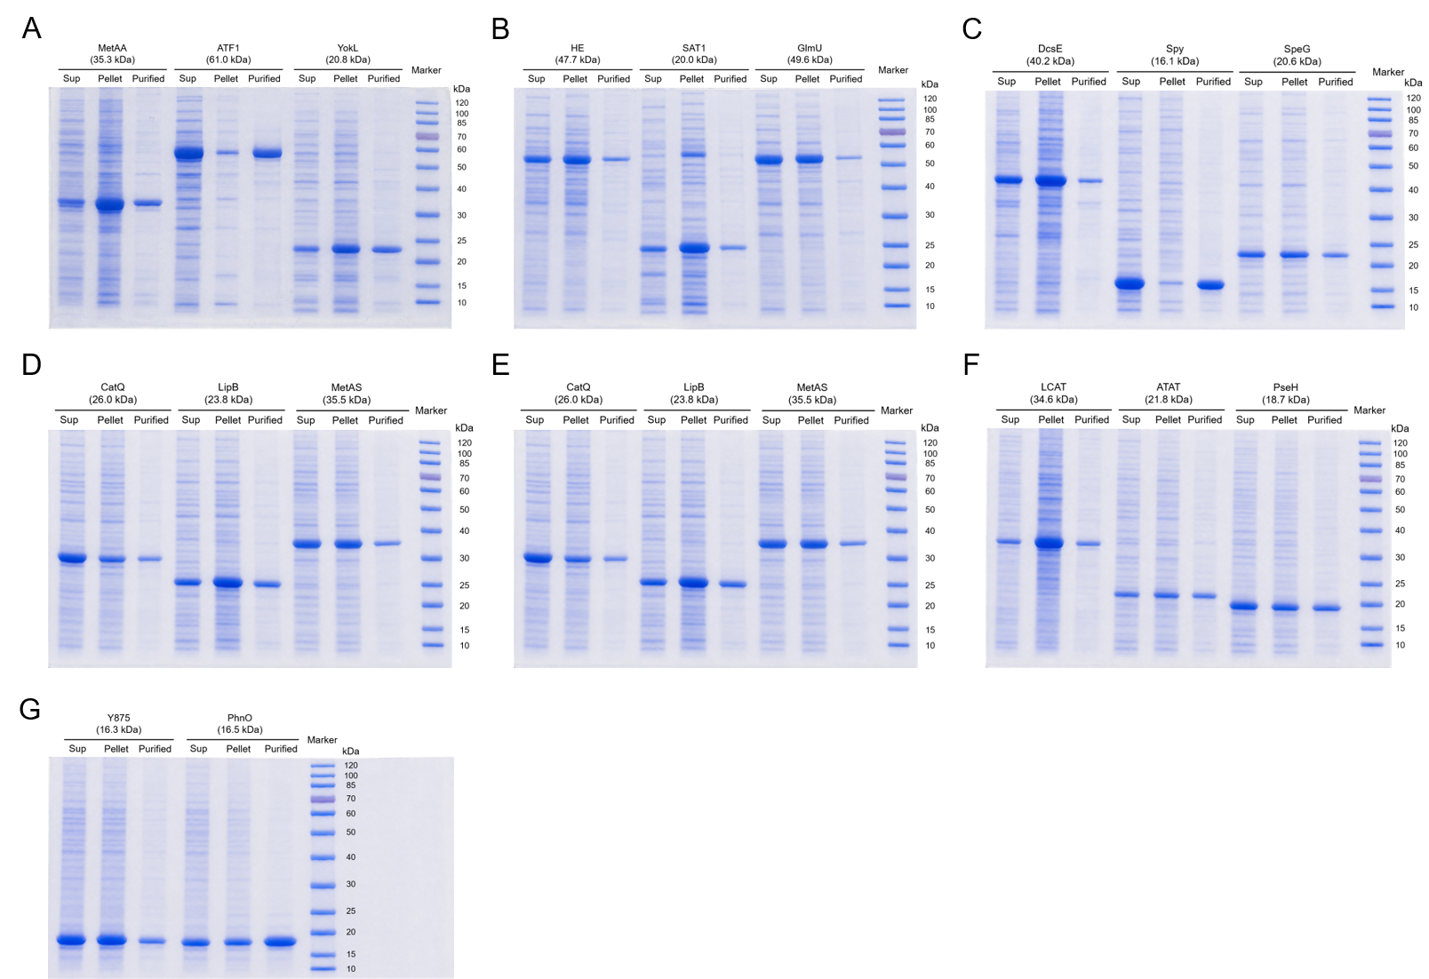
图注，SDS-PAGE analysis of recombinant proteins expressed in E. coli BL21(DE3). Supernatant (Sup), pellet (Pellet), and purified protein (Purified) fractions are shown for the indicated protein samples.

Enzymes | MetAA | ATF1 | YokL | HE | SAT1 | GlmU | DcsE | Spy | SpeG | CatQ | MetAA
Concentration (g/L) | 1.21 | 0.97 | 0.88 | 1.56 | 1.78 | 1.05 | 1.34 | 1.55 | 1.64 | 0.62 | 1.36
Enzymes | LipB | MetAS | PagP | Apx3C | YjcK | LCAT | ATAT | PseH | Y875 | PhnO | LipB
Concentration (g/L) | 1.87 | 0.86 | 0.93 | 1.24 | 1.37 | 0.98 | 1.33 | 0.87 | 1.43 | 1.05 | 1.63
Enzyme concentration in the assay

用于酶活测定的酶浓度表

Enzyme | K_{m} (μM) | V_{max} (μM·min⁻¹) | k_{cat} (min⁻¹) | k_{cat}/K_{m} (μM⁻¹·min⁻¹)
MetAA | 1213.43 ± 102.10 | 101.60 ± 6.41 | 67.74 | 0.056
ATF1 | 1488.76 ± 99.38 | 82.70 ± 4.64 | 55.13 | 0.037
YokL | 1963.84 ± 99.38 | 75.08 ± 4.70 | 50.06 | 0.025
DcsE | 2557.16 ± 355.82 | 69.40 ± 6.84 | 46.27 | 0.018
SAT1 | 2731.65 ± 279.56 | 63.33 ± 5.00 | 42.22 | 0.015
GlmU | 2852.55 ± 224.29 | 59.86 ± 2.70 | 39.91 | 0.014
HE | 2918.41 ± 162.92 | 65.80 ± 1.86 | 43.86 | 0.015
LipB | 2935.37 ± 390.59 | 63.57 ± 6.65 | 42.38 | 0.014

Group | Enzyme | Acetyl-CoA | p-Aminophenol | k_{cat}/K_{m} (μM⁻¹·min⁻¹) | Relative activity (%)
No enzyme | - | + | + | No detected | No detected
No Acetyl-CoA | MetAA | - | + | No detected | No detected
Heat-inactivated enzyme | MetAA | + | + | No detected | No detected
1 | MetAA | + | + | 0.056 | 100
2 | ATF1 | + | + | 0.037 | 66.1
3 | YokL | + | + | 0.025 | 44.6
4 | DcsE | + | + | 0.018 | 32.1
5 | SAT1 | + | + | 0.015 | 26.8
6 | GlmU | + | + | 0.014 | 25.0
7 | HE | + | + | 0.015 | 26.8
8 | LipB | + | + | 0.014 | 25.0
Table X. Enzymatic activity of candidate enzymes toward p-aminophenol under different reaction conditions.

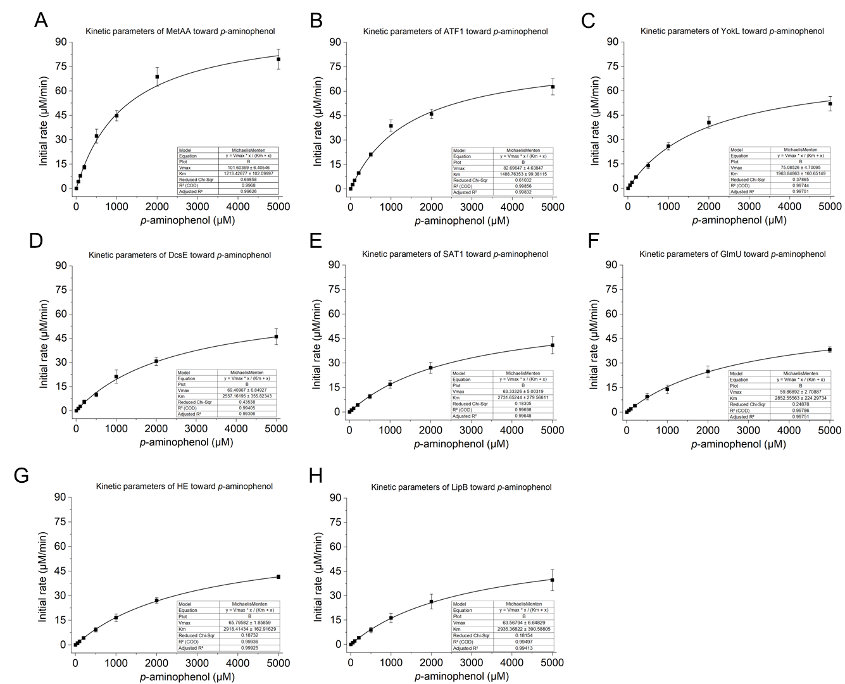
Figure X. Michaelis–Menten kinetics of candidate enzymes toward p-aminophenol.
Michaelis–Menten kinetic analysis of MetAA, ATF1, YokL, DcsE, SAT1, GlmU, HE, and LipB using p-aminophenol as the substrate. Initial reaction rates were measured at increasing concentrations of p-aminophenol and fitted to the Michaelis–Menten equation. Data points represent the measured initial reaction rates, and the solid curves indicate the corresponding nonlinear regression fits. The fitted kinetic parameters, including Km and Vmax, and the goodness-of-fit statistics are shown in the respective panels.

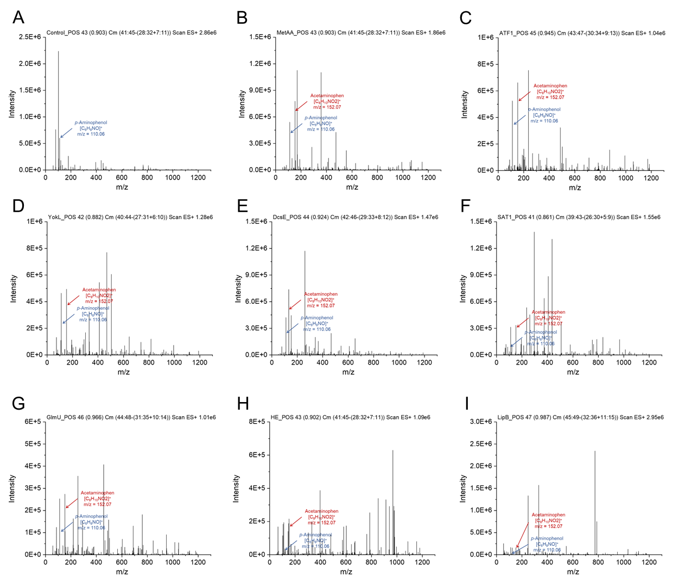
Supplementary Fig. X | LC-MS analysis of p-aminophenol acetylation by candidate enzymes. Positive-ion LC-MS spectra of the control and eight enzyme-catalyzed reaction samples. Enzyme reactions were performed with 1000 μM p-aminophenol under the conditions used for the enzyme activity assay, while the control contained the same reaction components without enzyme. p-Aminophenol and acetaminophen were monitored as their protonated molecular ions, [M+H]⁺ at m/z 110.06 and 152.07, respectively. The detection of the m/z 152.07 ion in enzyme-containing reactions supports acetaminophen formation from p-aminophenol.

液相图

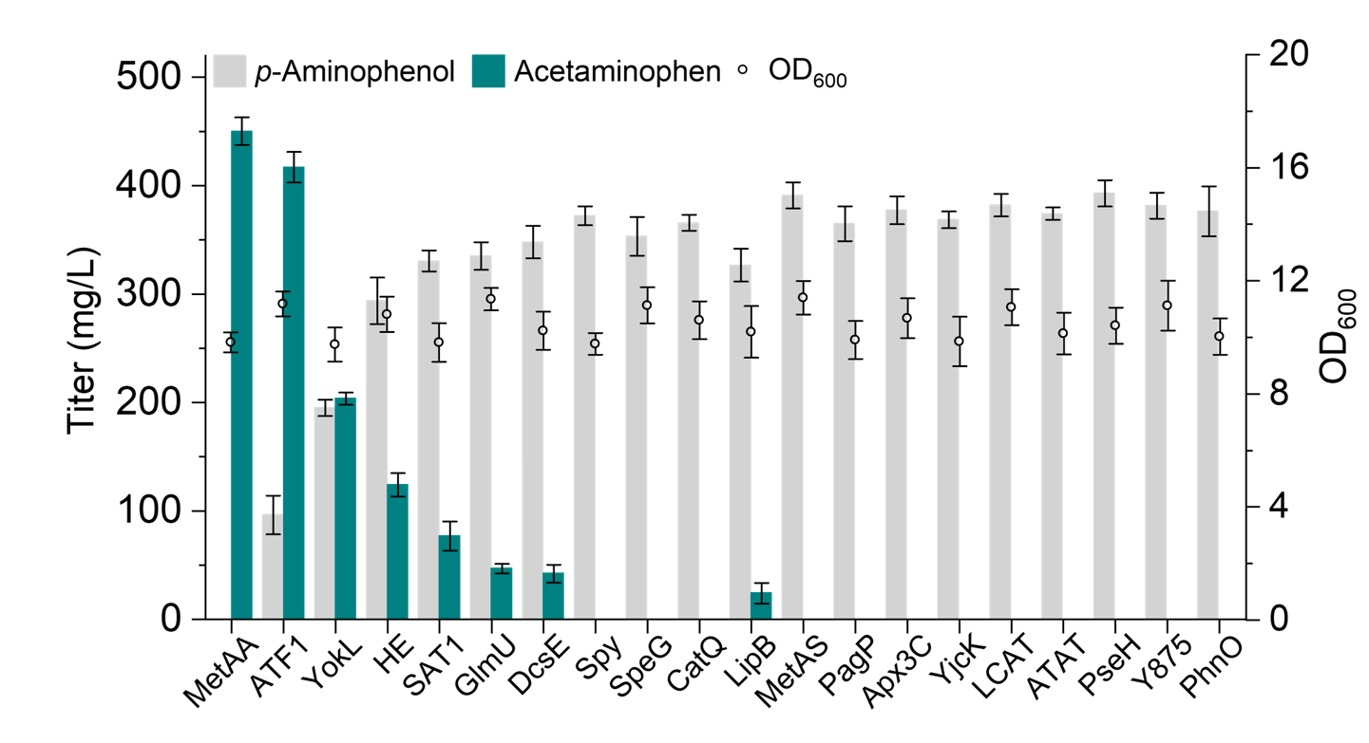
产量图

