INSTRUCTIONS:


To change which block you’re using, press one of the blocks in the list on the top right side.

The custom image one lets you import a png file into the map editor!
To create a 1m x 1m block with a different colour, just create a 42x42 image.

Pressing ‘E’ will place in the block that is selected.
The explosion and light bulb are special, and that the first is a light source, and the last is a particle emitter. To change which particle is used, open the context menu and change the string for particles to a particle in the modding documentation.

Holding ‘E’ will spam the blocks.

Pressing the “Human for scale” button will spawn a transparent human which you can use for a size reference.

Holding the left mouse button while hovering over a block will let you drag it.

Pressing Left Shift will snap the block to an invisible grid. You can also hold Left Control to select multiple blocks. Holding the left mouse button will create a selection box which can be used to select multiple blocks easier. Holding Left Control and the left mouse button lets you drag all blocks that are selected around, you can also snap them via left shift. That’s a lot of buttons to hold.

You can quit the application by pressing the “Esc” button.
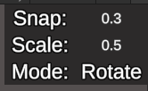

Changing snap will change how much, well, moving the blocks will snap.
Changing scale will change how much blocks snap scale.
Changing the mode will let you either rotate using A/D or scale using W/S/A/D.
You can also change the mode by pressing ‘M’.

Holding Left Shift will also snap the rotation amount to 15°. Pressing ‘R’ will reset the rotation.

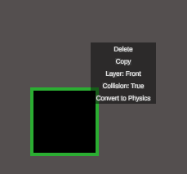
Pressing the right mouse button while a block is selected (or hovered over) will bring up the context menu. This is still very buggy, it is recommended to use the context menu on one block at a time, however it does fully support multiple blocks.
Pressing delete, well, deletes all the blocks selected.
Copy copies the block. Pressing ‘E’ will spawn in the copied block.
You can change which layer the block is on, the front or the back.
You can also change if the block has collision.
You can convert normal blocks to physics objects, and vice versa. They will have a physicalbehaviour as well, allowing you to delete them and stuff while in game.

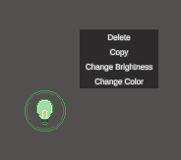
The two special blocks, as I said before, have different context menu options.
The light source can have its brightness and colour changed. Colour is in R, G, B, A.
The particle emitter can have its particles changed.
Changing the scale of both the particle emitter and light source will affect it in game. The light source will be larger, and the particle emitter will emit quicker.

When your map is done, you would want to compile it into a mod.
Press the button labelled “Compile” in the bottom right corner.
A new UI box appears.
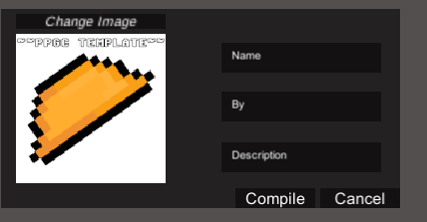
By clicking on the input fields, you can change the name, by line, and description of your mod / map.
You can change the image of the mod / map via the “Change Image” button.
Hitting compile will open up your file explorer. Navigate to your PPG mods folder.
Save the mod / map to your mods folder (make sure to name the folder!).

Time to open PPG!

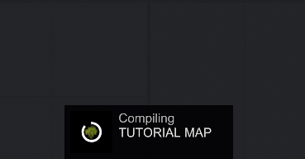
The mod will compile. If there’s an error, check the debug log, fix it inside your main.cs script, and contact me on discord with the error message.
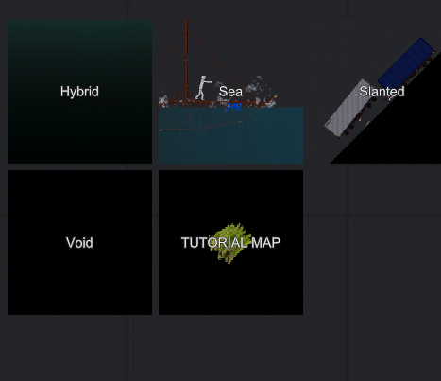
As you can see, my map as successfully compiled! Let’s open it and see what’s inside.
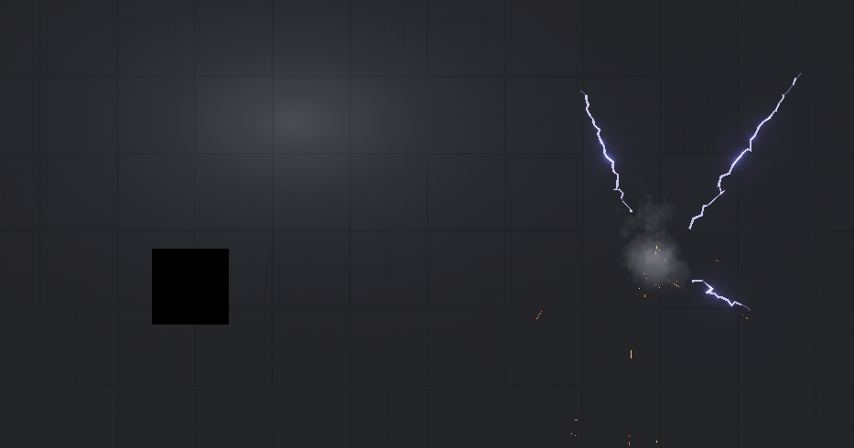

Would you look at that! One block, a light source, and a particle emitter emitting sparks!
HOW TO ADD THE COMPILED MAP TO AN EXISTING MOD:

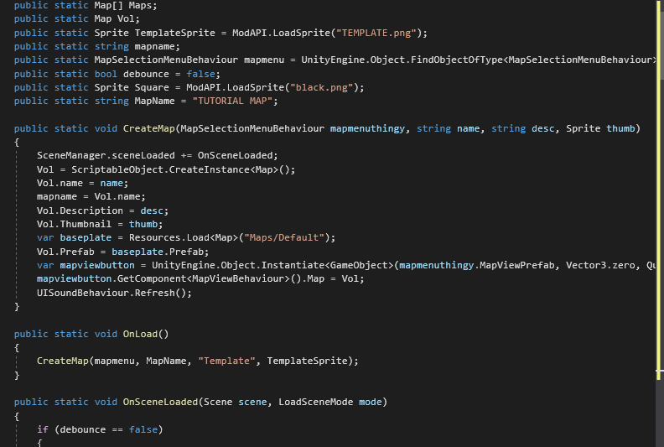
Literally just copy paste everything into the right spot.
I WANT TO BE UPDATED WHEN THE MAP EDITOR UPDATES / I WANT TO SUGGEST NEW FEATURES:

I’ve set up a discord literally just for announcements, updates, and suggestions.
https://discord.gg/xm79PbzpDT
If you want to change anything with the mod / add in something that you can’t with the map editor, then you’ll have to edit the main.cs file and make those changes yourself.
You’ll also learn how the map editor works.

